BCHRD: “Envisioning a Trauma and Discrimination Free Bangladesh”

Bangladesh Centre for Human Rights and Development (BCHRD) was founded in 1994 as a follow up to the national non-government, non-profit, non-political human rights and humanitarian aid organization entitled “National Trauma free Bangladesh and property reduction.” BCHRD focus on the rehabilitation and prevention of human rights abuses, human rights awareness raising, human rights education, human rights advocacy or legal aid to victims of human rights abuses. Bangladesh Centre for Human Rights and Development (BCHRD) is very small and grass rote level organization and it was founded in 1994 as a follow up to the national non-government organization entitled “National Torture free Bangladesh and property reduction.” Since its conception, the BCHRD has been on a path of constant growth while staying focused on its one main objective: to provide immediate assistance and rehabilitation for the trauma victims especially victims of trafficking, victims of violence against marginal child and women of this country.
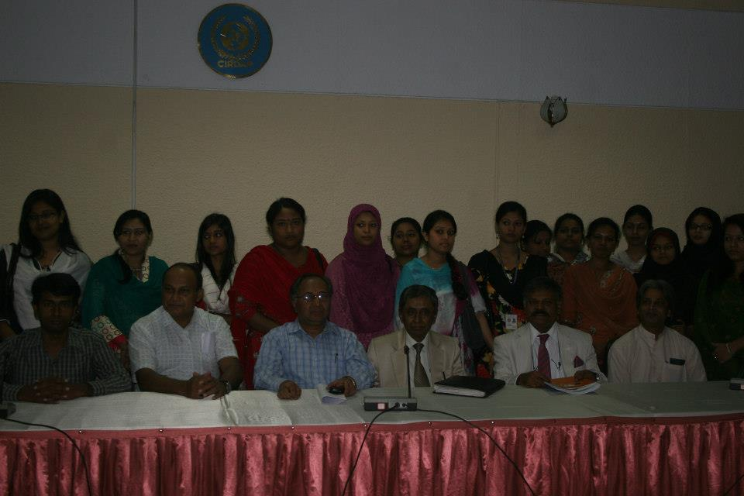
BCHRD team with Chairman of National Human Rights Commission and Member of Law Commission and Others prominent human rights defenders and green activist.
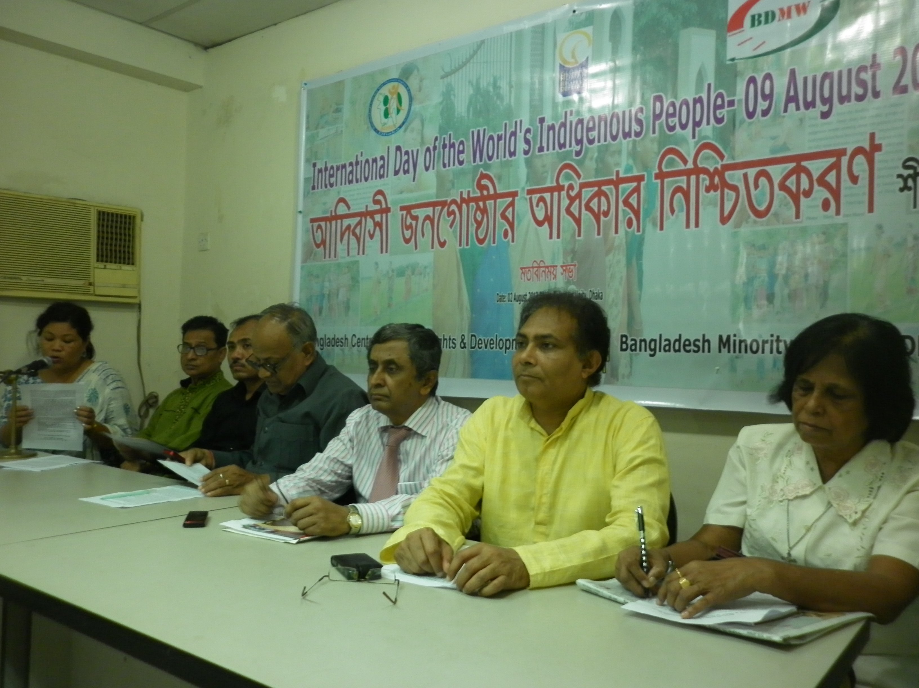
View Exchange meeting on minority issue with human rights defenders, green activist

BCHRD have over 25 years experienced in the base line democracy, good governance, human rights, election monitoring, survey, trafficking, women and girl empowerment, water and sanitation for marginal people, non-formal education for marginal children’s and marginal young women, training, education, trauma counseling, Life skills Training, Skills Development Training and research and Rehabilitation program. Therapy and rehabilitation of victims of Trafficking, victims of torture, violence, TOV, domestic violence including ethnical and minorities’ victims of trauma in Bangladesh; A survey and Research based activities. BCHRD implemented democracy, good governance, human rights, economic rehabilitation programs for the victims of trauma since 2010 with financial assistance of Taiwan Foundation for Democracy, The May 18 Memorial Foundation South Korea, International Indigenous Women Forum, Global Human Rights Defense (GHRD), BRCT, Wbb Trust, Rainbow Nari O Shushow Foundation, Save the Environment Movement, Aparajeyo-Bangladesh in Bangladesh, For sustainable economic growth of the trauma victims BCHRD formed Victims Associations (Vas) at the grass root level. So far it has been formed in all districts in Bangladesh. BCHRD have 12 staffs, 700 Volunteers non paid, 1000 Networks Members including CSOs, CBOs, Club, Community participation and youth organization in all over Bangladesh. Around 25 VAs has been formed in Bangladesh. BCHRD do not fund to its network/partner organization. BCHRD works with network member as strategic partnership organization.

1. | Year of working of BCHRD | : | 1994
 | Legal status |  | Registered with the Department of Social Services, Ministry of Social Welfare, Govt. of Bangladesh, Registration No. Dha-03193, Date: 26/10/1994
2. | Address of central office | : | Flat C-28, Level-16, 27 Bijoynajar, Dhaka-1000, Bangladesh  4/A, Shekertek-10, Mohammodpur  Dhaka-1207, Bangladesh  Cell Phone: 01976535340  Email: infobchrd@gmail.com
3. | Contact person’s | : | Md.Mahbul Haque (mahabub)  Executive Director, BCHRD  Email: mdmahbulhaque@gmail.com  Cell: 01976535340
4. | Working area |  | Although BCHRD is based in Dhaka but it is implementing different activities in all districts in Bangladesh through network persons or local CSO’s.

Vision
The vision of BCHRD is a torture and discrimination free Bangladesh

Mission
To increase opportunities for treatment of victims of torture and violence, herein after TOV, through Community Based Rehabilitation (CBR) in local communities in Bangladesh with the effective use of government and local resources, and the prevention of such human rights abuses.

Strategy
- To prevent torture victims by trauma educating, human rights education, informing and rousing the conscience of people, especially of the professionals.

- Ensure community participation at the local level against torture, Violence (Organized Violence, Political Violence, Domestic Violence and others Violence).

- To restore the mental and physical capacity of trauma the victims of torture through a multidisciplinary approach.

- To reintegrate the violence victims (men, women and children’s) to his/her own world by rehabilitation works.

Objectives
The main objective of the BCHRD is to rehabilitate a victim of torture to the point that they can be re-integrated back into society. Approaches are both curative and preventative. The unique curative approach used is a multidisciplinary one known as the integrated rehabilitation approach (IRA). This involves professionals including physicians, physiotherapists, psychologists, counselors, lawyers and social workers. The members from these departments meet frequently, know one another’s roles intimately and work as one. One of many recent developments has been the creation of the human resource department (HRD); this department is in charge of cross-training and sharing of information and ideas internally as well as the challenge of training externally. Its long term objective is to create awareness about the basic human rights among the target sectoral groups in order to protect, promote and to ensure respect for and realization of the Universal declaration of the Human Rights and the fundamental provision of rights of Constitution of Bangladesh. As such the organization is registered under social welfare Registration Act, 1961.

OBJECTIVES
Ultimate Goal:
Provide victims of trafficking with a combination of treatment and rehabilitation in order to allow full integration back into their communities and previous lives.

CURATIVE
- Integrated Rehabilitation Approach (IRA)
- Community Based Counseling (CBC)
- Community Based Entrepreneurs Development Program

PREVENTATIVE
- Victim’s Associations (VA)
- Door to Door Campaign Against Torture (DDCAT)
- Task Force against Torture (TFT)
- Home Visits (HV)
- Research and Documentation
- Lobbying for change and spreading awareness

Rehabilitation programs of BCHRD:

PSYCHOLOGICAL SUPPORT SERVICE
Training on Trauma Counseling:
Trauma Counseling: This series is a multidisciplinary training program for those who work with trauma survivors of abuse, violence, war, accident, crime and disaster. It consists of 84 clock hours of classroom instruction presented in two 42-hour courses. All instructors have been involved in diverse areas of trauma counseling with a variety of traumatized populations in acute to chronic situations. Courses may be taken for graduate or continuing education credit, which may also be used for licensing and certification requirements. The program is open to clinicians and practitioners in the medical, mental and behavioral health services as well as social service, finance service, legal service pastoral and bereavement counselors who work with survivors of substance use, eating disorders, physical illness, criminal justice, rehabilitation, and recovery.
Completion of the two Trauma Counseling courses results in a Certificate of Completion, which may be used to apply for certification as a Trauma Counselor with the Association of Traumatic Stress Specialists or the Traumatology Institute.
Understand psychological, behavioral, somatic and cognitive sequelae in children, adults and communities caused by experiencing traumatic events. Receive an overview of trauma, identifying traumatic populations and issues involving traumatic injury and resolution. Understand the neurobiology of trauma, trauma's effect on brain development and the body, and traumatic memory and learning.

Counseling and Supervision
The counseling department is often the first to see distraught trauma survivors. Primary tasks include emotional support and listening, discussing their mental and physical problems and finally discussion of their economical situation. At this point the counselors decide on the severity of the case and what combination of services they will receive under the IRA. Home-visits are made in severe cases when it is necessary to provide counseling for family members and for follow-ups. Study mental Health status problems of Adibashi Victims In Bangladesh.

Psychotherapy
The psychotherapy department was established in 1997. There are three clinical psychologists, one full-time and two part-time. In addition to sessions with the victims of torture, there are training sessions taking place internally as well as externally and active networking with other psychological organizations.

Psycho-education for Trauma Survivors
Survivors of torture often have to deal with an onslaught of psychological difficulties and need specific information about what is happening – the symptoms, the causes and the implications of the problem in question. The survivors are often shunned by their family and friends and so the more family and friends know, the less they will blame the person who is experiencing these problems and thus can be supportive to that person.
Trauma survivors make up a large percentage of clients in most service areas, yet few settings include services to meet their needs. Our Trauma Counseling Certificate Program is one of our most popular and critically needed training programs. Participants have three years to complete approximately sixteen days of training. You can enroll anytime.
Testimony from a local clinician and graduate, "The certificate in trauma counseling has made me more knowledgeable of the etiology of trauma and PTSD in the children and adults of the cases I supervise. It has made me more sensitive to seeing the underpinning of trauma such as sex abuse and domestic violence, which often results in the acting out behaviors of children and the alcohol and substance abuse of adults."

MEDICAL CARE
The somatic department deals mainly with minor surgeries, provision of medication and other basic physical attention. Any case too severe for them will be referred to one of many health care facilities. Over the years they have created quite a network of local hospitals and clinics they refer patients to including eye specialists, neurologists, gynecologists and more, and of course the BCHRD takes care of the fees on behalf of the victims. Follow-up involves patients returning to the BCHRD or home visits.

Physiotherapy
Physiotherapists are not very common yet in Bangladesh and so it is highly unusual to have such an innovative group of skilled physiotherapists in one institution. Many victims are not aware of this profession and are sometimes skeptical until they realize how much better they feel after being exposed to this type of treatment. In order to see and treat as many victims as possible, they will sometimes group together people with similar ailments and perform group therapy sessions. They have also developed basic instructions with diagrams for the patients to take home so they can continue therapy at home.

LEGAL ASSISTANCE
The legal department of the BCHRD was developed. Up to this point, emphasis had only been placed on medical and psychological aspects. He believed a legal department was necessary as every act of trauma is a potential case and approximately 90% of victims are involved in a false case.

Cultural Activists against Trauma (CAAT)
It is widely known that it is much easier to remember and retain information if it is presented in the form of a play or movie. Using these visually effective media as a way to communicate information about human rights and the plight of trauma victims is the objective of mobilizing cultural activists. Not only is it more difficult to retain information when reading it, but a large portion of the public are illiterate and have no other means of understanding their rights. By organizing the mobilization of cultural activists, awareness could be spread through the age-old art of storytelling to the most remote areas of the country.

Fact-finding & Urgent Action
The purpose of fact finding are to stand beside the victims immediately, to find the facts; and to create pressure on authority through writing urgent action to help ensure justice. BCHRD’s Fact-Finding Missions investigate the use of torture in Bangladesh by visiting each of the country’s regions on a regular basis and meeting with citizens from all walks of life, from farmers and laborers to academics and governmental authorities. It serves an invaluable role as an objective third party seeking out the facts surrounding each reported case of torture in individual communities by conversing with the victims and their families, witnesses in the community and the alleged perpetrators themselves. Each mission concludes with the submission of a report to the Ministry of Home and other concerned authorities encouraging urgent action on each case.

Documentation
This activity ensures <a base of information> for ready references concerning human rights and legal matters by managing a library of books and cutting and clipping information from newspapers.

Networking and Lobbying
BCHRD is very keen to maintain regular networking for lobbying and advocacy against any violations. Presently it is actively involved with different professional bodies, journalists, NGO’s tread union, political leaders to form ready protesting and rehabilitative bodies for immediate action against any violations. It also lobby for the reformation of bad laws especially those relating to torture.

Hot Line 01976535340,
Another BCHRD prevention initiative is its 24-Hour Hotline. This service monitors the use of violations throughout the country and acts as catalyst for immediate intervention by receiving information through its hotline facility in Dhaka. This telephone communication is meant to stand beside the victims and their families as quickly as possible. It remains open for 24 hour.

Gender Aspect: Equal Opportunities and Treatment Regardless of Gender
BCHRD prides itself on the equal treatment of men and women within its own offices and projects and seeks to do so with the individuals it treats as well. Women from rural areas are rarely able to travel to Dhaka for treatment as they are often unable to leave their home villages without being accompanied by a male family member, while many more are deprived of legal justice due to cultural norms and religious constraints in a male dominated society.

Leadership of HRDC

Executive Director: An Executive Director (ED) will be responsible for the overall administrative leadership of the organization and implementation, monitoring and supervision of all project(s) activities undertaken by the organization. The ED will appoint other relevant project staff and is responsible to BCHRD’s Executive Committee.

Executive Committee: Seven members from the general committee will be elected for two years to form the Executive Committee. In accordance with BCHRD’s Constitution, this committee will oversea all of the activities of the organization through the preparation of the organization’s annual budget, monitoring progress on projects being undertaken and submitting an annual report to the general committee. The Executive Committee will appoint Executive Director (ED) and will consist of following 7 members:

1. President 2. Vice-President 3. General Secretary
4. Treasurer 5. Member at large (*3)

Development approaches of BCHRD:
- Facilitate people’s participation in need assessment, planning, and implementation of activities.
- Assist community organization for sustainability of development process, mobilization, and optimum utilization of local resources.
- Develop and promote local voluntary activities through a group of volunteers.
- Stimulate and encourage development of human potentials for self-improvement.
- Initiate, develop, and implement demonstrative projects; experiment innovative ideas; conduct action research.
- Mediate and confer among donors, Govt. and other development organizations as a part of regular policy advocacy for desired social changes.
- Develop strong organizational network for sharing experiences and obtaining services for sustainable development.

Implementation Strategy:
BCHRD implements different activities either by receiving supports Development Partner organization or in partnership with other organizations. Community participation, networking, linkage, membership, and gender sensitization are considered in the implementation process. BCHRD materializes its mission and vision encompassing components of a certain program or integrating different components of two or more programs. In case of intervention, program activities are carried out through field offices. BCHRD gives importance to the achievement of the Millennium Development Goals (MDGs).
Financial Manual:

BCHRD is a non-profit voluntary social welfare agency. It has been implementing various programs/activities in different fields since its inception in the year 1993. By the time, it has received a sizeable amount of fund and has also mobilized its own resources to finance those activities throughout these years. Because of these experiences BCHRD has already developed standard procedures for the maintenance of financial matters of BCHRD. It follows a strong financial policy based on transparency and accountability to the funding agency as well as to the beneficiaries.

In the above context, BCHRD has been adopting following financial policies and standards to ensure its financial transparency.
- Receipt and transfer of the fund: Once the fund is received from the donor, the matter is brought to the notice of the Executive Body of BCHRD who discuss is the proposal against which the fund is advanced, different components of project with respective budget line, time frame and other related strategies for effective implementation of the project activities including some guidelines in matters of the maintenance of the accounts and fixing up the accountability of the respective accounts staff. The transfer of fund to the project site are also done according to the guidelines given by the EC.
- Budget-wise financial plan for expenditure: An annual financial plan is worked out component-wise for a particular project with the help of the senior staff and the Executive Director in line with the financial budget provision Expenditure should not exceed the budget line against the particular component. In case of such need of over expenditure, lese expenditure the approval of the Executive Body would be required.
- Transfer of fund to the project level: On the basis of the financial plan the fund is transferred from the mother account (The account of the project) to the project level to be handled by the Executive Director or authorized staff. Subsequently the funds are disbursed on the basis of component-wise requisition submitted from the field. Before requisition of fund for a particular month/period, the project manager or the field officer, as the case may be, should submit the complete statements of expenditure incurred during the preceding month/period.
- Mode of salary payment: Salary of officials/staff of more than Tk. 10,000.00 in both field and Head Quarter level should be paid in cheque. Amount less than that may be paid in cash. Proper records and acquaintance roll against each payment should be maintained.
- Outstanding Cheque: The Accountant shall review all outstanding cheques on a monthly basis. The organization will place a stop order on cheques, which remain outstanding for six months or more.
- Monitoring of financial matters: Regular monitoring of financial expenditure are to be done by monthly, quarterly and annual financial reports through prescribed monitoring tools and formats developed in consultation with the donors. The monitoring is done both at the field and Head Quarter level.
- Review of financial matters: The transparency of financial activities of BCHRD is evaluated in each monthly meeting of the staff at both field and Head Quarter. Review of financial matters is also done in the regular meeting of the Executive Committee. Necessary feedback is provided for efficient management of financial matters.
- Audit of accounts: Accounts and expenditure are audited annually by a Govt. Registered Audit Firm selected and appointed by the Executive Body. Besides, internal and periodical audit is also conducted to ensure transparency of the financial matters. Every project is subject to separate financial audit and the entire projects are also audited annually by external and authorized auditor/firm appointed by EC of BCHRD.

Gender Policy:

BCHRD believes that gender equality and gender mainstreaming are the most important instruments contributing to the empowerment of women in Bangladesh. This will help our women improve their life style as well as actively contribute to the nation building. Keeping this in view, BCHRD has been pursuing the policy of gender equality and gender mainstreaming in matters of employment and selection of beneficiaries. Some of the important aspects of gender policy adopted by BCHRD is given below:
- BCHRD works with the most vulnerable rural and urban women and adolescent girls and children. These programs are mainly meant for the promotion of women and girls for their mainstreaming or reintegration in the society which ultimately helps their development socially and economically.
- In matters of employment, BCHRD always follows gender equality and for the purpose, BCHRD recruits at least 55% women as its staff member in field and Head Quarter.
- In order to achieve the goals of gender equality and gender mainstreaming, the training and orientation on advocacy and leadership development is provided to both the employees and the beneficiaries.
- BCHRD regularly participates in the national and international level for dialogues, workshops and seminar discussing various aspects of gender equality and gender mainstreaming towards formulation of policies, strategies and planning for Elimination of Discrimination against Women.
- One of the main Gender Policies is to ensure participation and involvement of women in decision making, planning and program implementation.

Human Resources Development:

Every Program under implementation by BCHRD has necessary provisions for human resource development. For this purpose regular staff development activities are ensured. A work plan and a training module and schedule is used for the purpose. This staff development training is arranged during the entire project period on different project related activities to promote human resource development.

In the same way the target beneficiaries, peer educators, outreach workers and other members associated with the project are also given due orientation on different issues/activities of the project. Thus their knowledge of life skills is increased. Activities thus carried out surely help develop human resources.

Monitoring and Evaluation (ME):

Monitoring and evaluation are the key strategy and step to ensure proper implementation of the project activities. Following measures are taken by BCHRD to ensure effective monitoring and evaluation:

- Different Monitoring tools are used to get appraised the progress of project activities. These tools are developed in consultation with the donors which may differ from project to project according to the nature and need of the project. These monitoring tools are used for monthly, quarterly, half-yearly and annual reports. In some cases fort-nightly report is also required. The monitoring is done at the field level where the project-in-charge is assigned to monitor the activities. It is done at the headquarter level by the central monitoring and evaluation team comprising the coordinators of planning, R&D, Implementation and the MIS cells.

- Monitoring is also conducted through field visits of the senior officials of BCHRD Head Quarter, senior officials of the Govt. Ministries and departments and donors. These visits of the senior officials help find out obstacles/bottlenecks of the project and thereby help in providing necessary feedback for strengthening of the project activities.

- Evaluation of the project activities is also of utmost importance in order to assess the achievement of the targets and goals set for the project. Generally evaluation is conducted annually unless a project with less than one year period requires so. Mid-term evaluation is also conducted for a project usually of longer period like 3 years or more. There might be both internal as well as external evaluation of the project activities.

