UGANDA PUBLIC RESCUE FOUNDATION
uprf
(Non-Governmental organization for human rights and legal aid services of needy persons)

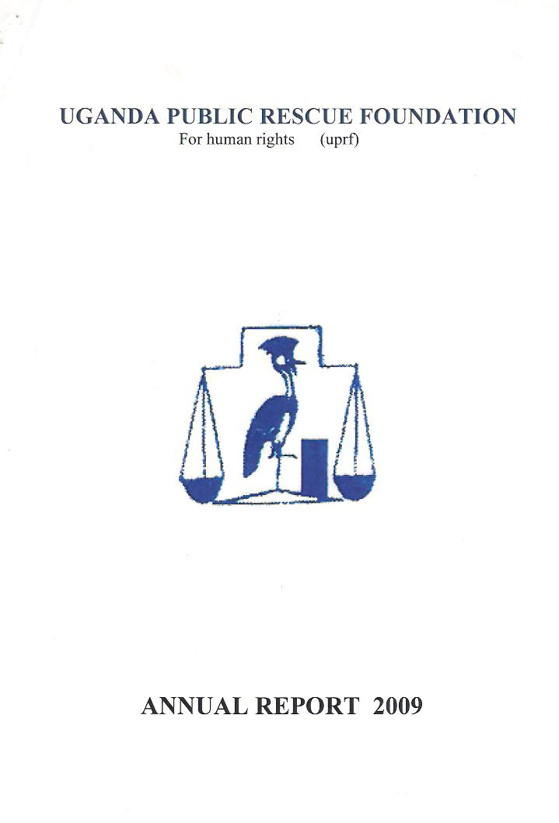

Accessing justice for all;
Empowering the communities

ANNUAL REPORT 2009

CHAIRPERSON’S REPORT

I am privileged to present yet a report of the Uganda Public Rescue for year ended 31st December 2009.

This report gives a detailed Account of progress made during the first year of implementing UPR’S Strategic plan 2009-2014 whose theme is,” making access to justice a reality for the poor”. The strategic plan was adopted at the beginning of this year and will guide the project’s direction for the next four years. It’s with much pleasure that i am reporting on progress towards fulfillment of this plan and the Uganda public Resource objective in general.

The year 2009 saw UPRF widen its coverage to reach the most vulnerable in need of legal aid services. The foundation opened three new branches increasing the total number of branches to 4. That is in Kampala, Masaka, Gulu, Mbale and Luzira. The growth of the project has not only been in coverage but also the package of services being delivered by the nation has greatly improved. A number of new projects were started and integrated in uprf’s original activities. The criminal justice programme implemented in Luzira prisoners on remand is but one example with support from PCMU and WACODA and UPRF started two new programmes in Masaka one decongesting prisons and protection and promotion of children’s rights respectively. UPRF is also spearheading an anti human trafficking campaign supported by the American Bar Association.

During the same period, the 21/2 (two and a half) years programme to strengthen the Capacity of the UPRF came to an end. The programme was instrumental the Capacity of staff, raising the profile of UPRF and advocating for inclusion of legal and human rights protection. It greatly impacted the area of skills development and capacity building, Information technology, research and programme development, strategic planning, management support and development of the legal aid regulations and human rights.

On behalf of the entire community of UPRF I take the opportunity to thank WACODA and other organization for funding the programme technical support and the UPS staff who did the actual implementation of programme activities. UPRF will remain indebted to all of them for their overwhelming support in the pursuit for access to justice for all. Communication between UPRF branches and the head office and the board has greatly improved. Introduction of an operational management team in Kampala, internet connectivity and email, availability of computers and contracting a permanent courier company have facilitated a channeled communication system.

Given the bigger and much better foundation has become, it was important to under take a general review of the structure to under take a general review of the structure and set up of a human resource and management professional firm was contracted to restructure the project to fit in the structure of its parent the other organization. Although implementation of the consultant’s report will need some time to take root, the proposed structure is much better and will introduce new positions which will greatly improve service delivery.

UPRF is very grateful for the continued financial support it receives from WACODA. And PCMU (people church ministry uganda) we also appreciate the technical support provided by Government of Uganda Departments and all the other partners who provide technical support. It’s with your financial and technical support that together our Vision A” Ugandan society where all human rights are respected promoted and defended to ensure access to justice for all is religion or socio-economic status,” to the citizens of Uganda is achieved.
Finally, I extend my sincere thanks to the staff of Uganda public rescue foundation under the stewardship of the Executive Director Mr. Yiga Robert who had steered the organization to greater heights. His continued hard work and commitment to the organization is much appreciated. I also thank the board of Executive for the strategic direction and policy guidance provided to UPRF towards fulfillment of its objectives.

Yours sincerely


OLIVA NAKYANZI
Chairperson.

- DIRECTOR’S REPORT.
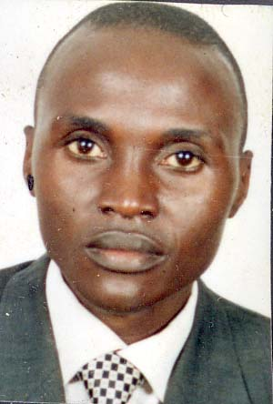
It’s with pleasure that I report about the successes and achievements of the year 2009.To a large extent 2008 was very successful and a land mark year in the history of the project foundation.

During the year, UPRF went through the process of nurturing the three new branches in Masaka, Luzira, and Mbaale which have strongly taken root and picked up so well. The new branches came in hand with new programmes in the UPRF system. A must mention is the criminal justice programme implemented by UPRF Masaka branch. The programme targets indigent prisoners on remand provision of legal aid services to prisoners. The programme is very unique and has received support from different stakeholders. It has significant impact on prisoners in terms of changing their attitude and enhancing their knowledge of their legal and human rights.

The use of paralegals in implementation of some activities has been of great value and a relief to advocates to focus on other issues of importance. Opening of the new branches and strengthening the existing ones has shown that the need for legal aid services is still overwhelming. UPRF will use the lessons learnt during 2009 to embark on an expansion programme to ensure fair and balanced access of our services by vulnerable people across the country.

Apart from the daily activities of attending to clients, counseling, advising and representing indigent clients, UPRF spearheaded awareness raising workshops on protection and promotion of people’s human and legal rights. The sensitization programme has increased people’s knowledge of their rights and thus built their capacity to defend and protect them. The programme has been successful due to the support from other JLOS Institutions. It is hoped that with increased legal and human rights awareness campaign the population will learn to advocate for their rights and respect other rights.

In the same year UPRF entered into new partnership to implement a number of programmes all geared at increasing access to justice to the poor. A child desk has been introduced in the UPRF Masaka office focusing on children’s rights. The paralegal programme has been instrumental in rolling out the prison decongestion programme in Masaka Uganda.

With support from PCMU and WACODA, UPRF undertook a human trafficking campaign in eastern and northern Uganda. This was a full fledged campaign that started with a situation analysis to establish the incident of cases and was followed by media campaign nationally. Though outcomes of the campaign are still being implemented, the process revealed other issues of contention that are in line with access to justice.

Related to the above, UPRF successful completed the sexual and Gender Based Violence Study which was conducted in seven Sub-counties in Masaka Uganda. This was done in partnership with PMU and WACODA Organization partners.

With its stakeholders for increased performance. A number of activities were implemented in partnership with other institution for credibility and efficiency. Through networking and imitation of partnerships, the organization was training and attending high profile meetings.

Internally, the organization improved communication systems by introducing a wireless internet connection. Every member of staff has an email address facilitating exchange and access of information amongst staff and other partners.

The human resource review implemented by UPRF is expected to yield a proper structure that will nurture all UPRF current and future plans. The exercise is intended to transform the organization into professionally and objectives. The recommendations of the review are expected to provide UPRF with clear guidelines and policies that UPRF will hold onto for continuity.

Although many challenges lie ahead, proper mechanisms and system put in place should be able to guide UPRF through most of its challenges. UPRF should consolidate and sustain achievements of the recent ended capacity strengthening programme in order not to become a victim of its own success. The need to develop a culture to document and report all activities of the foundation should be looked at with keen interest for the advantages are enormous. Issues of resource mobilization and fundraising should be given first priority since this is the backbone of the organization. A shift from a single donor to a multi-source of funding appears to be the best option to support the organization’s expansion plans.

In doing all this, the need to keep close links and relationship with Government institutions and other relevant stakeholders. This shall remain central to UPRF in pursuit access to justice for all and fight for human rights in the coming year.

Yours, faithfully

YIGA ROBERT
Executive Director

UGANDA PUBLIC RESCUE FOUNDATION

BACKGROUND

The Uganda Public Rescue Foundation is a non Government organization registered as a company limited by guarantee under the companies’ laws of Uganda and under NGO’s registration statute 1989.

The board of trustees works above a multidisciplinary management and staff team who implemented board policies. During year 2008 UPRF had a total number of 4 fulltime staff and volunteers spread across its 7 at secretariat. Consultants and research assistants were hired on contact basis to supplement studies/research conducted by UPRF during the period under review

Human rights and public interest litigation: this covers test cases and other cases of general public importance.

Achievements and highlights of the year
The year 2009 was significant year of UPRF operations. During this year the foundation experiences so many achievements.
Users of the justice system face physical, communication, technical and financial barriers in the quest to access justice and human rights; the Uganda Public rescue Foundation (UPRF) is the perfect solution for hands on assistance for the citizen base.

UPRF is a non-profit Human Right organization that offers Legal aid to indigent persons. Putting particular emphasis on those charged with criminal offences or those facing serious Human Rights challenges in the nation justice system. It was conceived in year 2008 in the context of justice law and order sector (JLOS) reforms as one of the new models for improved administration of justice in Uganda. The foundation envisions a society in which disadvantaged people have improved access to justice in fulfillments of constitutional requirements. It has the mission of establishing national mechanisms for public defense of poor people and human rights promotion
UPRF is now in its serious years of operation foundation and regards legal aid services to poor people as a factor in promoting the right to liberty and fair hearing, alleviating poverty and ensuring professional, cost effective, complete and quality legal aid services as core values and fight for Human rights.
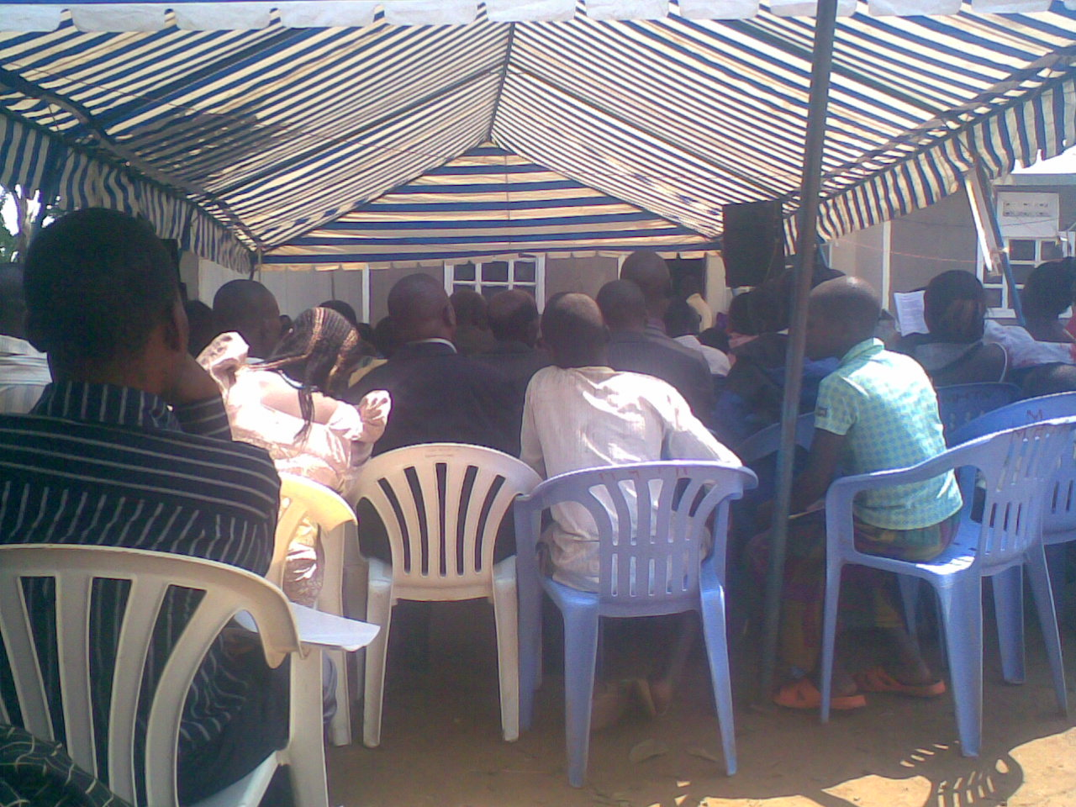

Workshop on Human rights sensitization at Masaka Bukomansimbi.

Vision, mission and vision of the Uganda public Rescue Foundation:
UPRF vision is a society in which disadvantaged people have improved access to justice in fulfillment of constitutional requirement and their human rights is fought for. The mission is to establish a national mechanism for public defense of the poor particularly those facing criminal cases and serious human rights challenges in the justice system. Purpose: offering legal services to the indigent persons.

UPRF’s activities are pursued under priority areas indicated below:

Public defense: legal representation of disadvantaged people with serious cases and or serious human rights violations in the criminal justice system. I.e. women, men, disabled, children’s rights.

Capacity building: strengthening service mechanisms, governance, membership, management, staff resources

Advocacy: involvement and commitment of GOU resource to public defense increased and behavior change communication.

Networking: Synergies with ongoing initiatives to improve the administration and GOU exploited and harness by UPRF.

Public defense: the core program under public defense is access to justice. This covers criminal defense, land assistance, succession, petty commercial claims and legal technical services and public interest litigation. Program activities include legal advice, medication, litigation counseling, institution visits, and literature provision and human rights protection.

Capacity building: under this program, UPRF endeavors to engage qualified individuals to offer legal service and seeks to establish access points in various parts of the country in order to achieve national coverage.
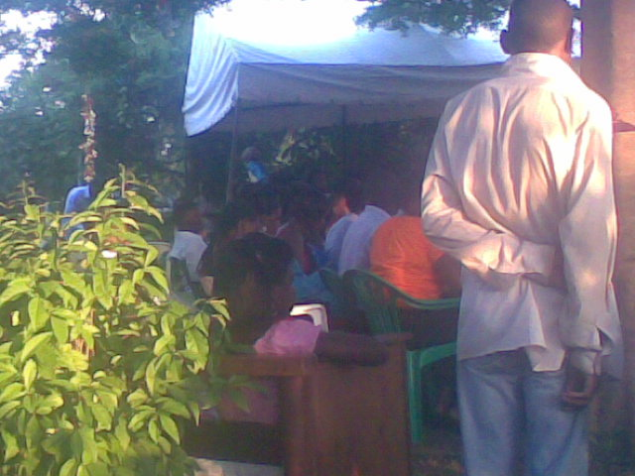

Workshop at Mbale, training community leaders on matter of law and Human rights.

Advocacy: The advocacy program features the ABY program for youths, prisoners and community leaders. The program aims to reduce sexual violence against youths and features crime prevention and prevention of HIV/AIDS infection among youths. It uses cross generational sex (CG) and transactional sex (TS) as the major topics of focus.
During advocacy campaigns, UPRf staff and youths trained as peer educators carry message on the risks causes and consequences of CG and TS to youth, community leaders and prisoners. Issue that are covered include human rights, laws on sexual offences, parenting, gender and law, HIV/ aids infection and prevention and other related matters. one significant aspect of the ABY program in training of peer educators, these are left in the community after being empower with skills to train avoid and train others to avoid risky sexual behavior. The peer educators then continue with the advocacy using dram, music and meetings to reach out to fellow youths in schools, community leaders and prisoners. Community leaders include LC leaders, opinion leaders, teachers as well as pastors. The experiences of prisoners is used to inform the exercise in the sense that people become aware of the more severe conquences of risky sexual behavior which include the loss of the right to liberty and other attendant rights. Prisoners are also empowered to break the silence and use their experience to warn others of the challenges they face well its growth as well as challenges. The growth highlighted the significant of the foundation and its relevancy to global solutions to problems facing the worlds’ poor. while the challenges served to strengthen the foundation

The foundation has made significant progress as a non-Governmental organization in criminal justice and human rights promotion. It has also made and documented the following achievements.

Capacity building: during the reporting year UPRF was able to launch and conform the relevance of its new service model that was implemented in Masaka, Mbale , Mukono, Kampala and Magisterial are-as. The new service delivery model that had been documented during the previous year was disseminated and was noted for its replicable, cost effective self-propelling nature and the capacity to accommodate professional carrier growth as well as sustainability. The lawyers practicing in the models are:

A number of cases were registered at the various access points and submitted to the foundation.

During this period the foundation continued to again recognition as a specialized service provider along side other legal aid service providers. UPRF also took stock of its record and noted a list of young lawyers that the foundation as mentored and are serving in different organization and agencies all over the country.

The ABY program:
The number of peer educator trained rose from 35 to 51 during the report period of 2008-2009
By June 2009 over 11,365 people had been reached by the ABY program featuring HIV/AIDS and crime prevention particularly sexual violence. They were reached in the Districts of Masaka,,Mbala, Mpigi and Kampala. The ABY project team consisted of the multidisciplinary group with appropriate training in Human Rights, skills training, HIV/ AIDS Gender and Law. The ABY project was an innovation in using minimum resources to reach maximum number of people.

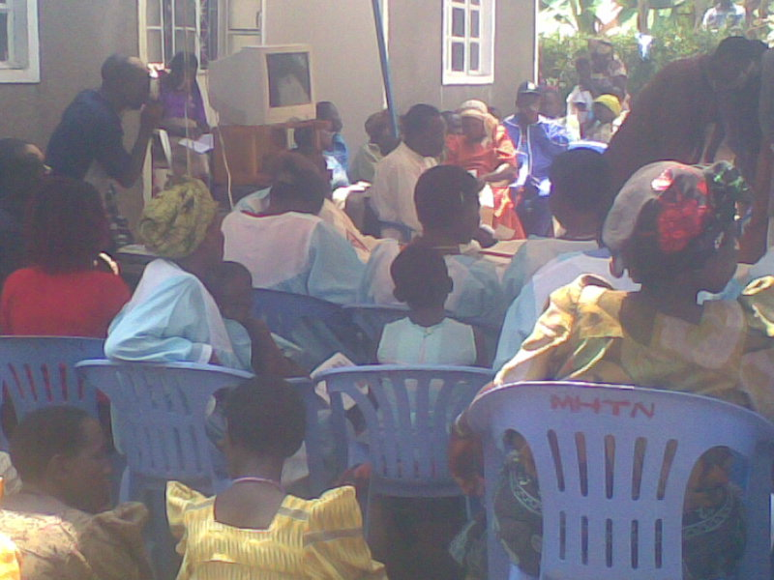

Workshop in Human rights training, skills on HIV/Aids Gender and law at masaka.

UPRF also designed .the highlights for the year was a selection of the CEO Yiga Robert as an Ashoka fellow. This means that he had joined an exclusive class of social entrepreneurs and he his now an Ashoka fellow. This has exposed the foundation to various resources and support that may lead it to sustainability. In May 2009 Robert was inducted into the A seminar at a high profile function in South Africa

Credit goes to our founder, PCMU and WACODA, stakeholders and others as well as to the UPRF Board, management committee, all the lawyers and other staff of the foundation and the following key supporters: Ashoka Innovators for the public, UPS, UNHCR, UHRC, LASPNET, ACTV, 1 Zawedde Lubwama and Co. Advocates (Kampala), Uganda Government/Judiciary, prison and police, law council, law society.

Following the launch of the new service model in 2008, the foundation has undergone foundational growth. This now calls for changes in governance, and scaling up in terms of approach, geographical coverage, programs and membership. Future activities will take account scaling up in the areas indicated below.
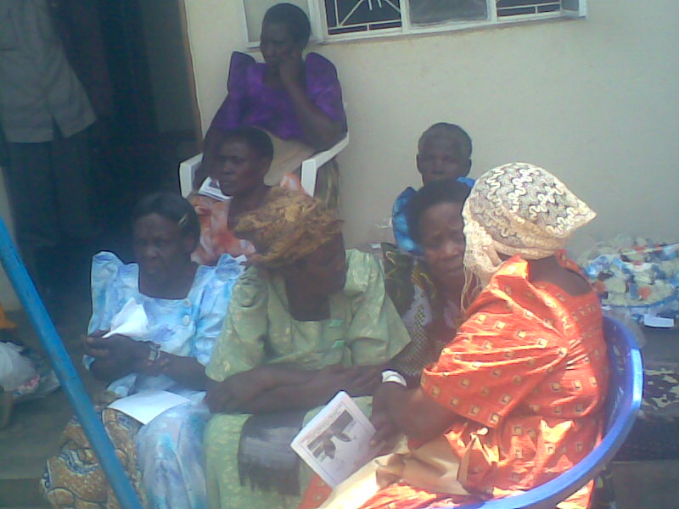

Workshop on Domestic Violence and Human rights at Mpigi
- Client response/approaches: UPRF client response now goes beyond litigation for criminal cases and extends to other Human rights issues such as land rights, inheritance, behavior change communication and crime prevention advocacy, petty commercial claims including debt collection for small business as well as offering technical legal service in the preparation of legal documents e.g. agreements, wills, affidavits, hence more people needing legal aid can now be reached with support services. UPRF is also scaling up in terms of approach to service delivery through adoption of novel and best practices from other jurisdiction. This is one of the measures to improve safety and security for the citizen base.

- The foundation will also scale its Geographical coverage to ensure a presence in all magisterial areas in Uganda before roll over to other jurisdictions in the world.
It is anticipated that a minimum of 20 access points will be established by the end of year three.

- There is also scaling up in terms of partnership/ membership to go beyond lawyers to other levels.

- All this means scaling up both the financial and Human Resource base to ensure availability of service providers.

UPRF as plans to make change in the governance structure to fit anticipated changes.

The need for such changes has arisen due to exposure to the resources introduced through PCMU and WACODA solutions. Soon the new strategic plan will take into account the said changes.

Networking.

CHALLENGES
The period covered by this report was also a period of challenge. UPRF experienced an attempt by the staff with support of some corrupt elements in the WACODA the organization that controlled the Basket Fund to high-jack the organization without involving the founders. It was quite a trying moment as the leader of the racket conspired with the fiancé department and resorted to forgiving company cheque stole some money from the foundation accounts as they hoped to flame the signatories fortunately the mischief was stopped by the arrest of the accounts assistant, by the name Kassagga Jonna, while tendering one of the forged cheques. Other frauds were discovered and he was charged with forgery and other offences. In a way this was a set back. Due to this loss the foundation was subject to repetitive audits in effort to establish wrongdoing on the top administration. This subjected staff to stress and uncertainty. As a result some of the theft. But UPRF has been service model.

Those involved in the theft and fraud also started a hate campaign in which they insinuated that UPRF had close down. But the development of a website and some adverts rescue the situation.

Because the ED was subjected to stress, the effort to look for funding slowed down and UPRF received small grants from, PCMU and WACODA in addition to stakeholders funding that stopped in October, Seed Grand from Charles Terry and ICJ.

There was need for need for strong commitment to make the organization stand

The newly established branches Masaka, Mbale and Luzira lacked operation vehicles. It became very costly and inconveniencing to the staff to use public means in their operations, running daily errands between the courts, prisons and project offices which are quite a distance from each other.

Increased clients in need of legal representation despite the budget allocations remaining constant. This hindered effective service provision not to mention the costly operations in litigation matters.

Our activities in up country branches especially Masaka, Mbale and Kayunga were hampered due to absence of resident judges and land tribunals. This means judicial activities in these areas take place only twice a month. This has made us ineffective and has reduced case resolution creating increased backlog at our branches and in court.

Increased number of pending cases because clients failed to follow up their matters vigilantly especially due to transport costs. Also a number of clients wait until their matters are overtaken by events before making a follow up at our respective office.
MEMBERS OF THE FOUNDATION
MS. OLIVA NAKYANZI CHAIRPERSON
MR.BUGEZA RICHARD MEMBER
MR.MULINDWA CHARLES MEMBER
MSS. ZAWEDDE PROSSY TREASURER
MR.SEKAMANYA NOAH MEMBER
MS.NAKASIITA SECRETARY
MS NAMATA SYLIVIA MEMBER
MR. KALUNGI CHARLES MEMBER
MR.MATOVU IBRAH MEMBER
MR. OBONG VICENT MEMBER
MR.SAM OGUTI MEMBER
MR. OLOKA ANTHONY MEMBER
MR. BYALUHANGA JAMES MEMBER
MS. NAKAKANDE JANET HEAD OF LITIGATION
MR. YIGA ROBERT EXECUTIVE DIRECTOR

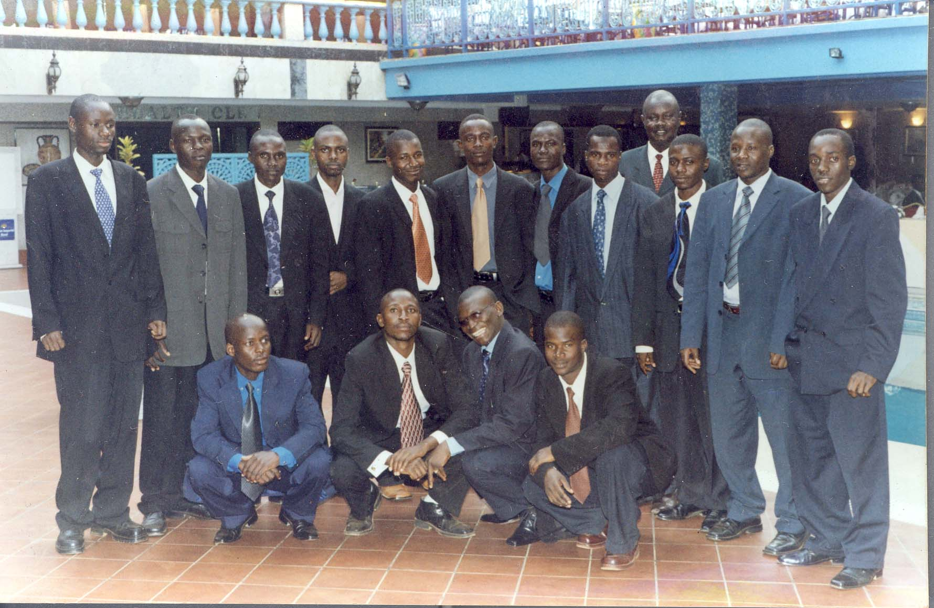

Some members of UPRF after a workshop at Grand Imperial Kampala.3rd left Executive Director Yiga Robert.

UPRF VISION
A Ugandan society where all human rights are respected promoted and defended to ensure access to justice for all is a reality irrespective of gender, age, ethnicity, religion or socio-economic status.

UPRF MISSION

- To become a leading provider of legal services of choice in order to ensure access to justice for the poor and vulnerable people so as to promote the socio-economic development of Uganda.

- To work with the poor and vulnerable communities especially women, children, disabled, to active justice, equality and equity though legal Aid provision, legal human rights education, research and advocacy net working and co-a lotion building.

UPRF GOAL
To contribute to the rule of law, and good governance in order to achieve social development.

UPRF VALUES
- Equality of all persons before the law
- Passions for justice
- Respect for human dignity
- Accountability
- Integrity
- Service excellence
- Efficiency and effectiveness

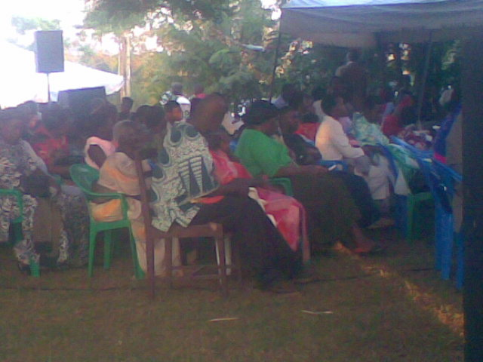

Community leaders of Wakiso District Human rights workshop by uprf

UPRF STRATEGIC OBJECTIVES

- To provide high legal aid services to indigent men, women and children.
- To promote the respect for rights and the rule of law in Uganda.
- To provide legal aid services to prisoners or persons who due to financial constraints
- To promote universal respect for human rights, implementation for the provisions of the universal declaration of human rights in Uganda.
- To carry out investigations through registered private detection agencies and therefore give reports to the concerned authorities on matter of human rights in Uganda.
- To act as arbitrators between the offenders and the victim
- To provide a forum for discussion through a close exchange between human rights organizations, community, individuals and government officials.
- To offer free legal representation to especially under privileged persons including appeals and other procedural process that may require legal representation at all levels.
- To encourage and promote observance of the rule of law and legal protection of human rights and sensitize masses on HIV/Aids.
- To participate in internal Human Rights law seminars, conferences, regulars conferences and even other related issues.

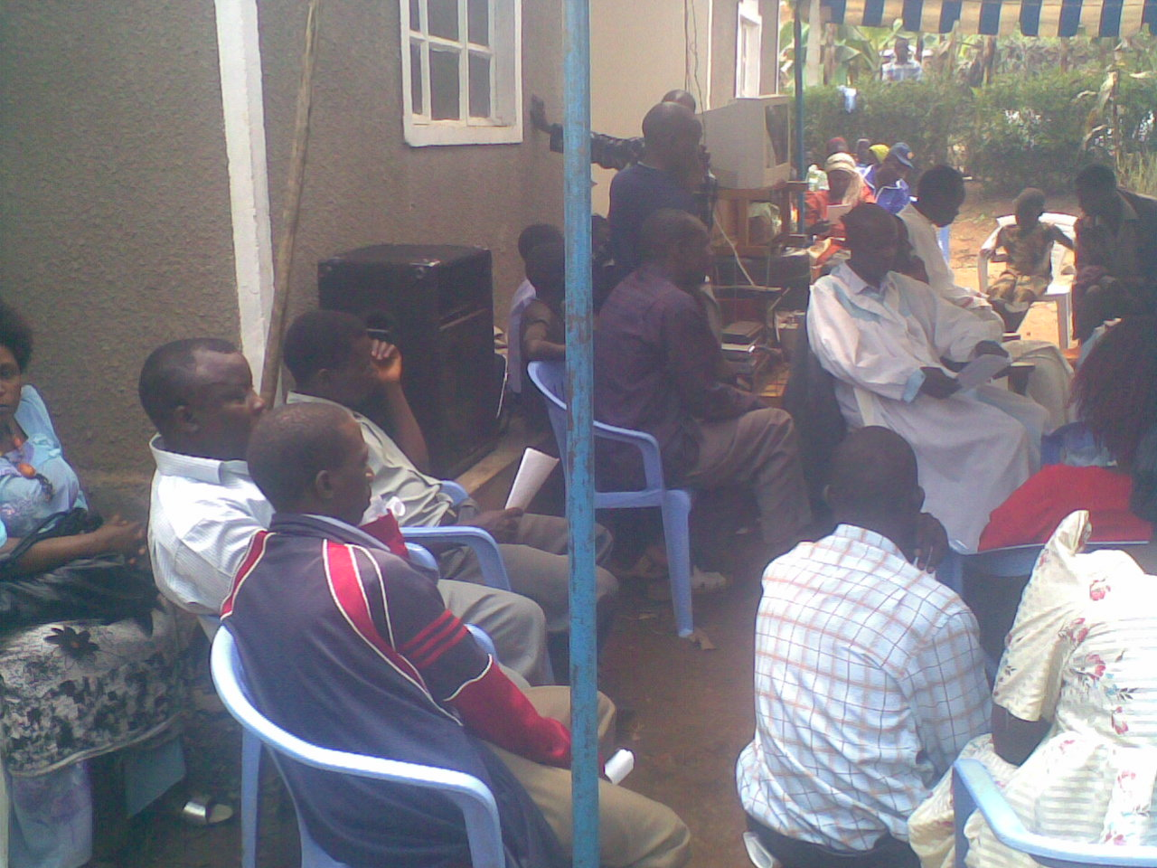

Human rights by uprf at Mpalampa Village Masaka District

PROGRESS TOWARDS FULLFILMENT

LEGAL SERVICES

During the period and the review, UPRF operated seven clinics. They included one in, eastern (Jinja), northern (Gulu), Midwestern (Masindi), southwestern, central (Kampala) and Luzira. All the clinics are run by fully qualified advocates, legal assistants, volunteers and clerks, Who provide court representation, legal counseling and advice, education and information to indigent persons, men, women and children .branch receive cases of different nature including land and property disputes, employment and accident claims, divorce and separation, domestic/ marital problems, administration of estates, child abuse, civil and criminal cases. The legal staff normally apply all the necessary options there is to have client’s cases settled but use of alternative Dispute Resolutions systems are strongly encouraged.

During the reporting period a total number of 294 cases were handled in UPRF and 200 cases were resolved. Out of those clients, 476 were female and 266 were males, 93 were old clients while 193 were new clients.(Details of cases handled by UPRF and by gender are in table 1&2 ).

Clients matters were handled both in the house by use of ADR system s of mediation, negotiation, counseling and advice and courts of law with an average of 25 cases being handled in court on a weekly basis. Most cases are beyond ADR mechanisms, focus was on court representation and training prisoners on how to defend themselves before judicial personnel while court. A total number of 105 prisoners were assisted to secure bail and a big number was benefited through the weekly education sessions and one on one legal advice and counseling provided by paralegals.

In Masaka, on top of the lay clients handled 33(thirty three) refugees from person were handled in terms of legal representation and advise. Only one was released others await the next high court session. In Masaka 5 sensitization programmers on radio kitara were conducted.
UPRF employs 3 advocates. The advocates are supported by legal assistants, paralegals. Clerks and volunteers spread across the Head office. The legal staff remains the majority of the staff since they perform the core functions of UPRF.

It is hoped that with the ongoing structural review of this team will further be strengthened to perform even better
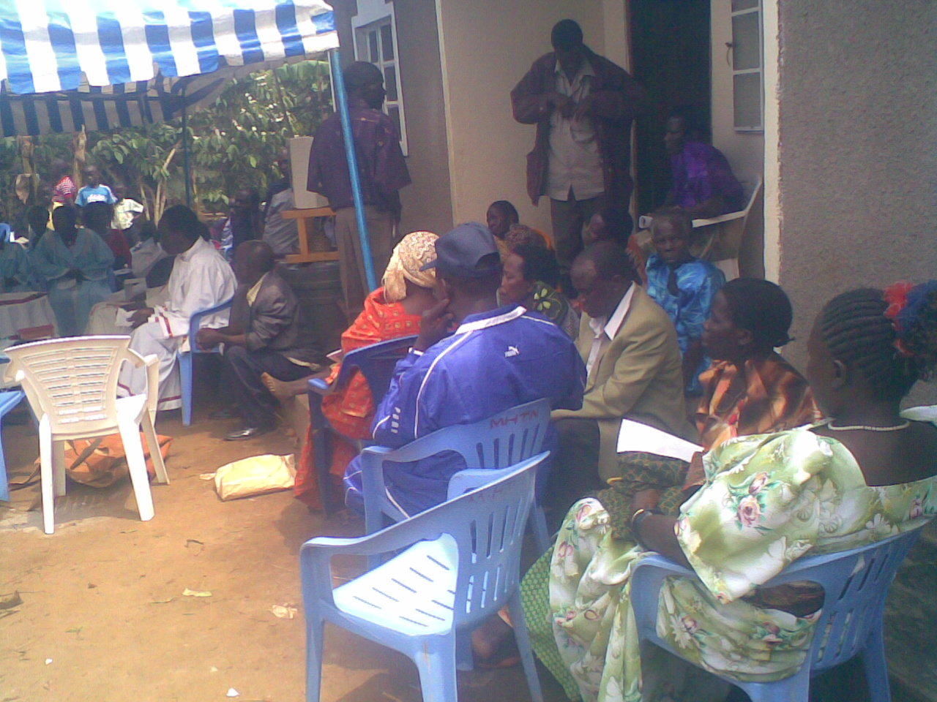

.

Information, Education and Communication
During the reporting period, the information, Education and communication (IEC) Objective was mainly delivered through seminars and workshops, handouts on simplified materials and posters on legal issues and human rights. There were also several radio programmes which were run by UPRF in Kampala. The seminars and workshops were intended to raise awareness among communities on their legal and human rights. All branch offices conducted awareness raising workshops at parish level. In some places, a needs assessment was conducted ahead of the actual sensitization. In other areas UPRF was responding to the need expressed by judicial personnel and local politicians while in others UPRF took the initiative.
A total of 10 sensitization workshops were conducted around the Districts facilitated by both the UPRF staff and external resource persons in legal and human rights awareness training.
The major focus of the workshops was on the following topics;
- Land tenure systems and property rights
- Children’s rights and their responsibilities
- Succession and Administration of estates
- Constitutional rights of prisoners
- Marriage, separation and divorce
- Local councils and their judicial powers
- Criminal offences, responsibilities and criminal justice systems
- Law on fishing (special focus on fishing communities like Kalangala)
- Sexual offences and protection of vulnerable persons
- Enforcement and protection of Human rights.
The training sessions were supplemented by use of posters illustrating the various violation of human and legal rights. The posters were developed by UPRF staff and were distributed to the different participants for a multiplier effect.
Around 20,000 copies of posters this printed and distributed. We plan to continue this activity in the coming year for areas that were covered.

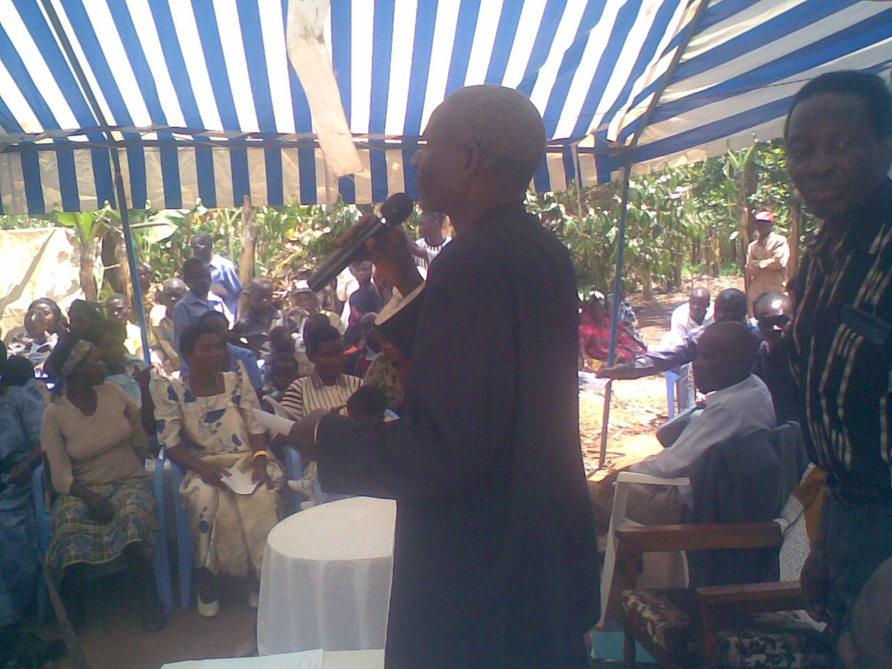
In Luzira area which mainly focuses on indigent’s prisoners, the IEC learning was delivered through sessions conducted weekly in each section of the prisons (Upper, Women, Remand and Murchison prisons). Each session was attended by more than 30 prisoners who were taught about the ingredients of their cases, the mandatory bail period, and the tactics to defend themselves in Court. Paralegals would in intervals hold a one –on-one legal counseling and advice to prisoners. This was aimed at restoring their hope and giving them confidence in areas where they felt inadequate.

Radios programmes like were conducted in three clinics, Mbale and Masaka and also for specific programmes like the human trafficking campaign. In other branches the radio programmes aimed at informing the public of the establishment of the programes .and the actual services provided. Once they had been oriented to the public, the UPRF organized talk-show programmes on topic issues which were aired on the local radio stations. This has popularized the UPRF among the communities they serve, by providing information on contentious issues like land rights and domestic law, human rights and HIV/AIDs sensitization.

Human trafficking
During 2009 UPRF with financial support from Wacoda spearheaded an anti-human trafficking campaign. The campaign with a situation analysis conducted in selected districts of Masaka and Eastern Uganda and then followed by a media campaign.
Radio programmes were run on CBS FM station to educate people about human trafficking parties at risk and its different forms. Unfortunately, some of the target groups especially in very remote places were not reached either in access ability to radio sets or lack of radio signal due to geographical disadvantage.
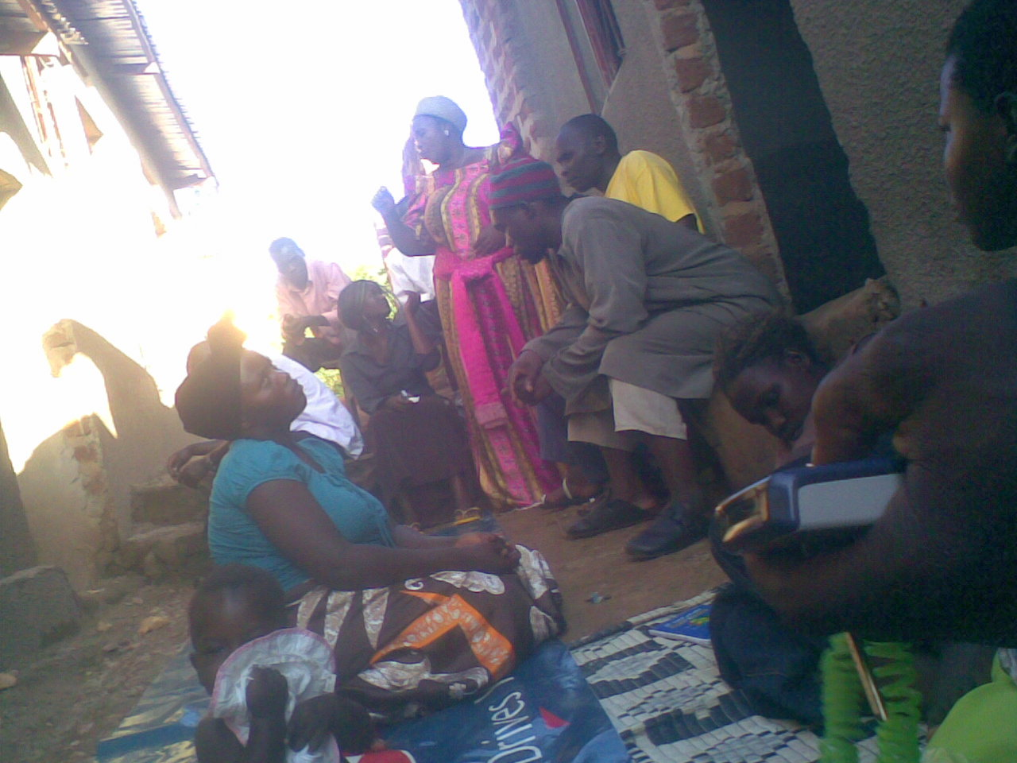

Uprf Members sensitizing Residents of Busega on their rights to property

Member of uprf sensitizing community at Kibinge on human rights issues.

In addition to radio programmes, a live TV Talk show was hosted on WBS Television. The viewers had opportunity to shown clippings of horrific incidents of human trafficking. The timing of the show was favourable and so many people participate which showed that the topic was of interest to the general public.

A news paper supplement was written and published in Uganda Daily newspapers both the new vision and the Daily Monitor in which deep informative insights on human trafficking phenomenon were presented.

RESEARCH, PROGRAMME DEVELOPMENT AND GROWTH.

New branches
During the period in review, UPRF established three new branches in Masaka to serve that region, Mbale region and Luzira for Luzira prisoners. The new Branches have increased the total number of UPRF Branches to 4. The Branches were established in partnership with North South institute-Vienna funded by they Austrian Government. The Branches were a pilot programme for accessing justice to prisoners and refugees in the established areas for 4 months which were successfully completed. The programmer has been taken on by UPRF main donor wascod: however, plans to have programme activities mainstreamed in the legal Aid fund are underway.

- Use of paralegals

The new Branches introduced UPRF to new areas especially the criminal justice programmer and use of paralegals which have been integrated in the UPRF system. Each of the new branch has an Advocate who is supported by paralegals who had client sensitization, legal advise, counseling and legal research
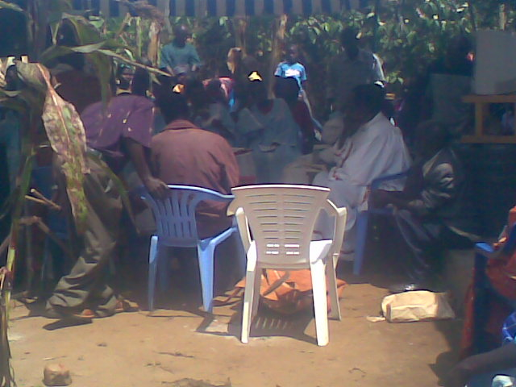

Human rights sensitization by uprf

- Criminal justice programme

The criminal justice programme is implemented by UPRF Luzira branch which focuses on needy prisoners (Upper, Murchison, women and Remand).Under this program 111 bail application were filed and applicants were represented by advocates from the UPRF in conjunction with members of the UPRF who were acting probono.We received tremendous assistance from the judiciary by the way of judicial activism given the fact that all the applicants had been committed for trial, before the high courts of Uganda.

Gender based violence survey
The UPRF successfully completed the4 sexual and Gender Based Violence (GBV)
Study which was conducted in seven districts in northern and eastern Uganda. This

was done in partnership with international Rescue committee, UNICEF and Christian Children’s Fund (CCF).The study was intended to make a situational analysis relating to GBV in Acholi- land, Teso region, and lira district. It was established that women and the girls child are at an increased risk of violence .The problem was evidently prevalent in the area of research. The major causes being; separation of families leaving girls and women to fend for themselves which forces them to offer sex in return, breakdown in law and order due to the prolonged insurgency in the area. Other causes were erosion of traditional structures and values and the Resistance Army (LRA) rebels. The role of UPRF was to conduct the research which was done successfully and a detailed report was handed over to our partners for further action and implementation.
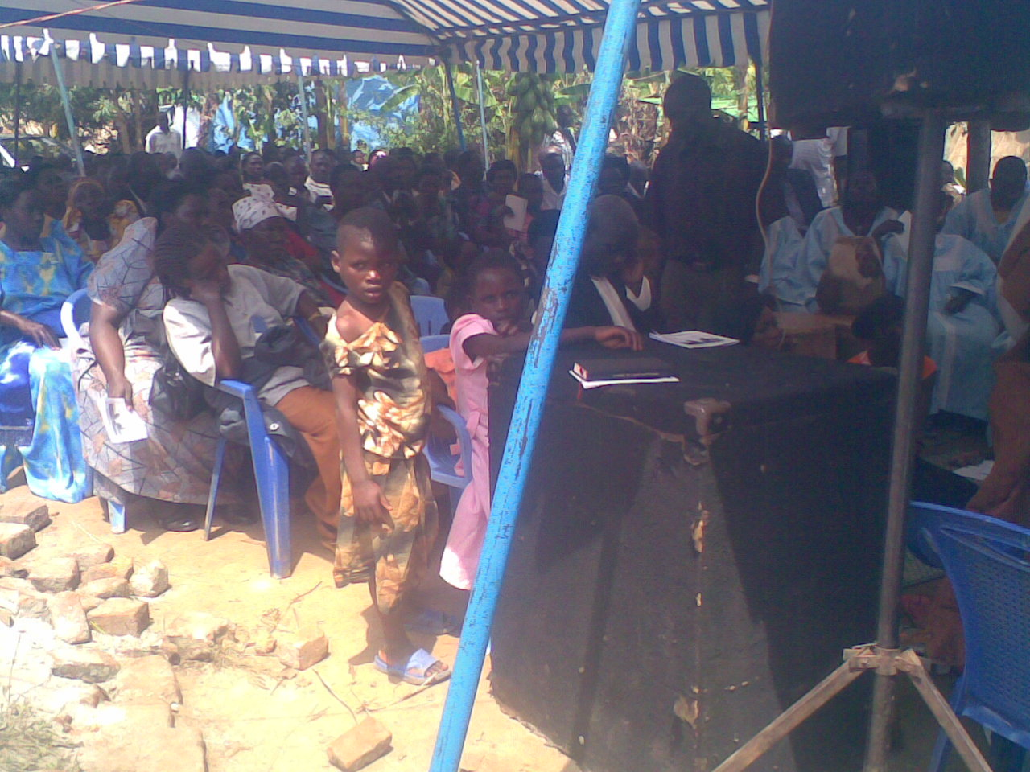

Workshop on Children, Rights at Kayunga

The child rights defence desk
In partnership with war child Canada the above project was introduced in Gulu. A
Project advocate was recruited with two legal assistants to run the project whose activities are mainly to receives and attend to children who are victims of child abuse, neglect and those affected by any form of child rights violations. Clients are received at the child Rights desk through referrals, and camp vists.The project is deeply involved in creating awareness through sensitization workshops, camp visits radio talk-shows, and distribution of awareness materials in form of flyers, booklets and posters.

Since its inception in September 2005, the programme has received remarkable acceptance by the stakeholders and the beneficiaries especially give the background situation of its geographical scope.

Paralegal advisory services.
These parts of the pilot project under UPRF Eight paralegals were recruited, uniquely from non-legal backgrounds. The prisoners under this project have been educated on their constitutional rights and the criminal justice system. Through paralegals, the prisoners are linked to other criminal justice stake holders and this will have a great impact in decongesting the prisons.
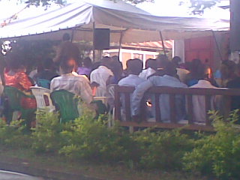

Consultative meeting by uprf members

Staff training and development
Through the capacity strengthening programmes, the UPRF staff have had wide training to enhance their skills in delivery of quality legal services and management .A mop-up workshop was conducted for all the staff to acquire skills on advocacy and mediation. UPRF and the PMU organized a workshop to train legal aid lawyers to enhance and prepare them to assist victims and suspects who are in prison or remand in other senior management staff like the senior project Advocate underwent training in project management, supervisory and management skills offered by other service providers like the Human Resource Consultancy and Makerere University Business School (MUBS) respectively.
In total five capacities building workshop and course were attended

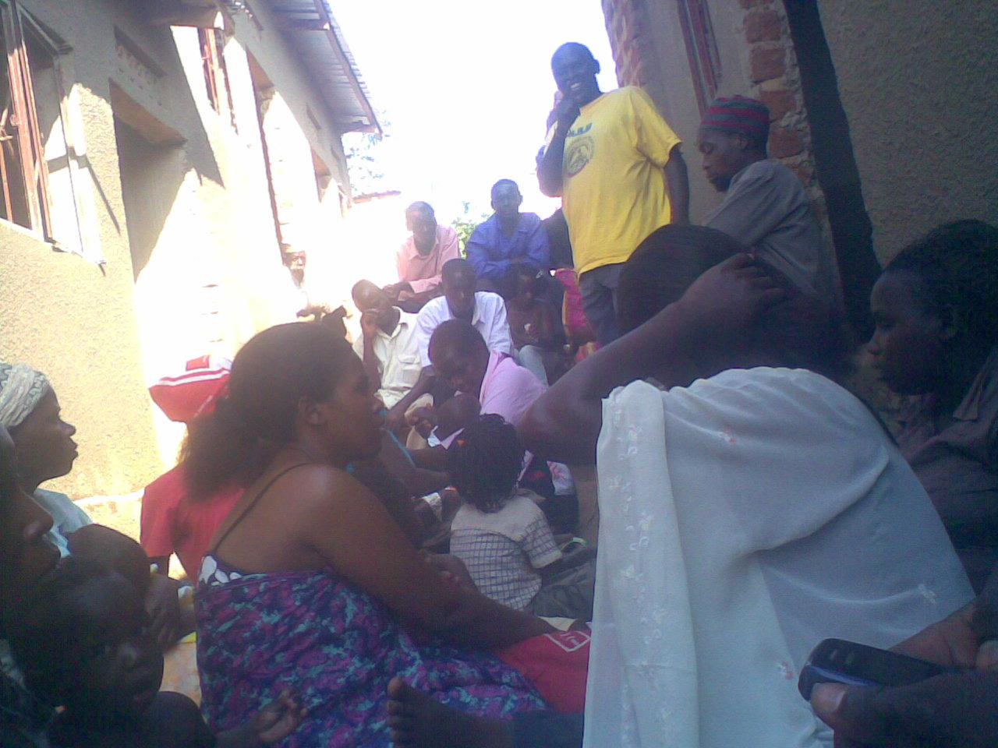

Uprf member sensitizing people of Busega kabaale on their Rights

Challenges
Achievements were registered amidst a number of challenges which slowed down our activities and made an impact on our expected outputs. These included among others the following;
The newly established branches of Mable, Masaka, and Luzira lacked operational vehicles
It become very costly and inconveniencing to the staff to use public means in their operations ,running dairy errands between the courts , prisons and the project office which are quite a distance from each other .

Increased clients in need to legal representation despite the budget allocations remaining constant. The hindered effective service provision not to mention the costly operations in litigation matters.

Our activities in the up country branches especially Masaka, and Mbale were hampered due to absence of resident judges and land tribunals. This means judicial activity in these areas take place only twice a month. This has made us ineffective and has reduced case resolution creating increased backlog at our branches and in court.
Increased number of pending cases because clients fail to follow up their matters vigilantly especially due to transport costs.
Also number of clients waits until their matters are over taken by events before making a follow up at our respective branches.
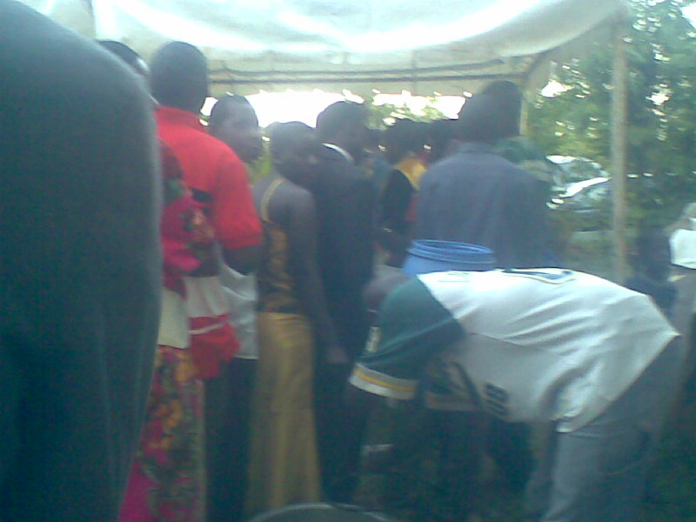

Members of uprf lineup for lunch after Annual General meeting, 31.Dec.2009.

UPRF AUDITED ACCOUNTS AS AT 31st DECEMBER 2009
Bakamuka & Co. Ground Floor, Yamaha Building plot 8 William Street
Certified Public Accountants P.O.Box 350, Kampala, Uganda
Phone: +256 (0)756743666
Fax: +256 (0)702453904
E-mail: yigober@yahoo.com

Report of the Auditors to the Members of Uganda public rescue foundation
We have audited the financial statements of the Uganda public rescue foundation for the year ended 31 December 2009, which are set out on pages 2 to 11.

Respective responsibilities of Management and Auditors
The Project’s Management is responsible for the preparation of these financial statements. Our responsibility is to express an independent opinion on these financial statements based on our audit.

Basis of opinion

We conducted our audit in accordance with International Standards on Auditing. Those standards require that we plan and perform the audit to obtain reasonable assurance about whether the financial statements are free from material misstatements. An audit includes an examination, on a test basis, of evidence relevant to the amounts and disclosures in the financial statements. It also includes an assessment of the accounting policies used and significant estimates made by management, as well as an evaluation of the overall presentation of information in the financial statements. We believe that our audit provides a reasonable basis for our opinion.

Opinion

In our opinion, the financial statements give a true and fair view of the state of the Uganda public rescue foundation Project at 31 December 2009 and of the results of its operations and cash flows for the year then ended in accordance with International Accounting Standards.

Bakamuka & Co. 12 April 2010 Certified Public Accounts Kampala, Uganda

UGANDA PUBLIC RESCUE FOUNDATION (UPRF)
A COMPANY LIMITED BY GUARANTEE AND NOT HAVING SHARE CAPITAL.
Funded by

PEOPLES CHURCH MINISTRY UGANDA (PCMU)

BALANCE SHEET AT 31ST DECEMBER 2009

 | NOTE | 2009  Ushs. | 2008  Ushs.
FIXED ASSETS | 3 | 70,669,849 | 71,283,151
CURRENT ASSETS  Debtors and prepayments  Cash at Bank  Cash in Hand | 4  5 | 16,357,230  182,887,924  452,270, | 13,213,930  348,994,937  422,070
CURRENT LIABILITIES  Creditors and accruals | 6 | 20,599,305 | 217,479.391
NET CURRENT ASSETS |  | 179,098,119 | 145,151,546
NET ASSETS |  | 249,767,968 | 216,434,697
Financed by
CAPITAL FUND | 7 | 70,669,849 | 71,283,151
GENERAL FUNDS | 8 | 179,098,119 | 145,151,546
 |  | 249,767,968 | 216,434,697

These financial statements were approved by the Board on ……………. 2010 and were signed on its behalf by
…………………………………. Executive Director
…………………………….Treasurer

UGANDA PUBLIC RESCUE FOUNDATION
A COMPANY LIMITED BY GUARANTEE AND NOT HAVING SHARE CAPITAL
Funded by
PEOPLES CHURCH MINISTRY UGANDA (PCMU)

INCOME AND EXPENDITURE ACCOUNT
FOR THE YEAR ENDED 31 DECEMBER 2009 (CONTINUED)

 | 2009  ACTUAL  USHS. | 2009  BUDGET  USHS | 2008  ACTUAL  USHS.
Seminars and workshops
Kampala and masaka | 9,908,822 | 12,048,000 | 8,490,800
Kabarole | 2,131,779 | 2,592,000 | 1,014,000
Jinja | 2,131,778 | 2,592,000 | 1,235,000
Gulu | 2,,131,778 | 2,592,000 | 830,000
Kabale | 1,184,322 | 1,440,000 | -
Masindi | 1,184,321 | 1,440,000 | -
Sub-Total | 18,672,800 | 22,704,000 | 11,569,800
Legal Aid
Filling costs, travel, fees and facilitation | 16,599,800 | 13,680,000 | 12,450,801
Pro Bono Lawyers / Legal assistance | 400,000 | 9,900,000 | 150,000
Legal aid-other | 543,000 | - | -
Networking | 13,811,854 | 7,110,000 | -
Sub-Total | 31,354,654 | 30,690,000 | 12,600,801
Office Rent
Kampala and masaka | 8,897,731 | 8,820,000 | 15,790,000
Gulu | 4,358,073 | 4,320,000 | 4,200,000
Kabarole | 4,358,073 | 4,320,000 | 4,060,000
Jinja | 4,793,880 | 4,752,000 | 1,930,490
Masindi | 3,268,554 | 3,240,000 | -
Kabala | 3,026,439 | 3,000,000 | -
Sub-total | 28,702,750 | 28,452,000 | 25,980,490
Rights a awareness campaign and Communication
Kampala | 3,736,753 | 3,215,600 | 3,716,238
Kabarole | 1,255,036 | 1,080,000 | 1,858,120
Gulu | 1,255,036 | 1,080,000 | 1,858,119
Jinja | 1,255,036 | 1,080,000 | 1,858,119
Kabala | 418,345 | 360,000 | -
Masindi | 418,345 | 360,000 | -
Fax, postage, email | 6,066,007 | 5,220,000 | -
Sub-Total | 14,404,558 | 12,395,600 | 9,290,596
Local consultancy
Consultancy expenses | 17,646,500 |  | 4,416,000
Strategic planning | - |  | -
Audit fees | 6,244,500 | 20,448,000 | 5,145,000
Legal fees | - |  | 400,000
Sub-Total | 23,891,000 | 20,448,000 | 9,961,000
UGANDA PUBLIC RESCUE FOUNDATION (UPRF)
A COMPANY LIMITED BY GUARANTEE AND NOT HAVING SHARE CAPITAL.

Funded by

PCMU

INCOME AND EXPENDITURE ACCOUNT
FOR THE YEAR ENDED 31 DECEMBER 2009 (CONTINUED)

 | 2009  ACTUAL  SHS. | 2009  BUDGET  SHS. | 2008  ACTUAL  SHS.
Other
Media/ publicity campaign | 6,251,745 | - | -
Research | 5,498,200 | - | -
CBA Awareness campaign | 1,492,000 | - | -
Other expenses | 1,773,000 | - | -
Land desk and other expenses | - | - | 35,777,733
Sub-Total | 14,914,945 | - | 35,777,733
Total Recurrent Expenditure | 637,446,064 | 696,151,600 | 478,322,290
Surplus before Exchange gain | 25,225,352 | - | 24,056,080
Exchange (loss) / gain | 8,721,221 | - | (22,972,270)
Surplus for the year (To General Fund) | 33,946,573 | - | 1,083,810

UGANDA PUBLIC RESCUE FOUNDATION (UPRF)

A COMPANY LIMITED BY GUARATEE AND NOT HAVING SHARE CAPITAL.

Income and Expenditure Account for the year ended 31st December 2009

REVENUE | BUDGETED  (USHS.) | ACTUAL  (USHS)
Finding from WACODA | 49,820,000 | 8,972,731
Expenditure
Office and equipment & fittings
Furniture and equipments | 3,040,950 | 8,972,731
Library books | 2,000,000 | 1,614,200
Administration and office running
Stationary & Publications | 1,200,000 | 1,549,778
Communication & Postage | 2,800,000 | 1,527,116
Travel/per diem | 3,600,000 | 2,263,200
Bank charges | 200,000 | 100,000
Rent | 7,800,000 | 4,625,000
Electricity | 200,000 | 100,000
Water | 330,000 | 802,584
Salaries | 5,800,000 | 2,960,000
Office running/miscellaneous security | 820,000 | 638,052
Machine/furniture maintenance | 160,000 | 733,800
Staff traveling & work shops
Seminars & workshop | 8,029,100 | 3,521,000
Rights a awareness/publicity
Literature & provisional meetings | 5,750,000 | 1,379,100
Field related activities
Advocates field expenses & prison surveys | 5,500,000 | 1,062,100
Evaluate Expense | 2,000,000 | -
Contingence | 790,000 | 350,000
Totals | 49,820,050 | 29,598,661
Surplus | - | 10,674,121

