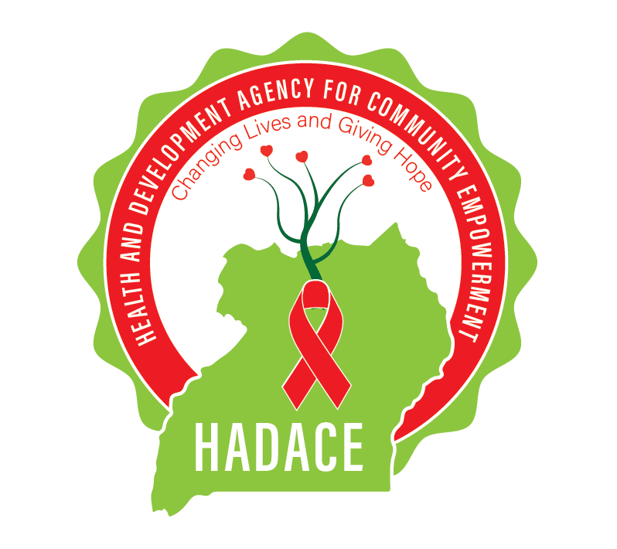
HEALTH AND DEVELOPMENT AGENCY FOR COMMUNITY EMPOWERMENT (HADACE)
“Changing Lives Giving Hope”
Mission:
- To promote efforts that empower the community with focus on capacity building in Agriculture, Health, Human rights, Education, Environment and advocacy for multi-sectoral approaches to community socio-economic development.
Vision:
- An empowered and poverty free healthy society of women, men and children able to economically sustain itself, uphold and fulfill their rights, and living in harmony within the natural and sustained environment.

Core values:
- Integrity
- Transparency
- Respect
- Diversity

Empowerment

Stewardship

OUR MOTTO
The organization motto shall be “changing lives and giving hope”

Organization back ground:
Health and Development Agency for Community Empowerment (HADACE) is a voluntary and charity, Non-partisan and Non-Government Organization formed on the basis of helping the poor, vulnerable communities, orphans, women and the general community and population in Uganda.
It gives support in form of improved agricultural inputs, medical, education and empowerment to communities such as income generating sources and sustainability means and trainings, and other basic needs of life to orphans and vulnerable children (OVCs)
OBJECTIVES
- To promote community participatory approaches that enhance the health of the most vulnerable members of the community especially children, adolescents, women and disabled persons with emphasis on gender issues and equal rights of Orphans and vulnerable children.
- To empower communities in the prevention, mitigation, care and support for people living with HIV and AIDS and affected families through sustainable community based initiatives.
- To design, complement and implement activities intended to protect and manage the natural environment and promote sustainable development and support to community based development initiatives through food production and productivity in a gender inclusive approach
- To advocate for and promote human rights issues and empower the local communities to actively participate in the planning, implementation and monitoring of community Programmes.
- To access the youth with adequate information and services on adolescent reproductive health, sexuality, HIV/AIDS, STDs, Condom use, counseling and teenage pregnancy particularly in rural communities.
- To strengthen knowledge, skills and attitudes of farmers on sustainable agriculture, bulk production, value addition, market linkages and profitable farming intervention for Increase household income through self-help projects hence eradicating household poverty in rural areas.
- To promote and establish learning centers as nurseries, primary, secondary and vocational schools that shall provide relevant academic standards for children in the area and other neighboring places, spiritual, business, technical and vocational education and trainings.
- To foster, improve and promote on the availability of safe water to the rural communities through capacity building on sanitation and hygiene.

BENEFICIARIES
HADACE-Uganda mainly targets people in most need such: Orphans, vulnerable children, adolescents, persons with disabilities, women and people living with HIV/AIDS and entire community populace with needs in line with our set programmes.
Target group:

Children: To provide healthy personality development acquiring vocational skills and professional development for their sustainability.
Women: Identifying the poor women and providing income generating activities to them through formation of self help groups and adopting family planning & welfare programs relating opportunities in various vocational fields by providing training in the respect fields for sustainability as their own.

Widows: Creating opportunities in various vocational fields by providing training in the respect fields for sustainability as their own so that they can look after their children.

Youth: To Prevent the youth from participating in the antisocial activities. Provide academic as well as carrier guidance to the youth. Provide vocational training to the skilled persons. Fixing the targets to the youth for their future life. Counsel and motivate them to achieve their targets .Up gradation of the skills for the skilled workers with latest technology. Creating the self- employment opportunities. Engaging the youth in the work nature and keep away from the idleness. Creating the youth as a role model to the future generation. Involving them in the welfare activities and implementing the Government policies. Preventing the youth from the drug addiction. Creating awareness for the youth on the chronic diseases like HIV/AIDS etc.

PROGRAMMES
HIV/AIDS Awareness and Mitigation Development (HAM)
Environment Management and Sustainability (EMS)
Agriculture, Food production and Productivity Enhancement Programme (AFPE)
Water, Sanitation and hygiene (WASH)
Livelihood and Community Empowerment (LCE)
Education and Vocational Skills Development (EVS)
Interventions of the Organization:

- Promote livelihoods, Capacity building and development of leadership qualities in all levels and all the sections of people in the targeted area.
- Generation of data base on ground realities of the concerned issues.
- Creating awareness by way of information dissemination to communities.
- Creating interest among communities to work with the cause.
- Involving all the stakeholders in all the programs as partners at all levels.
- Proper planning and implementation

Specific Objectives

- To promote value education in the working areas.
- To promote sustainable livelihoods with community participation.
- To develop sustainable resource management in the areas.
- To promote self – help groups for the grass root empowerment.
- To create awareness on HIV/AIDs and other chronic diseases for the healthy society.
- To develop network among the stake holders.

Problems / Issues identified in the target area.

- Poor educational infrastructure facilities in the project areas
- Lack of awareness on health and hygienic conditions
- Drinking water problems
- Inaccessibility of government health services
- Spread of HIV/AIDs and other chronic and communicable diseases
- Lack of livelihood opportunities
- Gender inequality & Lack of equal rights over needs.

Strategies
- Mass meetings with the support of all working areas
- Work with Community Based Organizations ( CBO’s) and like minded groups
- Planning through Community participation
- Advocacy Strategies.
- Activities for the advocacy
- Convergence with different stakeholders and line departments.
- Strategic planning

Present activities:

- Literacy program
- Child sponsorship program
- Education program
- Awareness camps on HIV/AIDS, supporting special events like women’s day, water world day etc
- Income generation programs
- Health and sanitation programs

Activities of the organization

Human rights protection (children & women)
Formation and training of child protection committees, community dialogue meetings, and support to community led initiatives on child protection, translation of key legal and policy documents into local languages, data collection on violation of children’s rights and supporting formal education for Orphans and Vulnerable Children in operational areas. The program is responsible for reducing conflicts in our homes and tribes settings, discrimination of women, decision making, fighting, torturing of children in society and in our homes. The program is also meant to create a friendly environment for children and women where there rights are respected and have the right to share information like other people in the community.
On the other hand, the program aims at mainstreaming gender in all her work to bridge/reduce the imbalances that exist between men and women in terms of roles, decision making, power relations, access to resources and opportunities. It encourages men and women to participate in her programs as one step of empowering them. In this, HADACE focuses on development and implementation of a gender policy for the organization, capacity building of other community based organization’s with a focus on Gender/conflict related tasks in the Ruwenzori sub region, involvement of the Board, identification and training of gender/conflict focal persons within the organization and staff plus continuous sensitization of staff and beneficiaries to ensure that there are no more conflicts taking place in the communities of the Ruwenzori sub region.
And the major beneficiaries are children, women and other people living within our scope.

Following the situation of the violation of women rights in the rural settings in Uganda HADACE exists to defend and acts as a voice for women rights in our communities.
At HADACE, we believe that women have the capacity to think, lead and implement everything like men or better.

- Livelihoods Support
Provision of sustainable and profitable means of livelihoods, training of Income Generating Activities and financial management, support to Orphans and Vulnerable Children (OVCs’) to attain vocational skills and provision of basic start up tool kits to very and poor beneficiaries in the community.
- Environmental Protection and conservation.
Training of Youth Support Groups, formation of Environmental Protection and Conservation Clubs in schools, establishing a tree nursery which acts as a demonstration site and supplies tree seedlings to the community. HADACE will open a tree demonstration garden in 2019 which will be used as a learning centre for tree growers, students and environmentalists.
- Reproductive Health
Behavioral Change through Communication, awareness and sensitization, guidance and counseling, distribution of Information Education and Communication materials, HIV/AIDS Counseling and Testing and community outreaches.
- Education
This is a cross-cutting activity in all the programs of HADACE-Uganda as an integrated activity. HADACE-Uganda is supporting 32 orphans and vulnerable children by provision of scholastic materials, school fees and basic materials. We are getting a very big challenge in terms of funding considering the level of poverty resulting from poor agricultural outputs and their low prices in rural areas because of agriculture being the main source of income in rural areas. There are many orphans and vulnerable children (OVCs) that need support but the financial capacity of HADACE-Uganda cannot support beyond the 32 beneficiaries.
FUTURE PLANS BY 2022
HADACE is planning to provide home, education and all other basic needs of life to all homeless children in Uganda.
Sustainability measures include; having children homes, HADACE schools, children specialized clinic, farm lands for sustainable food production, reliable water supply and efficient water and sanitation to the HADACE homes and surrounding communities.

Contact Address

The official headquarters of HADACE-Uganda are in Kamwenge Town Council, Mbarara road, P.O Box 1444 kamwenge district in Western Uganda where the organization is currently operating.
