AGAPE OF HOPE FEMALE YOUTH DEVELOPMENT ASSOCIATION
P.O.BOX 427, KASESE – UGANDA
E – Mail: agapeofhope@gmail.com

ANNUAL REPORT 2014

A WORD FROM THE BOARD CHAIR PERSON
on behalf of agape of hope female youth development association (AGoHYDA), I have the pleasure of presenting the 2014 annual report by highlighting our activities and capture land mark achievements and challenges that were encountered during the year 2014.

In particular, I would like to thank the workers of Agape of hope who have played a key role in sustaining our vision and mission in which young women’s aspirations, rights and productive potential skills are being recognized and utilized in the frame work of equitable and sustainable human development.

As mandated, agape of hope has been implementing their activities under the three thematic areas of adolescent reproductive health, skills development and human rights promotion in Kasese district.

We received some support for training materials in tailoring; have trained 45 young women in tailoring and crafts, conducted radio talk shows and trained community leaders and youth on adolescent reproductive health issues. In addition, legal registration with the national NGOS board and registrar of companies was accomplished.

Agape of hope will continue advocating for pro – young women friendly programs as well as gender sensitive policies to help young women express their views and speak for them to ensure improved health, social and economic well being of the female youth in community development initiatives.

Finally, I would like to express my sincere gratitude to all those who have supported us technically, financially and morally during this period in promoting our activities. I look forward to their continued support.

All the above would not have been successfully implemented without a team of committed board members and a dedicated staff. I therefore acknowledge the valuable and voluntary support of the staff and the board members for the continuing to put their resources at the service of Agape of Hope.

We all need to remain dedicated and united to keep agape of hope strong.

Thank you.
KAHYANA JOSEPH
CHAIR PERSON BOD, (AGoFYDA).

- INTRODUCTION
Agape of hope female youth development association (AGoFYDA) is a community based, non – governmental organisation founded in 2005. It is legally registered in the district and with the national NGO board and the registrar of companies.

The year 2014, ultimately came to an end and the organization not only celebrated its 9th anniversary of existence but also the successful conclusion of the three years planning period 2011 – 2014.

During the year, the volume of the activities continued to grow within the community and the group level. Significant studies were made in the direction of lobbying partnership and legality of the organisaton level while scaling up our programs to other areas in the district.

Whilst our programme areas focused on empowering the young people especially the female youth including adolescent girls, young mothers school drop outs and maids (working in hotels, bars and homes) it also put keen interest to include orphans and young people with disabilities.

- VISION
A society recognizing the values and dignity of the female youth for sustainable development.

- MISSION
To empower the female youth with basic knowledge and skills to enable them actively participate in community development and become responsible citizens in society.

In 2014, the organisation continued implementing their activities in three thematic areas of skills development and education, adolescent reproductive health and human rights promotion to achieve the organizational objectives which include:
- To enhance the female youth with basic knowledge and information on human rights.
- To equip the young people with life skills for the prevention of STDS/AIDS and early pregnancies.
- To enable female youth acquire vocational skills to help them earn a living in their own communities.

This report also present the activities implemented, achievements made and challenges faced in the year 2014.

- ADOLESCENT REPRODUCTIVE HEALTH (ERH)
This program highlights adolescent reproductive health issues among young people including early marriage, early pregnancies/un intended pregnancies, abortions, family planning, and child headed households, obstetric fistula, and STDS including HIV/AIDS. The beneficiary being the adolescent girls, young women in and out of school.

During the year, several community meetings were held involving young people, parents, guardians, community leaders to create awareness about adolscent reproductive health. This resulted into:
- Reduced number of earl marriages and early pregnancies as reported by the community peer educator.
- Increased responsiveness of community leaders to sensitize their constutuents.
- More youth turning up for voluntary counseling and testing services.
- Some young women rejoining and staying in school.
- Increased number of girls coming up for skills training at our center.

- SKILL DEVELOPMENT AND EDUCATION
This program involves skills training for young women in tailoring, knitting, hair dressing and crafts making especially beads, necklaces and bracelets. This year 2014 alone, 35 young women were trained in tailoring and 10 in crafts; making all trained totaling to 45. The organisation has 5 sewing machine and 2 knitting machines with a full time trainer/teacher. Both theory and practical lessons being conducted in a work shop at the organizational site.

Most of the beneficiaries are young women, young mothers, school drop outs and orphans. We did provide accommodation to young women who came from rural areas /sub counties with difficulties in securing a place to stay in while in Kasese town.

Training materials were provided by trainers while the organisation provided start materials for the first one month of the training. Qualified trainees return to their own communities to practice the skill for income generating.

Whereas Lindsay (Canada) supported the program with 2 sewing machines and a bag full of training materials, Heldi (USA) supported us with $10 for the training materials for the young women.

- HUMAN RIGHTS PROMOTION
The program focuses on young women, young mothers, orphans and children by sensitizing them on women’s rights, social and economic rights. Noting that gender based violence (GBV) and violence against women(VAW) are synonymously on increase in Kasese district and in the Rwenzori region at large; it is a contributing factor to why young girl migrate from their homes to take refuge in town centre of Kasese, Hima et.c. Agape of hope tasked to mobilize and sensitize communities through community focus group discussions facilitated by community process mobilisers to overt the vice.

During the year, we were able to form 10 community focus groups with 10 members in each area to continue sensitizing their communities on women’s rights.

It is worth noting that out of the 10 women who divorced due to misunderstanding with their husbands, 3 started a tailoring training course with us and have rejoined their families. This program has been made possible by involving local leaders, religious and community process mobilisers (CPM) with in their respective communities.

- MEMBERSHIP, REGISTRATION AND PARTNERSHIP
Agape of hope have membership with:
- Development Network of Indigenous Voluntary Organizations (DENIVA)
- National Association of Women’s Organizations in Uganda (NAWOU)
- Women network of Uganda (WOUGNET)
- Uganda small scale industries association (USSIA)
- Uganda national aids service organisation (UNASO) through Kasese network of AIDS service organisation (KADINASO)
- Uganda National NGO Forum
- Doctorate of industrial training
- Kasese District Development Network.

We have secured registration up to the national level with the national NGO Board registration number S.5914/9837 and registrar of companies.

We also have partnership with Foundation For Community Development and Empowerment (FCDE), a U.S.A.NGO operating in Kasese district. The last follow up was done and an evaluation team from USA led by Mrs. Heldi visited agape of hope.

- ACHIEVEMENTS.
Over the year 2014, with the help of a staff, board members and the community; we have been able to register the following:
- Certificate of registration with the national NGO Board and registrar of companies
- Membership registration with DENIVA and USSIA
- 45 young women trained in both tailoring and craft (beads, necklaces, bracelets)
- Received support for training and materials for tailoring work
- Conducted a training workshop for head teachers from Bukonzo east on girl child education.
- Conducted two radio talk shows on the importance of girl child education and women’s empowerment initiatives.
- Two board members attended external training by DENIVA and WOUGNET.
- We scaled our programs to other three sub counties of Kyabarugira, Kitswamba and Bugoye (Busongora county) in Kasese district
- We provided accommodation to young women trainees in skills development those from far rural areas of the district.

- CHALLENGES
During the year, we faced some challenges both as a group and beneficiary levels which include but not limited to:
- Inadequate sewing machines and training materials for tailoring to match the number of trainees.
- Lack of startup take home tool kits for the take home tool kits for the trained vulnerable young women in tailoring to help them apply the skills acquired to start earning a living in their own communities.
- Lack of ICT equipment for documentation of information.
- Inadequate capacity building for both the organisation and board members to help effectively deliver services.
- Community could not accept the use of contraceptives to reduce family size.

- .4A successstory of Mule Zeres Nyabahasa:
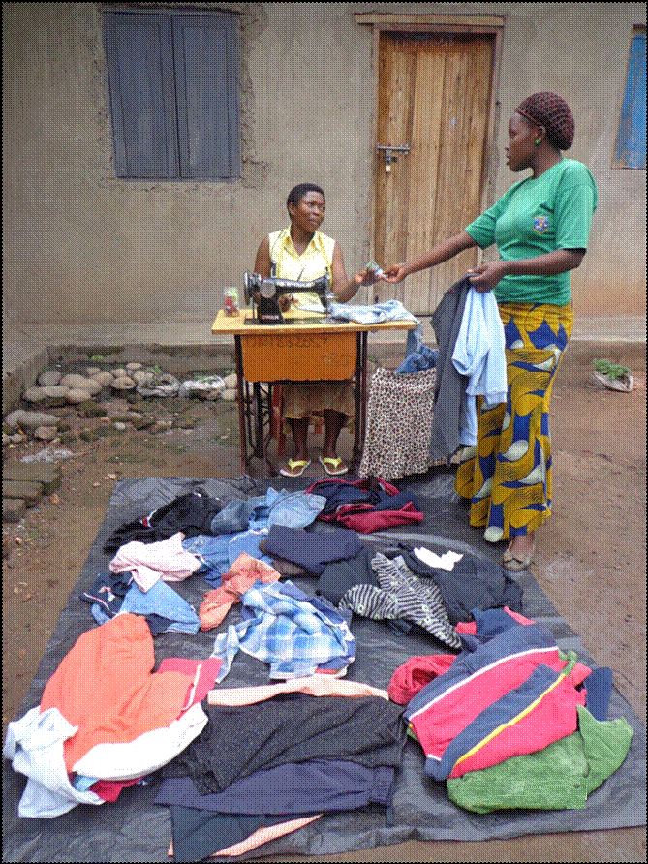
Zeres(seated) doing business of selling 2nd hand clothes
& tailoringin a town suburb of Kasese.
Am now 22 years old, was pregnant at the age of 17 and had to drop out of school at S.3 level. Am a young mother to twins from Rwasande, a rural village in KyabarungiraSub county in Kasese district. I stayed with my parents at home because the man who made me pregnant had another wife and even refused to take care of me.
Life became difficult for me right from pregnancy to birth and when it came to caring for the twins. According to our tradition, I was nicknamed, “Nyabahasa” meaning a mother to twins and twins have to be introduced formally with their father to the family of the girl, which was not done here for my case, therefore, my mother was being harassed by my father because of me. My early pregnancy caused family misunderstanding between my father and mother .As a girl ,I got embarrassed and silently tortured in mind when my mother was being mistreated. He blamed girls’ education as wastage of family money and time.
I suffered from poverty and domestic violence while at home as I could not manage to provide for my twins .It was until July 2013,when my local church advised me to join Agape of Hope to train in adolescent sexual reproductive health education and I also decided to under go training in tailoring skills. While on training at Agape of Hope, I started earning some money from repairing and mending customer’s clothes. After the death of my mother, aspirations to buy own sewing machine after acquiring skills caused sleepless nights to me until Agape of Hope linked me to ‘both sides of the coin,’ a project sponsoring young entrepreneurs to manage their businesses in the Rwenzori region. Luckily enough, I passed the sponsor’s assessment test and qualified for a 3- weeks training in entrepreneurship skills development. After training, I was given UGX 500,000 (worth US $ 200) which I used for buying a sewing machine and second hand clothes for business. Am a single parent mother, head of a household and happy because am now earning some little income to enable me pay school fees for my twins, pay house rent in the town suburbs, meals and meet other basic needs for my family of 3.
I advise my follow young women and girls in and out of school to avoid early pregnancies which may hinder their further education and that they should not produce many children because it becomes very expensive to provide them with basic needs if you don’t have employment or a business enterprise. Therefore, I encourage young women and girls to join Agape of Hope in promoting adolescent sexual reproductive health and skills development activities to help change the life of many for the better.
B2.5 A story of how our work changed the community
Many people in the community of the project area had a belief that talking about contraceptives encourages helotism and cancer in women, this myth silently kept out many people to talk and listen about it. Adolescent sexual reproductive health and rights program training on application and use of contraceptives to reduce family size and early pregnancies attracted the attention and participation of many beneficiaries in our community.
We have established a team of community peer educators(CPEs)who voluntarily continue training and disseminating information to others about our work in their communities. Community members including young women, men and girls can now talk freely about contraceptives, how to access and use them by interacting with village health workers and community peer educators .The schools we work with have attributed the reduced number of teenage pregnancies among school girls as a result of our work. Young women / youth out of school are now rejoining school for more learning or other training centers for skills acquisition that enable them to earn a living and become responsible citizens in their communities. Out of 445 school dropout girls sensitized, 59 girls have rejoined primary school level, 36 girls have rejoined secondary school level while 278 young women decided to join non-formal skills training centers for employable skills and 85 of them are now earning income to help themselves and their families.
Mule Zeres ‘Nyabahasa’, the one narrating her success story above is one of those whose life has changed and many more girls emulating her lifestyle have equally benefitted and their lives have changed whereby some have continued schooling, others have started small businesses, some have joined leadership positions while others are self employed.
C. Organizational strengthening:
C.1 Initial objectives of the organization at the start of grant;
1. To increase awareness to the community about the use of family planning and application of contraceptives.
- To network with other family planning providers in Kasese district.
3. To build organizational capacity in the administrative of contraceptives.
C.2The organization met some of these objectives/ goals.
C.3 Objective/goal1 of increasing awareness about the use and application of contraceptives was met using the following strategies;
- conducting radio talk shows whereby we shared with a larger community using the local FM radios whereby the listeners also gave their feedback by responding to the message delivered by asking questions and contributing to the content.
- holding community meetings with the chairpersons of sub county local government using their voice to disseminate information to their people as they go to communities.
- Objective/goal2 was met because we worked closely with the health centers where family planning services are available.
- Objective/goal3ofbuilding the organizational capacity in the administration of contraceptives was partly met in that training was done for drug shop owners only who are business oriented and prone to leave the area any time depending on business opportunities. Training would have included the community health workers and the village health teams who are all true residents of the area and are always selected by community members to deliver services. They were not trained by the project because they were not included in the initial project design, however, they helped us greatly during the project implementation. They need to be trained for the sustainability of the project.
C.4Unexpected challenges and opportunities faced include;
Challenges;
- Huge river floods during the first rainy season of February-May affected our beneficiaries in the two sub counties of Kilembe and Maliba by sweeping away their buildings and crops. Kilembe hospital was flooded and closed for more than a month, crop gardens were destroyed and two primary schools closed.
- Roman Catholic founded institutions (schools, churches, organizations, families) were opposed to the practical use of contraceptives in reducing early pregnancies.
Opportunities;
- The government of Uganda had passed a policy to promote girl child education hence sanctioned local leaders in the sub counties to sensitize parents and girls about dangers of early marriages and early pregnancies.
- The established community structures like village health teams (VHTs) and community health workers (CHWs) assisted us in promoting the project work by mobilizing for us girls who wish to come for vocational training and sensitization on family planning training.
The organization’s responses to the above challenges/opportunities;
- We advised the families of our affected beneficiaries to move/relocate to safer zones gazette by the local government. The local NGOs, government, Red cross, Private sector and individuals provided some relief items to them.
- We encouraged abstinence among girls in and out of school while we continue to disseminate information through local FM radios for individuals of any religious denomination to decide for themselves.
- We quickly trained local leaders and drug shop owners to help us to work as a team in sensitizing girls/young women on ways of preventing early pregnancies basing on government policy of promoting girl child education.
- We formed a team of community peer educators (CPEs) to work with the already established community structures like village health teams (VHTs) and community health workers (CHWs) to continue sensitizing young people in their own communities by equipping them with knowledge and skills to assist girls/women on adolescent sexual reproductive health and rights.
C.5Yes.The organization is stronger today than it was one year before.
C.6The number of donors increased by 1 in addition to GFW.
C.7We have expanded the reach of our programs and more girls/women than boys/men are involved in the project work than before .We have reached new populations of 496 girls/women in10 sub counties participating directly in activities and 653 girls/women indirectly benefitting.
C.8We have improved our programs effectiveness by designing monthly activity plans from the yearly work plan for better service delivery to communities. Our 2 staff and 7 board members have trained in developing a strategic plan and monitoring and evaluation tool. 2 members and I staff of Agape of Hope participated in2 neighborhood assemblies conducted by DENIVA(Development Network of Voluntary Associations) at national level to equip them with skills of conducting platforms for neighbors within sub counties or parishes to discuss issues affecting their community and holding the duty bearers or rights holder accountable to the people they serve. This is done in reference to the constitution of the republic of Uganda which provides for freedom of assembly and freedom association (article 29). We lack the skills to develop a group web site and updating it.
C.9The project has helped us to expand and develop new partnerships. We signeda Memorandum of Understanding with Foundation of Community Development and Empowerment (FCDE)a US-based 501(c)3 organization to provide institutional capacity for organizational development, develop a strategic plan, conducting a needs assessment, project design/management and monitoring and evaluation for Agape of Hope.
C.10The staff, board and volunteers were trained in team leadership skills to enable them work as a team in accomplishing group tasks to benefit the beneficiaries and the community at large.
C.11 Initially, we were using only 1 local FM radio but with the grant from GFW the media coverage was increased to 2 local FM radios. The only 2 local FM radios we have in the district are manned by religious institutions (Anglican church and Roman church) and interestingly to note is that believers of religions will like to listen to their FM radio station. Therefore, a large coverage of listeners is served than before.
C.12The organizational capacity has been strengthened in some ways specifically in developing a strategic plan, a monitoring and evaluation plan, acquiring 2 laptops for technology, recruiting 3 female volunteers and using more of the social media to cover a large population.
C.13Regarding the internal systems and infrastructure to help the organization to do its work, the challenge for the organization continues to be;
- Lack of means of transport (a motor cycle or small van )to facilitate staff to enable them reach or deliver services to beneficiary communities.
INCLUSSION
A team of 50 community peer educators trained and in place to voluntarily continue sensitizing girls and young women and disseminating information to the young and old people in their own communities. Volunteer workers (5 young women) recruited at Agape of Hope strongly committed to work voluntarily with community peer educators in shaping lives of girls/young women in schools and communities. Reduced teenage pregnancies among school going-age girls. Increased numbers of young women reporting to health centers/drug shops for advice on contraceptive use. Equipment for information/data processing and storage using laptop computer and modem connected for internet access use at our office.
The organization has great potential to improve the lives of girls and women in communities using the established existing community structures, community peer educators, mass media, community leaders, our skills training center and outreaches as strategies to disseminate relevant information on use of contraceptives to reduce teenage pregnancies and empower the victims of early pregnancies.

