(A)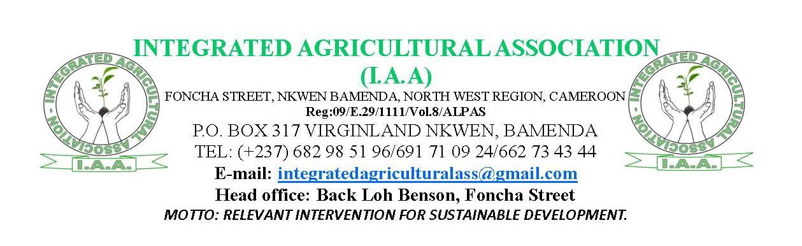
PROJECT REPORT ON SENSITIZATION AND SUPPORT ON FAMILY BASED GARDENS-SEED DISTRIBUTION.
PROJECT NAME: I.A.A VEGETABLE PROJECT; SUPPORTING FAMILY BASED GARDENS WITH SEED AND KNOWLEDGE FOR IMPROVED NUTRITION AND POVERTY ALLEVIATION.
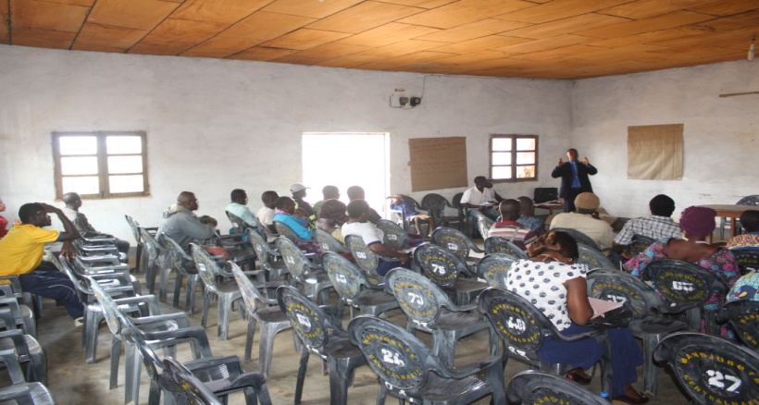
Dungrila Pascal M Giving Lectures on Sustainable agriculture
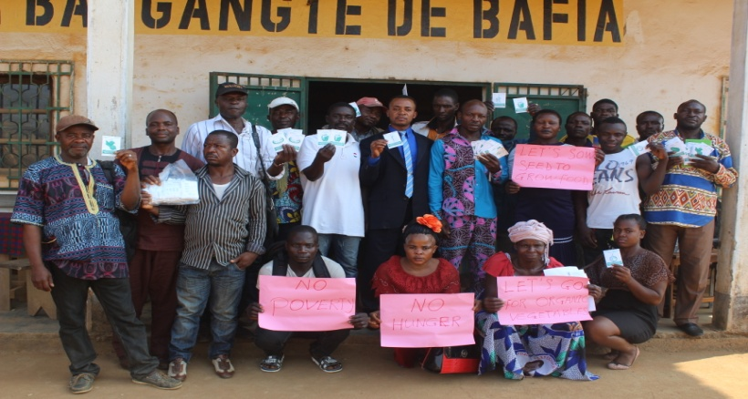
Beneficiaries received seed packages & gave thanks.

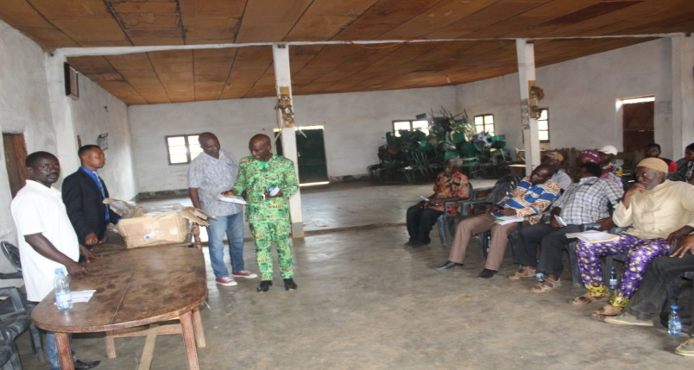
Agriculture Delegate and Mayor observing seed packets.
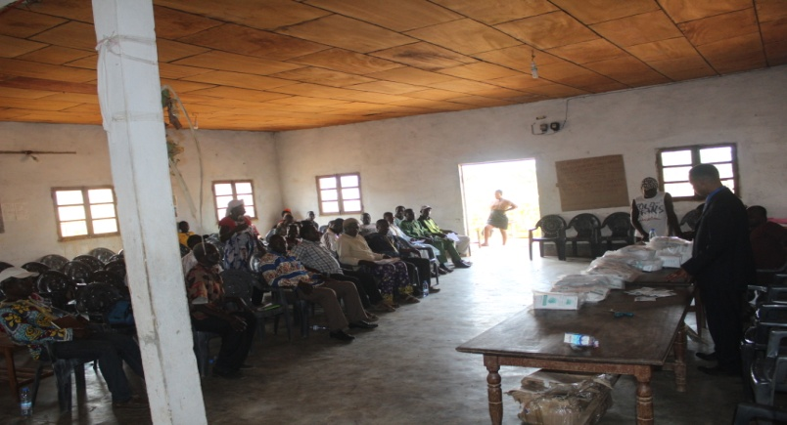
Dungrila Pascal presented the seed to beneficiaries
I.A.A Volunteers making seed distribution.

1.)PRESENTATION OF I.A.A.
Integrated Agricultural Association (I.A.A) is a Cameroonian non-profit, non-sectarian and apolitical Organization founded on the 5th of March 2016 by the founder; Dungrila Pascal Mbimenyuy, recognized on the 28th of February 2017, as a non-profit NGO by Law No 90/053 of 19/12/1990 governing associations in Cameroon, with authorization Nº 09/E.29/1111/Vol.8/ALPAS. Her aim is to ensure Food security, Promote Disease prevention, Promote Social Justice, promote social, economic, and environmental well-being by (i) helping to create “sustainable economic development in rural communities in Cameroon,(ii) empower and train youths and women-owned producer cooperatives, and (iii) educate Cameroonians about the importance of organic farming and organic food.
I.A.A is a Youth led Organization with main focus on empowering farmers through organic food production and commerce. I.A.A also transforms subsistence farms into profitable businesses by helping smallholder farmers access good training, affordable capital, quality inputs and better crop prices. I.A.A is passionate about creating social change and food equity, and the organization provides farmers with essential knowledge as a strategy to ensuring food security and fighting poverty across Cameroon. I.A.A has over two years of experience in nonprofit leadership with a focus on smallholder farmer empowerment, defending indigenous minority rights, education, health care and community development in Cameroon.
2.) ACKNOWLEDGEMENT.
Integrated Agricultural Association (I.A.A) wishes to thank Future in our Hands UK for giving her financial support and Seed Program International USA for donating Seed to start this work in Bafia. I.A.A also grateful to Bafia Council, Divisional Delegate of Agriculture and Rural Development for Mbam et Inoubou (Bafia), CAMGEW, COHESODEC for their moral and technical support in this work. She also wishes to thank all the community members and her volunteers for being very resourceful and supportive especially in the mobilization of beneficiaries and seed distribution.
3.) A WORD FROM PROJECT LEADER.
I.A.A has the absolute passion to create social change and to ensure social, economic and environmental wellbeing of the rural population in Cameroon. Despite the challenges at start of the project, she is determent to take up challenges to forge ahead for success. Hence, this report is prepared to share the project successes and challenges to the public. This is a project with greater ambition in terms of livelihood improvement, social, economic and environmental wellbeing, even though the impact at still is still below expected results. However, we learn a lot through practical examples and there is a high possibility to build skills and experiences while in the field. We remain objective, passionate, focused in what we do and ready to grow this project. We think that is important for the Government, NGOs and Individuals to work collectively in poverty alleviation and to feed the world. Vegetable gardening is an enterprise with several advantages over many agricultural enterprises, but still has many challenges which need to be addressed. Given that this project has greater ambition and still at the pilot phase in Bafia, we are opened to anyone or institution interested in this work to support us continue this work in Bafia.
We have the absolute privilege that through this project we are contributing to fight poverty, and ensure food security through sustainable vegetable gardening.
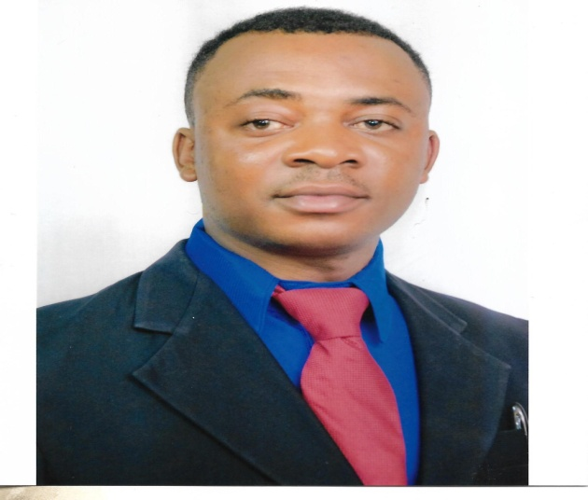
Dungrila Pascal Mbimenyuy.
Agriculture and Nature Conservation Campaigner.
Founder/Executive Director.
Integrated Agricultural Association (I.A.A).
4.) BRIEF PRESENTATION OF THE PROJECT.
I.A.A initiated a project in June 2019 in Bafia, Mbam et Inoubou Division, Center Region, Cameroon. This project is supported by FIOH UK, SPI USA and MINADER Bafia. This project is titled: I.A.A VEGETABLE PROJECT; Supporting Family Based Gardens with Seed and Knowledge for Improved Nutrition and Poverty Alleviation.
Goal: To fight poverty and malnutrition by planting and supporting family gardens for livelihood improvement.
5.) Objectives.

1.) To train women and youths in sustainable gardening to use vegetables production as a strong financial incentive for poverty alleviation and livelihood improvement.
2.) To achieve food security and poverty reduction through enhanced utilization of agricultural knowledge and innovation.
3.) To support the generation, dissemination and adoption of improved technologies for vegetable production and marketing.
4.) To identify crops diversification options that can increase income, preferably while improving nutrition and/or natural resource management (ie water and soil health).
5.) To develop and promote appropriate evidence- based models for sustainable value chain development for African agricultural commodities using vegetables production and marketing as an example.
6.) To fight youth unemployment and joblessness by using agriculture as a tool for job creation.
7.) To add value to the vegetable industry through value addition and the creation of market links between smallholder farmers and agro processing centers.
8.) To expand the utilization of safe, quality, diversified, value-added vegetable products and derivatives.
Given that I.A.A is specialized in solving environmental challenges including poverty and hunger, she believes that individuals, families and groups could be empowered with skills, tools, resources and connections they need to take control of the challenges they face. However, I.A.A aims to work with poor families to help them build wealth and be self reliant. She wants to use sustainable vegetable gardening as a strong financial incentive for poor people to alleviate poverty, given its numerous advantages over many agricultural enterprises. Her aim is to support individuals, families and collaborate with MINADER Bafia to organize them in 15 village level vegetable gardening groups and 4 community based vegetable producer cooperatives and provide them with the opportunities to benefit from skills and be adapted to the local environment, and locally produce a variety of seeds they require for their agricultural activities. I.A.A will work with 200 farming groups in Mbam et Inoubou Division as she is not only interested in working with poor families but with farmers in general. She will also train and support those who know nothing about gardening and those already engaged in gardening. I.A.A will also encourage youth to take up careers within the vegetable value chain by helping them acquire skills and resources required to create a steady and profitable gardens in their various communities so that risk of youth unemployment and rural urban migration could be minimized.
6.)SEMINAR ON SENSITIZATION AND SUPPORT ON FAMILY BASED GARDENS-SEED DISTRIBUTION.
6.1)THEME: “INVESTING IN AGRICULTURE AND UNDERSTANDING THE ROLE OF ORGANIC VEGETABLES GARDENING”
I.A.A estimated to train and give a start up support to 140 families in conservation agriculture practices. 70 families and 10 groups were invited to attent the seminar which held on the 11/12/2019 at Foyer Bangante in Bafia. Benefiaciaries were drawn from villages at the outskirts of Bafia town. However, 29 families and 7 groups attended the seminar making a total of 36 attendees. 36 beneficiaries received training in sustainable agriculture which included; (i) economic principles (ii)social principles (iii) environmental principles. And sustainable agriculture practices ( Organic/Conservation agriculture methods which included the following principles; (1) rotating crops and embracing diversity (2) planting cover crops (3)reducing or eliminating tillage (4) applying integrated pest and disease management (5)integrating livestock and crops (6) adopting agroforestry practices (7) managing whole systems and landscapes. However, beneficiaries were encouraged to use compost manure,farm yad manure as well as cow dung, pig waste and fowl droping for fertilizer. 36 participants also received 15 sachets of different kinds of vegetables seed each as start up support, making a total of 540 sachets given out.
The seminar was attended by the Divisisional Delegate of Agriculture and Rural Development (MINADER) Mbam Et Inoubou Division, Center Region-Cameroon, His Delegation and Secretary General of Bafia Council. The two personalities together with Dungrila Pascal Mbimenyuy, Director of I.A.A officially opened the seed boxes in the presence of the beneficiaries. They expressed their readiness to continue supporting this project in Bafia until its goals are atained. Seed Program International USA donated 3 medium size boxes of vegetables seed to I.A.A, but as they passed through the Cameroon Custom, one of the boxes could not be received and we were unable to track down the missing seed box. I.A.A understood that this is dryseason and which is marked with a lot of celebrations including death celebration and even funerals. In a rural seting any of these, usually makes the whole village displaced to the ceremony as everyone is social and close to each other. I.A.A will continue with the seed distribution door-to-door and will be visiting planted gardens in April and July 2020 to evaluate the seed impact on the families and will colloborate with MINADER to organize 15 village level vegetable groups, and 4 community based vegetables producer cooperatives so that they can benefit from skills, tools, resources and conections required for sustainable farming.
7.)PRESENTATION OF BAFIA.
Bafia is a community where unemployment, poverty, poor health and poor nutrition are critical issues that affect the population especially peasant women and their children. Those of the sorounding villages are of high risk, given that such communities lack access to electricity and potable water, access to finances, collateral security and are not able to participate fully in decision making processes locally. Opportunities on entrepreneurship, capacity buildings and access to land are limited. Where these facilities are available they are not reliable, affordable and accessible. Some of these women are marginalized, less educated; suffer from domestic violence and their girls fall victims of child trafficking and early marriages. Some peasant women in Bafia suffer from HIV/AIDS and other diseases. Agriculture is the main occupation of the population in the outskirts of Bafia. Poverty hit hard and women lack farm input like tools, organic manure and improved seeds. They are poorly organized and lack basic skills and support in farm planing and business. These problems need to be addressed in ways that are environmentally , socially and economically sustainable.
8.)PROJECT CHALLENGES.
The following challeges exit as the projec began:
- Poor organization of gardeners (farmers)
- Over utilization of chemical fertilizers and pestisides.
- Gender bias in land ownership.
- Vegetables are highly perishable
- Dificulty in seed sourcing (production)
- Lack of sufficient or ready market and poor participation of beneficiaries.
9.)REFLECTION ON THE WAY FORWARD.
1.) As concerns poor organization of gardeners (farmers), I.A.A is thinking to work closely with individual farmers and help them organize in groups and build their skills, so that they can benefit from group opportunities that an individual farmer would not have without belonging in a farming group.
2.) Technical follow-up will be ensured by I.A.A to make sure that gardening is absolutely organic, with only the use of organic manure for fertilizer and natural methods for pest and disease management. She will work closely with gardeners in this community to surpervise and locally certify their produce as organic.
3.) I.A.A is thinking to partner with Bafia Council, so that individuals/families especially women could pass through I.A.A to obtain gardening plots from Bafia Council along the river banks in Bafia. She will also plead with community leaders to continue with support in sensitizing community members.
4.) I.A.A is thinking to establish a seed farm in Bafia, which will be a focal point for farmers to receive practical training on the local methods of seed production, do experiment and research on different seed varieties, including conservation agriculture practices and how to connect with local seed producers and adapt to native species. She will also buy and supply vegetables produced by farmers in this community in order to create ready market for them to reduce post harvest losses.
10.)TESTIMONY FROM BENEFICIARY.
Belan Suzanne.
We are so glad to benefit from your support. However, your lectures on sustainable agriculture practices in particular, have re-instilled hope and belief in our farming activities. We think that the seed and training received on the use of organic manure for fertilizer and natural methods of pest and disease control methods is promising an increase in our production/income, thereby giving us an ultimate reason to use conservation methods in agriculture for more benefits.
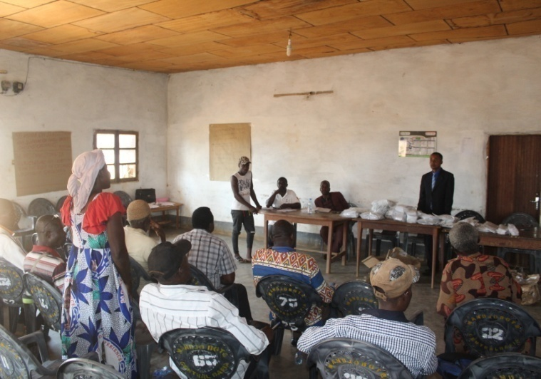
Belan Suzanne expresses gratitudes for support.
(B)
11.) PROJECT FINANCIAL STATEMENT.

11.1) ORGANISATION NAME: INTEGRATED AGRICULTURAL ASSOCIATION (I.A.A)
11.2) PROJECT NAME: I.A.A VEGETABLE PROJECT; SUPPORTING FAMILY BASED GARDENS WITH SEED AND KNOWLEDGE FOR IMPROVED NUTRITION AND POVERTY ALLEVIATION.
11.3) PROJECT INCOME: 158,000FCFA (250poundsteling)
CURRENCY: (FCFA)
DATE: 11/12/2019
S/N | DESCRIPTION | QUANTITY | UNIT COST | AMOUNT
1 | Program/training charts | 7meters | 500frcs | 3500frcs
2 | Transport for I.A.A team (4 volunteers) | 300kms | 100frcs | 30,000frcs
3 | Venue hired/chairs | 1 day | 20,000frcs | 20,000frcs
4 | Program brochures. | 100 copies | 100frcs | 10,000frcs
5 | Invitations | 100 copies | 100frcs | 10,000frcs
6 | Communication credit for I.A.A team. | 4 persons | 4000frcs | 16,000frcs
7 | Food/water for seminar | 41 people | 750frcs | 30,750frcs
8 | Transport for community leaders | 5 people | 2500frcs | 12,500frcs
9 | Facilitator fees | 1 day | 10,000frcs | 10,000frcs
10 | Assistant facilitator fees | 1 day | 5000frcs | 5000frcs
11 | Photography | 1 day | 8000frcs | 8000frcs
12 | Bookmarkers | 2 packets | 2250frcs | 2,250frcs
 | TOTAL |  |  | 158,000FCFA

