ANNEX A.
Application Form

I. Background Information

1 | Project Title | Re-social integration of tribes community through development of social, economic standard
2 | Requested Amount t (in US $ only) | US $ 11026
3 | Name of the implementing organization | Association for Community Training (ACT)
4 | Name of Bank and Name of account | Association for Community Training  Indian overseas Bank IOB,  Mugaiyur Branch,  Tamilnadu, India  Account No. 2276,  Bank Code. 0772  Swift Code. IOB AIN BB 070
5 | Contact information (mailing address, telephone & fax, email, and websites) | The Secretary  Association for Community Training (ACT)  Mugaiyur 605755  Villupuram Dist  Tamilnadu, INDIA  act_mugaiyur@rediffmail.com  Tel.No.04146 240239
6 | Mandate and key objectives of organization | To protect and promote indigenous tribe’s community of villupuram district, Tamilnadu, India  To enhance their hidden talents to be skilful in suitable economic activities and lad a independent life  Re social integration of innocent Tribe’s who are conditioned to be isolated and discriminated
7 | Person/s in charge or the organization | V.T.Irudayamary Retied Headmaster Age;58  Secretary,

8 Brief description of experience and expertise of proponent organization in the
implementation of similar projects

ACT-Association for community training’s mission is human transformation. This is why it was born in 1985. Indigenous tribes population who were spreaded in 110 villages falls in the Blocks of Mugaiyur, Villupuram District in Tamil Nadu state was our only intervention people who are working in 150 more stone quarries known as crusher units where stones are digged out, sized to various model to cater to the need of construction of building. From time immemorial, they were taken by quarry owners promising good salary and habitation made to live in the thatched settlements near quarries conditional to be isolated, their children are not allowed to go to school but are engaged as child labourers along with their parents. Thus, their life’s are shrinked to quarries and settlement they are not exposed to outer world. During 1985 – 2005 at 15 years mission of redeeming them from the custody of illegal vested interested people ACT was able to release a total of 2468 Tribes families for 75 quarries and helped to Re-integration. We were able to achieve this through the collective support of media police and court still more peoples are yet to be released. Main streaming their children in to local school, facilitating the parents with goatry , milk cow support, involving them in to some other small vending initiatives done so far. We were able to cover maximum families and still more indigenous women, children and youth are under our special consideration as we look out of line donors in this context us happen to know about you….

II. Rationale

We did a comprehensive survey with the support of local young volunteers which covered 185 quarries in 28 destination where we met 4062 Tribes family and have collected socio, economic, health, educational, environmental data. Thanks to 63 young volunteers who stood in our mission. Collected information’s are documented in the form of papers and Audio cassettes and kept in our office with the availed enumeration we have organized them as quarry workers unit in every villages, taken for registration, every families are provided identity card (family card) issued by ILO Indian Labours Office, Government of Tamil Nadu through our intervention with the proven record they able to cast their vote, buy food commodities at Government run fair price shop, to claim accident and death relief. Thus a total of 2468 tribe’s families have got their social identity. They now face the big problem is permanent job to protect themselves, to lead on dignified, self sustainable life. We fear that if they are not provide such support then they may have chance of go back to quarries and undergo trials and tribulation as hostile loosing social identity. Therefore we have evolved this project.

III. Objectives

To abide by the UN declaration on the rights of indigenous peoples and allows the tribes to take a suitable place in the society.

To take them in to self contended, secured, independent life style by providing technical assistance and relevant standard setting activities. Promotional activities to improve their culture, health, human rights the environment and socio, eco development
IV. Strategy

- Life skill training for 3 batchers 50 beneficiaries per batch (women, children and young boys and girls) respectively,
- To set up sewing school (tailoring skill training centre) for both illiterate and literate young girls, 1yr training aged ranging from 14 to 25 years 40 girls per year basis. It will be continuous program, non-stoppable to cover all tribal neediest girls.
- To setup Auto mobile technology workshop to train 40 tribes boys for 1 yr, for 14 years to 25 years.
- Goat and milk cow support for 20 tribal women. An unit of the Goat kid to 10 women (couple of kids) worth Rs.5000/- and milk cow for 10 women worth Rs.15000/-
- Resource persons for both objectives will be invited from human resource development, District collectorate ,Villupuram
 | Month 1 | 2 | 3 | 4 | 5 | 6 | 7 | 8 | 9 | 10 | 11 | 12
Activity
Training | X
Sewing school | X | X | X | X | X | X | X | X | X | X | X | X
Automobile Technology | X | X |  | X | X | X | X | X | X | X | X | X
Farming support (Goat) |  | X
Farming support(Milk Cow) |  | X

V. Results and sustainability (maximum 2 paragraphs)

Trainers of sewing will have knowledge be capable in the areas of cutting stitching, Embroidery and making readymade garments after training she can prefer to start either house hold sewing shop or work in any reputed garment factories of her native town. It is demandable, gives permanent revenue. The trainers who prefer sewing can avail local bank loan up to Rs.25000/- until course completed certificate since no one such trainers go to banks from tribal sector asking business due to living condition and de motivation keeps them away from in the mean time banks are ready to support them.

Auto mobile technology is the finest trade today, he can easily get a job citing certificate and resume as more industries requires so as india becomes industrialization attracts world investors. We can find mush rooming of industries in every local town.

Since tribes settlements situates in and around sedimentary Rockies, suitable to maintain stocks grazing no need of keeping green fodder and concentration. In course of breeding within 3 years she can have small goat farming as a kid yields 3-5 kids in one breeding in six month timing. Cost of goat is worthy Rs.4000 to Rs.5000 after three years no side job is needed to undertake but goatry will became Goatry is closely associated with tribe’s environment a permanent occupation. Goat milk, meat manure are the consumable item.

Life skill training gives them boosted confidence, defence mechanism knowledge in the areas of personal health menopause, using sanitary napkin breast feeding safe sexual behaviour, family planning, Group formation, minutes taking, decision making power, rights to information act which will empower them to with stand in life.

VI. Partnerships (Maximum 1 paragraph)

- DR.Bennet Benjamin will touch our project to depute their external evaluating team and to handle technical support to the project. Address follows.
DR.Bennet Benjamin,
Development consultant
Human Resource Development Center (HRDC)
YELLAGIRI Hills, Tirupattur
Vellore Dist, Tamilnadu, INDIA
Email: bennetben@rediffmail.com

Follow Up of the project:-

Motivation against open defecation toileting mixing excrete in to local water bodies eliminating water borne diseases since the tribe’s are illiterates under motivation very low level of health understanding grown-ups of tribe’s polluting in the street, ground the house be toileting, urinating ,elders uses common lands.

To your surprise no tribe’s houses has created with eco-san toilets and safe drinking water , drainage system either sides of street. Such are the most pressing issue here, flies sets on hand and food while children eats food in front of house and adult, teenage girls face worst kind of suffering for changing sanitary towel. During menopause (menstruation) in the public and lack of privacy. So tribe’s girls and women prefer early morning and sunset but there is chances to sexual threats there. After having implemented the program the tribe’s will be redeemed from existing sorry plights by undertaking line project.

If the donor agencies agreed to accept this need too to implement the sanitation program and we shall under take every effort us it requires motivation on ECO-SAN-TOILETS and water management workshop. Construction to ECO-SAN-sanitation as an initial measure to Tribe’s quarters. Portable water arrangement will be sought from local panchayats.

VII. Monitoring and evaluation Arrangements (maximum 2 paragraphs)

10 members monitoring team will be set up, consist of tribal elders, young’s, board members of ACT which will under table concurrent monitoring they will be closely associated in the areas of problem shooting, job replacement, community support etc.,
An internal Both will be summarized and submitted to dear donors in the form of text evaluation will be carried out by the board of ACT and external by…… along with visible photocopies A, Audited statements valid case study records and special thanks giving.

VIII. Detailed Budget Proposal

ITEM / activity | # OF UNITS | COST PER UNIT $US |  | Total
Budget item 1 Training
Training  Life skill training for 3 batches for each women, girls young (both sex) Rs.5000x3 prog. Rs.15000 cost included preparation of resource materials hiring film show equipments cost of resource person, conveyance and working lunch etc | 100 | 3 |  | 300
Budget item 2
Sewing School  Training centre with electricity sanitation water and eco garden available at ACT | - | - | - | -
- Consumable sewing machines 10 numbers @ Rs.7000/- | 10 | 159 |  | 1591
- Training tools and equipments to provide each trainee like (Scissor, Thread, Bobbins, Scale, iron box, wooden box etc) | 10 | 57 |  | 568
- Wooden chairs 40 members 40 x Rs.1500/-each | 40 | 23 |  | 909
- Cutting table two members for the trainees group usage available at ACT

Budget item 3

Auto Mobile Technology  (Training Centre available)  - Second hand two wheelers 1, four wheelers 1 | 2 | 852 |  | 1704
- Cost of oiling, greasing and compressor machines altogether |  |  |  | 227
- Required training tools and equipments |  |  |  | 227
Budget item 4
Farming support  Cost of 10 units of Goarty @ Rs.7,500/- | 10 | 170 |  | 1700
Insurance coverage Rs.500/- per unit of Goat kid 10 units x Rs.500/- | 10 | 12 |  | 120
Budget item 5

Farming support  Cost of 10 milk cow @Rs.15000/- each | 10 | 341 |  | 3410
Insurance coverage Rs.1500/- per year | 10 | 34 |  | 340
TOTAL
 |  |  |  | 11096

Conclusion:

The project not only seeks financial support but tribe’s to Re-social integration and allow them to live in independent life style without any external threats , sexual abuse harassments that was the main affair in their previous life. The project gives them boosted confidence, defence mechanism in the face of sexual harassment. The project frees them from tortures of money lenders who pay money on exorbitant interest.

ANNEX B.
Organization Profile
(Maximum 3 Pages)

- Background: (Experience for 27years).

The Association for Community Training - ACT is a non profit, non Governmental, secular Social work organization working for the cause of the weaker sections of the society for the past twenty three years in Villupuram District.

ACT initially was promoted in the year 1983 by a Team of young educated and likeminded individuals who had hands on experience of educating and organizing the agricultural landless labourers both women and men, Quarry workers children and youth and such other community development activities in Mugaiyur and Thirukoilur region of Villupuram District of Tamilnadu with a vision of socio economic, educational and cultural development. These individuals are from the same district belonging to Dalit community who had the shared/common vision of empowerment of marginalized/impoverished segment of the society.

Initially they started of with organizing the agricultural labourers for the empowerment through awareness education, community health education and promoting small savings among women, environment protection, and literacy programme for adults and children and evening coaching classes for children. ACT also concentrate on focusing several issues pertaining to the vulnerable/weaker communities including discrimination against Dalit.

Executive Committee members of the organization and Designation:

S.No | Name | profession | Age | Designation
1.  2.  3.  4.  5.  6.  7. | Mrs.A.Synthiya  Mrs.V.T.Irudayamary  Mr.V.Abel  Mrs. S.Revathi  Mrs. J.Regina Mary  Mrs. D.John Britto  Mrs. Amutha | Teacher  Rtd Teacher  Social worker  Social worker  Social Worker  Social worker  Social worker |  | President  Secretary  Treasurer  Executive member  Executive member  Executive member  Executive member

- Goal and Objectives

- To provide Re-social integration facilitation for equal footing and co –existence
- Promoting social, educational, economical background
- To provide clean and green environment at tribe’s quarters and required motivation so,

III. Structure:
Describe the organizational structure of our organization
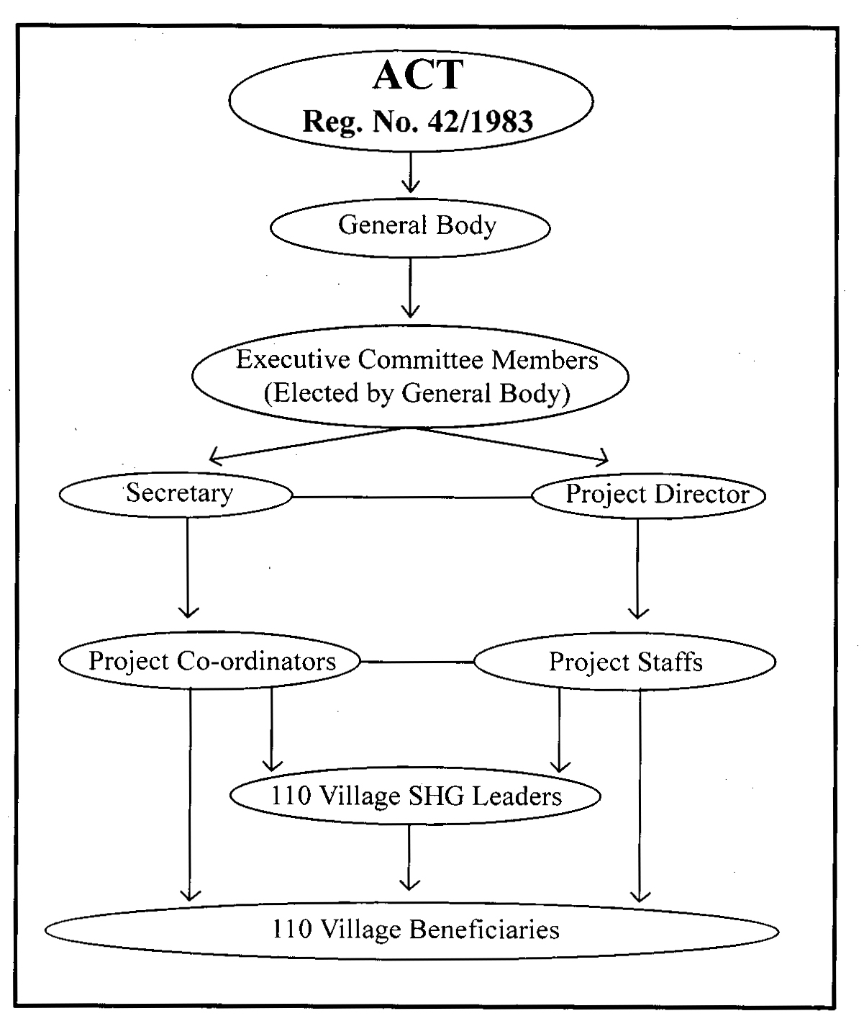
IV. Activities, Networks and Affiliation/s

Currently we have formed 5000 un organised and construction labourers welfare union in villupuram district , Tamilnadu state. They have set out rules and regulations. The whole members are provided identity card provided by ILO- Indian labourer Organization, Government of India.

This apart we started to organize other field of un organised and construction labourers like hawkers, toddy collector .cobblers. Scavengers, bullock cart people .sand quarry workers. Every quarry workers are facilitated to avail educational assistance to school final children, accident claim. Death relief citing identity cared. workshop, training are arranged on varies human right issues

Net works:
Association for Community Training (ACT) is a member NGO of below said net working,
- Quarry workers Action and empowerment Network-(QWAEN) state level
- South Central India Network for development Alternatives(SCINDeA)
- Low External Input Sustainable Agricultural Network, state level
- Tamilnadu Voluntary Health Association (TNVHA) State level
- Emmaus community Welfare Network (ECOMWEL)
- Dalit development forum, Tamilandu, state level
- Joint Action for Sustainable livelihood (JASuL)

V. Partnerships and Financial Support

S.No | Name of the Programme | Duration | Funding Partner
1 | :“Self Development Support of Widows, Positive and Resource poor Women” | 2010-2011 | Associated Country Women of the World  Mary Sumner House  24 Tufton Street  London  SW1P 3RB
2 | Independent Income Earning opportunities (through Goat rearing, pust cart, puffed rice fired corn)poor women(Tribe’s) entrepreneurs | 2008-2009 | Associated Country Women of the World  Mary Sumner House  24 Tufton Street  London  SW1P 3RB
3 | Sustainable Livelihood  Resource Development and Self Reliance of the implementing organization and Dalit Resource Poor Women Farmers through Sustainable Agriculture Practices and water management | 2007-2009 | Emmaus International  47 avenue de la Resistance,  93100 MONTREUIL  France

