ULTIMATE LIFE FOUNDATION

2012
ANNUAL REPORT

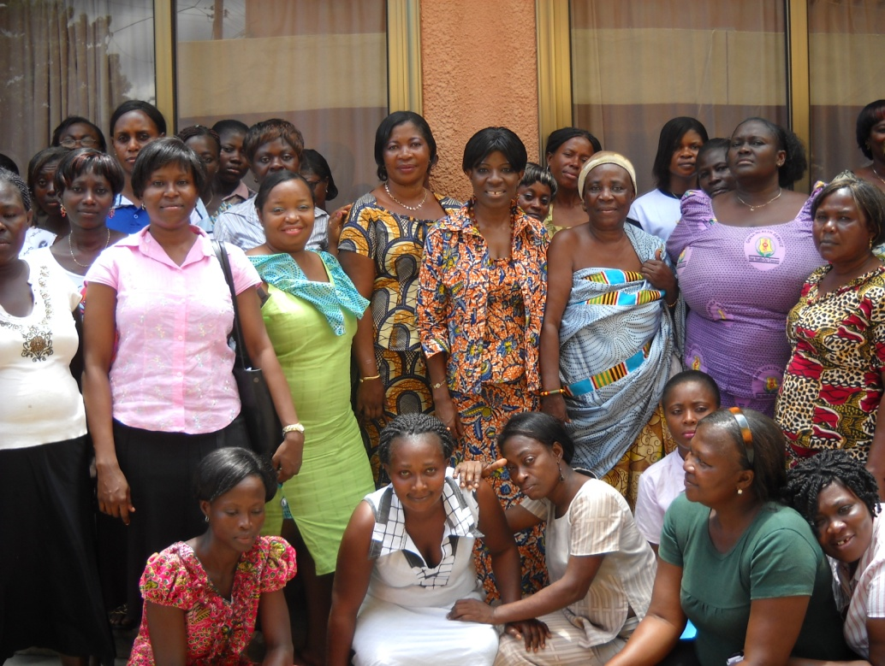

PREPARED BY
ULTIMATE LIFE FOUNDATION

TABLE OF CONTENTS

BOARD OF DIRECTORS 4
CHARMAN’S MESSAGE 5
BRIEF DESCRIPTION OF THE ORGANIZATION 6
THEMATIC AREAS: 6
PARTNERSHIP AND COLLABORATION 6
KEY PROGRAMME ACTIVITIES CARRIED OUT IN THE YEAR UNDER REVIEW 7
THE WAY FORWARD 13
STRATEGIC PLAN FOR 2013 14
GENERAL INFORMATION 15

BOARD OF DIRECTORS

CHAIRMAN : WILLIAM AYISU, Executive Director(F&A)

TREASURER: CYNTHIA TACKIE, CEO, Libra star Catering Services Ltd.

SECRETARY : PRISCILLA KORANKYE, French Adult Trainer (Education)

DIRECTORS : DR. ALBERT BENNEH Medical Consultant
HILARY ASHIA Public Health Consultant
DR. CYNTHIA ASHA, Medical Doctor, Nkawkaw Gov.Hospital
GEORGE H. KORANKYE, Executive Director(Programmes)

SENIOR MANAGEMENT

WILLIAM AYISU - EXECUTIVE DIRECTOR (F&A)
GEORGE H. KORANKYE- EXECUTIVE DIRECTOR( PROGRAMMES)
DEVINE DAGODZO- DIRECTOR

CHARMAN’S MESSAGE
Economic growth and development depend largely on citizenry meaningful contribution to their economic and social development. Developmental goals therefore cannot be achieved without firm guarantee for the health of PLWHIV/OVC. An integrated approach to facilitate care and support for Person Living with HIV (PLHIV) and Orphans and Vulnerable Children (OVC) in the society cannot be overlooked.
ULTIMATE LIFE FOUNDATION, since its inception has been able to impact the lives of its members and Orphans and Vulnerable Children (OVC) caused by HIV/AIDS.
As a human institution, the organization has encountered problems which impeded the smooth running of the programs outlined. Despite these challenges, the organisation has been able to achieve over 80% of its goals through its own local resource mobilisation. Additionally, support from some of our donors helped us in diverse ways to forge ahead.
I would like to acknowledge the contribution of several organizations and individuals including the Ghana Aids Commission, N.A.C.P, NAP+ Ghana and OICI for the various roles they played in the development of these PLWHIV / OVC in the catchment areas.
It is our hope that, the dedication and team spirit will continue in the coming years to ensure a total achievement at organizational goal and objectives.

BRIEF DESCRIPTION OF THE ORGANIZATION
On 25February 2003, Ultimate Life foundation was founded by a group of People Living with HIV (PLHIV) as a non-governmental, non-profit and non-political organization.
The organization was established as the will of the citizens to participate actively in the fight to prevent, control and eradicate HIV and AIDS and other communicable diseases in rural communities and in Ghana as a whole.

Our prime object is to facilitate PLHIV to seek and access appropriate treatment for the disease. Through advocacy, income generation, care and support for its members and other low-income groups, Ultimate Foundation is able to sustain itself to a very large extent. We collaborate with a number of key stakeholders including the National Association of People Living with HIV (NAP+), Ghana AIDS Commission, Ghana Health Service, and many other NGOs working in HIV and AIDS.

THEMATIC AREAS:
An ultimate Foundation programme, covers four thematic areas including:

- EDUCATION AND CAPACITY BUILDING
- HEALTHCARE AND NUTRITION
- INCOME GENERATION
- ADVOCACY

PARTNERSHIP AND COLLABORATION
Local and national partnership and collaboration is key to Ultimate Foundation growth and development. Therefore, we build strong collaboration with key stakeholders from the community to the national level. The main partners directly involved in our activities include:
- Ghana Aids Commission
- Opportunities Industrialization Centres International of Ghana
- Health Coalition Of NGOs, Ghana
- NAP+Ghana
- National AIDS Control Programme
- Ghana Health Service, Eastern Region
- Nsawam Municipal Assembly

KEY PROGRAMME ACTIVITIES CARRIED OUT IN THE YEAR UNDER REVIEW
Education and Capacity Development Programme

EVIDENCE BASED HIV/AIDS INTERACTIVE CENTRE ACTIVITY PROJECT
PROJECT DURATION | JANUARY 2012-DECEMBER 2012
DONOR | OPPORTUNITIES INDUSTRALISATION CENTERS INTERNATIONAL
APPROVED | GHC 7,500.00

THE AIM OF THE PROJECT:
Educate PLs on all they need to know about HIV/AIDS
Provide psychosocial counseling and preventive healthcare education to People living with HIV/AIDS and those at high risk.
Create a Platform for PL’S to fraternize and share their personal experiences
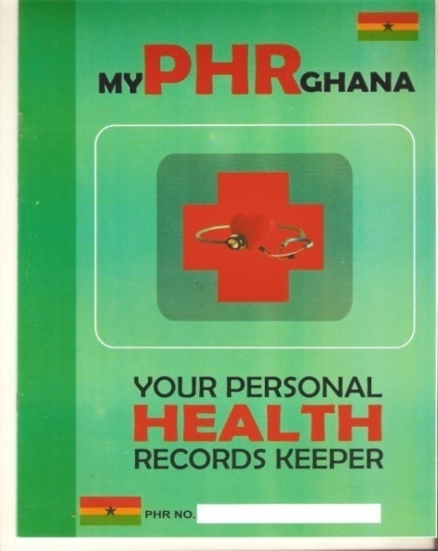
IMPLEMENTED ACTIVITIES:
- A health education exercise was organized
by the Ultimate life foundation for its members
to keep their personal health record. Subsequently
400 booklets for personal health record keeping
designed and printed by the organization was
distributed to 150 PL’s and 250 members of the public.
Location: Nsawam government hospital conference room
Date: 24 February 2012

- A House to house HIV / AIDS advocacy and education programme was undertaken by the members of ULF using local languages including, Ga, Hausa, Eve and Twi. Members visited residences of identifiable commercial sex workers / wansam(Circumcision practitioner) and barbers to follow up on and monitor advice on best trade practices.

Date: 28th of October 2013
Location: Adoagyiri Zongo

- A home based care training programme was organised by the ULF for its member and the general public on the on Universal precautions against HIV AIDS. Topics treated included Prevention of Vertical Transmission, Prevention of Blood to Blood Transmission, and Prevention of Sexual Transmission.

Location:Nsawam government hospital conference room
Date:24th of November 2012

HEALTHCARE AND NUTRITIONAL SUPPORT

PROJECT DURATION | JANUARY 2012-DECEMBER 2012
DONOR | GHANA AIDS COMMISSION
APPROVED | GHC 20,000.00
ULTIMATE MEDICAL SUPPORT PROGRAMME

THE AIM OF THE PROJECT:
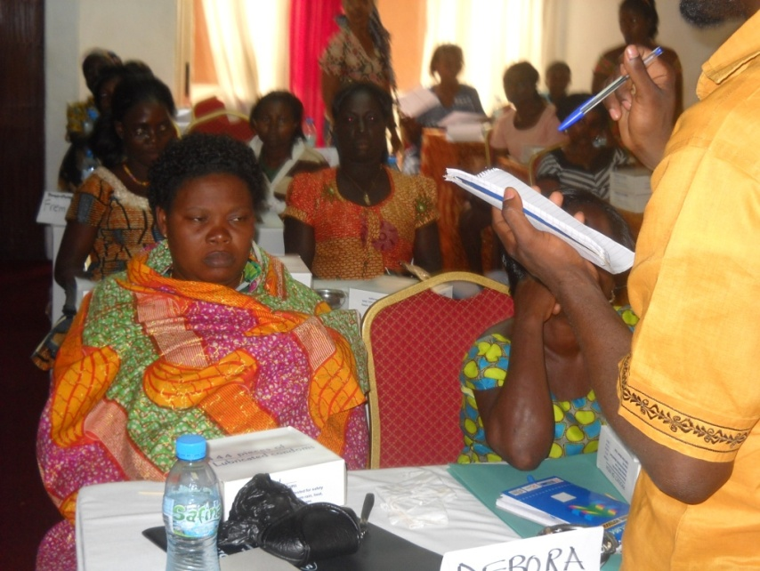
Ensure that PLS living in the Nsawam municipality has unimpeded access to healthcare so they can live longer and happier.
IMPLEMENTED ACTIVITIES:
- In cooperation with the Nsawam
District Hospital Ultimate Life
Foundation dispensed on a monthly
basis, ART medication to 200 PLs
over the project period of 12 months.

Location: Nsawam Government Hospital.
Date: January –December 2012

- In collaboration with the District National
Health Insurance Scheme Ultimate Life
Foundation provided health insurance
PLHIV in a group adherence counseling just before receiving their art medication
coverage for 195needy people living
with HIV/AIDS for the year 2012.
Location: Offices of Ultimate Life Foundation January - December 2012

HEALTH MICRO-CREDIT
PROJECT DURATION | JANUARY 2012-DECEMBER 2012
DONOR | ULTIMATE LIFE CONTRIBUTION
APPROVED | GHC 10,000.00

THE AIM OF THE PROJECT:
- Provide micro-loans for NHIS premiums and health products and services
- Provide micro loans for health products and services not covered by the National Health Insurance Scheme
IMPLEMENTED ACTIVITIES:
- Between June and September 2012 Ultimate Life Foundation provided credit for health insurance premiums to 1,000 members of the community who are in the low income bracket and are unable to access the National Health Insurance Scheme, and other health products and services not covered by the scheme.

- A capacity building programnme involving the provision of training and technical assistance to the ULF was organized by to capacitate Ultimate Life Foundation to manage the loan fund and eventually, provide technical assistance to member borrowers. The programme also facilitated the implementation of a training on loan appraisal and evaluation training, including techniques in the conduct of interviews. Training on Loan Delinquency Management was also provided, as preventive measure and remedial process, to counter possible recurrence of payment delinquency problems. Training sessions on project management, monitoring and evaluation was also provided.

Location: Nsawam Secondary School.
Date: 10th.-13th. June 2012

- SUPPLY OF FOOD AND NUTRITIONAL SUPPLIMENTS
PROJECT DURATION | JANUARY 2012-DECEMBER 2012
DONOR | OPPORTUNITIES INDUSTRALISATION CENTERS INTERNATIONAL
APPROVED | GHC 20,000.00

THE AIM OF THE PROJECT:
To help supplement the food and nutritional need of PL’s and OVC.s
IMPLEMENTED ACTIVITIES:
- Distributed the following food items to
1080 PLS and OVC’s from January to
December 2012over a 12 month as follows:
- 800 gallons of gallons of Cooking oil
- 600 bags of Tom Brown
- 380bags of Sorghum
This activity was executed on every last
ARRIVAL OF NUTRITIONAL SUPPLIMENTFOR PL's AND OVC's
Location: Nsawam Government Hospital
Date; Last Thursday of every month
The project was supported by Opportunities Industralisation centres international, within the and realized in collaboration of Ultimate Life Foundation.

PLHIV AND OVC's SHARING AMONG THEMSELVES, NUTRITIONAL SUPPLIMENT

INCOME GENERATION
VEGETABLE FARMING
PROJECT DURATION | JANUARY 2012-DECEMBER 2012
DONOR | NATIONAL AIDS CONTROL PROGRAMME
APPROVED | GHC 7,000.00

THE AIM OF THE PROJECT:
- Enhance the nutritional intake of PLHIV to support the ART regimen
- Engage PLHIV in vegetable farming to increase household income.
IMPLEMENTED ACTIVITIES:
- A stake holder meeting was organized on the 25th of January 2012. In Attendance were members of ULF, the national AIDS Control programme, the Ghana aids commission, the municipal assembly and local community leaders to deliberate on means to achieve maximum results for the project.
- A training programme on Income Generation Activities, team work and the cultivation, and export of vegetables was organized for project participants on the 10th of February 2012.
- A two acre land acquired for ULF by the National Aids Control Programme was prepared for the cultivation of Maize and vegetables crops such as Tomato, Green Pepper, Cabbage, Lettuce, Cucumber cauliflower and Onions.
- ULF had four boreholes sunk for the purpose of irrigation.
- The planting of Seedlings and maize seeds were completed in April
- The Crops matured in July 2012 members of ULF harvested 1000kg of Tomatoes,300kg of Green Pepper,600kg of Cabbage,500kg of Lettuce,1,200 kg of Cucumber and cauliflower and 1000kg Onions which was worth GHC 15,000.00 in July 2012. 25% of the products were distributed to members and the remainder packaged and sold locally or exported.

Location : Piabo - Nsawam

VEGETABLE FARM PROJECT PARTICIPANTS

THE WAY FORWARD

- The organization will continue to support PL’s and OVC’s and the lower income members of the municipality and elsewhere within Ghana to contribute their quota towards national development
- The organization will empower women economically, socially and psychologically to improve upon their standard of living
- Provide nutritional support for PL’s and OVC’s in the municipality
- The organization will promote positive sexual behavior among vulnerable groups through active dissemination of HIV/AIDS information and condom promotion as a preventive measure
- The organization will link up with international donors to help achieve the set goals and objectives.

ACTIVITY | PERSON RESPONSIBLE | TIME FRAME | COST  (GHC)
PROVIDE NUTRITIONAL SUPPORT FOR PL’sand OVC’s | PROJECT MANAGER | JANUARY -DECEMBER | 10,000
STIGMA REDUCTION CAMPAIGN | EXECUTIVE DIRECTOR (F &A) | JANUARY - DECEMBER | 6,000
ADVOCACY AND GOOD GOVERNANCE | EXECUTIVE DIRECTOR (F &A) | JULY - NOVEMBER | 5,000
CAPACITY BUILDING WORKSHOP FOR MANAGEMENT STAFF | PROJECT MANAGER | 10th. -13th. December | 3,000
HEALTHCARE FINANCING FOR PL’s AND THE UNDERPRIVILEGED POOR | EXECUTIVE DIRECTOR(PROGRAMMES) | 3rd.JANUARY -31st.DECEMBER | 50,000

STRATEGIC PLAN FOR 2013

GENERAL INFORMATION

HEAD OFFICE
LOCATION: - MISSION STREET – NSAWAM
ADDRESS: - P.O.BOX 298 – NSAWAM, E/R
TELEPHONE: - 024 4833953, 020 4988864
E-MAIL: - ultimatelifefdn @ yahoo.com
BANKERS: - GHANA COMMERCIAL BANK-NSAWAM
AKUAPEM RURAL BANK-NSAWAM
CITIZENS RURAL BANK
AUDITORS THRINITY CONSULT
CHARTERED ACCOUNTANTS TAX EXPERTS, &
MANAGEMENT EXPERTSH/N 216 PETROLEUM ESTATES
ACHIMOTA – ACCRA
P.O. BOX MB 676
MINISTRIES -ACCRA

