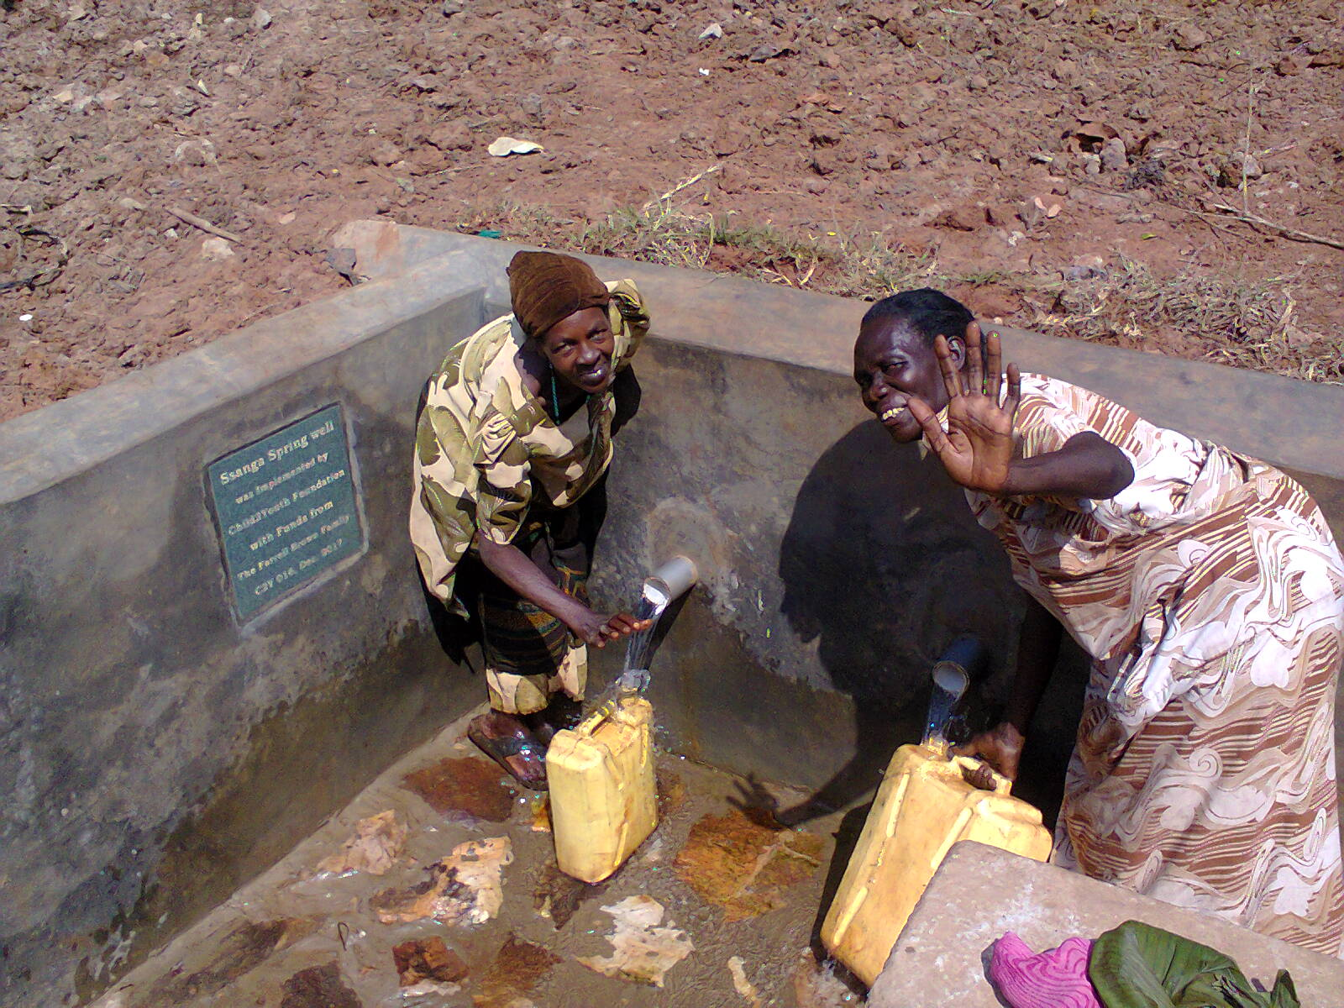
Some of Ssanga village women very happy with and as they fetch water from the constructed water source.
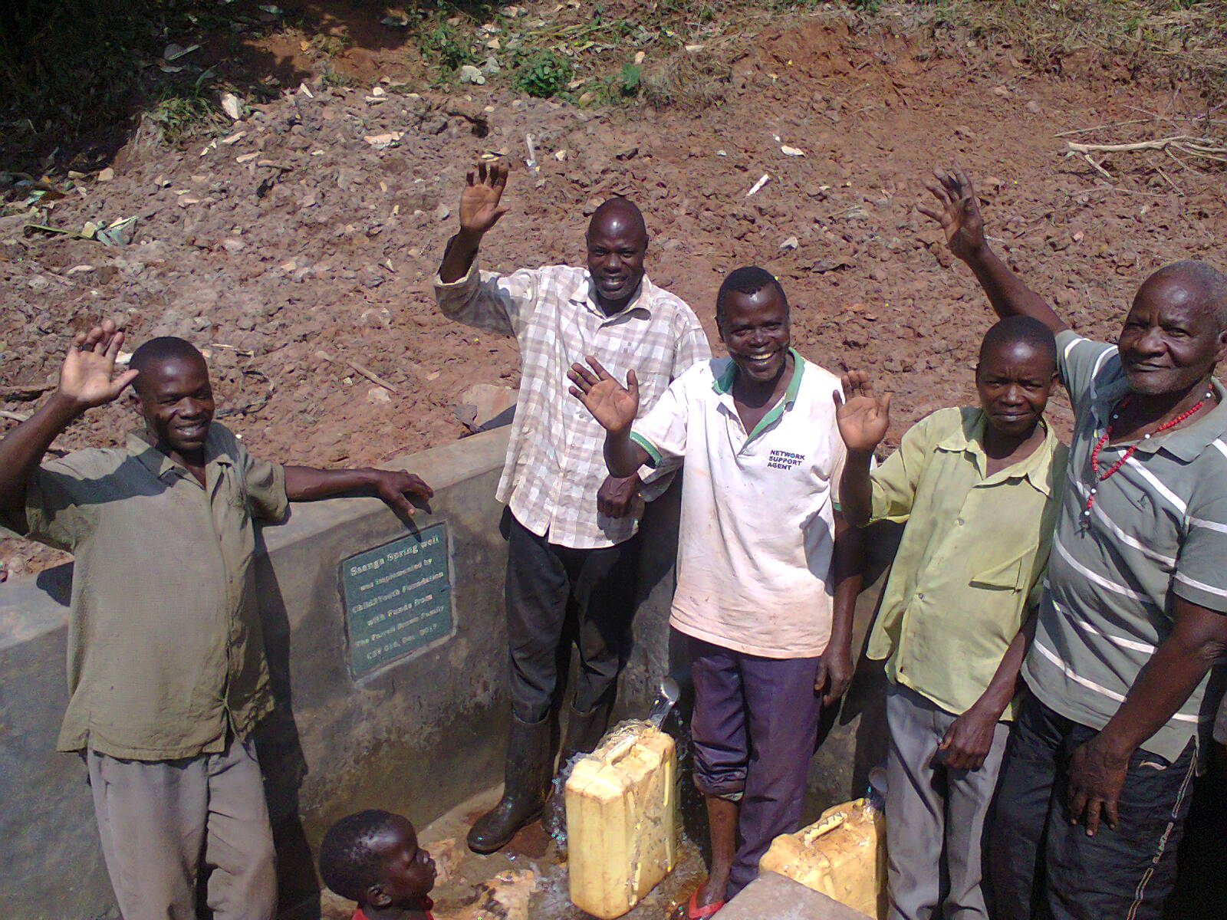
Some of Ssanga village men very happy with and as they fetch water from the constructed water source.

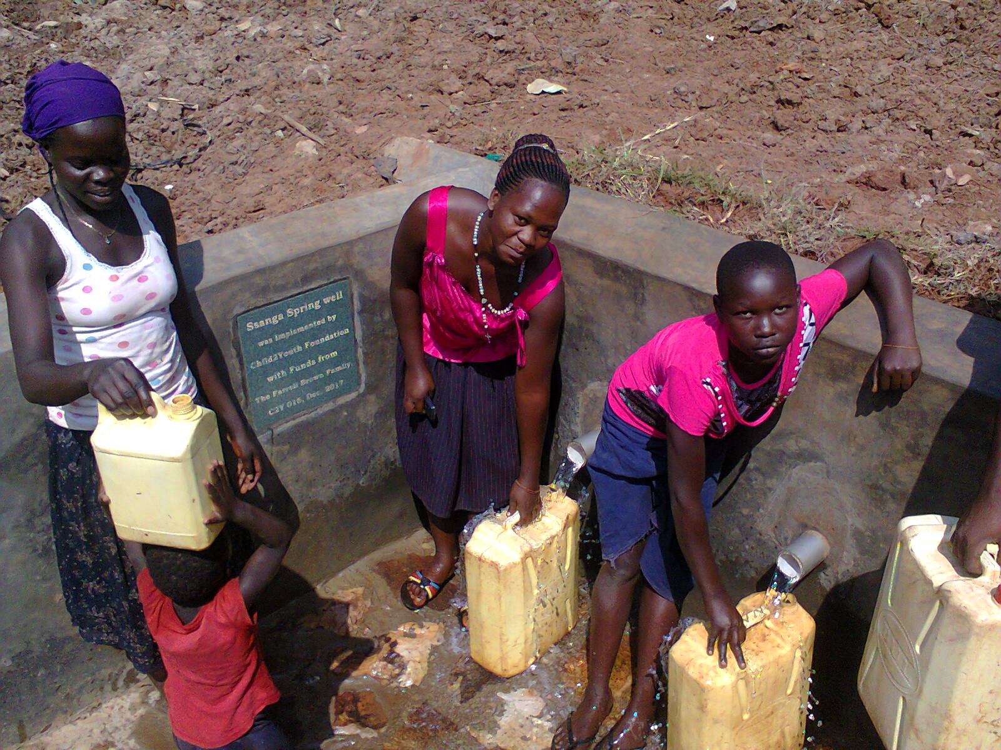
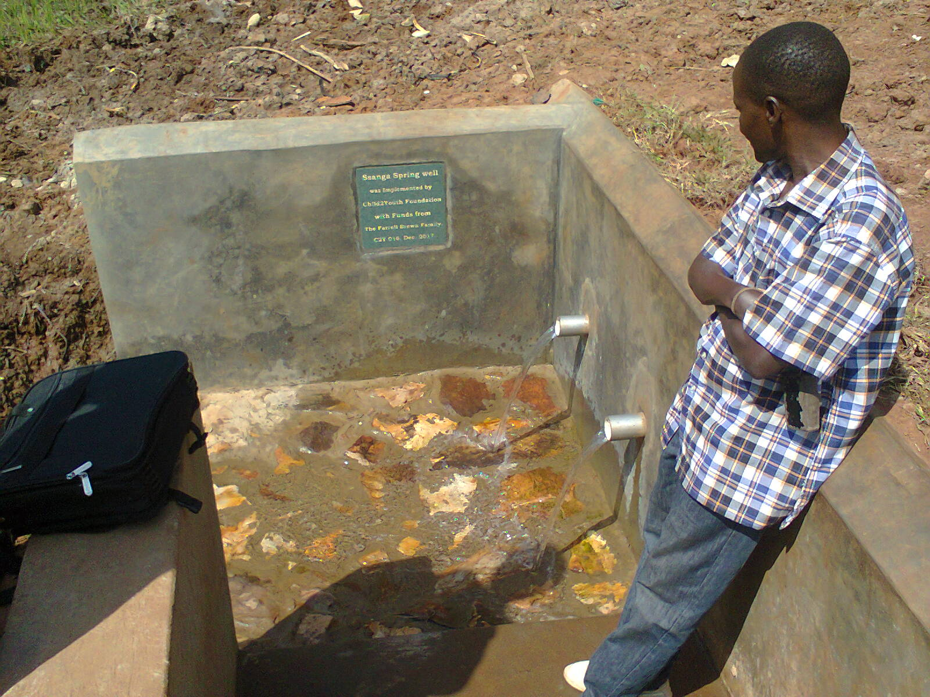
Joel, Child2Youth Foundation looking at the constructed Ssanga village water source.
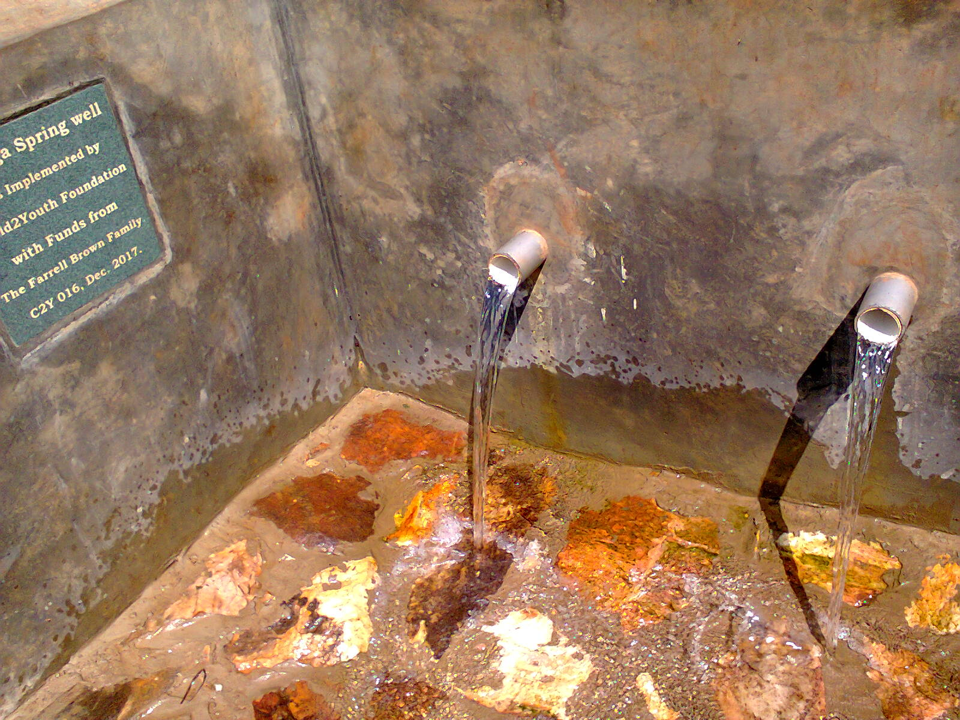
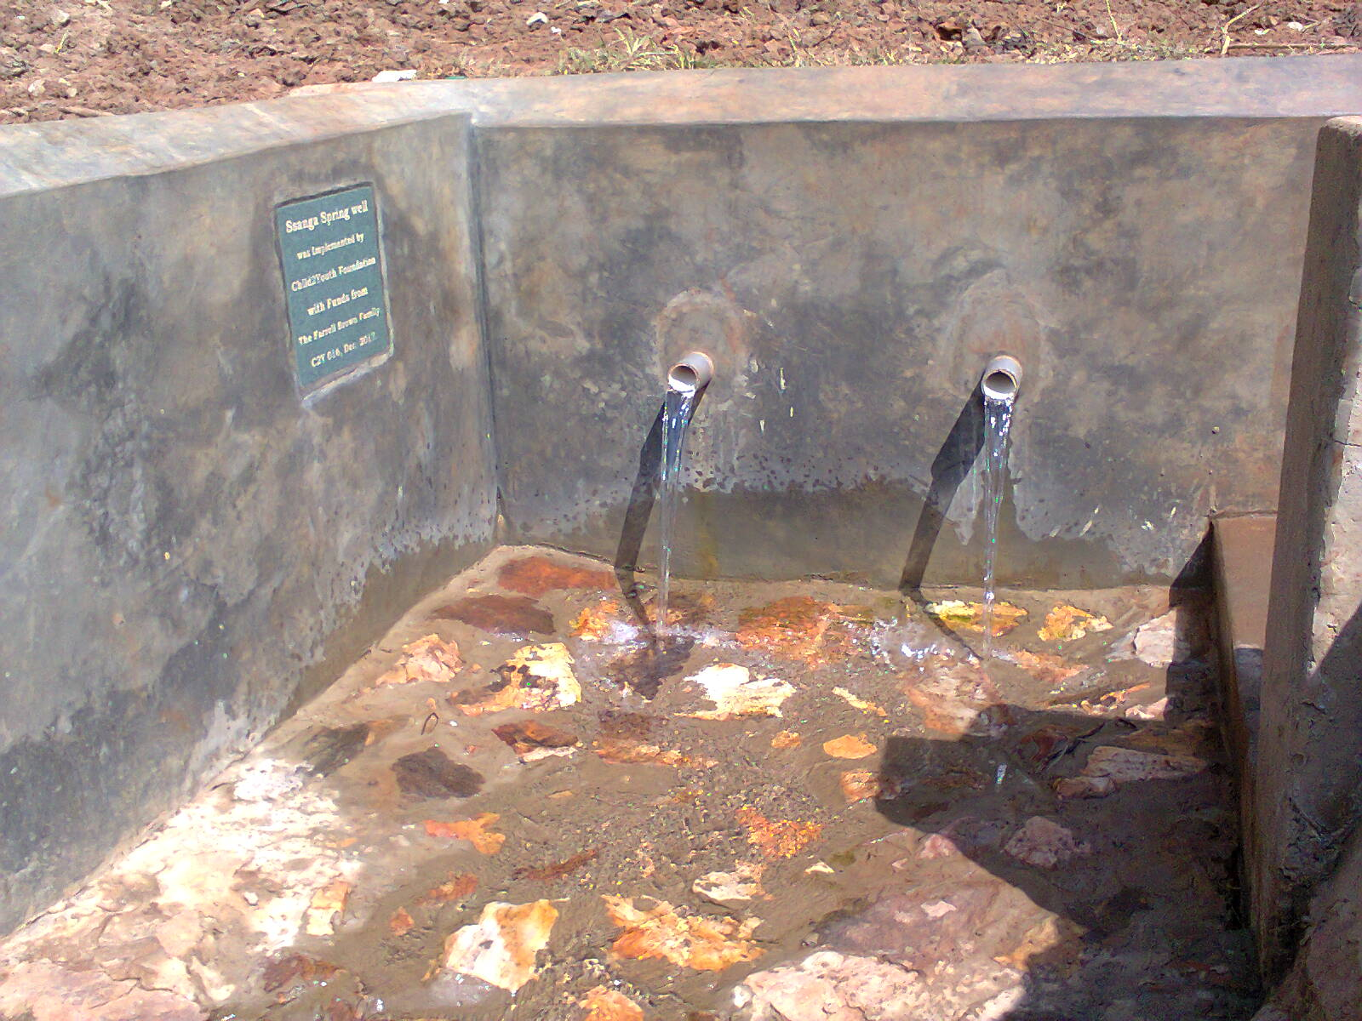
The constructed Ssanga village water source has two out let pipes.
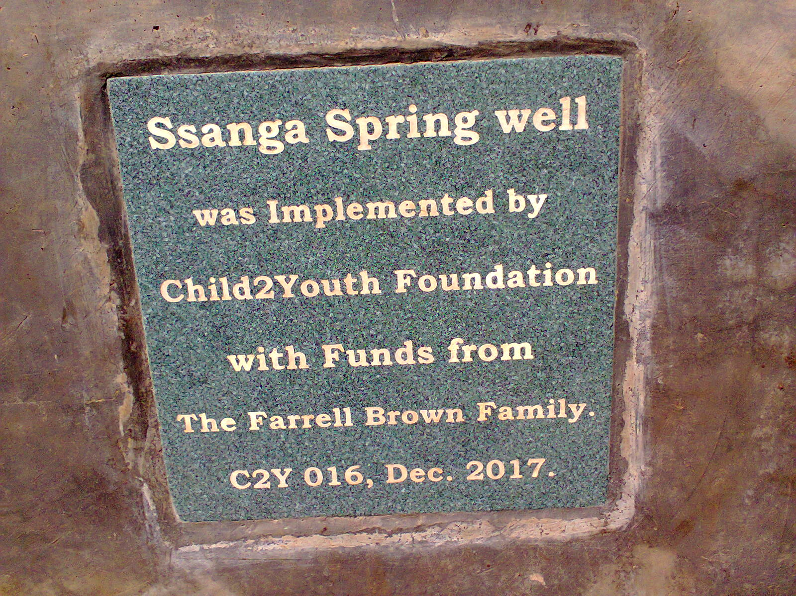
The plaque as it appears on the constructed Ssanga village water source.

