Proposal
BIG SMILE Indonesia

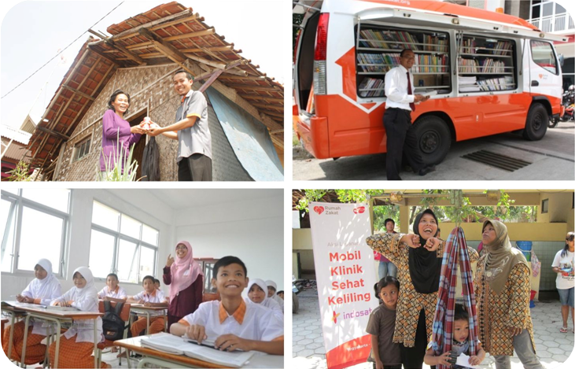

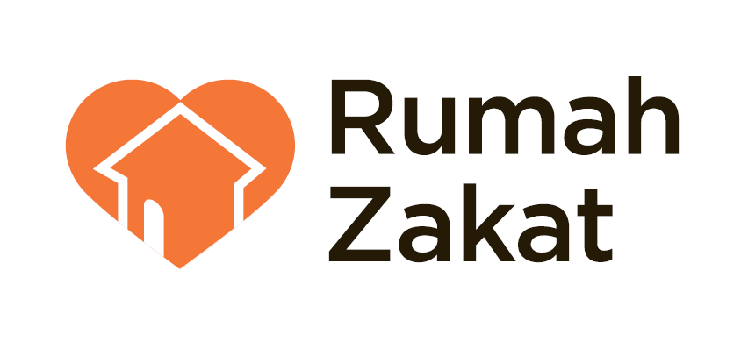
Jl. Turangga No.25C Bandung – Indonesia
Telp. +62 22 7332407 Fax. +62 22 7332478
Email welcome@rumahzakat.org I Website www.rumahzakat.org

LEGAL FORMAL

Rumah Zakat is National Institution of Amil Zakat, which having legitimation by the legal documents :

Notarial | : | DR. Wiratni Ahmadi, SH No. 31 Tgl 12 Juli 2001
Document of LAZNAS | : | 42 tahun 2007 (revisi)
Certification of Domicile | : | 05/DP/I/2006
Ministry of Law and Human Rights’ Decree | : | No. C-1490.HT.01.02.TH 2006
State Sheet of Indonesia | : | Tgl 22-08-2008 No. 68
Deed of Foundation Change | : | No. 01 Tgl 05-02-2010
Tax Identification Number | : | 02.083.957.7-424.000

CONTENT

1. | MILENNIUM DEVELOPMENT GOALS
2. | RUMAH ZAKAT PROGRAM CONTRIBUTION OF MDGS ACHIEVEMENT
3. | SYNERGY OPPORTUNITIES WITH MRS. SHAMEELA
4. | PROGRAM DESCRIPTIONS
5. | COOPERATION BENEFITs
6. | COOPERATION FLOW CHART
7. | CLOSURE
8. | ATTACHMENTS

1 | Milennium Development Goals
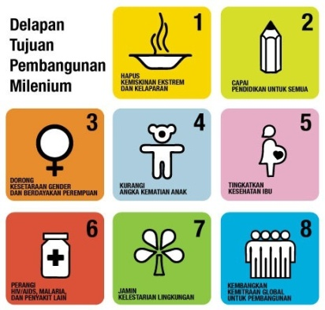
The Millennium Development Goals (MDGs) are eight international development goals that all 193 United Nations member states and at least 23 international organizations have agreed to achieve by the year 2015. The goals are:
- Eradicating extreme poverty,
- Achieving universal primary education,
- Promoting gender equality and empowering women
- Reducing child mortality rates,
- Improving maternal health,
- Combating HIV/AIDS, malaria, and other diseases,
- Ensuring environmental sustainability, and
- Developing a global partnership for development

On September of 2000, Indonesia Government attended the millennium summit in New York and signed the Millennium Declaration. The Signing of Declaration was a world leaders’ commitment reducing half of people starvation number, alleviating gender gap at all levels of education, ensuring all children to complete primary education, reducing 2/3 child mortality amount, and reducing half of people without access to clean water number by 2015.

Nowadays, the MDGs has become an important development reference of Indonesia, as listed in RPJM (Medium Term Development Plan) 2010-2014. However, to achieve the objectives of the MDGs requires solid cooperation of all, including public, private and donor institutions.

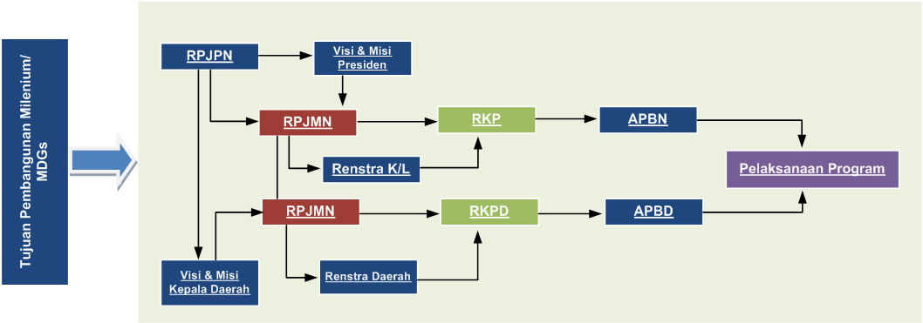
MDGs Integration in Development Plan Document

Beside of development planning, achievement acceleration of MGGs is also held by making the Presidential Direction no. 3 of 2010 about equity of development, that confirms :
- The need of road map to achieve the MDGs at the national level
- The making of action plan of MDGs acceleration achievement in local area
- The increasing of the funding for MDGs related programs
- The development of Innovative financing development schemes

However, all forms of strategic efforts that have been made by government to achieve MDGs targets, will be difficult to implemented without all stakeholders participation. not only from community as the focus of empowerment, but also from private and donor institutions. So that, the synergy between all entities will be able to accelerate the Indonesia achievement of Indonesia MDGs.

The Main Task in Achieving the MDGs

2 | Rumah Zakat Program Contribution of MDGs Achievement
Rumah Zakat as a philanthropy institution that makes the efforts to achieve the MDGs goals of Indonesia, tries to make the empowerment programs for integrated community development. The Rumah Zakat empowerment programs are integrated for an area, called ICD (Integrated Community Development), which have area scope equivalent as the district/village scope.

As the complement of our ‘Smile’ programs, which have been held through the series of ‘Entwining the Smile of Indonesia’ campaigns since 2010, now Rumah Zakat evolves with the new programs that included in BIG Smile of Indonesia campaign. BIG Smile of Indonesia is the theme that invite you to join the campaign to change the poor and needy to be more empowered, happy and then, smile. BIG Smile is the next step of our campaign ‘Entwining the Smile of Indonesia’.

By our four ‘Smile’ program categories, which are Senyum Mandiri (economic empowerment programs), Senyum Sehat (Health programs), Senyum Juara (education programs), Senyum Lestari (enviroment conservation). Rumah Zakat seeks to contribute for the achievement of MDGs in Indonesia.
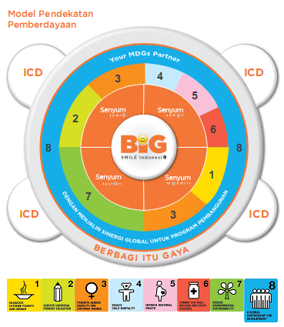
Synergy of Rumah Zakat ‘Smile’ programs categories in supporting MDGs achievement

3 | Synergy Opportunities With Mrs. Shameela

In the pursuit of the MDGs achievement in Indonesia, Rumah Zakat invites you to contribute in BIG Smile Indonesia programs. BIG Smile Indonesia is the program core from all the ‘Smile’ programs we had. The programs are : Senyum Mandiri (economic empowerment programs), Senyum Sehat (Health programs), Senyum Juara (education programs), Senyum Lestari (enviroment conservation)

The synergy of Mrs. Shameela with Rumah Zakat, becomes a contribution for the community health, education, and economic empowerment and improvement, especially for the needy and poor people.
4 | Deskripsi Program


Program Core : Education
Value Core : Giving the quality education and children life skill development, encouraging children to be empowered
No | Name of Program | Description | Amount of Donation  ($ 1 : Rp. 9180) | Specification
1 | Sekolah Juara  School of Champion | The program consist school set up, giving the free and qualified education for the needy and poor community. The school activities are designed compatible with the government standard. We use Multiple Intelligences learning approach, that enable the student to explore their potencies. | 2.200.000.000  $ 239.651 | Education facilities set up & operating cost for a year (for elementary school)
1 | Sekolah Juara  School of Champion |  | 2.650.000.000  $ 288.671 | Education facilities set up & operating cost for a year (for junior high school)
2 | Beasiswa Juara | The scholarship program for the student of Sekolah Juara, held by Rumah Zakat | 375.000  $ 41 | 1 elementary student of Sekolah Juara for a month
2 | Beasiswa Juara |  | 450.000  $ 50 | 1 junior high school student of Sekolah Juara for a month

3 | Gizi sang Juara | The Provision of the healthy food for the students of Sekolah Juara, held by Rumah Zakat. | 1.650.000  $ 180 | 150 elementary students of Sekolah Juara per day
3 | Gizi sang Juara |  | 825.000  $ 90 | 150 junior high school students of Sekolah Juara per day
4 | Lab Juara | The computer and language laboratory procurement program to support the quality learning activities, held by Sekolah Juara, by using the information and communication technology. So the school can produce, not only supreme graduation but also has technology skills, by the procurement of computer unit and also the internet network, supported by the qualified instructor. | 385.000.000  $ 41.939 | Laboratory set up & operating cost for a year
5 | Beasiswa Ceria | The scholarship with the frequent assistance program for the bright elementary, junior, senior high school, and college students from the poor and needy family. The donation commitment for this program is minimal a year for each student. | 155.000  $ 17 | 1 elementary student per month
5 | Beasiswa Ceria |  | 180.000  $ 20 | 1 junior high school student per month
5 | Beasiswa Ceria |  | 205.000  $ 22 | 1 member usia SMU per 1 bulan
5 | Beasiswa Ceria |  | 500.000  $ 54 | 1 college student per month
6 | Mobil Juara | The procurement of vehicle for learning media, which designed to be mobile and provide the attractive learning atmosphere. The program also consists of provision of book, audio visual media, and also online-connected computer unit. | 900.000.000  $ 98.039 | a Vehicle set-up & operating cost for a year

7 | Pusat Pengembangan Potensi Anak (P3A) | The children potencies development program, based on local potencies and the interest of the children in our ICD areas. We hope that the children will get the skills and certain competencies, which can promote them to be empowered. | 200.000  $ 22 | A child per month
7 | Pusat Pengembangan Potensi Anak (P3A) |  | 55.000.000  $ 5.991 | Development Center facilities set-up
8 | Kemah Juara  The Camp of Champion | The annual program of Rumah Zakat, which is the recreation and creativity event for the children from ‘Anak Juara’ (orphan children or children from the needy and poor family) and the students from ‘Sekolah Juara’ programs. | 450.000  $ 49 | A child from the Central Java & East Java.
8 | Kemah Juara  The Camp of Champion |  | 550.000  $ 60 | A child from the West Java, Jakarta, and Sumatra.
8 | Kemah Juara  The Camp of Champion |  | 650.000  $ 71 | A child from Papua, Sulawesi and Kalimantan.


Program Core : Community Health
Value Core : Accessible health services and the acceleration of healthy life style implementation in the community
No | Name of Program | Description | Amount of Donation  ($ 1 : Rp. 9180) | Specification
1 | AMARA  (Armada Sehat Keluarga) | The provision of health services, using special vehicle, that give the mobile service in our ICD area. The service is given according to the need priority in each area, by the promotive, preventive, curative and rehabilitative approach. | 1.525.000.000  $ 166.122 | A vehicle & operating cost for a year
1 | AMARA  (Armada Sehat Keluarga) |  | 915.000.000  $ 99.673 | Operating cost for a year
2 | Siaga Sehat | The health service program consists of health counseling, medical examination, and also free medication for the needy and poor people. | 5.500.000  $ 599 | The service for 100 patients
3 | Khitanan Massal | The circumcision service program for the needy and poor people. | 507.500  $ 55 | for one child
3 | Khitanan Massal |  | 25.385.000  $ 2.765 | For 50 children

4 | Siaga Gizi Balita | The baby nutrient enhancement which is indicated as the ‘red’ in the nutrition threshold of Baby Health Checking Card. | 720.000  $ 78 | A baby per month
4 | Siaga Gizi Balita |  | 100.000.000  $ 10.893 | 25 babies for 6 months
5 | Siaga Posyandu | A series of programs to improve the function and the performance of Posyandu in increasing the health rate of mother and child | 62.500.000  $ 6.808 | The facilities set-up and operating cost for a year
6 | Rumah Bersalin Sehat Keluarga (RB Sehat Keluarga) | The procurement of free health facility, consists of: maternity clinic and polyclinic, giving the basic health intervention service for mother and child, also for the needy and poor people. This program also provides the ambulance service for the patient and corpse. | 3.512.000.000  $ 382.571 | Health facility set up & operational fund for a year
7 | LBG  (Layanan Bersalin Gratis) | The health service program for mother, consists of: pregnancy examination, USG, dan maternity process. The program is not only being held in the Maternal House of Family Health (RBSK), but also being held by midwive, which has been appointed by us, within the ICD area. | 1.250.000  $ 136 | A program member in Java or Sumatra Region
7 | LBG  (Layanan Bersalin Gratis) |  | 1.550.000  $ 169 | A program member in Kalimantan, Sulawesi and Papua region
7 | LBG  (Layanan Bersalin Gratis) |  | 2.150.000  $ 234 | Lactation nutrition program (for 6 months)
8 | ARINA  (Ambulance Ringankan Duka) | The procurement of vehicle, that give the free ambulance service for the patient and corpse, for the needy and poor community | 465.000.000  $ 50.654 | APV type vehicle and operating cost for a year
8 | ARINA  (Ambulance Ringankan Duka) |  | 175.000.000  $ 19.063 | Operating cost of ambulance service for a year


Core Program: Economic Empowerment
Value core : The provision of facilities and support activities in developing business belongs to the community, which leads to the individual and community empowerment
No | Name of Program | Description | Amount of Donation  ($ 1 : Rp. 9180) | Specification
1 | Balai Bina Mandiri | The program consists of supporting facilities for community empowerment activities set-up, within the ICD area. | 168.500.000  $ 18.355 | The facility set up and operating cost for a year
2 | KUKMI  (Kelompok Usaha Kecil Mandiri) | The economic empowerment program based on community micro-business, that consists of capital investment and provision of supporting facilities. The investment is given based on business assessment. | 99.500.000  $ 10.839 | 10-20 member for investments and business assistance for a year
3 | Sarana Usaha Mandiri | The economic empowerment program, consists of the provision of supporting facilities for community business activities. The program is based on the feasibility assessment of the business. | 5.000.000  $ 545 | One member
4 | Pemberdayaan Ekonomi Berbasis Agro  Jenis Ternak:  - Domba  - Sapi | A community economic empowerment programs in livestock, with sheep and cattle fattening schemes. | Ternak Domba  400.000.000  Sheep breeding  $ 43.573 | 8 (eight) beneficiaries will get intervention programs, such as:  - livestock infrastructure set up  - capital investment and sheep fattening operating cost for 3 months  - business assistance
4 |  |  | Ternak Sapi  472.500.000  Cattle Breeding  $ 51.471 | 30 beneficiaries will get intervention program, such as:  - livestock infrastructure set up  - capital investment and cattle fattening operating cost for 3 months  - business assistance
5 | Pelatihan Skill Produktif | Youth productive skill capacity development program as an investment to become productive young entrepreneur. The focus of the program is local potency. | 100.000.000  $ 10.893 | Training program package and operating cost for 6 months

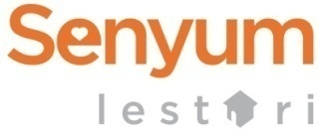
Program Core : Environment Conservation
Value core : Environment conservation oriented program and the disaster awareness
No | Nama Program | Deskripsi Program | Donasi | Satuan Program
1 | Kampung Lestari | Environment conservation program, based on the home/community empowerment, which consists of:  - The competencies skill upgrading of community representative  - Environment conservation oriented infrastructure subsidies  - Community hygiene facilities | 75.000.000  $ 8.170 | A program package and operating cost for a year
2 | Water Well | The provision of clean water and public sanitation in ICD area, to support the implementation of healthy life style in the community. | 62.000.000  $ 6.754 | An infrastructure set up package
3 | Siaga Gizi Nusantara  Varian Jenis:  - Tumis Jamur  - Sosis Ikan  - Sosis Ayam | Food package provision addressed not to the disaster victims and other critical condition, such as starvation. We use the EOE (Easy Open End) package to make distribution process easier and also to make it easy to consume.  Every donation for The Siaga Gizi Nusantara includes the production and distribution costs for the disaster areas and other locations with critical conditions, which are in a Rumah Zakat network office. | 92.500.000  $ 10.076 | 5000 packages (package for donator/corporate partners)
3 |  |  | 148.000  $ 16 | 8 packages (package for retail donator)
4 | Siaga Bencana  - Rescue Team  - Dapur Umum  - Trauma Healing | Rescue team is humanity program specialized for disaster condition handling, focusing on Emergency and Rescue | 85.000.000  $ 9.259 | A package and field operating cost
4 | Siaga Bencana  - Rescue Team  - Dapur Umum  - Trauma Healing | Disaster handling program, focusing on food provision with maximal capacity of 1000 packages/day | 175.000.000  $ 19.063 | A package and operating cost for 5 days
4 | Siaga Bencana  - Rescue Team  - Dapur Umum  - Trauma Healing | Trauma Healing is disaster handling alternative program, focusing on community psychological recovery as impact of the disaster | 50.000.000  $ 5.447 | A package and operating cost for a week

5 | Cooperation Benefits
By cooperating with RUmah Zakat through our programs, we hope that we can get the benefits as follows :

- Building up the good image of community solidarity, that can lead good relation with the surrounding community.

- Supporting BIG Smile Indonesia campaign which more integrated by your social donation support. It also supports the achievement of MDGs in Indonesia.

- Your community/Institution will get promotion space about the program, in Rumah Zakat’s media, such as:
- Logo-inserting and the news coverage in our website : www.rumahzakat.org
- Logo-inserting in our magazine ’Rumah Lentera’ for minimal donation Rp.50.000.000/$ 5.447 and the multiplication thereof.
- News coverage in ‘Rumah Lentera’ for 1/3 full color page for minimal donation Rp.150.000.000/$ 16.340
- News coverage in ‘Rumah Lentera’ for 1/2 full color page for minimal donation Rp.300.000.000/$ 32.680
- News coverage in ‘Rumah Lentera’ for full color page for minimal donation Rp.550.000.000/$ 59.913

- Program implementation report as the responsibilty for your social donation.

6 | Cooperation Flow Chart



The donation can be transferred to the bank account with recipient name: Rumah Zakat Indonesia as follows :

- BCA | 094 301 6001
- Mandiri | 132000 481 974 5
- Mandiri Syariah | 125 00155 55
- BNI Syariah | 155 555 5589
- Bank Muamalat | 101 00361 15
- Bank Mega Syariah | 1000000 270
- Bank DKI Syariah | 701 700 7000
- Bank Jabar Banten Syariah | 0000 3721 45999
- Permata Bank Syariah | 377 100 1555
- BTN Syariah | 702 100 1555
- Danamon Syariah | 789 588 08
- BRI Syariah | 1000 859 172
- OCBC NISP Syariah | 247 80000 9000
- Bank Bukopin Syariah | 880 1111 042
- BII Syariah | 2 700 005599
- CIMB NIAGA Syariah | 5200 100 131 005  502 0100020 002

7 | Closure

Thus we submit this proposal and we are looking forward for follow up discussion about our programs. We are very glad for the further discussion if you have any proposed program besides.
Thank you so much for your time and attention.

Bandung, March 31th 2012
Overseas & Internet Marketing Div Head
Rumah Zakat

Mariana Silvania Hazhirah
NIA. 1012003001019

Contact Person :
Dony Nur Rakhman
Hp | : | +62 8562010188
Alamat kantor | : | Jln. Mijil 18 Bandung Jawa Barat
e-mail | : | dony_nur@rumahzakat.org
Call Centre | : | 0804 100 1000
SMS Centre | : | 0815 7300 1555
Web | : | www.rumahzakat.org

8 | Attachements
BIG SMILE Indonesia Program Documentations
- Senyum Mandiri
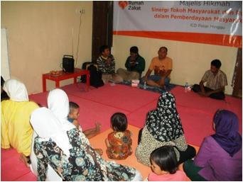 | 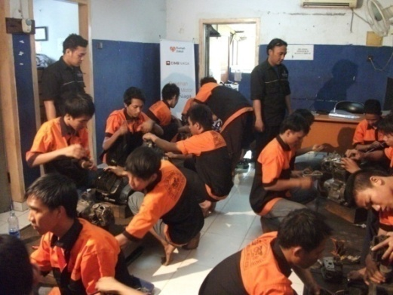
ICD Member Assistance in Balai Bina Mandiri | Automotive Productive Skill Training
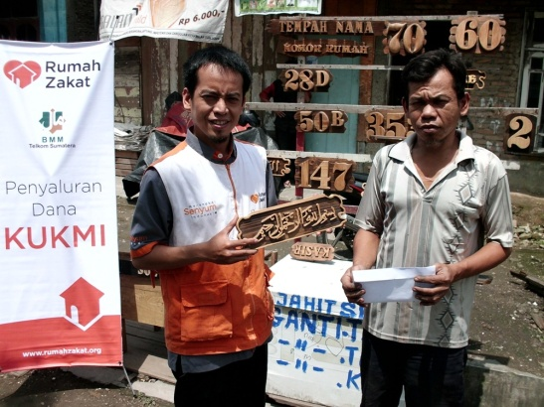 | 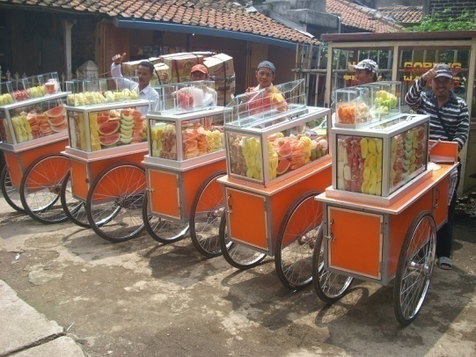
Rumah Zakat empowerment member | The beneficeries of business facilty aid
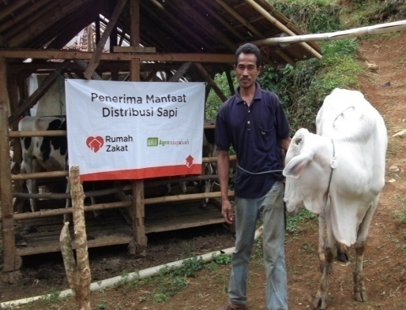 | 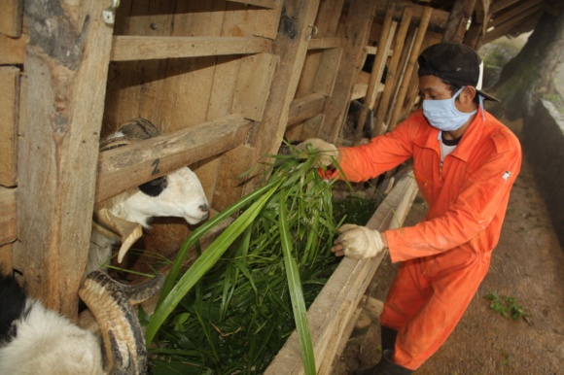
Cattle breeding-Agro based empowerment | Sheep breeding-Agro based empowerment

- Senyum Juara
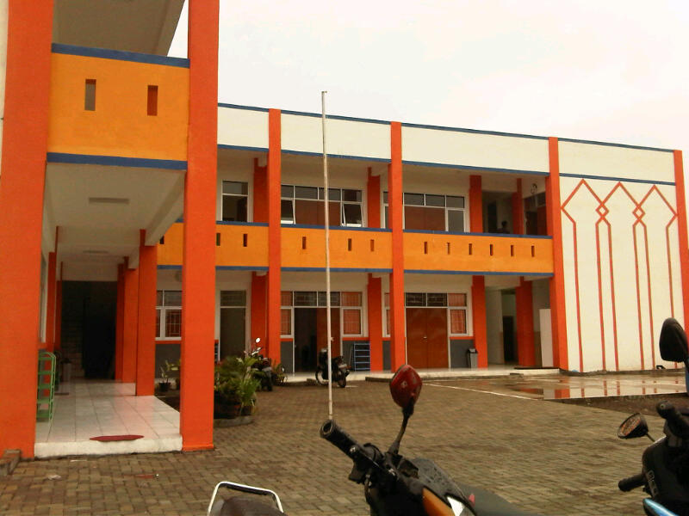 | 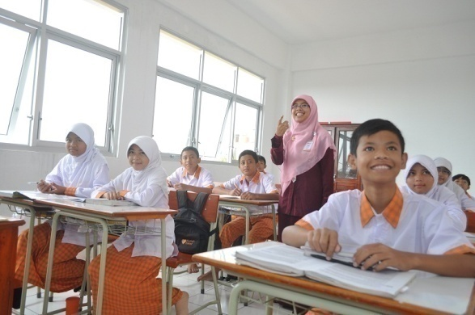
SMP Juara in Bandung (Junior high school) | The learning activities in Elementary Sekolah Juara
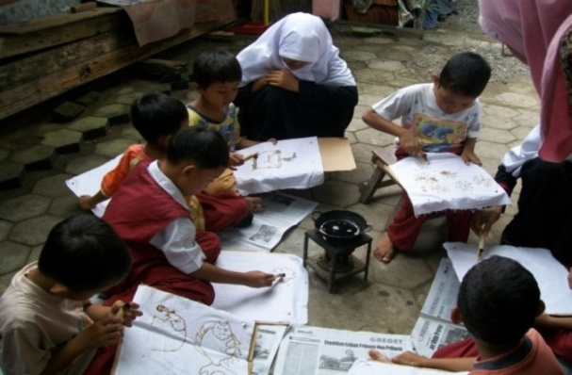 | 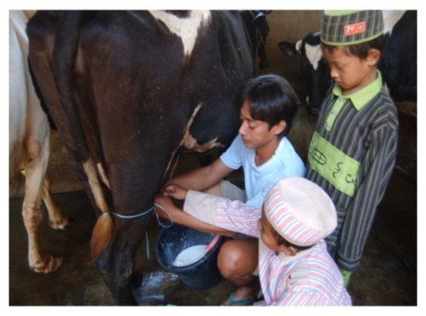
Anak Juara development in outdoor activities as the part of the non formal education activity in Beasiswa Juara Program
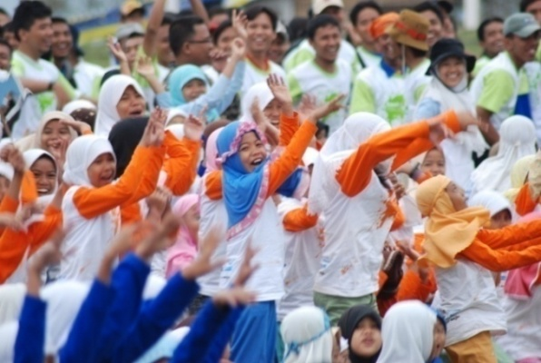 | 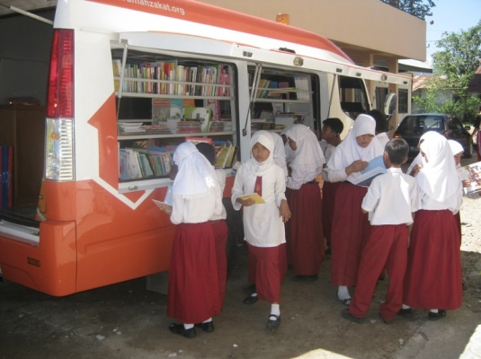
Kemah Juara activity | Mobil Juara

- Senyum Sehat
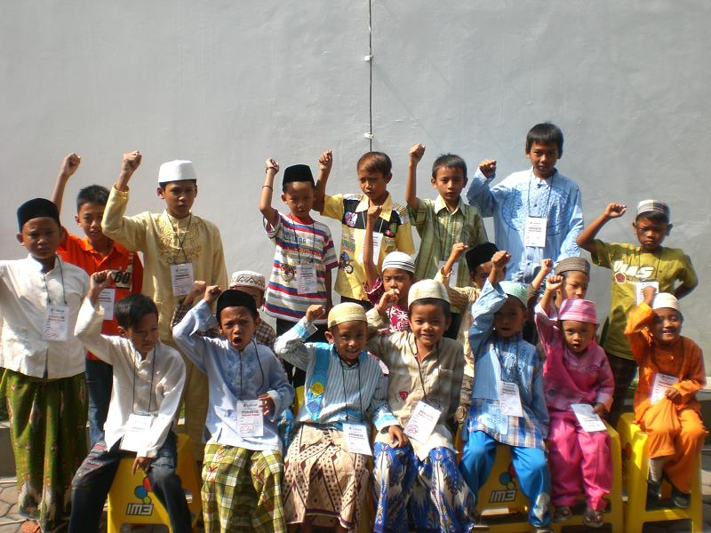 | 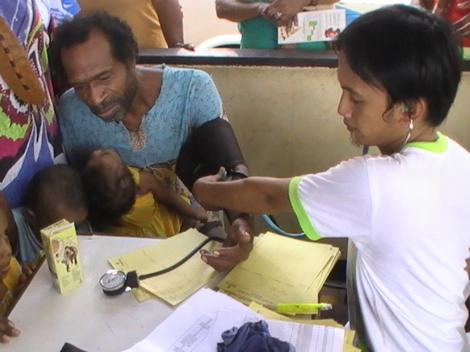
Mass Circumcision of program member | Siaga Sehat Program activity
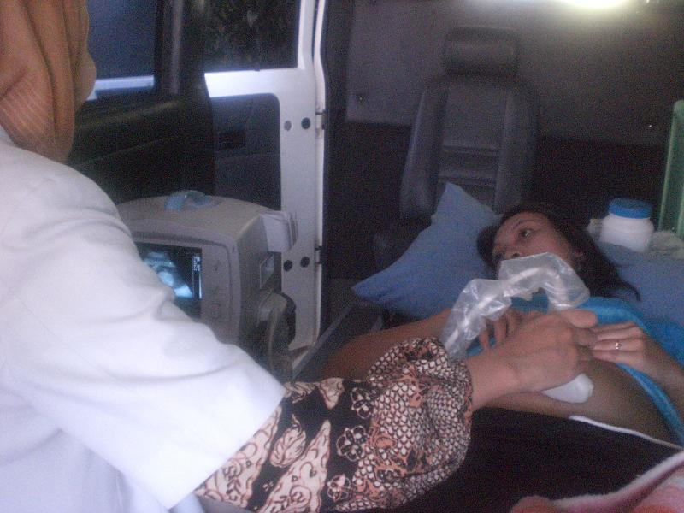 | 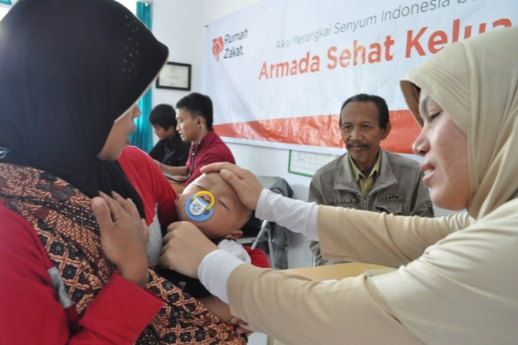
Free USG service for the member of Layanan Bersalin Gratis | Siaga Gizi Balita Program activity
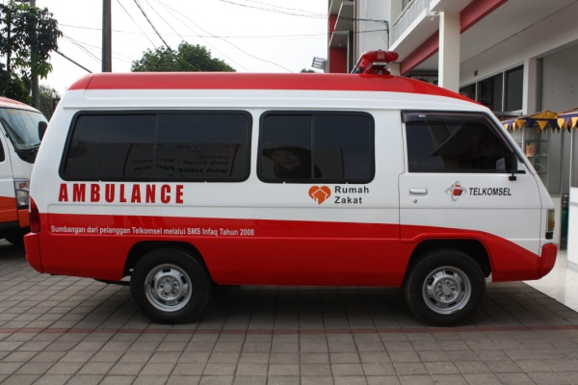 | 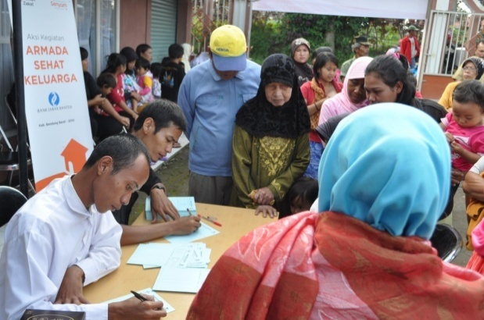
ARINA (Ambulans Ringankan Duka) | AMARA  (Armada Sehat Keluarga) activity

- Rumpun Program Senyum Lestari
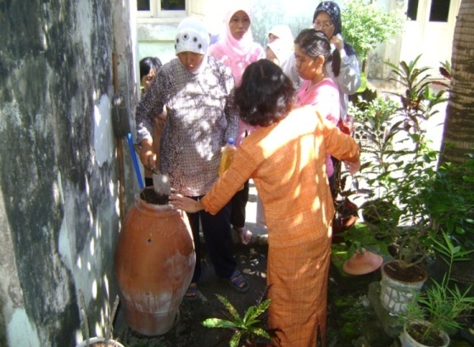 | 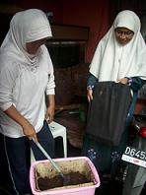
Garbage recyling process activity in Kampung Lestari Program
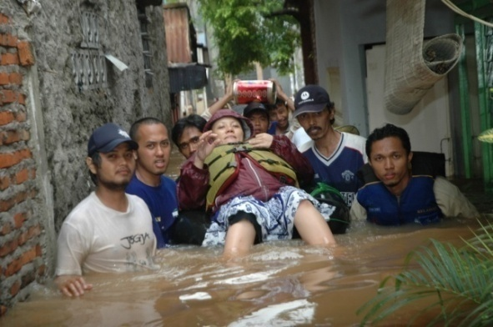 | 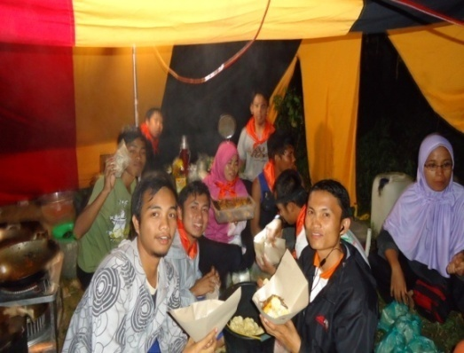
The Awareness of Disaster and public kitchen
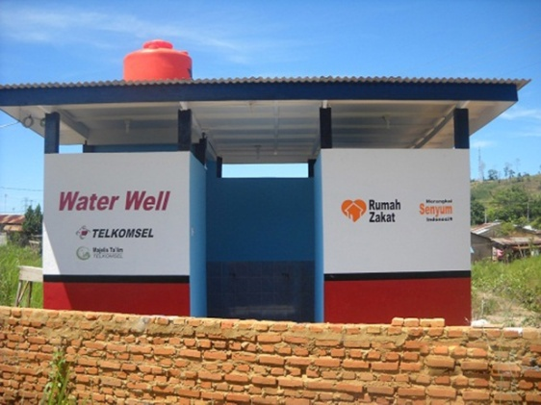 | 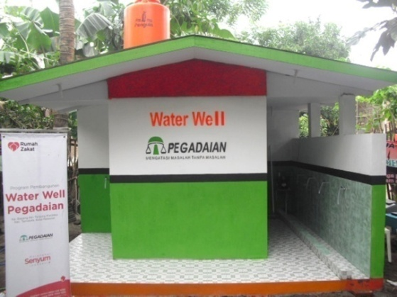
Water Well

