

**Special Consultative status with United Nations economic and social council: ECOSOC in 2013 and OSAA: Tax Exempted**

**Facebook page: fb.me/ongadet . twitter: @A12KLA24kou. Skype: ong.adet1**

**http://www.adetogo.ong**



**UN SDGs NGO Major Group : Amis Des Etrangers au Togo**

Autorization n°2810/MISD-SG-DAPSC-DSC of 10 Décembre 2004. Tax- exemption No 715/MPDA/ 2014

PO. BOX: 20123.

Lomé Togo.

**ELECTRIFICATION PROJECT FOR 25000 HOUSEHOLDS IN TOGO**

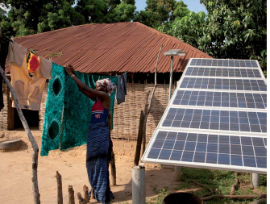

Total power to installe is 63,250 Mégawatts or

2,53kWc/ménage

**Project cost: $US 12,640,000**

***Duration: 20 years or 240 months***

Avenue Jean Paul II BP : 20123 Lomé- Togo Tel : (+228)22349806/92473495/99495859 [sossougadoss@yahoo.fr](mailto:sossougadoss@yahoo.fr)

1. CONTEXT

The socio-economic development of Togo, which has suffered the last decade of political upheavals and saw the performance of these different sectors especially energy deteriorate sharply. 2 million out of 7million only people are electrified.

Therefore ; Togo is severely handicapped to carry out the fight for sustainable human development: for lack of required infrastructure, the cost of electricity and petroleum products which is prohibitive, new and renewable energies that are not sufficiently implemented and especially the quality of service that does not meet the requirements of the economic world.

In the context of the liberalization of the electricity and hydrocarbon markets, the sharp rise in prices of petroleum products and the threat of supply disruption, there are questions of the viability and competitiveness of Togolese economy especially in the choice of energies and relative technological orientations as well as how to supply the country taking into account environmental concerns. So the only solution that can be considered is photovoltaic solar energy because Togo benefits from an average of 4, 4 kWh / m² of sunlight. In fact, photovoltaic solar power can supply community pumps (supply of drinking water), illuminate classrooms, health clinics, charge mobile phones, supply businesses, which can generate considerable revenues in the rural areas.

To achieve one of the millennium goals which is the reduction of poverty, the NGO Amis Des Etrangers au Togo abbreviated ADET proposes to make a study to feed solar photovoltaic households in Togo in the mediums as the penetration rate of these areas is 6%.

1. GOAL AND OBJECTIVE

In Togo, the overall rate of electrification of households in Togo at the end of 2009 varies between 15 and 25% with a probable estimated value of 32% by the World Bank in 2015.

In view of these data, the NGO: ADET sets itself the goal of electrifying 25,000 (twenty-five thousand) households in TOGO. Therefore this project will :

- in the long term, significantly reduce greenhouse gas emissions;

- in the medium term the development of these environments

- in the short term to generate jobs.

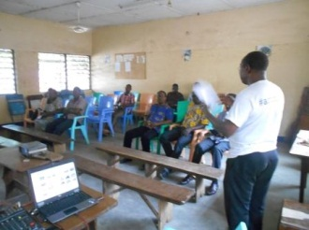 Power for all education 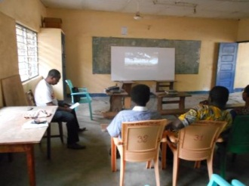

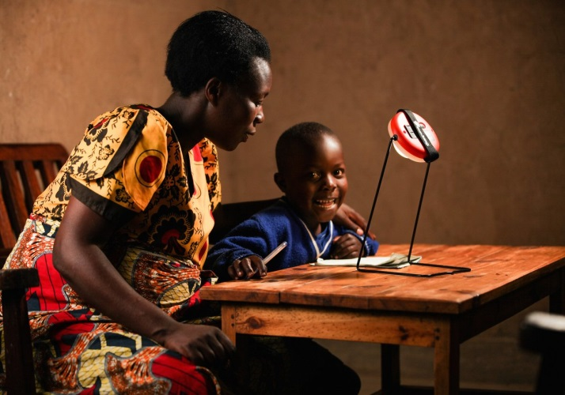 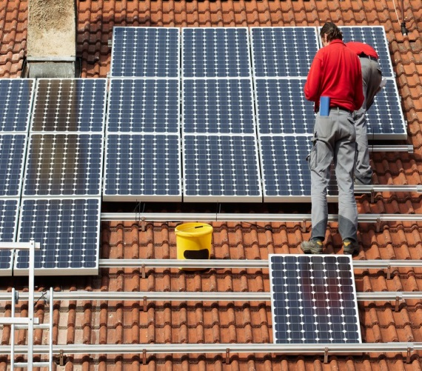

Child education facility Technician renewable power installation

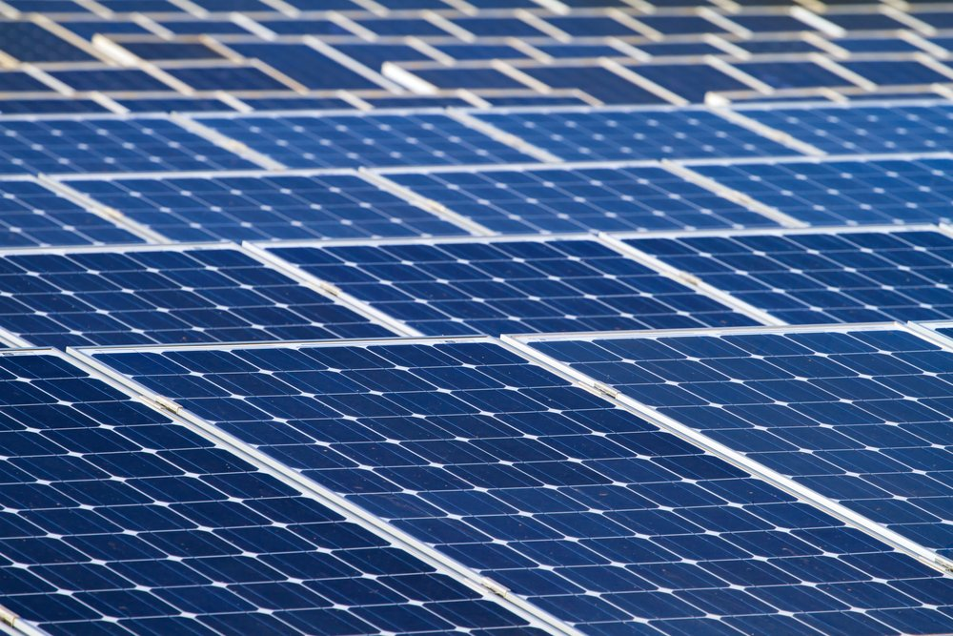

PV photovoltaics installation

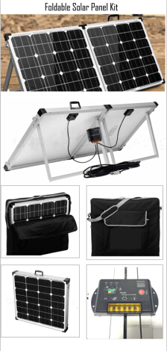 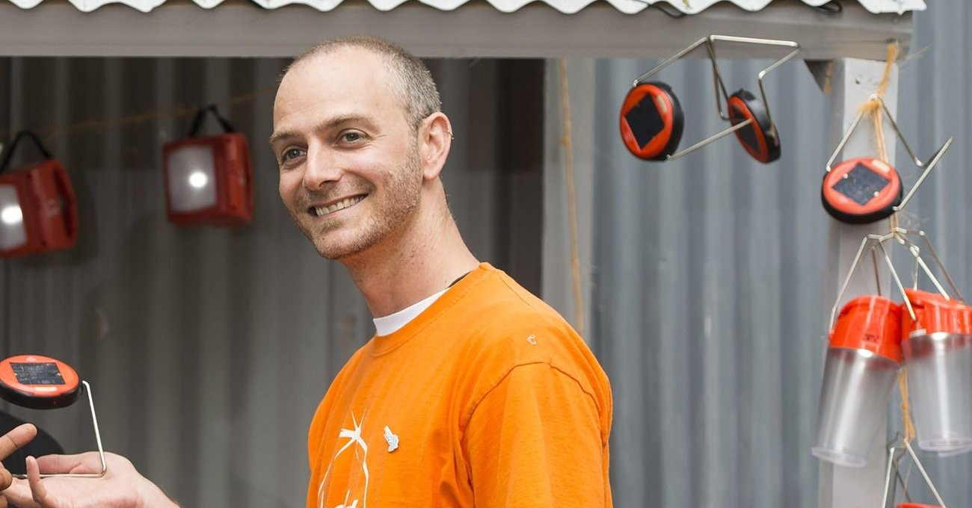

Solar lumps

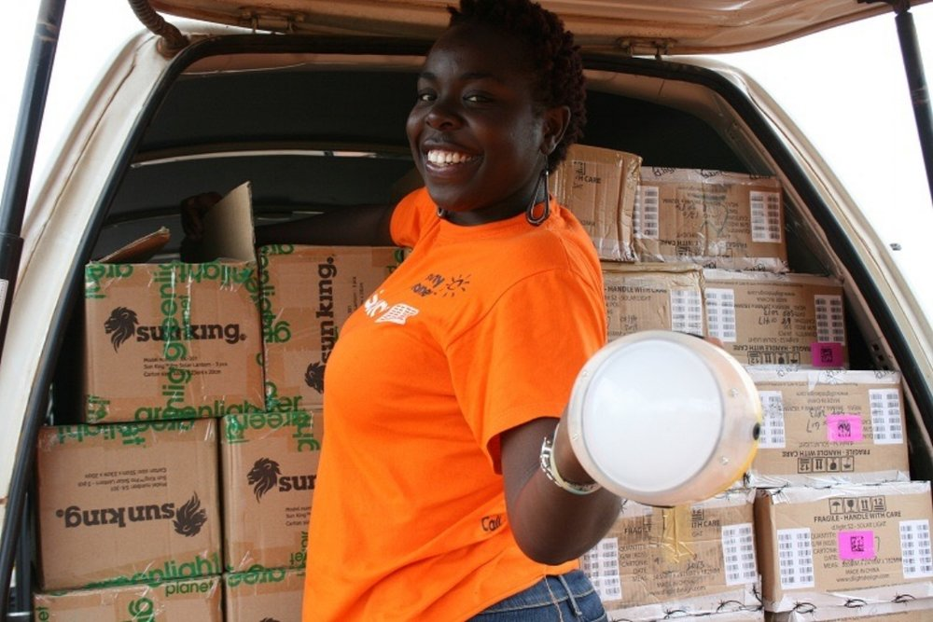

Solar lumps marketing and distribution

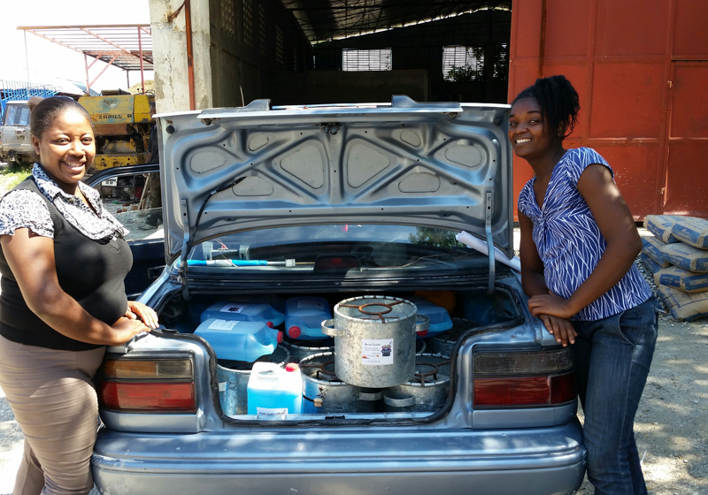 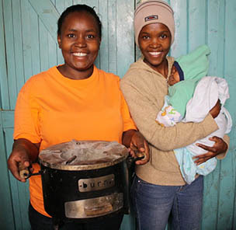

Happy women with Clean cookstove

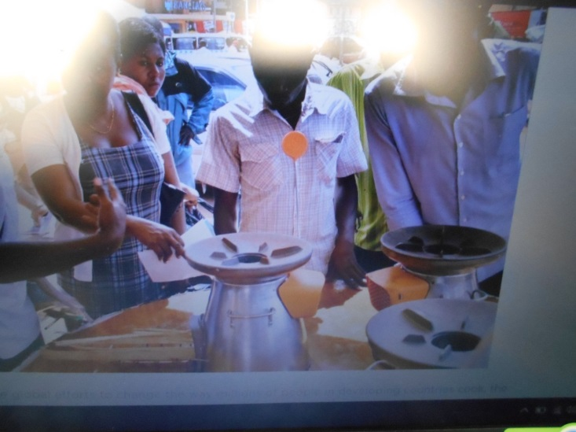 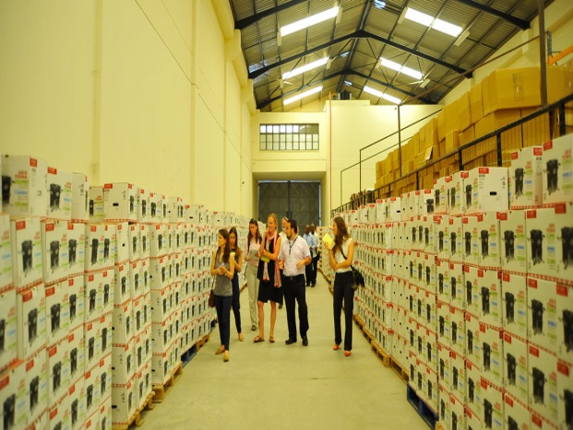

Clean cookstoves for climate change mitigation Cookstoves stocks for gender equalty

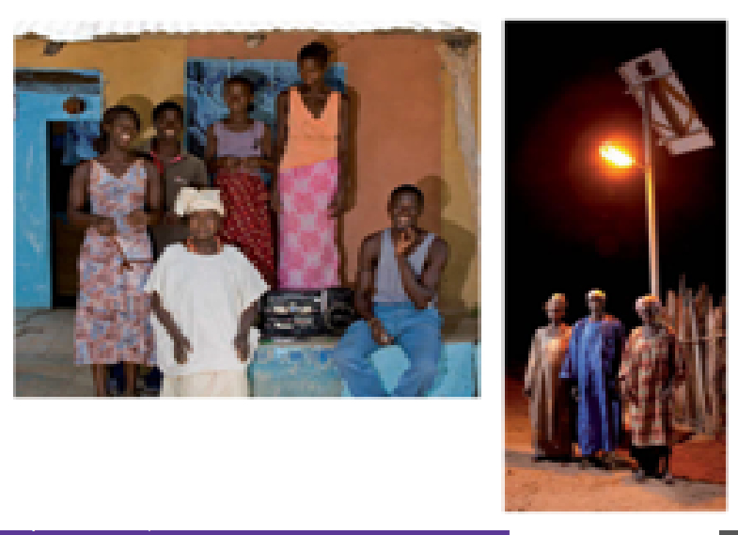

Social and security impact photos

1. STRATEGY AND LIST OF ACTIVITIES

The activities and strategies are summarized in the chart opposite:

|  |  |  |  |
| --- | --- | --- | --- |
| **N0** | **ACTIONS** | **Duration** | **STRATEGIES** |
| 5 th years  1 | Identification of beneficiaries and target groups | 6 months | Identification meetings with local authorities and financial partners |
| 2 | Awareness raising of beneficiaries | 3  Years | Community mobilizations |
| 3 | Technical and financial calls for proposals for development actors in the field of renewable energies; | 3 Years | Invitation to tender following the rules of transparency of  Markets. |
| 15th years  4 | Installation of solar equipment and kits in identified households | 6 Months | In the conduct of the project, a control office that will be chosen, will proceed:  -dimensioning of the installations;  -transport of solar and electric equipment;  -The break of appliances and equipment;  -the tests and measurement  -the final start-up. |
| 5 | Beneficiary training  maintenance of facilities  solar; | 2 Months | By service providers |
| 6 | Follow- up and evaluation | Every 4 years | Technical visits, verification of measurements and functionality of facilities inventory and  evaluation of installations with operational difficulties. |

1. EXPECTED RESULT

The expected results are that by the end of the project, more than 25,000 (twenty-five thousand) households of six people in the five regions of Togo will benefit from solar photovoltaic energy.

1. ESTIMATED BUDGET

Currently the estimated cost of a solar photovoltaic system for a household is US $ 4000 on average. This rise in solar photovoltaic prices is due to the non-exemption of customs duties and taxes.

In addition, the equipment is imported by traders who must honor their tax vis-à-vis the customs and tax authority. Indeed, to the question of why photovoltaic solar systems are expensive in Togo; a survey of 10 solar photovoltaic service providers revealed a problem with the non-exemption of the renewable energy tax.

The total cost of the project is estimated at:

|  |  |
| --- | --- |
|  | Cost 25000 households  (without subsidy) $ US |
| Facilities | $US 10,000,000 |
| Loads | $US 2,600,000 |
| Local contribution | $US 40,000 |
| TOTAL | $US 12,640,000 |

Funding for the program will come from different types of resources:

* The contribution of the Togolese State corresponding to the exemption from taxation (customs duties and VAT) will contribute 26% of the envelope ;
* The valuation of tonnes of carbon avoided will contribute 5% ;
* A 60% subsidy element will contribute, as in any rural electrification program, to cover part of the investment amount. It contributes to the economic and social profitability of the program. (Institutional Donors and Patrons) ;
* international investments for 10% with a profitability limited to 3% by local partners ;
* beneficiaries 2%.

1. Economic analysis

In rural electricity access projects, it is usual to conduct a 20-year economic analysis. This choice is related in particular to the lifespan of production equipment (20 to 30 years). The economic analysis also takes into account an actual discount rate of 5%, costs and revenues as well as depreciation and income taxes.

Therefore, based on cost and revenue estimates, it is possible to analyze the cash flows generated over 20 years and the profitability of the operation for a contractor who engages in infrastructure operations. The hypothesis adopted is to aim for a profitability rate of 10% over 20 years for the operator, which represents a significant return on investment. On the other hand international investors likely to support the operator (loan or capital contribution), the level of profitability is 6% for the said project with 1% annual interest to be paid to the lessor after 5 years of installation.

1. CHOICE OF TECHNOLOGIES

The developed equipments are: photovoltaic lighting, photovoltaic pumping, photovoltaic refrigeration, telecommunications whose isolated installations (BTS Indoor and Outdoor) are mainly powered by photovoltaic systems and modern and low-carbon stoves

The applications of solar lighting contribute to the development of rural electrification (domestic needs, lighting of health centers, literacy center and public areas) which improves the coverage rate of the country in electricity. The applications of solar pumping are village hydraulics (water for domestic use).

In Togo; the technology used in the various projects realized is polycrystalline coupled with lead acid accumulators.

1. STANDARDS

International standards for PV modules are IEC 61215 (crystalline cells) and IEC 61646 (amorphous cells). Modules that have been tested to these standards tend to last longer and produce more energy than those without certification. If a module meets international manufacturing and design standards, this should be clearly stated on the product. The certificate of a PV module can usually be verified by searching the product in online databases provided by certified organizations.

To do this, the technical direction of the NGO: ADET will identify suppliers manufacturing quality solar equipment adapted to African climatic conditions;

1. EXPERIENCES

From June 11 to December 10, 2012: Studies of profitable redeployment of the TOGO TELECOM solar workshops.

Mission:

* Presentation of the catalog of all the solar workshops installed on the various sites,
* Identification of components of solar workshops still functional,
* Presentation of the available solar energy potential and set aside in the Company.
* Proposal for sites on which solar sources could be deployed economically in a cost-effective manner, taking into account the operating costs of Generating Sets (GE).

« STUDY OF THE LIGHTING NETWORKS OUTSIDE OF TOGO TELECOM SEATING POWERED BY SOLAR PHOTOVOLTAIC »

2010-2011: Study design and realization of photovoltaic electrification of 10 households in Lomé.

From March 10 to November 10, 2009: Study and design of a software for the dimensioning of an electrical installation in solar energy for the account YIL Agence Afrique.

1. SOCIO-ECONOMIC AND ENVIRONMENTAL IMPACTS

* Social impacts

- At home, better lighting allows children to do their homework in good conditions.

- At home, electricity reduces domestic accidents unlike kerosene, gas, or candles, and prevents children from inhaling fumes from fuel.

- Public lighting promotes the fight against insecurity, in particular by reducing the number of flights. Security is also the benefit of electricity most often cited by the population.

- Electrification gives households access to information via radio or television. Home recharge of mobile phones facilitates their use and improves the links with the outside. Finally, cybercafés can be installed, opening the field of Internet use.

- Comfort, domestic resilience and living conditions are greatly improved, especially for women. Electricity alleviates the workload of household chores and contributes to gender promotion. It allows the development of domestic income-generating activities that can be carried out by women, such as market gardening, snacks, sewing ...

* Economic impacts

- The cost of services rendered (lighting, radio, television, etc.) by electricity of renewable origin is much lower than that of the use of kerosene, gas and batteries. The energy bill of a household is reduced by about more than 20%.

- Domestic, commercial and craft activities can be continued after dark by lighting. The quality of the work, the products manufactured and the services are improved and the security is reinforced.

- Electrification creates local jobs, whether for the installation of equipment, but also for their operation and management. Technicians are responsible for the maintenance of the electrical systems and the staff collects the royalties and manages the customers, an accountant establishes the invoices and ensures the good management of the funds. Finally, a manager must lead the team and ensure relations with other stakeholders.

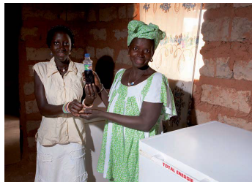 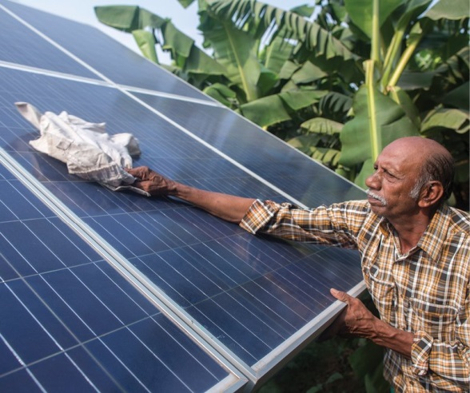

* Environmental impacts

In fragile ecosystems, the use of local sources of renewable energy to replace fossil fuels reduces pollution from batteries and the transport and use of oil. The emission of 250 tonnes of CO2 is avoided during the first 20 years of operation of electrical systems and promote community resilience.

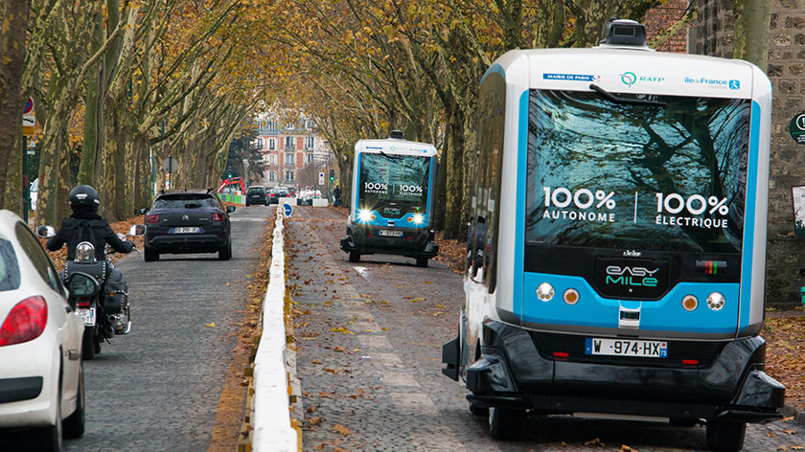

Secondary income generating activities

- Promoting the transfer of technology by importing products from countries as follows: USA, China, India, Sweden, Italy, France, Thailand, Indonesia, Philippines, Australia, Great Britain, Canada, Rwanda, Kenya, Egypt, Uganda, Tanzania, Morocco, Denmark etc ... some of which are: All Power Labs Italy, Alsa Solar Systems Ltd., Althelia Climate Fund , Ankur Scientific Energy Technologies, Antenna Technologies Foundation, AORA Solar, Asantys Systems, Aquanovis, Ausar Energy, Autarsys, Backwoods Solar Electric Systems, Benoolend, Becquerel Institute, Bergey, Best Brands Inc., Bornay, Capta Hydro, cdw Stiftungsverbund gGmbH, Clear Resource, CosmoSol, Customized Energy Solutions India, DEG, Generaciones Fotovoltaica de la Mancha GERES, General Electric India, Gigawatt Global Off-grid, Gildemeister energy storage, GRID - Grassroots and Rural Innovative Grid Alternatives Development, Green Housing and Energy, GSE, Hotspot Network, Humanist Institute for Co-operation with Developing Countries (Hivos), HOMSOL, HT Energy, Technolectric, The August Company; Tiger Power, Trama TecnoAmbiental (TTA), Trine, Trojan Battery, Turbolent, Turiani Hydro Power, Uni of Southampton, Kingspan, LED Safari, LDK Engineering Consultants, Ludewa Clean Energy, Light of the World, M-Power, MARGE, Martifer Solar SA , Masar BV, Mlinda Charitable Trust, Mobisol, MSS Mola Solar Systems, Multi Power Source, MWH, NECRA International, Nizam Bijli, Novatron, NRG Solutions, Odyessey Energy Solutions, Australia Off-Grid Energy, FOSERA, GOGLA, SELCO, ICE etc. ....

- Promotion of local commerce and business, marketing, insurance, repairs, maintenance, ... ..

**ANNEXE**

|  |  |
| --- | --- |
| Geographical situation of the Project | Village of Ponio, koussoumtou, Yégué, ountivou, Touhoun, Hlandé, Avévé, Sivamé, Azimé,Adamé, Atissokodji, |
| Postulant organisation | NGO: Amis des Etrangers au Togo: ADET |
| Person in charge | BEWELI Wiyao B. |
| Total amount | twelve millions six hundred and forty thousands Dollars  12,640,000 Dollars US |
| NGO ADET participation | 40,000 dollars US |
| Amount researching | 12,600,000 dollars US |
| Duration of project | 20 year or 240 months |
| Expected date of starting | 07/01/ 2019 |
| Date of the project elaboration | December, 2013 |

