BACKGROUND OF EPHA:
ENVIRONMENTAL PROTECTION AND HUMANITARIAN AGENCY.
E P H A
E P H A
P.O. Box 107, Kigoma—Tanzania
Tel: +255 28 280 3042, Fax: +255 28 280 3043
Email: ephatz@yahoo.com
ENVIRONMENTAL PROTECTION & HUMANITARIAN AGENCY

The Environmental Protection and Humanitarian Agency (EPHA) is an Organization founded on 8th June, 2007 and registered under The Non Governmental Registration Act, 2002 with Registration No. OONGO/1414.

FOCUS / VISION:
- To foster confidence 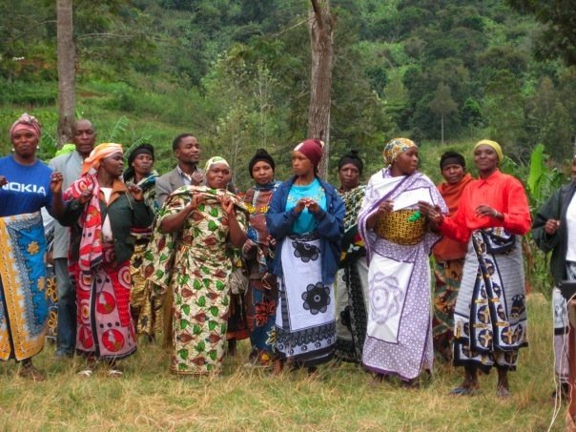in female gender to become independent economically, socially and politically.
- To provide a vehicle for low income communities through local and international partnership 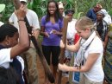
- To create an outlet to pupils/students clubs for their voice to be heard on ssues that are important for them.
- To empower women on sustainable economic livelihood initiative projects, to fight against hunger, disease,  and ignorance.
- Recreational sports and youth reshaping projects.
- Environmental Protection Club (EPC) through 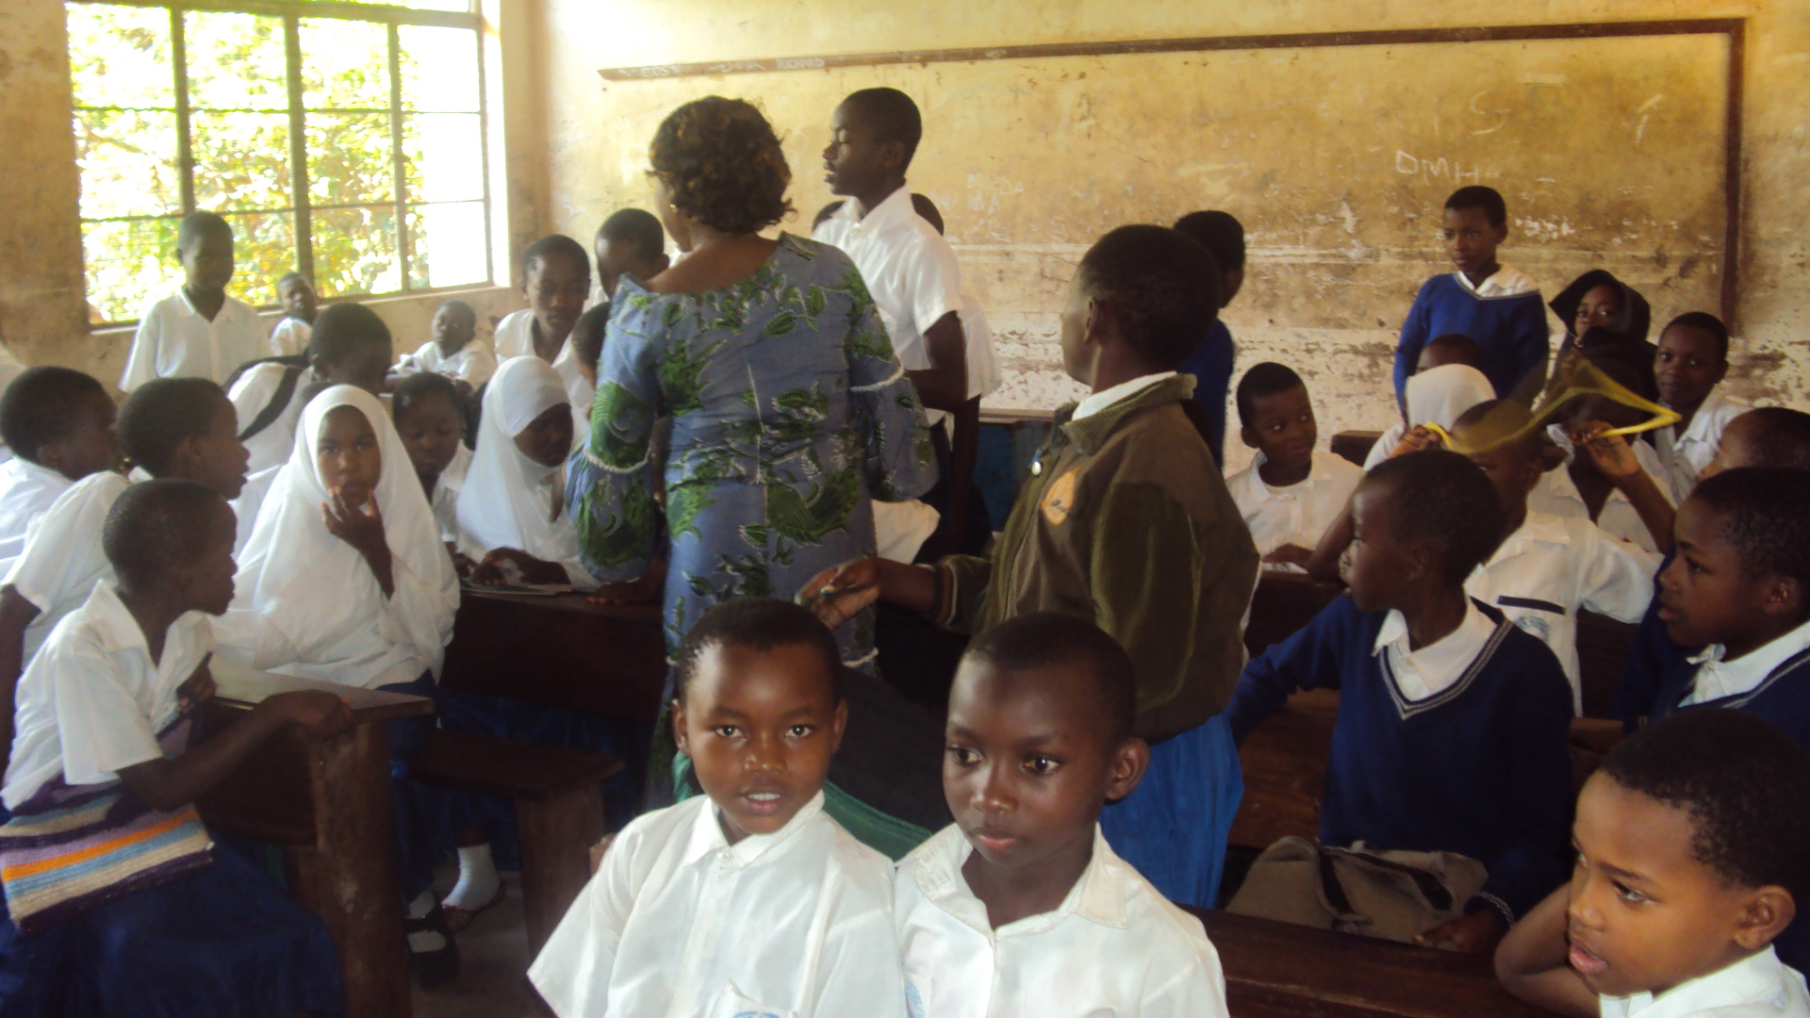students/pupils initiatives
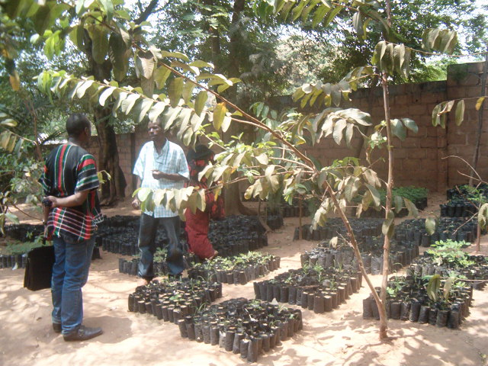

- To develop women health projects and training to their human rights
- To create an opportunity for international volunteers to 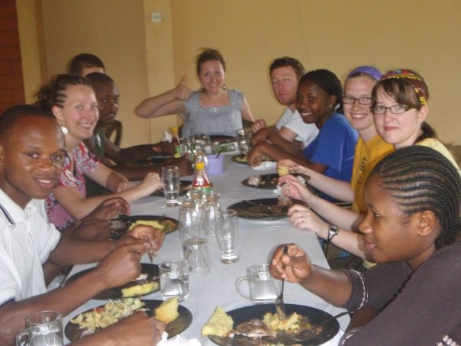serve our marginalized communities


Mission:
Our mission is to promote and support environmental conservation and livelihood with a gender and participatory approach through advocacy, capacity building and action research. We also aim at supporting sustainable and regenerative programs that have measurable outcomes and replicable models with beneficial results to reduce poverty, improve human right and health.

Why are our initiatives important?

EPHA believes that “ There is a simple way to help our proor female and other related beneficiaries community; Many of the World’s economies: invest in the education of female gender …” (Nike CEO, Head of UNICEF and Melinda Gates agreed).
By providing female gender with education and other economic, social – based supportive opportunities there is a very direct connection to shaping the post – crisis world in many ways because they will then help transform their families, their villages and ultimately their country since women are the mass force of the country economic back born.

Smart economics

“More than two decades of the research has shown that investing in women is smart economies economics…”-Ngozi Okonjo- Iweala, Managing Director of the World Bank

How do our initiatives work?

Since its establishment, EPHA (a women led organization) is running Environmental conservation project, eco-Tourism and Human rights programs which focuses on the convention on the elimination of All Forms of Discrimination against Women (CEDAW), The Declaration of Violance Against Women (DEVAW) and the Convention of Children Rights (CCR) , Positive norms and customs to protect these most vulnerable.

The organization expands and develops those activities in six major sartorial orientations such as;
- Female education support
- Women and girls Income Generating Projects
- Sustainable Agriculture and livestock
- Legal Aid and Services
- Huamn rights & human health
- Students and Pupils –Club (EPC)

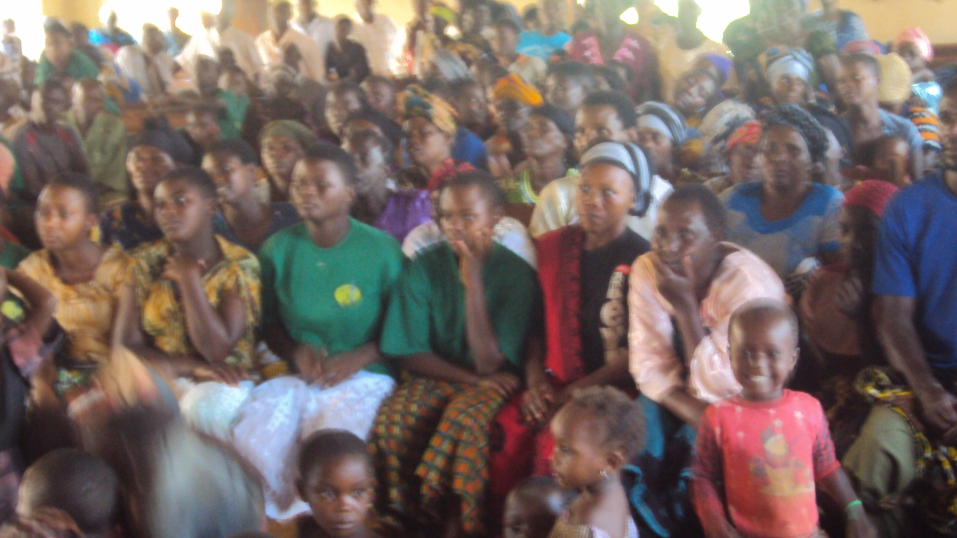
EPHA Women human rights Education and Protection campaign Project in Kigoma rural area- Tanzania.

