- Title of the Project :Accessing Drinking Water to Tribal’s and dalithes
in 3 Villages of Varikuntapadu Mandal.
2 Objectives :
1. To Access Safe Drinking Water to theTribal & Dalit Communities.
2. To create and build socio-economic Awareness among the Rural community on Water and Sanitation.
3.To improve the health conditions and the educational opportunities of 5,500 people of varikuntapadu mandal SPSR Nellore district
4 To educate and build socioeconomic Awareness and Access Health Education.

3 Name & Address of Account: REAL IMPROVEMENT GROSS ROOT
Holder HUMAN TRIBE SOCIETY (RIGHTS)

4 BACKGROUND INFORMAION:The proposed project is to be located in Varikuntapadu Mandal . It falls under the jurisdiction of Nellore Dist., of A.P. Varikuntapadu is one of the Mandals of Nellore Dist. Varikuntapadu Mandal has 24 Revenue Villages with 28 hamlets. The Mandal jurisdiction is spread out in an area of 350 Sq.Kms. The total population of this Mandal is 29,980 of which scheduled castes consists 12,900 and scheduled tribes 4,500. While the rest of the population are the other backward classes and forward castes. However these two are the vulnerable sections in the villages who often deprived of several amenities. Agriculture is the main occupation of people. When the tanks and water canals dry up. We have only to rely on bore-wells for irrigation and of short-term cultivation such as Vegetables, flowers, green leaves and the like.When underground water goes down, then even the bores dry up and thus the agricultural operations come to a stand still. The target communities of this project are scheduled caste, scheduled tribes and the backward classes of these societies who are mainly either the agriculture labourers or tenant farmers or marginal farmers having small land holdings, in any case not exceeding 3 acres.Since agriculture is absolutely a rain based and people are vulnerable and they do not find employment throughout the year. In such cases people usually migrate from one area to the other in search of employment. This problem of exodus also has a great negative impact on education of their children. The daily earnings from Agriculture are meager because the employment opportunities are less as the labourers are more. In any case the average income of a labourers does not exceed more than Rs.20/- per day. This situation also is one of the main reasons for the backwardness of the children in the field of education.
5. Who will be helped by this support ? dalith and Tribal Women suffering with drinking water.

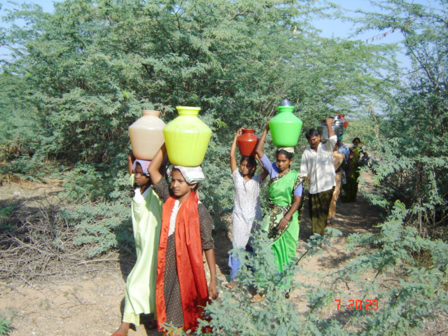
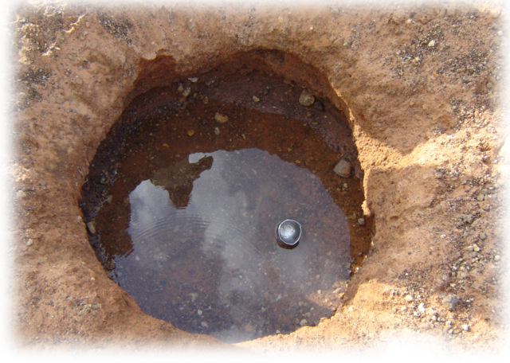

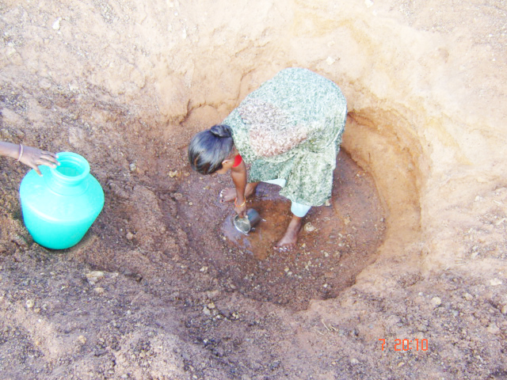

Picture view of suffering for Drinking Water
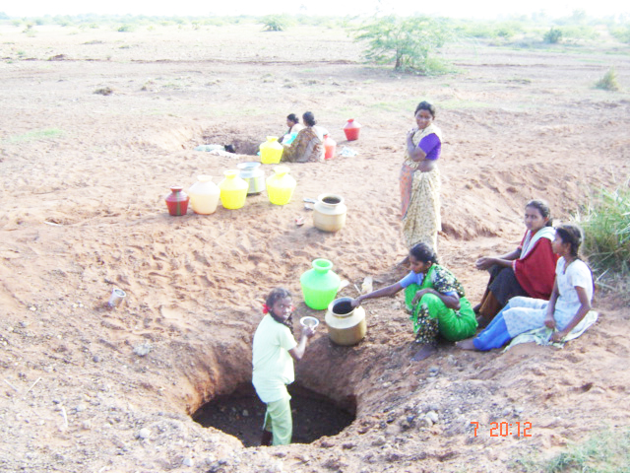

6. Geographic Region Served : South Asia, India, Andhra Pradesh, SPSR Nellore District, Varikuntapadu Mandal. ,1)vempadu,2) vengamambapuram, 3)asokenagare,

7. Amount of Request : $ 6,750 USD ( cost of drilling of 3 bore-wells at250ft. depth and cost of 3 motor and pipes and fittings

8. How will Funds Be Used? : The above pictures will explain the need of safe drinking water to the poor tribal community in Varikuntapadu Mandal of Nellore District, Andhra Pradesh, India, South Asia, for getting a pot of drinking water. People will go more than ½ kilometer, even with that distance. They are not getting safe drinking water. They will get drinking water with mud. Hence RIGHTS proposed to drill borewell and hand pump / Electrical motor to supply water to the poorest of the poor.
9 SITUATION OF WATER ANS SANITATION IN DEVELOPEING CONTREY LIKE INDIA: Almost fifty per cent of the developing world’s population – 2.5 billion people – lack improved sanitation facilities, and over 884 million people still use unsafe drinking water sources. Inadequate access to safe water and sanitation services, coupled with poor hygiene practices, kills and sickens thousands of children every day, and leads to impoverishment and diminished opportunities for thousands more. Poor sanitation, water and hygiene have many other serious repercussions. Children – and particularly girls – are denied their right to education because their schools lack private and decent sanitation facilities. Women are forced to spend large parts of their day fetching water. Poor farmers and wage earners are less productive due to illness, health systems are overwhelmed and national economies suffer. Without water, sanitation and hygiene, sustainable development is impossible.
10. Project Strategies : Demand driven and participatory approach., Focusing on areas which do not have serious water quality and quantity problems. Focusing on rehabilitation or augmentation of existing water supply systems. Generous sanitation subsidies. Cost sharing by the community.
11 SPECIAL FETURES OF THE PROPOSAL : The Project tries to create sustainable community managed water supply in rural villages. The focus is on rehabilitation of defunct and augmentation of inadequate installations. By giving training in bore well rapier mechanism The emphasis is put on management rather than on the implementation of water supply installations. Therefore, two districts which do not have serious quality and quantity problems were chosen. Many villages are getting improved water supply through the Project but the main achievement will be the implementation and management models that the Project develops.
12. Number of People Helped by this Support: Around 2150 deletes Tribal families in 3 hamlets consists of 2200 members for each hamlet will benefited by this support. And also all villages in varikuntapadu mandal by rehabilitation of defunct and augmentation of inadequate installations
13 Expected results:
1. Improved access to safe drinking water
2. Improved sanitation conditions
3. Strengthened ability of the community to manage and
maintain its water supply systems and sanitation facilities
4. Improved hygiene practices among the community and school students
5. Primary schools in rural areas physically improved and equipped
6. Students and teachers supported with school kits and training programs

Main Activities:

Water: The aim is to provide access to 45 liter of water per day per person. The design process is participatory in approach, directly involving the beneficiaries. Organizing of a trained working team, selected from among the local population, in charge of creating the new facilities and maintaining them in the future. The participation of the population is on a voluntary basis and represents an in-kind contribution to the project implementation. Construction of water supply systems. Following the standards required for similar projects in INDIA one public standpipe for every eight households is planned. Technical advice is provided by the staff of the local partner and the DDC (District Development Committee) technicians, in accordance with the technical designs of DONER experts. The community’s sense of ownership is being strongly developed by the direct involvement of the beneficiaries in the construction activities.

Sanitation: Planning of sanitation systems based on the target of one toilet for each household. In consultation with donor agency and RIGHTSNGO technicians, the beneficiary families, and in particular the women, participate in the selection of the site for each latrine in order to avoid contamination of the
water sources. Organizing of training sessions addressed to the beneficiary population on suitable methods for upgrading, constructing and maintaining the toilets. Construction of 350 toilets. The project proposes three types of economically and ecologically sustainable and culturally acceptable systems that aim to complete the natural nutrient and water cycle: EcoSan, Sulav and Biogas. The project offers a new philosophy for dealing with what is presently regarded as waste and wastewater. Each solution is discussed with clusters of 20 beneficiaries. During this activity the beneficiaries are informed about the characteristics and construction methods of the different systems.
Community ownership: Creation of a Ward Maintenance Fund through a minimal charge to the population for the construction of the water supply systems and sanitation facilities.Creation of Water User and Sanitation Committees (WUSC). To ensure a strongly participatory approach and shared project coordination, a WSUC composed of members of the beneficiary communities is set up. To reinforce the role of women in the decision-making processes, their presence in committees must not be less than 40% of the total.
Hygiene Promotion: General assessment of hygiene and sanitation behaviour and practices. Organization of awareness campaigns for the beneficiary population on: (a) proper management of the water sources, (b) drinking water use and storage, (c) purification systems, (d) garbage disposal and environmental hygiene,(e) personal hygiene and sanitation issues. Operationally, the campaign selects key hygiene promotion personnel from among the more motivated people within each ward. The approach follows the PHAST (Participatory Hygiene and Sanitation Transformation) principles regarding direct participation of individuals, and in particular women, in group processes. School Sanitation and Health Education Campaigns (SSHE) target rural schools, involving students in establishing a safe school environment.
Development and distribution of Information, Education and Communication (IEC) materials (flip charts, leaflets, posters, etc.) to beneficiary families, local schools, community centres, health posts, etc. Distribution of Hygiene Kits (soap, toothbrushes, wash basins, etc.) to students to facilitate behavioural changes in hygiene practices.

14 BANKING DETAILS
Bank Name : UNITED COMMERCIAL BANK (UCO BANK)
Bank Address : UCO Bank, Brundavanam, Nellore-524 002
Andhra Pradesh, India
Name of Account: R I G H T S
Account Number : 10450100002127
RTGS Number : UCBA 0001045,
SWIFT Number : UCBAIN BB338,

15.ESTIMATION FOR ONE YEAR:

Sl.  No. | Description of item | Amount  INDIAN Rs.
1. | Drilling of Bore well @ 250 feet x Rs.100/- x 3 bores | 75,000-00
2. | Cost of Casing pipe @ 40 Feet x Rs. 100/- x 3 bores | 12,000-00
3. | Cost of pipes for Bore well @ Rs. 1000/- x 15 pipes x 3 bores | 75,000-00
4. | Cost of Motor with starter @ Rs. 46,000/- x 3 | 1,38,000-00
5. | Cost of Electrical connection@ Rs. 10,000/- x3  ( beneficiary contribution ) | 30,000-00
6. | Salary to the project Coordinator@Rs2500x6(organization contribution) | 15,000.00
7 | Audit and evaluation charges | 5,000-00
8 | Training on bore well mechanisms and motored mechanisms@ Rs 250x6 months x30 members | 45,000-00
 | Total | 3,95,000-00
 | Less: Local Contribution 10% | 39,500-00
 | Amount Requested | 3,55,500-00
 | Amount Requested in usd | $ 6,750 USD
CONCLUSION: We place this request, with great confidence and have hope for your kind and speedy consideration. Our Experience in villages working as social activists has prompted us to start such safe drinking water accessing. Because the co-operation and unity among the target people in our villages have given us a hope, confidence and plan of action to change the situation for better. I once again, humbly beseech your good will and generosity to consider our case sympathetically and sanction the same at your earliest.
Thanking you sir, with warm regards.
Yours faithfully,
(T.JAYAPAUL)
To,

Respected Sir,

Greetings from RIGHTS, Varikuntapadu of SPSR Nellore District, A.P.

Sub:- Submission of Project Proposal to access Safe Drinking Water to
the under privileged Daliths & Tribal people – Reg.

* * *
Hear we are submitting proposal to access Safe Drinking Water to under privileged Dalith & Tribal Communities who are suffering to get both drinking water & irrigation water. They are collecting mud-mixed water in dry River banks (chelimalu). The pictures enclosed in the project clearly explain the situation. They carry water from more than 1 KM. Even a old women also carrying water with a great difficulty. Due to lake of access their lands also became barren lands. The village people elected Sarpanch (Village head) requested RIGHTS NGO to access drinking water to the Daliths & tribal and also to their fields. We discussed the same with the beneficiary group and prepared this proposal. They proposed to drill 3 bore wells in 3 Dalith & Tribal hamlets and install electric motor. There by the people will get safe drinking water. The cost of the project is € 4780 EUROS = $ 6,750 USD
Please go through our proposal and support us to access safe drinking water to the Dalith & Tribal’s in Varikuntapadu Mandal of SPSR Nellore District, Andhra Pradesh, India.

Awaiting for your compassionate reply and support.
Thanking you, Sir.

Yours faithfully,
Encl :
Project Proposal. (T.JAYAPAUL)

