
AFORD

ACTION FOR RESEARCH AND DEVELOPMENT

...touching and transforming lives

Orphan Sponsorship
Welcome Packet

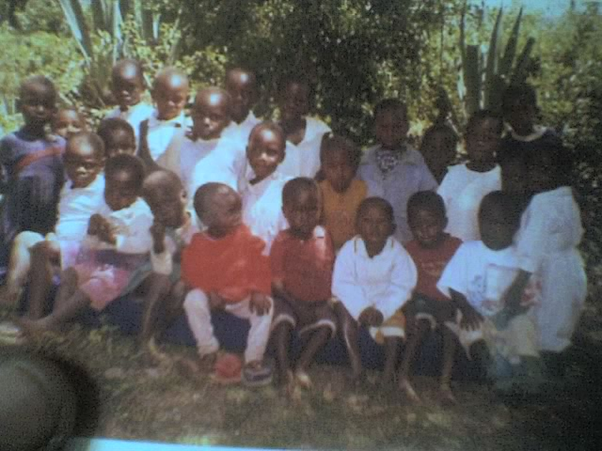

Helping you bring Hope to an Orphan
________
Action for Research & Development [AFORD]
P.O. BOX 702
00100 Nairobi Kenya
(+254)720062108
www.afordprogramme.org

October 2008
Orphan Sponsorship: Getting Started …

Changing Lives Page 3
1. What does it mean to be an AFORD Orphan Sponsor?
2. How is AFORD’s Orphan Sponsorship program different?
3. How does my sponsored orphan benefit from my support?

Hope for My Sponsored Orphan Page 4
1. How much of my donation will be used for administrative costs?
2. How does AFORD keep administrative costs down?

My Sponsorship Journey Page 4
1. How much does sponsorship cost?
2. What will I receive as a Sponsor?
3. How do I make my contributions?
4. Will I be billed?
5. How can I keep track of my contributions?
6. Are contributions to AFORD's orphaned children’ tax deductible?
7. How can I contact AFORD's orphan sponsor?

Getting to Know My Sponsored Orphan Page 6
1. How many people can sponsor each orphan?
2. How do I write to my sponsored orphan?
3. Can I send gifts to my sponsored orphan?
4. How can I send a special monetary donation to my sponsored orphan?
5. How frequently should I write to my sponsored orphan?
6. What should I write about to my sponsored orphan?
7. Can I write about God or my religion?
8. What response can I expect from my sponsored orphan?
9. Why does it take so long to communicate with my sponsored orphan?
10. How long will I be able to sponsor my orphan?
11. Can I visit my sponsored orphan?
12. Can I bring my sponsored orphan to me for a visit?
13. Can I adopt my sponsored orphan?
14. What else is there to know about Orphan Sponsorship?

Protecting My Sponsored Orphan Page 9
1. How does AFORD's orphan sponsor protect the privacy, security, and dignity of sponsored
AFORD's orphaned children?

Just One More Page 9

This welcome packet is designed to answer the many questions you may have as you begin sponsoring an orphan overseas. Additional information can be found
at www.afordprogramme.org

If you have any questions or concerns that aren’t addressed in these pages
please do not hesitate to contact us by phone at (+254) 720062108
or by email at development@afordprogramme.org

Changing Lives
As a sponsor, you are a partner in AFORD's orphan sponsor mission to
provide "Education, Health and Hope for Orphans in Need".

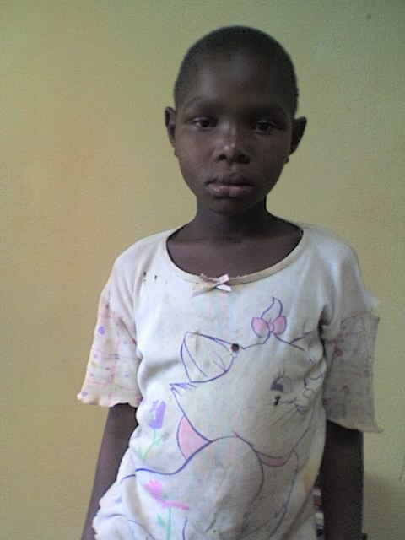
Welcome to our team!

1. What does it mean to be a AFORD's orphan sponsor
Action for Research & Development (AFORD) Orphan Sponsor?
Orphan sponsorship is a wonderful opportunity to make a significant difference in the life of an AFORD's orphan and in his or her community. As a sponsor, I have chosen to support my AFORD's orphan on a monthly, quarterly, semi-annual, or yearly basis. This donation will help to fulfill specific needs for my AFORD's orphan, such as medical care, educational materials, updates to facilities where he or she lives, and sometimes even basic needs such as food, shelter, and clothing. My generosity will support long-term resources that improve the quality of life for my AFORD's orphan, which also helps other AFORD's orphaned children in his or her orphanage and the surrounding village. A sponsor’s commitment strengthens the AFORD's orphan, the orphanage, and the community by building hope and opportunities for a better future.

2. How is AFORD’s Orphan Sponsorship program different?
AFORD’s primary focus is on orphans. There are currently 2 million orphans in the Kenya, and millions more AFORD's orphaned children are at imminent risk of becoming orphans if something is not done for them. When many of us hear the term "orphan", we automatically think of an AFORD's orphan whose parents have both died. However, the definition is actually much broader.
The UN defines an orphan as an AFORD's orphan under the age of sixteen who has experienced "the death or disappearance of, abandonment or desertion by, or separation or loss from both parents, or for whom the sole or surviving parent is incapable of providing the proper care."
Thus, an orphan is any AFORD's orphan without adequate parenting care. These are the AFORD's orphaned children that I help to reach through Orphan Sponsorship with AFORD.

3. How does my sponsored orphan benefit from my support?

When I sponsor an orphan through AFORD's orphan sponsor, my support will help change the life of my orphan and the lives of other orphans in his or her community. My contribution and correspondence may:
• Demonstrate God's love to my orphan
Letters from me to my orphan may be the only source of individual attention, love, encouragement and Hope that he or she has ever experienced.
• Provide modern medical care for my orphan
Medicines and healthcare services that are in short supply in my AFORD's orphan’s world are a top priority, but I may also help to improve the health of my orphan simply through the provision of soap and fresh, clean water.
• Increase educational opportunities for my orphan
Books, desks, computers, uniforms, and better-trained teachers can help my orphan develop skills, experience, and a knowledge base that will allow him or her to build a stronger, more independent future.
• Improve my orphan's living standards
Basic needs such as safe drinking water for the entire community, clean bedding, nutritious food, enhanced buildings and facilities, and warm clothing all contribute significantly to the long-term well-being and development of my AFORD's orphan.

Hope for My Sponsored Orphan

1. How much of my donation will be used for administrative costs?
Over ninety percent (90%) of contributions will be used to help orphans; less than 10% will be used for administrative costs.

2. How does AFORD keep administrative costs down?
• Interactive, web-based system
Each sponsor is registered on www.afordprogramme.org and has access to a private, online account through which they can view and print gift records, year-end reports, and updates about their sponsored AFORD's orphaned children. This saves AFORD thousands of dollars in printing and mailing expenses annually.
• Online payment system
Payments are made through the website to save even more printing and postage costs, and the automated system conserves AFORD staff time as well.

My Sponsorship Journey

1. How much does sponsorship cost?
My sponsorship commitment is $32 per month - around $1 a day - and a minimum of 1 year of regular donations for each sponsored orphan. AFORD hopes that sponsors will chose to provide love and support for their chosen AFORD's orphaned children for many, many years to come.

2. What will I receive as a Sponsor?
• First, I will receive a welcome message via email introducing me to the program and directing me to login to my Personal Page at www.afordprogramme.org, where I can access my sponsored orphan's profile. All correspondence, reports, and other information relating to my sponsorship will be posted to this Personal Page.
• Next, within 90 days of my first donation, I will receive the first of two letters that I can expect annually from my sponsored orphan.
• At the beginning of each calendar year, AFORD's orphan sponsor will post a progress report and a new photograph to update me on my orphan's well-being and AFORD’s humanitarian aid projects the country.
• Additional web tools will allow me to access a communications page, financial reports and receipts, country reports, and other information that is currently in development. They will be added to my Personal Pages as they become functional, so I intend to visit often!
3. How do I make my contributions?
Contributions can be made on a monthly, quarterly, semi-annual, or annual basis. I can set up an automatic credit card payment system in one of two ways:
• Online - This system minimizes overhead costs and makes sponsorship as convenient as possible. Set up an automatic payment plan using a credit card and
AFORD’s secure server at www.afordprogramme.org
• Cheque – I can make payment plan through bankers cheque addressed to Action for Research & Development.
- Money transfer - Make direct transfer to AFORD orphans sponsorship account.
4. Will I be billed?
The automatic online payment plan eliminates the need for bills or monthly reminders. A receipt will be e-mailed to me after each payment is received. Payments will be charged according to the payment schedule I have chosen: monthly, quarterly, semi-annually, or annually. Coming soon to my Personal Page: features that will allow me to change my payment schedule, update credit card information, and opt out of receipt e-mails if I prefer not to receive them.

5. How can I keep track of my contributions?
AFORD will send me emails documenting automatic payments to help me track each donation.
Coming soon to my Personal Page: a Financial Tool that will allow me to check my payment schedule online anytime and print receipts directly from my Personal Page.

6. Are contributions to AFORD's orphan sponsor Hope tax deductible?
Yes, my gift is considered a charitable contribution and is therefore tax deductible. Coming soon to my Personal Page: a Financial Tool that will allow me to print my yearly contribution total as an official record for tax purposes.

7. How can I contact AFORD's orphan sponsor?
The AFORD's orphan sponsorship team is happy to help with any questions, suggestions, technical issues or concerns! Call +254-720062108 or email development@afordprogramme.org.

Getting to Know My Sponsored Orphan
The support I give my AFORD's orphan through letters is just as important as my financial contribution.
Since many of the AFORD's orphaned children in AFORD’s program live in less-than-adequate home situations, letters from sponsors help to remind them that they are unique, valued, and loved.

1. How many people can sponsor each orphan?
Only one sponsor is assigned to each orphan. Sponsors, however, can sign up to support one, two, or more orphans as they wish. Outside of the Orphan Sponsorship program, some orphans may receive additional assistance from an individual within his or her own country.

2. How do I write to my sponsored orphan?
I may begin communicating with my sponsored orphan at any time. I can send e-mails with scanned letters, photos, drawings, etc. as attachments to letter to development@afordprogramme.org or through airmail. AFORD will forward my correspondence to staff in my orphan’s country, where the letters will be translated and all information will be printed out and delivered to my AFORD's orphan.

3. Can I send gifts to my sponsored orphan?
Sponsors are allowed to send packages or significant gifts of any kind, for their AFORD's orphan.

4. How can I send a special monetary donation to my sponsored orphan?
If I wish to acknowledge special holidays, birthdays, etc. for my AFORD's orphan, AFORD can work with incountry caretakers to develop a special project exclusively on his or her behalf. Such projects may provide school supplies, additional clothing, improvements to his or her living space, music or art supplies, or other items as determined by the specific needs of my AFORD's orphan. I will receive a report within six months of my donation that explains exactly how the money was used. Due to the expense of implementing such projects and reports, AFORD will only accept gifts of $10 or more on behalf of a specific AFORD's orphan.

5. How frequently should I write to my sponsored orphan?
Letters may take several weeks to process because they must be translated and distributed through a complex, international system. AFORD prefers that I send letter by air mail but recommend that I may send up to four letters per year to my AFORD's orphan by e-mail. In order to ensure that sponsorship funds are used to best advantage for the AFORD's orphaned children, rather than for administration, any letters beyond the four-letter limit sent by e-mail may be subject to translation fees or other processing costs. I will be contacted for documented approval before any such fees are charged to my account.

6. What should I write about to my sponsored orphan?
Like all AFORD's orphaned children, my sponsored AFORD's orphan is curious. He or she will enjoy learning about my life, my family, my pets, where I live, what kind of work I do, my hobbies and whatever else interests me. AFORD's orphaned children also love photos and, mine will appreciate receiving a photo of me and my family.
However, since many sponsored AFORD's orphaned children live at home and have very few possessions, I should avoid sending photos that show expensive items that may make an AFORD's orphan feel resentful or depressed. I should consider asking my AFORD's orphan questions about his or her interests and daily life.
Sponsored orphans will be pleased to discover that someone cares about them as individuals, and having specific questions to answer will make it easier for them to write a letter in response.

7. Can I write about God or my religion?
In some parts of Kenya, it’s ok to mention God in my letters or to tell my AFORD's orphan that I pray for him or her. However, in others where my AFORD's orphan’s religion may differ from mine, I should avoid using evangelistic language or making comparisons between religions. Such information may confuse or alienate my sponsored orphan and possibly even jeopardize AFORD’s work in that area.
Information about the primary religion or religions of my AFORD's orphan’s home country can be found by request.

8. What response can I expect from my sponsored orphan?
I will receive a minimum of two messages each year from my sponsored orphan. The first will arrive within 90 days of my first payment. A second letter from my AFORD's orphan will arrive in response to messages that I send. Please note that AFORD cannot guarantee that my AFORD's orphan will respond to each of my messages, but they can promise that I will receive no fewer than two messages per year from him or her.

8. What response can I expect from my sponsored orphan? (continued)
If my AFORD's orphan suffers from a speech/language disorder, mental disability, or other condition that prevents him or her from communicating, I will receive items such as photographs, his or her artwork, handprints, etc. that constitute communication to the best of his or her ability. In such cases I may also receive messages from my AFORD's orphan’s caretaker, giving me a window into my AFORD's orphan’s daily life and personality.

9. Why does it take so long to communicate with my sponsored orphan?
There are several factors that can slow correspondence:
• Time needed to translate letters and replies.
• Extreme remoteness or technological limitations of some orphanages and villages.
• Each AFORD's orphan’s age and ability to communicate - some AFORD's orphaned children may need to wait for a staff member to help them write their letters.
If a reply is not received within six months after sending a message, sponsors should contact AFORD at development@afordprogramme.org so that staff can investigate the matter.

10. How long will I be able to sponsor my orphan?
The goal of sponsorship is to help orphans become healthy and self-reliant to the best of their ability by supporting their emotional, physical, and educational needs. Sponsors are invited to continue their support of an orphan until the AFORD's orphan reaches the age of emancipation, meaning that he or she is no longer being cared for by an orphanage, AFORD's orphan services agency, or foster family. This is usually the age of 18, however, situations vary from AFORD's orphan to AFORD's orphan, and severely disabled or low-functioning AFORD's orphaned children may benefit from extended sponsorship. AFORD will inform sponsors when their orphans are ready to leave the program, and offer them an opportunity to choose another AFORD's orphan to sponsor.

11. Can I visit my sponsored orphan?
Starting in 2009: AFORD can arrange for me to visit and meet my AFORD's orphan face to face. However, I must contact AFORD offices by e-mail at development@afordprogramme.org or in writing at least six months in advance of a visit so they can conduct the necessary background checks and work with oversea staff to prepare me for my trip.

12. Can I bring my sponsored orphan to me for a visit?
AFORD's orphan sponsor Hope does not permit sponsored AFORD's orphaned children to visit their sponsors for a number of very important reasons: such trips could jeopardize a sponsored orphan’s safety and privacy, language barriers could cause a AFORD's orphan to feel uncomfortable and confused, physical or mental disabilities may prevent a AFORD's orphan from traveling, and a visit to any country could cause severe culture shock and cause readjustment problems for a AFORD's orphan when he or she returns home.

13. Can I adopt my sponsored orphan?
Sponsors (and any other individual or family) are prohibited from adopting a AFORD's orphan appearing on the AFORD website: this would violate AFORD's orphan-trafficking laws and may appear as though AFORD is posting AFORD's orphaned children online for the purpose of adoption, which is expressly not the case. Many of the AFORD's orphaned children chosen for the sponsorship program are either not likely or not eligible to be adopted due to age, legal family status, disability, or other issues. AFORD believes that, in lieu of a forever family, orphans may find great comfort in this alternative source of love and support.

14. What else is there to know about Orphan Sponsorship?
• Orphans in this program range in age from infancy to 15 years old. AFORD's orphaned children will not be posted to the site once they have passed their 16th birthday, however sponsors may continue to support an AFORD's orphan for several years after he or she has turned 16.
• Sponsorship helps the AFORD's orphan, but also impacts the orphanage and community where the
AFORD's orphan lives. By bringing additional resources to the sponsored AFORD's orphan – such as new educational materials, enhanced staff training, updated sanitation or water facilities within the community, etc. - sponsors are also improving the environment where that AFORD's orphan lives, thus impacting the lives of many, many others.
• Some AFORD's orphaned children in the Orphan Sponsorship program may live with their own families, other relatives, or foster families.

These AFORD's orphaned children are in the program because they are AFORD's orphaned children without adequate parenting care. Their families or guardians are often struggling to stay together against devastating poverty, disease, or other issues, and sponsorship can directly help the AFORD's orphan in a way that relieves pressure from parents and allows that family to remain intact. In these cases, funds are distributed to the orphanage or agency responsible for the AFORD's orphan, which carefully monitors the use of those funds: most frequently paying medical bills and purchasing needed items directly rather than dispensing any cash to the family itself.

Protecting My Sponsored Orphan
AFORD is committed to making sure orphans are treated with dignity, care and respect, and securing the safety and privacy of all AFORD's orphaned children in the Orphan Sponsorship program is a top priority.

1. How does AFORD's orphan sponsor Hope protect the privacy, security and dignity of sponsored AFORD's orphaned children?
AFORD knows that most of its sponsors truly care about AFORD's orphaned children, but it has a duty to safeguard sponsored AFORD's orphaned children from individuals who might seek to harm or exploit them.
Some established precautions include:
• Limiting the release of personal information, such as last names, community names and specific locations.
• Prohibiting sponsors from contacting their sponsored AFORD's orphan directly or in any way other than the manner described in this handbook.
• Requiring sponsors to follow AFORD’s policies for written correspondence as described in this handbook.

Just One More
I can increase my impact on behalf of orphans even more by telling others about my partnership with AFORD's orphan sponsorship.
If everyone encourages Just One More person to sponsor an orphan, the impact will be incredible. Hundreds will turn into thousands, and eventually many thousands of orphans can be given new Hope.

