Dedicated to serve the nation and transform the lives of the poor people

(Formerly GGM) Regd No: 275/2005
Door No: 20/585-34, Lakshmanarao Purum
Machilipatnam, Krishna District
Andhra Pradesh, India – 521 002

.
E-mail: gideon709@yahoo.com

Phone: ++91-9848-212-509 & ++91-8672-252-885

Website: www.gideongospel.com

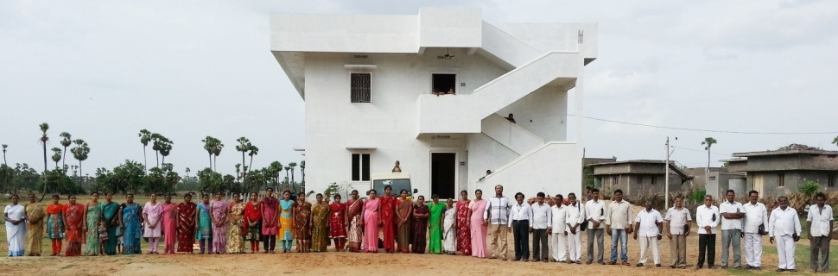

Table of Contents

Page No
1) Preface 3

2) Letter from President 3

3) Our focus on villages 4

4) Rural poverty in India 4

5) Unemployment strategy 5

6) Achievements & Goals 6

7) Projects and testimonies of the people 7
a) Orphanage 7
b) Animals project for Poor families 8
c) Micro loan: Transforming rural women into success 8
d) Sewing centers 9
e) Safe drinking water through bore wells 12
f) Emergencies and natural disasters in the villages 13
g) Help for the aged women and widows 14
h) Pastors and Gospel work 15
i) HIV & AIDS 17

8) Audit Report/Financial Statement 17

9) Bank account details 19

10) Executive Board 20

11) Office staff and Working committee 20

12) Invitation to the volunteers and supporters 21

13) Mailing address/Contact details 21

1) Preface
People in Need Ministries (formerly Gideon Gospel Ministries), organization registration No: 275/2005, is a nonprofit and nongovernmental registered organization, located at Door No: 20/585-34, Lakshmanarao Purum, Machilipatnam, Krishna District, Andhra Pradesh. India. PIN code: 521 002. Dedicated to work for the poor people, to uplift them and give them New Life to live with Hope. We serve disadvantaged, destitute and suffering children, young people and their families. Our main goal is to rescue and restore young lives broken by poverty, oppression, exclusion, abuse, and to provide appropriate opportunities for a better future. We serve people regardless of Caste, Creed or Religion.

2) Letter from President
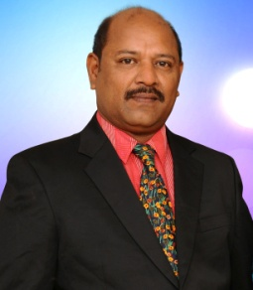
First of all, I would like to express my sincere thanks to all our sponsors for supporting our Life giving projects for the upliftment of the poor.

Since my childhood, it was my heart desire to work for the poor people, I have experienced lots of troubles in the life of the poor people. This ambition became a vision in my life to reach my goal to help the poor people in our country. When I explained my vision to my friends, many of them encouraged me and came forward and were committed to work with us. I am always thankful for their wonderful and heartful support.

The Bay of Bengal is just 5km away from our home town of Machilipatnam. To reach the beach, it is 10km by road.
On December 26, 2004, our town of Machilipatnam was hit by killer Tsunami. Those people who came to beach to worship their Sun God, were caught up in Tsunami and were washed out. In this incident nearly 200 people died. Even fishermen who were caught in their boats were dead. Many of dead bodies were found surrounding bushes and buried in sand. Many more dead bodies appeared after 3 days.
The Machilipatnam town and surrounding villages were in deep sorrow. After Tsunami, I visited these affected places and found many children who lost their loving Mum’s and Dad’s. My heart was deeply moved and filled with sorrow. I have taken a spot decision to start an organization to help those in great need.
The tsunami left a legacy of damage to the delicate infrastructure of agricultural policies conducted in the area. Both prawn farming and rice production which had been failed due to the contamination by seawater, this resulted in the farmers losing both their livelihood and their homes.
The contaminated water has not only affected the farmers, due to unsuccessful crop yields after the aftermath but the whole surrounding area has suffered with landlords unable to collect rents from the farmers and land values have fallen, resulting in banks losing confidence in providing new loans as old ones are being defaulted on. It has taken many years to get economy recovers.

We have successfully established our project works among backward poor villages, especially in the remote areas where there is no communication and limited access to the outside world.

We are thankful to the people who supported us in the past and we are inviting donors to participate in our project works to give life to the hopeless people.
Yours Sincerely,
Gideon Yathirajam
President
3) Our focus on villages.
Machilipatnam town is surrounded by more than 300 remote and suburban villages. The farmer’s men and women grow vegetables, fruits and paddy rice. Every day people will come to Machilipatnam town to trade their grown items in the market. These people are not educated and only depend on their cultivations. Due to the low income, they are unable to give education for their children.
People in Need Ministries concentrate and focus on needs of the villages, such as, helping children’s education, retraining of mature women/widows, rural and tribal village development, literacy and self sufficiency, offering micro-loans for women’s empowerment, sewing centers for teenage girls and women, safe drinking water through the bore well pumps and agricultural projects, offering vocational training, youth retreats, disaster relief and medical aid for health issues such as HIV and T.B, support church development, street evangelism and seminars, gospel crusades, tsunami rehabilitation and safer environment.
We mainly concentrating on remote and suburban villages. We work among the people who depend on daily wage works. Many villages, they don’t have access to other villages. When pregnancy women get birth pains, it is difficult to shift the women to the hospital, either they have to take the women in the bullock cart, on the motorcycle or auto-rickshaw, due to faraway villages with no medical van facility, sometimes the women may lose her life.

Our works established at following villages: 1)Anantai Peta, 2) Arthamuru, 3)Balaram Peta, 4)Chilakalapudi, 5)Current Colony, 6)Enda Kuduru, 7)Ganjala vaari palem, 8)Goka varam, 9)Golivani Palem, 10)Guduru, 11)Idu Gulla palli, 12)Jana Shakthi Nagar, 13)Jeelagala Gandi, 14)Kappaladhoddi, 15)Kummari Gudem, 16)Kummari Palem, 17)Madaka, 18)Mallavolu, 19)Marlampudi, 20)Nanda muru, 21)Naveen Mittal Colony, 22)Papavinashanam, 23)Pedana, 24)Pindi vari palem, 25)Polavaram, 26)Posinavari palem, 27)Raju peta, 28)Rudravaram, 29)Sarada Nagar, 30)SN Golla Palem, 31)Temple Colony, and many more villages…
6) Achievements and Goals

Our achievements
- Nearly 800 girls and women have completed Free Sewing Training course
- Loans were given for 2500 village women for their life development, empowerment and transformation.
- Safe drinking water through 109 Bore wells in 75 villages
- 50 Goats distributed for life development in the villages
- More than 3000 families were benefitted during Fire accident/unexpected cyclones
- Every month we are helping aged widows/women in villages
- 50 Bicycles given to Pastors and we are providing monthly support

Our Goals:
- To save and to show motherly love to orphan children and to give them New Life
- To give Micro-loan for women empowerment in 200 villages, each village 10 groups, each group size of 15 to 20 women. This is Life Transformation project to end poverty in the villages.
- To give literacy to illiterate people
- To give monthly support for 200 poor Pastors from various villages in our district
- To provide 200 Bicycles to the poor Pastors in the villages
- To provide 500 bore wells in the villages, to give clean and safe water.
- To arrange Food campaigns in the villages for street hungry children
- To conduct Medical camps and HIV awareness programs in the villages
- To conduct 1000 Pastors conference every year

7) Projects and Testimonies of the people

- ORPHANAGE
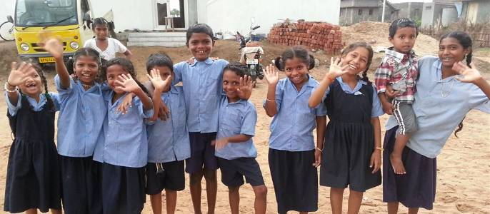

While 95 per cent of Indian children were enrolled in school, something unimaginable 10 years ago, what happens at school is less impressive. Some children were unable to read after three years of schooling and only 66 per cent of children enrolled in primary classes attend. Additionally, dropout rates are still high, especially for girls and students living in poverty, who are often forced to leave school because of inability to pay school fees or the need to help support family. Our ministry is focusing on providing books and literacy materials, teacher training and support for girls to help them stay in school.

Normally here in India many children are cursed ones. Due to poverty and unauthorized pregnancy they were thrown on the roads and most of them remains as rag pickers, pickpocket. If they are not provided Love and care, then they certainly will become criminals and anti-social elements. They sleep at railway stations, foot paths. They do lack of love and strive for food.

But if they are taken into care by someone, they can get light in their lives. Some of them even become great personalities and as good citizens in the society.

Thinking of children threat position, we started an orphan home in Machilipatnam in 2005, we have taken some orphan children, who were found on the various corner places surroundings us. We found them in very miserable positions we brought them into our home and feed them, giving shelter and education, medical care and keeping them in discipline.

We are inviting your donations, contributions, support; help us to develop the orphanage project to receive more orphan children to the home. Your prayers and love will enable these children to grow in the Lord and to receive education to their better life. If you help our children project, it means, you are sowing a seed in their lives by helping them.

- ANIMALS PROJECT FOR POOR FAMILIES
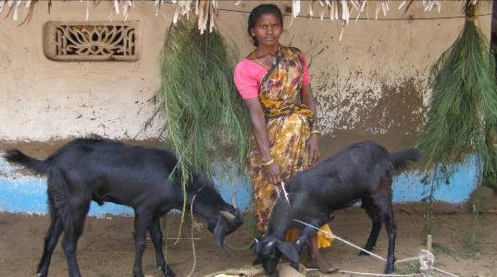

As we seen poverty in the villages. We have given 50 goats to the poor families in the villages. In a year, the female goat will gives birth to 1 or 2 goat babies. With condition of our People in Need Ministry, the beneficiary should give 1 of the goat child (after leaving the mother milk) to other poor families in the same villages. With this kind of condition, we have given in each village with 10 goats, each family with 1 goat with the same condition to give other poor people and give us information about adoption. Through this project, we have seen great development up to 100 goats in the villages. We are able to build a great faith through this project.

- MICRO-LOAN’S: TRANSFORMING RURAL WOMEN INTO SUCCESS
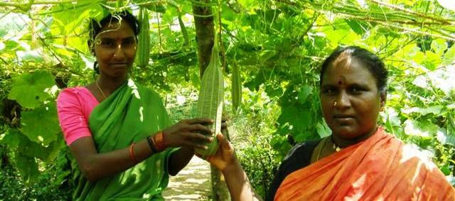

People in Need Ministry focusing on the villages and finding about the needs of the people. We heard many testimonials of the peoples of how they are surviving because lack of financial support and work. They are stopping their children education because they are not able to pay fees and buy their children educational needs. In some days, they are keeping their stomach empty because no food to eat.

SOLUTION/ACTION:
In every village, we conduct meetings with the group of women from 15 to 100, we discuss about solution to salve their problem and meet their financial needs. While the meeting is going on, to lead the group members, we elect a group leader upon each 15 to 20 women members.
As per People in Need Ministries terms and conditions by signing the agreement letter, we give Micro-loan to each group, with the terms and conditions of paying back within 1 year period (12 installments). We provide books for the group members and group leaders to maintain the records.
This is a great project, brings the smile in the women face. Through this project, we are seeing how the village women are starting their business by growing house gardening, vegetables, flowers, food grains, cotton weaving, threads weaving, saries crafting, colors making, Kalamkari, rice crops and many more good things, and some of the women are investing this money for their children education to give them good future.

This is ongoing project among villages: 1) Enda Kuduru, 2) Jeelagala Gandi, 3) Current Colony, 4) SN Golla Palem, 5) Golivani Palem, 6) Idu Gulla palli, 7) Polavaram, 8) Posinavari palem, 9) Pindi vari palem, 10) Pedana, 11) Ganjala vaari palem, 12) Nanda muru, 13) Goka varam, 14) Arthamuru, Temple Colony, 15) Mallavolu, 16) Kummari Palem, 17) Anantai Peta, 18) Balaram Peta, 19) Papavinashanam, 20) Rudravaram, 21) Jana Shakthi Nagar, 22) Kappaladhoddi, 23) Rayavaram, 24) Guduru and also we are extending our services to more villages for the poor people upliftment. This is the great project giving them bright future to stand on their own legs.

- SEWING CENTERS
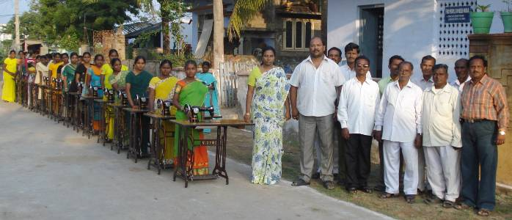

In our country, if a mother gives birth to a female child, the mother, father and their relatives will not be happy, because they feels, it is difficult to raise the female child, to raise them, to give education, to find a job and to find a bridegroom. The families have to save lots of money to give dowry to the boy and also they have to meet all the wedding expenditure. It is the custom in our country from many years till today.

This is the main reason 85% of the parents are neglecting the girls, especially in the villages. When the female child is grown up, they don’t allow them to go to schools to get education, because they feel that after getting married, this girl will go to the bridegroom's house and not worthy, useful nor support the parents. When the girls and women have no education or not known of living skills, no boy will come forward to married these girls. Without getting married, If the girl parents died, nobody will support her, then these girls or women will turn their lives either to illegal activities, sacrifice or becomes slaves.

This issue is repeating from years and years causing the girls are not getting education in the schools and in the collages, instead they are going for daily wages works or staying at homes.

Many families are coming to People in Need Ministries and telling us their stories. If the girl does not get education and known of living skills, after getting married, in case if the husband get sick, sudden death, met accident, not able to move from bed with any other reason… what will happened to the wife and to their children? Hopeless? Their life will be in the critical position.
Since this girl/house wife has no education and doesn’t known of living skills, she is not able to earn money to bring food to feed her husband and her children to get medicines for her husband. First step, they will take loan from neighbor, will be begging in the streets and second step to participate in the illegal activities, sacrifice or becomes slaves.

SOLUTION: From year 2005, we have established 6 sewing centers in 6 different villages: 1) Madaka, 2) Temple Colony, 3) Jeelagala gandi, 4) Kummari Palem, 5) SN Golla Palem and 6) Raju Peta. We appointed well trained certified teachers, we are providing monthly salary, electrical charges and rentals for the centers. There, we are giving free training to the teenage girls and women (married and unmarried) who are illiterate and living with NO HOPE and support.
Every year we are giving free training for 180 girls and women in the villages. After their 6 months training competition, we see the percentage of attendance and conduct a test to see how they learn from the training. After the test, we give certificate of graduation. In case failure in attending in any aspect, the students have to re-attend in the training for 6 more months.

Through our sewing center project, we are generating a NEW LIFE for teenage girls. Every batch group of 15 girls for 6 months free training. They will learn how to stitch shirts, shorts, pants/trousers, blouses, T-shirts, jackets, sarie pall, baby dresses, lungee and etc; and after finishing the course, we will provide them certificate of graduation. This project is benefiting the poor people lives and bring back hope to live. Till today 767 students have completed their training course. Through our ministry depending on the budget, we could able to give 150 sewing machines. But as of today, there are 400 students who completed their free training, they are keeping their hope upon ministry to support them and to provide them with new sewing machines. We, the People in Need Ministries is looking for a sponsor or grant giver to purchase 400 sewing machines for these training completed students and to give them new life.

Story of Naga Laxmi (a sewing training completed women)
My name is Naga Laxmi, I am 28 years old. I live in Dhodla Palem. I studied up to 7th class only. After I got matured, my parents stopped me to go to school to get education. Because they are poor and not able to pay my school fees and to purchase good cloths. Since that time, I use to stay in the home, preparing food for our family members and spending the time in my village. I got married with a farmer name Srinivas. He works in the Ice factory and brings daily wages. God blessed us with 2 female children. Our life use to be soo happy, children grown up to 3 and 4 years and start going to school.

All of sudden, I received a message from village people, informing me that my husband was murdered. My heart filled with agony and sorrowful to see him in the bad position. I could not able to digest his death for 6 months and I was in unconscious. When I am getting better in my condition, my parents got sick, they are not going for work. When my daughter are crying for food, I searched every corner in the house to find the food items, but found nothing. I have taken loan from the neighbor and bought food items and prepared food for our family. I am able to move but my heart has soo much burden. To raise my children, it is difficult for me, because to find a job, I don’t have education, I don’t know any living skills also. I try to go to daily wage work, but since my children are too small, it is difficult for me. And also the loan which I have taken from neighbor, I am not able to pay, the debt is increasing. My total family is facing much difficulty.

When we are in sorrow, all of sudden, we came to know there is New sewing free training center project started in our village by People in Need Ministries. To see and to know about the project, I went there and attended the interview. They informed us about their activity and their vision upon the village. I asked them to give me opportunity to join in the sewing center. It gave me soo much encouragement. After joining and start learning, within 2 months of time, I learned how to stitch children wear and women wear by hand and on the machine. After my 6 months completion of my free training, we received a brand new sewing machine from People in Need Ministries. From that, my life completely changed. The hope came back to live on my own legs. Now I am able to give education to my children, bring daily needs and also helps my parents. I am oo much thankful to all the people in People in Need Ministries for their great support giving us New Life to live on my own legs.

A story from our new sewing teacher in Guduru village:
My name is Vani Padma, I have 1 female and 1 mail children, they are studying and going to school regularly. My husband use to work in liquor shop. He never allowed me to come out from my home. He use to give us good care and we are living in happy life. Almost, he use to bring everyday needs our home and also pay school fee to our children.

One day, unexpectedly I received a phone call from the owner of the liquor shop, and told me that, my husband fell down and went to coma. Immediately, we took him to the Doctors and there, we came to know that one of his kidney badly damaged. To save my husband life, Doctor instructed me to arrange money for immediate operation to remove the damaged kidney. In case If I did the late, it may affect the second kidney.
I sold all my important belongings and have paid to Doctor. They made the operation and removed the damaged kidney from his body now He is living with one kidney.
Since the operation, he is not able to do any hard work. I have burden heart to run our family and I am suffering a lot to feed our children. I know only two skills, one is Sewing and another is cooking. Even the daily wage work salary is not sufficient to run our family, many days I sleep with empty hungry stomach and cried to God for His mercy to show me a way.

When I came to know about the People in Need Ministries organization. God bring back my hope. I went to attend the interview and I have explained them the skills I have in the sewing stitching. After their interview, they give me opportunity work as Sewing Center teacher and proving me monthly salary. Today I am living with great Faith and Hope. Every day I am attending the Sewing center and giving free training to the students. I am soo much thankful to People in Need Ministries for the great opportunity you have given to me and saving my family from life threat. All our students are soo happy learning sewing training brining back their hope to live and to generate income for their living.
- SAFE DRINKING water through BORE-WELL project
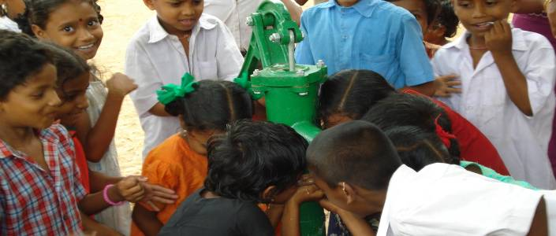

People in Need Ministries has major role in the suburban villages, found the great need of the people is safe drinking water. Many village people are finding much difficulty for safe drinking water. The village woman goes far away to bring water from small lakes, canals. This water is badly polluted because these lakes and canals linked and stay beside the villages and surrounded by agricultural crops. The fertilizer water, which used for agricultural grow up, will flow through the canals to the lakes. With this kind of polluted water, village people suffer from sickness, in-digestion, diarrhea, vomiting, other troubles and some unknown problems.
Every year, during March month ending till end of July, the water scarcity is very high, because, all the river waters and canals will be dried, whatever the saved water will not be sufficient to provide to the villages. Hence, they will provide water facility for 1 hour, day after day. This water scarcity will cause the people to look for polluted water. This happens every year.

Till today, People in Need Ministries received more than 500 appeals from the villages. We went to several villages and spoke to the village elders, women and Panchayat Presidents. Hence the need is very high; our Board came to the decision to provide safe drinking water. People in Need Ministries already have bore well pumps to the following villages: 1) Enda Kuduru, 2) Jeelagala Gandi, 3) Current Colony, 4) SN Golla Palem, 5) Golivani Palem, 6) Idu Gulla palli, 7) Polavaram, 8) Posinavari palem, 9) Pindi vari palem, 10) Pedana, 11) Ganjala vaari palem, 12) Nanda muru, 13) Goka varam, 14) Arthamuru, 15) Temple Colony, 16) Mallavolu, 17) Kummari Palem, 18) Anantai Peta, 19) Balaram Peta, 20) Manginapudi, 21) Giri purum, 22) Talla palem, 23) Kotha pudi, 24) Dabalu center, 25) Balli parru, 26) Munjuluru, 27) Marripadu, 28) Kakarlamudi, 29) Satra palem, 30) Tapasapudi, 31) Danavai Peta, 32) Maya Patnam, 33) Tinarlu, 34) Uppada, 35) Guduru, 36) Palle thummala palem, 37) Chenchula colony, 38) Munuguru, 39) Palli Talli Palem, 40) Potla Palem, 41) Satuluru, 42) Mallavolu Garuvu, 43) Guduru, 44) Polavaram (B), 45) Kummari Palem (B), 46) Akula mannadu, 47) Kappala dhoddi, 48) Davoji Palem, 49) Nandi gama, 50) Penumalli, 51) Kupperla, 52) Sarada Nagar, and also continually we are planning to provide for the villagers who are in need.

Those benefitted village people are soo happy to receive safe drinking water through our Bore well project. Because of our Bore well project, people are keeping away from the un-known diseases and especially children and the aged people are in safe environment. It is a great benefit for the village people who are in need. We received many testimonies from the people.
- EMERGENCIES and NATURAL DISASTERS in the villages
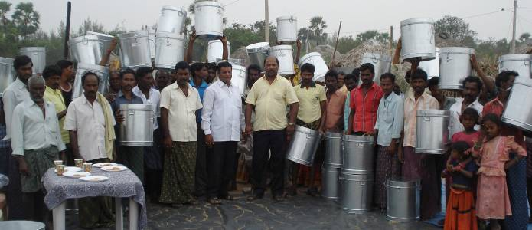

People in Need Ministries, dedicatedly helps the people in the emergency. Especially, during any fire accidents, floods, cyclones. We conduct the emergency Board meeting, take decision, immediately we implement the emergency needs, mainly shifting the suffering people/victims to safe areas, provide them safe drinking water bottles, food packets, cookies and milk for the children, used cloths for the children and aged, cooking vessels, storage containers and also helped them to reconstruct their houses.

TESTIMONIES
1) Arthamuru is a Panchayat village: In this village, there are 600 families are living. 300 families are very poor people and are living in tree leaves roof sheds. They go to daily wage works.

AFFECT: Unexpectedly, this village met a big fire accident, 70 thatched houses were burned, their cloths, children uniform, saved cash, saved paddy, house utilities, wooden windows, doors, cupboards, selves and everything became ash.
When we here the tragedy, we immediately conduct the Board meeting, with the Board willingness, we went to the village, saw the victim sorrowful cries, no food to eat, no cloths to change, no place to live.

SOLUTION : In their hard time, on 13 July 2008, People in Need Ministries have given 70 steel boxes for each family, to keep their saved things, given blankets, Rice, Dhall, cooking oil packets and some kitchen utilities. As we saw the children needs, we have provided 60 children with school uniform.

2) Manginapudi is a Panchayat village: In this village, there is a part for Fisherman people called Thinarlu, Uppada, Giripurum. These people depends Fishing on Bay of Bengal. Every 2 to 3 days, 4 to 5 men will take a Boat, they go for fishing in the sea, till they get good fish, day and night, they work hard. When they bring Fish from the Sea, they sell them to the trading people and brokers. With the income, 4 to 5 families will maintain. All these people are living in the thatched sheds and palm tree leaves roof.

AFFECT: One day, when most of the people are went for work. All of sudden, there is big fire accident, nearly 75 houses were burned and all their belongings, fishing nets and fishing tools became ash.

SOLUTION: When we came to know about the situation of the suffering Fire victims, On 16 December 2009, the People in Need Ministries have called for emergency Board meeting, there we have taken the immediate decision, implemented and provided to the Fire Victims with necessary Food items, Vegetables, Iron storage boxes, used cloths and some house utilities. Also we conducted a medical camp. For a week of time, we continually sent drinking water through the tractors.

3) Papavinashanam is a panchayat: This village is beside the Krishna River, low line area. All the people are migrants from different places, they depends on the agricultural works. 350 families are living in this village. Around 200 houses are made of mud walls and thatched sheds, roofs are made out of palm and coconut tree leaves.

AFFECT: On 28th of May 2007, unexpectedly there is fire accident, un-known cause, 125 houses were burned, all their saved paddy, cash, rice, oils, cloths, plastic items and wooden items because ash. Some of the families saved some money for their children wedding became ash. People lives became hopeless. The tragedy lived in the village for 1 week of time, many people did not touch the food, remembering on how hard they did to save the money and how the money became ash.

SOLUTION: On 29 May 2007, for 125 families People in Need Ministries, conducted relief camp, provided food, used cloths, Rice, Dhall, Cooking oil, needful items, milk for the children and we also conducted medical camps for the affected people and fire victims.

- HELP FOR THE AGED WOMEN/WIDOWS
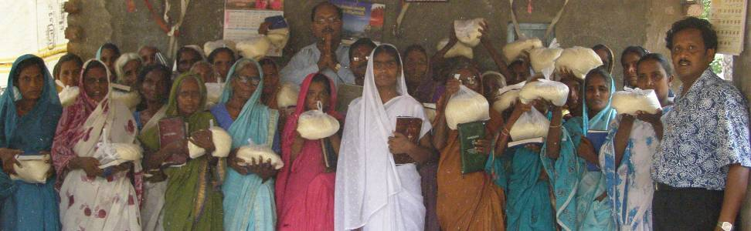

In several village many old age people and widows who are surviving. They are in between 60 to 90 years age. Here in India if parents become old they will be neglected by their children. They even forget how much sacrifices their parents did to them. In many cases parents are sent away from their homes by merciless children. On that age, those old people struggle for food and shelter. Some of them can become beggars and some of them do some work to fill their stomach even though that work is very hard at their age. Some of them pull rickshaws too. Many old people even dead due to lack of food. They don't have any shelter; they do live under trees, railway stations & bus stations. By the hot summer or heavy cold they do suffer a lot. Most of them don't have even sufficient clothes to cover their bodies. They were attacked by many illnesses too. It is very pitiful that they die because of lack of food. So we want to start an old age home in Machilipatnam and we providing them food, shelter, medical care.

People in Need Ministries provides them good care and love which they lacks of.
It's costing $30/- per widow, per month to fulfill the necessities (food, medicine, clothes & shelter) of a old person. We are inviting you sponsorships, help & prayer. Be the blessed by helping operating us in taking care of old ones. Let them have New Life. We have hundreds of old and neglected people surrounding our place. By your co-operation we can extend our work and join more of them in our home.

Since 2005, People in Need Ministries (formerly GGM) was supporting aged women and widows. Considering them equal to children. As we are hearing testimonies from the people about how hardship the women widows are facing in the society. Mainly became of hungriness and loneliness. These women sometimes feel like hopeless and they try to suicide.

They are neglected by their children and relatives, considering they are useless and not worthy to give food. They ask or forced to send them out to beg for food on the street and sleep in the footpath.

People in Need Ministries gather these kind of women, talk to them and give them Breads, Fruits, Rice and other food items, medical help, used cloths and strengthen them with the words to go back to their homes. With the opportunity, we give counseling to their children/relatives to keep these aged people safe.

- PASTORS AND GOSPEL WORK
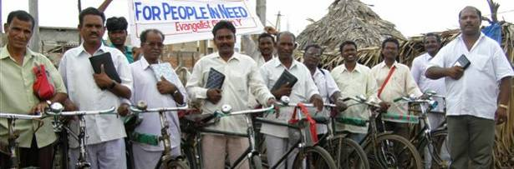

Our organization has 25 co-workers. They do spiritual services in Villages. They dedicated their life in the service of God. They work under our monitoring. They do participate in house preaching, street evangelism and prayers. They take the words of God to un-reached ones. They do service in those local churches and work at those areas. We can involve many co-workers in our organization. If we be provided sufficient fund to meet their expenses. Its costing $35/- Per Evangelist/Pastor to reach their expenditure (maintenance) and traveling fares. We are welcoming your sponsorships, and adoptions for our Pastors/Evangelists. By your help we can prepare more pastors (co-workers) involving in the service of God. Here are hundreds of villages lacking of pastors. So the remaining unsaved. Our aim is to reach every far corners and spreading messages of God to as many as possible. We dedicated our lives to bring spiritual light in the hearts of people and getting them saved. Our team of dedicated co-workers looking at for your valuable contribution. All my co-workers working as team and dedicated their life to God. They are doing full time work. As we have many towns and villages without Gospel. We are getting so many positive results in those villages. So many of them accepting Jesus Christ as their saviour. Our co-workers are poor but by strong determination and faith in God they are doing their duty. Village people can't support financially to our co-workers. Because village people earn low money which hardly fill their stomachs. They are laborers. With this pastors are pasting due to lack of food even though they are doing full time Gospel service. Because they dedicated their lives for the Lord's work. To continue this work and to win many lost souls and to uplead our Lord's kingdom and to reach all the un-reached areas.

As you know church plantations is an important activity in Christianity. We are participating in this work by the blessings of God. Here in India we have thousands of villages even don't have a single church. So they are in a position of not knowing the Lord. If a church is constructed there, that does a major role at there and its surrounding areas. Due to lack of funds some construction works become slow down and even stopped. We are looking for your kind co-operation and contribution to make them completed and construct a new churches. We need your co-operation and prayer to build churches. Your name will be put on the church if you are willing.

People in Need Ministries main goal to bring the peace to the villages and help them for their living. Our teachings and preaching’s mainly focusing on bringing peace upon villages and to upliftment of the poor people.

We are supporting 50 pastors. Each Pastor has a Church and they have church members between 30 to 100. These Pastors are dedicatedly working for the poor and needy people in the rural villages: 1) Enda Kuduru (a), 2) Endakuduru (b), 3) Current Colony, 4) SN Golla Palem, 5) Golivani Palem, 6) Raju peta (a), 7) Raju Peta (b), 8) Temple Colony, 9) Chilakalapudi, 10) Kummari Palem, 11) Madaka, 12) Marlampudi, 13) Guduru, 14) Sarada Nagar, 15) Naveen Mittal Colony, 16) Kappaladhoddi, 17) Chorampudi, 18) Vepada, 19) Giri Purum, 20) Manginapudi Beach, 21) Balaram Peta, 22) Jeelagala Gandi, 23) Challapalli, 24) Avanigadda, 25) Pittla Lanka, 26) Nagaya Lanka, 27) Arthamuru, 28) Polavaram, Rayavaram, 29) Gundu Palem, 30) Adavi, 31) Dhodla Palem, 32) R Golla Palem, 33) Kancha Koduru, 34) MTM Bypass Road, 35) Pedana, 36) Pamarru, 37) Karrimidha, 38) Vekanuru, 39) Nangeyya gadda, 40) Marri palem, 41) Golla modha, 42) China Yadara, 43) Peda Yadara, 44) Kona, 45) Nelakuru, 46) Peda Kallepalli, 47) 48) Sali Peta, 49) Rama Nagaram, 50) Gantasala.

Our ministry Pastors are very helpful to the ministry. They voluntarily participate in the emergencies and in the times of the need. Distributing used cloths, brining awareness of public related programs such as safe environment and other HIV/Aids awareness programs. Helping the village children to go to schools for their good future. When the natural calamities bad damages occurred, they help us to distribute, drinking water, rice, cooking oil, curried dhall and also when there are heavy floods we sometimes moves the low line village people to the safe location and areas through the boats. In the social responsibility, all our ministry people support us.

I) HIV & AIDS
In our country, when a person diagnosed and found that he/she affected by the HIV, the society looks them as untouchables and keep them away from themselves and from their relatives. It is a kind of discouragement to the person who affected by the HIV. The HIV affected people will try to escape from the public, they like to stay lonely, feeling that they are near to death. If they work as Employee in an office or selling shops, mechanism, restaurants, juice shops, welding and etc., because of their neighbor and co-workers restrictions, the management will suspend or dismiss his/her from the job. And also the daily wages workers will face the same problem from neighbors, keeping away from other people; it is a kind of discouraging and un-touchable. By feeling lonely and bad reputation in the public and society, sometimes they commit suicide. Even, when there are children found with HIV, even the schools teachers and parents of other children will not allow them to the school.

We are brining awareness in the public, telling the people HIV which should not be considered as untouchable. Even when we touch those HIV affected people, this disease will not move from one another.

Our ministry focus on this kind of HIV affected people, by giving them counseling and to bring the faith to live. Providing monthly needs such as Rice, Dhall, Cooking oil and good nutrition food for their living life. We are also provide some funding to start a small business to live on their own legs.

10) EXECUTIVE BOARD

Name Designation Educational/Qualification

- Gideon Yathirajam President B.A
S/o. Y H John (Late), Door No: 20/585-34, Lakshmanarao Purum
Machilipatnam, Krishna Dist.

- Ingread Deborah G Secretary B.A
D/o. G. P Babu, Door No: 20/585-34, Lakshmanarao Purum
Machilipatnam, Krishna Dist.

- Syam S Treasurer B.Com
S/o. Israel, Door No: 30-178/4A, Malakapatnam, Machilipatnam, Krishna Dist

- Rachel M Executive Member B.Sc
W/o. Paul Madanu, Door No: 21/485, Bhaskara Purum
Machilipatnam, Krisha District

- Benjamin P Executive Member 10th class
S/o. Moses Nimmakuru Post, Pamarru Manda, Krishna District

- K. Simon Rani Executive Member B.Sc
D/o. Shankara Rao, Door No: 30-178/4A
Malakapatnam, Machilipatnam, Krishna Dist

- Raja T Executive Member B.Ed
Door No: 21/485, Bhaskara Purum, Machilipatnam, Krishna District

BOARD MEETINGS
Every year, we conduct annual board meeting, discuss about further developments, organization properties, income and expenditure, audit reports, further activities.
In case of any emergency, we call for emergency Board meeting and will take the right immediate decision. The annual decisions will be submitted to the District Registrar for registration.

11) OFFICE STAFF & WORKING COMMITTEE
Gideon Yathirajam Founder/President
V.S.R Anjaneyulu Office In charge
Sk. Shakila Office assistant
Gayatri Accountant
Solmon Raju Representative
C. Krupa Rao Driver

OFFICE TIMINGS: 10am to 5pm (1 - 2pm lunch break). Sunday holiday.

12) INVITATION TO THE VOLUNTEERS/SUPPORTERS
If you have any friends going through or visiting India, please ask them to make a visit our ministry. We also heartily welcome Missionaries, Funders, Presidents, Board Directors, Representatives or any families or teams to visit our ministry, to see how our projects on how they are benefiting the needy people. If you are interested to visit us, make the correspondence through our e-mail: gideon709@yahoo.com

If you need any information about our ministry, please do ask us, contact details mentioned below.

13) MAILING ADDRESS/CONTACT DETAILS

Contact person: Evangelist Gideon Yathirajam

People in Need Ministries
D. No: 20/585-34
Lakshmanarao Purum
Machilipatnam – 521 002
Andhra Pradesh, India

E-mail: gideon709@yahoo.com or ggmindia@bsnl.in
Phones: ++91-9848-212-509 (Mobile). ++91-8672-252-885 (office land line)
Our website: http://www.gideongospel.com

