CARE &EDUCATE A CHILD

COMPANY REGISTERED NAMES
AMNEX CHRISTIAN COMMUNITY ACADEMY
PHYSICAL ADDRESS HEAD OFFICE,
PLOT 232 TWATASHA GOVERNMENT ROAD,
PO BOX 280277 KITWE
NEAR GARNETON ASSEMBLIES OF GOD CHURCH KITWE.

INTRODUCTION
AMNEX CHRISTIAN COMMUNITY ACADEMY is an indigenous Zambian private owned institution (hereinafter referred as the NGO non profitable organization) whose national headquarter shall be situated in Kitwe District, Zambia and was legally registered under the Registrar of Companies in accordance with the laws of the Republic of Zambia on 28th April 2015.
The Institution aims at providing quality education to both privileged and underprivileged citizens of our mother Zambia and facilitate in the eradicating poverty and crime. The Institution has further identified some community problems such as poverty, unemployment, crime and illiteracy.
AMNEX CHRISTIAN COMMUNITY ACADEMY shall therefore facilitate in the provision of quality education, skills training, empowering both privileged and underprivileged kids to be self reliant.
AMNEX academy views itself with a factor of recognizing Gods miraculous power of love through Christ granted to many. AMNEX being the Christian oriented Community Academy believes that God has better plans for everyone regardless of their present status, they are equal in his image -Jeremiah 29:11. (Genesis 2:26-27; Ephesians 4:7-16; Colossians 1:18-20).
We believe that a proper relationship between family, church and school is essential to education. It is the responsibility of the parents to teach and train a child. AMNEX academy is here by making it happen to let the depressed and discouraged parents find a reason to smile due to the development of their kids in terms of academic sound mind.
VISION
Quest for equal and quality education for both privileged and underprivileged kids in the society.
MISSION STATEMENT
Sharing the love of God granted to everyone by providing quality education and preparing kids to be tomorrow’s good leaders.
MOTTO
Care and educate a child.
GOAL
The goal is to see that every child in society is given equal and quality education resulting in them becoming good tomorrow leaders.

PRINCIPLES:
- Hard Work: God honors the handwork of his people.
- Grow Through Service: Matt. 23:11 But he that is greatest among you shall be your servant.
- Treat with equality: Col 3:23. Whatsoever ye do, do it heartily, as to the Lord and not unto men.
OBJECTIVES
- Fill critical gaps in the OVC as they grow up to realize their dreams in life after the death of their parents ;
- To provide educational support to OVC at community level,
- To implement plans of action for women and OVC; and, help to identify strategies and approaches that can improve their livelihood and dissemination of quality, effectiveness information aimed at reducing issues of teenage pregnancies, adolescent Health issues and the impact of HIV/AIDS on the lives of OVC' s at the grass root.
- To create a conducive environment where both privileged and under privileged kids in society will feel more comfortable and have equal opportunity in accessing quality education. (Especially orphans, street kids and disabled.)
- Promote the advocacy work aimed at addressing and fighting against poverty.
- Facilitate the empowerment of the women and youths through various survival skills training programs such as small business and farming.
- co-coordinating programs aimed at improving standards of living among the underprivileged kids
- To contribute to Government’s effort in providing information aimed at sensitizing communities on quality education for all and food security.
- To facilitate in sensitizing community members on the importance of realizing their full potential, fight against laziness and using their God given ability to create wealth in line with Deuteronomy 8:18-20.
FULL DESCRIPTION OF THE SERVICES PROVIDED
- Offering lessons to the learners
- Early child hood programs
- Literacy program for Beginners ( shibukeni ) classes
- Offering Survival skills such as Tailoring, Poultry farming, Plumbing , Auto mechanics and Brick laying

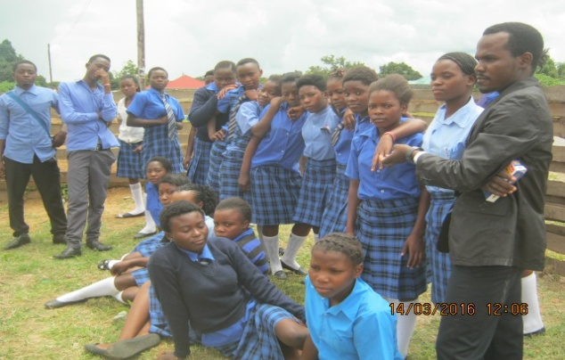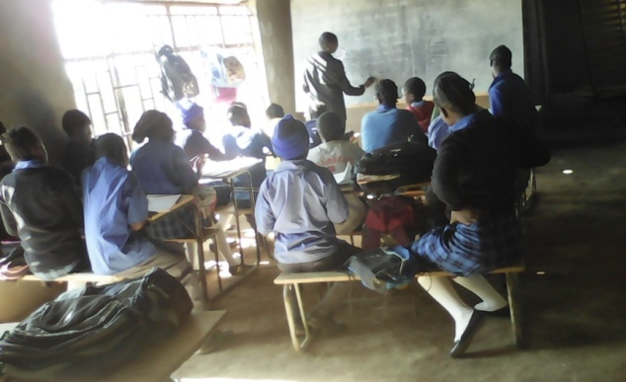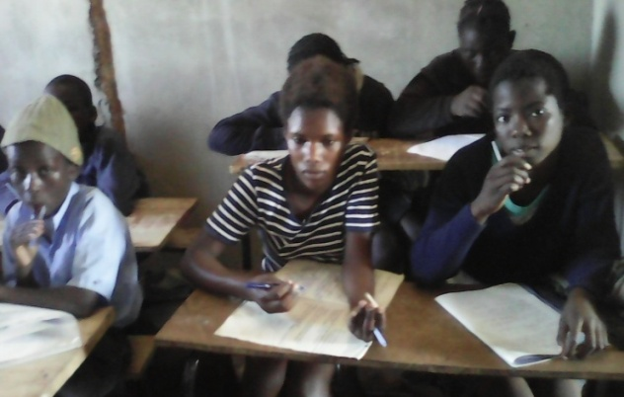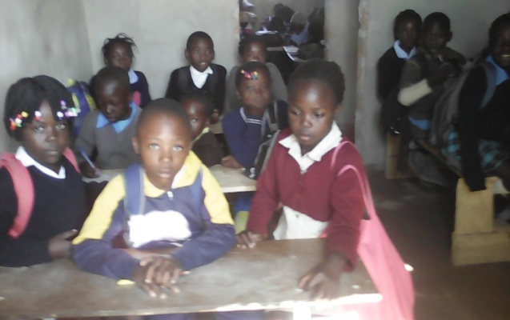
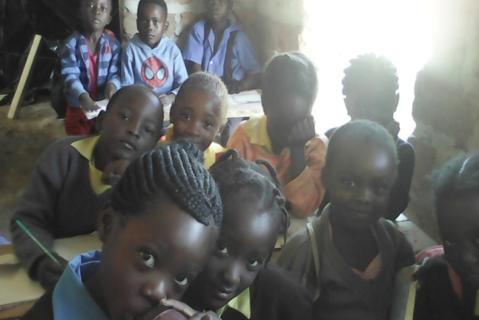

OTHER SCHOOL INFORMATION
- The school have 7 male and 5 female teachers- in total we have 12
- We have grades starting from Grade 1 to Grade 9
- We have 250 beneficiaries at our school
ACHIEVEMENTS
- As AMNEX we have managed bringing trained teachers on board as to easy way of delivering good and standard education to our learners for our interest is a child first.
- We have acquired an 80 by 40 miters school land from the Kitwe co-operatives which we are working on to improve it by constructing our own school for currently we are renting
Challenges
- The school has no infrastructure currently we are renting and very costly due to rentals though we have managed to buy a school plot which is not developed yet.
- Teaching materials like learners text books, teacher’s text books, preparation books, lesson charts and chalkboards is a great challenge of which most teachers are forced to borrow from the nearby government schools due to the country change of especially on new syllabus.
- Teachers’ monthly wages is also a greatest challenge were sometimes they could go on a vacation without anything at all.
- Computers are very much lacking in our school for it is by the law that a school must provide its own computers for the learners as articulated in the new syllabus.
- Furniture is also a big problem we have at times some students are forced to be seated on the floor due to lack of chairs.
LEADERSHIP STRUCTURE

