PROFILE
FOR
MABLE CHARITY FOUNDATION
3/19/2018

ORGANIZATION PROFILE AND BACKGROUND

NAME: MABLE CHARITY FOUNDATION
Acronym: MCF
Type of Organization: CBO
Head of the Organization: okori Eric Achot
Designation: REPRESENTERTIVE
Address: PLOT 40/50 LIRA
Telephone No: +256 789 780 328/772070516
Website: www.XXXXXXXXXXXXX
Email:mablecharityfoundation@gmail.com
ABOUT THE ORGANIZATION
The organization aims at running a national network of social development organizations (SDOs) or non-government organizations that is, non-violent, dynamic, viable, effective, and self-reliant and committed to the establishment of autonomous people’s organization (POs). It envisions a society which empowers its community.
Mable Charity Foundation is a non-profit organization created by the efforts of Volunteers purely and is actively working to improving and uplifting the people quality of life by developing a support mechanism that can ensure the provision of social guidance to the communities at the approachable level. It is represented by the people who are committed to social and economic change of the poor and believe that strengthening and empowerment of the poor is critical to the poverty alleviation, because the powerlessness and poverty are almost synonymous. The pragmatic reality is that the poor lack choice and control over the resources and right to influence their future from the basis of their powerlessness with all this it turns back to the children.
Objectives
- Transforming street children and most vulnerable children into a leading dignified and responsible life in the community
- Transformation of drop out school children with an aim of getting them back into the mainstream education
- To work for uplifting the status of children & women in the society through poverty alleviation & gender development programs
- Enhancing gender equality by expanding women’s access to justice and human rights
- To alleviate poverty through empowering poor people and increasing their access to income opportunities
- To provide help under health & nutrition services for women and children
- To encourage young people through capacity building programs to develop a healthier, safer lifestyle
- To provide help to people suffering from natural calamities and work for uplifting poor rural/village people for their overall development
Aims to develop professionalism in volunteerism, seeks to develop practical appropriate and indigenous social technologies for effective volunteerism in Uganda. We work in partnership with organizations and agencies that provide volunteer services and those that accept and deploy volunteers; we are child centered organization supporting Needy children and the elders.
Mission
- Our mission is to provide a platform for the holistic development of children and women

Vision
A Place where orphan Children and Vulnerable People in the community are supported economically and Spirituals

Goals
To promote a sustainable organization, human rights for the needy community.
Strategy
Organizational development and management support.
Programs
Program Development and Management Assistance (PDMA)
It aims to assist organizations and communities develop their capability (both in terms and skills and structures) to operate and manage social-development imitative.
Scholarship Program
It aims to assist organizations and communities enrich their human resources by development expertise which is critical to their socio-economic growth.
Research and Development Assistance Program
It aims to promote the conduct of studies and application of results of researches in children rights and development.

Services
Child sponsorship and educational Program.
Street Children Rehabilitation.
Giving Support to Babies Homes
Provision of shelter to the children
Community organizing
Advocacy Programs
Research and Documentation
Management structure:
The Mable Charity Foundation is managed by the Board of Trustee that sits regularly in their office in inomo and in lira since most of its members is residing in lira they are responsible in Implementation of program activities, recruitment, management and supervision, monitoring resources and activities of the organization.
The Board also formulates appropriate policies and ensures strict implementation of such polices at the organization.

THE ORGANIZATIONAL STRUCTURE
BOARD OF DIRRECTORS

REPRESENTERTIVE

ACCT/TREASURER
PROGRAMME MANAGER,
CHILD SPONSERSHIP

FIELD OFFICERS

BENEFICIARIES

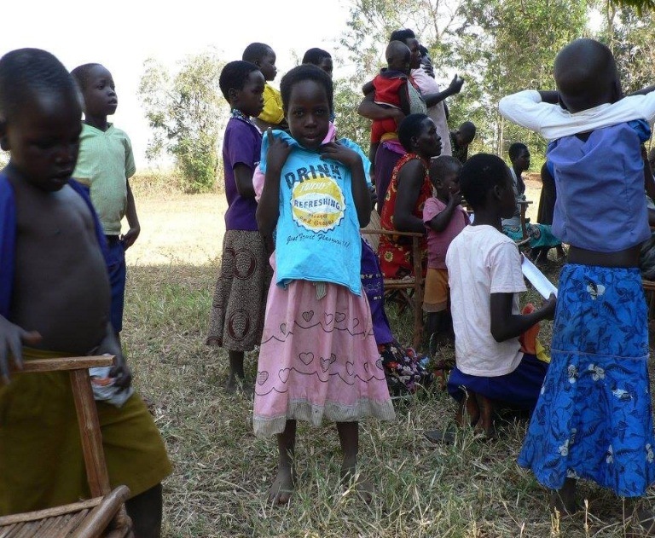  Distribution of cloths donation from student of Holland university that paid a visit to our children sometimes back. | 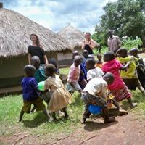  Student of Holland University Volunteering with the foundation, Playing with the children that we do support in the community.
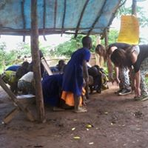  The student teaching in one of our temporally community class. This is our pre class for children who are unable to pay school fees and children who are needy. | 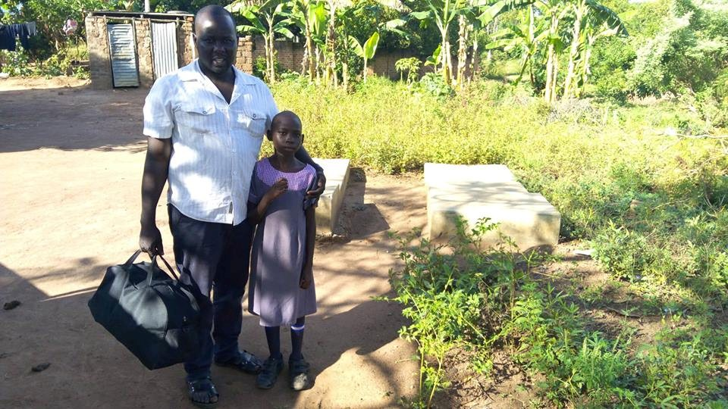  After one year after she has lost her parents I want and pick from her grandmother who is her caregiver and we took her to school and at the moment she is living with my family.
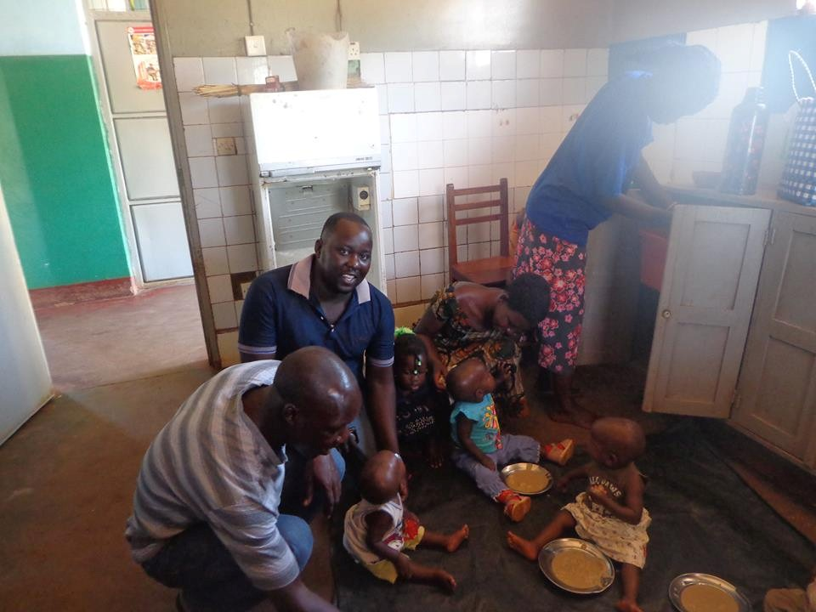 | 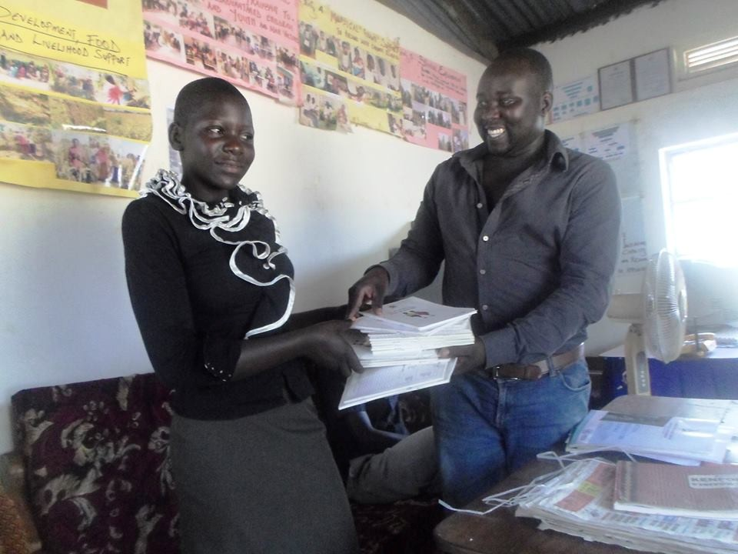
Our team feeding the children at the Babies Home lira/Party our olds Girl received a Book Donation from the Foundation Representative in Uganda at our office.

