VALAMPURI FOUNDATION
3/64 Kanakku Appusamy Street,
Mandapam, Mandapam Post,
Ramanathapuram District,
Tamilnadu, India
Email: valampuri2010@gmail.com
Cell: 9442942753

Annual Report for the year 2013 -2014.
Origin
Valampuri Foundation is a voluntary organization working for Child Development, Women Development and Environment Care. It was established in the year 2010 with the aim of serve for the poor and marginalized in the Ramanathapuram district by a group of young social workers. It has been carrying out progressive programme for women and children and campaign on Mitigate Global warming and Make poor and marginalized to cope with climate change.
Legal Entities
- Valampuri Foundation is registered under Indian Trust Act on 02.06.2010 with the registration number 474/2010.
- Valampuri Foundation has the Income Tax PAN number; AAKFV0546Q

Vision:
To promote a life with dignity and healthy among the children and women in the rural areas and also ensuring Green Environment to the most marginalized children and women in the rural areas.
Mission of our organisation:
- To create awareness on social, cultural, economical, health and environmental subjects.
- To develop through education to win holistic development.
- To organize people associations and forums among supportive sectors to enhance the strength of collective activities.
- To improve the people participation and community ownership.

Project Area:
We are working in Ramanathapuram, Tirupullani and Mandapam blocks of Ramanathapuram district, Tamilnadu, in which around 200 families from 15 villages are covered.

Activities and Achievements:
1. Village Level Awareness Programme on Livestock rearing & Caring
Agriculture is the main source for the rural people and the other side their next income source is livestock rearing like goat, cow, hen, pig etc. Due to climate change and global warming and unnatural agriculture these livestock have been affected by various bacteria and viruses. By these disease the poor farmers may lost their goat or cow which their only property.
In this juncture we were jointly organized with Reliance Foundation, a village level awareness campaign on Livestock rearing and caring, This campaign was organized at Pokkanarenthal and Keelaseethai from Tirupullani block, Peravur from Ramanathpauram block Therkkuvaniveethi from Mandapam block, Kalianagari, Parappuvayal, Theerthandathanam and S.P.Pattinam from Tiruvadanai blocks of Ramanathapuram district.
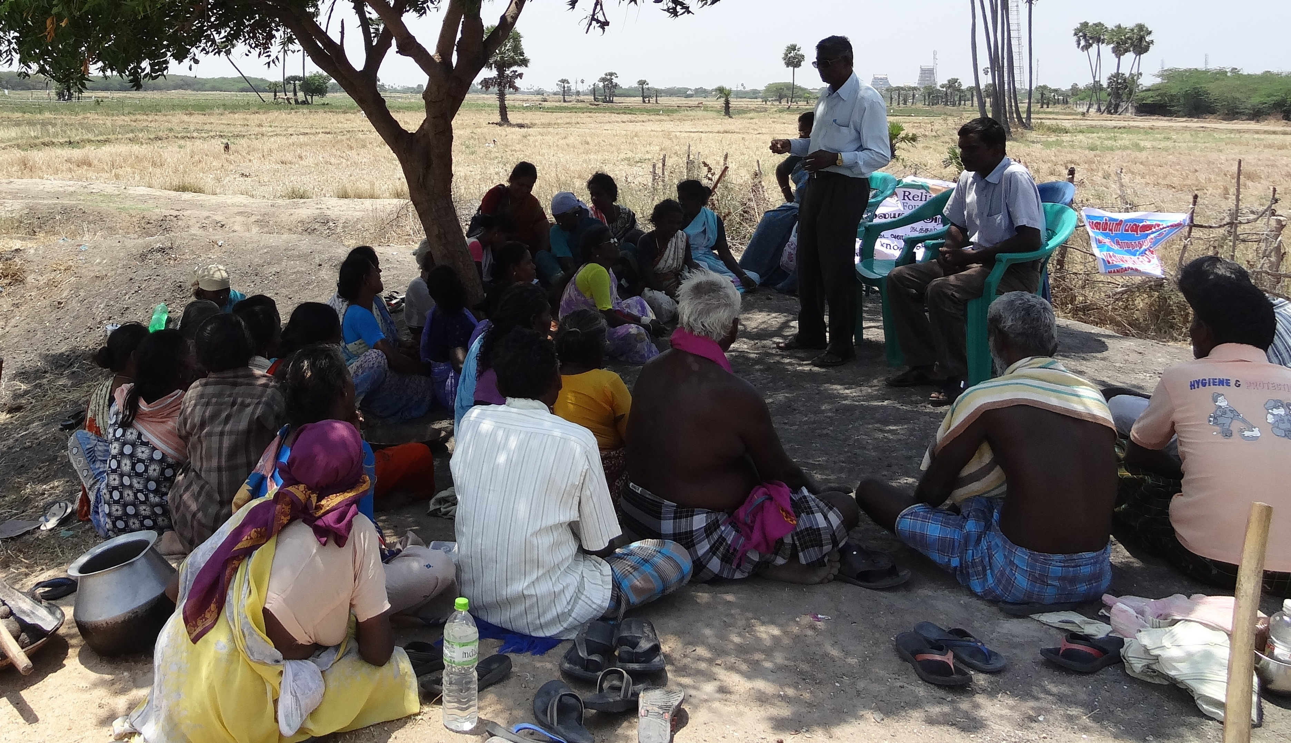
Village Level Live Stock Awareness Meeting at Keelaseethai
This programme was facilitated by Dr.R.Santhanam, Rtd Medical Officer for Veterinary, Tirunelveli. Mr.Antony Arun from Reliance Foundation, Mrs.K.Thalainambu, Director, VRD Trust were other resource people. Mrs.Malar, Coordinator, Valampuri foundation had organized well.
2. Training on Bio fertilizer
Mitigate Global Warming and Make poor and marginalized to cope with climate change is the main objective of Valampuri Foundation. To mitigate global warming and to prevent disasters, we have been promoted bio fertilizers to the farmers. This programme was organized on 01.12.2013 at Kalimankundu village. Mr.M.Rasu, president, Kalimankundu panchayat had inaugurated while Mr.Sivaprakasam, State Convenor, JASUL,and Mrs.Shanthi, Zonal coordinator, JASUL were the main resource persons. Around 100 farmers from various villages had benefitted.
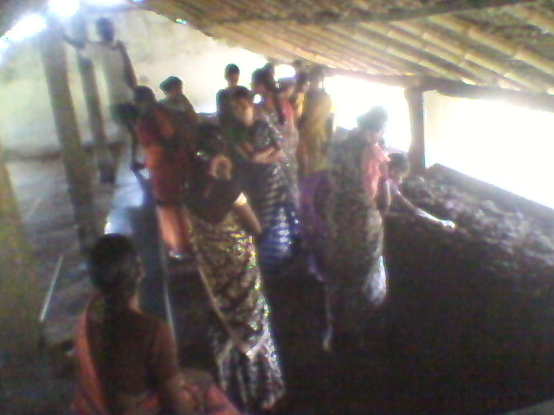
Farmers in the Vermin compost Unit at Perunkulam
3. Workshop on Organic farming
The abundant usage of Chemical fertilizers and pesticide had worst exaggerated the agriculture, soil and water. The poor and marginalized farmers are being vulnerable due to the cost of agriculture external inputs. To aware the farmers we organized a workshop on organic farming at Devipattinam. Mr.Sivaprakasam, expert in organic farming had leaded the workshop. 60 farmers from various villages of Ramanathapuram Taluk had got scientific information on chemical farming and had intense to promote organic farming.
4. Free Computer Training Programme
To support the young educated poor girls we have provided cash support for computer education. During this reporting period 12 poor girls from Mandapam, Ambedkarnagar, Peravur, Salaivalasai and Therkkuvaniveethi had completed their computer education with the support of Valampuri foundation.

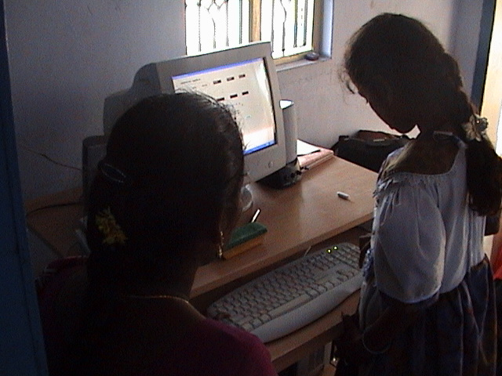
Free computer Education
5. Free School Uniform to Poor Children
To help the parents and stop the school drop outs and school discontinues the organization provided free school uniforms to the poor children. By the help of number of local donors had donated free uniforms. During this reporting period we have given 57 school children with 2 sets of uniforms, 1 school bag, 10 note books, 5 guide & reference books and geometry boxes.
6. Health Awareness programme
To aware the rural people on the need of their health we organized village level programme in 9 villages of Ramanathapuram district. The programme was took place by an expert team consisting of one medical person and two social workers. The team had conducted village level awareness programme especially for rural women. Around 200 women were covered and pamphlets explaining the issue had also distributed.
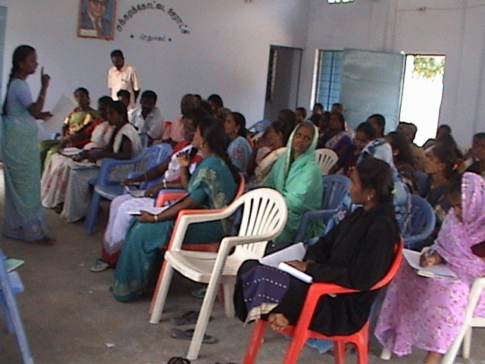
7. Training on EDP to women.
To empower the women the organization has been organizing the women as SHGs and gives trainings in various topics. In this view we had arranged two days EDP training to the women to develop their entrepreneurship skills. This programme was conducted at Ramanthapuram on 12.022014 in which 42 women from 14 SHGs were benefitted. Mr.K.R.Raju, State Trainer on EDP, Tiruchy had facilitated the training.
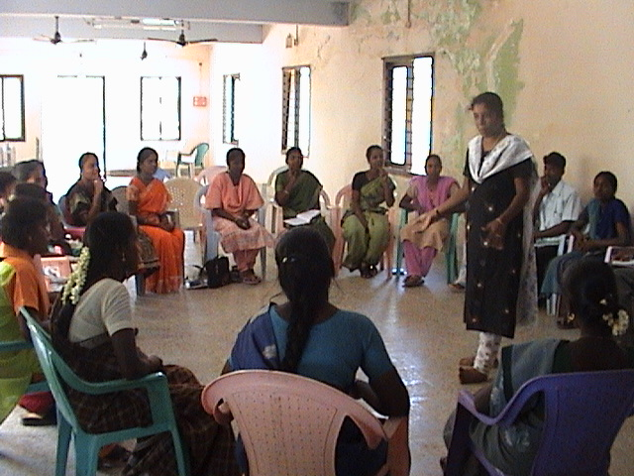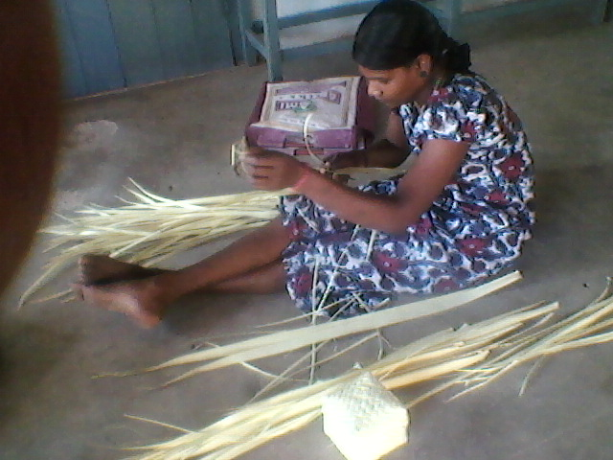

8. Awareness Programme on Global Warming and Climate Change:
The coastal areas of Ramanathapuram district are longest and face several environmental problems due to the climate change. The “Pavalaparai” (coral reef) the birth place of fishes are totally in hazardous position and it affects the fish workers’ livelihood. We organized a one day programme for the coastal people on the importances of Pavalaparai and disseminated the information.
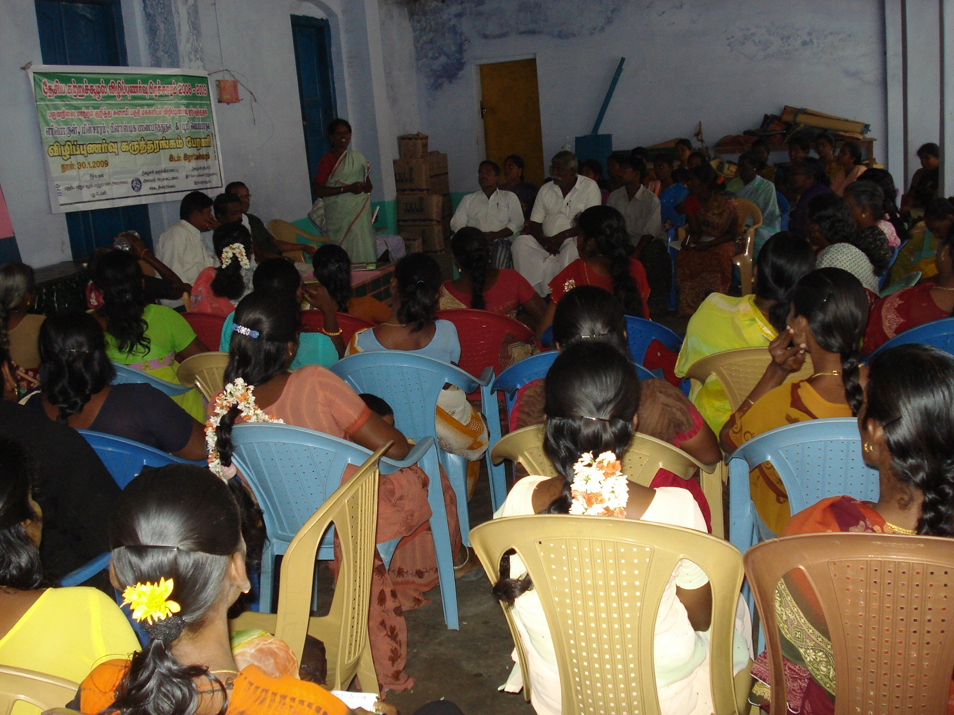
Programme on Global Warming
The Prgramme was organized on 30.06.13 on the theme of usage of fuel, electricity, water, plastics, forests, rivers and coastal ecosystem to improve the climate in the coastal area. More than 70 women around Rameswaram were participated. Mr. J. Prabakaran, PAD, was resourced the participants. Before the workshop a rally was organized at Rameshwaram. Mr.V. Kannan, Inspector of Police, Rameswaram Town begins the rally and ended with lecture of Mr.V.Jeyachandran, Head Master of Govt. Hr.Sec.School, Rameswaram.
9. Awareness programme on Renewable Energies
In renewable energy wind power and solar power has the number one place in technical and it is also viable in practical. But this is seasonal. In this developing world power is the most wanted and needed, because we are live in an e-world which is totally run after electricity.
To disseminating the theme about renewable energy to the rural mass, we had arranged a awareness workshop at Ramanathapuram. 85 rural people including, village leaders, youth club leaders, women self help group members, local school teachers were participated in this workshop.
Mr.D.R.Anand, B.E. Consultant, Sathyam Infotech, Chennai had facilitated the seminar and lively detailed about the solar power which we can easily get and it could be renewable. He added that Government of India and government of Tamilandu both boost this system with huge amount of subsidy.
Board Members:

Mr. D.Arockiaraj, B.A. | Managing Trustee
Mrs.H.Malar | Finance Trustee
Mrs. G.Radha | Trustee
Mr.M.Arumugam, D.M.E. | Trustee
Mrs.R.Deivanai | Trustee

The board approved the activities, financial statement and annual report. We circulated the minutes of the board meetings and recorded it. The Managing Trustee Mr. D.Arockiaraj is the chief functionary of the Organisation and he was paid no remunaration.

Conclusion:
We express our sincere thanks to our board members, donors, networks, NGOs, government officials, and CBOs for their support. Valampuri Foundation expects the same support in coming years too.

