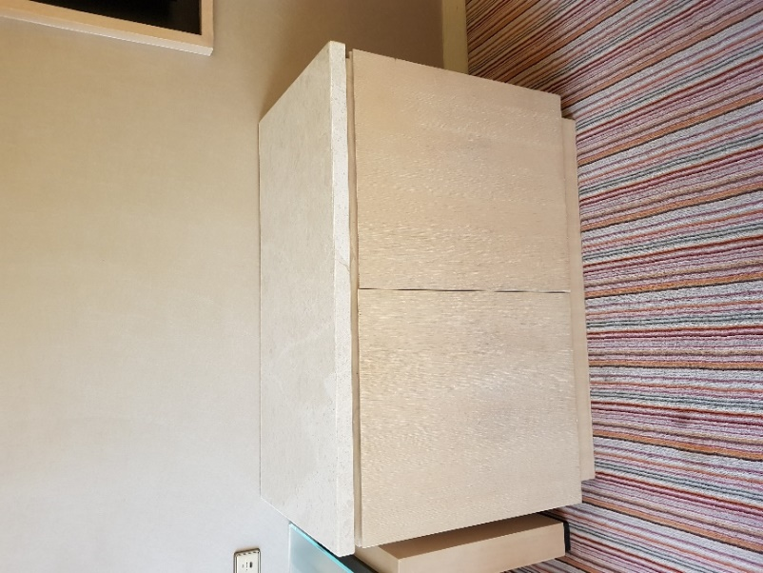
Mini-Bar Cabinet 60cmL x 120cmW x 85cmH – 20

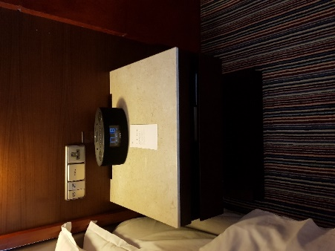
Bedside Table 45cmL x 45cmW x 55cmH – 43
45cmL x 48cmW x 55cmH – 75
45cmL x 50cmW x 55cmH – 29
45cmL x 58cmW x 55cmH – 57

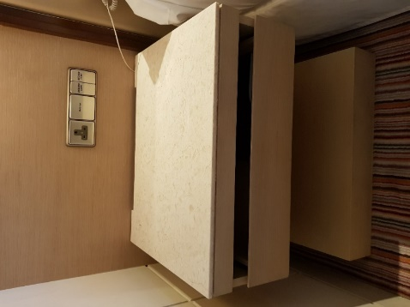
Bedside Table 45cmL x 29cmW x 55cmH – 8
45cmL x 32cmW x 55cmH – 16
45cmL x 35cmW x 55cmH – 81
45cmL x 48cmW x 55cmH – 93
45cmL x 50cmW x 55cmH – 66
45cmL x 58cmW x 55cmH – 295

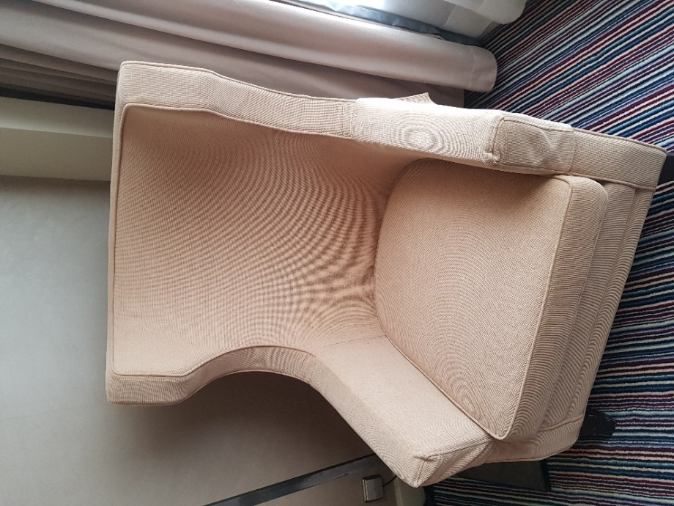
Tub Chair 64cmL x 73cmW x 109cmH – 390

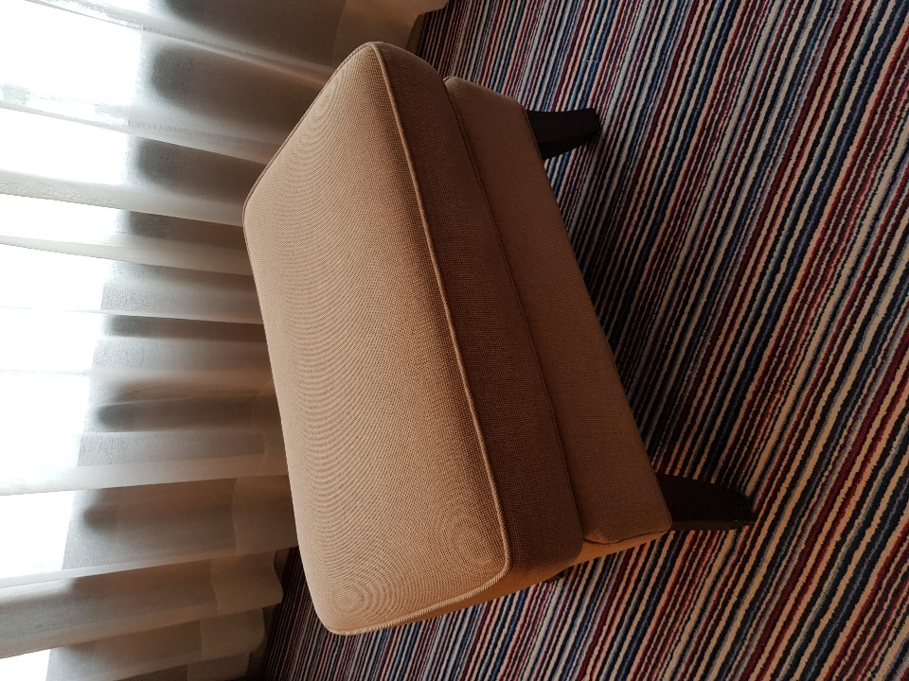
Ottoman 37cmL x 61cmW x 41cmH – 250

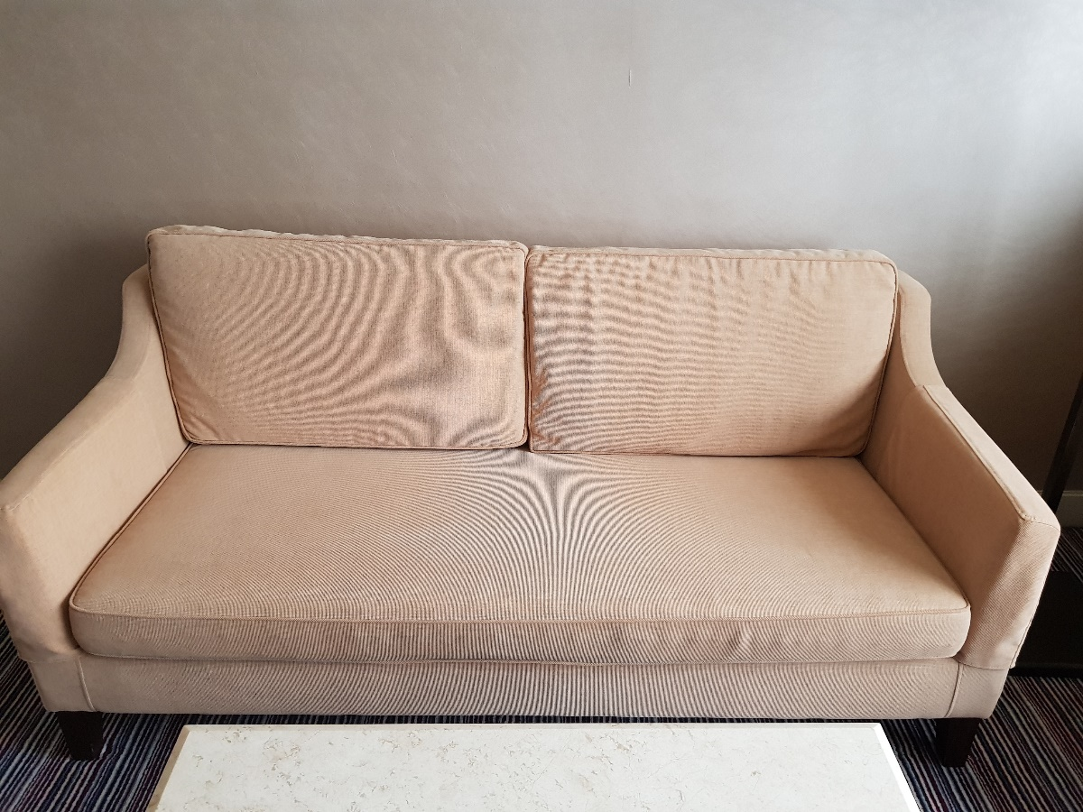
3 Seat Sofa 84cmL x 178cmW x 77cmH – 40
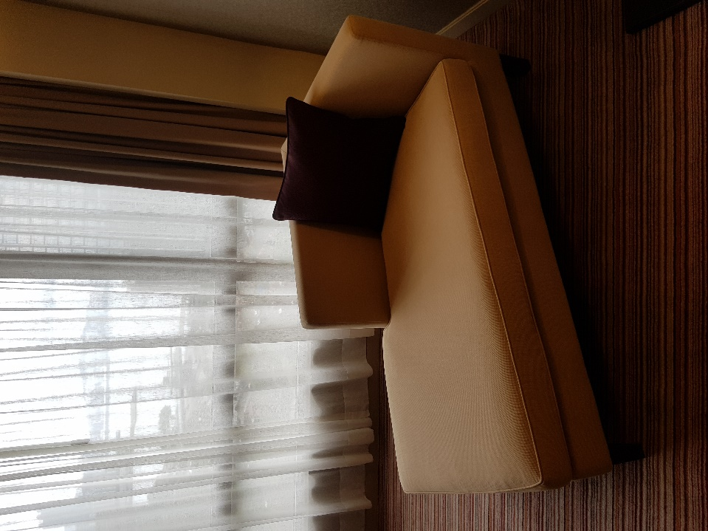
Chaise Lounge 80cmL x 150cmW x 76cmH – 4

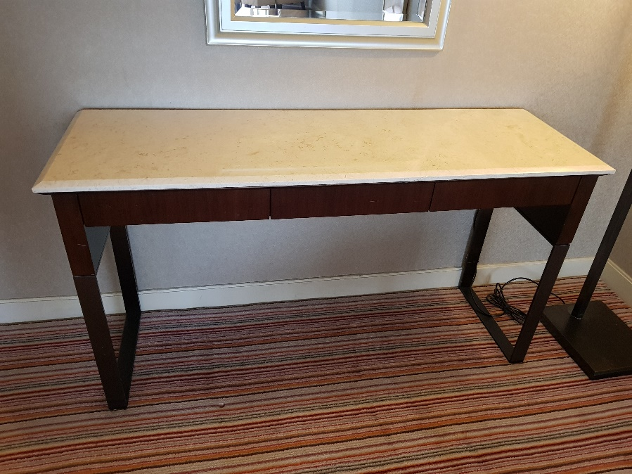
Dresser Table 40cmL x 140cmW x 75cmH – 2

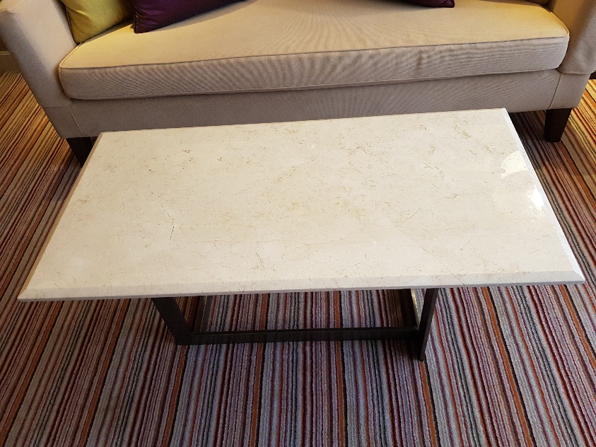
Marble Coffee Table 50cmL x 100cmW x 77cmH – 45

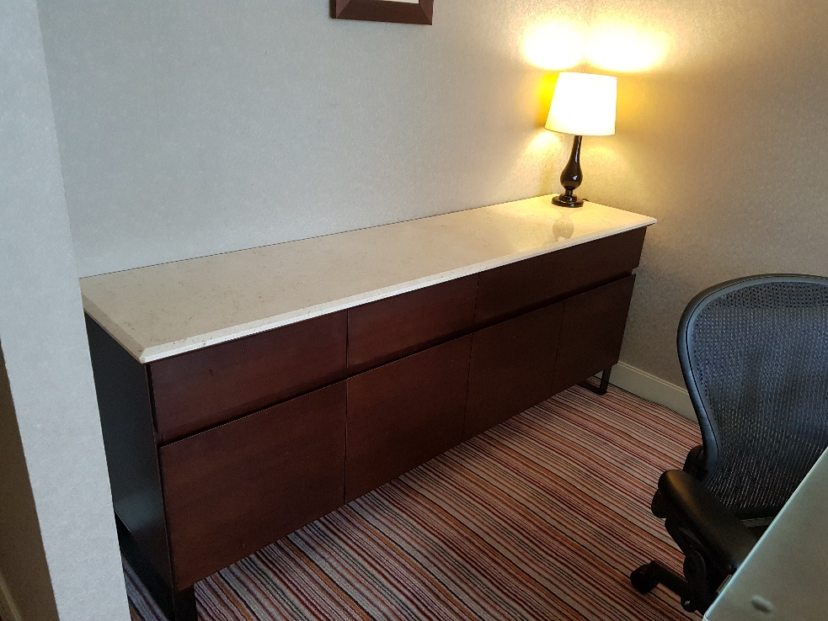
6 Drawer Cabinet 45cmL x 190cmW x 75cmH – 4

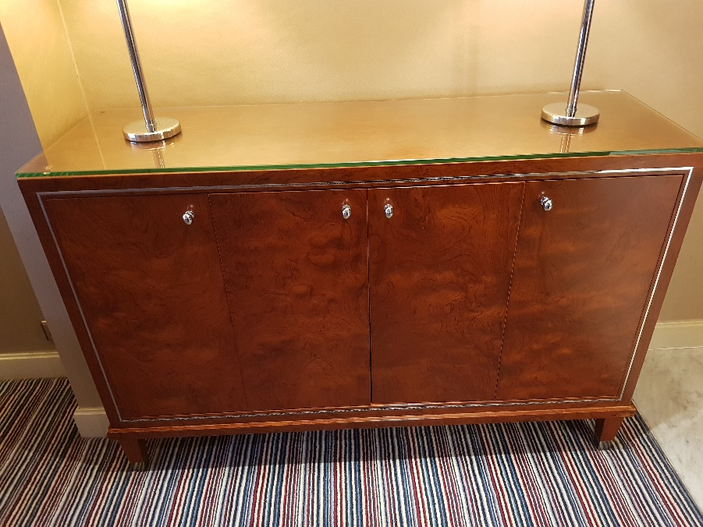
4 Door Cabinet 40cmL x 130cmW x 86cmH – 8

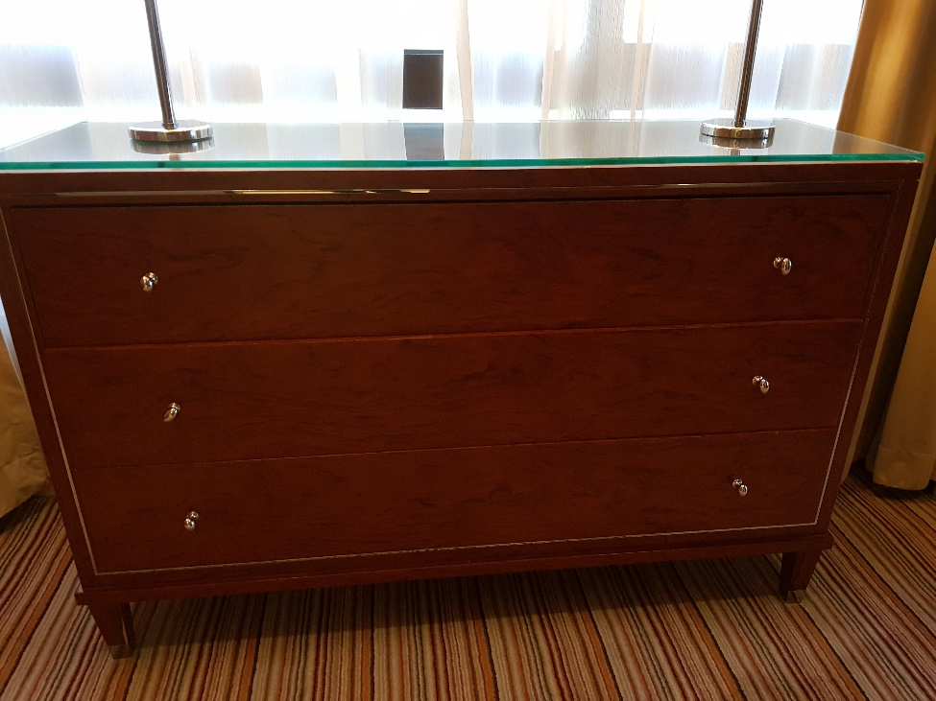
3 Drawer Cabinet 40cmL x 130cmW x 86cmH – 5

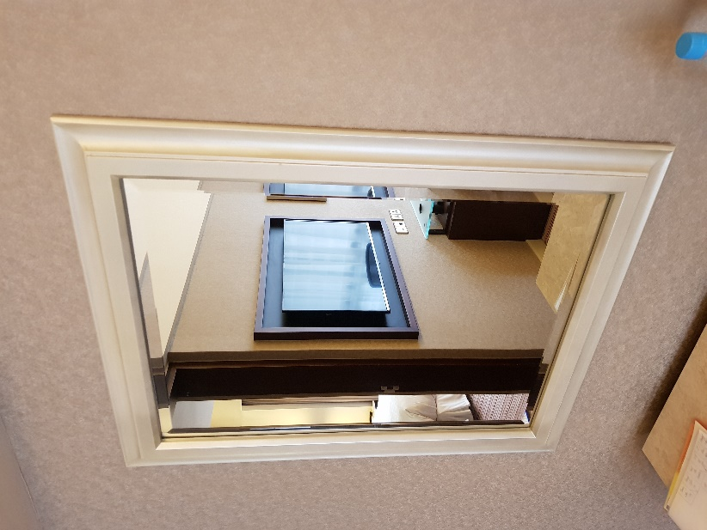
Mirror 90cmL x 70cmW – 10

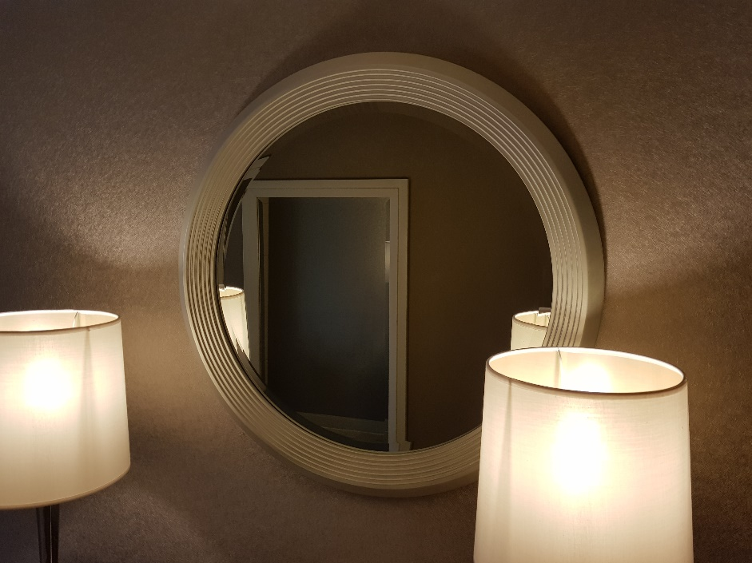
Mirror Diameter 80cm – 5

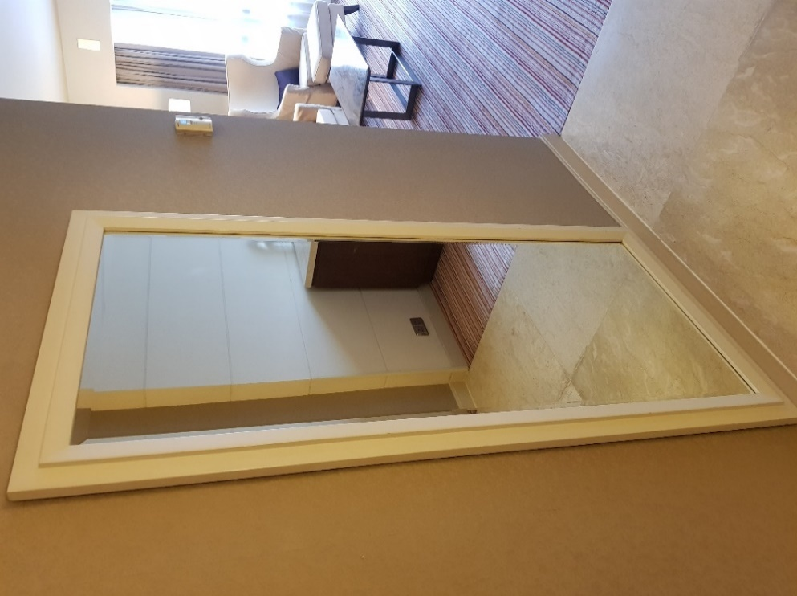
Mirror 170cmL x 80cmW – 7

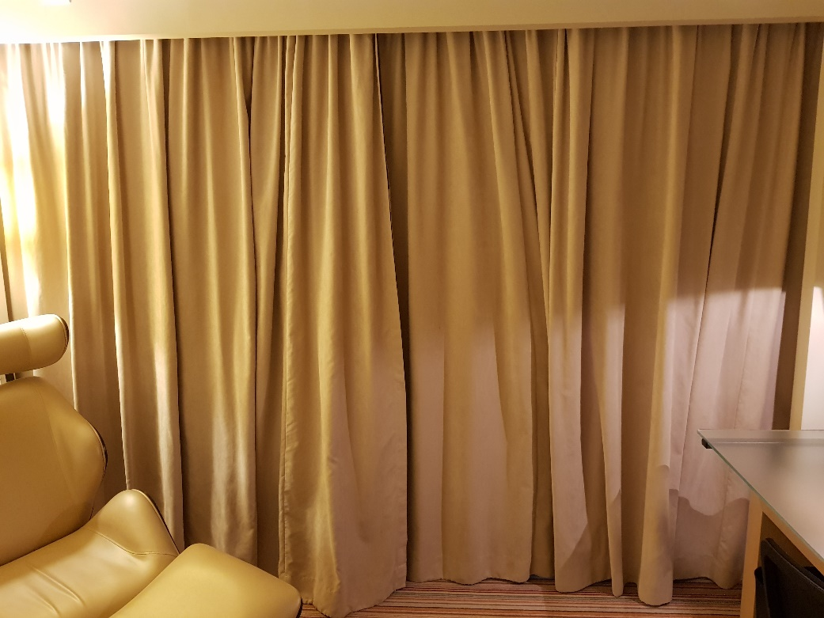
Black Out Curtain – 300pairs

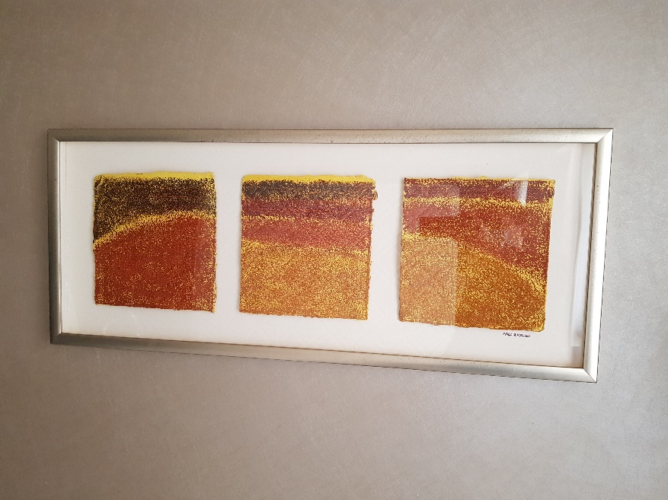
Art Work 41cmL x 99cmW – 150

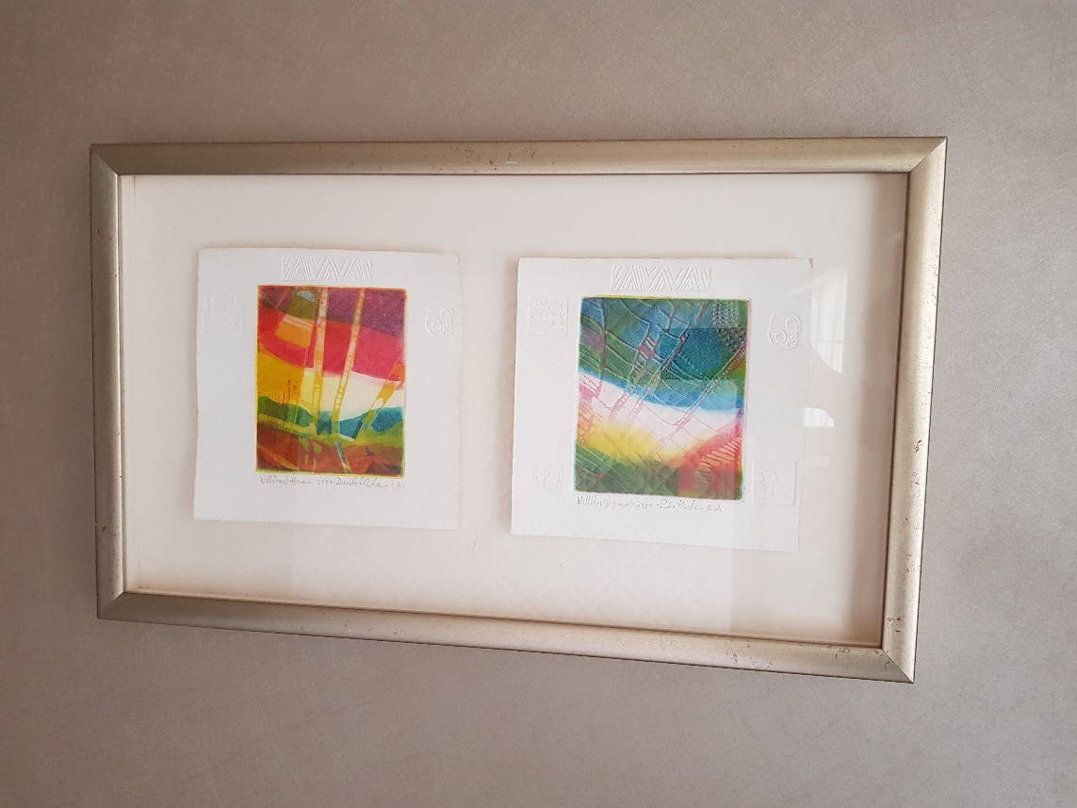
Art Work 37cmL x 62cmW – 50

