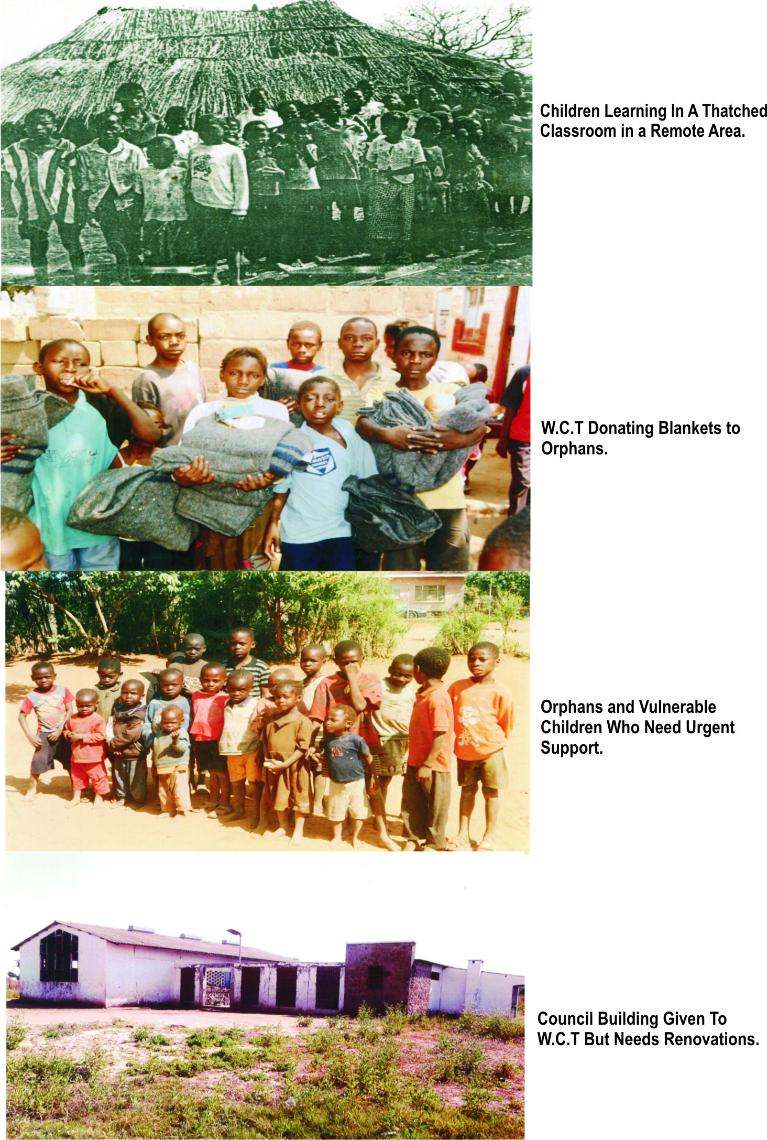

**Some Orphans & Vulnerable Children Who Need Urgent Support.**

**Council Building Given To W.C.I But Needs Renovations**

**W.C.I Donating Blankets to**

**Orphans**