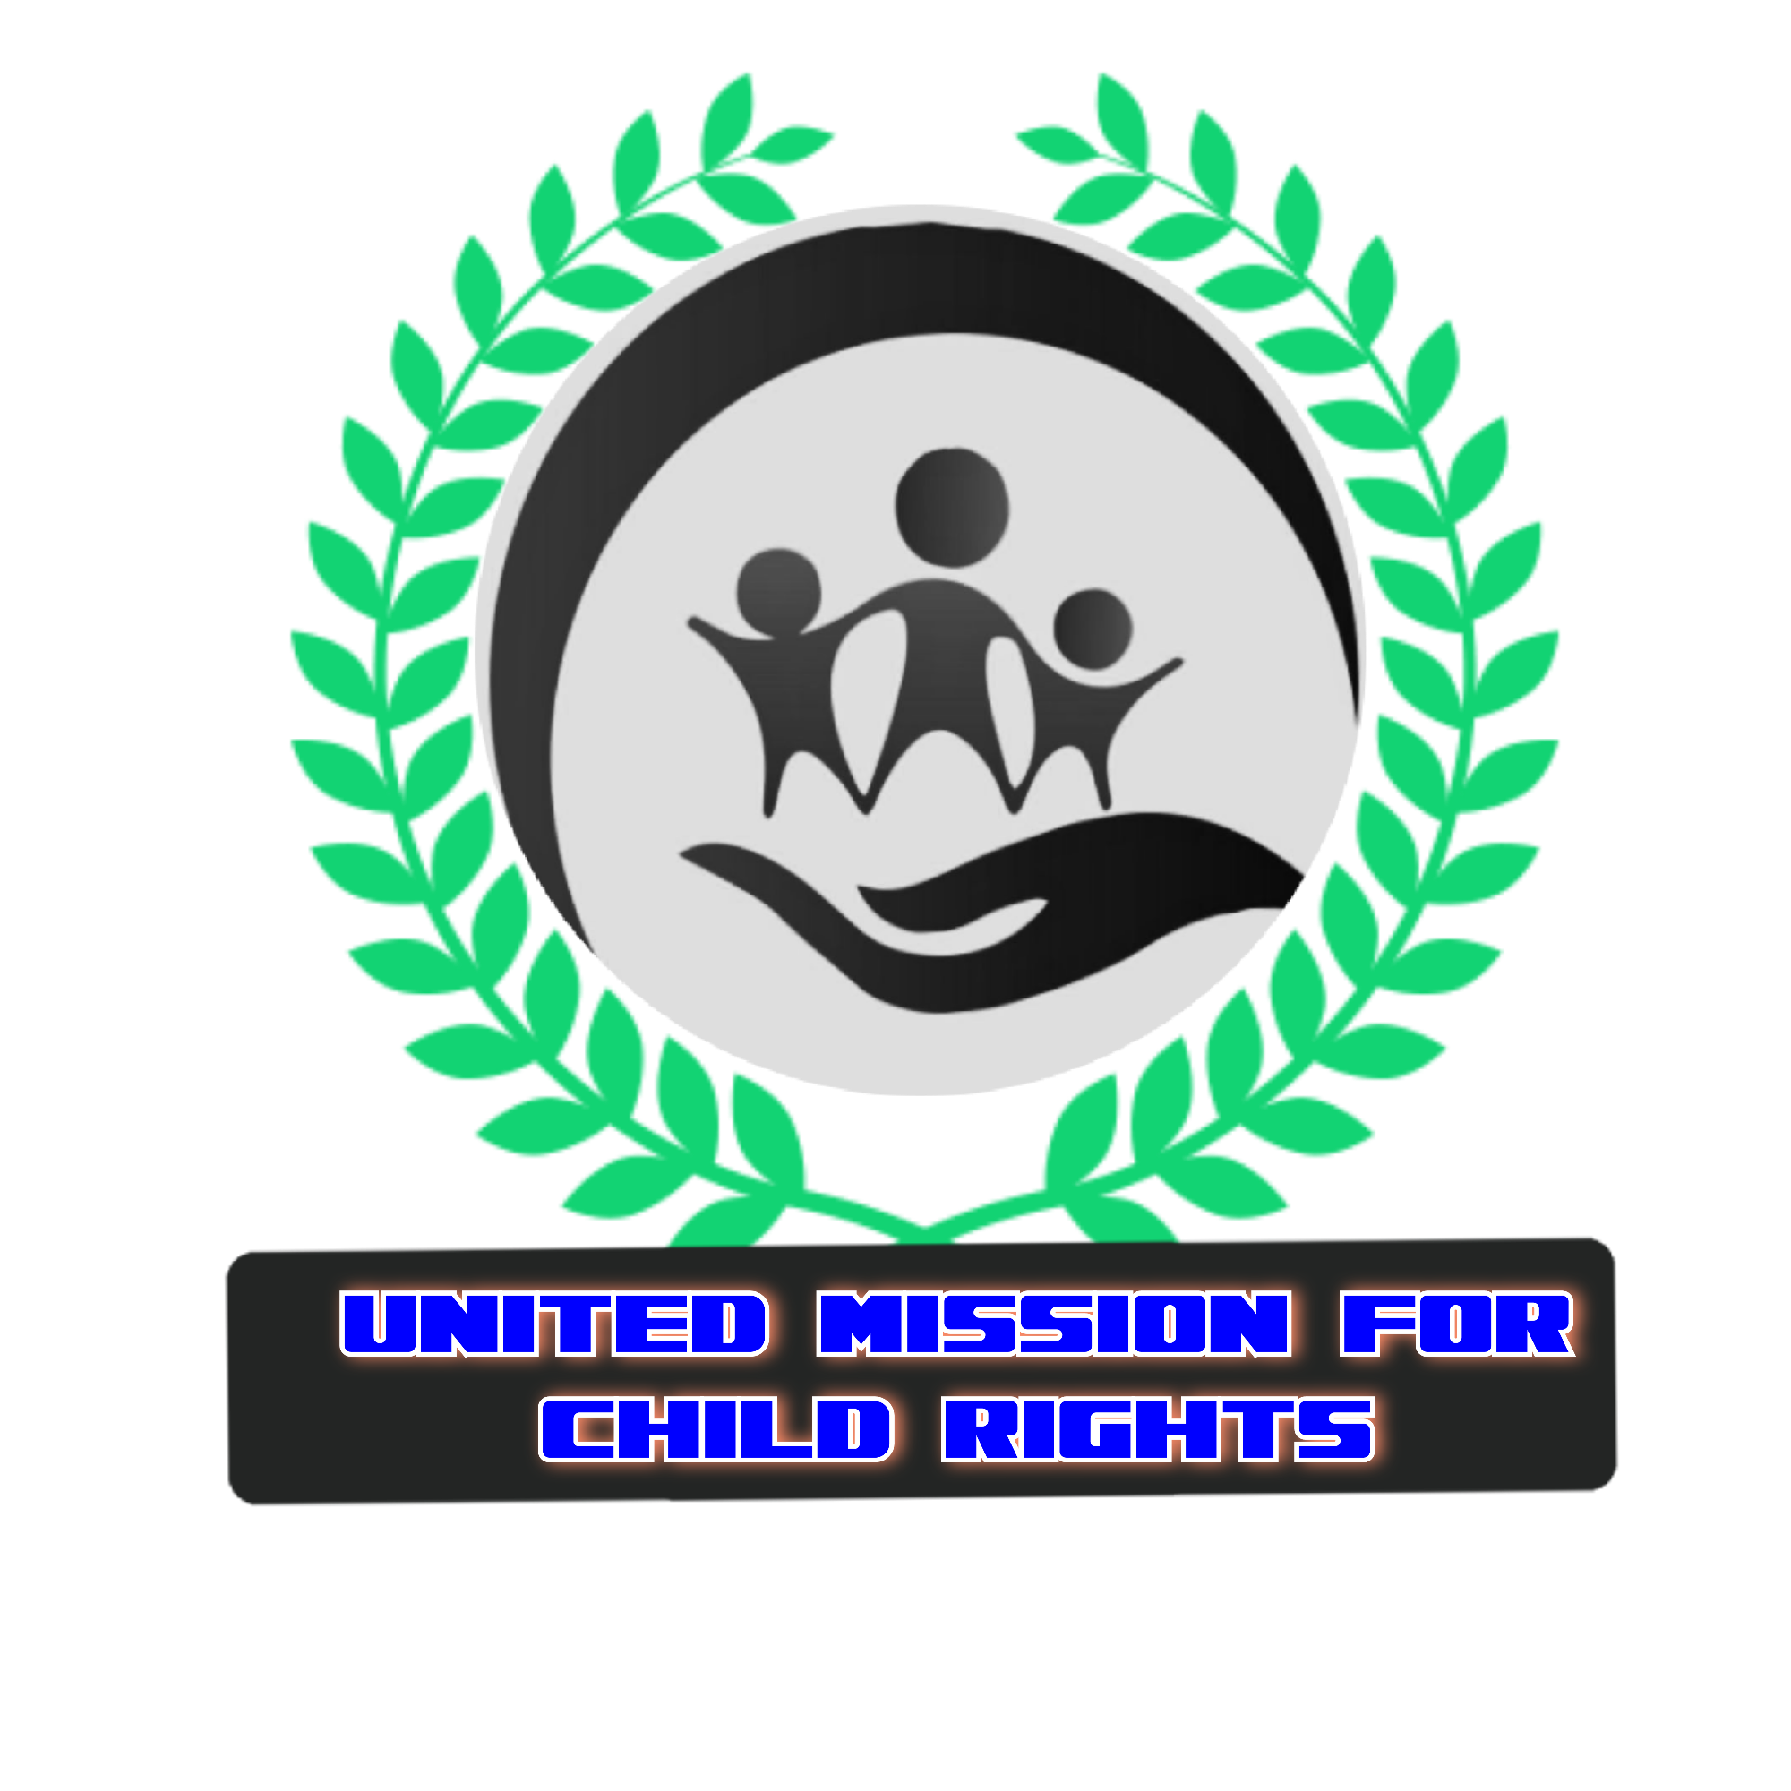

The Organization profile for United mission for child rights (UMFCR)
Name of the organization | United mission for child rights (UMFCR)
Date of establishment | ^{15th} July 2020
Legality (registration) | Registered with Uganda National NGO Board, Terego NGO Forum, Terego District Local Government.  Registration date: 7/July/2021  Certificate NO. 636/023
Contact address | Physical: Odupi sub county,  Imvepi refugee settlement  Terego District  Northern Uganda  Tel: +256777152582 / +256772053342  E mail: umfcr.org@gmail.com  Web site: https://umfcr.websites.co.in
Contact persons | 1. STEPHEN BIDA  Executive director  +256777152582  stephenbida2019@gmail.com  2. OBETRE GEOFREY  Program Manager  +256779332955
Organization background | United mission for child rights (UMFCR) is a refugee led organization voluntary association of individuals, Non-Governmental Organizations (NGO). it has been registered in accordance with the laws and regulations of the Republic of Uganda to operate. The organization defend on members contribution to carry out its activities to the communities of refugee and host. United mission for child rights was founded on 15/July/2020 by group of humanitarians individuals or workers both refugees, and nationals who contributed their ideas to improve the life of children in the refugees and host communities in Imvepi refuges settlement Terego district northern Uganda. The mission started in Imvepi refugee settlement Terego District northern Uganda in particular with a purpose of promoting, advocating the status of life of the children in refugees and host communities, for equal rights and respect for children rights in the communities. The founder members realized a need to collect the, children and vulnerable persons towards a common goal of improving their way of life in line with protection, education, health, and agriculture. There comes into existence an organization united mission for child rights to provide a solution to the marginalized national and refugees children.
Vision | A peaceful United and healthy world offering the marginalized children with an opportunity to have a say and be involved in the socio-economic development decisions affecting them”.  '' To ensure that 75% of children and their Caregivers are empowered on child protection, health, child Education, and agriculture.
Mission statement | Our mission is to focuse on working towards: restoring hope among vulnerable children and communities that have been affected by poverty, abuse, violence, disease, civil war, conflict and other natural calamities, through psychosocial support, sensitization, community outreaches, educational support, child protection support”
Values  Goal | - Team spirit, and non discrimination
Values  Goal | - Solidarity, and integrity
Values  Goal | - Accountability and transference
Values  Goal | To empower, protect and Educate The destressed, needy, neglected vulnerable children and communities by providing them with necessary assistance and services to support there life in the communities.
Shared value | Every Child is my Brother / Sister.
Objectives | - To create social stability and awareness to children and communities on sexual Reproductive health rights and other related adolescence issues.  - Creating avenue for advocacy for child rights, peaceful resolution of conflicts and sustain socio- economic development among the marginalized communities.  - To advocate for a society whereby children with disabilities have equal rights and opportunities for growth and development.  - Improved access to education and psycho-social well-being of marginalized children.  - Increase household income through self-help projects hence eradicating household poverty among the victims of armed conflict and marginalized communities.  - To facilitate the rehabilitation of traumatized children through sports and MDD  - To ensure that children are safe and healthy and protected at home, in school and communities.  - To promote and advocate for the full realization of the rights and well-being of all children in Africa and the refugee communities.  - To speak out against child rights violation and facilitate collective action to ensure children rights are respected and their well-being realized.  To Educate children, youths and women/men on peaceful coexistence in the communities.
Thematic areas | CHILD PROTECTIONS, LIVELIHOOD, PEACE EDUCATION, EARLY CHILDHOOD DEVELOPMENT AND FINANCIAL LITERATURE  SUB - ACTIVITIES  community-based Child protection  The purpose of Child Protection Services is to ensure that, children are safe and protected to prevent any future abuse or neglect through the provision of supportive services, awareness and sensitization, training of caretakers, parents, and children on child protection to protects children from physical abuse, neglect, and sexual abuse. Child protection services also helps families obtain needed services to guarantee their children are safe from harm.  Peace education  In order to bring peace in the community of conflict, war, and disasters, there's need of physical and emotional support to youths, women, children and adults, And this shall be done through awareness and sensitization, community dialogue and meetings on peace and reconciliation, provision of skills trainings, Materials support to the traumatized, vulnerable and stressful affected people. Creation of youths centers and children forum centers.  Gender based violence  Gender-based violence (GBV) refers to all harm inflicted or suffered by individuals on the basis of gender differences. Its intention is to establish or reinforce power imbalances and perpetuate gender inequalities. GBV can affect females or males; however, it affects women and girls systematically and disproportionately. GBV includes, for example early and forced marriage, female genital mutilation/cutting (FGM/C), sexual violence and abuse, denial of access to education and reproductive health services, physical violence, and emotional abuse.  When gender-based violence is perpetrated by aid workers against the affected population it is called Sexual Exploitation and Abuse (SEA). Sexual exploitation and abuse may include forms of GBV as well as the exchange of money, employment, goods, or services for sex and/or sexual favors, or other forms of humiliating, degrading, or exploitative behavior.  UMFCR carry this activity through awareness and sensitization, community dialogue and meeting, sex education, counseling and referral of GBV cases to the services provider and authority. Development of IEC materials to the community.  Livelihood  Provision of sustainable agriculture and profitable means of livelihoods, training of Income Generating Activities and Establishment of demo gardens, kitchen garden and bee keeping sites to support to Orphans and Vulnerable Children (OVCs) to attain vocational skills and provision of basic start up tool kits to beneficiaries War affected children in the community more especially the school dropout.  Early childhood development  Early childhood development (ECD), also known as nursery education, is a branch of education theory that relates to the teaching of children (formally and informally) from birth up to the age of eight. Traditionally, this is up to the equivalent of third grade. ECE is described as an important period in child development. This shal be done through establishment of nursery school, child space to educate and mentor children to understand and build Educational career.  Financial literature  Financial education is a basic life skill that has a direct impact on personal well-being. Basics like money management, savings, investing and debt will lay a strong foundation for money habits if imparted from a young age.  Learning personal finances and important money skills at an early age provides with lots of opportunities to apply them in real life. If you are already in a habit of budgeting, saving regularly and spending wisely, think about the jump-start you get in life. This will be done through formation and training of VSLA groups. Training of community members about financial literature and business groups and direct support to the beneficiaries. Eg savings materials.
Experience / achievements | Current and past projects
  Sources of funding | Project running | Status | Donor contact
  The Organization Carry out it's program activities volunteerly with Out been Funded and depending on membership fee and contribution from it's members. | Community based child protection | Continue | Non
Organization structure | 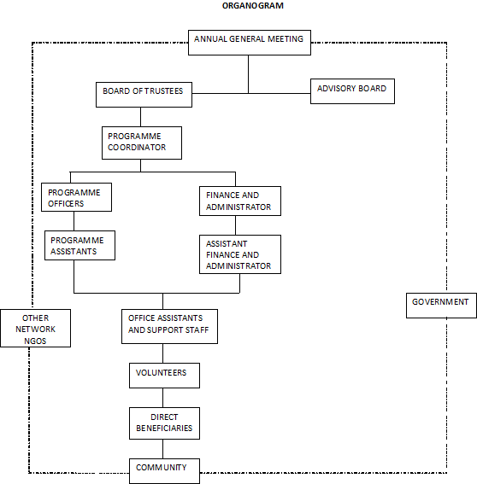  Organization structure
Statement of staffs
  Board | sex | Age | Position | Contact | Commitment
  Stephen Bida | M | 30 | Chair person | 0777152582 | H member
  Rose Mary | F | 45 | Treasurer | 0780668058 | H member
  Joseph mukulia | M | 29 | Secretary | 0776698004 | H Member
  Emmanuel Baraka | M | 30 | Board member | 0775513937 | H member
  Management
  Obiter Geoffrey | M | 26 | Program Manager | 0779332955 | Full time
  Amon Bala | M | 24 | Asis Field Coordinator |  | Full time
  Kepo Alison | M | 40 | Field coordinator | 0787094983 | Full time
  Cadribo Faustine | M | 24 | Asis Field Officer | 0779016931 | Full time
  Supporting staffs
  Juliet Nakatel | F | 23 | CBF | 0783847437 | Part time
  Bida Dona peter | M | 24 | CBF | 0788525933 | Part time
  Amon Bala | M | 26 | CBF | 0777308220 | Part time
  Monika bako | F | 32 | CBF | 0788118661 | Part time
  Waru Moses | M | 27 | CBF | 0776957922 | Part time
  David Sibert | M | 30 | CBF | 0783786142 | Part time
  Jackson Taban Peter | M | 28 | CBF | 0786526825 | Part time

