Assessment Report Flash Flood 2013 Rajanpur
Date: August 13, 2013
As moon soon rains are on flow in the whole country, in that result “Hiltorent Flash Flood” started on August 02, 2013 night from Koh-E-Suliman Mountain Ranges through four main case ways i-e “DARA KAHA, DARA CHACHER, Kala Bagh Khosra & Sori Shumali” that badly affected the following union councils of two Tehsil in District Rajanpur;
Sr. # | UC Name | Tehsil
1 | Tibbi Lundan | Jampur
2 | Harrand | Jampur
3 | Wah Leshari | Jampur
4 | Dajal | Jampur
5 | Hajipur | Jampur
6 | Jahanpur | Rajanpur
7 | Fatehpur | Rajanpur
8 | Kotla Eson | Rajanpur

The discharge from these four case ways on August 03, 2013 at 05:30 PM announced by the District Government is as under;

The agricultural land is also destroyed and cant estimated at the current scenario. The houses destroyed reported but all the above mentioned loses are not declared by District Government because all the District Government is busy to rescue the affected population and to save the band of canals.
District Government announced the emergency in the affected areas of these two Tehsil. District Government with the support of all other humanitarian organizations is busy to rescue the affected population.
The above mentioned areas are affected badly and the main ways to enter these areas are cut off, as Dajal is surrounded with the flood water and no way to approach the Harrand, lal garh, tibbi lundan & Lundi Saidan. Similarly the way to hajipur is also cut off. The rest of areas are not approachable at this time.

Immediate Needs:
The following items are required immediately for the affected population;
- Camps/Tents
- Assistive Devices for PWD’s
- Cooked Food
- Clean drink water
- Medicine
- Hygiene kits
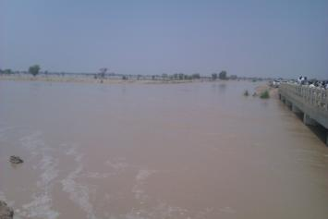
- Dry ration
Deputy Speaker Punjab (Mr. Sher Ali Gorchani) briefing to Media regarding flood situation
The way to Hajipur from Fazilpur
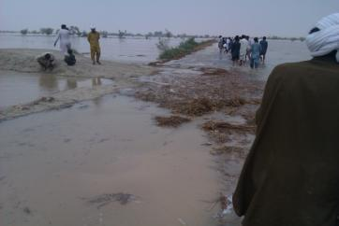
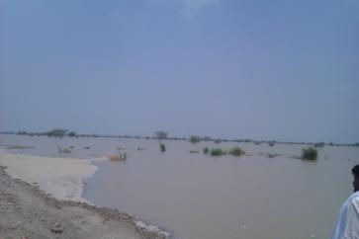

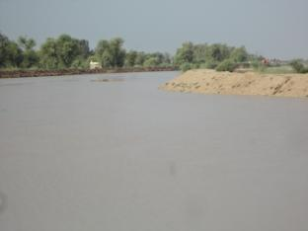
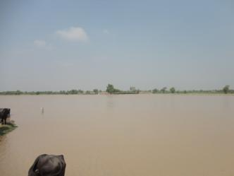

The view of destroyed agriculture
The way cut off to Hajipur from Fazilpur side

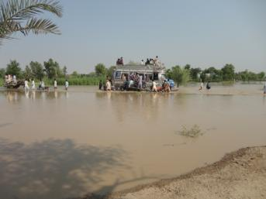
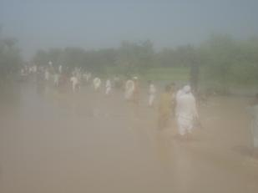
The way cut off to dajal from jampur side
The affected population travelling to safe side

