
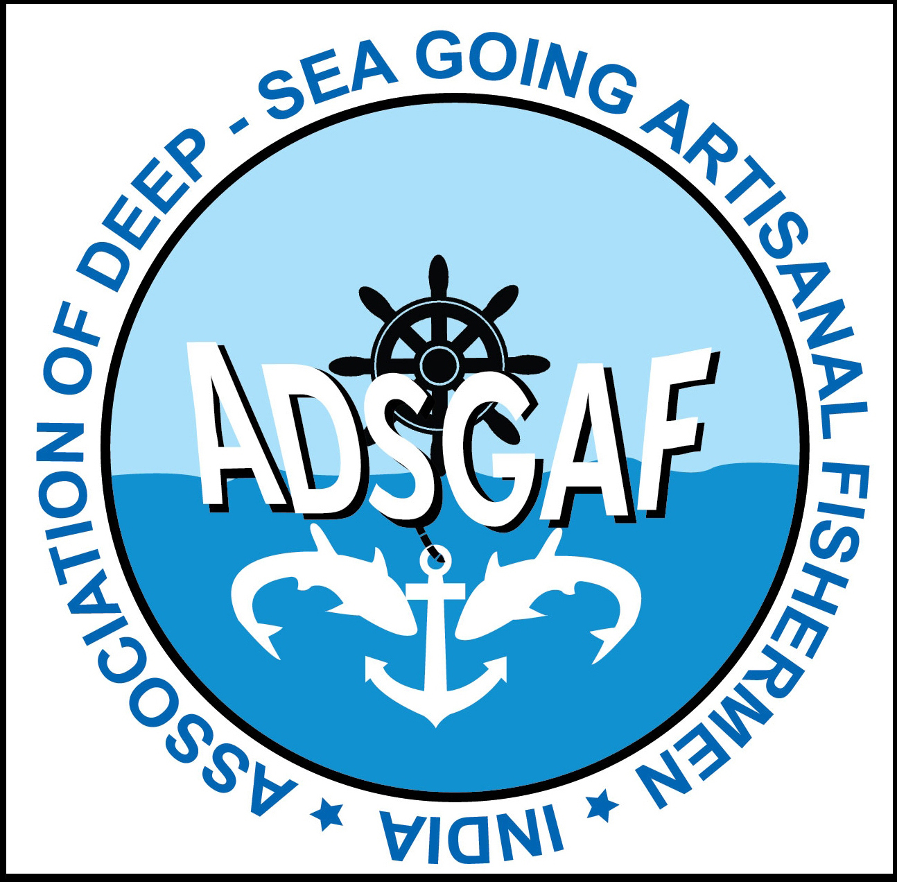
Demo on the operation and applications of solar energy in Out Board Engine boat
Demo on the operation and applications of solar energy in small boat were organized by ADSGAF and BOBP-IGO in association with Jagath Jothi Solar Company (P) Ltd on 24th January 2013 at Neerody, Kanyakumari District. This demo was based on the successful trial and subsequent operation of solar energy system in bigger boats of in-board engines which was organized earlier in the month of Novermber 2012 by ADSGAF and BOBP-IGO in association with Jagath Jothi Solar Company (P) Ltd.

The demo was carried out at out board engine fitted plywood boat owned by Mr. Stellus of Neerody. There are 24 fisheries officers from six countries including India arrived Neerody to see the demo. They are Mohammad Nazim Uddin-Upazila Fisheries Officer, Mohammad Mahbubur Rahman-Inspector, Md Abdulla Al Hasan-Upazila Fisheries Officer and Md Moshiur Rahman- Upazila Fisheries Officer from Bengladesh, G. Mohana Pai-Assistant Commissioner (Fisheries), S. G. Patwari-Junior Fisheries Scientist, V. Senthil Kumar-Inspector of Fisheries, T. Vijayaraghavan-Inspector of Fisheries, Bharat Bhushna J. Sahoo-Assistant Fisheries Officer from India, Afran Rouzani Pulungan-Marine and Fisheries Services of North Sumatera, Zuyetti-Head of Fishery Business License Section, Ali Firman Herlambang- Directorate of Fish Resources from Indonesia, Mohamed Adhuham- Assistant Data Processing Officer, Aminath Inasha-Administrative Officer, Mohamed Naseef -Senior Project Officer, Aminath Suha-Assistant Food Technologist from Maldives, Pyit Pyo Oo-Deputy Assistant Fishery Officer, Hlaing Win -Assistant Fishery Officer, Tin Zar Lin-Assistant Fishery Officer and Min Kyaw Zin-Assistant Fishery Officer from Myanmar, MMA Sampath Maheepala -Research Officer, AN Samanthi Seneviratne-Quality Control Assistant, Chaminda Kumara Sapumohotti-District Aquaculture Extension Officer and Ganesan Dhanabalasingam-Fisheries Resources Management Assistant from Sri Lanka. The above team was headed by Dr. Y.S. Yadava-Director BOBP-IGO who is organizing training on Code of Conduct for Responsible Fisheries to the visitors. Srinivasan, Jayaraj, Rajdeep Mukherji and Sarif Uddin are other members from BOBP-IGO who came with the team.

Neerody parish priest Fr.Perera welcomed the visitors. ADSGAF Chief Executive J. Vincent Jain talked about the solar project in smaller boats. He said that the unexpected and uncontrolled hike of fuel cost is one of the problems in fishing now a days. The major chunk of the investment in fishing voyage is fuel. The department of fisheries, Govt of Tamilnadu is supplying 250 liters of kerosene for one month with the coast of Rs. 25 per litter. But, it is sufficient for only one voyage. The duration per voyage is 5 to 6 days. They buy from the black market for their requirements and the cost per liter varies from Rs. 40 to Rs. 45. Hope the solar energy system will help them to save fuel cost and it will be a boon to the community and their fishing activities.

Dr. Y.S. Yadava inaugurated the demo by switching on wireless. Dr. Yadava said that generally, fishermen carry charged battery in boats for lights and for the operation of navigational and safety equipments. Recharging will be a major problem for the owners of smaller boats’ fishermen. They need to run the engine exclusively for recharging because while fishing, they do not run the engine. Running the engine for recharging is highly expensive and affects the income of fishing. There is lot of research mainly focusing to improve the quality of solar power plants, which are lighter, more durable, energy efficient and more cost-effective. A full powered solar energy operated boats can be seen soon in our ocean. It will be more helpful to the small scale fishermen.
Solar engineer Sadhish Kumar from Jagath Jothi explained the functions of the system. He said that the installation of solar system in one plywood vallam is Rs. 30,000. The company planned to lower the cost if fishermen buy bulk quantities.

ADSGAF president Selvorian, Executive committee members Lawrence, Sesadimai, Jermanse, are attended. Mr. Vargheese, Mr. Edwin of Neerody helped to organize the demo in Neerody

