CERTIFICATE

OF

MEMBERSHIP

Presented to

Horizon Social Assistance Development Organization

an Affiliate Member of the

World Federation for Mental Health

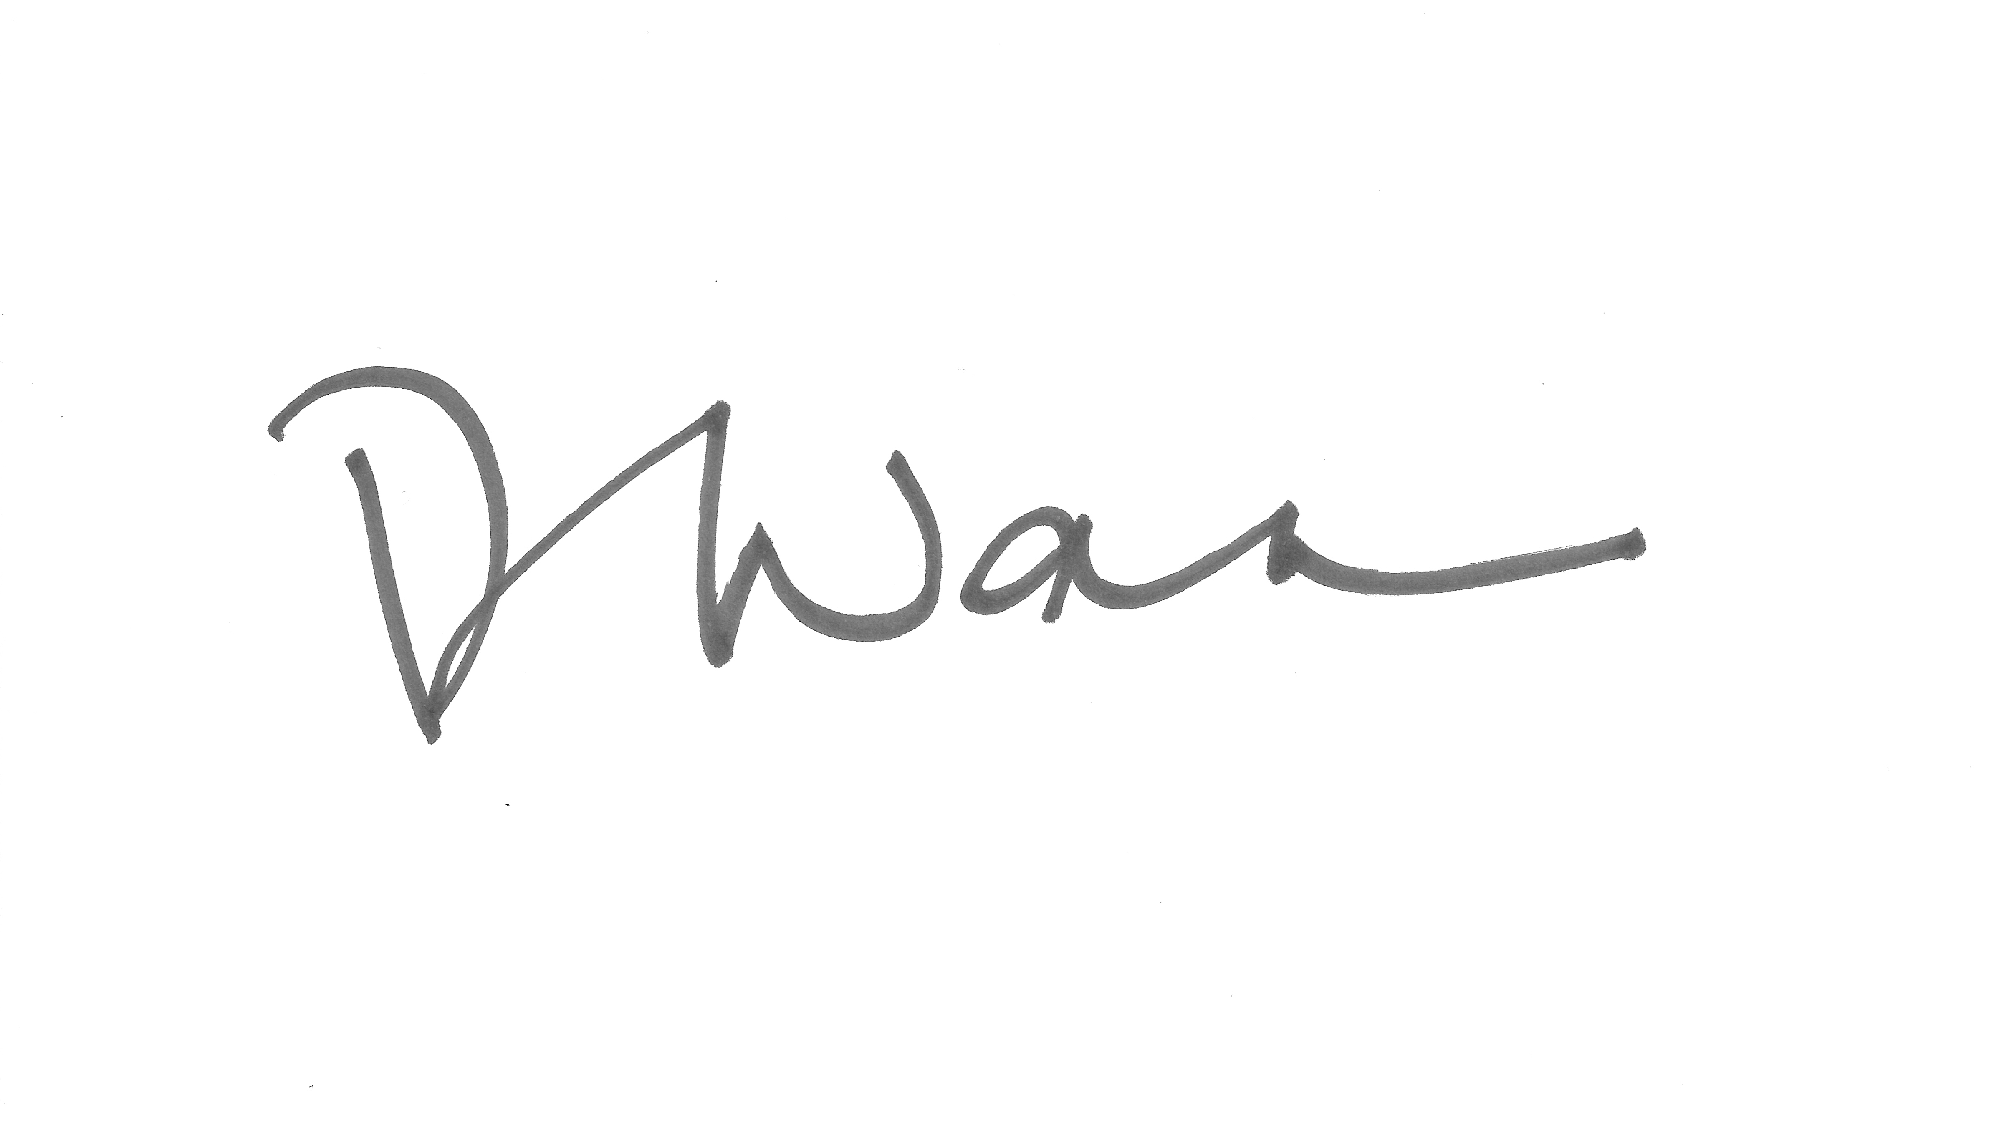
Deborah Wan
President Membership Expires – October 1, 2012
World Federation for Mental Health

