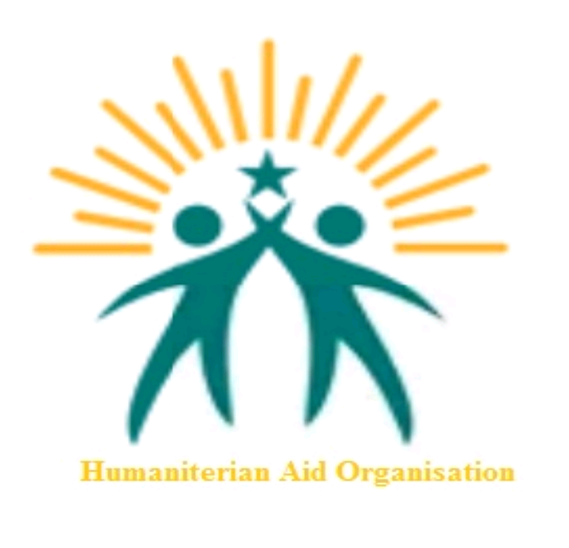 ORGANIZATION PROFILE

Name: Humanitarian Aid Organization(HAO)
Location: Kakuma1 Zone1 Block12.
KAKUMA REFUGEES CAMP
KENYA.
Charity and non_Profit Organization
. VISION: Exists to provide Education, Health, build resilience, clean and nuisance free environment, climate change and natural disasters research.
. MISSION: its works to provide services by building dignity to refugees and host Community.
. GOALS AND OBJECTIVES: we work with others to help the world needy through Education and various projects, regardless of race, gender, Creed, age, nationality, color or belief.
. ACTIVITIES:
. WASH (hygiene and sanitation)
.SGBV: sexual gender based violence
. Education in leadership
. Education in Computer Literacy
. Social Community Development
. Health
. Peace Building (conflict resolution)
. Mentorship program
. Human rights
.ophans, widows and elders
. Business and entrepreneurship
. Hairdressing and beauty.
. Sustainability Development Goals SDG's

. LINKS:

. Farming and Healthy Education
. Solidarity Hull CIC
. Rescue Wing International

. CONTACTS:
TURKANA WEST SUB-COUNTRY KENYA
Email: mathmourdossantosefrson@gmail.com
Call or WhatsApp: +254705784593
Facebook page : Humanitarian Aid Organization
https://free.facebook.com/Humanitarian-Aid-Organization-970263659692663/?_ft_=mf_story_key.4184259074959756%3Atop_level_post_id.4184259074959756%3Atl_objid.4184259074959756%3Acontent_owner_id_new.970263659692663%3Athrowback_story_fbid.4184259074959756%3Apage_id.970263659692663%3Aphoto_attachments_list.%5B4184258548293142%2C4184258538293143%2C4184258564959807%5D%3Astory_location.4%3Astory_attachment_style.album%3Atagged_locations.104037839633310%3Atds_flgs.3%3Aott.AX_JIQA6MnONUXOi%3Athid.970263659692663%3A306061129499414%3A164%3A0%3A1622530799%3A6197661681369457919&__tn__=C-R

