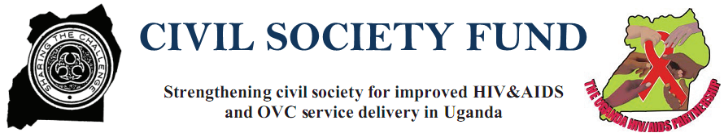

CRANMEDIC MEDICAL SERVICES – COMMUNITY BASED ORGANISATION

(CMMS-CBO)

END OF SCIPHA III PROJECT REPORT:
Project Title: STRENGTHENING CIVIL SOCIETY FOR IMPROVED HIV/AIDS AND OVC SERVICE DELIVERY IN UGANDA (SCIPHA)
CSF Grant Number: JCRC/SCIPHA/008/14
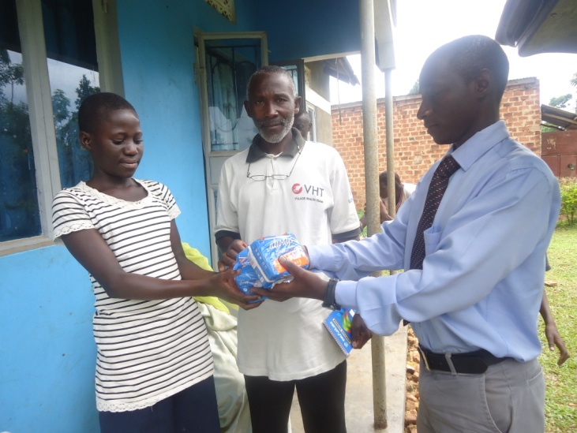

The director CMMS –CBO and a VHT hand over sanitary towels to a PLHIV adolescent girl in Sekiwunga, Kiringente Sub County
Reporting Period: January to December 2014
Prepared By: | Reviewed and Approved by:
Name: Serunjogi Steven | Name: Birabwa Harriet
Title: M&E | Title: Field coordinator
Email: s.serunjogi@yahoo.com | Email: hbirabwa@yahoo.com
Phone: 0777027801 | Phone: 0753429720
Signature | Signature
Date the Report was prepared: 13/Jan/2015 | Date the Report was submitted: 13/Jan/2015

CRANMEDIC MEDICAL SERVICES – COMMUNITY BASED ORGANISATION

(CMMS-CBO)

END OF SCIPHA III PROJECT REPORT:
Project Title: STRENGTHENING CIVIL SOCIETY FOR IMPROVED HIV/AIDS AND OVC SERVICE DELIVERY IN UGANDA (SCIPHA)
CSF Grant Number: JCRC/SCIPHA/008/14

EXECUTIVE SUMMARY
The SCIPHA project (Strengthening civil society for improved HIV& AIDS and OVC service delivery) under Joint clinical research centre (JCRC) is implemented with funding from Civil Society fund in 19 districts in Uganda. Mpigi district is one of the districts and Cranmedic medical services community based organization which was sub contracted by JCRC/ SCIPHA has continued to offer HIV care and treatment services in the sub counties of Buwama, Kiringente, Mpigi town council, Muduuma and Nkozi in Mpigi district in the third quarter 2014.

At the end of this year 2014, 2320 PLHIV have been reached with care and treatment services. Below are the achievements:
- 183% newly PLHIV were enrolled for HIV care and treatment.
- 146% PLHIV accessed cotrimoxazole prophylaxis
- 153% PLHIV adolescents received STI screening and management
- 155% PLHIV children received OI screening and treatment
- 115% PLHIV accessed CD4 services
- 150% PLHIV were accessed TB screening and treatment
- 143%PLHIV adults accessed OI screening and treatment services
- 56% PLHIV were provided with social services to improve quality of life
- 141% TB patients were accessed for HCT services
- 400% PLHIV were provided with family planning services and SHR education
- 151% PLHIV received PHDP
- 229% discordant couples received risk reduction counseling
- 29% eligible PLHIV were referred for ART program
- 165% infants received Early infant diagnosis

ED Andrew

PROGRAMME BACKGROUND DATA

Programme thematic Area: HIV Care and Treatment
Sub- Themes:
- Prevention with positives
- Condom promotion and distribution
- Prevention of mother to child transmission of HIV
- Prevention and treatment of sexually transmitted diseases
- Discordant couple counseling
- Counseling on disclosure
- Behavior change communication to prevent cross/ re infection
- Care, treatment and support
- CD4 laboratory monitoring
- STI screening and treatment
- T.B screening , referral and treatment
- Management of opportunistic infections
- Family planning services
- Early infant diagnosis
- Antiretroviral therapy service
- TABLE 1: PROJECT BENEFICIARIES
Target group | Denominators* |  |  | Project Targets
 | Females | Males | Total | Females | Males | Total
- Children |  |  |  |  |  | 50
- Adults and adolescents |  |  |  |  |  | 441
*Denominator refers to the total number of the targeted population in the area operation as stated in the proposal

TABLE 2: BRIEF ANALYSIS AND ACHIEVEMENTS:

Thematic area (HIV care, BCC, condoms, HCT, etc.) | Project Targets | First Quarter Achievement | Second Quarter achievements | Third Quarter achievements | Fourth quarter achievements | Cumulative including this Qtr
Refer and enroll newly PLHIV/TB patients for HIV care services and support | 294 | 164 | 141 | 171 | 64 | 540
Support PLHIVs to access cotrimoxazole prophylaxis | 1765 | 806 | 614 | 713 | 456 | 2589
Conduct STI screening and management for adult and adolescent PLHIV | 1529 | 724 | 547 | 617 | 466 | 2354
Conduct clinical monitoring and OIs management for children living with HIV. | 200 | 82 | 67 | 96 | 65 | 310
Support PLHIV to access CD4 services | 176 | 47 | 54 | 55 | 47 | 203
Support PLHIV to access TB screening and treatment services | 1765 | 806 | 614 | 713 | 531 | 2664
Support adult PLHIV to access OI screening and treatment services. | 1512 | 656 | 528 | 567 | 420 | 2171
Provide social service to PLHIV to improve quality of life | 176 | 00 | 00 | 50 | 50 | 100
Support TB patients to access HCT services | 24 | 9 | 8 | 10 | 7 | 34
Provide family planning services and SRH education to PLHIVs | 588 | 724 | 547 | 617 | 466 | 2354
Provide a minimum package for health dignity and prevention to PLHIV | 1765 | 806 | 614 | 713 | 531 | 2664
Provide risk reduction counseling to discordant couples | 24 | 12 | 10 | 18 | 15 | 55
Refer ART eligible PLHIV for ART program | 294 | 38 | 16 | 22 | 12 | 88
Early infant diagnosis 12 months and below | 5 | 6 | 7 | 10 | 10 | 33

Table 3: District(s) and sub-counties of operation:
No. | District | Sub-county (s)
1. | Mpigi | Buwama
2. | Mpigi | Kiringente
3. | Mpigi | Mpigi town council
4. | Mpigi | Muduuma
5. | Mpigi | Nkozi

- Total cost of the project as per contract 27,500,000 USH
- Amount received this quarter 6,875,000 USH
- Funds utilized to date as per submitted bank statements : 6,875,000 USH

SUCCESS STORIES:

SUCCES STORY ONE
FORMATION OF DISCORDANT COUPLE GROUP
Amongst the Most at risk population (MARPS) are the discordant couples. Cranmedic SCIPHA team has continually offered HIV Care and treatment services to PLHIV, MARPS. Among the services offered include risk reduction counseling among discordant couples.
In order to reduce chances of contracting the virus among discordant couples, ongoing counseling is done by VHTs and Cranmedic SCIPHA staff. In an attempt to promote peer to peer counseling, the idea of formation of a discordant couple group was born.
It was on the 13th September 2014 when Cranmedic SCIPHA staff organized a special dialogue with the discordant couples in sango parish, Buwama sub-county. Many issues were discussed in order to encourage the discordant couples to remain in the same state where the HIV negative partner should remain negative. The issues discussed included:
- The idea of formation of a discordant couple group was sold to them and they liked it. A committee for the discordant couple group was also set up.
- Consistent condom use with demonstrations on how to use them was done for both male and female condoms after which they were freely distributed.
- HIV positive partners were encouraged to have a good drug adherence and compliance to lower the viral load and reduce chances of the other partner to acquiring the virus
- HIV negative partners were encouraged to retest to check whether sero-conversion has taken place or not.
- Child bearing in a discordant relationship was also discussed.
Cranmedic staff elaborated to them the importance of the club once formed, then SCIPHA VHT was tasked to follow up the issues of the club with Cranmedic assistance.
Within one month’s time, the club was formed with the name OBULAMU BWEBUGAGGA consisting of 28 discordant couples majority of which had twins.
Below is the committee:
- Chairperson …………Kiwanuka Matia 0755334551
- Vice chairperson…..Nakibuule Mariam 0779679660
- Secretary ……………….Musoke Benard 0756609946
- Treasurer ……………Nabalesa Godfrey 0775062101
- Mobilizer …………..SSekaggo Kaaya 0755893138
- Patron ……………..Kagugube Agnes 0754383877

Objectives:
- To encourage other discordant couples to join the club through music and drama
- To reduce stigma and discrimination among members.
- To start up income generating activities in order to improve the quality of life of discordant couples.

Activities:
- Farming currently growing potatoes
Future plan
- To start up a drama group that will attract other members to join the group.
Challenges
- Inadequate capital to boast up their future plans
- Lack of drums to initiate an MDD activity.
- Limited market for their produce.

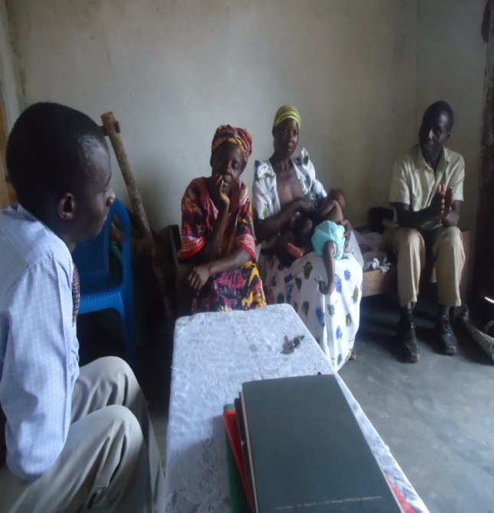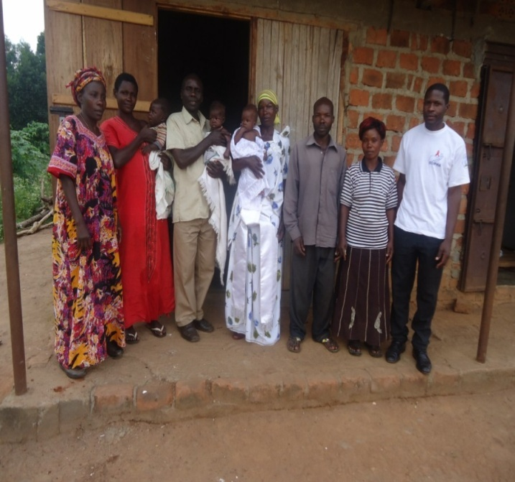

Cranmedic staff and VHT talking to one of the Committee members of obulamu Bwebugagga discordant couple group –Sango Buwama discordant couple.

SUCCESS STORIES TWO:

THE BLIND PLHIV BOY GETS HOPE
On the Monday 08/09/2014 SCIPHA team from Cranmedic set out to offer comprehensive HIV care services to PLHIVs that had had been mobilized by the VHT CORP Mr, kiggundu Sulaiman and VHT Nansubuga Catherine to convene at Nalwoga Sarah’s residence who is a PLHIV. The convening place was the meeting place for the PLHIV club Kololo – Sekiwunga positive initiative.
As the HIV information session commenced, a young boy walked into the room and sat in the middle of the people that had gathered but guided by other PLHIV where to sit. All the attention of the PLHIVs was drawn to the boy. The boy introduced himself as Ssenoga Travis and was 9 years old.
One of the PLHIVS said “Ssenoga is very unfortunate, he is blind and yet HIV positive but currently has no care taker”. The grandfather who was taking care of him died 2 months ago and the laboratory assistant at Sekiwunga health centre who used to give him extra social support died one week ago. Another PLHIV mentioned “the grandmother is not caring and the boy goes without meals and yet has to take his medication.
The VHT CORP said Ssenoga was brought to that home at the age of 3 months. The where about of the mother were unknown. The father who was HIV discordant at the time the boy was identified as being HIV positive vowed never to care for the boy. It was claimed that the father was alive and stayed in Kyaliwajala one of the Kampala suburbs.
When it was time to check on the books of the PLHIVs to see if CD4 monitoring was up to date as well as check on their pill balance for adherence, Ssenoga slowly moved out of the room. In about 10 minutes he returned and said “ musawo my bag containing my files and my drugs is here. Please check it.”
On checking the bag it had all the documents showing his ART care record since the age of 4 years. Surprisingly the bag looked like a small dispensary which felt threatening to the SCIPHA clinician. It contained 12 bottles of Abacavir/ Lamivudine, 3 bottles of Niverapine and polythene dispensing bags containing cotrimoxazole.

On checking Ssenogas knowledge on the ARV use, the blind boy said “ I take abacavir/lamivudine 5 tablets in the morning at 7 am and 5 tablets of the same at 7 pm in the evening. I also take 1 tablet of niverapine in the morning at 7 am and 1 tablet of the same at & pm in the evening. This I do every day but I stopped taking the septrin because when I take it my Jaw aches.”
From the boys tale he was knowledgeable but since he was blind the clinician gave him the two different bottles of the Abacavir/ lamivudine and the Niverapine to see if he could differentiate the two. Despite the Niverapine bottle being longer and the Abacavir bottle being shorter the boy was calling the Niverapine bottle the Abacavir bottle.
It therefore became evident that the blind boy had been taking the Niverapine 5 tablets twice a day on occasions mistaking it to be Abacavir/ lamivudine. This was a touching moment as it meant the sorry boys liver was predisposed to damage from hepato toxicity because of the high dose of Niverapine.
This was a big concern and when the clinician asked if Ssenoga had a caretaker, the PLHIVs said the caretaker who is his grandmother was around but had refused to escort the boy to the meeting place where the PLHIvs had gathered. Ssenoga moved out to go and call the grandmother and he came back after ten minutes in a very disappointed state and said “she has refused to come she says she is looking after her grand children who are children to her biological son.”
In trying to get the grandmother into the ARV treatment plan of this boy one of the VHTs goes to call the grandmother. She comes wearing an angry face and her statement on reaching was “What is the problem? I told that boy to pick up his clothes and his drugs and leave my home but he refused because for me I do not understand those things.”
The SCIPHA Cranmedic team talked to the grandmother who looked agitated and not ready to listen about the importance of her involvement in the care of the boy at least helping him to differentiate the two bottles of Abacavir/ Lamivudine and Niverapine because the boy at least knew the number of pills to take and the time to take them.
After the grandmother showed no intention of helping the boy it became an outcry for the PLHIVS to the SCIPHA team to see how the boy could be helped. Temporary a PLHIV was requested to see to it that the boy took his medications well since she stayed two households away from where Ssenoga stayed.
When the grand mother left Ssenoga moved to the clinician as a follow up on what had been discussed about forming youth clubs and involving the children in a number of activities including income generating activities like craft work. Holding one of the craft bags that the SCIPHA Cranmedic team had given them as samples of what other children make he asked “can you teach me how to make these?” It was interesting so the clinician said yes. The VHTs and PLHIV club was put to task to form the child club so that Ssenoga could be one of those to benefit from the trainings.
On leaving the community the SCIPHA Cranmedic team had a big task ahead of them to see how to help Ssenoga Travis. On Thursday 11/09/2014 during the JCRC national team mentorship exercise at Cranmedic a tale of the ordeal opened up the journey to helping Ssenoga, as the country director of the SCIPHA project said an appointment should be made so that Cranmedic as a CSO takes Ssenoga to JCRC for a full medical examination and then eye check up can be done in Mengo hospital as improvement of his sight would be key to improvement of his adherence to his ARVs.
A VHT or a PLHIV in the locality was to be identified so that Ssenoga could be tagged to him/ her for support and follow up of care.
The community based care and treatment interventions of SCIPHA- Cranmedic team were key to rescuing Ssenoga from the hepatotoxicity due to the Niverapine overdose. However a lot has to be done so that his life style is improved holistically
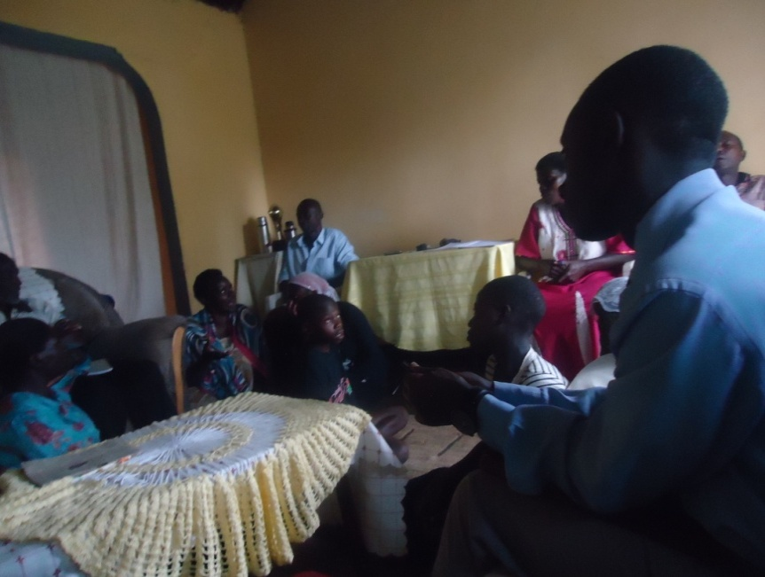
Ssenoga, the boy sitting in the centre during the PLHIV meeting in Sekiwunga, Kiringente.

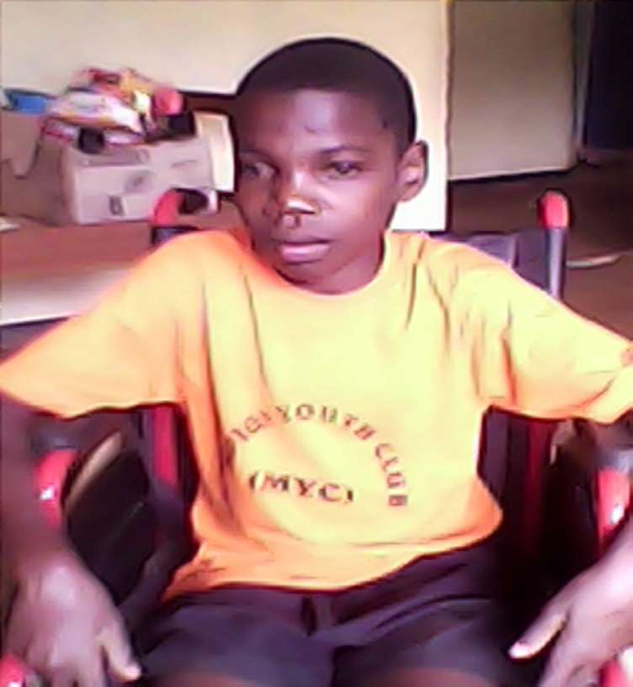
Senoga Travis is now having a good drug adherence and compliance living happily
SUCCESS STORIES THREE:
MUDUUMA YOUTH CLUB (MYC)

With Support from SCIPHA

With funding from CIVIL SOCIETY FUND (CSF).
Overview:
With the support from SCIPHA with funding from the Civil Society Fund, Crammed medical services community based organization has been able to change the lives of children living with HIV in Mpigi District by involving the child PLHIVs in clubs and one of the most successful is the Mpigi Youth club that is now making its extension to other sub counties like Muduuma where Muduuma Youth Club is now formed.
MOTTO OF CLUB:
  - “If other children can be healthy why not us”
  - “Abaana abalala bwebaba bayina obulamu obweyagaza lwaki siffe.”

Objectives of muduuma youth club.
- To assist each other to cope up with a good drug adherence and compliance strategies, and encourage our fellow children who had lost hope in swallowing their drugs to regain strength because ARVS are our life.
- To develop the skills of PLHIV children in income generating activities like handcraft.
- To encourage HIV positive parents to test our fellow children for HIV and if found to be HIV positive encourage them to join Muduuma Youth Club.
- Sensitize the community on importance HIV testing and drug adherence through Drama.

Location:
Muduuma youth club (MYC) is situated in Tiribogo in Muduuma subcounty, Mpigi District along Mityana road, The club uses the home of one of the PLHIV/VHT who also acting as the Jajja of the club-Nakindu Daisy( 0782160698) as the official meeting site.

Membership:
The VHT who is also a PLHIV and the grandmother (Jajja) of the MYC identifies HIV positive children and sells the idea of enrollment into the Muduuma Youth Club to the guardians. If it is accepted the children are brought by the VHT on the meeting days of MYC for enrollment.
The VHT reminds the different families of these children of the meeting days to ensure consistent attendance.
Any person below the age of 18 and is HIV positive is eligible for enrollment into this child HIV positive club.
Muduuma youth club executive committee.
Nalugwa Florence………………………………………….. 15years (chair person)
Lugenda Derick………………………………………………15years (vice chairperson)
Nakanwagi Suzan…………………………………………….13years (secretary)
Other child members include:
Nambi Regina……………………………………………….. 15 years
Namilimu Florence………………………………………… 09years
Kyobe Mardi ……………………………………………… 06 years
Serwadda Marvin……………………………………………10years
Co-coordinators Miss Nakindu Daisy (VHT/PLHIV). She is the Jjaja of the children.
Muduuma youth club meetings:
During school days, these children meet every Saturday at 2:00pm and during holidays they meet daily at 2:00pm after doing some house work for their parents.
Contribution towards success of the myc.
- Active participation is encouraged to ensure that children own the club for sustainability purposes.
- Motivation by their fellow children in Mpigi Youth Club visiting them and helping them in instilling skills in crafts and bag making has made them like their club and in a few months will catch up with the pioneer club.
- The SCIPHA project with funds from CSF provides beads, threads and clothes and other materials as well as the training of the children in the craft work.
- The purchase of their craft items will provide these children a little penny to cater for their basic needs as well as purchase of drugs for opportunistic infections.

PHOTO GALARY
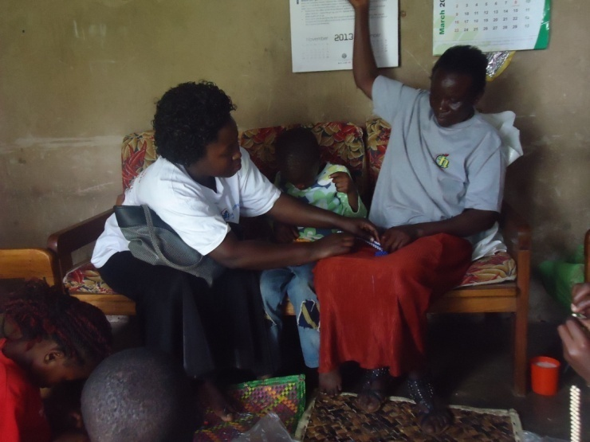
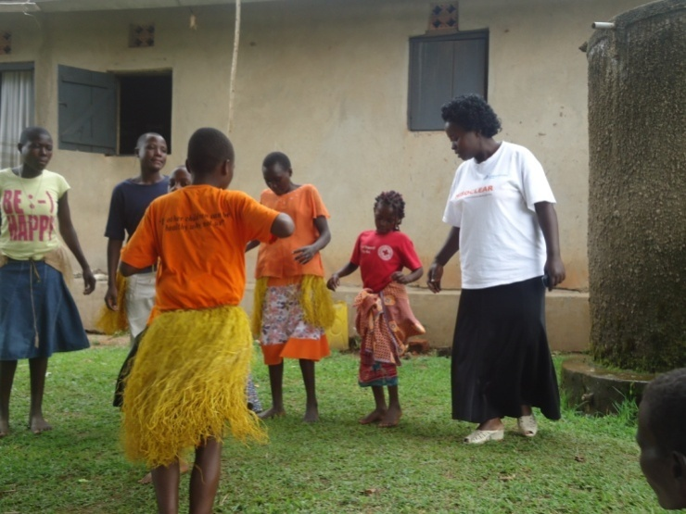
Training the Jajja of the club MYC members training fellows in Muduuma
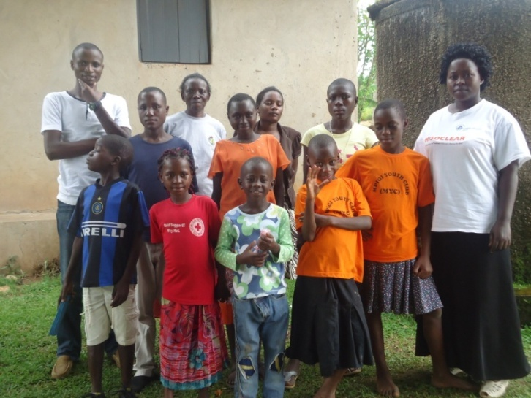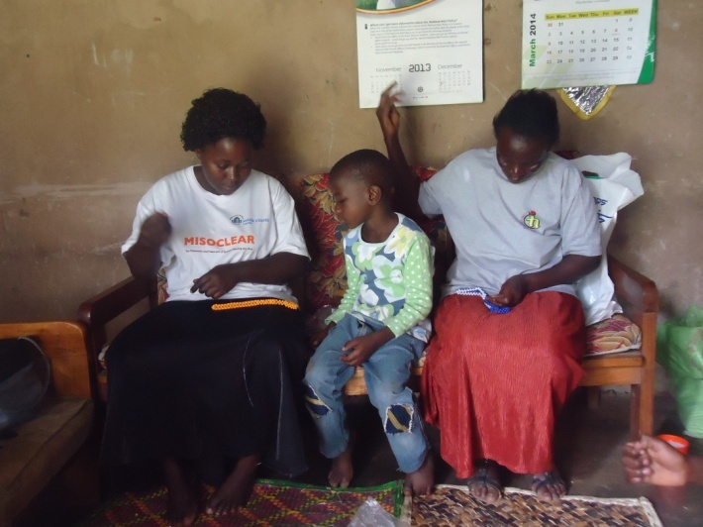
DDA left went to the ground to the see the new club in Muduuma

The benefits of Muduuma Youth Club (MYC).
- Through drama the club will fight stigma among HIV positive children in the subcounty.
- The adherence of the children to ARVs and cotrimoxazole prophylaxis has improved as a result of peer influence from fellow PLHIV children that take their medications well.
- The new club will visit communities and sensitize them through their music, dance and drama on importance of EMTCT, drug adherence and so on.
- Through drama the MYC will fight stigma against HIV positive children in schools.

Challenges of the club.
- The newly formed club lacks dancing attires, T-shirt and drums
- Due to varying ages whereby some need to just be kept with a bit of games and play but the club lacks dolls, balls, swings or even game boards to make their minds active via games activities.
- There is still no ready market for the Craft products of these children and yet the sales are meant to help these needy children.
- The adolescent girls need to be supported with sanitary pads.
- Some of the children who are members of the club are in school but lack scholastic materials and school fees.

SUCCESS STORY four

FORMATION OF MUNUNUZI –SILK CLUB
On Monday 31st March 2014, SCIPHA team from Cranmedic Medical Services-Community based organization (CBO) visited Kayabwe parish in Nkozi sub-county to offer care and treatment services to PLHIVs. During service delivery, it was discovered that some PLHIV still had stigma and therefore never turned up for the services. ‘Some PLHIV have remained home because they do not want to be known by others’.
Among the sessions held, importance of formation of clubs was discussed and PLHIVs were told to form one. VHT –Nasuuna Yudaya was tasked to follow up the club and start joint projects.
When SCIPHA team returned in Kayabwe on 11th June 2014, the VHT reported that ‘I worked hard on the task left behind and here is the new club called: Mununuzi –silk club’. She continued giving details about the club, presenting to us their committee, activities performed, office location and challenges faced. She was advised to contact Sunrise Inspirational counseling Association (SICA) organization in Kayabwe which volunteered and offered these PLHIV training in liquid soup making and paper bag making. The SCIPHA team also witnessed the training and thanked the SICA organization for the support.

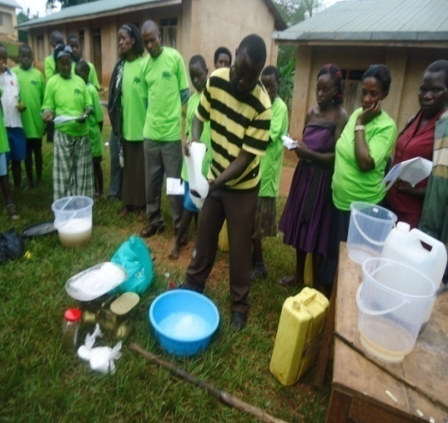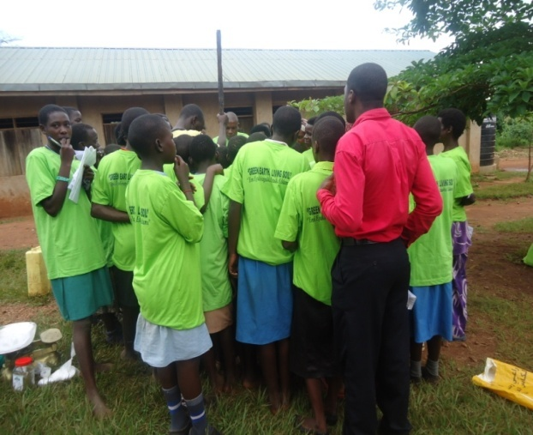

Mununuzi Silk Club Offices –located in Kayabwe in the premises of the VHT and meetings are held every Friday
Committee members:
Chairperson Nampeewo Aminah
Vice chairperson Namukasa Saudah
Treasurer Najjemba Winfred
Secretary Mbidde Rehema 0752659236
Coordinator –Nasuuna Yudaya 077965160/0754965160
Activities :
- Liquid soap making
- Paper bag making
- Cash round saving scheme where each member every Friday contributes something in the club according to one’s capability and earning
- Money lending- Members are allowed to borrow money from the club after writing a request letter to the committee members to grant her permission to get a loan.

Challenges:
- Inadequate capital. They would like to increase on their output products but they have limited funds. ‘Please lobby for us funds so that our projects can expand’ said by Madam Nampewo.
- Stigma amongst some PLHIV has hindered them to join with their fellows. However, some have joined the club and are no longer shy.
Despite some of the challenges encountered by the club, it is still going on smoothly.
CMMS-CBO staff observed that all members were happy during their club activities and were promised to deliver the message to JCRC so that they can support the club.
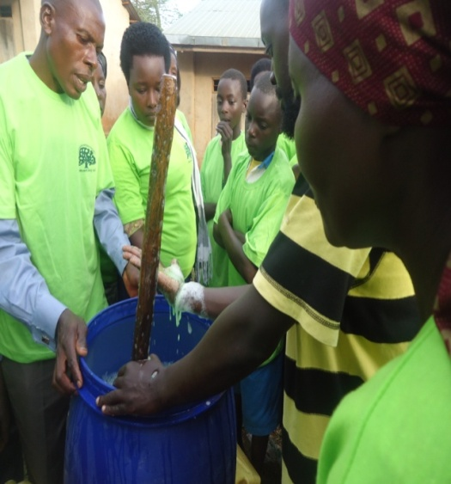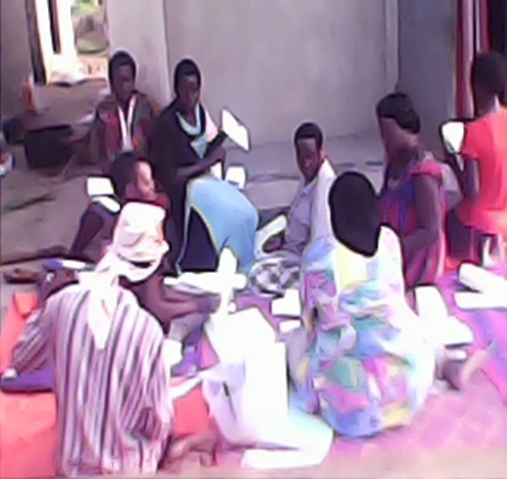
PLHIV mixing liquid soap PLHIV making paper bags
PLHIV collecting savings
One club member testified that ‘Now I can eat well, take my children to school, worries are no more since I am being encouraged by my fellows. Another member testified that ‘now my drug adherence is good –CD4 cell count is high and stigma no more because of the encouragement I get from the club members.
SCIPHA team was thanked for the services offered to PLHIVs. For without this team some PLHIVs would still remain in hiding and would lose out on these key services including club formation. Members of Mununuzi –Silk club in Nkozi Sub County have improved on their days earning.

Challenges faced in scipha three
- The bad roads in the rainy season made most areas in the community hard to reach.
- Lack of nutrition support for PLHIV children reduces their adherence to ARVs.
- Poor adherences to ARVs in some places like Katende because the PLHIVs are made to pay a fee before accessing ARVs at the health facility.
- PLHIVs still lack start up material/ capital for income generating activities.
- PLHIVs referred to the government health facilities to access health care services are told to pay a fee of 5000 shs. This has become a barrier to the referral system.
- Stock outs of the requirements for the CD4 machine, the CD4 machines are of small capacity and frequent electric power cut offs.
- The rainy season interrupted the implementation of activities.
- Lack of raincoats, umbrellas and gumboots for the SCIPHA – Cranmedic team interfered with the activities in the rainy season.
- Stigma and discrimination is still a hindrance to some PLHIV moving to the community meeting centers.
- Since the home based care component was removed from the modes of service delivery the bedridden PLHIVs that cannot move to the convening areas in the communities fail to access HIV care services.
- PLHIVs fail to get treatment for opportunistic infections at the health facilities and are told to buy them from private drug outlets. Those with no money go without treatment
- PLHIV children fail to adhere to their ARVs because they do not have any food to eat at home.

LESSONS LEARNT
- Utilizing the formed PLHIV clubs in communities can be influential in the mobilization of PLHIVs in communities for HIV related interventions.
- Discordant couple clubs are influential in mobilizing couples for HIV testing as well as ensuring HIV risk reduction strategies amongst newly identified HIV discordant couples.
- The setting up of youth clubs and offering youth friendly services has been identified as a key to improvement of the acceptability of parents to have their children tested for HIV as well as enrollment into HIV care centers.
- Most PLHIVs in communities know the importance of involvement in PLHIV clubs and the setting up of income generating activities but the main hindrance is the lack of capital or start up material.
- VHTS that are PLHIVs are more active in implementing HIV care activities in the communities as compared to VHTS that are HIV negative.
- Some islands like Kamutenga have no latrines; people empty their bowels in the lake.

BEST PRACTICES
- Using children from youth clubs to improve the livelihoods of orphans and vulnerable children by training them in income generating activities.
- The start up of a discordant couple club in Buwama in a bid to improve on HIV risk reduction interventions.
- Enrollment of children into youth clubs is important in improving the adherence of PLHIV children to their ARV treatment.
- Community dialogues conducted have made the CSO and the SCIPHA project to be known further at ground level.
- The four tent model of service delivery has helped our clients to get services at one stop point.

Prepared by:
Birabwa Harriet
Project Coordinator (Crammedic)

