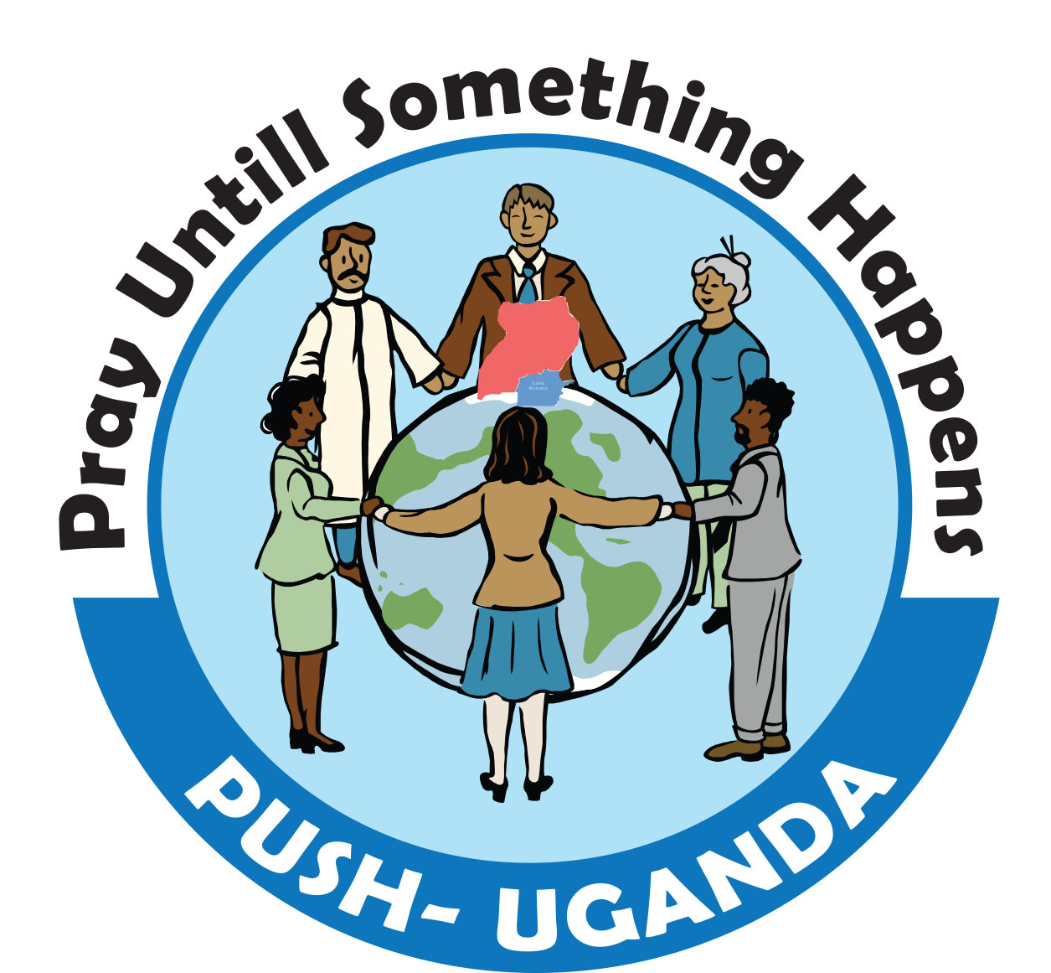
PUSH UGANDA


THE REPUBLIC OF UGANDA

Pray until Something Happens (PUSH Uganda) is a Charity, non-governmental and nonprofit making humanitarian organization set up for the alleviation of poverty and sickness through the provision of education, medical facilities, relief, clean drinking water, training programs and supporting evangelism in Northern Uganda. Supporting locally-led initiatives that strengthen young people and valuable Adults, helping them to overcome poverty and protect the rights of children and Women.
The organization was formed in 2015 and registered in 2016 with Lira Local Government, and the Government of the Republic of Uganda Reg. No LDLG/2016/057 as a Non- Governmental Organization (NGO). The main office of the organization is located in Lira - Northern Uganda. The organization was formed to response to the continued complex poverty situation in Lango and surrounding Districts formally affected by arm conflicts of the Lord Resistant Army (LRA), cattle rustling by the Karamojong tribe and natural disasters. The targeted communities include returnees after displacement, refugees and the general needy community.

Vision: A better tomorrow than today through improved environmental, social, and economic aspect of life.

MISSION STATEMENT: To alleviate poverty and give people of Northern Uganda formally affected by war and natural disasters a brighter future for peaceful human co-existence.

OUR GOAL: To respond to vision of young people, women and men whose human rights should be respected and fulfilled while at the same time containing an integrated holistic emergency humanitarian and development interventions approaches.

BRIEF BACKGROUND HISTORY THAT LED TO THE PROBLEM NOW.

Arm conflict in Northern and Eastern Uganda for a period of over 20 years combined with violent looting, destruction of properties and lives as well as cattle raids by the Karamojong resulted to the displacement of over 1.5 million people. Over the same period, the Lord Resistant Army (LRA) rebellion displaced over 80 percent of the ethnic Acholi population in Gulu, Kitgum, and Pader Districts and over 150,000 in Lira District where Push Uganda is now operating.

Persistently, living conditions are generally been so bad. There is poor access to safe and clean drinking water; sanitation facilities especially in rural primary schools, hospitals are insufficient. Heavy reliance on poor traditional method of farming characterized with low yielding seeds and rudimentary agricultural inputs as a result inadequate access to modern agricultural practices.

Majority of households have inadequate household assets as a result of persistence low household income. Despite the country’s universal primary education policies, a number school going children are still out of school. Access to medical care by majority poor households is low as a result of poor provision of medical care.

Push Uganda with support from its development and humanitarian partners is position to support the targeted communities in re-building their homes and basic social service delivery to the needy which needs a lot of support and prayers.

MAIN OBJECTIVES:

To provide better condition of life for the persons affected by war, natural disaster and poverty in the community of Lango sub region through offering access to:- Education, clean drinking water and hygiene sanitation, livelihood, relief distribution, health services, HIV/AIDS awareness and psycho-social support to the traumatized and needy persons through Evangelism.

SPECIFIC OBJECTIVES:

- Providing clean drinking water and sanitation training, hygiene development by drilling boreholes and provision of sanitary facilities, constructing toilets and bath shelters.
- To link up with Humanitarian Foundations, Churches, Ministries, locally and worldwide to serve the different disadvantaged community groups within target areas as opportunity may allow.
- Providing educational support through Vocational training, setting up resource training centers for computer training, Child sponsorship, and school twining programmes and distributing scholastic materials to the vulnerable young people.
- Promoting Agriculture and Environmental protection by providing tools, seeds and seedlings, food security training and firming practices.
- To provide support and relief to Northern Uganda regions through religion, and social programs, in an effort to positively impact and improve the social and economic life of the vulnerable people of Northern Uganda.
- To generate awareness of the importance of family, education, health and social activities so that the young peoples of Uganda may develop the skills needed to effectively participate in their communities as adults and stimulate change in the Uganda regions.
- To sensitize, mobilized and organize the general population around to get involved in all national programmes relevant to nation building and fund raising of resources from within and out side the country to support the programmes.
- The promotion, development and preservations of positive cultural values relevant and necessary for human advancement and civilization such as music, dance, drama and seminars, recreational activities and psycho-social support to the needy community.

STRETEGIES:

(i)- Child Care and Education Support Scheme:

In Lango sub region, a number of orphan and vulnerable children are found. The problem of orphan and street children is acute due to death of HIV/AIDS affected persons, remirrages, absecence of love and security in the families, family disputes, and expeoited girls. PUSH Uganda envisage mainstreaming these children in nation building by provding care, support and protection in Orphan Children Home. PUSH Uganda will establishing child care or orphanage and sponsorship programme to provide comprehensive programme from preschool through primary, middle and high school. This will be integrated with vocational skills/entrepreneurship and training support in tailoring to equip the needy disadvantaged children with necessary knowledge and skills and looking for sponsorship and school twinning programees

(ii)- Water and Sanitation :

Access to clean and safe drinking water is a driving force for sustainable development and the eradication of poverty and hunger. Lango sub region has low water coverage. Surface water coverage in the region is not safe and sufficient for human consumption and dries up during dry season. Percentage of households that fetch unprotected and unsafe water is still high. Women and girls spend long time travelling long distances fetching water because of their gender role in the sub region. Provision of clean and safe drinking water by drilling boreholes, building bath shelters, toilets in re-settlement areas, schools and in the communities hosting for refugees plus hygiene training are some of the interventions PUSH Uganda will engage on.

(iii)- Emergency Relief Supply:

PUSH Uganda has positioned itself to offer humanitarian assistance during life threatening period. The most vulnerable persons during this period include women, children, and persons living in internally displaced people’s camps. PUSH Uganda will contribute emergency assistance to help reduce the risk of death among the most vulnerable communities from disease associated with lack of proper health services, lack of clean and safe water, poor sanitation, food insecurity, and poor nutrition in IDPs camps. Provision of relief aids of food, medical supplies, clothes, household utensils like beddings, saucepans, plates, cups to replace the lost ones/destroyed by natural or human disasters like war etc will reduce high rates of illness and death.

(iv)- Community Health & HIV/AIDS Awareness Project::

Death rate from HIV/AIDS related infections now top of the list in the world. The disease has therefor become the greatest cause of sickness and death even among community all over Uganda. Every effort should therefore be geared towards fighting it. This project recognizes the threat HIV/AIDS poses to the entire community, and would like to reverse it at the earliest opportunity, if funding support permit.

(v)- Socio-Economic Empowerment::

Grass Root Social and Economic Empowerment (GSEE) aimed, to provide sustainable development solutions to the rural poor especially the disadvantaged, women, youth and children due to the effects of war or disasters by provision of famers’ agro-inputs and small grants to start the business, provision of tools, training, seeds and seedlings to the farmers.

(vi)- Peace and Conflict Transformation:

Carry out peace education on conflict transformation through training seminars, conferences, workshops forum in schools, colleges and institutions of higher learning in Lira and neighboring districts targeting the affected communities and formerly abducted children and displaced families. Supporting Evangelism in the community by providing Logistical support needed to the pastors.

ACHIEVEMENTS.

- Carried peace education to schools, colleges, and institutions of higher learning in Lira.
- Carried counseling to the traumatized formerly abducted children in Lira.
- Supported 13 war affected young people at Nelko Vocational Centre with one time fees support from HARD RELIEF. The Centre has enrollment with 158 out of which 107 are destitute as a result of war in Northern Uganda, and are on subsidized payment by relatives, however, complementary assistance is required.
- Distribution of relief support in Lira internally displaced camps; clothes, houses hold utensils, blankets, and shoes.
- Carried out HIV/AIDS sensitizations, giving scholastic materials like pens, books, uniforms to the vulnerable school going children.
- Providing hygiene training to the Community and Rocket energy saving stoves for cooking.

PARTNERSHIP AND FINANCIAL SUPPORT

For the organization to grow and accomplish the set goals, there is need for partnership, and financial support for backing up the activities as spelled above.

We seek those individuals, groups, Churches and Foundations who feel touched to help the suffering communities in Northern Uganda- Lira in any way, be involved with us and contact us on the address provided.

We shall be grateful to partner with you over this noble work of reaching and impacting the communities with the transformational programmes and activities.

CONTACT INFORMATION:

Tommy Moses Awio
Country Director,
PUSH UGANDA
P.O Box 1010 Lira – Uganda, Africa
Tel: + 256 – 775 – 711 822
Email: push.ug2015@gmail.com/
tobet246@gmail.com
Facebook: tommy awio
Website: pushuganda.org

