PLAN FOR FUTURE CONSTRUCTION OF COMPLETE VILLAGE COMPLEX IN LAYE
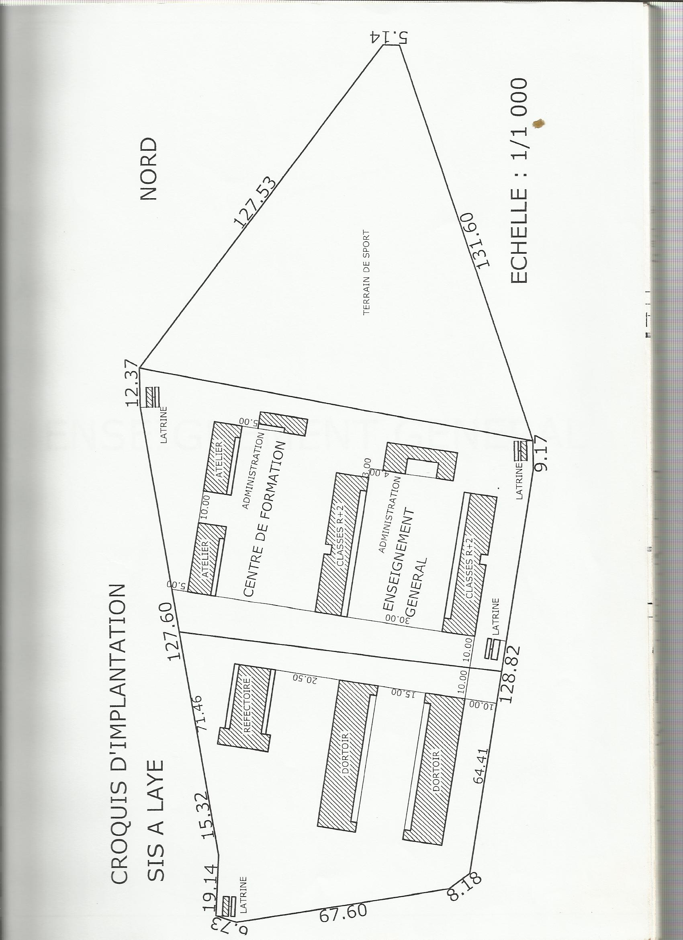

FRONT VIEW OF SCHOOL - 1

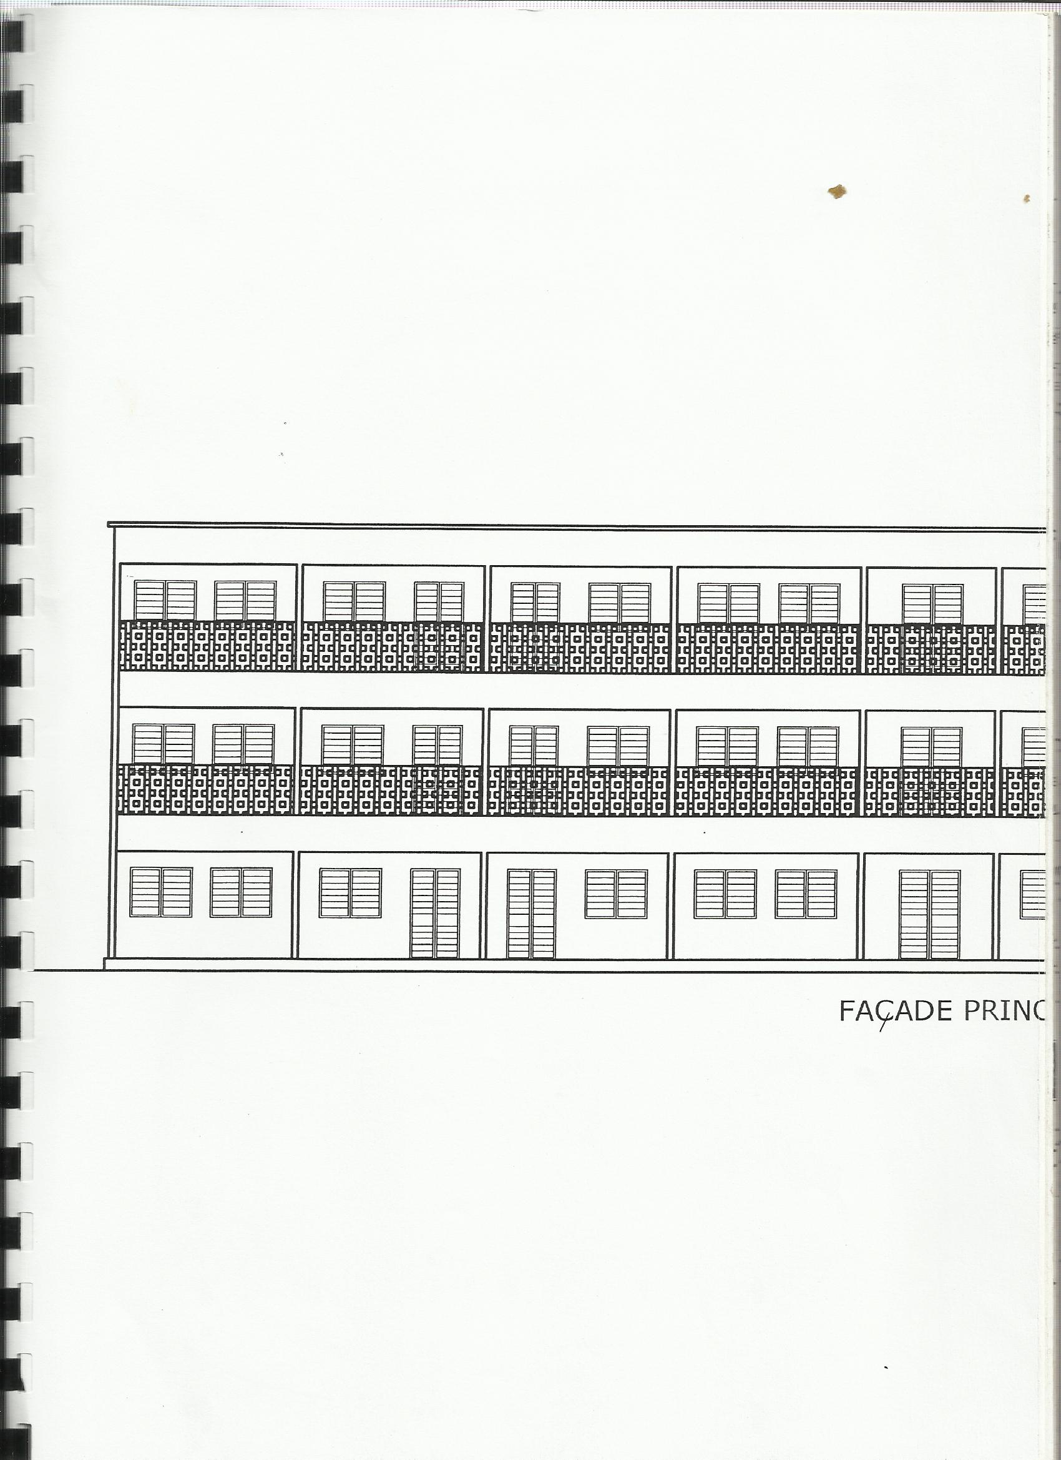

FRONT VIEW OF SCHOOL - 2

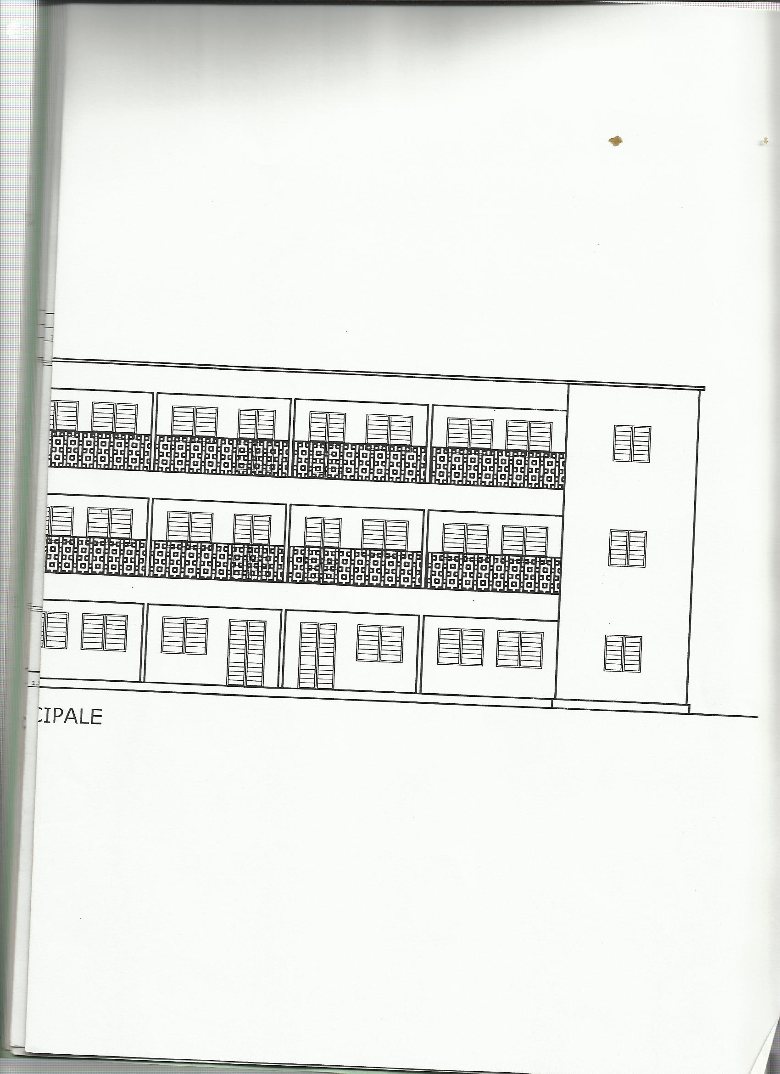

CLASSROOM PLANS - 1

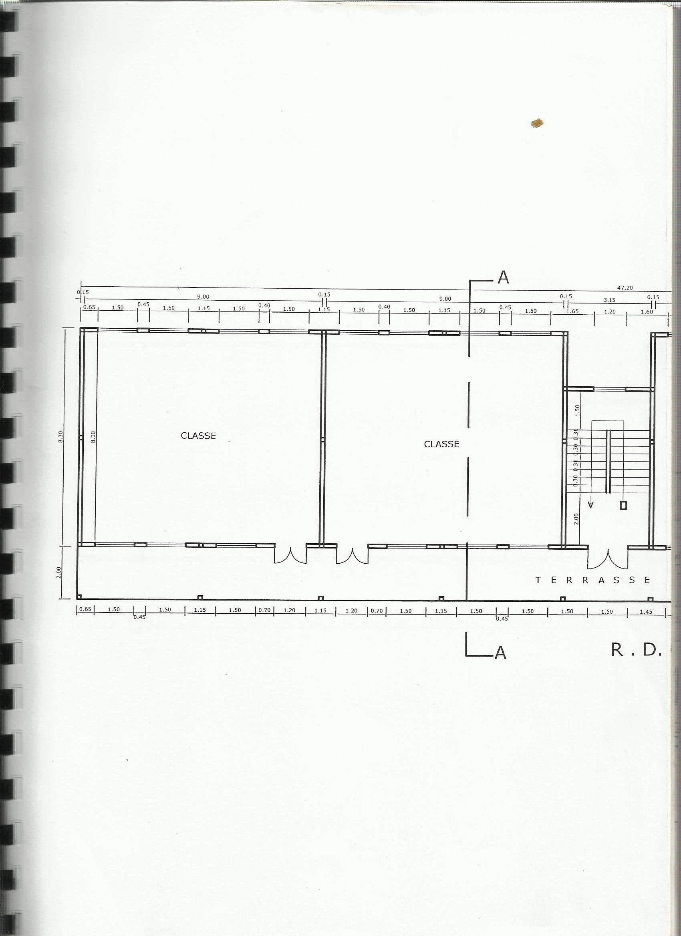

CLASSROOM PLANS - 2

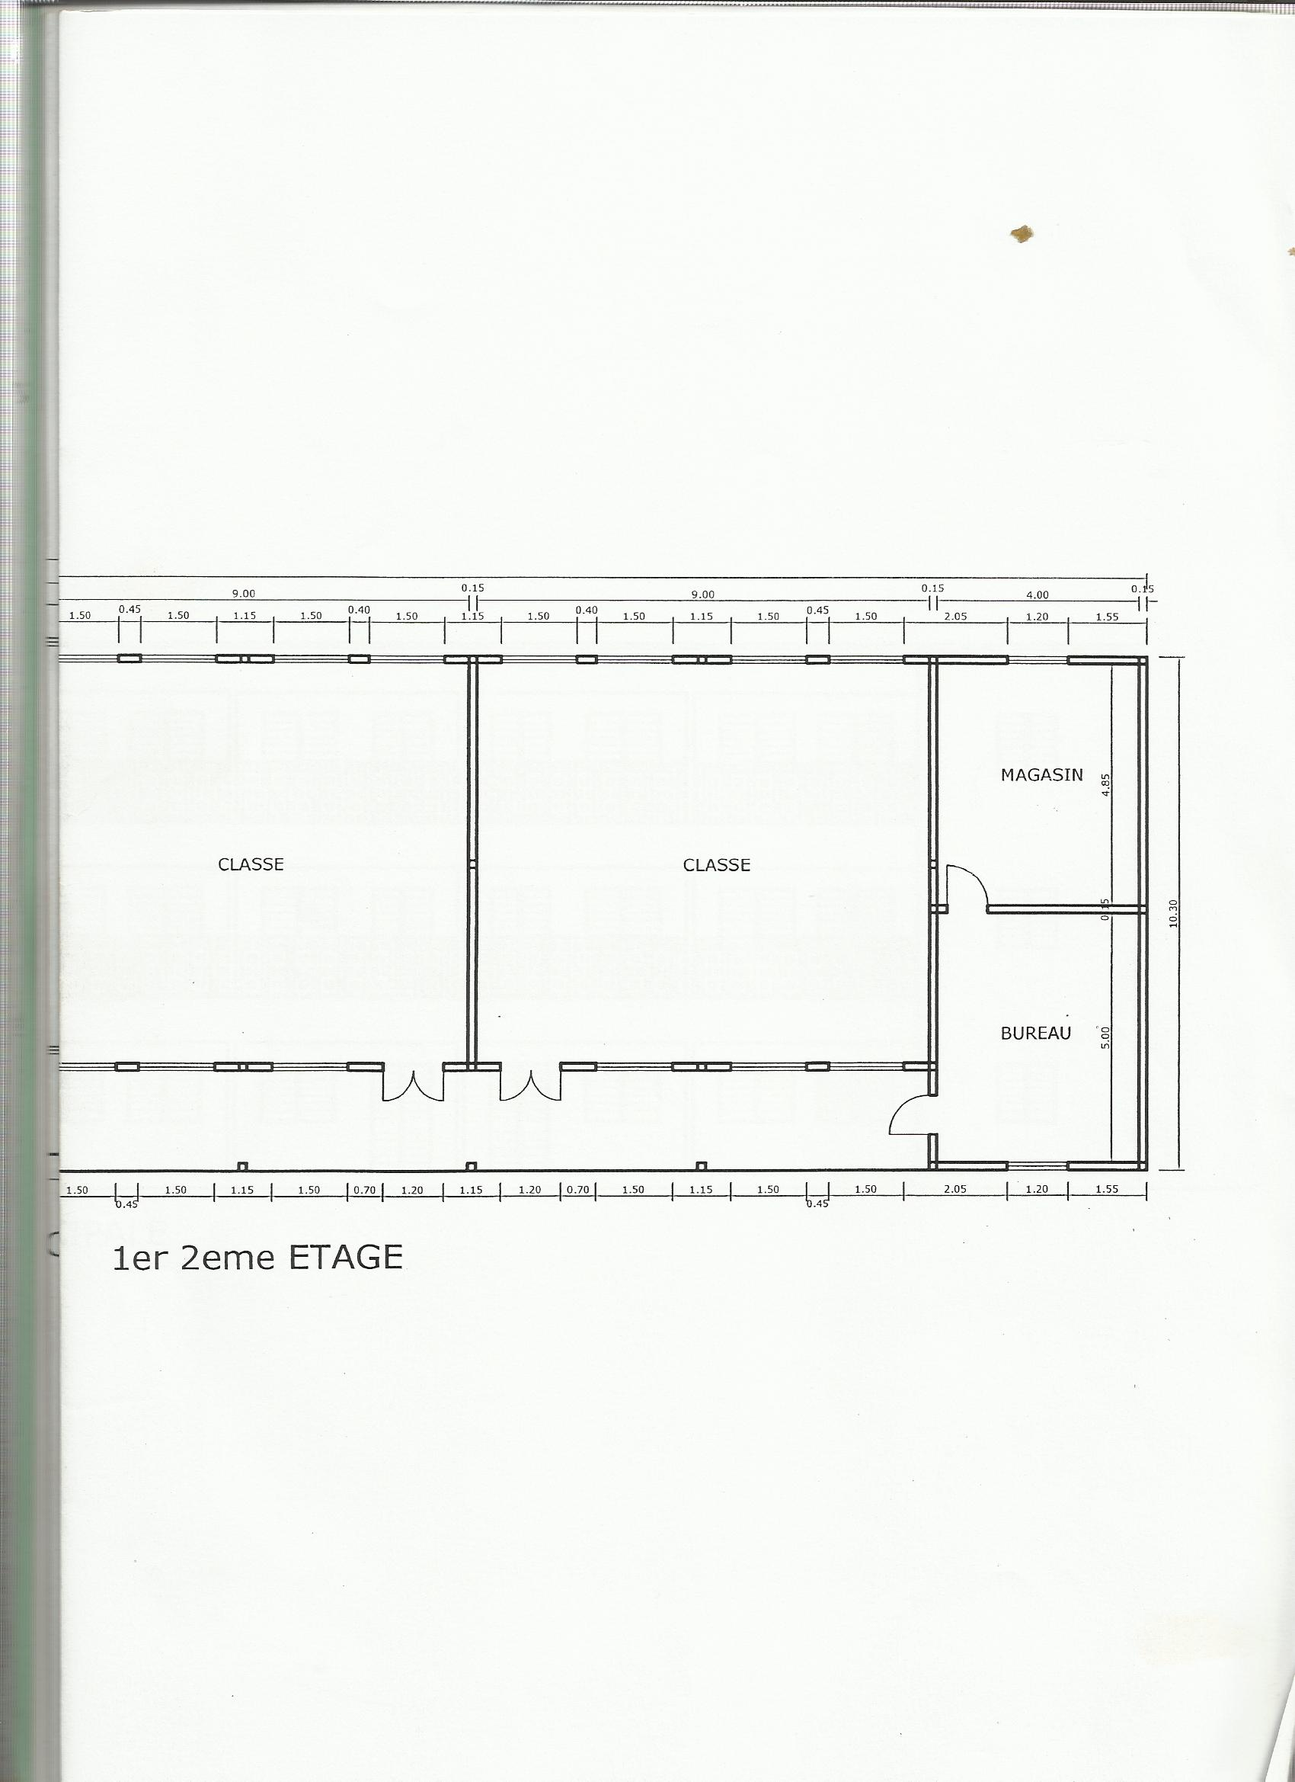

CLASSROOM PLANS - 3

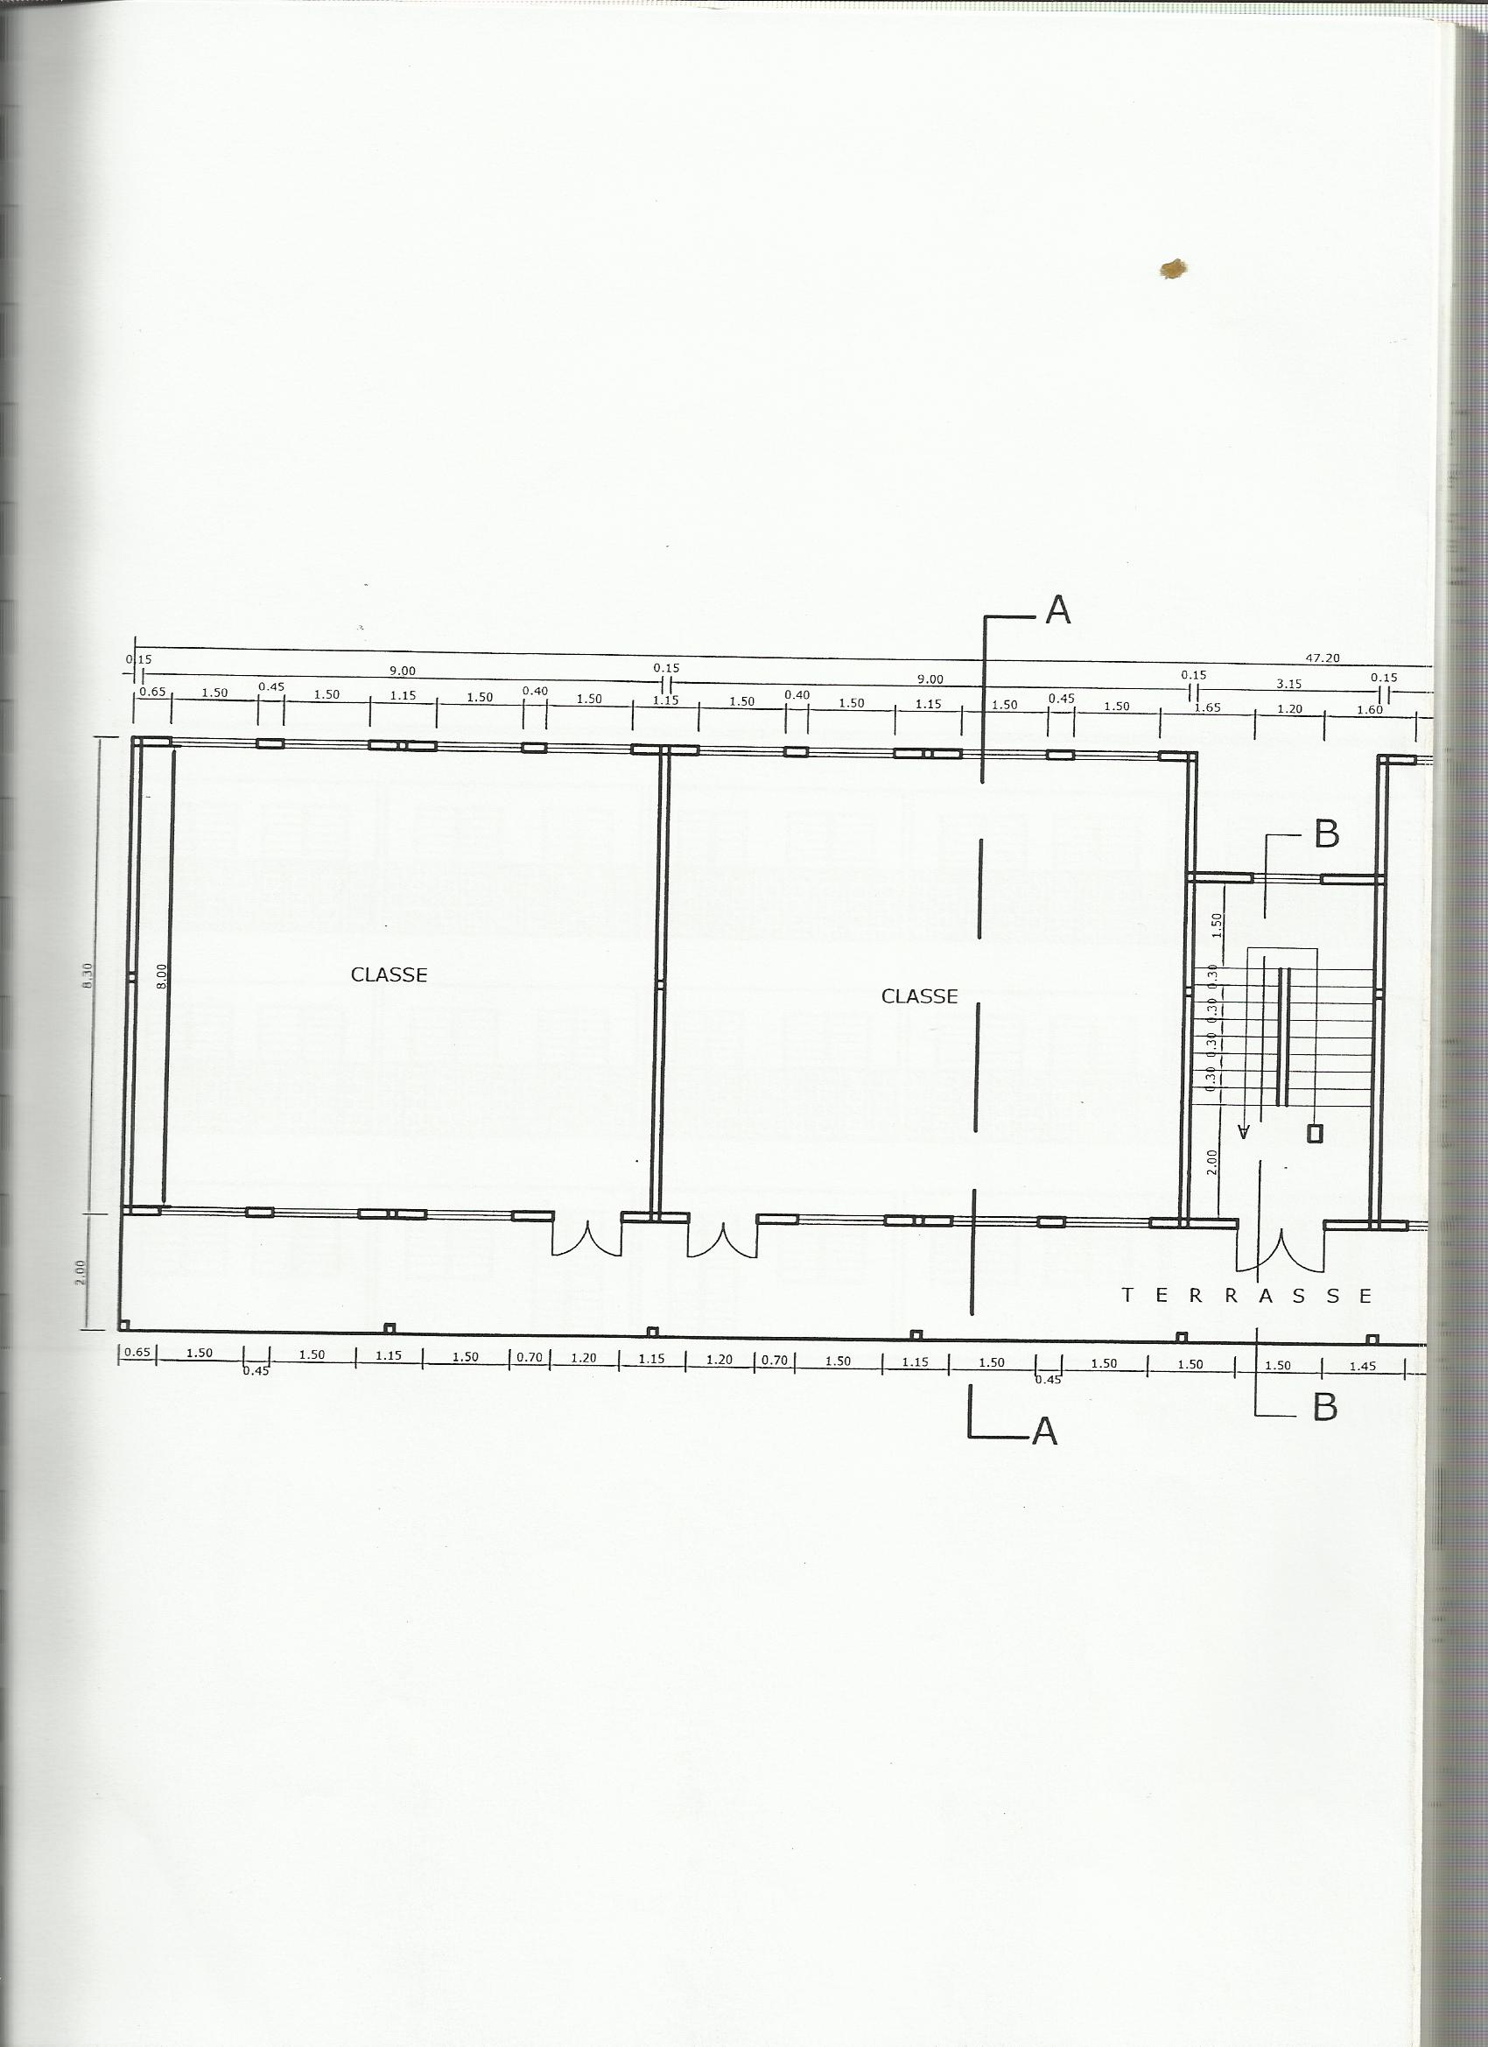

CLASSROOM PLANS - 4

