

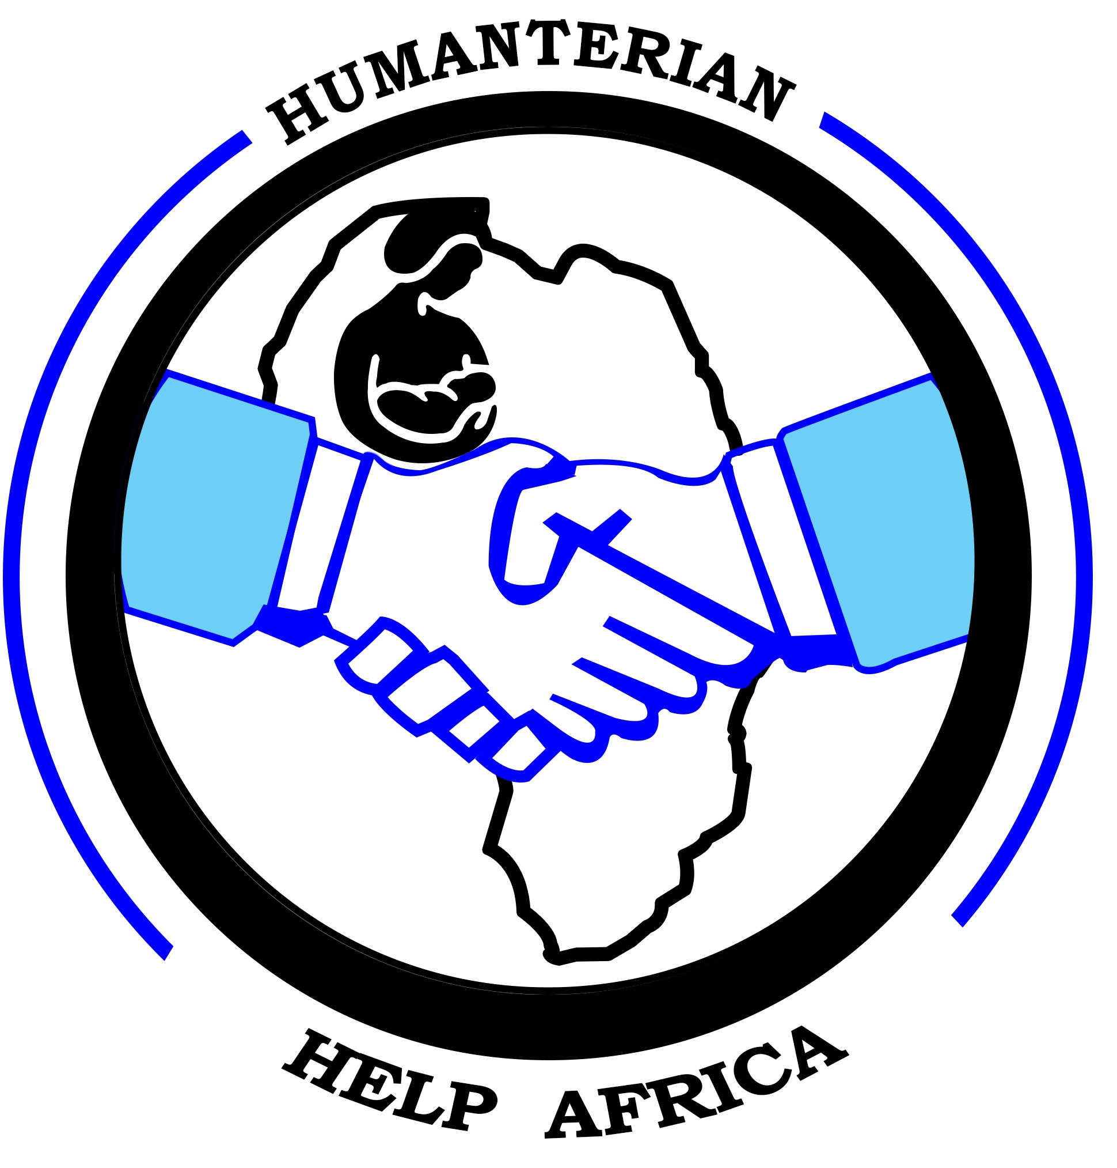

# ORGANISATION PROFILE

**FOR**

# HUMANTERIAN HELP AFRICA

**Contact Person:** Eudu Luke Emmanuel

**Location:** Kaberamamido District, Uganda

**Telephone:**  +256 775999044/+256704544849

**Email:** [emmaeudu@gmail.com](mailto:emmaeudu@gmail.com)

**P.O BOX 498 SOROTI, UGANDA**

# Abbreviations

**HIV/ AIDS**

**LRA - Lord’s Resistance Army**

**CRC - Convention of the Rights of the Children**

**HHA-Humanterian Help Africa**

**MoES - Ministry of Education and Sports**

**BTVET - Business, Technical Vocational**

**NGO - Non Government Organization**

# Background

**Humanterian Help Africa** was founded and registered as a non-profit Christian, Community Based Organization in Uganda in 2016 in Anyara Sub County Kaberamaido district. It was established with a mandate to help and support the disadvantaged children, sustain livelihoods, education and human rights for the most vulnerable members of the community. The vulnerable children are orphaned, abducted children, neglected, school dropoutsyouth, abandoned or simply living in acute poverty and are frequently affected by the ravages of HIV/AIDS.

**Background of Teso Region.**

After the along time of war in teso region since 1984-2008 of Uganda Government and during the time of civil war, women, youth and children were subject to a lot of pressure. Women, youth and children in teso is the least considered group of society and faced a lot of intricacies through all these time. Many of them suffered in health and mind due to the war caused troubles. Many others suffered due to humiliations and harassments. The children and youths of teso couldn’t able to fetch the education required though it is one of the most significant factors of development. Women, youth and children suffered due to lack of medical facilities and health care.

To support and encourage development in the areas of education, health and human rights, Humanterian Help Africa (HHA) came into existence. HHA aimed at backing the weaker section of the society. We are giving the impression of being hooked on improve the educational programs that we work hand in hand with the local council in the communities to make sure children go to school and,we have also established Bible Study Classes that is available in our study centre in Ogerai every Saturday we meet there and encourage the children with the word of God

In local teso, HHA means “we comfort” and it plays the role of curing the weaker section of the community from their affected injuries. HHA established in the year of 2015 as a community Based organization in Anyara. Till the establishment of HHA, the organization is struggling its way to build a secured society through better education, health care and public awareness. HHA was formed by three young men and today it is blessed with 5 members. The members of HHA include men and women from different skill sets. The members includeteacher, Driver, Development worker and peasant. HHA works under the effective management of Board of Directors. There are 5 directors in the board and the BOD meets once a year. In the annual meeting, the board selects a chairperson and executive members for the coming year. The board also plans the next year’s activities and HHA annual plan start at January every year.

***Founders of the organization***

The following people are the founders that established the organization for the community’s achievements.

1. **Angeno Grace**
2. **Eudu Luke Emmanuel**

***Boards of Directors***

HHA general assembly have selected a Board of Directors (BOD) of 5 members, as the organizational policy makers and setting the direction the CBO to achieve its objectives, annual yearly master plan in accordance with the Vision and the Mission of the CBO, the Board of Directors The term in Office will determine the CBO bylaws, normally the Board meets quarterly and at any time needed for the extraordinary Members are:

1. **Eudu Luke Emmanuel Chair person**
2. **Eesu David Vice Chairperson**
3. **Olupot Joseph General Secretary**
4. **Angeno Grace Treasurer**
5. **Isalu Irene Mobilizer**

**About Uganda**

Called “the Pearl of Africa” Uganda is a lush and fertile country. This East African nation is rich in wildlife and natural resources. Uganda is a landlocked plateau straddling the equator and bordered by Southern Sudan to the north, Democratic Republic of Congo to the west, Rwanda and Tanzania to the south and Kenya to east. The country lies in a cradle on mountains and is home to half of Lake Victoria and the source of river Nile.

The Republic of Uganda is a modern construct of the result of Unification of ancient kingdoms and much other smaller independent chiefdom. In all, Uganda embraces 52 different ethnic groups. Music and dance are integral to each of these cultures, as is a rich tradition of storytelling and folklore. Uganda’s population is estimated at nearly 35million, 50% of whom are under the age of 15. English is the official language. Uganda depends on an agricultural economy with 85% of its workforce engaged in farming, forestry, and fishing largely on a subsistence basis. Coffee is the main commercial and export crop. Others ate tea, tobacco, fish, cotton, flowers and other horticultural products.

After achieving independence from Great Britain in 1962, Uganda was ruled by two brutal dictators: Idi Amin (1971-79) and Milton Obote (1980-85) who were responsible for the deaths of nearly 1 million people. In 1986, Lt. General YoweriKagutaMuseveni seized power and established a government that remains in place today. Under Museveni’s tenure, Uganda economy has stabilized, its education improved and its infrastructure steadily rebuilt.

However, since 1987 the Lord’s Resistance Army has been engaged in brutalarmed rebellion in the North of the country. Operating from bases in the Southern Sudan, LRA has abducted tens of thousands of children and at clandestine bases, terrorized them into virtual slavery as guards, concubines and soldiers. In November 2005, the United Nations announced its intent to increase its activities in northern Uganda in the coming year to help the 2 million Ugandans displaced by Africa’s longest running, yet least reported conflict.

## Facts about the children in northern and eastern Uganda

Significant investments in children, youth and women in recent years have led to developmental successes in Uganda, notably in primary education and in the fight against HIV/AIDs. However, in the north and eastern Uganda, two decades of conflict between the Government and the Lord’s Resistance Army (LRA) spurred a severe humanitarian crisis marked by widespread insecurity and massive displacement. Uganda has ratified the convention on the Rights of the child (CRC), and the optional protocol to the involvement of children on armed conflict. A children’s Act, based on the CRC was passed in 1996.

## Issues facing children in Uganda

* Malaria respiratory infections and diarrhea are the main causes of under 5 mortality.
* Approximately 90,000 babies are infected by HIV annually through mother to child transmission.
* Nearly half of the estimated 2 million orphans are orphaned due to AIDS with the total expected to rise to 4.5 million by 2019.
* Children and women comprise 80 percent of the 1.4million people forced to flee their homes due to conflict and land slides. They live in more than 200 camps with very limited services.
* The LRA abducted more than 25,000 children since 1986-2011.

# Mission Statement

There is an orphan crisis in Uganda. Currently the country is home to nearly 2.4 million children who have lost one or both parents to HIV/AIDS, extreme poverty and civil conflict. In fact, Uganda has the largest orphan population per capita of any country in the Africa.

## VISION

**We confort.**

## MISSION

**To empower the vulnerable community.**

### Focal areas

1. Teaching the word of God
2. Primary Education
3. Health
4. Community empowerment
5. Vocational education

## GOALS

The goals of Humanterian Help Africa in accomplishing the mission are respectively envisaged per focal area.

1. Reducing the impact of illiteracy, poverty and HIV/AIDS in Teso
2. To enhance access to education for disadvantaged children and youth.
3. To contribute to improved healthstandards for children and youth.
4. To build these children’s self-esteem and give them life skills for a better living.
5. Ensuring right to education to deprived urban children.

# Sources of funding

Humanterian Help Africawill benefits from the friends who will give in their money, materials/Items and many volunteers who will visit the organization and give their time, money and support, and also benefit from fundraising by Children’s Choir, grants and donations from churches, schools, sponsors and other organizations.