JOSEANNEX MESSIAHS MUSIC GROUP
Po box 31010 kampala , UGANDA

This is a wonderful music group started in Uganda by Kiwanuka Joseph, born in LWEZA VILLAGE on 17th APRIL 1987
The Prents are Mr Kiwanuka Lawrence a builder and Mrs Nakachwa Elizabeth a local poet and a local music composer and plays . the parents are both alive.

This is a community based and non profit Organization in LWEZA village near Kajjansi Town along Entebbe road.

BACK GROUND FOR THE GROUP

After analysing the problems faced by my community in Lweza , I was inspired by the spirit of helping my fellow youth many of whom have talents but can not attain school at this modern moment.

My fellow youth some of them are school drop outs and others had been drug addicts , and in so doing they were faced with many problems like poverty , proposing early marriages to girls, being dettained in prison because of idle and disoderly ,
In conclusion, my fellow youths were faced with many problems of which many youths in my village were so much uncertain about the future . because they were not even unsure of the next move to life , because of of poverty and diseases faced by them .

As I studied in the seminary , many youths took me to be a role model , a person who can atleast be listened to by other officials in the community , a person who can help them . In my heart I had the inspiration of the late Princess Diana who helped the poor and the marginalized especially in AFRICA. She was a royal who bent down for the down trodden with her practical help .

That is why when I left the seminary embarked on the continuity of helping my fellow youths in the community of LWEZA. IN UGANDA. Some of whom are ex religious and seminarians and other local youths who feel that they have a talent in music.

I started with 4 people but now I have got 30 youths who fully participate in the trainings of voices and skills in dancing and knowledge of music as a whole.

THE MAJOR PROBLEM

The problem is the musical instruments , because during our voice training , you will see that there are musical instruments which we hire from another group AND this is very expenisve for us to maintain,
that is why we are requesting for our own musical instruments .

ACHIEVEMENTS

We have achieved in participating in a cultural dance gathering in LWEZA
We have presented dances during political campaigns
We have worked in markets and streets of Kampala for Charity
We have visited the AIDS Orphans
We have visited the former drug addicts in CORSU hospital.

We are happy to see the people changing their former lives and having a goal in life through music.

NEEDS FOR THIS GROUP

We need musical instruments , and music system .

We need some books for learning music instruments.

We need funds to build a center where we can build the headquarters of our Organization . because the place where we gather is not enough .

We need some expertise to come and give lectures to my fellow youths especially those lecturers from abroad.

We need to have a link to the outside world and to perform with other people onstage on big events , like independence days , charity days , exchange travels for music, columbus day , and other big days of countries .

OUR GOALS

The youth will be trained to sing classical , traditional , country, praises and worship , jazz . Ochestra music , cultural dances, and secular dances .

To eradicate poverty among the youth in the community of Lweza.

To train the youths new skills of music and stage performances

To open the doors of developments in the community through music.

To open the youths to outside world of music .
The youths will be educated to acquire necessary qualifications in music and other fields of their choice.

The youths will exchange study trips if any , to outside continents .

We expect to finally eradicate poverty , ignorance , deseases , among the youths.

The YOUTHS of JOSEANNEX WILL BE THE BEST GROUP OF PERFOMERS IN THE WORLD.

The group will grow in a big Charity Organization that has links to every where and establishes its branches every where in the world.

The youths will perform music on many ceremonies in the world.

In Order for our group to stand we need to collaborate with the donors , and other musical groups for better performances and achievements .

PICTURE DISCRIPTION
This was the group of young ladies and men who participate in singing.
Many of them are school drop outs because of lack of school fees and now they are unemployed ,

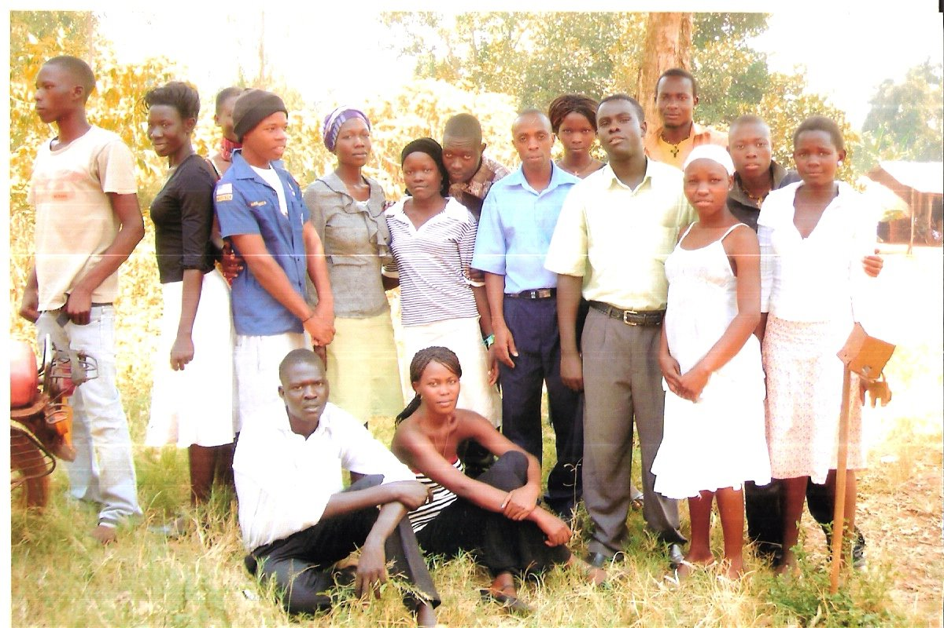

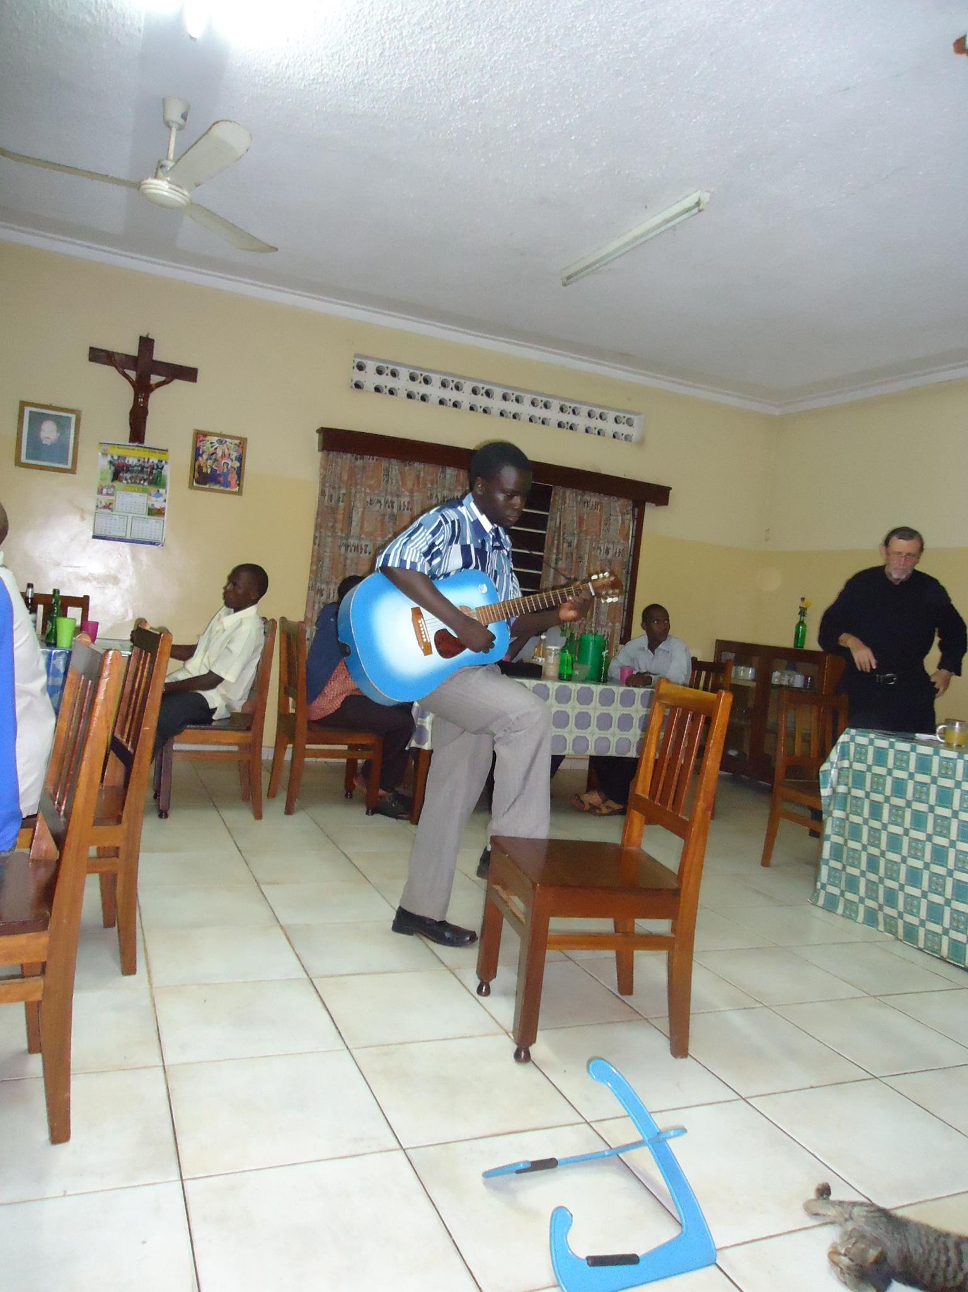
JOSEPH WAS INTERTAINING THE GROUP ON A FEAST DAY

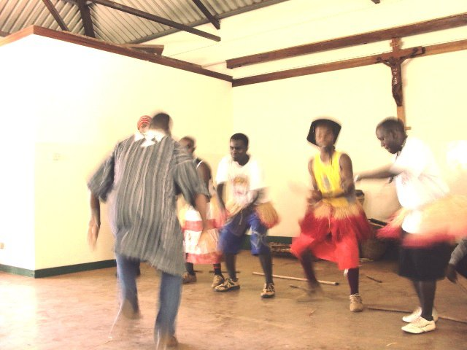

A DANCE WITH THE FIRST MEMBERS IN THE GROUP

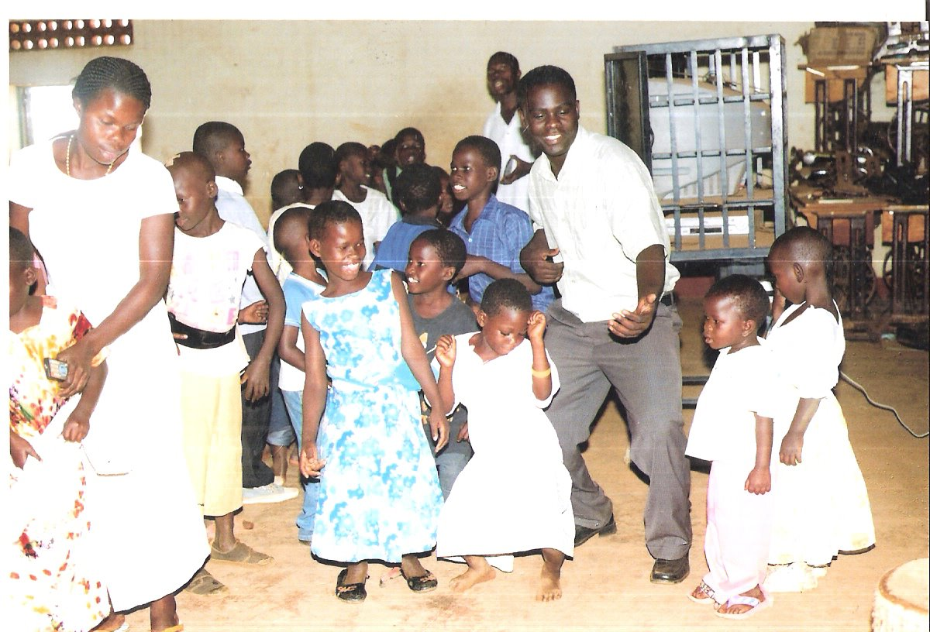

THIS IS A PARTY THE YOUTH PREPARED FOR THE UN PREVILEDGED CHILDREN IN JINJA .

ACCOUNTABILITY IN MAKING JOSEANNEX MESSIAHS A SUCCESS.

ITEMS | PRICE | PRICES IN INTERNATIONAL CURRECY
JAZZ BAND AND DRUMS . | 10 MILLIONS UGANDAN SHILLINGS | 4160 $
.2 BASS GUITAR  .2TRUMPETS  . 2 SAXOPHONES  .2 SOLO GUITARS  .4 VIOLINS  .4 VIOLA  .1 KEYBOARD PSR 500-1000 , YAMAHA.  . 2 SETS OF MUSICAL COSTUMES.  . SET OF LOCAL DRUMS. | 30 millions uganda shillings | 12,500 $
MUSIC SYSTEM  .1 MIXER  . AMPLIFIER  . BASS AND STEREO SPEAKERS  COMPUTER AND SOFT WARE FOR MUSIC.  .MICROPHONES | 10-20 MILLIONS UGANDAN SHILLINGS | 8330 $

STORE ROOM WILL TAKE ABOUT 1000 $

THE WHOLE PROPOSED AMMOUNT

IS

25,990 $ -----30,000 $
FOR THE PARCEL : you can send through KIWANUKA JOSEPH . p.o box 31010 KAMPALA UGANDA

OR

ST MUGAGGA BOY’S HOME P.O BOX 471 JINJA
As a donation .

Money , through Centenary Rural development Bank
On account number SAVINGS ACCOUNT 3020088509

, for any question please contact KIWANUKA JOSEPH
PHONE NUMBER : +256774191983

EMAIL : kiwanukajoseph2001@yahoo.com
jkkiwanukajoseph4@gmail.com

