TRUE AFRICAN FOUNDATION (TAF)
P.O.BOX 1, BUTALEJA
Tel: +256-788233721/0755565825
Email: trueafricanfoundation4africa@gmail.com

31^{ST-} JAN-2021

RE: JANUARY MONTHLY REPORT

1.0 Preamble
This monthly report is prepared in reference to multidimensional activities executed for the month ending today 31st – January-2021. It consists of a couple of activities conducted, challenges, lessons and good practices, vis-a- viz recommendations
Objectives
- To build confidence and restore hope in the OVC and their caretakers through home visits for PSS and other educational message deliveries.
- To promote holistic service delivery through social, economic and educational sections hence agitating for a comprehensive community welfare especially individuals in households affected/infected by HIV/AIDS.

2.0 Activities
2.1 Planning meeting
Following the official opening of TAF offices on 11th –Jan -2021, a planning meeting was held presided over by the ED ,his administrative speech consisted of new year welcome remarks, recent strategies for organizational development/interventions ,including new cooperatives for funding Under several occasions, the staff dully engaged in
2.2. Follow up Start up Uganda
The focus of this initiative is to identify youth within the community, primarily between 14-25 years, who have an interest in increasing or developing entrepreneurial skills. The primary objective is to engage youth through a series of camps to think critically about potential income generating activities that resolve challenges in their communities, develop business skills, and give them access to potential investors and stakeholders. Efforts are made to ensure that groups formed will be gender balanced, support female entrepreneurship, and incorporate youth groups formed from past Start Up editions.

2.2.1 Objectives
- To discuss on the achievements so far achieved related to their started business
- To discuss on the challenges and problems faced with in their started business
- To brain storm on what can be done (way forward) in order to help achieve their set goals.
- To build networks of support for youth-led innovations
2.2.2. Findings
Through the discussion which involved the students with in the clubs at different schools and the staffs of TAF, we were able to find out and note down the achievements, challenges, and the way forward in each youth start up club formed and the following below are the key issues discussed.
They have been able to start up the liquid soap business and been able to save up some money with their patron in charge of helping them at school.
They have been able to train some members from lower classes on how to make liquid soap before the outbreak of the COVID-19 pandemic. They managed to produce and supply their liquid soap to the school before the outbreak of the pandemic
The money obtained from the liquid soap was used to set up the piggery project and also formed a club of their own.
They have been able to save around 400,000 from liquid soap making
They have improved on the quality of their liquid soap
They have managed to teach other fellow students skills like public speaking, marketing, budgeting and saving.
They have been able to widen the market of their liquid soap through market research
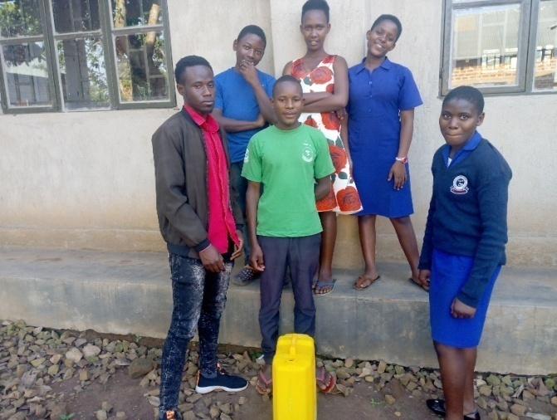
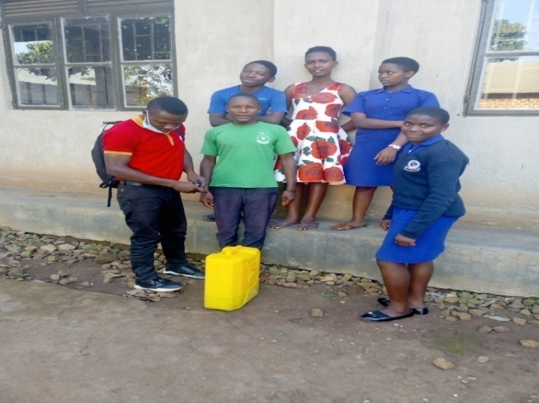
Butaleja Modern Youth Start up Club-
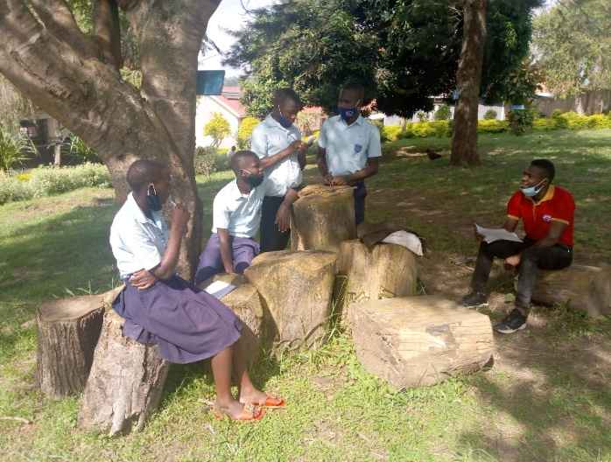
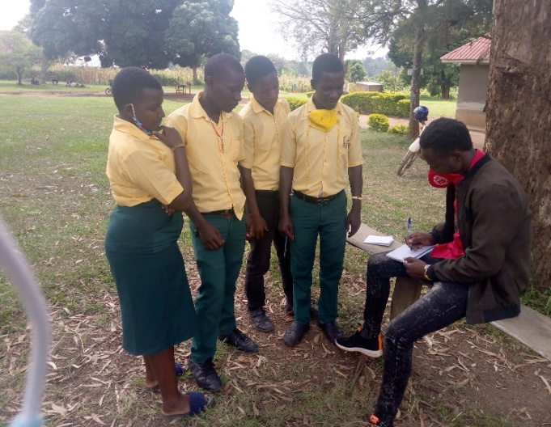

St. Mary’s SS ,Kapisa youth startup club Butaleja SS youth startup club with TAF Staff

2.2.3. Challenges
- Limited market as most of the students who used to buy their soap have not yet reported back due to the pandemic outbreak thus affecting their produce and supply as well. That’s to say they used to sell their soap to the school but because the population of the students have reduced hence reduction in the demand by the school too.
- Inadequate requirements or materials to use like packaging materials, among others.
- Inadequate capital to expand the business
- Lack of supervision from Peace Corps representatives
- Limited market due to COVID-19 pandemic
- Lack of co-ordination as the participate in the group come from different locations making difficult to co-ordinate during holiday times thus affecting them.
- Limited time as their time is being divided and allocated to different activities since there are in candidate classes thus limiting them to concentrate in their business.
- Inadequate materials like buckets, jerry cans, and capital to purchase necessary required to aid liquid soap making
- High transport costs incurred while purchasing the requirements to use in the production of liquid soap as it requires them to move all from deep village to Masaka town to access the material

2.2.4. Details of youth reached within their respective schools template below
CHILD NAME | SCHOOL | CARE TAKER | ADDRESS
ASOBOLA RACHEAL | ST. PAUL | KYOMUGISHA JOVIA | BUTALEJA
KAWOOYA EMMANUEL | ST .PAUL | NAGUJJA GETRUDE | BUTALEJA
BBIRA JUDE | ST. PAUL | KYUNGIRIZI CHARLES | KAPISA
BWAMI GEOFREY | ST. PAUL | NALUKYAMUZI BABRA | KAPISA
JJEMBA ABUBAKER | ST. BENARD | NAMULI MABINAH | NAMPOLOGOMA
SSENSIITI JULIUS | ST. BENARD | BIRIMUYE DEOGRATIOUS | DOHO
SSEKYONDWA JOSEPH | ST. MARY’S KAPISA | SSEKYONDWA GERALD | NAKYENYI- LWESINGA
KYOMPAIRE SHIVAN | BUTALEJA SS | KEBIRUNGI FLORENCE | DOHO
SSEMAGANDA FRED | ANGELS | NAKAWONDE MARIA | HIMUTU
NDYAMUHAKI DEVINAH | ANGELS | TIBENDA JACKSON | NABIGANDA
KAVUMA RODGERS | ANGELS | NZAMUKUNDA FLORENCE | KYAZANGA
TAYEBWA SARAH | ANGELS | TAYEBWA ANANIA | HISEGA
NAMPEERA EDITH | ANGELS | MUTEBI NOELENA | NAMUNASA

2.3. Viral load collection
This field activity was conducted by Mr. Kiwanuka Ben and Madam Ramurah in liaison with health facility’s PSWs from Nabiganda H/C IV and Kiwangala H/C IV who supported them and made OVC files available for extraction of relevant data (viral load information) . However several cases of; displaced OVC files, transferred files to adult data rooms due to age factor (18+ OVC) were reported at the facilities reached by the staff.

Tabulated number of OVC per Health centre
Sub county | Health Centre | Total No. OVC at Facility & active on program |  | OVC with misplaced files |  | OVC with VL suppression |  | OVC with non-suppressed VL
 |  | M | F | M | F | M | F | M | F
Butaleja T/C | Butaleja H/CIV | 12 | 18 | 03 | 05 | 10 | 15 | 02 | 03
Nabiganda T/C | Nabiganda H/C IV | 25 | 35 | 00 | 00 | 17 | 34 | 08 | 01
Total |  | 37 | 53 | 03 | 05 | 27 | 49 | 10 | 04

2.4. OVC birth certificate procession and distribution exercise
TAF doesn’t underestimate the importance of birth registration for OVC, it is one of the key activities championed under child care and protection, it serves as a proof of parents before the law to provide legal protection and identity for their children, it also establishes citizenship and nationality of the child, legal relationship between the parent and the child. Therefore, on a proud note am grateful to report that through NIRA a total of 120 OVC from Nabiganda T/C and Butaleja T/C were supported to register birth and all received birth certificates –distributed by Mr. Ndawula Jude TAF field official.
TAF staff poses with OVC that received birth certificates in Nabiganda T/C
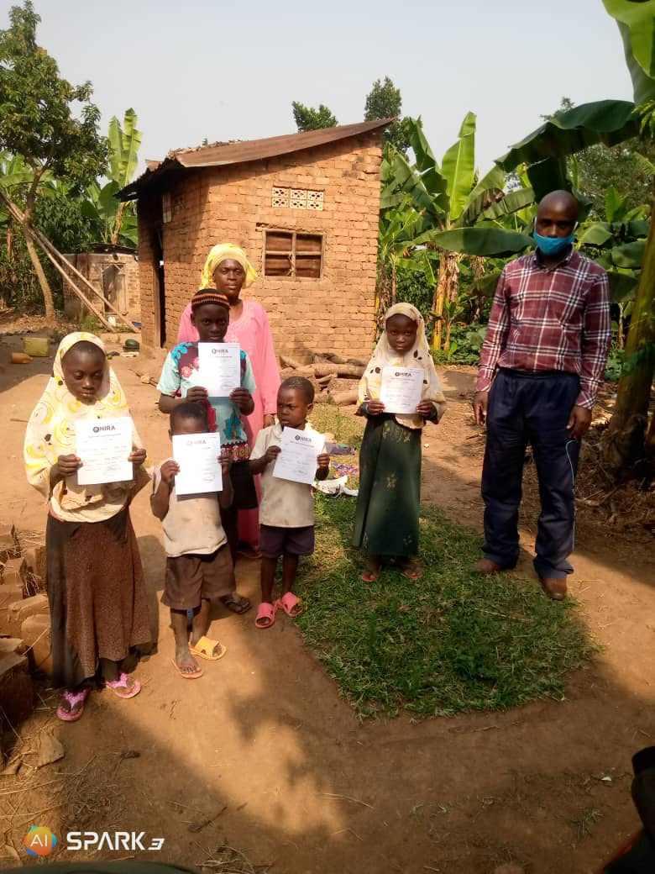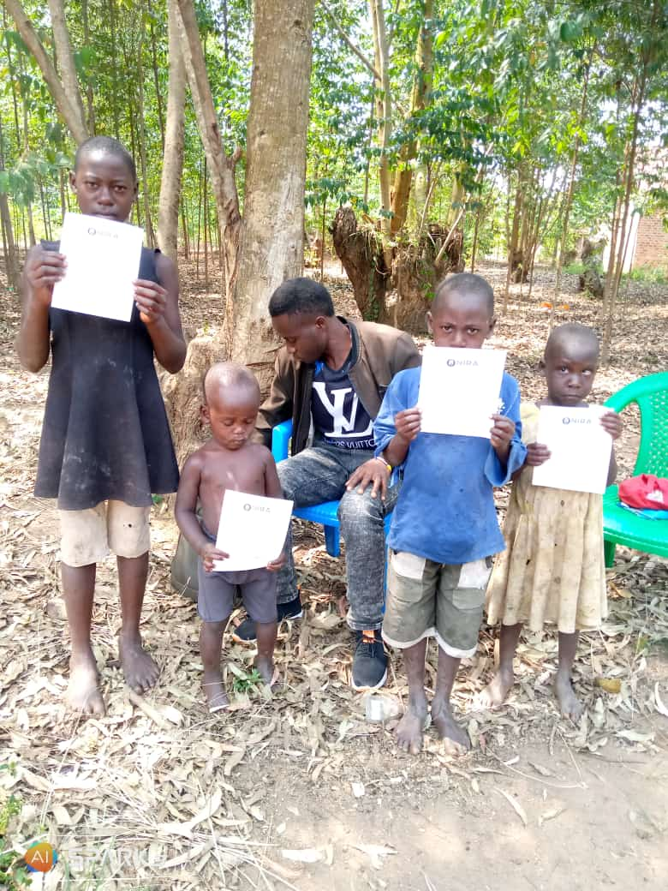

2.5. Home visits
Home visit is one of the core component in OVC programming conducted on a routine-quarterly basis for HIV/AIDS affected/infected OVC and families which is executed to capture validated household information and monitor families .It emphasizes primary family-centered care and a range of services such as household economic stability and security ,education support, Psychosocial Support, Health care and Child protection, thus several interventions were made by the staff to offer articulated services in both Butaleja T/C S/C and Nabiganda T/C
2.5.1. Objectives
- To gather relevant particulars of OVC/caretakers required in birth registration
- To deliver Birth Certificate to identical OVC households.
- To monitor and conduct adherence support visits to HIV+ OVC and make other necessary social interventions.
- To offer other health information services regarding to COVID-19 prevention and control measures.
- To monitor case plan progress in regard to OVC/Caregiver’s set goals.
2.5.2. Achievements/findings
- Most of the OVC were registered birth and received their birth Certificate trough VHTs under Uganda Government program.
- During home visits, we noticed that most OVC in Candidate Classes managed to go back to school, however they lack scholastic materials and other educational materials for effective learning and progress.
- 98% of the HIV+ OVC are still adhering to ART medication and have their viral load suppressed which portrays a credit to the primary givers/ART treatment supporters.
- Poor hygiene is still rampant and was observed among the households visited ie some families were found without latrines, others were found sharing small rooms with domestic animals in which in one way or the other affects the entire household health
See the field photos
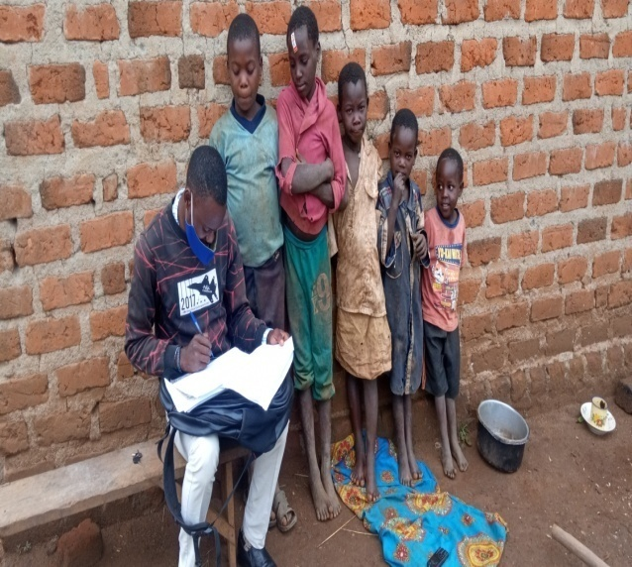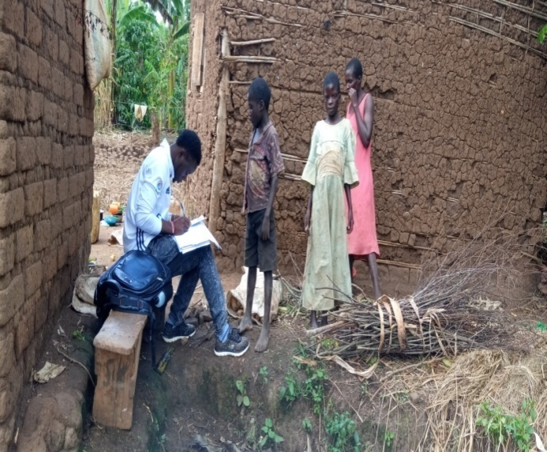TAF staff conducting routine monthly house hold visits in Nabiganda T/C
2.6. Data management & Record keeping, Updating case files
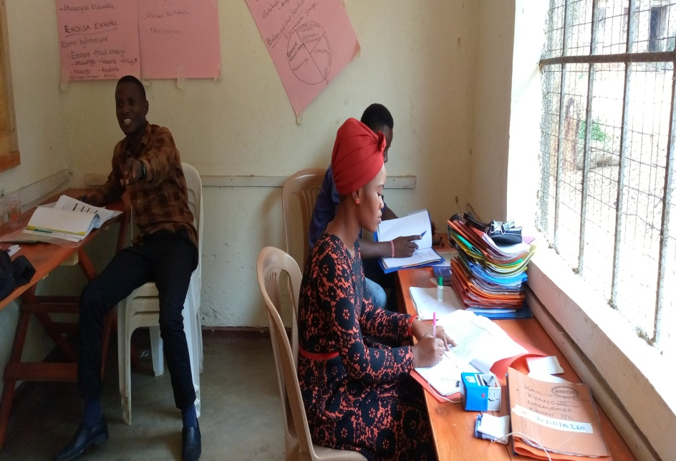
Caption:
As part of the routine quarterly activities, appropriate case file management was accordingly conducted by the staff to cohere the data management protocols, some of the sub activities included viral load updating and also updating necessary data into the registers for the services received by the beneficiaries, including making applicable documentations in the case files for the services rendered to OVC/Caregivers and placed them back in the lockable shelves for safety and confidentiality reasons. This aimed at availing enough evidence in the parent case files especially in regard to the quarterly services.

3.0 General challenges

- High expectations/suspiciousness. Since the activity was conducted during the lockdown and when the government and other community based organizations had started distributing food/COVID supplies, this drilled the OVC/ caregivers to raise hopes for tangible support.
- Overlapping vulnerability levels in most of the households visited which very supersedes the available resources.
4.0 Lessons and good practices
- Commitment by the staff observed through healthy time management
- Routine home visit is a key component in realization of house hold challenges for appropriate intervention hence problem harmonization especially those that inflicts the wellbeing the OVC
- Lobbying for services is paramount in advocating for the deprived and marginalized populations.

5.0 Recommendations
Poverty among the interest groups is still alarming, therefore more material and immaterial support is required to boost households in areas economic stability and security, education and health for comprehensive transformation.

6.0.Conclusion
Despite the contemporary constraints associated with finances visa-a- viz COVID 19, much has been done in accommodation and facilitation of the monthly activities giving birth to the compilation of this report. Notably further generous efforts, commitment and cooperation is called upon to continuously support the deprived and marginalized communities especially in embracing the organization goals and objectives hence elimination of the vulnerable populations from a state of despair. However, to embark on this more material and immaterial input are required in the areas of economic stability, Health and education especially geared towards empowering the interest groups.

Prepared by:
……..……………………
Wadidi Jackson Team leader -TAF

