Proposed Program to George Mason University

Patriot to Patriot

Yara Mowafy

Jordan Bivings

Fall 2012

Patriot to Patriot

**Mission**

This program will reallocate a small percentage of the monetary value of unused meal plans to students with food insecurities and allow them to have access to a meal fund on campus.

**Project Goal**

The goal of this program is provide meal plan options for students with food insecurities.

**The Program Patriot to Patriot will...**

1. Feed students with food insecurities.

2. Make this a community effort that will unite this institution.

4. Empower students to be stewards of the community in which they are a part of.

3. Provide an additional resource to students in need.

5. Engage the Mason community in an innovative effort to address hunger issues on campus.

**Define Program**

The World Health Organization states that food security includes both physical and economic access to food [and that it] includes the following aspects: access to sufficient quantities of appropriate food, availability of adequate income or other resources, and stability in obtaining appropriate food at all times. Patriot to Patriot is a program designed to reallocate a small percentage of the monetary value of unused meal plans from students and faculty/staff to students on campus with food insecurities.” The students that this program is supporting are students who do not meet the criteria of being food secure. The unused meal plans that will be recycled through Patriot to Patriot include but are not limited to Traditional Plans, Block Plans, Freedom Funds and Bonus Funds.

**How it Works**

Currently, Mason meal plans are prepaid and must be used by the end of the week or the semester (depending on the plan) and are therefore not refundable. According to the Mason Card Office website “the consumption expectation is that all Traditional and Block meal swipes be used by the end of each week/semester. Remaining meals do not roll over.”

Traditional meal plans are based on a weekly allotment of 10, 15 or 19 meals per week. Traditional meal plan holders have until 5:00 a.m. every Friday morning to use them. In contrast, Block meal plans, Freedom Funds and Bonus Funds expire at the end of the semester.

At the best of our knowledge, and with the help of Laura Callahan, Mason Money Manager/Card Services Coordinator, on average 25% of traditional meal plans and 7% of block plans are unconsumed.

Patriot to Patriot is going to refunnel a small percentage of the monetary value of left over meal plans. This money will be a combination of unused weekly Meal Plans, unused Block plans, and leftover Freedom and Bonus Funds.

The program will be based on an electronic system and will operate under the existing Mason Card Office system. At the beginning of each semester, students, faculty and staff will have the option to select the redirecting of funds of the value of their unused meal plans towards the Patriot to Patriot fund. At the end of every week, a portion of the value of the meal plans will automatically be funneled into a pool of funds specifically designed for food insecure students. There will be transparency in this process and all details regarding the transactions will be very clear to all participating students, faculty and staff.

Figure A shows an example of how the option to participate in the program will be displayed. Either while choosing housing preferences or simply purchasing meal plans, an option to partake in the program will appear. The drop down menu will have the following options:

-Yes, I choose to partake in the Patriot to Patriot Program.

-No, I do not choose to partake in the Patriot to Patriot Program.

Also, there will be a link present underneath these options that will redirect users to an informational page. This link is for those who are not knowledgeable about the program or those who wish to learn more before making a decision.

**Eligibility**

Patriot to Patriot is designed to assist students with food insecurities. Funds directed through this program will only be available to students who qualify. In order to qualify, students must show proof of financial need in accordance with the Financial Aid Office on campus.

**Project Timeline**

December 2012 - having conversations with stakeholders and drafting proposal.

January 2013 - Begin planning phase for the creation of the pooled fund under the already existing Mason with supporting web infrastructure (Assuming stake holder engagement and agreement)

August 2013 - Program’s inaugural semester

**Innovation is Tradition**

George Mason University is a diverse campus that serves more than 32,000 undergraduate and graduate students. With this high volume population it would be beneficial to the university to offer more services than a high caliber education. Patriot to Patriot poses a great opportunity to empower students to become stewards for each other, this would allow students to be change makers in the most humanistic way.

A key part of the university’s mission statement is “Innovation is Tradition.” As part of the student body, we, Yara Mowafy and Jordran Bivings, are aiming to be innovative in the Mason community through our care and consideration for the students in need. We have a concern that not all students at Mason have equal access to the same resources. Through this innovative program, we are attempting to address the perceived need of enabling these food insecure students. And while there are similar national programs this would be unique to the Mason campus, as it has not been done before.

A revered quality is finding a creative solution to a perceived problem; it is George Mason University’s responsibly to create local and global leaders that bring positive and effective change. And thus, we hope that the administration supports our efforts to move our generation forward. All in all, we seek to serve the Mason Community by providing assistance from Patriot to Patriot.

**Figure A**

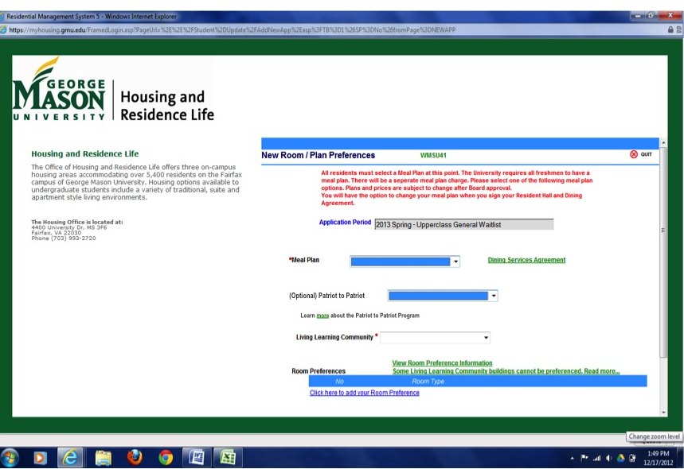

**Figure B**

