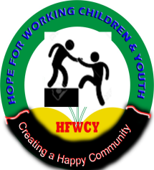
HOPE FOR WORKING CHILDREN AND YOUTH
ORGANIZATIONAL PROFILE.
Back ground
“Hope for Working children and youth” (HWCY) is a community based child and youth focused organization (CBO) which works with children, youth, families and vulnerable communities to fight poverty in all its manifestations including deprivation, cases where children and youth lack basic socio-economic needs, exclusions, where children and are not allowed to participate in decision making and vulnerability to risk.
The organization is registered as a community based organization (CBO) with Kampala Capital City Authority (KCCA) Reg. no. NAK/13/403 and has been able to extend services to Ngora and Mayuge districts respectively. WCY was started in Kampala District in 2010 by a group of 20 youth. These youth with a shared vision and mission came together to improve and empower their lives and those of other vulnerable children and youth so as to enjoy their fundamental human rights through access to trainings, development in life skills and access to income earning opportunities and better basic social economic services as regards to HIV counseling, information on STDs/STIs.
With support from members and partner organizations like Kampala Capital City Authority (KCCA), Action for community development (ACODEV), Reach a hand, Restless development, Save the children, Initiative for social economic rights (ISER), Emmanuel International and World Vision, beneficiaries have been able to participate in and benefit from various trainings i.e. Life skills. Sexual reproductive health training, entrepreneur skills training, leadership and governance skills training. Youth and children have also participated in the organizations detailed schools partnership program, community outreaches, income generating activities (IGAs) and sanitation campaigns. This is done through the children and youth interest groups (Grass root groups) who have been formed in their respective zones of residence.
Who we are.
Hope for working children and youth (HWCY) is a child and youth led focused organization with programs on economic empowerment, child rights and sexual reproductive health rights (SRHR) HIV/AIDS awareness and prevention. We also fundamentally focus on changing social norms and values that limit access to sexual reproductive health services and information through designing effective communication strategies and community outreaches to create awareness.
We consist of dynamic, passionate, committed and skilled personnel in the areas of children and youth, SRH and entrepreneurship who believe in the power, potential and future of the young generation.
Vision.
To empower children and youth together with their families to be more self reliant.
Mission.
Offer opportunities to children and youth to enjoy fundamental rights and life skills for sustainable livelihood.

Our programs.
Peer education: Hope for working children and youth (HWCY) holds peer to peer outreaches to the community through our well trained and experienced team of peer educators. Though these youth are equipped with information on SRHR as well as life- skills, using the peer to peer approach we believe that young people relate best with their peers. These peer educators are sent to partner schools through the schools program. They listen to them, share experiences, have debates on some topics and relate through creative arts. These young people have been able to form clubs and where they pass on this information to their peers during their free time.
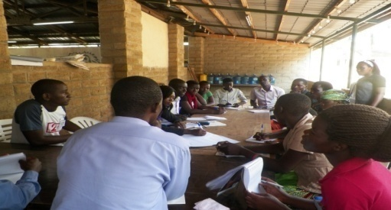

Youth led projects: Through this initiative children and youth identify with themselves in their grass root groups (GRGs) and come up with possible ventures they are interested in and these youth are linked to some of our partners like the International Labor Organization (ILO) for training under the youth entrepreneurship facility (YEF). Through this we believe that when young people are economically empowered, they are less vulnerable to the “something for something” mentality.

Schools program: Hope for working children and youth (HWCY) is a child and youth led organization with emphasis on both in and out of school children and youth. This program is implemented with partner schools where our team visits these schools to share with the in school children and youth on SRH, Child rights issues and club formation and support.

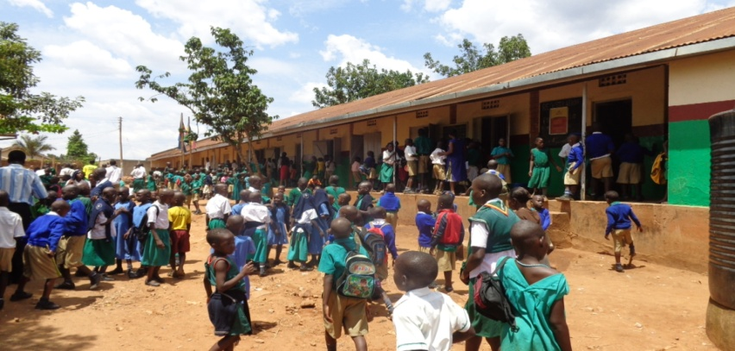

Our partners.
Kampala Capital City Authority (KCCA).
Save the Children.
Action for community development (ACODEV).
Reach a hand.
Initiative for social & economic rights (ISER).
National association for social workers in Uganda (NASWU)
World Vision Uganda.

Our core values.
- Transparency.
- Team work.
- Youth driven.
- Love.
- Accountability.
- Commitment.
Directors /Founders.
The organization was started by a group of 20 youth with a shared vision who came together to improve the lives of their peers with the main being.
Okiror James.
Ongit Desderius.

Hello Danny hope this mail gets you fine here are some photos that you can add to the web-site on some of our partnerships. This was a high level dialogue with KCCA technical wing on issues affecting youth under the UPLIFT project with World Vision Uganda. And Simo needs some drafts from you to share with the Youth Parliamentary Forum please comply. Thanks for the good work bro.

