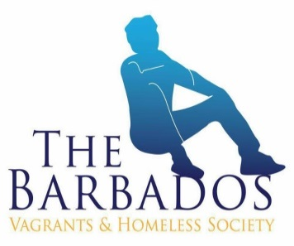

THE BARBAOS VAGRANTS & HOMELESS SOCIETY
Comprehensive Proposal
[Barbados]
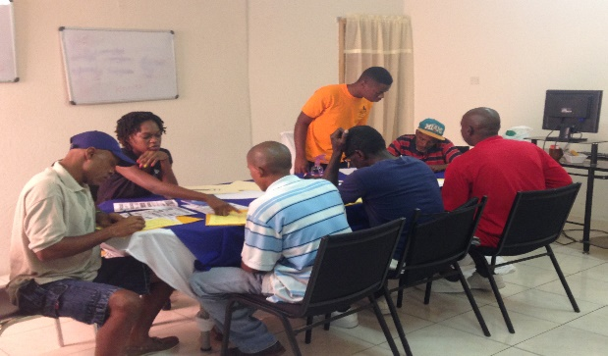
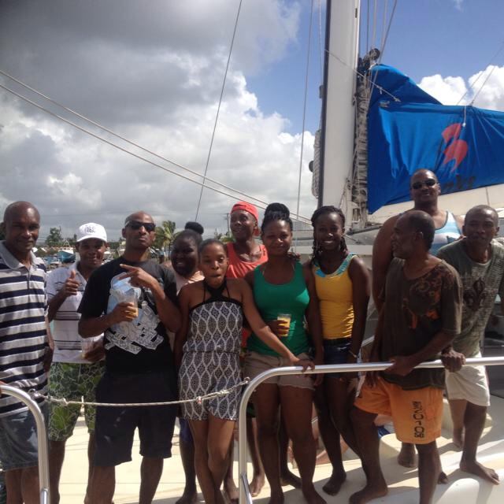
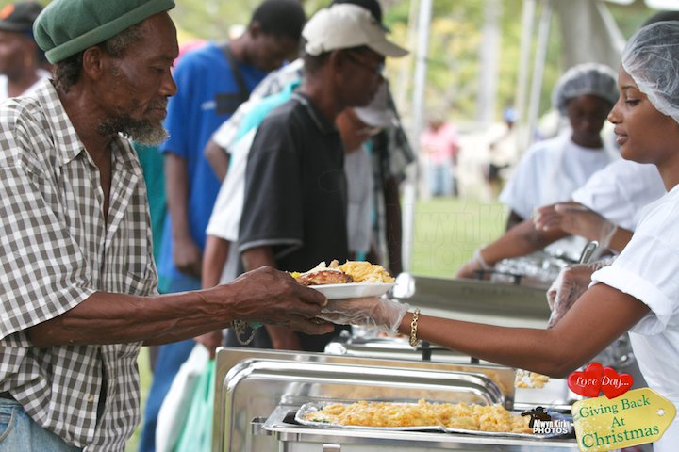
Figures
Section A
LOST
PROJECT PROPOSAL OUTLINE
1.3 Project Objectives
1.4 Project Activities and Time Frame
1.5 Success of programme
Section B
1.6 Evaluation Plan and Indicators
1.7 Sustainability
Section C
AT THE CROSSROADS
Section A.
PROJECT PROPOSAL OUTLINE
2.1 Project Summary
2.3 Project Objectives
2.4 Project Activities and Time Frame
2.5 Success of ATC

Section B
2.6 Evaluation Plan and Indicators
2.7 Sustainability
Section C
NIGHT SHELTER
PROJECT PROPOSAL OUTLINE
3.1 Project Summary
3.2 Project Objectives
3.3 Project Targets and Time Frame
Section B
3.4 Evaluation Plan
3.5 Sustainability
DIRECT CARE MINISTRY 18
Section A. 18
PROJECT PROPOSAL OUTLINE 18
4.1 Project Summary 18
4.2 Project Objectives 18
4.3 Project Activities and Time Frame 19
4.4 Success of programme 21
Section B 21
4.5 Evaluation Plan and Indicators 21
4.6 Sustainability 21
COMMUNITY PARTNERSHIP AND ON THE ROAD MINISTRIES 22
Section A. 22
PROJECT PROPOSAL OUTLINE 22
5.1 Project Summary 22
5.2 Project Objectives 22
5.3 Project Activities and Time Frame 23
5.4 Expected Results 23
Section B 23
5.5 Evaluation Plan and Indicators 23
5.6 Sustainability 23

LOST

Section A

PROJECT PROPOSAL OUTLINE

1.1 Project Summary
Barbados as a country has sought to maintain an acceptable standard of living for its citizens through a number of social programmes. As it works towards achieving the millennium development goal (MDG) of eradicating poverty. Nonetheless, the country still experiences pockets of poverty and indigence. To combat this, the country has pursued a number of poverty alleviation programmes, among them National Assistance and Relief-in-Kind Programmes. However, these programmes do not adequately service the needs of those who are vagrants or homeless. Consequently, BVHS seeks to address the issue of vagrancy and homelessness in Barbados. With the assistance of individuals and civil society, the organisation has implemented measures which fill these gaps in the delivery of services to these vulnerable persons.
Since the inception of the Life Opportunity Superseding Tomorrow (LOST) programme in 2010 over 410 persons have participated in this programme, (see Figure 1). This programme provided food, clothing, medical care and testing and haircuts to participants. 95% of these persons have received further assistance from the Barbados Vagrants and Homeless Society (BVHS). Some of these persons have also participated in other BVHS programmes.
The programme goals are proposed to meet the immediate needs of vagrants and homeless persons, while collecting data on the pervasiveness of vagrancy and homelessness in Barbados. To achieve these goals weekly breakfast and dinner will be prepared for at least 50 clients. Bi-annual events will be staged to feed, provide food hampers, clothing and medical care and testing to clients. BVHS also proposed to provide shelter and accommodation for vulnerable persons in need. The bi-annual events will be held during the months of June and December. It is proposed that staff, volunteers, various individuals and organisation will contribute financial and human resources to the programme. BVHS will implement a sustainability plan to ensure the longevity of the programme. Also, BVHS has proposed to monitor and evaluate the programme through various phrases.

Figure 1.1: LOST Success

1.3 Project Objectives
This ongoing programme seeks to meet the immediate needs of vagrants and homeless persons, while collecting data on the pervasiveness of vagrancy and homelessness in Barbados. The objectives of this programme is as follows:
- To introduce 100 new persons to the services
- To provide at least 50 persons with weekly breakfast and Friday feedings
- To provide bi-weekly nutritional supplements
- To provide bi-annual sessions where at least 150 vagrants and homeless persons can receive counselling, haircuts, medical care and testing, food items and clothing
- Provide nightly shelter for 40 persons over a six month period
- Assist individuals with finding accommodations

1.4 Project Activities and Time Frame
The programme will seek to provide weekly feedings, bi-annual events, shelter and housing for clients (See Error! Reference source not found.). The weekly feedings are to be provided at BVHS office. Breakfast will be prepared every Monday, Wednesday and Friday, along with a Friday dinner. The bi-annual events will be held in June and December each year. Where the following services will be offered at the bi-annual events:
- Counselling
- Haircuts
- Medical care – various on the spot tests are provided
- Distribution of food items
- Distribution of clothing

The programme will utilize the services of BVHS’ staff, technical persons and volunteers to implement the programme. The work plan gives details of the organizational arrangements. It illustrates programme activities, persons responsible and timeline for the activities (see Error! Reference source not found. and Error! Reference source not found.). Additionally, listed below are technical persons and groups and the task they will perform during the programme:
- A steering committee has been formed to guide the work of the project. The committee is comprised of experts from various sectors in society and Government. The committee will meet regularly to review the milestones as set out in the work plan of the project.
- A full time project manager will liaise with the chairman and the steering committee. The president will supervise the daily work of the project manager and will be providing guidance as directed by the board of members and trustees.
- Public relations will be the responsibility of Veoma Ali and Co., the president and the manager.
- Financial matters will be supervised by the Kirk Smith Consultancy
- Negotiations will be the responsibility of the president assisted by the Kirk Smith Consultancy and the project manager.

LOST Work Plan
BVHS Focal Area: |  | BVHS Operational Phase: |  |  |  | Project Start and End Dates: October 1st 2014 to October 1st 2015
activities list with responsible persons |  |  | Activity chart for October 2014 to September 2015
Activity | Responsible Party | Indicator | 1O | 2N | 3D | 4J | 5F | 6M | 7A | 8M | 9J | 10J | 11A | 12S
1.1 | Volunteers and Co. | clothing
1.2 | Qualified counsellors & psychologist | counselling
1.3 | Volunteers and Co. | food
1.4 | Volunteers and staff | breakfast
1.5 | HIV rapid testing | HIV testing
1.6 | B’dos Diabetes Assc. | Diabetes testing
1.7 | Heart & Stroke Foundation | Weighting/pressure
1.8 | Nurses | Medicals
1.9 | Barbers | Hair-cuts
1.14 | Kirk Smith Consultant Co. | Budget monitoring and preparation
Indicate Person responsible for Monitoring and progress reports: Mrs. Kimberley Harewood |  |  | Monitoring Frequency / Reporting
Monitoring & Record keeping | Case Manager
Progress Reports: Case Manager & Counsellors
Table 1.1: LOST Work Pla

Success of programme
Life Opportunity Superseding Tomorrow (LOST) programme is proposed to provide programme participants with food, clothing, haircuts, shelter and medical care and testing. Since 2010, over 450 persons have participated in this programme. 95% of these persons have received further assistance from the Barbados Vagrants and Homeless Society (BVHS). Some of these persons have also participated in other BVHS’ programmes.

Section B

1.6 Evaluation Plan and Indicators
A summative evaluation will be completed to determine whether the programme objectives were met and how satisfied were participants with the programme. The programme will be monitored by the case manager and counsellors.

1.7 Sustainability
In order to maintain the sustainability of the programme, BVHS has proposed the following measures:
- Collaborate with the hotel sector to supply food
- Acquire financial support to offset cost
- Obtain monthly sponsorship of food, clothing and other essentials
- Utilise the income generated from the farming programme

Section C

AT THE CROSSROADS

Section A.

PROJECT PROPOSAL OUTLINE

2.1 Project Summary
BVHS seeks to address the issue of vagrancy and homelessness in Barbados. The “At the Crossroads” (ATC) project is the vehicle that BVHS will be utilizing to realize this aspect of the organizational mission. As part of BVHS’ rehabilitation programme into society, the socialization and empowerment of participants will be of paramount importance to reduce recidivism. The focus will be on behavioural modification, so as to rehabilitate these persons, who are homeless and have found themselves without a purpose. Counselling will be provided in an effort to strengthen their capability to cope with life with a view to making them more empowered citizens. In previous cycles of this programme, 34 men have been reintegrated into mainstream society. They have secured homes, jobs, bank accounts and have re-united with their families. The rehabilitative programme is comprised of individual, group and family counselling sessions, outings, mentorship and life skills and social skills classes. An aftercare programme is also proposed. The aftercare programme seeks to provide a stable environment, where participants will have the opportunity to sustain themselves and apply what they were taught in the ATC programme. The aftercare programme will provide housing to participants for six months. Participants will have more autonomy than if they were in the rehabilitative programme; where they will supervise themselves. They will have access to individual counselling, group counselling and life and social classes. The programme will be monitored by the case manager and a summative evaluation will also be done. The programme will be sustained by collaborating with various organisations and communities to provide financial resources, food, clothing and other necessities. While BVHS will contribute to the funding of the programme by selling produce reaped from its farming programme.

2.2 Project Objectives
Barbados as a country has sought to maintain an acceptable standard of living for its citizens through a number of social programmes. As it works towards achieving the millennium development goal (MDG) of eradicating poverty. Nonetheless, the country still experiences pockets of poverty and indigence. To combat this, the country has pursued a number of poverty alleviation programmes, among them National Assistance and Relief-in-Kind Programmes. However, these programmes do not adequately service the needs of those who are vagrant or homeless. Consequently, BVHS seeks to address the issue of vagrancy and homelessness in Barbados. With the assistance of individuals and civil society, the organisation has implemented measures which fill these gaps in the delivery of services to these vulnerable persons.
ATC is a home care rehabilitative programme which seeks to empower and motivate individuals towards positive change; so that they will gain insight into the possibilities that can exist for their future. The aim of the programme is to provide vagrants and homeless persons with the necessary life tools to re-enter mainstream society. Behaviour modification techniques will be used to rehabilitate the participants. The programme will provide participants with housing, food, money management sessions, individual, group and family counselling, mentorship and job opportunities. Individual and group counselling will allow participants the opportunity to develop coping skills. While the family sessions will seek to reunite the programme participants with their families. Each participant will be assigned a mentor, who provides on-going support. It is expected that this programme will aid in reducing the number of vagrants and homeless in Bridgetown.
Additionally, it is proposed that the programme will include a six month aftercare programme. This component was conceptualized because some of the participants were repeating the ATC programme. In some instances, six-months of rehabilitation was inefficient for some of the participants to rehabilitate. Some clients returned to using alcohol and drugs after the completion of the programme. The aftercare programme is a follow-up programme which seeks to prevent recidivism among ATC participants. In a stable environment, the programme will afford participants the opportunity to sustain themselves and apply what they were taught in the ATC programme. The aftercare programme will provide housing to participants for six months. Participants will have more autonomy than if they were in the rehabilitative programme; where they will supervise themselves. They will have access to individual counselling, group counselling and other helpful classes.
Thus, the programme objectives are as follows:
- To introduce and rehabilitate 48 persons through the ATC programme over a 2 year period by procuring housing for 12 participants twice a year.
- To assist participants with the development of coping, social and life skills by providing bi-weekly individual counselling sessions over a period of twelve months.
- To assist participants reunite with family by providing family counselling sessions over a period of five months.
- To provide participants with on-going support by assigning each client with a mentor.
- To provide participants with a six month aftercare programme which will reduce recidivism.

2.3 Project Activities and Time Frame
The work plan gives details of the organizational arrangements. It illustrates programme activities, persons responsible and timeline for the activities (see Error! Reference source not found., Error! Reference source not found. and Error! Reference source not found.). In the initial phases of the project, technical assistance will be provided from various stakeholders. Listed below are the technical persons and the task they will perform during the programme:
- A steering committee has been formed to guide the work of the project. The committee is comprised of experts from various sectors in society and Government. The committee will meet regularly to review the milestones as set out in the work plan of the project.
- A full time project manager will liaise with the chairman and the steering committee. The president will supervise the daily work of the project manager and will be providing guidance as directed by the board of members and trustees.
- Public relations will be the responsibility of Veoma Ali and Co., the president and the manager.
- Financial matters will be supervised by the Kirk Smith Consultancy
- Negotiations will be the responsibility of the president assisted by the Kirk Smith Consultancy and the project manager.

At the Cross Road Work Plan
BVHS Focal Area: |  | BVHS Operational Phase: |  |  |  | Project Start and End Dates: October 1st 2014 to October 1st 2015
Activities list with responsible persons |  |  | Activity chart for October 2014 to September 2015
Activity | Responsible Party | Indicator | 1O | 2N | 3D | 4J | 5F | 6M | 7A | 8M | 9J | 10J | 11A | 12S
1.1 | Volunteers and Co. | Training of clients
1.2 | Qualified counsellors & psychologist | Personal counselling sessions
1.3 | Counsellors | Coping skills
1.4 | Counsellors | Family counselling sessions
1.5 | Counsellors | Church Educational Programme
1.6 | Tour companies | Educational tours
1.7 | Counsellors | Anger & Conflict management
1.8 | Volunteers | Maths & English Classes
1.9 | Psychiatric hospital | Conduct baseline assessments
1.10 | Counsellors | Group/Indivi-dual Counselling
1.11 | Businessmen, family | Attachment to mentors
1.12 | Counsellors | Family Counselling Sessions
1.13 | Qualified accountant volunteers. | Financial Management and Motivational session
1.14 | Kirk Smith Consultant Co. | Budget monitoring and preparation
Indicate Person responsible for Monitoring and progress reports: Mrs. Kimberley Harewood |  |  | Monitoring Frequency / Reporting
Monitoring & Record keeping | Case Manager
Progress Reports: Case Manager & Counsellors
Table 2.2: At the Cross Road Work Plan

2.5 Success of ATC
There were a number of highlights throughout the years in the programme. The organisation exceled in the number of persons assisted and successfully completed ATC. Clyde Mayers, Kemar Chase and Mark Gill were among some of the participants who completed successfully in the rehabilitative programme. These clients were provided with employment and are still working. They also reunited with their families. The organisation used recreational activities for these men such as educational tours every 2 weeks. Some of the attractions they visited were the Barbados Museum, Atlantic Submarine, Farley Hill and the Barbados Horticultural Society. BVHS also hosted a number of awareness activities, where clients spoke about their past experiences on the streets to audiences at the University of the West Indies and HM Dodds. Also as mentioned in the previous report, BVHS staff has grown. The staff has contributed to the success of these men. To mention one person in particular, Mrs. Kimberly Harewood, case manager. Mrs. Harewood has worked tirelessly with every client to make sure they reach their goals. She has competently worked to provide services to her clients. She worked with a team of case manager assistant, counsellors, teacher, mentors, motivational speakers. Some clients have stated that she was very compassionate towards them. Mrs. Harewood is the most valuable asset to BVHS.
The charts below shows that since BVHS started the ATC home-care rehabilitation programme, that 78% of its participants have successfully completed. However, 22% of participants have reverted to their previous lifestyles. 94% of graduates remained stable after the completion of the programme.

Figure 2.2: Clients in the ATC programme

Section B

2.6 Evaluation Plan and Indicators
A summative evaluation will be completed to determine whether the programme objectives were met and how satisfied were participants with the programme. The programme will be monitored by the case manager and counsellors.

2.7 Sustainability
In order to maintain the sustainability of the programme, BVHS has proposed the following measures:
- Collaborate with the hotel sector to supply food
- Acquire financial support to offset cost
- Obtain monthly sponsorship of food, clothing and other essentials
- Utilise the income generated from the farming programme

Section C

NIGHT SHELTER

PROJECT PROPOSAL OUTLINE

3.1 Project Summary
The purpose of the night shelter is to facilitate the care and protection of the vagrant and homeless persons in Barbados. The need for such a facility was seen within the past few months due to unstable and extreme weather conditions; environmental hazards as well as the recent death of one of our clients due to natural causes. Although the shelter has been a project which the organization wished to undertake, it became a more pressing issue due to these circumstances. This shelter, which is intended to be a temporary site for hopefully no longer than a year would provide a safe zone for homeless persons at night. Whilst the Salvation Army has a shelter, there is a waiting list and a $50.00 charge to stay. Sir Clyde Gollop’s shelter is free but it is always filled with persons using it as a permanent living facility. Consequently, persons who cannot be accommodated at these shelters, remain on the streets at nights. Our proposed shelter will house 30-40 persons per night on a first-come, first-serve basis, free of charge.

3.2 Project Objectives
The project objectives are as follows:
- To provide safe haven for 40 persons nightly
- To provide meals and baths nightly
- To introduce persons to BVHS programmes
- To refer client to other agencies (welfare, etc.)
- To provide on the road medical assistance
- To provide counselling and motivation
- To introduce clients, who need rehabilitation to At the Crossroads programme

Section B

3.3 Evaluation Plan
The project will be monitored by the president and case manager.

3.6 Sustainability
The project duration will be a year ending Sept 2015. BVHS intends to eventually add the Night Shelter initiative to its portfolio of programme. The following measures will be implemented to sustain the programme.
- Seek financial support to off-set cost.
- Seek monthly sponsorship of food, clothing and other essential Create a public aware programme -- Public Relations for the project will be the responsibility of Veoma Ali and Co. the president and the Project Manager.

DIRECT CARE MINISTRY

Section A.

PROJECT PROPOSAL OUTLINE

4.1 Project Summary
Homelessness can occur at any point in a person’s life and can be as a result of a myriad of reasons. Direct Care Ministry programme offers clients access to social services agencies, medical services counselling, educational classes, employment preparation and employment placement. The organization liaises with other agencies such as the Welfare Department, Verdun House and the National Assistance Board in order to ensure that the clients receive the services that they need.
The programme will focus on providing counselling, coping skills, classes, temporary shelter, housing, job placement, food (hampers) and a daily breakfast programme. The proposal outlines the persons responsible for accomplishing various tasks and timeline proposed to achieve its deliverables. The programme will be monitored by the case manager and counsellors. An evaluation will be done to determine if the programme met its objectives. Also client satisfaction will also be assessed.

4.2 Project Objectives
Direct Care Ministry programme aims to provide clients with access to social services agencies, medical services, counselling, educational classes, employment preparation and employment placement. The programme objectives are as follows:
- To provide social services to 120 persons, where they will be given food (hampers), clothing, necessary health care and nutritional support.
- To introduce 30 new clients to DCM with a year.
- To provide 1-hour weekly counselling to 120 persons in 12 months. Each person will attend counselling sessions for three months.
- To provide 40 persons with 1-hour weekly basic reading and mathematical skills classes.
- To liaise with the Barbados Vocational Training Board and volunteers to provide technical and vocational skills training.
- To liaise with the Ministry of Social Care and real estate agents to acquire appropriate and affordable accommodation for clients within four weeks of entry into the programme.
- To provide employment for at least 20 clients within three months of being in the programme. Through partnerships with the private sector. Resulting in 80 persons being employed in a 12 month period.
- To provide on-going support to clients through a mentorship programme.
- To provide church educational service.
- To provide recreational tours as part of self-esteem rebuilding.
- To educate young people on the importance of not becoming homeless.
- To facilitate public awareness and a prevention programme to keep persons off the street.

4.3 Project Activities and Time Frame
The work plan gives details of the organizational arrangements. It illustrates programme activities, persons responsible and timeline for the activities (see Error! Reference source not found. and Error! Reference source not found.). In the initial phases of the project, technical assistance will be provided from various stakeholders. Listed below are the technical persons and the task they will perform during the programme:
- A steering committee has been formed to guide the work of the project. The committee is comprised of experts from various sectors in society and Government. The committee will meet regularly to review the milestones as set out in the work plan of the project.
- A full time project manager will liaise with the chairman and the steering committee. The president will supervise the daily work of the project manager and will be providing guidance as directed by the board of members and trustees.
- Public relations will be the responsibility of Veoma Ali and Co., the president and the manager.
- Financial matters will be supervised by the Kirk Smith Consultancy
- Negotiations will be the responsibility of the president assisted by the Kirk Smith Consultancy and the project manager.

DCM Work Plan
activities list with responsible persons |  |  | Activity chart for October 2014 to September 2015
Activity | Responsible Party | Indicator | 1O | 2N | 3D | 4J | 5F | 6M | 7A | 8M | 9J | 10J | 11A | 12S
1.1 | Volunteers and Co. | Training of clients
1.2 | Qualified counsellors & psychologist | Personal counselling sessions
1.3 | Counsellors | Coping skills
1.4 | Counsellors | Family counselling sessions
1.5 | Counsellors | Church Educational Programme
1.6 | Tour companies | Educational tours
1.7 | Counsellors/BVHS staff | Cause of homelessness
1.8 | Volunteers | Maths & English Classes
1.9 | Psychiatric hospital | Conduct baseline assessments
1.10 | Counsellors | Group/Individual Counselling
1.11 | Businesspersons, family | Attachment to mentors
1.12 | AA, Verdun House NCSA | Drug/Alcohol sessions
1.13 | Qualified accountant volunteers. | Financial Management and Motivational session
1.14 | Kirk Smith Consultant Co. | Budget monitoring and preparation
Indicate Person responsible for Monitoring and progress reports: Mrs. Kimberley Harewood |  |  | Monitoring Frequency / Reporting
Monitoring and Record keeping | Case Manager
Progress Reports: Case Manager & Counsellors
Table 4.3: DCM Work Plan

4.4 Success of programme

Mr. Gazette, BVHS has been seeking to help him for the past 4 year, and he constantly refused our assistant, so he searched for a job on his own for 4 years without success. He finally came to BVHS after serving two years for burglary at Her Majesty’s Dodds Prison. While in prison, his girlfriend died from breast cancer and his 3 children became wards of the state and were place in a children’s home. M. Gazette was assisted on the said day and within 10min of meeting with Mr. Saffrey he was placed in employment and a roof over his head, Gazette is now employed and seeking custody of his children once again. BVHS record Mr. Gazette case at the fastest case ever to be dealt with in BVHS history.

Section B

4.5 Evaluation Plan and Indicators
A summative evaluation will be completed to determine whether the programme objectives were met and how satisfied were participants with the programme. The programme will be monitored by the case manager and counsellors.

4.6 Sustainability
In order to maintain the sustainability of the programme, BVHS has proposed the following measures:
- Collaborate with the hotel sector to supply food
- Acquire financial support to offset cost
- Obtain monthly sponsorship of food, clothing and other essentials
- Utilise the income generated from the farming programme

COMMUNITY PARTNERSHIP AND ON THE ROAD MINISTRIES

Section A.

PROJECT PROPOSAL OUTLINE

5.1 Project Summary
Many of our clients have expressed to the Barbados Vagrants and Homeless Society’s (BVHS) On the Road team that they are not getting support in their communities. Thus, as a result, BVHS’s has proposed the Community Partnership for Homelessness (CPH). The project will be community-based, where clients can receive assistance where they reside. Community managers will be assigned to districts, where they will liaise with BVHS to provide necessary items to assist clients. Clients will be able to access counselling, medical care, food items, clothing and referrals to other services. All managers will be trained and equipped on how to handle homeless and vagrants person. The project will seek to promote community cohesion, provide access to persons in need of BVHS’s services and to get the community involved in this process. The project will monitored by the case manager. The project targets are also outlined in the proposal.

5.2 Project Objectives
The programme objectives are as follows:
- To provide access to BVHS services to all vagrants and homeless persons living outside of the Bridgetown area.
- To inform all vagrants and homeless persons about BVHS’ services.
- To introduce 200 new persons to the organization.
- To provide two counselling sessions a month to clients in need
- To provide clothing, counselling, haircuts, food (hampers), and medical care.
- To refer persons to the nearest polyclinic for assistance
- To promote community involvement by selecting community managers
- Re-unite clients with families in their communities
- Provide on the road medical assistance

5.4 Expected Results
BVHS anticipates that this project will provide vagrants living in community access to BVHS services and will reach vagrants who are not aware of the services offered. It is expected that community members will become more involved in helping those persons who are most vulnerable. Also that the number of persons living on the streets in communities will be reduced.
Table 5.4: Project Targets

Section B

5.5 Evaluation Plan and Indicators
A summative evaluation will be completed to determine whether the project objectives were met and how satisfied were participants with the project. The project will be monitored by the case manager and counsellors.

5.6 Sustainability
In order to maintain the sustainability of the project, BVHS has proposed the following measures:
- Collaborate with the hotel sector to supply food
- Acquire financial support to offset cost
- Obtain monthly sponsorship of food, clothing and other essentials
- Utilise the income generated from the farming programme
- Select community managers

