
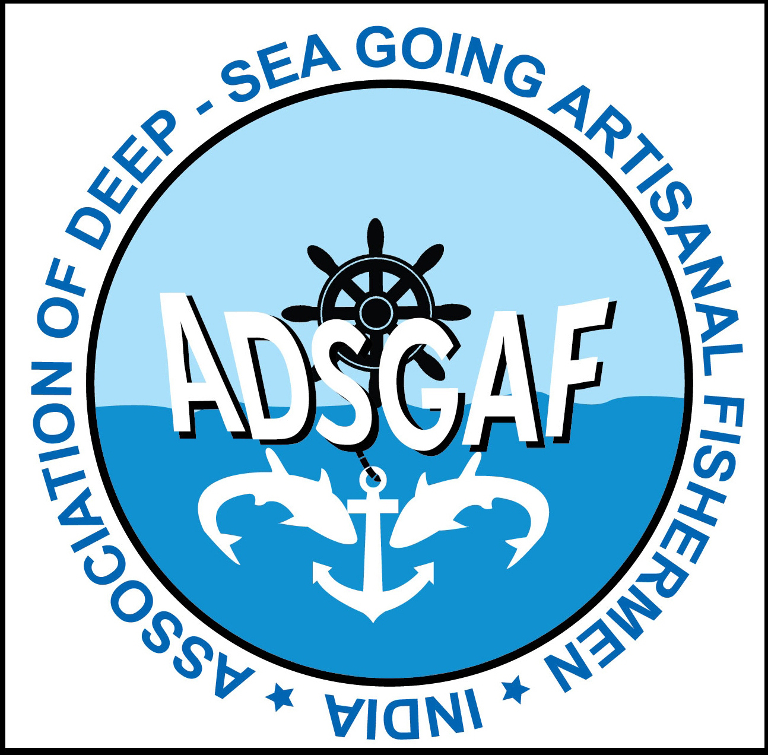
Trial on the operation and applications of solar energy in Cattamaran

The ADSGAF and BOBP-IGO had successfully made trial run and demonstration of the operation and applications of solar energy in bigger inboard engine boat and small outboard engine boat. Those boats are engaged in fishing in the deep sea, distant location and more number of days. Now the ADSGAF and BOBP-IGO made another attempt on a Cattamaran that engage in fishing either at day or at night which operate generally one man manually. Jagath Jothi Solar Company (P) Ltd developed a solar lantern with a small solar panel. The cost of the lantern is Rs.1800. There is a charging facility at the lantern where the fishermen can charge their mobile phone.

The trial was carried out at a Cattamaran owned by Mr. Ivan of Marthandanthurai on 01-02-2013. He has gone for fishing with this light for 4 times till date (08.02.2013). He opined that the light doesn’t have brightness unlike the gas light he used earlier. It is not water proof light and it is good if the light have little more length in size. He added that he is not in hurry or worry in gas
filling after every fishing as he has the solar lantern. In his place there is no retail gas filling center for gas light. The cost of filling gas is Rs.70 that can use for only one night. The solar
lantern is easy to handle and no need to pay filling charge.

The solar lantern has given to Mr. Ivan by the Mr. Selvorian, president ADSGAF in the presence of Mr. Johnson R. Franklin, Canada. ADSGAF Executive committee members Mr. Lawrence, Mr. George, Mr. Germanns, Mr. Encilome and Chief executive Mr. J. Vincent Jain are
attended. Dr. Y.S. Yadava, director BOBP-IGO sent greetings as he is unable to attend the programme.Mr. Aruldas, of Marthandanthurai helped to organize the programme.

