SERVE OUR NEW GENERATION
SONG



Address: S.T.N Colony Sabzal Road Quetta H.No 35
E-mail: infosong@yahoo.com
S.No Table of contents Page No

- Name of the organization 3
- Acronym 3
- Contact Person 3
- Registration Address 3
(a) Head Office 3
- Communication address 4
  - Telephone
  - Email
  - Founder
- Year of Establishment 4
- Registration No. 4
- Our Mission 5
- We Invasion 5
- Our Core Values 5
- Our objectives 6
- Area of Work 6
- Achievements 7
14. Recent Activity 9
15. Governig and Eextive Council 12

Name of the organization:
Serve Our New Generation

Acronym:
SONG

Contact Person
NAVEED AHMED
Designation: Chairman SONG
Mob#: +923458159160
Mailing address: naveedahmed341@rocketmail.com
Husain Saddiq
Designation: V. Chairman
Mob#:+923327822090
Mailing address: Husnain.naik@yahoo.com

Registration Address :
The office of the organization is located H.No 35 STN Colony Quetta Baluchistan.

Head Office
The Head office of SONG is located in Quetta Baluchistan.

Communication Address:

- Telephone : +92081-2021990
- Email: infosong@yahoo.com
- Founder : Naveed Ahmed and Engineer
Hussnain Sadiq.

Year of Establishment:
SONG established in 2011

Registration No.
2047

Introduction Of SONG
Song Baluchistan Quetta is a professionally managed devoted registered in 2014 Societies Act, 1860 in Pakistan, working since 2011 in District Quetta Baluchistan. Our organization active in community capacity building and issue based networking.
SONG believes that youth can change do everything. The primary focus of SONG is to ensure positive change in youth and empower them through, through Human Rights Education also provides a platform where youth can enhance their leadership, breakthrough knowledge, and innovative resources to advance the health of youth, families, and communities. The Leadership empowers youth to become community-minded individuals through diverse programs that foster confidence, knowledge and leadership skills

Our mission is:
To ensure positive change in youth and empower them and provide a platform where youth can enhance their leadership, breakthrough knowledge, and innovative resources and advance the health of youth, families, and communities.

We Invasion:
To empower youth to create a world where all young people are valued and thrived.

Our Core values :

- Respect for (every religion) and for tradition.
- Protection of staff Dignity and professionalism.
- Respect of Indigenous Knowledge.
- Clearness through logic of justice
- Zero patience for brutality
- No Gender biasness

Our Objectives
- To advocate about Human rights.
- To increase of literacy rate in the rural areas
- To Empowerment of youth through capacity building workshops, trainings, education
- To providing a basic mechanism for generating income.
- To create and organize institutional co-operative capacity building programs for youth that are living in the organization's areas of intervention.
- To polish the youth skills.
- To advance the health of youth, and communities and their communities.
- To promote Gender Equality.

Strategies
SONG will undertake all those intervention necessary for the attainments of its objectives

Areas of work:

- Youth empowerment through education both formal and informal
- Capacity building.
- Human Rights (Conflict management resolution, Universal Declaration of Human Rights and Civic education, Introduction of Democracy and democratic principles, Prevention of violence against women, gender fairness).
- Creation of income generating activities through Youth Skill training.
- Promoting the economic security of small-scale entrepreneurs.
- Education
- Health

Our Achievements:

After a training on youth activism in 2011 we formed a group of 8 people with the aim of positive change in the society from 2011 to 2013 we did many social actions project few are stated here
- A football match by the name of “Goal for Peace”, It was the time when people of Quetta were suffering from sectarian war and clouds of mercy was all around. We involved more than 600 people and people from all living communities such as Hindus, Christians were participated and their response was positive.

- The security gate was placed in a community where security issues were there and we appointed a guard here. We resolved two problems one secured the community and created job opportunity. The expenditures were barred from the community and an organization

- We distributed arose among the people of Quetta who were depraved from the tense situation of the city this activity brought a sort of happiness as it was an innovative activity which was practiced first time and after this I was practiced in the four other countries the world.

- Lecture on the environment in which people from different walk of people were present we tried to raise awareness about the importance of the ozone layer.

    - On February 2013 our small action of football match got an award from the British Council of Pakistan, it was a pleasant moment for us and also a ray of hope so we started thinking to emerge our this group into an organization but the problem was that our most of the members got jobs in the national and international organizations.
    - So now we two Mr, Husnain Sadiq and Mr. Naveed Ahmed were left, we started taking suggestions from different people and after seven months we are going to form organization by the name of the SONG (Serve Our New Generation).

Recent Activity:

Observances of international Women’s day celebrate with
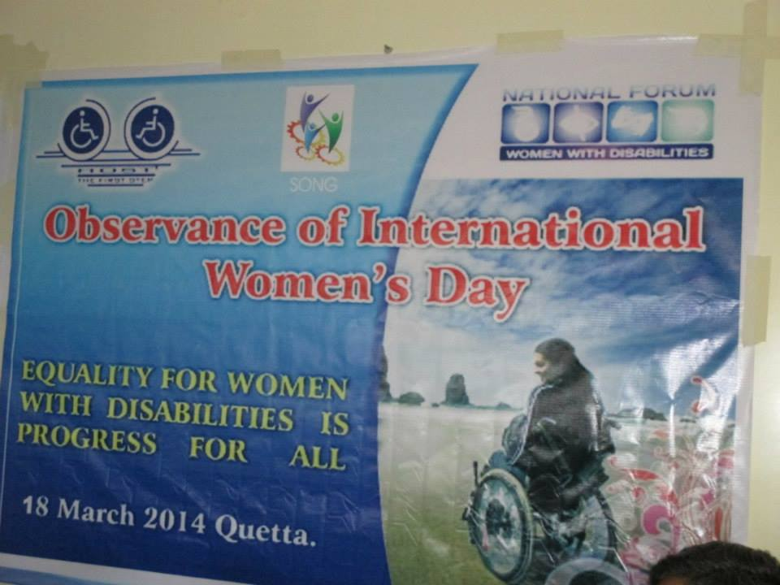

collaboration with NFWWD and HOST organization.
Venue: Rangon wala Women Community Center.
- Hussnain vice Chairman SONG
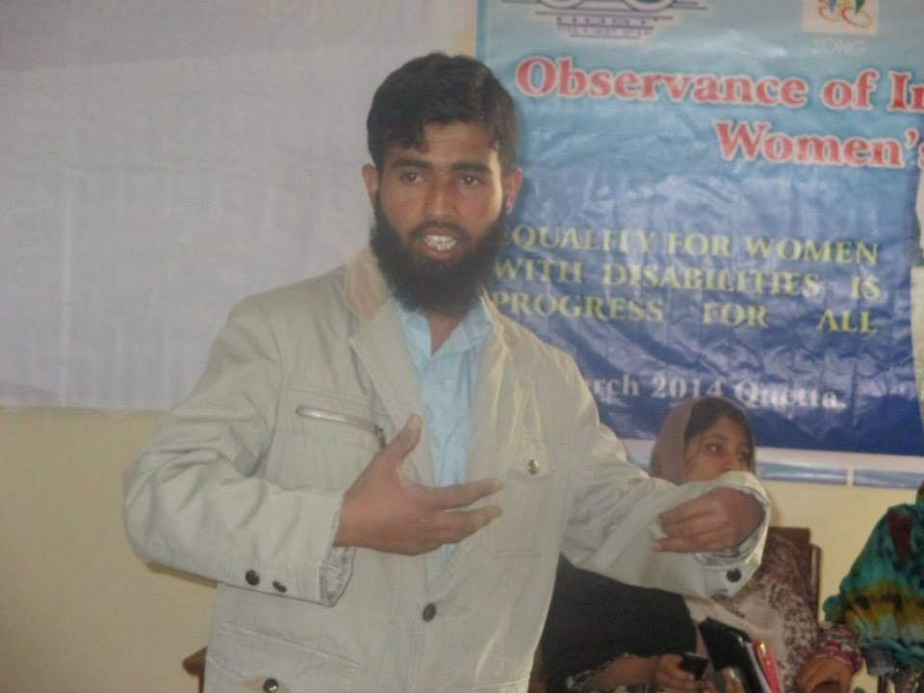

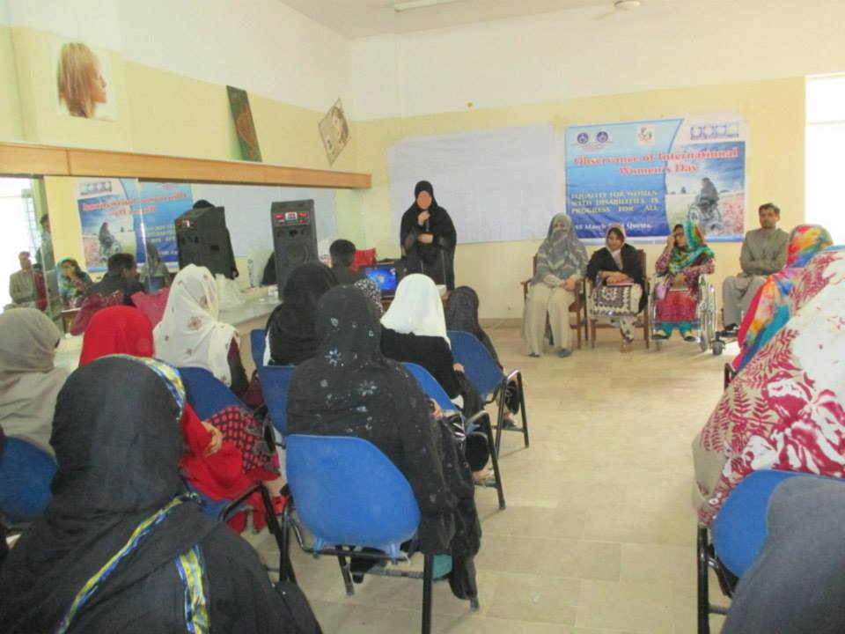

- Fouzia Loni Cordinator NFWWD

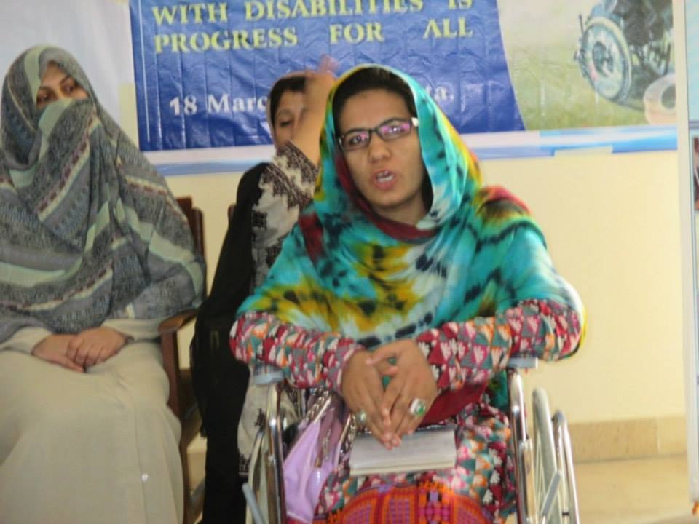

Guest :Shazia lango From national party
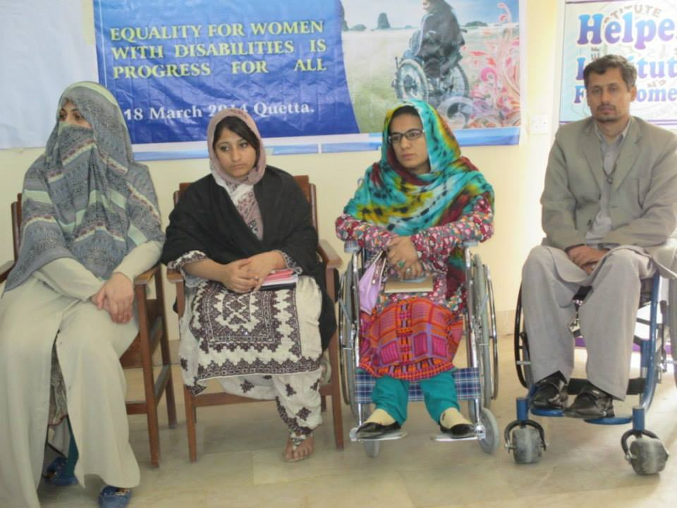

Speakers Shazia Lango Resercher National Party

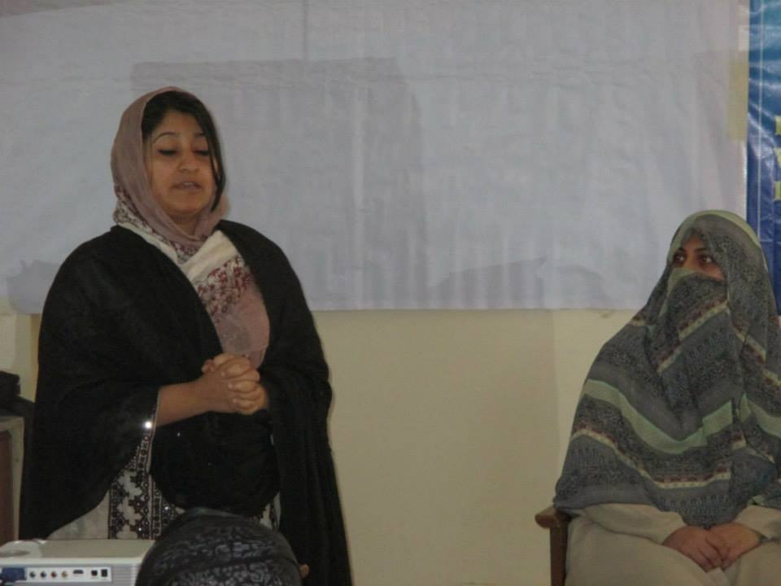

S.NO | Name | Designation | Address | Signatures
1 | Naveed Ahmed | Chairman | S.T.N colouny Sabzal Road Quetta. H.no 35
2 | Eng Hussnain Sadiq | Vice Chairman | Tajika bad Near Chaman Housing Quetta.
3 | Sanaullah | Secretary General | Killi Chiltan Saryab Road Quetta.
4 | Nasir Marri | Secretary Finance | 64 D Universty Of Balochistan Colouny Quetta.
6 | Yasmin | CEO
7  Ex Members | Nasir Rehan | Ex member | E52 colouny G.O.R Block 3 Quetta
8 | Ishaq jattak | Ex member | Universty of Balochistan Colouny
9 | Jawad Ahmed | Ex member | S.T.N colouny Sabzal Road Quetta. H.no 35

SONG GOVERNING AND EXECTIVE COUNCIL

