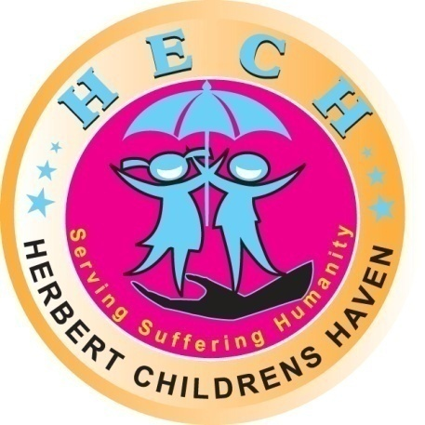

HERBERT CHILDRENS HAVEN PIT LATRINES PROPOSAL.(2012-2013)

Herbert Childrens Haven (HECH)
Kampala - Uganda
P O Box 37336
KAMPALA, Uganda.
Tel: +256 413580466
admin@herbertchildrenshaven,org
www.herbertchildrenshaven.org

Summary of the Pit Latrine Construction Proposal
Herbert Children’s Haven (HECH) is a community based Non-Governmental Organization (NGO) in Uganda, helping orphaned and other vulnerable children reach their full potential through education and other opportunities. HECH was inaugurated in 2009 and has grown to become a Voice in Uganda's fight for Children's rights, with more support from individuals, donors and agencies.

Herbert Children’s Haven is dedicated to serving suffering humanity step by step and finally creating an environment for children that respects their rights, health, child development etc.

The organization operates in rural areas with rural poor families and disadvantaged children such as orphans and vulnerable children affected by poverty and HECH is ensuring that children have access to quality basic education through the construction of its own school.

Introduction
The most vulnerable and marginalized in our community are the children who have been orphaned or suffering the effects and impact of poverty.

It is evident therefore that these orphans and other vulnerable children’s social problem is one of the biggest challenges facing many families and communities
Therefore, due to low resource base leading to poverty, they are denied the enjoyment of basic human rights, security, care, support and well being.

HECH has stepped in as a ‘core foster home’ for these children.

Mission
To make all children’s rights a reality ‘not just writing them in books’

Vision
To help children who would not have access to basic human rights, give them shelter, medication and education up to the university level.
PIT LATRINE CONSTRUCTION PROPOSAL
Background
HECH has successfully placed the 120 fostered children under its care to 40 foster homes. However these homes lack proper sanitation and hygiene facilities. HECH is to help these families by constructing pit latrines for every home.
Construction of pit latrines will improve hygiene conditions, reduce the risk of water borne diseases and promote better enrollment and attendance rates. Therefore HECH is working to mitigate the risks facing vulnerable children by strengthening community support networks

Pit latrine construction project aims to connect the children and their caregivers with services and support to meet their needs.

The pit latrines will be constructed in a two-in one pit latrine with a one attached bathroom and ‘curtain wall’

Justification for the construction of a Pit Latrine

HECH has 120 children staying or attached to 40 foster families who take care of the children’s needs. Much as these foster families have willingly accepted to take care of these children’s physical, psychological, mental and or emotional needs; some homes do not have all the proper hygiene and sanitation facilities.

During the home visits, it was observed that the existing pit latrines in some foster homes have poor ventilation and inadequate sanitation facilities (one toilet without a clean water source) which increases the chances of the children and their foster parents contracting airborne and water related diseases.

It is against this background that HECH is aggressively stepping in to help these homes by way of constructing a standard pit latrine for each home in order to improve on the hygiene and sanitation in these homes. Not only will that but construction of pit latrines in foster homes act as a motivation to the foster parents

Target Group
All the 40 foster homes accommodating the 120 fostered children.

Purpose
To improve on hygiene and sanitation in the foster homes and increased motivation to the foster parents to take care of these children.
Goal
To provide a healthy working relationship between HECH, foster parents and fostered children.
Objectives
To sustain good working relationship with the community.
To improve on the hygiene in the homes and community at large.
Time frame
Construction of the pit latrines is anticipated to commence in May 2012 through May 2013.
Conclusion
In summary:
We are requesting for support from donors for the construction of pit latrines.
Bank account details
BENEFICIARY'S BANK DETAILS
Bank: Standard Chartered Bank Uganda Limited,
5 Speke Road Branch,
P.O. Box 7111,
Kampala.
Telephone No. 256-0414-258511/7
Fax: 256-0414-342875, 231473
Swift address: SCBLUGKA
BENEFICIARY DETAILS
Account Name: HERBERT CHILDRENS HAVEN (HECH)
Account Number: 0102813967300

Budget
A full budget detailing items is attached.

 | DRAFT BUDGET FOR THE CONSTRUCTION OF PIT LATRINES FOR FOSTER HOMES
 |  |  |  |  |  |  | Exchange Rate
 |  |  |  |  |  |  | $1 = UGX 2500
 |  |  |  | Nos | Unit cost | Total | 2500
 | Item Description |  |  |  |  | UGX | USD
 | spades | pcs |  | 4 | 10 000 | 40 000 | 16
 | Hoes | Pcs |  | 6 | 12 000 | 72 000 | 29
 | Wheel barrow | Pcs |  | 2 | 140 000 | 280 000 | 112
 | Pick Axe | Pcs |  | 2 | 10 000 | 20 000 | 8
 | Panga |  |  | 2 | 12 000 | 24 000 | 10
 | Excavation - 40ft |  |  |  | 40 | 10 000 | 4
Cement | Building | Bags |  | 9 | 32 000 | 288 000 | 115
 | Plastering | Bags |  | 9 | 32 000 | 288 000 | 115
 | Floor | Bags |  | 2 | 32 000 | 64 000 | 26
 |  |  |  |  |  | 0 | 0
 | Slab | Pcs |  | 2 | 200 000 | 400 000 | 160
 | Wooden Doors | Pcs |  | 2 | 100 000 | 200 000 | 80
 |  |  |  |  |  | 0 | 0
Nails | Roofing Nails | Kgs |  | 2 | 7 000 | 14 000 | 6
 | Assorted Nails | Kgs |  | 2 | 6 000 | 12 000 | 5
 |  |  |  |  |  | 0 | 0
 | Plastic Pipe & Cone | Pcs |  | 1 | 25 000 | 25 000 | 10
 | White Iron Sheets | Pcs |  | 5 | 40 000 | 200 000 | 80
 | Builit |  |  | 10 | 8 000 | 80 000 | 32
 | Fascial Boards | Pcs |  | 3 | 12 000 | 36 000 | 14
 |  |  |  |  |  | 0 | 0
 | LABOUR |  |  |  |  | 500 000 | 200
The total for the one pit latrine |  |  |  |  |  | 2 553 000 | 1 021
There are 40 Foster Homes therefore 40 Pit Latrines to be constructed |  |  |  | 40 (Pit latrines x 2,553,000 = |  | 102 120 000 | 40848

