
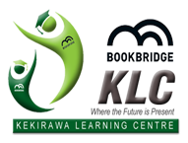

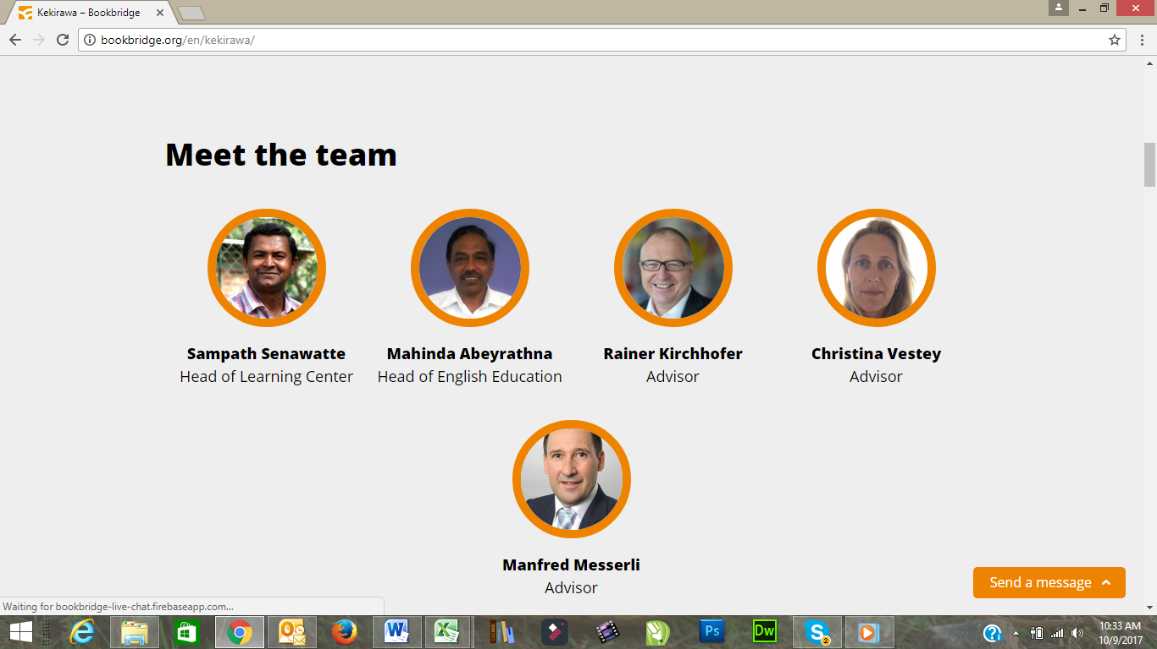
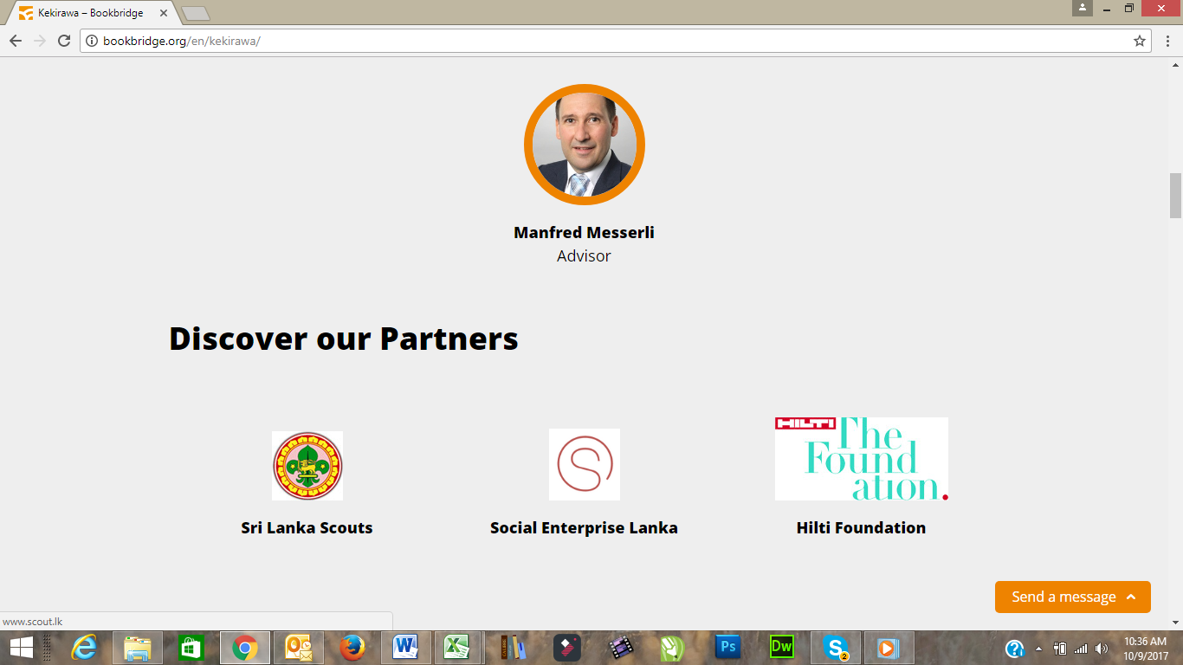



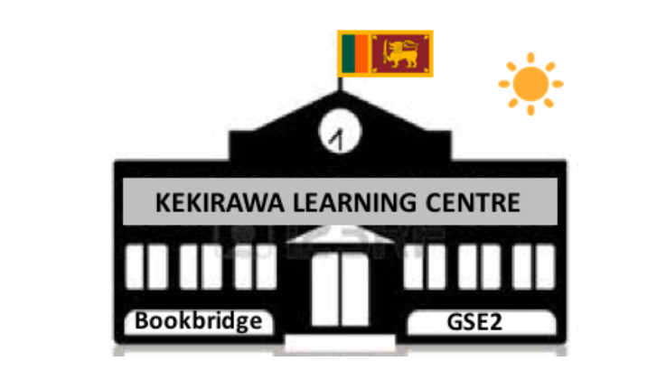

OUR VISION

Building an empowered and inspired sustainable community with knowledge, skills and values and a positive attitude towards life.

OUR MISSION

The Kekirawa Learning Center (KLC) is designed to meet the needs of the Kekirawa community, including children, teenagers, youth and adults, assisting them to discover their own talents and develop themselves to be self-sufficient members of the community.

The KLC provides high-quality and student-centered education and training, with a strong focus on English language, information technology and on new forms of media to all members of the community.

OUR GOALS
The KLC is a place where children, teenagers, youth and adults are able to learn how to speak, read and write in English, use modern ICT equipment and learn how to apply new media skills, as well as explore new career and business opportunities to enrich their job and life chances and gain self- confidence and be inspired to take ownership of their own lives.

By 2020, the KLC will be a happy and vibrant place where the community likes to meet!

OUR WORK – WHAT WE DO
Local stakeholder meetings, surveys and discussions with people form the surrounding communities a have shown, that the biggest demand is for English, ICT (information and communication technology) courses and personal development. Those subjects will boost our student’s potential in the labour market.

Since the KLC is a start-up business, the curriculum will start small and will expand with time and when the KLC has been established as an integral part of the community. Therefor the offerings at the KLC will start with English and ICT courses. To guarantee interactive and student-cantered education no class is bigger than 10 students.

ENGLISH
English courses are the main offering at the KLC. The courses are focusing on grammar, vocabulary and conversation, whereas conversational English is the main focus. There are different levels (beginners, intermediate, advance) for different age groups.

COURSE LEVELS
Beginners : English 1| English 2 |English 3
Intermediate : English 4 | English 5
Advanced : English 6

ICT AND BUSINESS ENGLISH
Stage – I the student has knowledge of Basic English vocabulary used in ICT contexts and is able to produce ICT texts on professional level. He/she masters appropriate terminology and has theoretical knowledge about delivering ICT presentations.

Stage – II the student has intermediate knowledge of ICT vocabulary and concepts. He/she is able to explain the meaning of ICT concepts using more elaborate vocabulary. The student is able to give ICT presentations in order to educate and influence other ICT professionals. He/she is able to produce ICT documentation that follows the correct format and traditions.
Stage – III the student has knowledge of ICT vocabulary at an advanced level. He/she demonstrates knowledge of idiomatic ICT and business English, is able to carry our elaborate discussions, argumentation and debates. The student compares and estimates concepts, develops argumentative, narratives and gives engaging presentations that leave a permanent positive impression on audiences. He/she produces high-quality ICT documentation that follows correct format and traditions and is able to develop documentation practices to meet local and global needs.

Contents
- producing coherent ICT/business-related texts and a longer Media Survey Report
- enhancing students’ overall oral competence in professional contexts
- acquiring information on the latest concepts in ICT/business using various literal and online sources

Starting level and linkage with other courses
- English Level Test passed or English Level Course completed.

Working life connections
- Current trends in the field of ICT/business are closely monitored. An ICT professional’s presentation.

Internationality
- Timetables allowing, the implementations are comprised of students from both the Finnish and international degree programs.

Learning methods
The learning methods of this course are the following:
- contact lessons
- independent studies
- virtual/blended learning

OTHER ICT COURSES
Tailor made courses in ICT available at the KLC:

- ICT for young children: in a playful way children between the age of 6 and 11 will learn to interact with a personal computer, learn the alphabet and get acquainted with the keyboard, apply basic computer skills through the usage of apps.

Certificate Courses & Diploma Courses in Computer Science:
  - This course is for young adults and adults (starting from age 12) to understand the computer science fundamentals, use of MS office and other applications, social media appliance for personal and professional use. Basic coding knowledge is taught with Raspberry PI , for Adults Computer Hardware Engineering, Computer Networking, and system Troubleshooting - All ICT courses are mainly taught in English.

Foundation course in CCTV – 02 Days

Training Course Overview
The CCTV industry is a world of endless change and rapid evolution. To keep pace with these developments our flagship Foundation CCTV course is constantly updated and this year, as always, it remains right at the ‘cutting edge’. It’s content is a perfect introduction for those who are entering the industry for the first time and is an ideal refresher for established professionals who need to move forward from older more traditional technologies.
There are no course prerequisites – anyone with an interest in CCTV, whether you are an engineer, sales consultant, specifier or operator this course will provide you with a solid base to further your career.
You will learn the basic fundamentals of CCTV. Delegates who successfully complete the course will receive an internationally recognized vocational qualification.

Course Content
By the end of this CCTV course you will have built a complete CCTV system
- The fundamentals of analogue and digital CCTV
- The importance of an Operational Requirement
- Surveillance Camera Code of Practice
- Selecting the best camera and lens combination
- Lighting and how to measure it
- Displaying best images for CCTV applications
- Digital storage and retrieval
- Transmission methods: Optical Fibre, coax, twisted pair, and free space Using test equipment, meters and tools
- Setting up IP and analogue CCTV systems
- Health and Safety, Working at Heights and electrical safety

Certification course in CCTV Installation and maintenance – 03 Days

Course Overview
The special skills of CCTV repair and maintenance technicians have never been in greater demand. This CCTV repair and maintenance training course is also invaluable to technically minded end users who wish to ensure that their own CCTV systems are operating with optimum accuracy and efficiency.
Who should attend?
It is important that only those who have completed our Foundation CCTV course or who have appropriate underpinning knowledge should attend this CCTV Repair course. Delegates will be able to successfully identify, diagnose and rectify a wide range of CCTV faults with confidence and efficiency.

Course Content
- Diagnosing and rectifying common faults
- Fault finding techniques
- Locating and rectifying cable faults
- Measuring video levels
- Identifying faults in video transmission systems
- Optimization of camera tracking and focus
- IP diagnosis and repair
- Servicing recording devices
- Maintenance requirements
- Health and Safety on site and in workshops

Practical CCTV Installation Training Course – 05 Days

Course Overview
The complete CCTV installation course, offering a superb blend of ‘need to know’ classroom theory and ‘hands on’ practical experience. Over 5 days we will provide you with the necessary knowledge and skills to work effectively in the electronic security and video surveillance sector.
From cabling to the latest IP integration techniques, this 5 day course is the perfect choice if you are looking to enter the exciting world of CCTV installation. There are no prerequisites.

What you will learn

- Install and maintain video over UTP
- Configure and programme digital recording devices
- Set up a range of colour, day/night and dome cameras
- Run cable properly and terminate cable with connectors RG59, URM70, RG11, CT125,
- Twisted pair and fibre
- Configure motorized zoom, varifocal, aspherical and fixed lenses
- Wire and connect video distribution amplifiers
- Connect and set up amplifiers using coaxial cable
- Configure an IP/Network CCTV solution
- Use test equipment effectively
- AHD, HDTVI and HDSDI explained

Course Content

By the end of the week, you will have built a complete CCTV system including a combination of static and maneuverable cameras and test signal generators fed over a range of video transmission media.

- The basic theory of television and CCTV
- The foundations of digital CCTV and IP
- Setting up, back focusing and zoom tracking cameras
- Selecting and applying appropriate lenses and filters
- Understanding different lighting parameters for CCTV cameras
- Practical lens calculations and the Operational Requirement
- Handling video and data storage media
- Setting up digital video recorders
- Selecting, connecting and installing cables
- Use of oscilloscopes, bar generators and other test equipment
- Commissioning, fault finding and routine maintenance
- Selecting and applying function switches on cameras
- Setting up and programming domes
- Installing cameras over twisted pair
- Using launch and equalizing amplifiers
- Fibre optic transmitters and receivers
- Setting up and terminating display screens
- British and European standards
- Health and Safety
LIBRARY

The Library offers a wide array of English books for different age groups and on various topics. Copies of national newspaper are displayed daily for everybody to read. In addition to all the donated English books the KLC will also have some Sinhalese books on stock for the non-English speaking population in the community.

The Library is open for all the students who are attending courses at the KLC and for library card-carrying members.

COMPUTER LAB:

There is a fully equipped computer lab installed at the KLC where the ICT students have the chance to practice and apply their acquired knowledge. The computers are also available for the library members and English student for accessing the Internet.

FUTURE COURSE OFFERINGS

After the start-up phase and when the KLC has been established as a quality learning centre the course offerings will gradually expand. Further possible subjects for the curriculum are courses in personal development and business development.
OUR IMPACT

What difference do we make

The KLC’s unique selling proposition (‘USP’) is that it will provide a clean, inspiring and modern learning environment, with classes limited in size to a maximum of 12 people to ensure a personal approach. In this protected learning atmosphere, the students will have the space to develop their abilities and talents. As teaching methods in Sri Lanka are currently less focused on individual teaching in the regular or in the high-price private tuition school system, the KLC will be able to stand out from the competition.

The KLC aims to contribute, in an entrepreneurial and sustainable way, to the economic and social development in the Kekirawa district. Besides its financial reporting, the KLC will put adequate focus on Social Performance Management from the very beginning of the venture and integrate it into the operational systems and processes. When we look to define the impact that the KLC should generate, we refer to the effects and benefits of our project on and to the local community. As the environment the KLC operates in is multi-dimensional, so is the way of looking at how to define the specific indicators and how to measure them.

What do we aim to achieve in the future
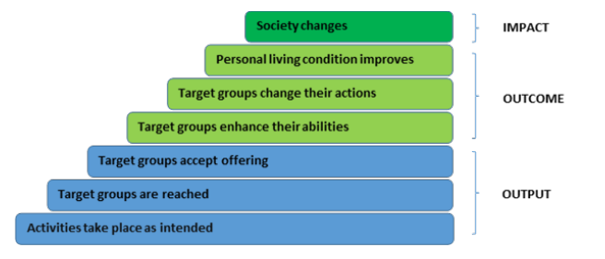
Linking this framework to vision and objectives we see that the KLC has the following main objectives.
- Offering of new learning opportunities of superior quality that meet the needs of the people
- Creation of good and suitable paid jobs within the KLC
- Creation of a lively new space of encounter and exchange

OUTCOME-LEVEL:
- Enriched jobs and life chances (through new capabilities)
- People becoming self-sufficient members of the community
- Enhancement of community spirit

IMPACT-LEVEL:
- Empowered community
- Improvement of quality of life
- Empowerment and valorisation of rural area

A double-bottom-line reporting standard, combining financial performance with social performance, will be introduced at the KLC. It is inextricably linked with these objectives. For this purpose, we will make use of a set of reliable and valid qualitative and quantitative indicators (including IRIS-Metrics) that are well accepted with leading impact investors globally.

PICTURE GALLERY

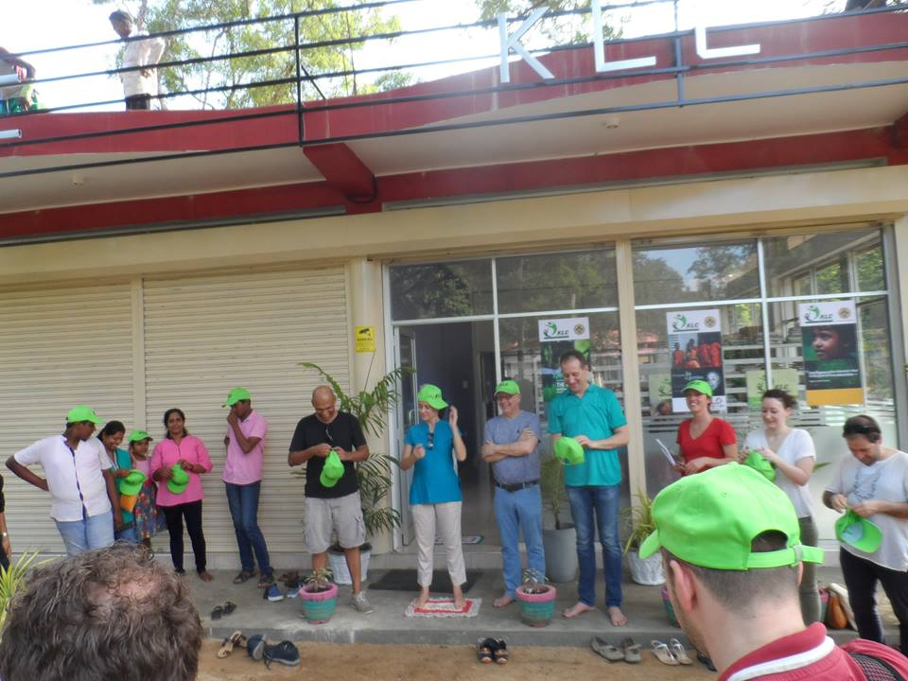

KLC LIBRARY
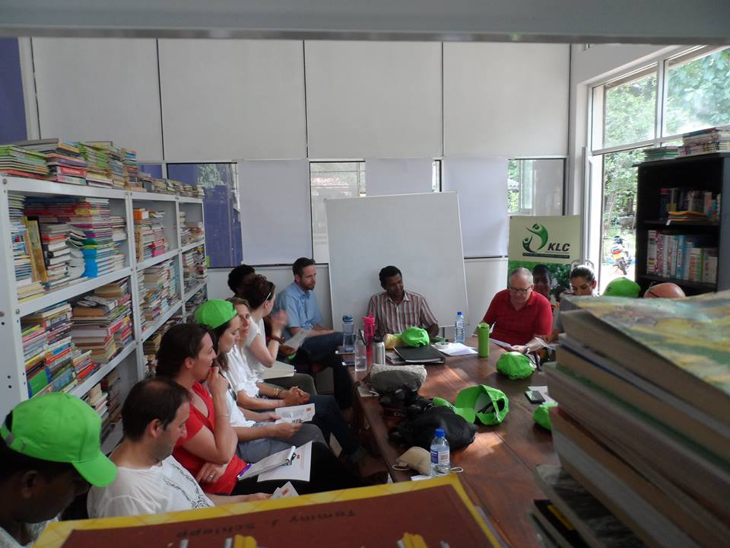

PREGRESS REVIEW MEETING WITH PARENTS

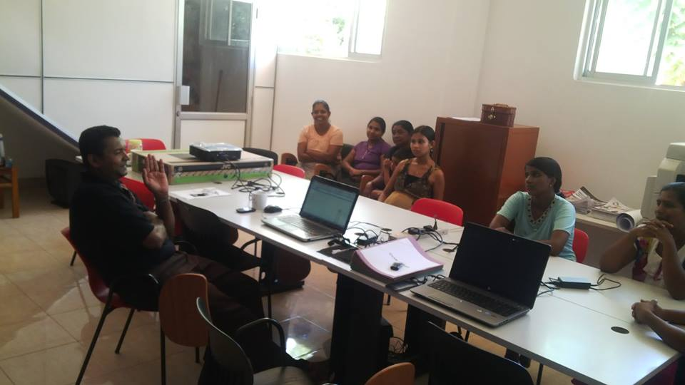

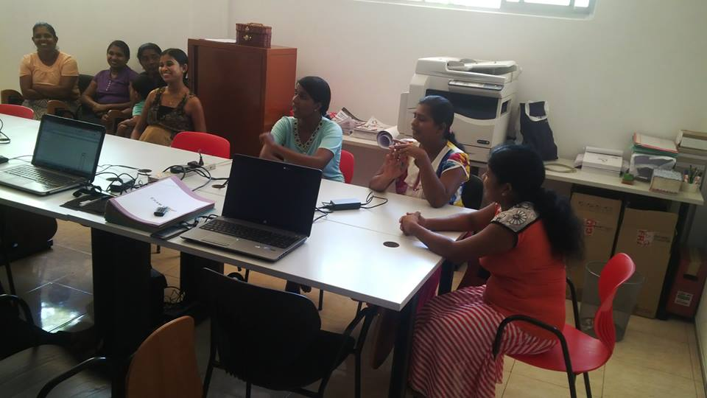

STUDENT CENTERED TEACHING – ENGLISH & ICT

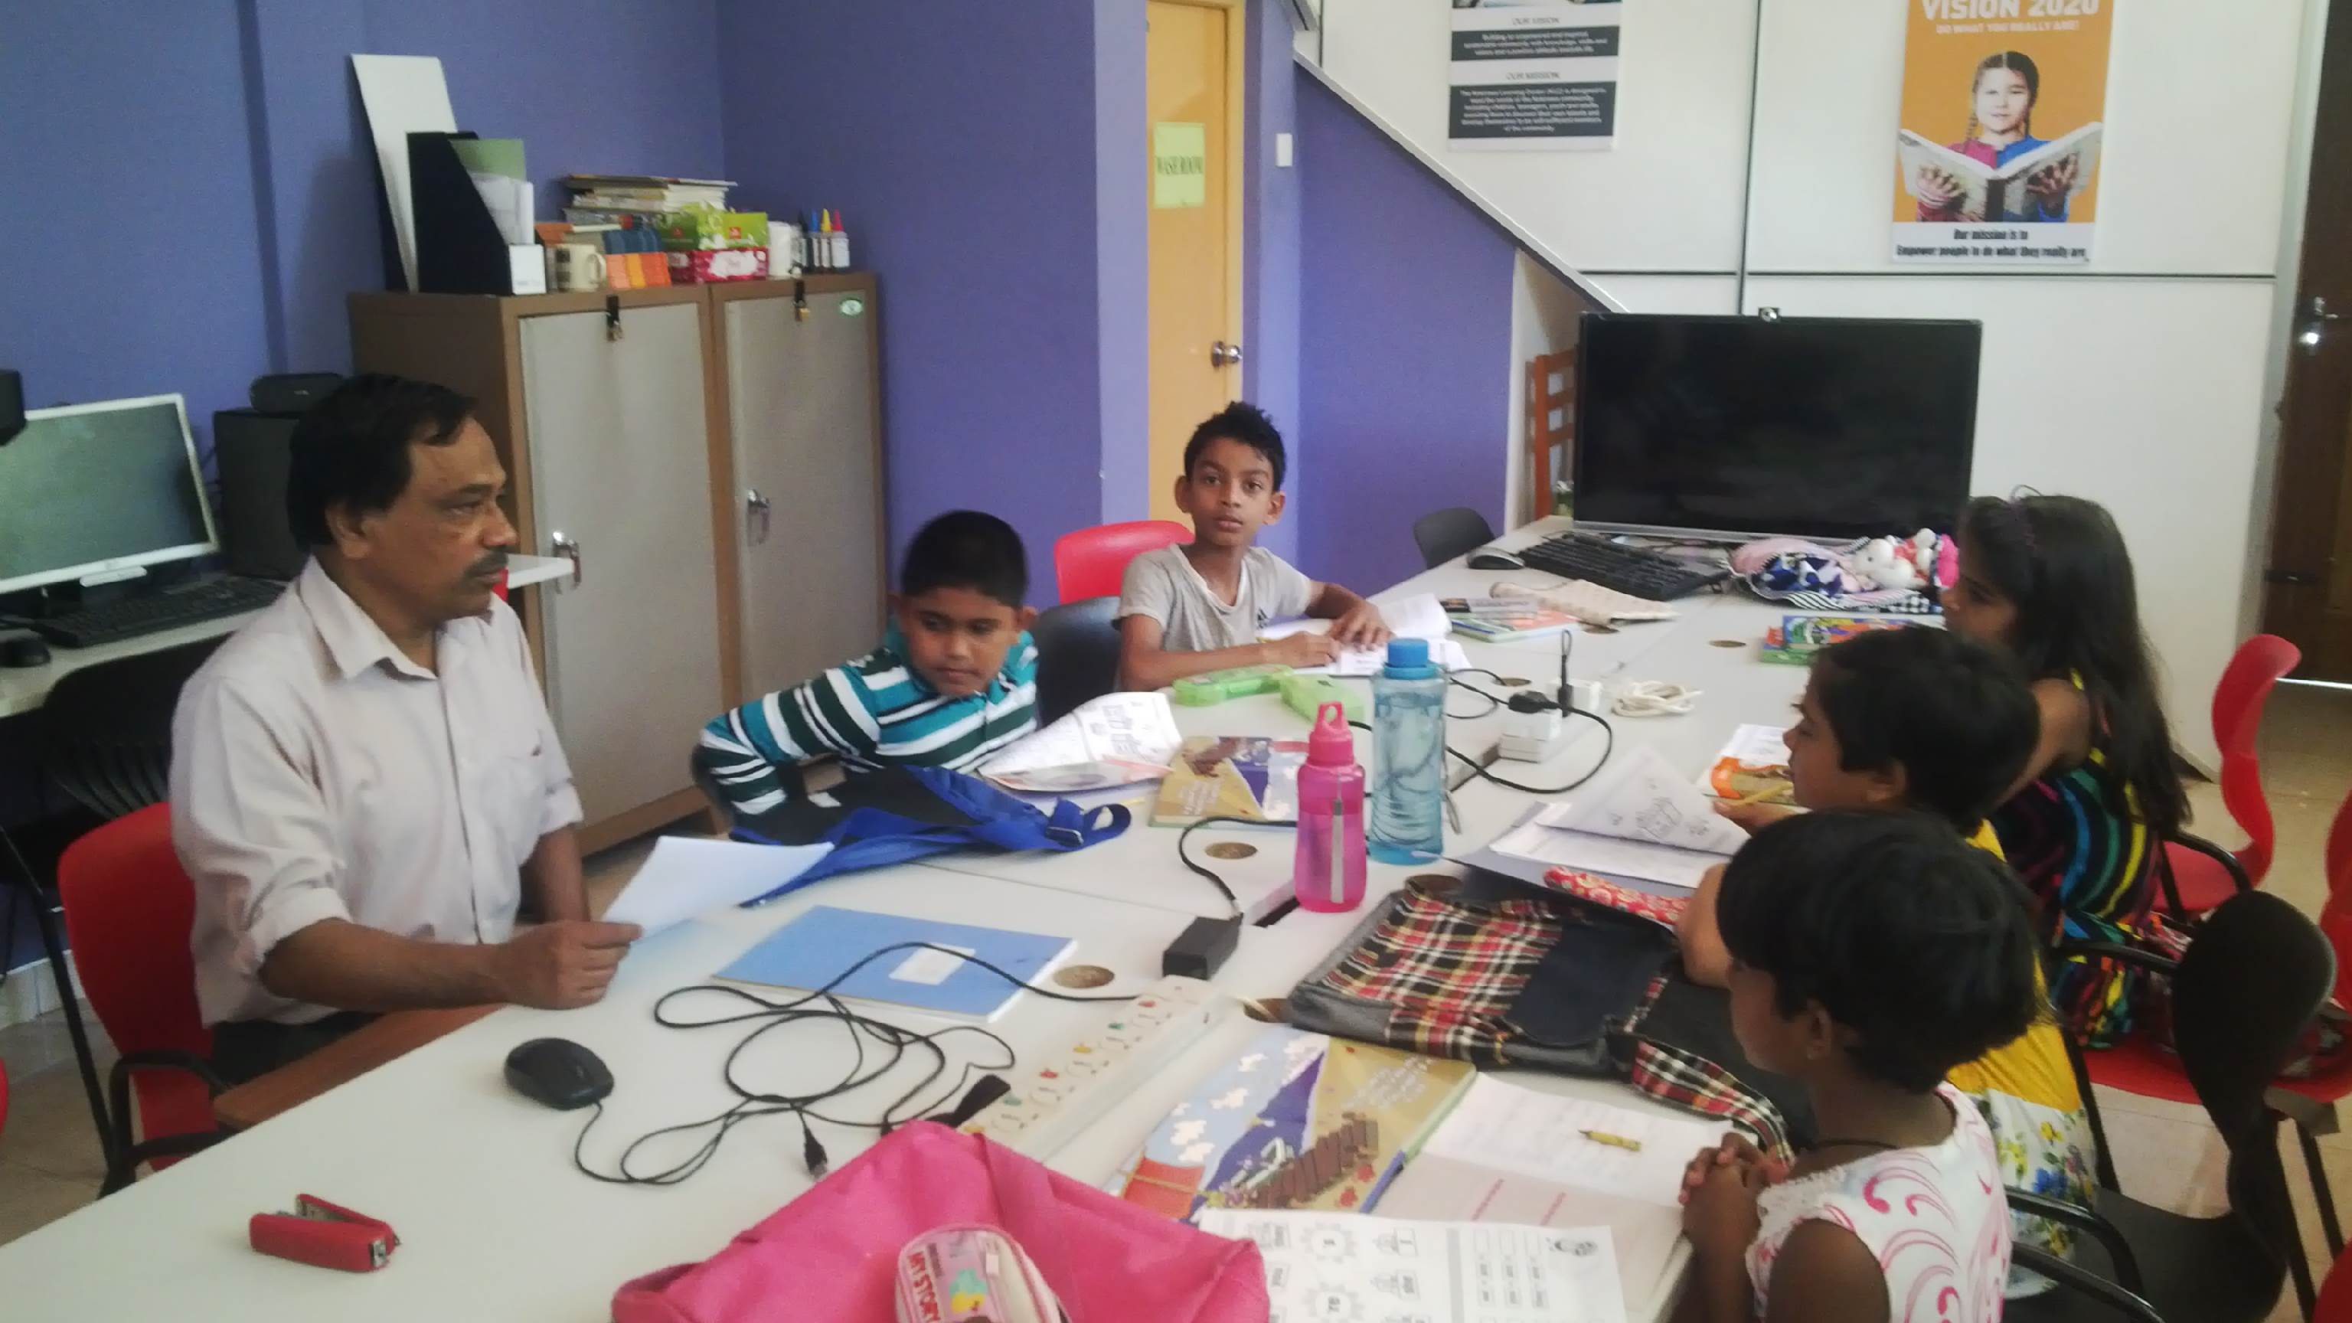
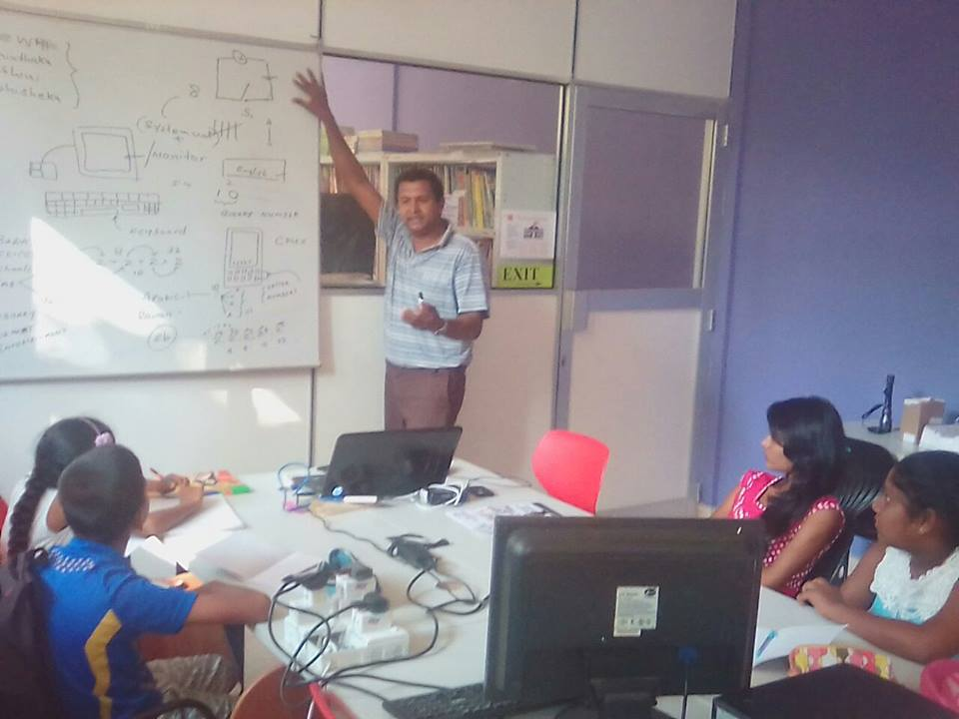
KLC SUPPORTING TEAM

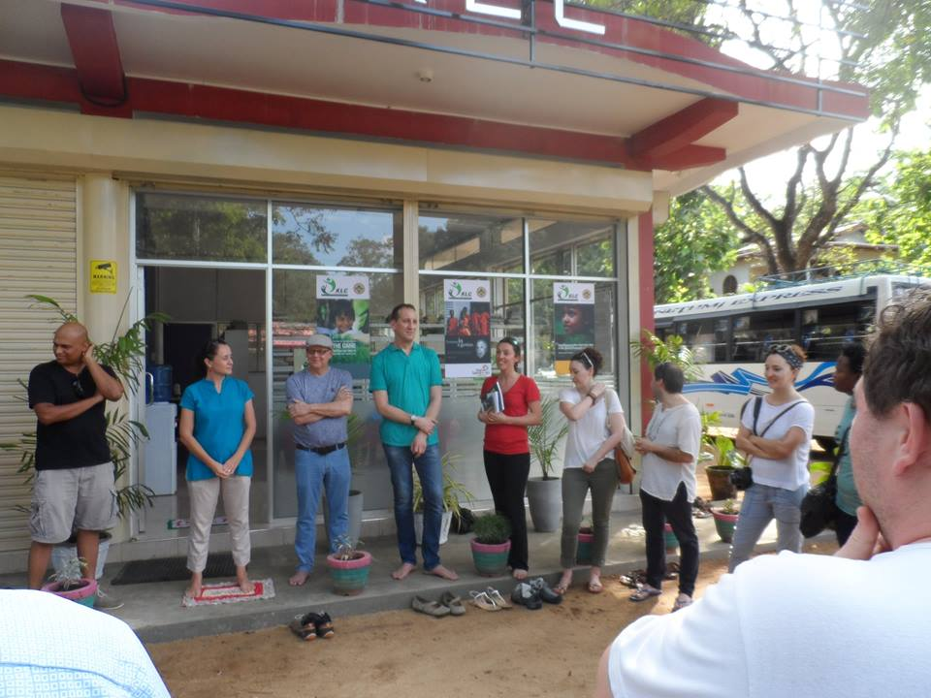
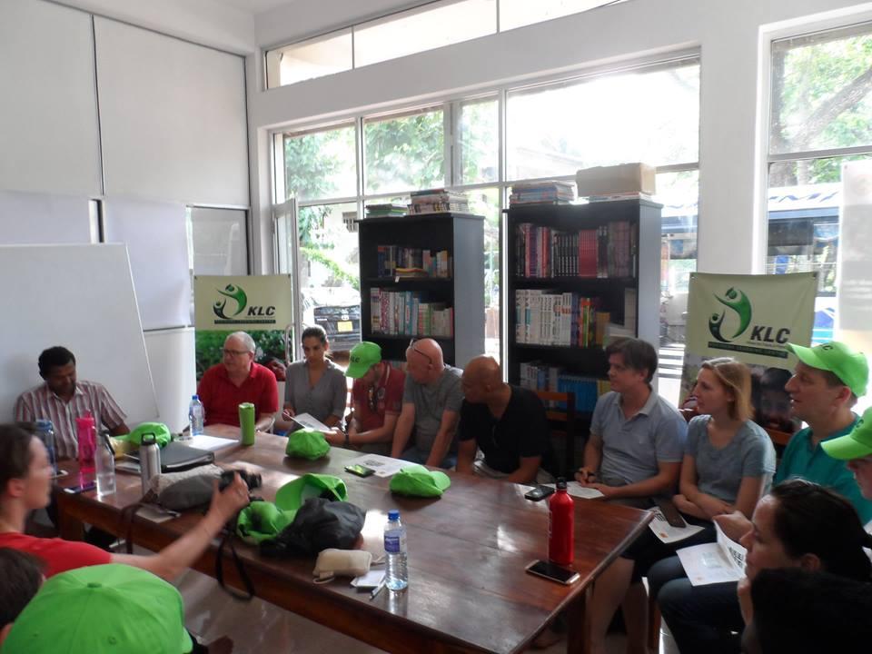
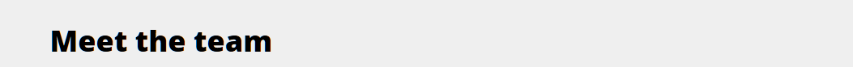
1
2
3
4
5

- Head of Learning Centre, ICT / English Teacher
- Head of English Education
- Advisory committee Member - Administration
- Advisory committee Member - English / ICT Curriculum
- Advisory committee Member - Marketing / PR & Finance

