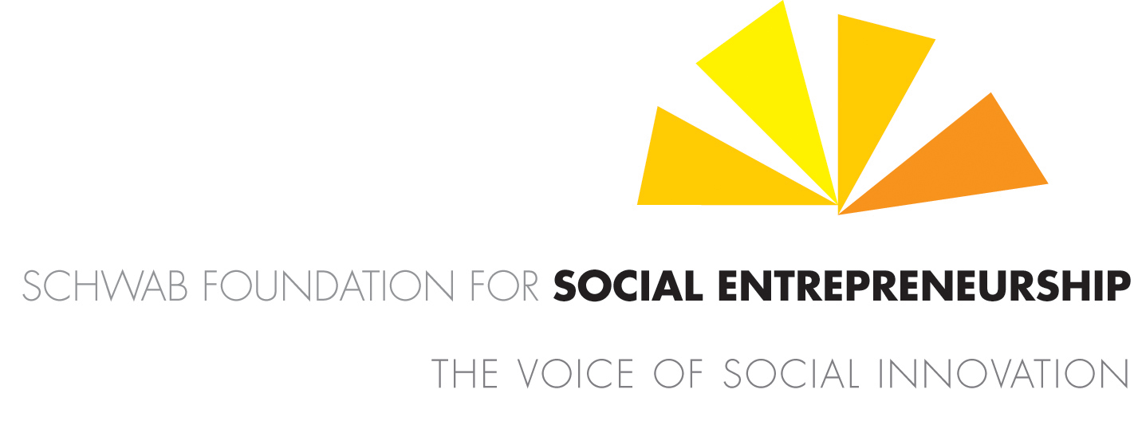



IN SEARCH OF THE “SOCIAL ENTREPRENEUR OF THE YEAR 2010” SUB-SAHARAN AFRICA
Schwab Foundation Social Entrepreneur Award for Africa 2010

Thursday, April 1, 2010 8:22 A M
From: francois.bonnici@weforum.org<francois.bonnici@weforum.org>
To:”Voice Of Grace Foundation”<vgf25vgf@yahoo.com>

Dear Ndonwi,

Thank you for applying for the Social Entrepreneur of the Year Award Africa 2010. Congratulations on the work you and your team are doing. It is truly inspirational for us to learn about the innovation of Voice of Grace Foundation, and it re-affirms our belief in the power and spirit of social entrepreneurship.

Narrowing down the large number of entries who most thoroughly fulfil our selection criteria has been difficult as always. The selection team has undertaken a comprehensive review of your application. While we were deeply impressed with your endeavours, your application has not progressed to the final stage for presentation to our Foundation Board. Given that we seek to recognise well established social entrepreneurs with tested innovations and most importantly proven social impact, we would recommend that Voice of Grace Foundation consider reapplying as it grows further.

We are very pleased that you participated in the selection process and are appreciative of all the time you have taken to share your work and experiences with us.
Please, be assured that all information remains safely on the highly secure servers of the World Economic Forum, and should you wish, can delete these permanently.
I would recommend that we at least keep your first round form as a record should you wish to reapply, or should we come across interested parties and wish to refer them to you.

Congratulations on all the recognition you have already received, there is clearly support and belief in what you are doing. We add our voice to that support and invite you to keep us informed of your progress. Best wishes for the continuing success and we look forward to hearing from you in the future.

Yours Sincerely,
Francois
___________
Dr. Francois Bonnicci
Head of Africa, Schwab Foundation for Social Entrepreneurship
World Economic Forum, Switzerland
Email: francois.bonnici.@Schwabfound.org
http://www.schwabfound.org

