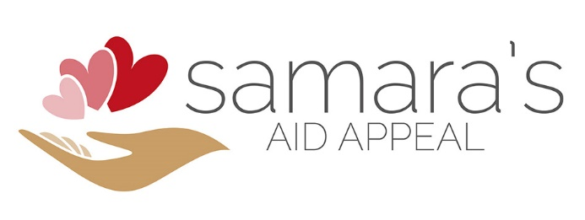 | c/o 161 Marine Parade  Brighton  East Sussex  BN2 1EJ  07960 937 716  www.samarasaidappeal.org  samara@samarasaidappeal.org
28th October 2015

Dear Sir/Madam

I write to ask whether you could assist me in sourcing medical equipment that is urgently needed to send as humanitarian aid to Syria.
Samara’s Aid Appeal is a new but rapidly growing humanitarian NGO and we have sent 25 artic lorries and containers filled with humanitarian relief items to Iraq, Syria and Jordan since October 2014. We have also bought and are sending a number of ambulances to Syria. I am in the process of registering as a charity in the UK, and until I have a registration number, we work under the umbrella of Feed the Hungry, a UK registered charity no. 1112955.
Syria has been described as the “worst humanitarian crisis of our time” and there are more than 12 million people in need of humanitarian assistance in Syria alone. As hospitals are regularly being bombed, and more than a million people have been injured in the escalating conflict, there is an urgent need to source medical equipment to care for these people. I am working with hospitals in Syria who are providing frontline emergency/ITU/surgical care to the civilians caught up in the relentless shelling, bombing and terrorist atrocities taking place in Syria.
One of the doctors I am working with runs a critical care team of 50 volunteers (doctors and nurses) and they are working in the most challenging conditions. He advised me last week that the situation has deteriorated rapidly and that they need as much help as we can get them, as quickly as possible. Currently they have to reuse items that are meant for single use only. They don’t have antibacterials and are reduced to simply washing these items under the tap between patients. What they can get hold of they have to use for everyone. It is life or death.
Because of the international sanctions against Syria and the breakdown of their infrastructure, very little is imported and medical equipment that does make it in is for sale at inflated prices. I am being asked to send the most basic, cheap and old items as they will make use of them. They just need something to work with.
Everything I send is donated freely without expectation and will not be sold, but will be monitored and used by my implementing partner NGO’s to treat the civilians caught up in this horrific war, and ultimately save lives. We will not hold donors of equipment responsible for any issues with equipment given to Samara’s Aid Appeal.

While they need everything that is used in a hospital setting, some of the most critical items include:
- defibrillators  - ventilators  - anaesthetic instruments  - surgical lamps  - suction  - surgical instruments  - cardiac monitoring equipment/ECG  - surgical tables  - syringe drivers | - resuscitation equipment  - hospital beds including critical care beds with air mattresses  - mobile x ray units  - portable ultrasounds with two probes  - blood pressure monitoring & stethoscopes  - examination beds  - laboratory equipment: blood and chemistry labs  - autoclave
They also need medical supplies that will ideally have at least 6 months before their expiry dates. However, I may be able to send some of the most needed items if they have passed their expiry dates.
- Cannulas, needles, extensions, cannula dressings  - Syringes  - Dressings & tape  - Sutures & Suture kits  - Gauze | - ECG electrodes/Defibrillator pads  - Suction/oxygen tubing & masks  - Airways  - Resuscitation supplies including ambu bags, resuscitation masks
I have consignments leaving for Syria over the coming weeks, and I am keen to send as much medical equipment as quickly as possible.
At Samara’s Aid Appeal we are all volunteers including me and to date, I have not covered my expenses for this work as I am keen to use every penny available to relieve suffering in the areas we are supporting. Every penny raised is spent on charitable activities and aid that is donated goes directly to serving the people in need.
If you can help in any way I would be so keen to hear from you. You can contact me at any time on 07960 937 716.

Yours Faithfully

Samara Levy
Founder

