AMERICAN UGANDAN DAIRY FARMING COMMUNITY
EMPOWERING THE YOUTH AND WOMEN IN AGRI-BUSINESS ENTREPRENEURSHIP

• PROFIT HAND IN HAND WITH SUSTAINABILITY AND SOCIAL IMPACT •

Agribusiness scheme seeks patient capital, supplemented with grants, for an investment in four stages, to expand agri-business entrepreneurship in Uganda.
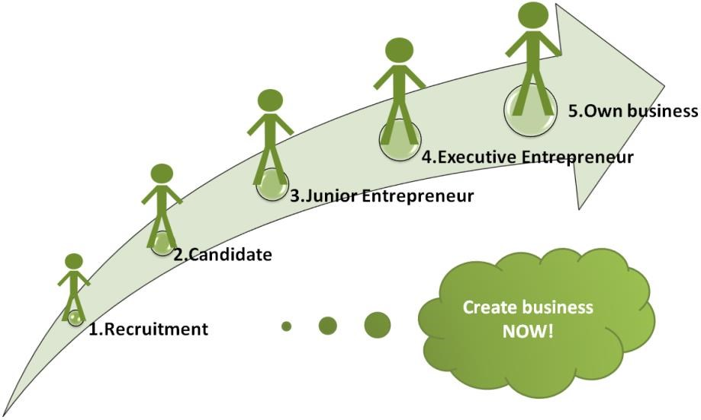

January 2020

Content
Content 2
- Executive summary 4
- Company presentation 7
  - Local Ugandan partner: American Ugandan Dairy Farming Community

- Business model 7
  - The ingrower® business model 8
- Mityana ingrower 10
  - Infrastructure and investment 12
    - Stage 1 – Crop production 124.1.2Stage 2 – chicken houses 13
    - Stage 3 – Ingrower mobile 15
    - Stage 4 – Expansion 15
  - Production 15
    - Stage 1 15
    - Stage 2-4 16

4.2.3 Entrepreneurs’ business 18
- Market, industry and competition 19
  - Food market 19
  - Customers 19
  - Competition 20
- Organization and management 21
  - Stage 1 organization 21
  - Stage 2-4 21
    - Organization 21
    - Board 22
    - Management 22
    - Training 24
  - Land ownership 24
  - Code of Ethics and Conduct 24
- Sustainability and social impact 25
  - Focus on women and poultry production 25
  - Entrepreneurship 26
  - Job creation 26
  - Development impact - households 27
  - Gender and youth 27
  - Indirect development impact 27
  - Change of attitude towards agriculture 28
  - Partner development 28
- Financial analysis 29
  - Investment 29
  - Operations 29
  - Profit and loss budget 31
  - Financial evaluation 31
- Sensitivity and risks 32
- Time schedule 34
- Appendixes 35
  - Recommendation from Bestseller Foundation 36
  - Certificate of incorporation “AUDFC” 38
  - Letter of recommendation - AUDFC 39
  - Land registration 40
  - Employment impact and businesses created 41

1 EXECUTIVE SUMMARY

For young people in Uganda, agriculture is generally seen as an unattractive sector and considered as a low-status occupation - not as a profitable business. As a result, smallholder farmers are grossly under-producing and fail to believe that farming can help them strive professionally, let alone improve their livelihoods.

The proposal is to establish a pilot agricultural production unit in Uganda. The business focuses on onsite production, processing and marketing of chickens - and later vegetables and feed. Local farm entrepreneurs will run their own business inside the project following the principles for the ingrower business model.

AMERICAN-UGANDA FARMING COMMUNITY LIMITED, locatedat P.o.box 29582, Kampala (UGANDA) represented here by Charles Lutaaya, Chief Executive Director.
Tel contact +256 773 648 908/ +256 706 241 844
Email at; audairyingcommunity@gmail.com
Website; www.audfc.com
The initial development ideas and related investments are from Ugandan shareholders who have studied dairying and value chain development with 14 years experience in organic farming practices from Europe and American farms.
The project started in 2012 with a farm at Kyotera on 320 acre piece of land, two years after another piece of land 175 acres was acquired in Mityana District. The company was registered in 2017 as a private company limited. It deals in Agriculture as whole and specialized in organic agriculture.
Board of directors/founders;
- Charles Lwanga Lutaaya, CEO.
- Fred Cosma Kasumba, Director.
- Fr. James Ssebayiga, Director.
- Julius Ssemyalo, Director.
- Nabiira Rachael, Director.
- Nalugemwa Veronica, Director.

COLEACP is our a partner whom we have an MOU with and her role in the AUDFC project is to provide technical assistance, which will be provided in terms of organic certification

Business model
Ingrower is a commercial project based on profit sharing with local entrepreneurs. The platform offers its beneficiaries (entrepreneurs) training, production facilities, operation capital, sales channels and business support. The local entrepreneurs run their own business inside the ingrower. Each has independent budgets and bank accounts. Gross profit from the production is shared 50/50 between the entrepreneurs and the ingrower. Entrepreneurs are, by the end of their stay, able to accumulate significant savings to establish their own businesses. Having left, they can continue to get advice and to buy and sell their products through the ingrower

Project
Site of the project is Busunju, Mityana District in Uganda.

Table 1. Implementation is outlined through four stages
Investment ste: | USD: | Time:
Stage 1 - Chicken houses | 107,632 | January –June 2020
Stage 2 - ingrower Mobile | 250,000 | July –December 2020
Stage 3 - Expansion | 674,000 | January-December 2021
Stage 4 - Crop production | 1,536,000 | January- December 2022
Total | 2,567,632
Stage 1:

Chicken houses
First stage is construction of 10 chicken houses (2000 chickens each) at the site in Busunju. The facilities will host possibilities for 10 young entrepreneurs who will start up their own business in the ingrower model. For first stage, the space will be reserved for young women above 18 years old. The women will produce chickens for one year and then leaving the space for the next entrepreneur. During their stay they will receive intensive training and support to become effective chicken producers. When leaving the will bring with them their capital savings to establish their own production outside the ingrower. Estimated investment need for stage 1 is about USD 107,632 and implementation during January- June 2020

Stage 2
Ingrower mobile
Second stage will introduce the ingrower Mobile in Uganda. ingrower Mobile is a software application developed to scale the ingrower concept to entrepreneurs having their own production outside a physical ingrower. The goal is to encourage young people to jump-start their own business and embrace entrepreneurship as an exciting and economic rewarding way of life. Designed and tested around the lessons learned on the ground - the aim of the app is to complement and scale up the services provided by the physical ingrower. By coupling face to face guidance with a selection of services offered through a mobile app, women and young people in hard to reach areas can access a platform in which advisors can support and motivate ingrower Mobile each entrepreneur directly. First version of ingrower Mobile will be launched in Uganda is ready by July- December 2020. The suggested first user-group will be 100 chicken farmers in Uganda.

Stage 3:

Expansion
The ingrower established in Busunju will be enlarged to in total 35 chicken houses with own incubation of eggs and a slaughterhouse facility. This will engage in total 35 entrepreneurs yearly and make the ingrower unit financial sustainable. Persons already having their own chicken production in the area can benefit from the infrastructure on an out-grower basis. Estimated commencement on the investment in January- December 2021

Stage 4

Crop production
Fourth stage will introduce feed and vegetable production with irrigation at the project in Busunju and give the possibility for starting up vegetable ingrowers and production of in-house feed for the chicken producers. The ingrower mobile will be extended to also services to vegetable producers – estimated time frame from January-December 2022.

Having all four phases implemented there will be a strong physical ingrower unit and an effective ingrower Mobile facility making the knowledge and tools accessible throughout Uganda.

Impact
The ingrower unit in Busunju will, when fully implemented, give space for 70 entrepreneurs at a time, who will stay in average one year in the project. Consequently, a flow of about 70 persons will every year leave the project with new skills, business experience and capital saved. The estimated result is that 1/3 of the entrepreneurs will succeed in starting up their own business. The remaining will get new skills to pursue better jobs or continue studying. Accumulating the jobs created by the project, the entrepreneurs and graduates will be about 1500 after ten years.

Capital is to be provided as social impact investment from private investors and financial institutions in Uganda as well as abroad and as loan/grants from social impact investors, NGO’s
(CSO’s) and governmental institutions. Total invest through all 4 stages is USD 2.6million.

When fully developed the ingrower itself will be financial sustainable and will provide significant social and economic impact to the local community in Uganda. Yearly turnover is to reach USD
2.8m and yearly net profit USD 480k. The financial assumptions for the base case indicate the IRR (Internal Rate of Return) to be above 15% in 10 years. Having reach full scale, cash flow is positive within the 2nd year and positive EBT (Earnings Before Tax) in the 3rd year of operation.

The parties
The American Ugandan Dairy Farming Community (AUDFC) is registered in Uganda as a private company limited by shares with an aim of developing a certified supply chain for poultry, dairy, fruit and vegetable products and feeds for local, regional, national and international markets. The company has set up an organic farm in Kyotera where we are growing fruits and vegetables, cereals and dairy farming on a 320-acre piece of land and we have expanded to Mityana district on 175-acre piece of land were the project (ingrower) will be implemented.

Ingrower Project is located in Mityana District, 54KMs from Kampala. The land is close to a big water source, River Mayanja and the soils are very fertile and sustainable for crop farming. Since the land is close to a big water source, irrigation will be feasible to establish.
The analysis, study and report provided in relation to the Busunju ingrower is done to the best knowledge and capability of the team. All relevant risks and mitigation of such have been covered to the best knowledge and capability, such as but not limited to access and availability of land, financial capacity of stakeholders, in-consistent supply of electricity, breakdown of irrigation, diseases, fluctuations in supply and price of inputs as well as off-takes, and variations in yield and productivities.

2 Company presentation

2.1. Local Ugandan partner: American Ugandan Dairy Farming Community
The American Ugandan Dairy Farming Community (AUDFC) is registered in Uganda as a private company limited by shares with an aim of developing a certified supply chain for poultry, dairy, fruit and vegetable products for local, regional, national and international markets. The company has set up an organic farm in Mityana District.

The initial development ideas and related investments are from Ugandan shareholders who have studied dairying and value chain development with 14 years’ experience in organic farming practices from Europe and American farms. The company employs: 1 Farm Manager, 1 Agronomist, 1 veterinary officer, 1 Accountant, 1 Field Officer, 1 Dairy Technician, 2 Community mobilizes, 2 Herdsmen, 2 Guards and 2 Drivers.

Vision is responsibly reared poultry, dairy and organic fruits and vegetables towards enhanced holistic human wellbeing. Mission is to enhance the wellbeing of our internal and external customers through access to safe healthy, certified organic dairy products, fruits and vegetables in a sustainable manner with focus on environment, social and economic viability.

Busunju Ingrower Project is located in Wakiso District, 54KMs from Kampala. The land is close to a big water source, River Mayanja and the soils are very fertile and suitable for crop farming. Since the land is close to a big water source, irrigation will be feasible to establish.

Busunju Ingrower Project
Charles Lutaaya, CEO
Tel: +256 773 648908
Email: audairyingcommunity@gmail.com
3 Business model

3.1 The ingrower business model
The entrepreneur receives knowledge and experience which he/she will use to expand the business within the ingrower and later to leave the incubation to establish own agricultural business based on the capital The ingrower scheme addresses the major challenges for smallholder agricultural producers by focusing on the lack of knowledge and missing economies of scale. The producers (entrepreneurs) work in close cooperation while maintaining individual incentives. The ingrower platform offers training, production facilities, land, irrigation, capital, marketing and business support. Local entrepreneurs, mainly youth, are invited to run their own business inside the ingrower. Each entrepreneur has independent business plans, budgets, bookkeeping and bank accounts. Gross profit of the production is shared 50/50 between the entrepreneurs and the ingrower.
saved. The ingrower provides operational support and facilities for young entrepreneurs to overcome the barriers of starting and running an agricultural business as well as advantages of scale despite every entrepreneur running a small business.

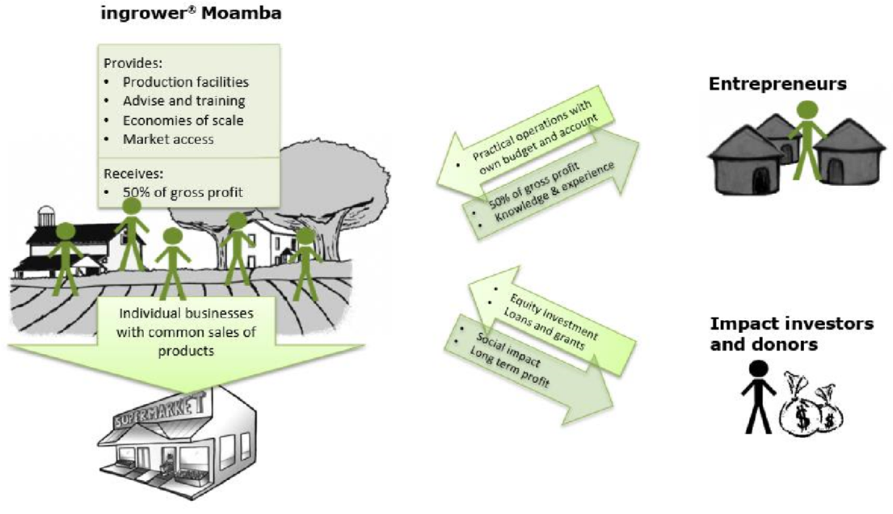

Figure 2. Illustration of the ingrower® business model

The ingrower provides the entrepreneurs with:
- production facilities (land, infrastructure, irrigation, production buildings, tools, etc.)
- training and individual support for business development
- training in agronomic and veterinarian techniques
- mechanized field preparation
- access to all required production inputs
- access to expert knowledge throughout the production life cycle
- improved market access due to the common marketing of products and logistics
- role models to compare with, motivation and competition with a peer group of fellow entrepreneurs

The entrepreneurs run separate businesses in a profit sharing scheme with the ingrower and are hence incentivized and gain experience to make own decisions.

When reaching the intended scale, the ingrower is financially viable and will provide significant social and economic impact to the local area. Furthermore, by strongly improving the household income of the entrepreneurs it will change the perception of agriculture, careers herein, incl. the youth and provide high-quality local produce for the fast-growing market, not the least the middleclass.

Strongholds of the ingrower business model:
- the entrepreneurs can start up without capital
- the entrepreneurs will get knowledge, experience and generate savings
- the ingrower combines the advantages of economy of scale and the advantages and passion that comes from small agricultural entrepreneurs
- entrepreneurs are equally challenged and supported to learn the required independency to become strong business people
- the entrepreneurs work alongside each other and there is a sound competition between them, which creates energy, motivation and adds status to the fact of being an agricultural entrepreneur
- products are sold through the ingrower which improves the marketing and ensures a premium price
- the ingrower is a financially sustainable and profitable business
- by improving the household income project will change the perception of agriculture, careers
- project will provide high-quality local produce of food

4 Busunju ingrower

With background in the ingrower business model and the local experience, the partners strive to implement a replication in Uganda. Scale and production will be adjusted to the local conditions, market and availabilities.

Figure 4. Land in Busunju

The proposed land where this project shall be situated in at Block 93 Plot 37, at Kawafu, Busunju, Busunju District. It measures 175 acres, with direct boarder with River Mayanja, which never dries. This in turn implies that the water table is low enough if boreholes have to be sunk for fresh water for drinking and irrigation. Hydroelectric power lines also pass through the land. It is free of any encumbrances and still virgin. It is private Milo Land, meaning that is it owned in perpetuity and there is no need to pay rents or rates.

The host community for the ingrower is a majority of farmers and friendly; thus, the community stand to benefit from the project. The project will also consider to establish accommodation for entrepreneurs who does not live in the area. This is will be done as a separate activity and not part of the investment. With the facility, it will be possible to source candidates from all over Uganda.

Project implementation
The development plan is divided in four stage. This to ensure that proof of commercial viability can be insured to the investors by each stage. The full implementation plan with estimated timelines can be found in part 10. “Time schedule “
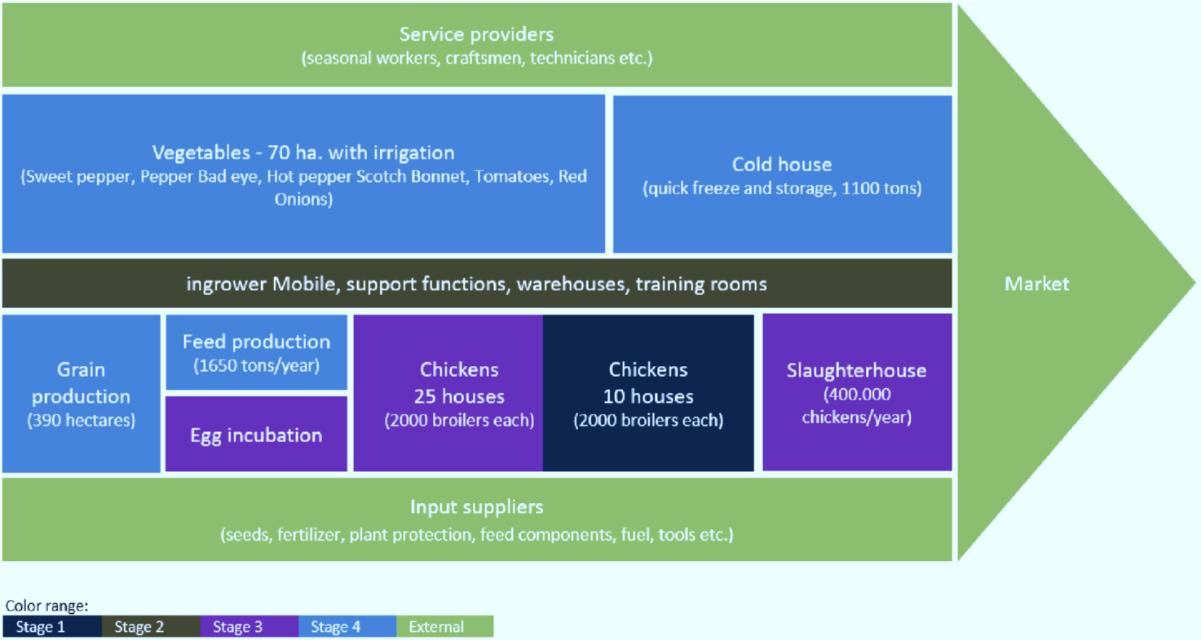

Figure 5. Development overview (4 stages)

4.1 Infrastructure and investment

4.1.1 Stage 1 – Chicken houses
Construction of 10 Chicken ingrower units
First stage is construction of 10 chicken houses (2000 chickens each). The facilities will host possibilities for 10 young entrepreneurs who will start up their own business at the site following the ingrower model. These will be sourced from the local community, interviewed and the best suitable will be selected. For first stage, the space will be reserved for young women above 18 years old. The women will produce chickens during one year and then leaving the space for the next entrepreneurs. During their stay they will receive intensive training and support to become effective chicken producers. When leaving they will bring with them their capital savings to establish their own production outside the ingrower. The project will partner with a Kampala based company, for the concern of chicks supply, feeds and technical support. Entrepreneurs will be given a subsidy for the first 6 months until production begins. The paid subsidy is deducted from the saved funds.

The trainers will assist the project as an external source during the first period. The project will employ two technical staff, one security personnel and a project Manager. Estimated investment need is USD 107,632 and implementation is planned for January-June 2020

Table 2. Stage 1 investment
Item | UGX | USD
Chicken houses, 10 units | 145,000,000 | 38,158
Project inputs and operation capital (chicks, feeds, drinkers, husks, charcoal, water etc) | 191,280,000 | 50,336
Salaries of Project staff for 20 months, | 72,729,000 | 19,138
Total | 409,009,000 | 107,632

The construction of 10 chicken houses has been valued at 145m UGX or USD 38,158. Each chicken house will cost about 14.5m UGX or USD 3,815 and the cost will include all building materials. It will have a simple structure similar to the ones already in existence. The bottom will be built with bricks, the middle part with some wire mesh and then the top with iron sheets.

The first phase will have 4 paid staff and below is the summary of their remunerations for the 20 months of the first cycle:
- Project Manager- 24m
- Project Accountant-16m
- 2 Technical staff -24m
- Security Guard – 9m
- Total - 73m (USD 19,238)

The project inputs and operation costs will take the biggest share of the stage 1 budget.
- Chicks and feeds – 104,000,000
- Vaccine and drug – 4,000,000
- Transport - 10,000,000
- Labor – 10,000,000
- Husks - 2,000,000
- Charcoal - 3,400,000
- Disinfectant- 4,000,000
- Water -3,000,000
- Other drugs - 2,000,000
- De-wormers - 2,000,000
- Feeders, drinkers - 10,000,000
- Subsidy to entrepreneurs for 4 months before production- 8,000,000
- Contingency- 28,880,000
- Total – 191,280,000

Having the concept in operation on ground in Uganda, the further stages will be to expand the production, add technology and develop the value chain – all to achieve financial sustainability while maintaining a high level of social impact.

4.1.2 Stage 2 – ingrower Mobile
Ingrower Mobile is a smart phone application which can be used both by chicken producers inside the ingrower and for any chicken producer all over Uganda. The app will be introduced in Uganda as part of the project.

The vision is to unlock the potential of young people: by motivating those who do not find agriculture an appealing industry, we show them how it is possible to transform their subsistence farming into successful agribusinesses. ingrower Mobile is a software application developed with this purpose by providing up to date technical assistance in professional agriculture management focusing on business planning, guidelines for rearing and feeding, healthy living conditions and disease management. Entrepreneurs can instantly follow their own up-to-date performance which helps them stay motivated and professionally manage their production.

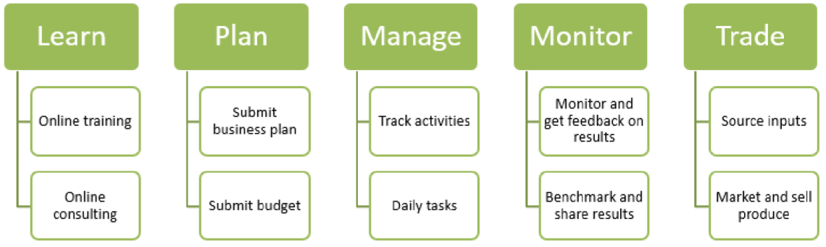

Figure 6. Ingrower Mobile functionality components
Iingrower Mobile
It supports the agribusiness entrepreneurs through all phases and provide motivation control over the entire production.

Introduction the ingrower Mobile makes it possible to provide parts of the ingrower services through a mobile app. In the Incubator the advisors support and motivate each entrepreneur directly.

Having a mobile app, to do some of the same kind of support, will have tremendous potential by reaching a much larger group of people. With ingrower Mobile, it will be possible to reach out to farmers all over Africa.

Introduction of the ingrower Mobile is planned July –December 2020. Initially it will be supplied to 100 users.

4.1.3 Stage 3 – Expansion
The ingrower established in Busunju will be enlarged to in total 35 chicken houses and will be enlarge with own incubation of eggs and a slaughterhouse facility. This will engage in total 35 entrepreneurs yearly and make the ingrower unit financial sustainable. Persons already having their own chicken production in the area can benefit from the infrastructure on an out-grower basis.

Table 3. Stage 3 investment in USD
Overall feasibility study | 86K
Construction of 25 additional chicken houses | 231K
Construction of slaughter and cooling facilities | 154K
Installation of egg hatcher | 124K
Operation capital | 79K
Total | 674K

4.1.4 Stage 4 – Crop production
Fourth stage will introduce crop production with irrigation at the project in Busunju and give the possibility for starting up vegetable ingrowers and production in-house feed for the chicken producers. The ingrower mobile will be extended to also services to vegetable producers – estimated time frame from January- December 2022

The chicken production will have own feed production with the capacity of about 1 tons/hour. The consumption at the Busunju ingrower is about 4.5 tons/day hence providing fodder also for commercial sales. Profit of such external sale is not included in the calculations.
Estimated commencement on the investment in January- December 2021.

Table 4. Stage 4 investment in USD
Irrigation study | 58K
Installing irrigation system | 636K
Field machinery | 165K
Warehouse and storage | 308K
Prepare land for feed production | 25K
Installation of feed production unit | 107K
Operation capital | 237K
Total | 1,536K

Having all four phases implemented there will be a strong physical ingrower unit in Busunju and an effective ingrower Mobile facility making the knowledge and tools accessible throughout Uganda.

4.2 Production

4.2.1 Stage 1
The 10 chicken producers have a house each for 2,000 chickens. They run 6 batches per year and feed the chickens to 1.8 kg. Mortality rate used for calculations is 8%. Total annual production is 110,000 chickens. Compared to small-farmer poultry rising, the ingrower will provide more even poultries in terms of size and lesser spread, while at the same time experiencing less mortality rate.

Table 5. Chicken gross profit calculation
GP calculations - chicken production (all values in UGX)
Costs | Units | UGX | Total (UGX)
Chicks | 2000 | 2,200 | 4,400,000
Feed (finished bought feed) | 2000 | 3,000 | 6,000,000
Vaccine and drug | 2000 | 200 | 400,000
Water | 2000 | 150 | 300,000
Dewormers | 2000 | 100 | 200,000
Other drugs | 2000 | 100 | 200,000
Labour | 2000 | 500 | 1,000,000
Transport | 2000 | 500 | 1,000,000
Husk | 2000 | 100 | 200,000
Charcoal | 2000 | 170 | 340,000
Disinfectant | 2000 | 200 | 400,000
Contingency | 20% | 1,444 | 2,888,000
Total cost per circle |  | 8,664 | 17,328,000
Sales
Mortality | 8 %
Kg/chicken | 1.50 | 11,333
Sales (1,8 kg) farm gate price | 1840 | 17,000 | 31,280,000
Gross profit |  | 8,336 | 13,952,000
Batches per year | 6 |  | 83,712,000

4.2.2 Stage 2-4

Table 6. Chicken production summary when on full capacity
Chicken production, summary
SUMMARY (UGX) |  | Per circle | Per entrepreneur | Project total
Number of houses |  |  | 1 | 35
Number of batches |  |  | 6 | 210
Chickens delivered |  |  | 11,040 | 386,400
Total sales |  | 31,280,000 | 187,680,000 | 6,568,800,000
Variable cost |  | 17,328,000 | 103,968,000 | 3,638,880,000
Production GP |  | 13,952,000 | 83,712,000 | 2,929,920,000
Entrepreneurs:
Return from GP | 50% | 6,976,000 | 41,856,000 | 1,464,960,000
Service fee |  | 729,126 | 4,374,756 | 153,116,460
Return to entrepreneurs |  | 6,246,874 | 37,481,244 | 1,311,843,540
Ingrower GP |  | 7,705,126 | 46,230,756 | 1,618,076,460
SUMMARY (USD) |  | Per circle | Per entrepreneur | Project total
Total sales |  | 8,454 | 50,724 | 1,775,351
Variable cost |  | 4,683 | 28,099 | 983,481
Production GP |  | 3,771 | 22,625 | 791,870
Entrepreneurs:
Return from GP | 50% | 1,885 | 11,312 | 395,935
Service fee |  | 197 | 1,182 | 41,383
Return to entrepreneurs |  | 1,688 | 10,130 | 354,552
 |  | 0 | 0 | 0
Ingrower GP |  | 2,082 | 12,495 | 437,318

Slaughtering
The project will establish its own slaughterhouse facility operated directly by the ingrower. Total production from the slaughter house is 386,400 slaughtered chickens per year. The slaughterhouse is operated as a commercial unit, not sharing gross profit with entrepreneurs.

Table 7. Slaughter operation summary
Summary, slaughtering
SUMMARY (UGX)
Part of each house sold through slaughter |  | 100% | 386,400
Batches per year |  |  | 6
Number of houses |  |  | 35
Chickens slaughtered per year |  |  | 386,400
Tunover |  |  | 966,000,000
Variable cost |  |  | 376,740,000
Total GP to ingrower |  |  | 589,260,000
SUMMARY (USD)
Tunover |  |  | 261,081
Variable cost |  |  | 101,822
Total GP to ingrower |  |  | 159,259

Vegetable production
70 entrepreneurs run in average 1 ha each. The area they have will be gradually increased as their experience and capability improve. Crops planned to be produced are Sweet pepper, Pepper (Bad eye), Hot pepper (Scotch Bonnet), Tomatoes, Red Onions. Average 2.0 vegetables cycles per year. The yield figures for each crops are indicated below, respectively based on existing small-farmer experiences.

Table 8. Vegetable production volumes
Crop volumes | Sweet pepper | Pepper (Bad eye)pper (Scotch Bonnet) |  | Tomatoes | Red Onions
Yield units/ha/circle | 8,000 | 16,000 | 16,000 | 15,000 | 20,000
Units | Kgs | Kgs | Kgs | Kgs | Kgs
Kg per units | 1 | 1 | 1 | 1 | 1
Ha. Harvest/year | 42 | 14 | 14 | 42 | 28
Total kg/ year | 252,000 | 168,000 | 168,000 | 472,500 | 420,000
Average kg/week | 4,846 | 3,231 | 3,231 | 9,087 | 8,077

Table 9. Vegetables gross profit summary
Production summary, vegetables
SUMMARY (UGX) |  | Per ha | Per entrepreneur | Project total
Total harvested ha. per ye ar |  | 1 | 4 | 140
Total sales |  | 20,062,500 | 80,250,000 | 2,808,750,000
Variable cost |  | 5,302,839 | 21,211,355 | 742,397,425
Production GP |  | 14,759,661 | 59,038,645 | 2,066,352,575
Entrepreneurs:
Return from GP | 50% | 7,379,831 | 29,519,323 | 1,033,176,288
Service fee |  | 1,592,524 | 6,370,095 | 222,953,325
Return to entrepreneurs |  | 5,787,307 | 23,149,228 | 810,222,980
Ingrower GP |  | 8,972,354 | 35,889,417 | 1,256,129,595
SUMMARY (USD) |  | Per ha | Per entrepreneur | Project total
Total sales |  | 5,422 | 21,689 | 759,122
Variable cost |  | 1,433 | 5,733 | 200,648
Production GP |  | 3,989 | 15,956 | 558,474
 |  | 0 | 0 | 0
Entrepreneurs: | 50% | 0 | 0 | 0
Return from GP |  | 1,995 | 7,978 | 279,237
Service fee |  | 430 | 1,722 | 60,258
Return to entrepreneurs |  | 1,564 | 6,257 | 218,979
 |  | 0 | 0 | 0
Ingrower GP |  | 2,425 | 9,700 | 339,494

4.2.3 Entrepreneurs’ business
The 70 entrepreneurs run the production as their individual business. 50% of the gross profit is their income that they receive on a personal bank account, while a value of some 70 USD per month will be allowed to be withdrawn and paid in cash to the entrepreneurs. The remaining will be retained, saved capital for the entrepreneurs to collect for investment in their own agricultural business when they leave the ingrower.

Table 10. Entrepreneur key figures
Entrepreneur results
Current values (no inflation)
 | UGX | USD
Income per year, chicken entrepreneurs | 37,481,244 | 10,130
Income per year, crop entrepreneurs | 23,149,228 | 6,257
Entrepreneur, average yearly profit | 30,315,236 | 8,193
Profit during 12 month | 30,315,236 | 8,193
Allowance during 12 month | 2,898,000 | 783
Savings when leaving after 12 month | 27,417,236 | 7,410

5 Market, industry and competition

5.1 Food market
The demand for quality food products is rapidly increasing in Uganda. The establishment of a middle class market segment with higher purchasing power improved the prices and the demand. When Kenya in 2017 lifted the bird-flue-imposed ban on poultry imports from Uganda it contributed to the increasing market pressure. Exports are also increasing to other neighboring countries. According to traders in the Kampala markets 2017 and 2018 have witnessed an increasing under supply of chicken and slaughtered poultry.

At the same time there is a tendency in urban and export markets to value products produced locally and with an origin that can be traced. The Busunju ingrower project will take advantage of this trend and develop the use of storytelling and branding focusing on how small, private quality entrepreneurs in Uganda learned to produce the broilers.

Open markets and kiosks, included in other grocery retailers, and independent small grocers, are traditionally the primary distribution channels for packaged food in Uganda. Nevertheless, the entry of new supermarkets and shopping centers is encouraging some consumers to switch to a different and novel shopping experience. By taking away the stress involved in haggling over items, the supermarkets channel increased its value share over the last 10 years. Also, most supermarkets allow consumers to benefit from in-store promotions (although prices are generally higher than those in open markets and independent small grocers).

A positive performance is predicted for the packaged food market in Uganda over the forecast period, although growth will be weaker than previously predicted due to the weakened economy. The economy should recover eventually from the effects of lower government revenue, with reforms put in place by the current government likely to yield results in the long run in terms of improved infrastructure. The increasing sophistication of Ugandan consumers and improving product quality will also be growth drivers.

5.2 Customers
The market potential for food is attractive and the volumes delivered from the project are small in comparisons with the total market. The project has a number of clients and channels to choose between. When fully established the key channel for the chicken production will be the quality-focused customers such as restaurants, hotels and high-end supermarkets.

Below listed are market channels according to the price level (low to high):
- traders buying directly from the farm
- open market places in Busunju and surroundings
- open markets in Kampala
- direct deliveries to supermarkets (such as Shoprite, Tuskeys, and local supermarkets)
- direct to institutional customers such as hotels/restaurants, company cantinas, and
- export to neighboring countries (South Sudan, Kenya, DRC etc.)

As the output of each of the ingrower entrepreneurs is relatively small even while they are apprentices at the Busunju ingrower, it is vital to the whole concept to organize the production quality and the delivery times. The ingrower has contacts to the above clients and will set up the common agreements.

5.3 Competition
The competitors will be other local producers and imports especially in terms of poultry. The competitive advantage is that the Busunju ingrower shall offer fresh quality products to very best local standards produced in Uganda which most customers value greatly.
Competitors:
- Large scale commercial farms (few in Uganda)
- Commercial out-grower schemes
- Cooperatives
- Small holders

Chickens
The slaughter facility will make it possible to brand the products and provide access to the premium price market. The competitors for low price markets are other local producers. For supermarkets and other high price markets, the competitors are mainly from South Africa and Brazil. The ingrower has a competitive advantage of offering locally produced chicken, which are perceived to be of higher quality as well as telling a positive story about local economic and social impact.

Vegetables
Having irrigation provides the advantage to deliver products also during the dry seasons. This is a strong competitive advantage when competing with other local producers. At this market, ingrower will have a price and delivery advantage.

6 Organization and management

6.1 Stage 1 organization
The Project will start small and will therefore build the human resource during the next stages of implementation. However, one of the project Directors will take the lead in having the project started.

- Director (Mr. Charles Lwanga Lutaaya)
Will drive the start and implementation of the project. Will execute the investment and monitor the work in progress. The first phase will include; recruitment of a Project Manager, supervise the construction of 10 chicken houses.

- Project Manager.
Will report to the Director and will head the production unit. He will supervise the technical staff and head the sales of the chicken i.e. he/she will be in charge of the markets and manage all external relations.

- Accounts Assistant
The Project for the start will have an accounts assistant who will manage finances and will deputize the project manager.

- Technical staff
There will be two and will coordinate chicken production, training and evaluation of students and will monitor the markets. The project will take an advantage of using the already existing staff in in the company who will work as technical staff and also supervisors of the entrepreneurs on day to day basis. The supervisors will report to the Project manager.

- Security Guard
Will take care of all the security needs of the ingrower. He will also report to the Project Manager.

To save project time, activities will run concurrently. The entrepreneurs will have oral training as construction of chicken houses is ongoing and as soon as it is done, production will begin.

6.2 Stage 2-4
After the stage 1- a larger organization dedicated to the ingrower will be established.

6.2.1 Organization
Management of the project implementation, start-up and following operations will be headed by a CEO. The CEO reports to the board. Under the CEO will be a level of supervisors and managers. The CEO is responsible for execution of the investment plan and thereafter for the ongoing operations. The CEO ensures the implementation of the strategic plan and supports and oversees the progress and performance of the staff. The Board provides leadership for strategic decisions, communications, evaluation and local presence including stakeholder engagement.

6.2.2 Board
Busunju ingrower will be headed by a Board of Directors, which is constituted to reflect the equity participants in relative proportion to their financial engagement. Since the majority of equity is expected to be with Busunju ingrower, the presence in the board is also supposed to be constituted accordingly, namely with the Chairman to be representing interests. The remaining equity is expected to come from Danish investors, predominantly social impact investors.

At the same time, the Board is to comprise representatives from the private sector and community who can offer a comprehensive range of perspectives, experiences and skills.

Figure
8
.
Organization chart

CEO
Production
manager
Chicken
supervisor
Crop supervisor
Slaughter
operations
Feed
production
Facility
manager
Logistics
Maintenance
Sales/
marketing
manager
Finance
manager
HR
Purchase
Accounting
Relations to
entrepreneurs

6.2.3 Management
The top-level of the organization is set via the head being the CEO (Chief Executive Officer) having 4 Managers in reference, the Finance Manager (also acting as the deputy to the CEO in her/his absence), the Production Manager, the Facility Manager and the Sales/Marketing Manager.

CEO
The management team is headed by a CEO while the team is constituted of functional responsible strong profiles when it comes to Finance, Production, Commercial and Facilities. Each of these has a few sub-ordinates to ensure efficient operations and ultimately profit.

The most important skills and criteria of the CEO are as follows;
- Several years of proven track record within management and running a business (P/L responsibility)
- Sincere interest in Agriculture
- Wide covering network of influencers; locally, regionally and preferably also at Federal level
- Great personality both in front of the Board members as well as out in the field
- Readiness to receive remuneration package reflecting production results

The CEO is the main driver of the project and vehicle of information exchange between the project and the board. The CEO must have the ability to take the lead on execution of the investment, administration and agricultural issues, with major responsibility areas being;
- Overall responsibility for all operations incl. staff and finances
- Monitoring, evaluation and motivation of staff
- Ensuring that permissions are obtained, due diligence on critical issues, morale and ethics throughout the operations
- Supporting the management that contracts with suppliers and buyers are fulfilled
- Monitoring progress of the project, collects feed-back from staff and entrepreneurs and provides feedback to the board
- Develops and evaluates incentive mechanisms of entrepreneurs and staff
- Responsibility for execution of the investments
- Ensuring ongoing local operations is according to timelines
- Ensuring that finance and management meets the expectations of the board

Finance Manager
Head of finance, incl. purchase, accounts, HR in general as well as relationships with the entrepreneurs. Besides, the Finance Manager is deputy to the CEO and the stand-in in case of her/his absence.

Production Manager
Head of production, incl. Crop Supervisor, Chicken Supervisor as well as Slaughter operations.

- Crop Supervisor
Responsible for coordinating the activities of the field of agriculture, ensuring the quality in terms of production and productivity, guiding entrepreneurs in any theoretical or practical difficulties to be encountered, monitoring the marketing of products and teach courses.

- Chicken Supervisor
Responsible for coordination of chicken production, correct use of all materials and animal production, guiding entrepreneurs in any theoretical or practical difficulties to be encountered, monitoring the marketing of products and responsible for training and evaluation of candidates in the field of animal production.

- Slaughter operations and feed production
Responsible for the coordination of all slaughter house operations, incl. relations with the Facility Manager when it comes to freezing and storage of the slaughtered chicken. Responsible for the chicken feed production line.

Facility Manager
This person is responsible for infrastructure, equipment, buildings, machinery and vehicles, incl. the storage of inputs (purchases in relation to the field activities) as well as outputs (both vegetables on chilled storage and frozen chicken on frozen storage).

Sales/Marketing Manager
All external customer relations activities are headed by the Sales/Marketing Manager. Priority is the establishment, execution and further development of long-term supply agreements with key off takers. Besides, the general promotion of "Raymond" as a brand and optimization of sales (in terms of short-term profit) of excess volumes is more of the regular and daily tasks.

6.2.4 Training
The production supervisors are in charge of the induction, training and education of the entrepreneurs in their respective area. Albertine Interventions for Development (AID) and Coleacp have been and will continue training based on experience and material.

6.3 Land ownership
Local project owner, director has the full owner ship to the land where project will be implemented.Landownership agreement is attached in appendix 11.6.

6.4 Code of Ethics and Conduct
The Busunju ingrower Code of Ethics and Conduct will be developed and set as fundamental principles, operational principles and standards to guide the actions and management of the organization.

Fundamentally, any operations connected to Busunju ingrower will be subject to certain standards, including but not limited to:
- Adherence to the UN Global Compact's ten principles in the areas of human rights, labor, the environment and anti-corruption
- Exclusion of companies with a lower ethical foundation, as an example companies related to the weapons, alcohol, tobacco and/or porn/sex industry
- Protection against misuse of the brand

One of the first tasks of the Board of Directors will be to develop the Busunju ingrower Code of Ethics and Conduct, based on sound Ugandan business principles, implementable in African context while striving to a level of international standards, where ever possible.

7 Sustainability and social impact

The ingrower is a unique social impact project that is business driven in all aspects.
Inspiration is local out-grower schemes.
Activities in the ingrower are sustainable, in all respects:
- Profitability oThe ingrower is for profitable business activities. Entrepreneurs must monitor production and make sure that activities are profitable. Persons who after instruction and training do not comply must leave the ingrower.
- Environmental oActivities which will harm people, animals (welfare) or the environment to Ugandan standard have no eligibility and will not be accepted. Production must follow all local rules and may not do any damage to surroundings.

Setting up an ingrower project in Uganda will:
- create jobs and income opportunities for also young unskilled and unemployed people
- generate a crowd of entrepreneurs who will establish own private agribusiness every year
- lead to significant business development and community spin-off activities in the region
- add new knowledge and technics to be used by the entire community
- increase the production of sustainable and locally produced food in Uganda
- change the perception of agriculture as a sector and agricultural careers
- change the perception of locally produced foods
- be a financial sustainable unit which can be replicated to all across Uganda

7.1 Focus on women and poultry production
Village chickens can make significant economical contributions to households, both as a small source of regular income, or as a liquid asset, which can be used by households to access food.

Our experience in expanding existing production by raising capacity to commercial standards in Uganda has shown that youth &young women are the most successful in training, both in terms of production and the development of business after training. Village poultry production systems are a particularly important income-generating activity for women, as they place little demand on mothers’ time, allowing adequate time allocation to child care, a crucial element to achieving good nutrition.

Furthermore, income from the sale of poultry products is often the main source of income for female-headed households, whereas male-headed households usually have multiple income. It has been found that 90% of income under the control of women is channeled back into their households or local communities, in contrast with only 30–40% for men (OECD, 2009), and that women use their income to increase the quantity and variety of foods purchased, on medical care, and on schooling for children.

Poultry are generally the most numerous livestock in resource-poor areas, where their contributions to food availability are both direct, through supplying nutrient-rich and culturally acceptable products for human utilization, and indirect, through enhancing crop, vegetable and other livestock production with the provision of manure and pest control.
Production of chicken does not require land clearing, contributes positively to ecosystem health, and can reduce loss of biodiversity by being a rich pool of genetic diversity and by being an alternate protein source to bushmeat. Recent studies on the relationship between income and poultry production systems show that extensive, scavenging poultry systems are most commonly found in rural, resource-poor areas.

7.2 Entrepreneurship
The gross profits realized from the project will be shared 50/50 between the Entrepreneurs and the Project owners. The Entrepreneurs will be able to start their own business with the capital saved from the project. Because of the advantage of economies of scale, the project, the entrepreneurs can continue to sell their products to the Ingrower which has a ready market.

To ensure that savings are made, the Entrepreneurs will have individual Bank accounts which they will not access until the time they are leaving the project. However, they will be provided with some facilitation throughout the project cycle.

On the other hand, the profits which go to the project will be used as running capital for the next group of Entrepreneurs who will join the project, and also manage the day today running of the in grower as it grows.

The project will empower the whole community economically and socially. The Women will empower to manage poultry production which will in turn improve their household incomes. This will lead to better standards of living, reduce domestic violence and improved health conditions of the family.

The investment will create the opportunity for 70 entrepreneurs per ingrower unit to support themselves by running their own private business within the project. The entrepreneurs stay in the project for an average 1 year. This gives a flow of about 70 persons entering and leaving the ingrower every year. From experience about 1/3 will end up establishing a sustainable business after their stay in the ingrower, 1/3 will take up another agricultural related position, while the remaining 1/3 fail in getting a full-time job for various reasons. This way around 23 new sustainable business are created every year.

Once successfully leaving, each entrepreneur is technically competent, has the understanding and acumen to run a business and has saved capital during the incubation period, in average about USD 6,000 – well situated to start own agricultural business

The 1/3 taking up another agricultural related position will still leave the ingrower with new knowledge and experience which they will use for achieving better jobs or continue their education.

7.3 Job creation
In addition to the entrepreneurs the project itself will employ about 43 persons at the ingrower.
About 25 will be unskilled workers and guards and 18 skilled workers and managers with medium technical or university degrees. For the 23 new businesses created yearly, the average employment on each farm will be about 3 persons. After 10 years, 210 created businesses will employ about 630 persons. The entrepreneurs leaving the project without starting their own business will be better prepared to get jobs. Overview of job-creation in Annex 11.6

7.4 Development impact - households
The main beneficiaries are the entrepreneurs who will run their business in the ingrower. They are typically unemployed youth mostly from neighboring villages which provide very few regular jobs, hence the youth is prone to otherwise be leaving the villages. The persons attracted (and preferred) by the ingrower are those with some motivation (best case passion) to start up a business but have limited resources and qualifications.

The ingrower gives them an opportunity to improve their livelihoods. The entrepreneurs who left are likely to build up their own business in the area or obtain some form of employment also using the skills obtained in the ingrower.

The entrepreneurs will be able to get an income of about USD 6,000 per year. This must be seen in comparison with the fact that many young people in the area are unemployed with no salary and most that have jobs are getting not more than a minimum salary - hence the beneficiaries will strongly improve their household income.

Capital saved of approx. USD 6,000 after (some two years and deducted by paid allowances) incubation is sufficient to start own agricultural business, take good care of the whole family. In year 10, without further expansion than the current growth plan, the total number getting their income from the project as well as those who have left the project to use their skills on own businesses or as employees, is a total of approx. 1,500 persons (appendix 11.6).

7.5 Gender and youth
The project creates significant impact on employment opportunities, also for women. Estimate is that minimum 60% of the entrepreneurs in the ingrower are women.
Experience has shown that for field production, young women are the most successful entrepreneurs. In the Mozambique project, the field entrepreneurs are mainly women and the chicken producers are approx. 50/50 between the genders. In average, in the existing projects 66 percent of the producers have been women. Thus the project enhances employment opportunities and livelihood for women in the village. Most women participating in the program had previously a small plot of land which they used for agriculture or life stock which made them to be self-sufficient. After the ingrower incubation, the women know how to improve and expand their activities to increase their income with agricultural production.

7.6 Indirect development impact
Input suppliers will benefit from getting new clients already the first years and afterwards an increasing number of clients who will purchase production inputs for approx. USD 1.3 m per year directly by the Busunju ingrower and additionally market possibilities for the entrepreneurs who has left to run their business outside the ingrower.
Retailers will get local high quality products of chickens and vegetables for a value of USD 2.8 m per year. This figure does not include the production from entrepreneurs who have left the project.
Consumers, such as restaurants and canteens will benefit from access to local production of good quality and with stable deliveries.
Other small scale producers in the area will be offered to use the services of the ingrower. For example, they can sell their production to the ingrower, buy inputs or use the services for preparing land and technical advice against an agreement. It can also be assumed that they will benefit from knowledge transfer via employees and entrepreneurs.

7.7 Change of attitude towards agriculture
The project will support a change to the perception of working in agriculture. , that young people start to look at agriculture as an attractive business. This has a very positive effect on the motivation and attitude among the young people. The strength is that they can see with their own eyes that someone with similar background can make an attractive income by doing agriculture.

In terms of attitude to local products, there has been a tendency that local products are seen as having less quality and safety compared to imported foods. This will change, and the project will support this development by delivering save and high quality products from local producers.

7.8 Partner development
Providing practical opportunities to agricultural students will be an advantage in the recruitment of students as well as strengthen the local goodwill.

Finally, the Busunju ingrower will have a huge impact even outside the supplies and the families who have access to salaries. It will create multiple job opportunities, reduce poverty and increase financial activities in general.

8 Financial analysis

It is assumed the price changes on inputs and outputs will follow the average inflation rate. In the calculations, the exchange rate is fixed on 3700 UGX/USD. It is assumed that an eventual change in exchange rate will be equalized by the inflation rate. The calculations are based on UGX currency and inflation rate is set to 5% and UGX/USD devaluation also to 5%.

As the purpose of stage 1 is to prepare for the commercial phase the financial analysis is based on the full developed project with all 4 stages implemented.

8.1 Investment
The project is a green field investment. All infrastructure and buildings have to be established. The total investment is USD 2.2 mill. indicated in Figure 9. Investment in 1,000 USD, indicates the investment items and values.

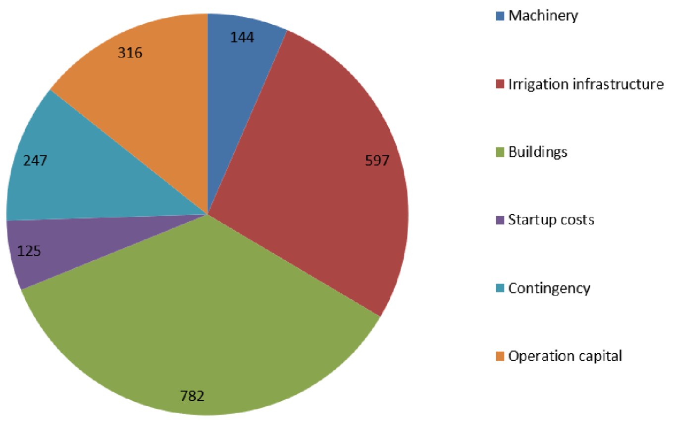

Figure 9. Investment in 1,000 USD

Machinery investment includes 1 tractors with implements, two small trucks for transport of products, cooling truck, Irrigation infrastructure is mainly for complete irrigation system, and generators. Buildings consist of a warehouse, product store, feed factory, cold room, slaughterhouse, 35 chicken houses and office/teaching facilities. In Startup costs is juridical assistance and external support the first year.
Because it is assumed the first ingrower unit in Uganda and a greenfield project the 15% is added to contingency. Operational capital is calculated as peak capital need +15%.

8.2 Operations
The revenue of the ingrower is generated from vegetable production, chicken production and slaughterhouse operation.

Vegetable production is based on 70 ha with irrigation producing high value crops in average two cycles per year. The crops grown are Sweet pepper, Pepper (Bad eye), Hot pepper (Scotch Bonnet), Tomatoes, Red Onions. Variable costs consist of production input, land cost and the share of profit paid to the entrepreneur in charge of the production. The vegetable production engages 35 entrepreneurs in total. The crop production contribute to the gross profit with USD 339k after the 35 entrepreneurs has received their share.

The chicken production takes place in 35 houses with space for feeding 2,000 chickens in each. Chickens are fed to 1.8 kg allowing 6 cycles per year resulting in a total production of 386,400 chickens per year. The revenue of the chicken production is based on an internal sales price (favoring the entrepreneurs) to the slaughter house. Gross profit is shared with the 35 entrepreneurs. Yearly gross profit for the ingrower is USD 437000 after the 35 entrepreneurs have received their share.

All produced chickens are slaughtered in the internal slaughterhouse – which is a separate business unit. Slaughterhouse is operated by the staff as a separate business unit. The slaughter operations contribute with a gross profit of USD 159000.

Feed production and egg hatching is service providers to the chicken production and is not calculated as separate business units.

In total the project will have a yearly gross profit of USD 936000 after payment of the 50% to the entrepreneurs, as illustrated in Figure 10. Ingrower gross profit in 1,000 USD after sharing with entrepreneurs.

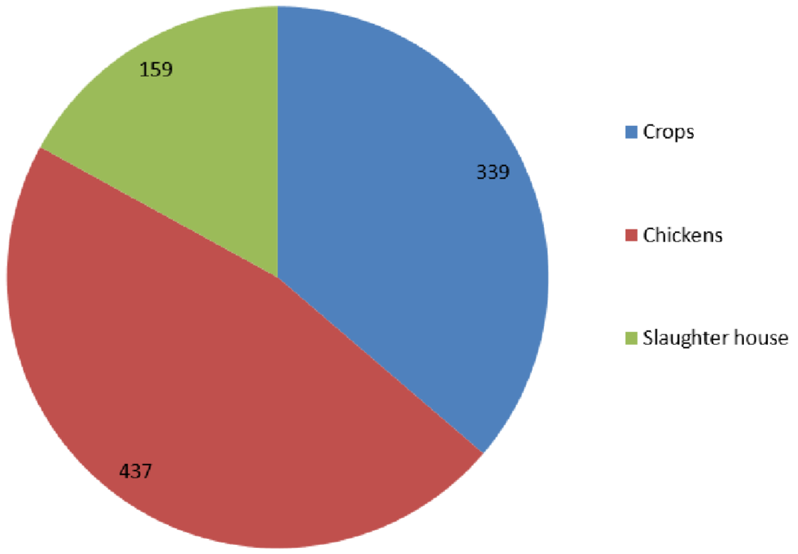

Figure 10. Ingrower gross profit in 1,000 USD after sharing with entrepreneurs

Fixed costs of the ingrower consist of salaries, maintenance and consumables. The staff is 18 technicians and academics and 25 workers/guards. Maintenance is set to 10% of value for machinery and 5% for building and irrigation. Machinery is depreciated over 10 years and buildings and infrastructure over 20 years. Additionally, is allocated 10% for contingency.

8.3 Profit and loss budget
Below budget, Table 11. Operations budget, is based on full capacity reach after 3 years. No inflation incorporated.

Table 11. Operations budget
Operations budget (USD) by full capacity (present value = no inflation)
 | Crops | Chickens | Slaughter house | Total | 1 ,000 USD
Turnover | 759,122 | 1,775,351 | 261,081 | 2,795,554 | 2,796
Variable costs | 200,648 | 983,481 | 101,822 | 1,285,951 | 1,286
Entrepreneurs share | 218,979 | 354,552 |  | 573,531 | 574
Gross profit | 339,494 | 437,318 | 159,259 | 936,072 | 936
 | 339 | 437 | 159
Fixed costs
Maintenance |  |  |  | 83,315 | 83
HR |  |  |  | 186,000 | 186
Consumables |  |  |  | 20,789 | 21
Contingency |  |  |  | 20,627 | 21
 |  |  |  | 310,731 | 311
EBITDA |  |  |  | 625,341 | 625
Depreciation |  |  |  | 83,315 | 83
Interest (in year 3) |  |  |  | 62,095 | 62
EBT |  |  |  | 479,930 | 480
Tax |  |  |  | 0 | 0
Net profit |  |  |  | 479,930 | 480

8.4 Financial evaluation
The IRR calculation, in Table 12. Profitability evaluation, is based on the investment value and the required operation capital. For the base case scenario, the IRR is 37% after 10 years, with an inflation rate on 5% p.a. Table 12. Profitability evaluation
Profitability evaluation Year 1  Currency: USD |  |  | Year 2 | Year 3 | Year 4 | Year 5 | Year 6 | Year 7 | Year 8 | Year 9 | Year 10
Inflation |  | 0% | 5% | 5% | 5% | 5% | 5% | 5% | 5% | 5% | 5 %
Internal rate of return (IRR):
Operating cashflow |  | -136,237 | 603,597 | 689,438 | 736,425 | 786,387 | 839,503 | 881,479 | 925,553 | 971,830 | 1,020,422
Minus:
Investments, net |  | -1,894,511 | 0 | 0 | 0 | 0 | 0 | 0 | 0 | 0 | 0
Free Cash Flow after investment |  | -2,030,748 | 603,597 | 689,438 | 736,425 | 786,387 | 839,503 | 881,479 | 925,553 | 971,830 | 1,020,422
IRR - 10 years: | 33.7 %
Average inflation: | 4.5 %
Return on investment (ROI):
Operating cashflow |  | -136,237 | 603,597 | 689,438 | 736,425 | 786,387 | 839,503 | 881,479 | 925,553 | 971,830 | 1,020,422
Minus:
Amortisation |  | -52,656 | -57,395 | -62,561 | -68,191 | -74,328 | -81,018 | -88,310 | -96,257 | -104,921 | -114,363
Interest |  | -86,106 | -73,096 | -62,095 | -56,465 | -50,328 | -43,638 | -36,347 | -28,399 | -19,736 | -10,293
Equity invested |  | -1,094,511
Pre-tax
cash flow project |  | -1,369,510 | 473,105 | 564,782 | 611,769 | 661,730 | 714,847 | 756,823 | 800,897 | 847,174 | 895,766
accumulated cash flow project |  | -1,369,510 | -896,405 | -331,623 | 280,146 | 941,876 | 1,656,723 | 2,413,546 | 3,214,443 | 4,061,617 | 4,957,382
cash flow investor (90 %) |  | -1,369,510 | 425,794 | 508,304 | 550,592 | 595,557 | 643,363 | 681,140 | 720,807 | 762,457 | 806,189
accumulated cash flow investor |  | -1,369,510 | -943,715 | -435,412 | 115,180 | 710,737 | 1,354,100 | 2,035,240 | 2,756,047 | 3,518,504 | 4,324,693
ROI - 10 years: | 37.6 %
Average inflation: | 4.5%

9 Sensitivity and risks

The calculation model is based on experience from Mozambique, inputs are based on assumptions and findings from Uganda, which are provided by Busunju ingrower team while danishknowhow has consolidated it all, supported by quotations for the bigger investments / expenses and information from the local partners.

Table 13. Sensitivity calculation
Sensitivity calculations |  |  | UGX 1,000 |  |  |  | USD 1,000
 |  | Net profit | IRR, 10 years | Entrepreneur, average yearly profit | Savings when leaving after 12 month | Net profit | IRR, 10 years | Entrepreneur, average yearly profit | Savings when leaving after 12 month
Base case | All values follow inflation | 1,775,741 | 34% | 30,315 | 27,417 | 480 | 27% | 8,193 | 7,410
Worst case | Crop loss increase from 25% to 35% and motality rate increase from 8% to 12% | 1,424,293 | 28% | 25,687 | 22,789 | 385 | 22% | 6,942 | 6,159
 | Crop and chicken sales prices reduced with 20% | 726,468 | 14% | 17,049 | 14,151 | 196 | 9% | 4,608 | 3,825
 | Tax exemption is not provided, 30% tax | 1,051,195 | 34% | 30,315 | 27,417 | 284 | 27% | 8,193 | 7,410
 | Contingency on cost and investments increase to 25% | 1,619,754 | 28% | 29,462 | 26,564 | 438 | 22% | 7,963 | 7,179
Best case | Crop loss reduce from 25% to 20% and motality rate reduced from 8% to 6% | 1,951,465 | 37% | 32,629 | 29,731 | 527 | 30% | 8,819 | 8,035
 | Crop and chicken sales prices increased with 10% | 2,300,377 | 43% | 36,948 | 34,050 | 622 | 36% | 9,986 | 9,203
 | No contingency cost effectuated | 1,879,732 | 41% | 30,884 | 27,986 | 508 | 35% | 8,347 | 7,564

In general, the sales prices are assumed to “follow” the input (cost) prices in real figures and hence should not affect the profitability. Table 13. Sensitivity calculation shows, however, that the sales price in relation to raised cost price can drop with 20% and remain with a positive net profit. It is, however, assumed that the government of Uganda will continue to support and protect the market for domestic food production, hence profitability in local food production will remain – even in a possible scenario of a UGX to USD devaluation.

On the other hand, should sales increase with 10% the IRR is above 40%. Such advancements could also be achieved via an enforced branding and storytelling in terms of truly domestic and local produce and/or strong and beneficial relationships to strategic off-takers.

Based on above calculations, input provided by the Ugandan team and the preconditions described, the analysis shows that the realistic expectations in monetary terms is a Return on USD Investment above 15%. This is in combination with an additional employment of more than 1,500 in the first ten years of operations.

All relevant risks and mitigation of such have been covered to our best knowledge and intent. Such as but not limited to access and availability of land, financial capacity of stakeholders, in-consistent supply of electricity, breakdown of irrigation, diseases, fluctuations in supply and price of inputs as well as off-takes, and variations in yield and productivities.

The analysis does not include any measure against corruption risk. The prevention of fraud and corruption is one of the key responsibilities of the daily management and the board. The fact that the project is owned by and that the majority equity comes from private Ugandans and that there are no government/institutional formal engagement, places the project relatively low on the scale of exposure to corruption. Therefore, just as fluctuation in foreign exchange rates UGX to the
USD/EUR, corruption is not included in the form of any tangible figures, but will have to be alerted throughout the start-up, implementation, as well as future decades of operations via strategies and strong action plans.

Next step is to lead out in the establishment of a team that can take the project to financial close. This should include the appointment of a project leader, whom will establish a plan, including budget to reach financial close. Such project leader may favorably be a candidate for the future management team of Busunju ingrower, not necessarily the CEO, but one of the proposed subordinates in the form of a manager.

10Time schedule
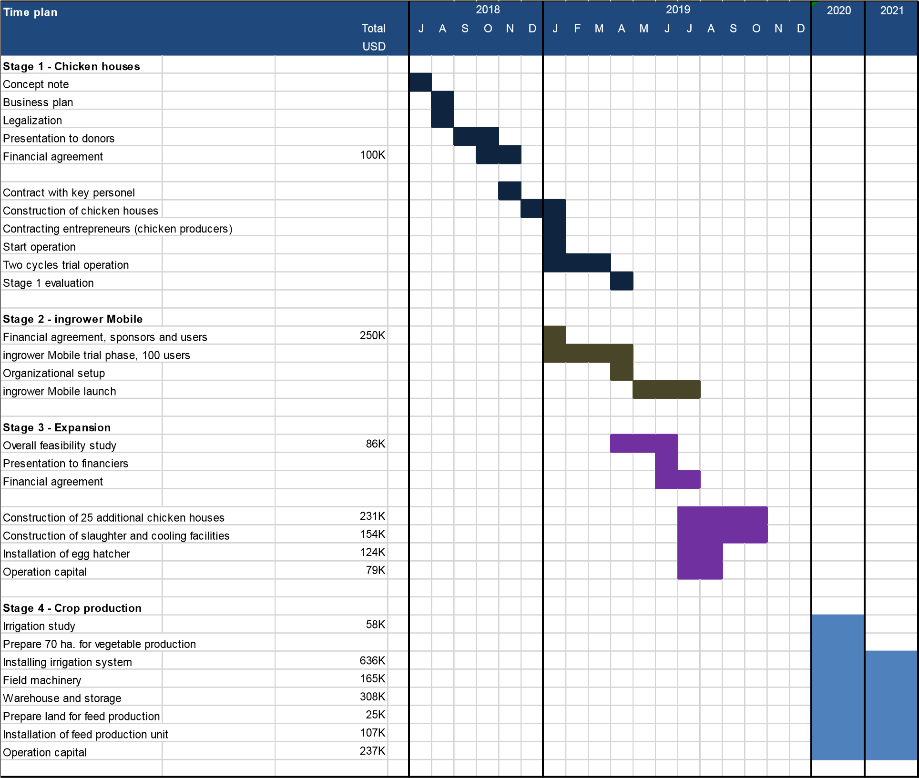

11Appendixes

11.4 Certificate of incorporation “AUDFC”

11.5 Letter of recommendation - AUDFC

( to be provided )

40

11.7Employment impact and businesses created
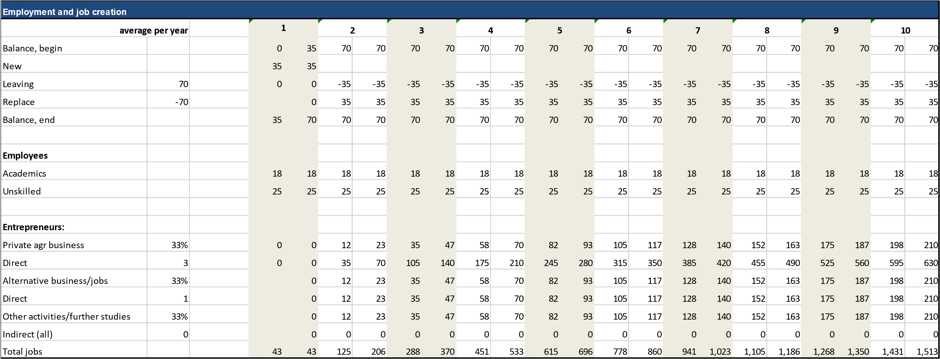
41

Entrepreneurs progress through different stages towards being experienced agricultural producers with capital savings. When ending the education stage they can choose to develop and enlarge their business further inside the Ingrower or establish themselves outside. In the case the entrepreneur decides to leave the ingrower she/he can continue to use some of the services from the ingrower on a reduced profit-sharing scheme. In all cases the entrepreneur will benefit strongly from production knowledge, business experience and capital saved. As an average the entrepreneurs stay in ingrower

11.9CV’s of main team members

11.9.1CV - Fred Kasumba

- FAMILY NAME: Kasumba
- FIRST NAMES: Fred Cosmas
- DATE AND PLACE OF BIRTH: 15 June 1959, Masaka
- NATIONALITY: Ugandan
- CIVIL STATUS: Civilian – Resident

Fred Kasumba is a qualified Certified Public Accountant and holds a Masters Degree in Business Administration. He is a Ugandan with over 28 years professional experience gained working in several countries in the East, Central and West African Region. He has audited in Uganda, Kenya, Tanzania and Ethiopia on EDF funded projects and in Rwanda on a UNHCR project. He has worked as the engagement partner on USAID, UNDP, NORAD and World Bank projects audits in Uganda. Mr. Kasumba has excellent computer skills.

Between 2007 and 2010, he was the Team Leader on a contract for Certification Audits, systems audit and training in EDF procedures, for ALL EDF funded projects in the Federal Republic of Nigeria; Between 2011 and 2015, he was the Team Leader on a contract for Certification Audits and systems audits for ALL EDF funded projects in the Federal Republic of Nigeria; He was the Team Leader to Verification and systems audits under several projects in ECOWAS.
Fred was the team leader of the Certification Audits for ALL EDF funded projects in Uganda during 2004-2006, and was the vanguard in setting up reporting formats for audit assignment. From 1998, he leads teams to provide external audit services for EDF funded projects in Uganda as well as training project staff in EDF procedures in Uganda.

Fred also is a very firm and focused certified accountant with strict fiscal disciplinary stance. His rich and varied experience of financial management systems and procedures of local and international donors such as The World Bank, and USAID would be a great asset to the project. Since 1996, he has been the quality assurance partner of all engagements DF&CO has been involved in. He has successful carried out systems audits for 10 projects in Nigeria and monitoring missions for PRIME.

Fred has had extensive training and exposure to EDF/EC procedures. He has conducted trainings in EDF procedures in Uganda and Nigeria. He has successfully trained project officers in both countries in preparing quarterly reports and replenishment requests. Therefore, his ability to handle the Farm’s financial affairs is not questionable.

11.9.3CV - Diana Balaba Sande
- Current Position: Project Manager-Uganda, danishknowhow
- Age: 40 years
- Marital Status: Married with four children
- Qualification: Msc Project planning and Management & BA-Social sciences (Economics major)

Resume
- An accomplished Banker with keen attention to details.
- Experienced community mobiliser and Development worker
- Skilled Project Manager with a record of delivering timely outcomes that reflect value for money.
- Team Leader with capabilities in organizing teams and motivating them to deliver on set targets.

Relevant experience:
- Business management with ADRA Uganda. Mastered skills and competencies in identification of Business partners, business plans development support, market surveys, liaison between ADRA and development partners, negotiation, and organization of Business meetings among others.
- Customer relations management, cash transactions, client sourcing and on boarding and back office risk management and strategy support with Stanbic Bank for a period of seven years.
- Community mobilization, coordination and sourcing for finances in respect to rural communities to empower them be self-reliant. I was the focal person in executing the said tasks with Hunger project in Mpigi District and the surrounding areas.
- Monitoring and evaluation of output-based projects on several assignments. -Report writing
- Development of funding proposals

