FOUNTAIN FAITH DELIVERANCE CHURCH MINISTRIES, BULUBANDI BRANCH UGANDA- AFRICA
P.O BOX 109, IGANGA - UGANDA
TEL: 0784 917060 / 0703 189740
Email: fountainbulubandi@yahoo.com

BACK GROUND OF THE MINISTRY

Fountain Faith Deliverance Church Ministries Bulubandi Branch. (FFDCMB)
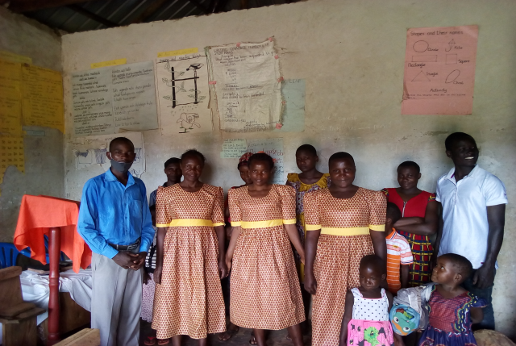
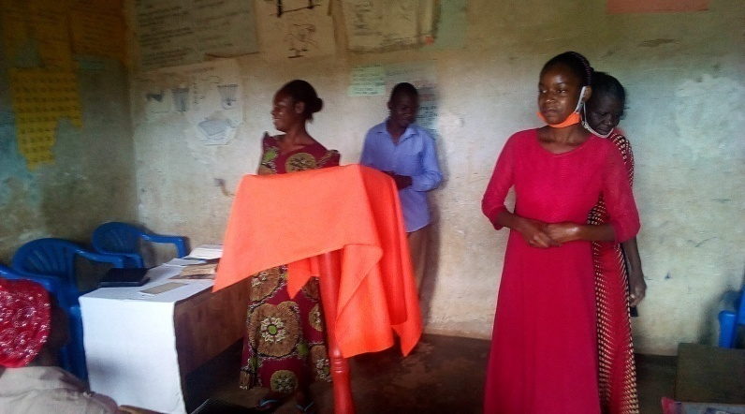

Bulubandi branch is one of the branches of the Fountain Faith Deliverance Church Ministries Uganda is having
It is located in the outskirts of Iganga Town.
This branch of the ministry started two years ago from New St James Nursery and Primary School Bulubandi Iganga –Uganda.
Born Again staff members, pupils and parents developed interest of having lunch hour service and the pupils in the boarding started on Sunday service from School.
This finally attracted the Community to have a church at School “New St. James Nursery and primary Bulubandi, Iganga – Uganda”

This church is having the following Executive Committee of pastors.
- Paster Naigende Robert
- Pastor Kalema Henry
- Pastor Mubezi Florence
- Pastor Nsaba Robert
- Sister Rose Namaganda
NB
Their post address and detailed particulars

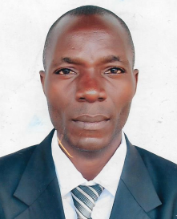

- Pastor Naigende Robert is the Head of this Branch of Ministries, Head of the New St. James Junior academy and over all seer of all projects at the branch.

- Pastor Kalema Henry is the church Administrator, Vice chairperson of piggery, banana, farm, fish pond, and secretary.
SACCO Committee for Fountain Faith Deliverance Church Ministries Bulubandi.

- Pastor Mubezi Florence is the treasurer for the ministry, piggery, fish pond.
SACCO and Head of tailoring and skilling department, choir mistress.

- Pastor Nsaba Robert is the Head of Development depertment and senior intercessor. Chairperson piggery farm.

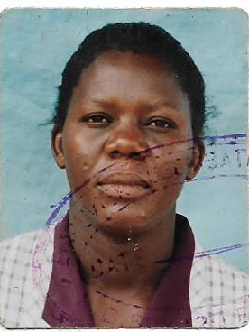

- Sister Rose Namaganda is the Head of church social welfare committee and secretary for the all committees.

- Sister Naigaga Jesca is field manager for ministries, farm.

- Sister Olivia Namulondo is the manager of church SACCO.

Vision
A nation where people live holistic life enrich with the Gospel of our Lord Jesus Christ (Acts 26: 16-18)

Mission
To preach, evangelize life and plant Churches to all Nations outreach by the Gospel (Mathew 28:19-20)

Aims, Objectives of the Church / Ministries
- To fulfill great commission of our Lord Jesus Christ by proclaiming the Word of God to all mankind (Mathew 28:19-20)
- To instruct and nature men, women and children in the Christian Faith and Holy living (Ephesians 4:1).
- To demonstrate God’s love and concern for people by engaging in selective community Development projects based on Biblical principles. Such projects may create employment and meet the temporal needs of the people (Luke 10:27)
- To support and propagate itself (Acts 2:47)
- To create a basis for protectionism for the naturally handicapped (blind, lame, crippled, deaf, orphans, widows and others)
- To establish churches, orphanages, schools, colleges / Universities, hospitals and bible institutions.
- To hold educational and evangelical programs through the media that is Televisions and Radios.
- To glorify God in everything (1 Corinthians 10:31)
- To hold and participate in local and international crusades, open air evangelism, Conferences, workshops, seminars and door-to-door evangelism.
- To solicit for and offers scholarships, bursaries to the disadvantaged children, youngsters and orphans.
- To carry on Hospital, schools and Prison ministries and offer them with spiritual and physical support.

Finance of the Church
This Church is funded by the weekly church offerings, Tithes and contributions collected from the believers well-wishers, Income from the Farms i.e. Piggery, fish ponds, banana plantation e.t.c.

However, sometimes we get assistance from some organizations like Samaritan Pure which help us to evangelize children by giving us gift boxes through their program operation charismas child, and also Evangel Church Nakavule which help us to evangelize in primary and secondary schools by giving us balls and bibles which we distribute to new converts after the evangelism.

Church ministries
- Women ministries
- Youth ministries
- men ministries
- children ministries
- Prison ministries
- Hospital ministries
- HIV/AIDS ministries
- Music ministries
- Pastoral ministries
- Missions (Evangelism/ Church planting/Seminars/ Conferences/ Crusade)
- Projects (schools, church, Institutions, Hospitals, Orphanages and recreational centers).

Intended projects to be implemented (By the church / Ministries or Development partners)
- Church Construction project
- Strengthen a bursary scheme
- Establishment of orphanage center
- Strengthen Nursery and Primary School
- Establishment of Secondary School
- Establishment of a Theological / Circular Institution / University
- Purchase of powerful Church music machines / instruments for missions and Evangelism.
- Purchase of movable pulpit stands for church missions and Evangelism.
- Purchase of Transport means for church mission and Evangelism
- Establishment of a SACCO / Church Bank
- Establishment of a Recreational Center
- Establishment of Radio and TV Station for Evangelism
- Establishment of a Hospital
- Establishment of income generating activities aimed at improving on the welfare of the Christians.

Challenges
- Elevating church structures is still a major challenge to the ministries/ church because of lack of enough resources.
- Lack of enough manpower to outreach the people in the villages with the Gospel, and open churches.
- Lack of financial facilities to outreach the people in the villages with the Gospel, and open churches.
- Financial hardship to pay rent for pastors, church and ministries office.
- Lack of Transport means to transport the ministries / pastors to the prisons, villages, home, school/ institutions and Hospitals for outreach missions.
- Failure to implement all the intended church/ ministries projects due to lack of resources.
- Failure to follow up those new converts and also proving them with religious literatures that is material needs, bibles and other literatures.
- Need to boast the church saving and Credit Cooperation so that Christians may acquire more loans hence improved better standard of living
- Need for more funds to conduct a baseline study in the areas of the role of the church in illiteracy reduction, poverty alleviation, food security, primary health care, moral revival and life skills acquisition.
- Lack of powerful church music instruments to be used in open air evangelism.
- Failure to help the disadvantaged people like the inmates, patients, Orphans and Vulnerable Children, elderly, widows with physical and spiritual needs / support and also to run church activities and others.
- Lack of ICT equipment (computers’ set, Video cameras, projectors and Digital cameras) to get photos and video coverage of all activities executed by the church and also to make timely reports for such actives.
- Failure to establish facilities likes schools/ colleges, health/ hospitals, recreational and orphanage centers to the disadvantaged groups.
- Hardship to offer scholastic materials and fees/ tuition to the increasing number of needy ongoing school children.

PIGGERY PROJECT FOR THE MINISTRIES
Piggery farm was started in 2019 to raise income for the ministries.
This was intended to raise income to buy church land and construction of the church and the offices of the ministries.
If the project moves (multiplies at good rate which can meet the church demand, We responds to them.
We proposed to give at least two piglets to every Christian who is prepared to start rearing to eradicate poverty in the country
The current stock 2020
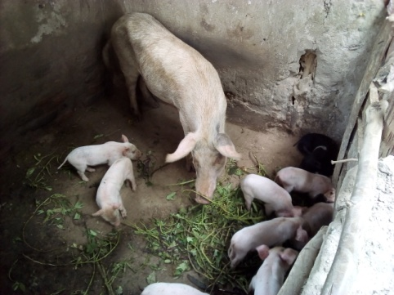
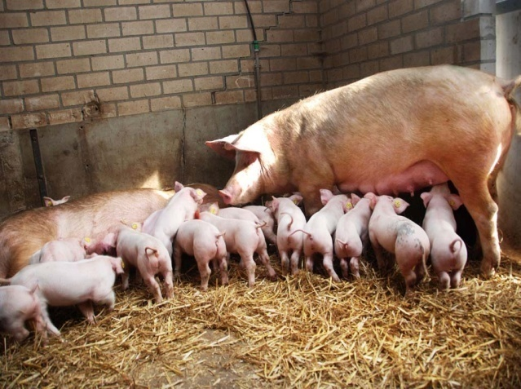

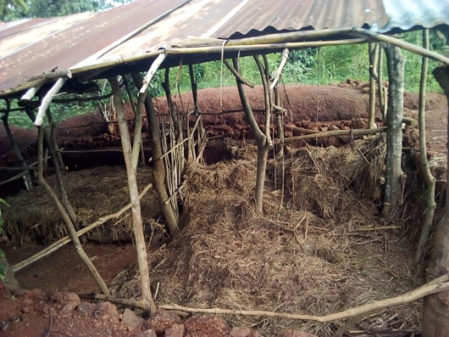
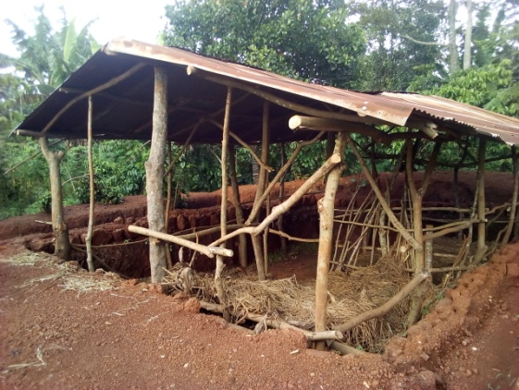
New pens construction for the piggery. It is most likely to be stocked in January 2021

Banana plantation (farm)
Banana growing is one of the projects carried out in the ministries. This increase food production and supplies for sale to meet the day – today expenditure of the ministries. Farmers are encouraged to start the same project to fight famine in our country.
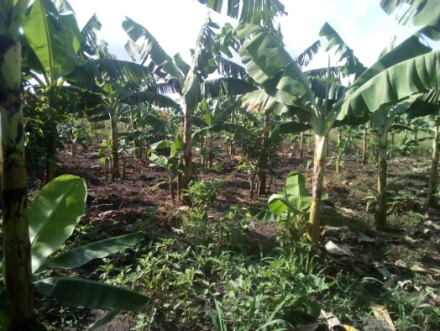

Tailoring / Textile project
Tailoring / Textile is one of the busy project, handled by the ministries.
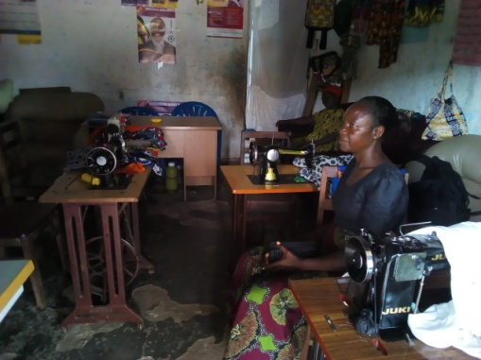
Women in the ministries are given skills in tailoring design and boutique management. This has helped to eradicate unemployment and women empowerment.

Shoe – making and designing, bags, wallet. This department involve mostly Youth both women and men.
This has helped the Youth to establish business related to making of marketable products.
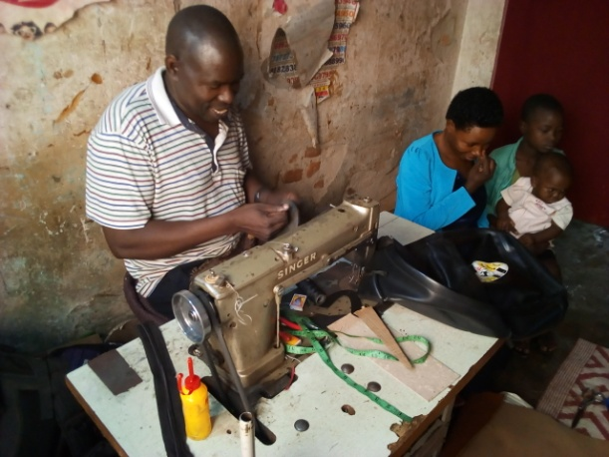
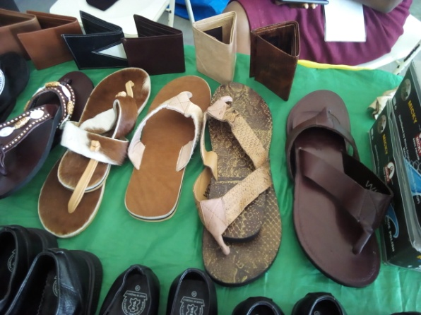

Fishing farming is also carried out on small scale. We have only four fish pond for the ministries but we would like to have a modern fish pounds with better facilities for the projects. This improves the health of our people as well as earning a living.
Some of the ponds shown.
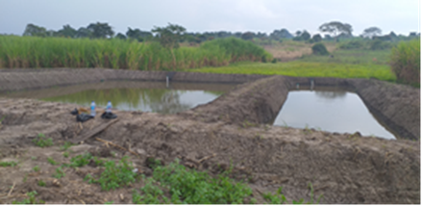

Education scholarship Foundation Scheme was started five years ago. We started with the Orphans and Families with various cycle of poverty.
This scheme has helped children to fulfill them educational vision. We have one at University level, some at Ordinary level and others at primary level.
The demand for this scheme has grown to unmanageable size.
Some of pupils and students enjoying the scheme.
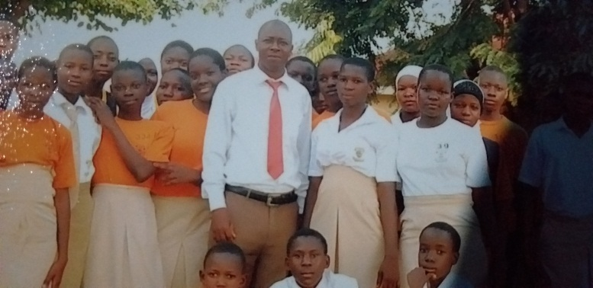

The New St. James Junior Academy.
This is an institution which was started with intention of setting the spiritual standard for both children to attain right spiritual back ground for better future as born Again families in the entire world.
The Administration and the staff is managed by pastors and born again employees for better glooming of our children.
It is Nursery and Primary level but a lot is still needed ranging in software and hard ware for smooth and effective running of this institution.

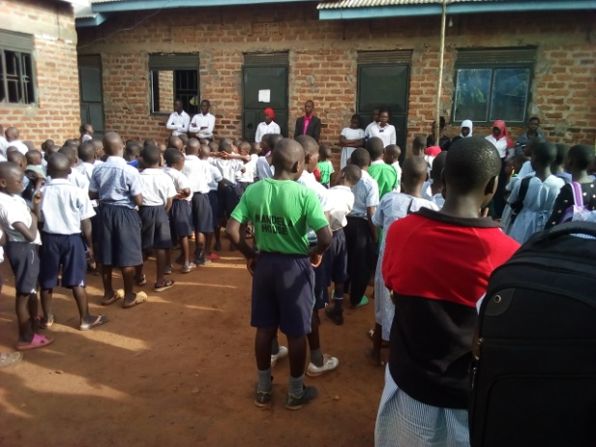
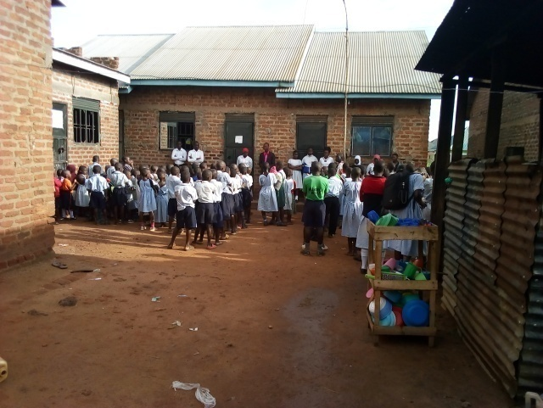

School garden

SACCO was established to educate the Christians the culture of saving and later to invest what was accumulated as saving to re-invest as working capital.
This has helped members to solicit for capital and start small scale business in various fields.
Photos of management committee members forSACCO
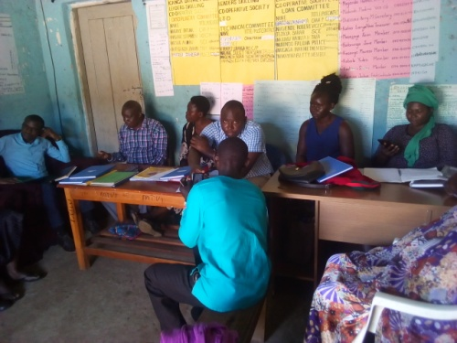
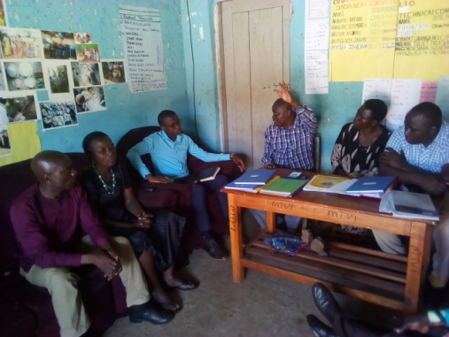

SACCO meeting

Current accomplishment
- School
- We bought the land for the school
- We registered the school with the ministry of education and sports of the Republic of Uganda.
- We registered the school with the registration bureau of the Government
- We opened up the school account with one of the famous financial institution which is licensed and registered by the Bank of Uganda ( Government Bank)

- Piggery project
We have constructed the modern pen with the carrying capacities of 200pigs for the ministries.

- Education Scholarship Foundation Scheme.
We have managed to support some students up to University level but the majorities are at lower level.

- Fish farming
We have managed to construct four fish pounds with carrying capacity of 10,000, fish in a season but still some facilities lacking.

- Tailoring / Textile project.
We have bought some machines but a lot is lacking in this industry and yet it imparts skills among women in the ministry.

- Shoe – making and bags
Only the machines have been secured a lot is still lacking for proper management

The Five Year Plan from 2020 – 2025
- Construction of ten classroom blocks and Administration blocks.
- To buy two water tanks, one for the school use and other for the Piggery farm use.
- To increase atleast fifty members in scholarship scheme.
- To construct more five fish ponds for the ministry.
- To buy atleast five design machines for tailoring and textile industry.
- To buy at least four modernmachines for making shoes, leather bag, wallet etc.
- To buy atleast one acreage of land to properly set vocational institute for skilling for example tailoring and design, shoe making and bags.
- To expand the piggery farm by atleast 10% by constructing more two pens for pigs
- Registration of the SACCO as a financial institution.
- To expand the banana plantation in order to increase food products from 5 to 10 acreage.

Blessings,

Pastor, Naigende Robert.

Fountain faith deliverance church ministry,

Bulubandi, iganga, Uganda, East Africa.

