ASSOCIATION OF FOOD, NUTRITION & DIETETICS (AFND)

(Registered Under the Tamil Nadu Societies Registration Act, 1975)

RADHIKA G M.Sc., R.D., (Ph.D)
(President)

Regd. Office: No: 25, Santhome High Road, Mylapore, Chennai – 600004 TEL NO: (9144) 4212 4284/8414, +91-9600099967
EMAIL: info@afnd.in ; WEBSITE: www.afnd.in

1. BACKGROUND OF AFND
Association of Food, Nutrition & Dietetics (AFND) has been initiated by the team of researchers, registered dietitians, nutritionists, and other health care professionals to empower the interlinking of food, nutrition and public health so as to promote optimal health for all. This association also targets to promote greater transparency and collaboration between individuals associated with the food industry and the study of nutrition that can best promote healthier lives through the right dietary practices.
The association works in the health-related issues with the following strategies:
- Research - Action research to understand knowledge, attitude & practice among public; collect facts and evidences; create and standardize questionnaires, tracking tools and screening programs that can capture actual scenario
- Health promotion - Through health communication and translational research
- Advocacy - Interface with stakeholders and media on the healthcare-related facts and evidences, through debate and dialogue on various forums, so as to create/modify nutritional policies in the state
- Networking – Interlinkage & collaboration with persons from different areas of expertise in food, nutrition and dietetics (consultants, advisors, entrepreneurs, educationists, researchers and healthcare professionals) to promote greater transparency, sharing of thoughts, exchange resources that can further improve the nutritional care.

2. INITIATIVES TAKEN BY AFND SO FAR:
- Centre for Food, Mood & Exercise (CFME)
Modern science through improved sanitation, vaccination, antibiotics, and medical attention has eliminated the threat of death from most infectious diseases. However, the disease profile is changing rapidly and is quite alarming due to faulty dietary practices, sedentary way of life and mental/psychological stress. The association of Food, Nutrition & Dietetics (AFND), jointly with Guires Healthcare PVT. Ltd. has been successfully running its India’s first venture to promote wholesome living - ‘Centre for Food, Mood & Exercise’ (Lifestyle Modification)- by providing scientific, holistic support to help people attain optimal health through informing, educating and communicating public sound, practical advice with regard to healthy diets, exercise prescriptions and psychotherapy.

Figure 1: Center for food, mood and exercise

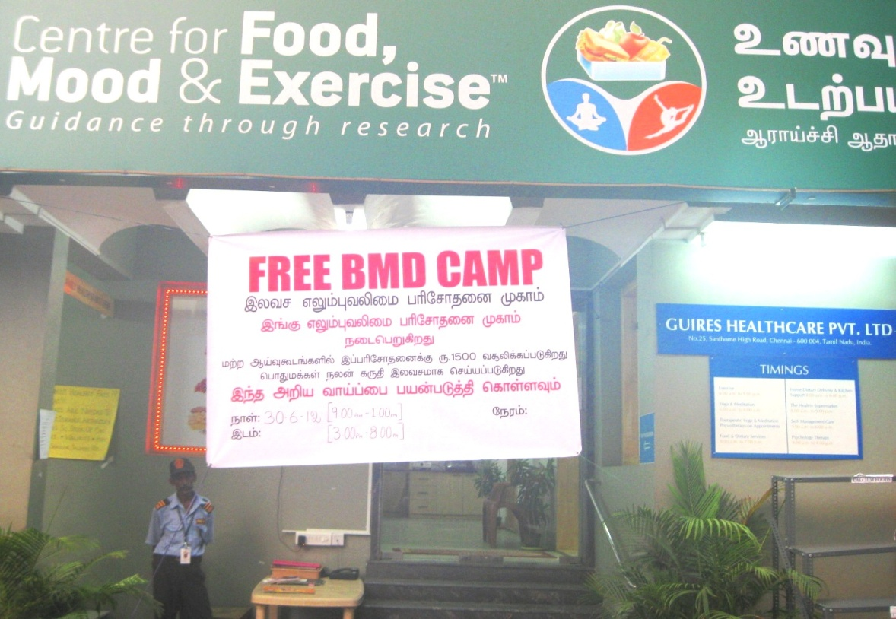

- Indian’s First Healthy Supermarket
There are several challenges associated with educating the public about healthy eating habits and they are:
- The choice of the shoppers being driven purely by advertisements and not necessarily being the healthier options
- Shoppers being duped by the so called “low fat” claim on the packed, which is sugar laden.
- Shoppers trusting in a brand name or product name that sounds like its good for weight loss
- In today’s scenario it is difficult to identify any one product that contains no artificial colors, or preservatives, and no MSGs, trans fatty acids or genetically modified ingredients

Considering all these challenges associated to identifying healthier alternatives among processed foods, AFND team initiated the healthy supermarket which stocks only healthier options and ingredients which are proved scientifically for the health benefit of prevention and treatment of diseases. The uniqueness of the supermarket are-

- All the products are segregated according to its level of processing and color coded for its easy identification (Green, Blue and Orange color racks)
- The products has nutritive tags (food, nutrition, per serving calorie fat & sugar information)
- High Sugar and Salt is indicated by red stars and high fibre and amount of whole grain is indicated by yellow stars
- First Supermarket with In-store nutritionist who would be available to guide purchase and provide free healthy cooking tips.
- Supermarket does not stock trans fatty acids, high glucose or fructose corn syrup products, and less or no artificial products.

Figure 2: Healthy Supermarket – Clinical nutritionist educating the child

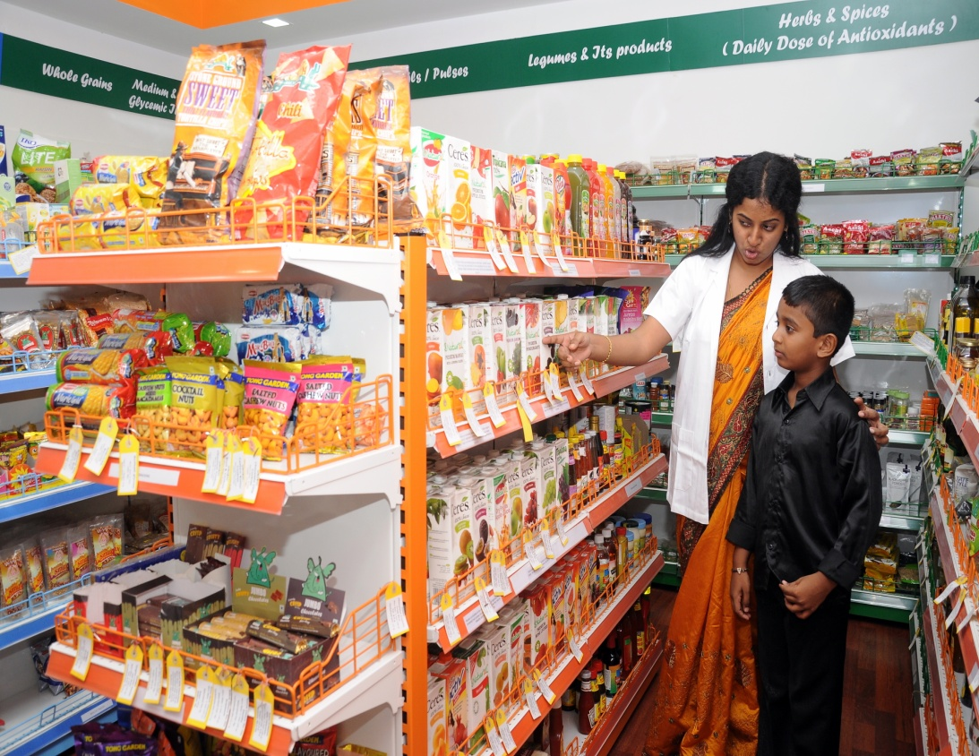

c. Healthy Kitchen
Everyone deserves to be healthy but the healthy choices start from the purchase of nutritious foods and it doesn’t stop with that, cooking wisely in a healthier way is also an equally important. As most of the ingredients are healthier while it’s in supermarket rack, but when it comes to kitchen, it loses its claim. Keeping this in mind, AFND initiated ‘Healthy kitchen’ wherein nutritionist plan healthy recipes conduct regular workshops on healthy cooking.
d. Book publication – “Kids & Teens: What you and your mother should know better about foods”

The book is specifically focused on pediatric nutrition and is based on the fact that as per research studies over the last 40 years, the proportion of children who are overweight or obese has significantly grown over the last two decades. Additionally, India’s face of ‘over-nutrition’ is an irony to many cases of under nourished children who are unable to achieve adequate height-for-age and weight-for-age.
(Book registration: ISBN 978-93-5067-924-1)

e. Awareness Program on ‘Healthy lifestyle & linkage of food, mood and exercise’ with:
- Faculty members of Vinayaka Mission University, Kanchipuram
- Army personnel in the military area, Chennai
- Representatives of the Lister laboratory

Figure 3: Talk show with Representatives of the Lister laboratory
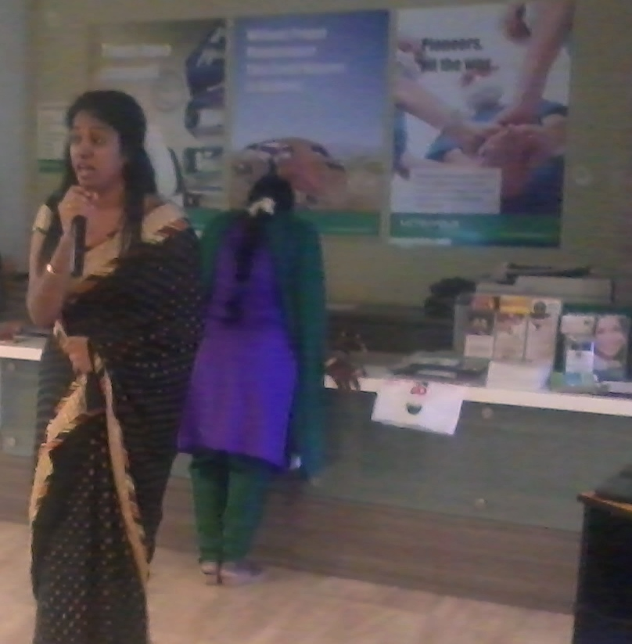
f. Screening & Awareness Program

- Calcium drive for healthy life
A program on ‘All about Calcium’ – role of calcium and its necessity in our fast paced lifestyle

Figure 4: Patient undergoing bone densitometry test

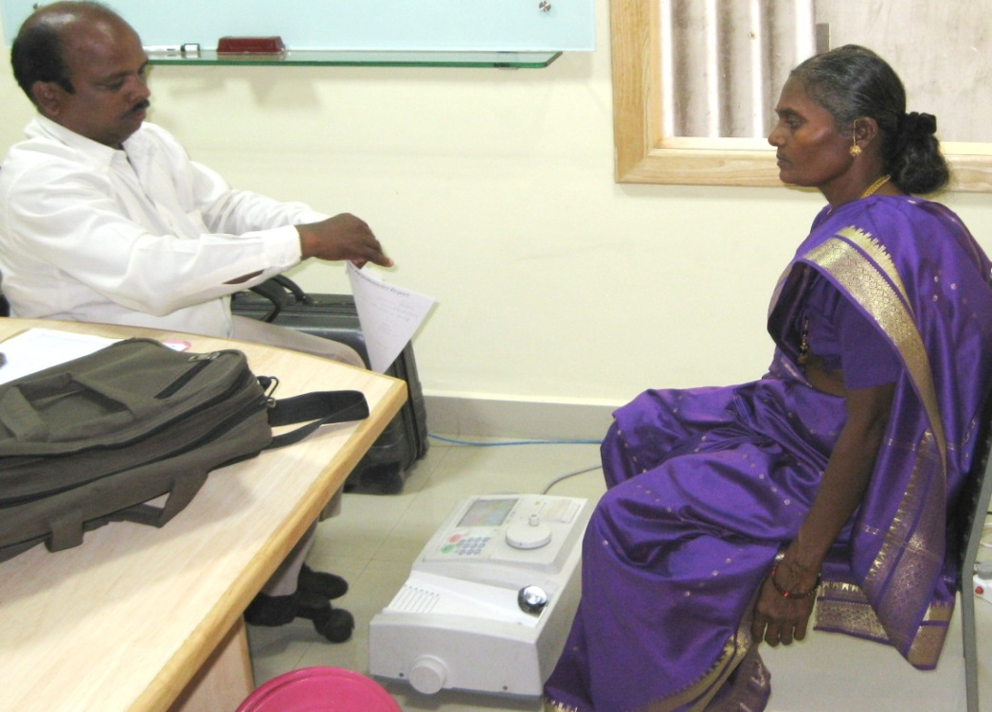

g. Developed low cost education materials with relevance to healthy eating, healthy cooking

h. ONGOING RESEARCH PROJECTS (RP)
RP 1: Food label usage and nutrition information awareness among South Indian urban consumers
Funded by: GuiRes Healthcare Private Limited
Duration: 3 Years; Budget: 5, 00,000 INR
RP 2: Electric light bulbs – product knowledge and environmental engagement among south Indian rural consumers
Funded by: Annammalai University
Duration: 3 Years; Budget: 5, 00,000 INR
RP 3: To assess the profile of Wellness Foods available in Chennai Supermarkets and their influence on chronic diseases – Cross Sectional Study
Funded by: GuiRes Healthcare Private Limited
Duration: 6 Month Budget: 1, 00,000 INR
RP 4: Awareness and Education on White rice versus brown rice among South Indian High Income group women
Funded by: GuiRes Healthcare Private Limited
Duration: 6 Month Budget: 1, 00,000 INR

i. FUTURE RESEARCH PROJECTS
RP 1: Development of whole grain based health food products for chronic diseases prevention and management.
RP 2: Awareness and Education on different cooking oils and its effect on chronic diseases prevention and management
RP 3: Health communication on Lifestyle disorders and its impact among employees working in Multinational Companies.
RP 4: Psychotherapy Intervention that improve physical and mental health in patients with cancer
RP 5: Impact of ‘Only Exercise’ (Only walking, Home based exercise, Aerobic or resistance type), ‘Exercise with Dietary Therapy’ and ‘Exercise, with Diet and Mood therapy’ among diabetic patients with only OHA.

3. FUTURE PLANS

  - Better network for greater collaboration: By interlinking persons from different areas of expertise in food, nutrition and dietetics, we initiate dialogue and exchange resources that can further improve the standards of nutritional care that is being offered.
  - Standardized resources for better accuracy: With the face of food and nutrition constantly changing, there is a need to create and standardize questionnaires, tracking tools and screening programmes that can capture actual situations.
  - Research opportunities for growth: By encouraging professionals to carry out research, there are great opportunities of growth and learning.
  - Translating research findings: The information generated through countless hours of research fails to have a purpose if it stays confined in laboratories. We target to generate research evidence based recommendations that can transform your lives.
  - Policy making – changing the face of health for a nation: With food, nutrition and dietetics playing a crucial role in health, our expertise can help in formulating nutritional policies.
  - Better educational material: We encourage our researchers and subject experts to review and publish research papers and books that add to your nutritional knowledge

TEAM MEMBERS:
- Ms. Radhika Ganesan M.Sc., R.D., (Ph.D)
President, Association of Food, Nutrition & Dietetics
Chief Clinical Research Nutritionist, Centre for Food, Mood & Exercise
Chennai, Tamil Nadu
Email: info@afnd.in

- Mr. Ganesan
Secretary, Association of Food, Nutrition & Dietetics
Chief Executive Officer (CEO), GuiRes Healthcare Private Limited,
Chennai, Tamil Nadu
Email: ganesh@guires.com

- Dr. Manjula Dutta M.D., DCH, MSc (Epid) (Canada), FRCP (EDIN)
Executive Member, Association of Food, Nutrition & Dietetics
Senior Consultant Epidemiologist
Chennai, Tamil Nadu

- Dr. Ashok M.D. (Community Medicine)
Executive Member, Association of Food, Nutrition & Dietetics
Chennai, Tamil Nadu

- Ms. Akriti Mendiratta B.P.T., PGDHM, MBA
Executive Member, Association of Food, Nutrition & Dietetics
Chennai, Tamil Nadu

- Ms. Kalai Chitra M.Sc., R.D.,
Executive Member, Association of Food, Nutrition & Dietetics

- Ms. Vasumathy B.P.T
Executive Member, Association of Food, Nutrition & Dietetics

- Mr. Srikumar B.P.T
Executive Member, Association of Food, Nutrition & Dietetics

- Mr. Prasanna B.P.T, M.Sc., M.Phil Yoga Science
Executive Member, Association of Food, Nutrition & Dietetics

- Ms.Shylaja B.A., Sociology
Member & Social Worker, Association of Food, Nutrition & Dietetics

- Ms.Kalai Arun B.A., Sociology
Treasurer & Social Worker, Association of Food, Nutrition & Dietetics

