Flag off function of trial run of Solar Energy Used Fishing Boat
Date : 30th November 2012

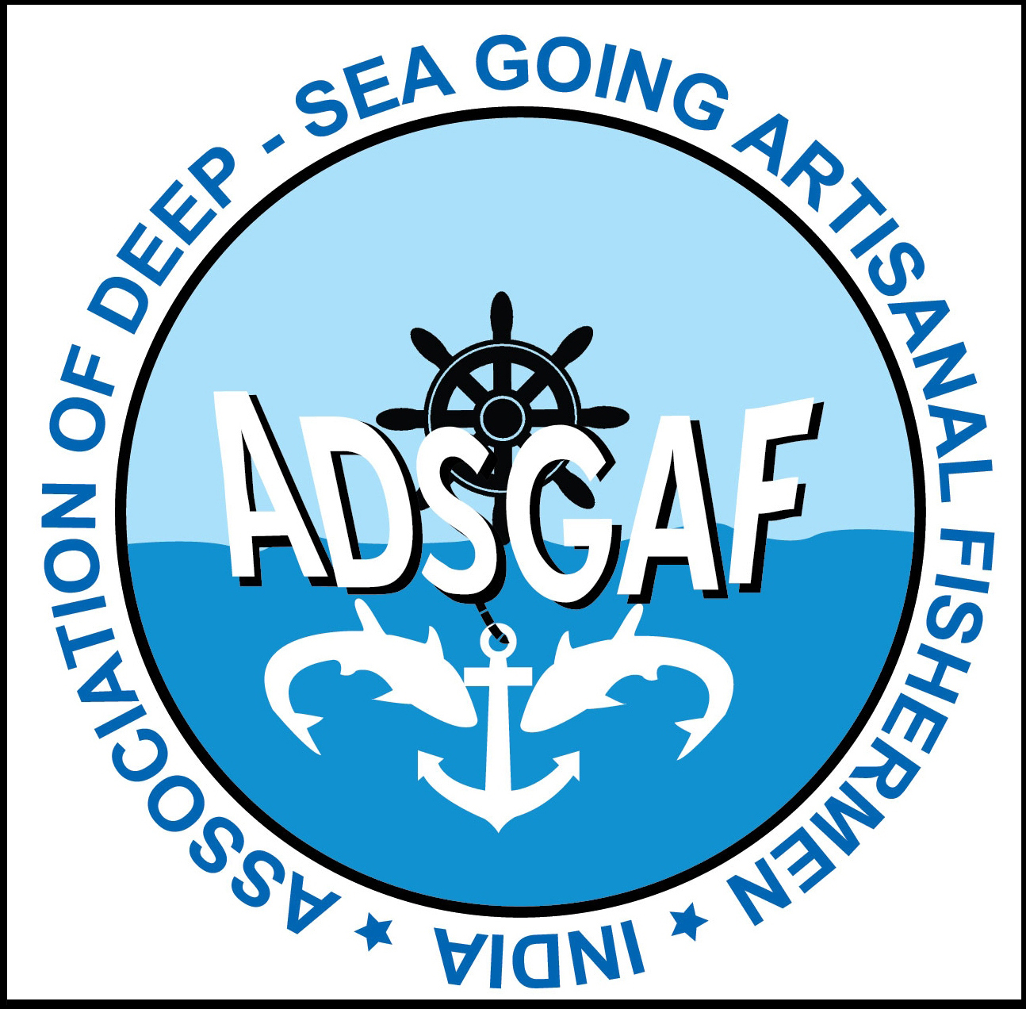
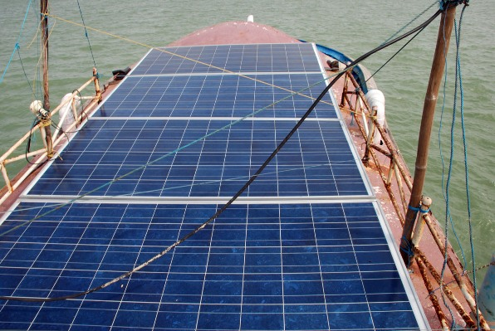
Time:10.00 am, Venue: Chinnamuttom, Kanyakumari

The trial run of Solar Energy Used Boat was jointly organized by ADSGAF and BOBP-IGO at Chinnamuttom fishing harbor, Kanyakumari on 30th November 2012. Mr. V.M. Suthan, Secretary, Kanyakumari Chinnamuttom Visai Padaku Meenvar Mattrum Urimaiyalarkal Sangam welcomed the gathering. Mr. Vincent Jain, Chief Executive, ADSGAF provided the details of the trial run. He said that the fishermen are running the engine continuously for charging the battery and some fishermen keep running the engine to prevent any restarting trouble. Thoothoor fishermen are spending 70% of the total working capital requirement per voyage for buying fuel. If they are able to use solar energy technology, products and its services properly, they could save significant amount of fuel and money and avoid unnecessary emission of CO2. Mr. S. Nagarajan IAS, Hon. Collector of Kanyakumari District inaugurated the trial run function in the presence of Dr. Y.S. Yadava, Director, BOBP-IGO and Mr. Mr. D. Durairaj, President, Sea Food Exporters Association of India, Tamilnadu Region. The collector mentioned in his inaugural address that using solar energy in fishing boat was an innovative idea which is being initiated by ADSGAF and BOBP-IGO. He congratulated them and wish them success. Dr.Y.S. Yadava said, “first of all I want to congratulate the ADSGAF for organizing this event specially inviting the district administration, officers from department of fisheries, representatives from various fishermen organizations, representatives from the industry. We are planning to undertake the same trial on few more boats based on their duration of the voyage which operate simultaneously from various coastal sates to know sea worthiness, power utilization, the cost effectiveness etc. I hope this will be benefitted by all the fishermen”. Fr. Thomas Kocherry, WFFP and NFF said that solar energy is the cleanest, abundant, renewable energy source available today. It is one of the best alternative energy for nuclear energy and will not affect human community. Mr. D.Durairaj said considerable research and development is needed to use solar energy in fisheries. He hoped this would be the first step taken by ADSGAF and BOBP-IGO, and wished it to be successful. Mr. Sankar, AGM, NABARD, Nagercoil said that it was appreciable that a fishermen organization came with a green idea which was being jointly implemented with BOBP-IGO. Dr. Renju Ravi, Senior Research Fellow, CIFT said this was a logical beginning made by ADSGAF and BOBP-IGO. He said he is proud to be part of the programme. Mr. Vijai, CE, NDFSF, Mr. Mariadas CE, KDFSF, Mr. Maria John, Chairman, KDFSF, Mr. Rajendramani, Asst.Director, MPEDA, Tuticorin Region, Mr. Subramaniam, Asst.Director, Dept of fisheries, Kanyakumari, Mr. Rubert Jothi, Asst.Director, Dept of fisheries, Colachel, Mrs Uma Maheswari, Project Officer, IFAD are attended. Mr. Encilome, secretary, ADSGAF proposed the vote of thanks.

