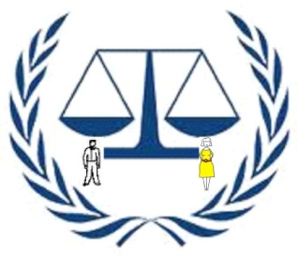
Building Equality
P. O. BOX 377 Bagamoyo,
Pwani (Coast Region) Tanzania
E-mail: buildingequality@yahoo.com
Website: http:///www.envaya.org/beba/home
Phone: +255 717 077 467, +255 712 134 282

1: Political, social and economic environments of an area
Bagamoyo district allocated at Coastal Region, United Republic of Tanzania. Bagamoyo District lies between longitude 38⁰ – 39⁰ South and latitude 6 – 7 East. The District shares borders with Indian Ocean in the East, Kinondoni Municipal Council in the Southern part and Kibaha District in Coast Region, Morogoro in the west, Pangani and Handeni in the North. Major Ethnic groups in the district are Wakwere, Zaramo, Zigua, Masai and Doe. According to district profile, 2012 the district had total population of 228,967 of which 113,991 are males and 114,976 are female. The most economic activities taking place in the district is only fishing. According to district profile, about 98% of the whole population depends on traditional fishing of which men main actors are leaving 2% of women acting as a market for. There is other cash crops like coconut but many of trees are old one hence need new initiatives to renew. 96% of Bagamoyo citizens live under absolutely poverty/under one dollar per day and many of them live at remote/village areas were social services are at minimal/poor stage.

2: Background of the problem
In Bagamoyo and Tanzania at general, power is inaccessible, unaffordable, and unreliable for most people. This traps people in poverty – students find it difficult to read after dark, clinics cannot refrigerate vaccines and businesses have shorter operating hours1
Bagamoyo and Tanzania at general, face an energy crisis due to high cost of providing electricity to dispersed rural populations, limited affordability, a lack of financial resources necessary to meet capital investment and operating costs, and limited of rural electrification funds by national utilities, NGO’s and agencies. There is a growing consensus that monopolistic hold of power utilities over their national electricity industries has contributed to the under-delivery of electricity. Energy reforms have proven ineffective for the rural poor: no rural electrification boards or organs and no independent power Producers (IPP’s) hence problematic. And therefore has the limited potential to provide all of our current and future district energy requirements. Since the solar source for renewable energy is clean and free, the district can protect the people, environment, and future economic development by using renewable energy sources to this end and have a number of possible options. Thus, as Bagamoyo receive on average 325 days per year of bright sunlight. This gives solar power the potential to bring energy to virtually any location in the district without the need for expensive large scale grid level infrastructural developments that’s far away from the district. And this can be capitalized as the only solution for health care among women and children suffering in the area through installments of solar accessories energy for effective health care at the district.

3: Statement Of The Problem
Each week, an average of 170 children would line up to be immunized by government issue vaccines delivered from Bagamoyo district hospital, 8 hours drive away with the land cruisers. When vaccine deliveries were delayed, newborn children remained unvaccinated against the diseases that run rampant in their region. Villagers would walk miles between local clinics trying to vaccinate their children, and some would never receive the immunizations they seek. At nights treats almost close to 60 patients per day per health centre. Doctors/nurses lives on-site at the centre for medical emergencies, but he is not often woken in the middle of the night without electricity or money for kerosene lamps after sunset. The remote clinic is nearly invisible to the 4,000 people living in three surrounding villages. Patients that would seek emergency medical care at night used to stay home, risking their lives to wait until morning. Without electricity, Miono, Chalinze, Msata and Kwaruhombo health centers cannot offer effective medical care. They use kerosene lamps to light nighttime surgeries, and have no power for refrigeration of lifesaving medicines and vaccines. Because they lack energy, generations of children are not immunized against preventable disease.

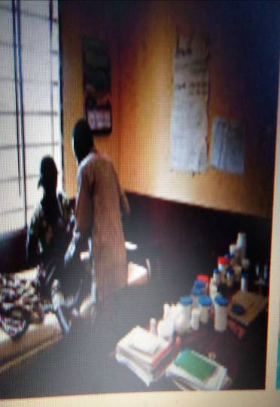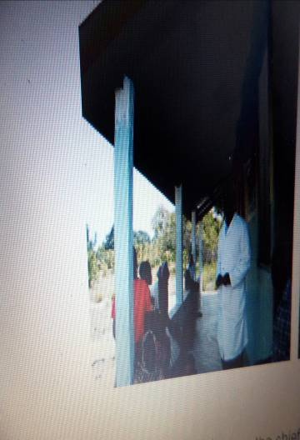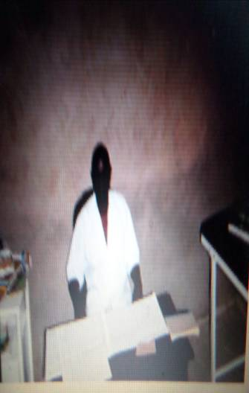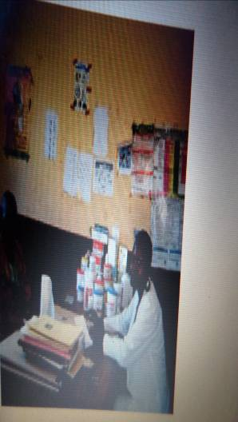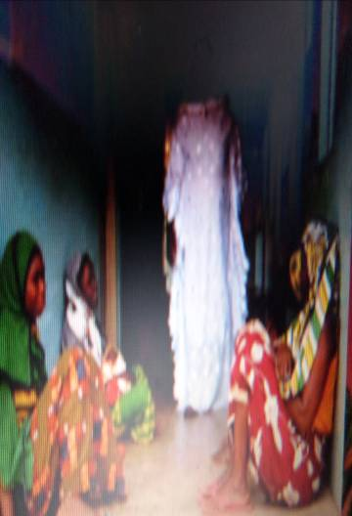
Dark evening services at health centers of Miono, Chalinze, Msata and Kwaruhombo Bagamoyo district

4: Rationale
Building Equality proposing to establish project solar installation in four health centers of Miono, Chalinze, Msata and Kwaruhombo Bagamoyo district. The four centers serve the population of 46,980. The project aiming to reduce motility rate through availability of timely vaccines and medicines (by having refrigerators that store thousands of medicines and vaccines) and access to safe and sanitary birth through power installation. To do so, With Global Hand partnerships of 22,500US$, it will have the power to help. Building Equality will buy solar inputs and install to those health centers. Using solar energy, we will install refrigerators that store thousands of medicines and vaccines. And replace unsafe and unsanitary kerosene lamps with energy saver bulbs in each room, providing healthcare workers and patients with the well-lit medical care they deserve. With light in their health centers it will make health centers accessible at all times of day to local people.

5: Aim of the project is to improve health services and medical care that reduces motility rate, risks birth and availability of day and night medical care and services in four health centers of Miono, Chalinze, Msata and Kwaruhombo Bagamoyo district through power installation by 2014.

6: Objectives are:-
- Decrease of motility rate by surely and timely immunized children against preventable disease through power for refrigeration that store lifesaving medicines and vaccines in at health centers of Miono, Chalinze, Msata and Kwaruhombo from current ratio 298 /1,000 to 50/1,000 by end of 2014
- Decrease of risks birth among women and introducing safe and sanitary light and services to both service provider and patients at health centers of Miono, Chalinze, Msata and Kwaruhombo from current ratio 674/100,000 to 300/100,000 by end of 2014
- Effective health services though availability of day and night medical care and services with up to date medicines at health centers of Miono, Chalinze, Msata and Kwaruhombo from current 42% to 90% by end of 2014

7: Project Activities
- Buying solar panels, solar refrigerators and associated inputs
- Transportation of solar panels, solar refrigerators and associated inputs to field area
- Installation, Wiring and bulb
- Conduct process, operational and qualitative research.
- Conduct research on the impact of the project and reporting.

8: Methods For Achieving The Goals, Objectives, Activities and project sustainability.

The primary methods for achieving the goals, objectives and activities of the Project will be:
- Installation of solar ready for use.
- Work closely with somebody with solar expert in case of any repair.
- Form health centre electricity committee which will collect money from phone charging and ensure good use and security of those solar equipments. The money will be served on health centres accounts.
- Form village electricity committee around those health centre which will ensure security of those solar equipments and centre for in kind contribution if needed.
- Committee will be formed to take responsible for sanctioning the operation of the centre in corporation with local councils; Faith based organization, District Community development office and District health office to integrate solar maintenance considerations into their development planning after project duration
9: Formative Evaluation - Primarily qualitative in nature, the formative evaluation will be conducted through interviews and open-ended questionnaires. Doctors, nurses, surrounding community and parents will be asked about the day-to-day operation of the general program, and other questions to provide feedback and ongoing improvement of the operation of the Project. The Project Evaluator will meet with project staff to share findings from the formative evaluation effort.
10: Monitoring of this project will relay on data collection about performance, time, and cost arranged in work plan, budget and method above. Data will be collected through, frequency counts, subjective numeric ratings, indicators, verbal measure to NGO members and recipients and data about number of dates, dollars, hours and physical amount of resources used on specifications. Meeting will be the best reporting system of the organization. Weekly meeting will be conducted to share and compare processed information whether correspond with work plan, method and general activities. SWOT analysis methodology will be encouraged short term and long-term to replicate the project sustainably.
11: Outputs:
- Stored of thousands of medicines and vaccines at four health centers of Miono, Chalinze, Msata and Kwaruhombo from current 10% to 95% by end of 2014
- Safe and sanitary day and night working environment at four health centers of Miono, Chalinze, Msata and Kwaruhombo from current 42% to by 95% end of 2014
- Night observable health centers infrastructure at four health centers of Miono, Chalinze, Msata and Kwaruhombo from current 9% to by 95% end of 2014

12: Project Design Matrix

Outcome | Outcome indicators | baseline data | target(the level of expected change after project implementation)
- Improve health services and medical care that reduces motility rate, risks birth and availability of day and night medical care and services in two health centers of Miono, Chalinze, Msata and Kwaruhombo Bagamoyo district through power installation by 2014. | Health services and medical care favours community welfare like birth women, children and entire population | Health services and medical care does not favours community welfare like birth women, children and entire population | Increased number of health centers with conductive Health services and medical care that favours welfare of entire population
2. Decrease of motility rate by surely and timely immunized children against preventable disease through power for refrigeration that store lifesaving medicines and vaccines in health centers of Miono, Chalinze, Msata and Kwaruhombo from current ratio 298 /1,000 to 50/1,000 by end of 2014. | Power for refrigeration that stores lifesaving medicines and vaccines in health centers are installed for sure and timely availability vaccines and medicines | Structures and strategies do not consider refrigeration that stores lifesaving medicines and vaccines in health centers to address unsure and non-timely availability vaccines & medicines | Lives of children are protected, death of children reduced and there is sure and timely availability vaccines and medicines
3: Decrease of risks birth among women and introducing safe and sanitary light and services to both service provider and patients at health centers of Miono, Chalinze, Msata and Kwaruhombo from current ratio 674/100,000 to 300/100,000 by end of 2014 | Power for safe and sanitary light and services to both service provider and patients at health centers are installed for. | Structures and strategies do not consider Power for safe and sanitary light and services to both service provider and patients hence increase risks birth among women and unsafe and unsanitary light and services | Lives of birth women are protected, death of women reduced and there is safe and sanitary light and services to both service provider and patients.
4: Effective health services though availability of day and night medical care and services with up to date medicines and night visible health centers of Miono, Chalinze, Msata and Kwaruhombo from current 42% to 90% by end of 2014 | Power for day and night medical care and services with up to date medicines and light for night visible health centers are installed. | Health centers have no power for day and night medical care and services with up to date medicines and night light for visible health centers | Entire population and services providers have effective health services that they deserve sustainably for day and night medical care and services with up to date medicines and night visible health centers

Outputs | Activities for each output
- Stored of thousands of medicines and vaccines at two health centers of Miono, Chalinze, Msata and Kwaruhombo from current 10% to 95% by end of 2014 | - Buying solar panels, solar refrigerators and associated inputs  - Transportation of solar panels, solar refrigerators and associated inputs to field area  - Installation, Wiring and bulb  - Conduct process, operational and qualitative research.  - Conduct research on the impact of the project and reporting.
- Safe and sanitary day and night working environment at two health centers Miono, Chalinze, Msata and Kwaruhombo from current 42% to by 95% end of 2014
- Night observable health centers infrastructure at four health centers of Miono, Chalinze, Msata and Kwaruhombo from current 9% to by 95% end of 2014

11: Work Flame
OUTPUTS | ACTIVITIES | Implementation highlights | Means of verifications | TIME FRAME |  | Budget for  each  activity | Responsible person
 |  |  |  | START | END | Budget for  each  activity | Responsible person
Health centers have surely source of energy for medicine and vaccine store, and safe and sanitary day and night working environment | Buying solar panels, solar refrigerators and associated inputs | Batteries, solar panels and other inputs will be bought ready for installation for energy provision on health centers of Miono, Chalinze, Msata and Kwaruhombo Bagamoyo district | Solar panels and associated inputs are bought and available to our office. Also receipts are available to the office. | Jan 1, 2014 | Jan 15, 2014 | US$ 20,000 | Organization secretary, chairperson, and treasurer, health officers
Availability of equipments to the field area ready for installation for service provision | Transportation of solar panels, solar refrigerators and associated inputs to field area | The organization will hire transport from Dar es Salaam to the field area where installation will take place | Solar panels and associated inputs are bought and available to our office. Also receipts are available to the office. | Jan 16, 2014 | Jan 20, 2014 | US$ 1,500 | Organization , chairperson secretary, health officers and treasurer
Health centers have source of energy for medicine and vaccine store, and safe and sanitary day and night working environment | Installation, wiring & bulb | Solar panel are installed to provide electricity in two health centers | Names of installed four health centers available. Also, through visit the field area | Jan 21 ,2014 | Feb 28, 2014 | US$ 1,000 | Organization secretary, project officer, Solar expert & health officers
Strategies are put in place in coordination of this NGO, staffs of health centers and surrounding community on how to make longer lasting the equipments | Conduct process, operational and qualitative research | There is management structure, good process of operation to maintain the equipments for longer lasting | Minutes on those meeting, agreed operation and processes are available the office and health centers | Mac 1, 2014 | Marc 15, , 2014 | 0000 | Secretary/internal evaluator, health officers and treasurer
Project impact are measured and ways forward are made. | Conduct research on the impact of the project and reporting. | Assess whether intended objectives, per cost and time achieved and provide way forward | Research report available to the office and donor | Mac 16, 2014 | Marc 30, , 2014 | 0000 | All NGO staffs, health officers and none executive committee

United Nations Economic Commission for Africa and United Nations Environment Programme: Making Africa’s Power Sector Sustainable: 2007 (PSR)
UN-HDR
Bagamoyo hospital report
WHO
Tanzania in figures 2010
Census 2010

