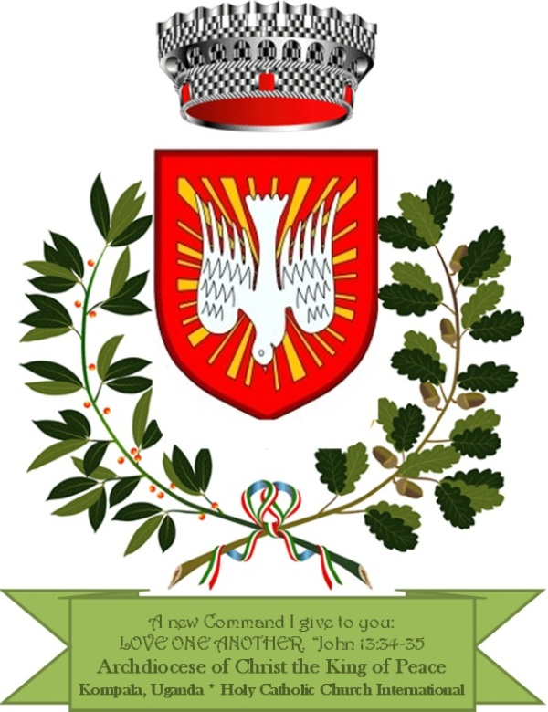
THE INDEPENDENT CHARISMATIC CATHOLIC CHURCH INTERNATIONAL-ICCCI
REG NO: 9103 S 5914/9556
P.O.BOX 70916, KAMPALA-UGANDA
HISTORY OF INDEPENDENT CHARISMATIC CATHOLIC CHURCH INTERNATIONAL-ICCCI
Independent Charismatic Catholic Church International-ICCCI was founded on 15th January, 2003 in Kasese District, Uganda as a Community Faith Based Organisation. It was legally registered with the Government of Uganda-National Board of NGOs as on 16th March, 2012. Under Registration Number: 9103 – S. 5914/9556. We operate in all regions of Uganda.
ICCCI was founded by a team of five committed community loving members to preach a Gospel based on holistic human and community development. Its major aim is to improve and enhance better living standards of the most vulnerable in Uganda. Women, children and orphans have no access to quality education, clean water, descent living, economic schemes and health due to poverty. The majority of the single mothers, young females and children lack clothing, bedding’s and food and poor health and nutrition in Uganda communities. The highest number of vulnerable children and orphans who dropout of school is idle without any productive activity. For decades rural communities are left behind in development and yet they play greater role in shaping the attitudes and development of a society.
We are focused on helping the vulnerable women, children and orphans transform themselves and develop them morally, intellectually, spiritually and economically.
MISSION: To empower and transform and the lives of the vulnerable and less privileged who live in misery, HIV/AIDS, hopelessness in Uganda through education, advocacy, lobbying and health and preaching. We train on A,B HIV preventive approach.
VISION: Holistic empowerment of the vulnerable persons in society.
GOAL: Reducing misery, suffering and contribute to alleviating abject poverty in Uganda.
ICCCI ACCOMPLISHMENT
Founded and runs St. Ambrose Orphanage Centre in Kasese District, since 2003.
ICCCI has opened four branches to deliver its services in Uganda.
Our organization has been at the forefront every Sunday in our churches on the fight against poverty, illiteracy and HIV/AIDS, emphasis on A, B preventive approach.
We have developed and adopted a Child Protection Policy.
We have initiated Women savings and Loans in all our churches allover the country.
We hold monthly workshops on: HIV/AIDS, nutrition, savings, peace and family life
Support to 150 OVC in Kasese, Bukwo and Kampala districts.

