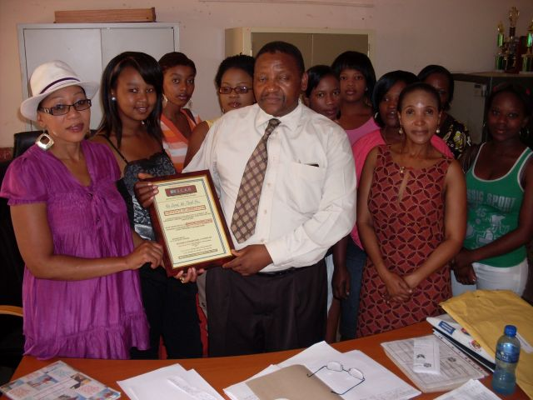
The OSCAR Project Team presenting thank you certificate to one of the partner in Edendale Township
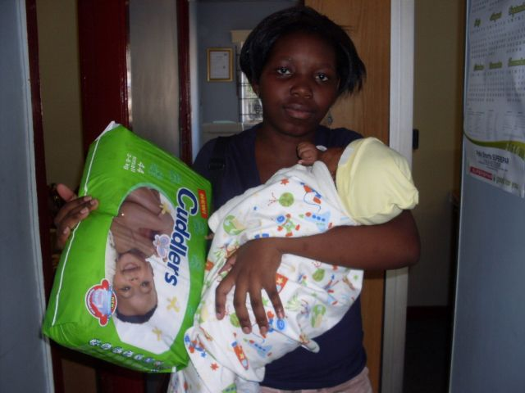
Social and general support to the mother with Diapers/ Nappies- OSCAR Project

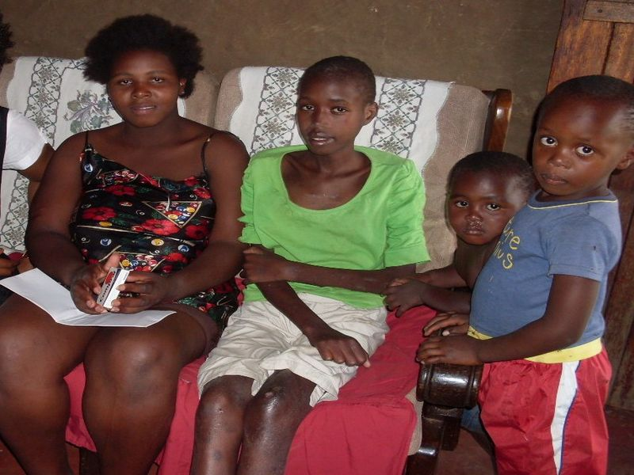
Social and general support from OSCAR Project to the child headed households affected and infected by HIV & AIDS
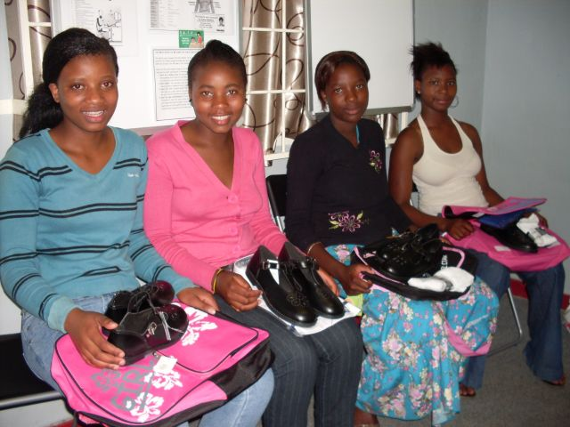
Young girls’ orphans and vulnerable children accessing education with help from OSCAR Project

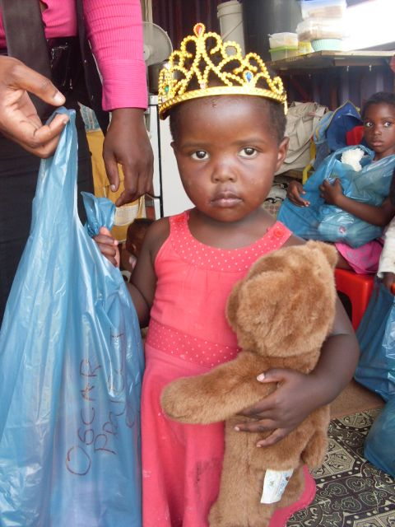
An orphan girl receiving a Christmas present from OSCAR Project- 2012

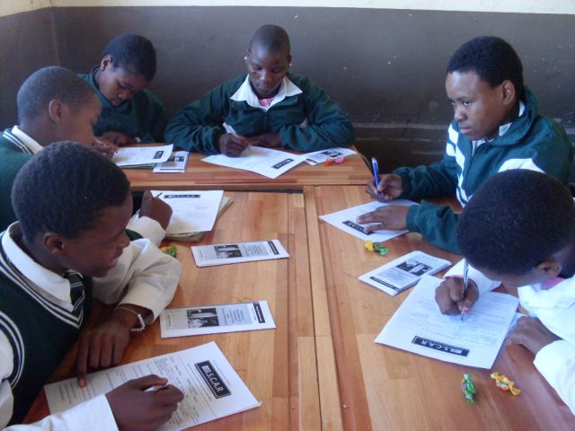

OSCAR Project life skills Activities in Secondary Rural School- 2012

