Global Hands On Universe
Galileo Teacher Training Program
(GHOU – GTTP)
2015
KATHMANDU

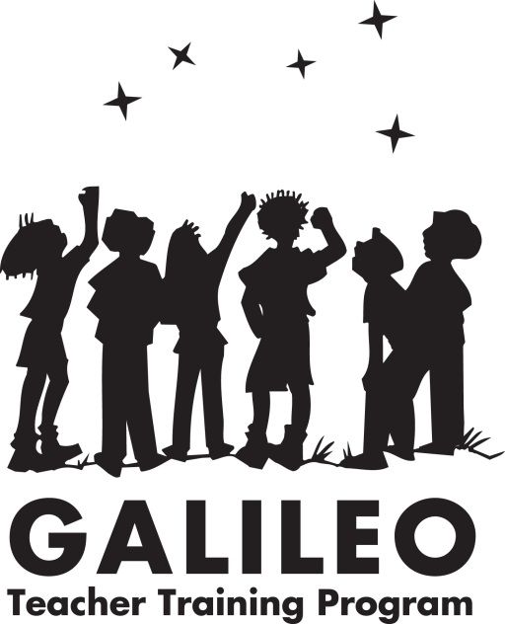

A program of: Organized by: Hosted by:

National Academy of Geo & Space Science
Correspondence Centre
222/20 Manbhawan, Lalitpur Sub-Metropolis - 20, Lalitpur
Nepal
PREFACE

The workshop that is the subject of this report was approved by the governing board of National Academy of Geo & Space Science. The members of the committee responsible for the report were chosen for their special competences and with regard for appropriate balance.

Any opinions, findings, conclusions, or recommendations expressed in this publication are those of the author(s) and do not necessarily reflect the views of the organizations or agencies that provided support for the project. National Academy of Geo & Space Science is responsible for the overall quality and accuracy of the report as a record of what transpired at the workshop. Additional copies of this report are available from the National Academy of Geo & Space Science, Correspondence Centre, Block No. 222/20, Jawalakhel-Lagankhel Road, Lalitpur Sub-Metropolitan City, Lalitpur, Nepal.

Internet, http://www.nagss.org

No part of this publication may be reproduced or transmitted in any form or by any means.

Copyright 2015 by the National Academy of Geo & Space Science
All rights reserved

A BRIEF INTRODUCTION

National Academy of Geo & Space Science (NAGSS)
National Academy of Geo & Space Science (NAGSS) is a private, nonprofit, educational organization dedicated to the furtherance of astronomy, space science and earth sciences and to their use for the general welfare. After its establishment in 2015, the organization has regularly been organizing various activities related to astronomy, space science and earth sciences and is taking its leap into becoming the first organization in the nation that organizes nationwide campaigns related to these sciences.

The organization believes science cannot be learnt only through lectures and theories and it rather emphasizes on giving practical education with the involvement of the students themselves which helps to broaden their minds and their interest in these sciences. In a country such as Nepal, where subjects like astronomy and space science are merely limited to lectures and textbooks and where equipments like telescopes are merely a dream of many young students, the organization is trying to make a difference.

Global Hands-On Universe (GHOU)
The Hands-On Universe (HOU) project began in the 1990s when Carl Pennypacker, a supernova research astronomer at University of California Berkeley, invited a group of astronomers and educators to a meeting at the Lazy-K Ranch near Tucson, Arizona, USA. In sharing of ideas about how to make astronomy education better, the idea of making real telescopes and telescope images available to teachers and students took root. Along with that, image processing software tools became necessary to provide, as well as cooperation among astronomers and observatories to make telescope instruments available for use by schools.

Staff members at TERC, Jodi Asbell-Clarke and Tim Barclay, were enlisted to devise curriculum guides for teachers and students to use image processing software and observatory images in classroom activities. Hundreds of teachers were trained in the curriculum techniques. Lawrence Hall of Science (UC Berkeley) staff were involved at the first progenitor workshop at Lazy-K Ranch and then later starting in 1998, with NSF and NASA grant projects that involved hundreds more high school and middle school teachers.

Over the years, countries besides the USA became involved and Global Hands-On Universe (GHOU) Association was formed as a non-profit organization with partners worldwide. The mission of HOU is to train teachers on the use of modern tools and resources for science education and engage students in international scientific projects. We also aim to promote interactive science projects among HOU countries and engage educators and students in a truly global cooperation.

Galileo Teacher Training Program (GTTP)
The Galileo Teacher Training Program (GTTP) was developed when the International Astronomical Union (IAU) – in collaboration with the leaders in the field of astronomy such as the Global Hands-On Universe project, the US National Optical Astronomy Observatory and the Astronomical Society of the Pacific – embarked on a unique global effort to empower teachers.

The GTTP goal is to create a worldwide network of Galileo Ambassadors and Galileo Teachers. These Ambassadors train Teachers in the effective use and transfer of astronomy education tools and resources into classroom science curricula. The Galileo Teachers are equipped to train other teachers in these methodologies in classrooms everywhere. Through workshops, online training tools and basic education kits, the products and techniques developed by this programme can be adapted to reach locations with few resources of their own, as well as computer-connected areas that can take advantage of access to robotic optical and radio telescopes, webcams, astronomy exercises, cross-disciplinary resources, image processing and digital universes (web and desktop planetariums).

Abbreviations
AEF – Arunima Educational Foundation
GTTP – Galileo Teacher Training Program
GHOU – Global Hands On Universe
NAGSS – National Academy of Geo & Space Science
NAST – National Academy of Science & Technology

CONTENTS
Introduction 1
Summary of the Key Points from the Workshop 3
Summary of the Workshop Sessions 5
Conclusion 13
Appendices 14

1

Introduction

This report summarizes the Global Hands On Universe - Galileo Teacher Training Program (GHOU – GTTP) held on September 20th – 22nd in Kathmandu, Nepal, organized by National Academy of Geo & Space Science (NAGSS), Nepal and hosted by Arunima Educational Foundation. The workshop was supervised by Ms. Bonnie Thurber, the President of GHOU General Assembly and was addressed through the web by Dr. Carl Pennypacker, astrophysicist and the President of GHOU. The workshop was focused on training the teachers on the effective use of astronomical tools in the classrooms, emphasizing practical sessions in the classrooms and making astronomy more interesting and easier to learn for the students. This workshop trained the participant teachers to use modern tools and resources for science education which ultimately would become beneficial to the students they teach. The workshop also evaluated the extent of the application of practical education of astronomy in schools and discussed how the participant teachers could make a difference.

The workshop focused to train the teachers on the following:
- Processing images using Salsa J
- Measuring the size of lunar craters and calculation of Plate Scale
- Calibrating a smartphone as a telescope
- Using Stellarium (Planetarium Software)
- Planning night-time observing sessions
- Observing the sky through a sophisticated telescope
- Learning the position of the sun at a particular time and during various seasons
- Viewing the night sky during the daytime from telescopes around the world using NASA and other robotic telescopes online
- Measuring distance using Parallax
- Making their own refractive telescope using PVC tubes and lenses
- Learning how to use the GTTP-Nepal website
- Learning about the planet Jupiter, its moons and its mass
- Exploring stellar-mass Black-holes
- Making a working model to identify major constellations seen from the Northern Hemisphere
- Practical application of in the classroom and/or after school

The workshop included an introductory session on the first day where all the participant teachers, NAGSS members and the AEF representatives introduced themselves. It also included speeches from Ms. Bonnie Thurber, President of GHOU General Assembly and Dr. Carl Pennypacker, President of GHOU. On the final day, certificates were distributed to the participant teachers. The Principal of AEF, Mr. Ishwori Prasad Lamichhane and the President of GHOU General Assembly Ms. Bonnie Thurber were facilitated by NAGSS executives.

2

Summary of the Key Points from the Workshop

The workshop was structured under the module of Global Hands On Universe – Galileo Teacher Training Program. Some key points from the discussions at the workshop sessions are discussed below.

Upgrading the Overall Teaching Methodology
Many workshop participants noted that the traditional path for teaching astronomy was not satisfactory for the development of the students as global citizens and that the traditional methodology must be upgraded for good. They all agreed upon the fact that lectures and textbooks are surely not enough for the young minds to learn and to explore. The students are still unaware of the modern technology, findings and new discovery on the field of astronomy. The participants also discussed the root causes to the problem. They agreed that the curriculum is not upgraded time to time and so the students these days are learning the same things that were taught a couple of decades ago and that they are not aware of the changes made ever since. Some participants also thought that the lack of resources is also a key reason that the students are deprived of practical education although being enthusiastic. The challenge for NAGSS and the participants will be to stay abreast of such findings and discoveries, occurring as they do outside the firewall of the classified teaching environment, and to apply these to meet the needs of the students. In Nepal, currently, relatively few very significant advances in astronomy and space science using the new technology are initiated in the academic sector. The role of the teachers has increasingly become to initiate new knowledge. Apart from that, the platform of GTTP also lets the teachers to lead their fellow teachers and organize workshops and training sessions of their own. NAGSS has been helping the students and teachers alike by publishing about the latest news and discoveries in astronomy and answering to their enquiries and questions related to astronomy in and out of the textbooks through the social media.

Learning and Leading
NAGSS believes that the teachers must be able to lead their fellow teachers and students on what they learnt on workshops like these. This helps spreading knowledge and developing themselves as leaders. It believes that a workshop like this must be followed by several others or else it would be somehow meaningless as the only motive behind organizing this sort of workshop is to spread the knowledge to as many teachers and students possible. The teachers realized this fact and NAGSS ensured them to help the participant teachers to organize follow-up workshops at local level.

Making Equipments from Locally Available Materials
In a country like Nepal, where the resources are limited, NAGSS emphasizes on making equipments and working models by locally available materials. This helps the students to be creative and to boost their enthusiasm leading to new inventions and discoveries. For instance, a telescope can be made by attaching lenses to PVC tubes and a model of a constellation can be made using a sheet of plywood, a chart paper and some LED bulbs. These are really helpful to motivate the children. The participants agreed to it and also learnt to make some of these by themselves.

Using Virtual Observatories, Planetariums and Online Robotic Telescopes
NAGSS suggested the participant teachers to use virtual observatories and planetariums available as softwares in the classrooms to let the students learn about the celestial bodies with no difficulty. These surely make the dull textbooks-relied classes more interesting. Participant teachers learnt using image-processing software Salsa J and virtual planetarium Stellarium and were excited to teach them in their classrooms later. The participant teachers also learnt about the online robotic telescopes and about the methods of extracting images from them.

3

Summary of the Workshop Sessions

Day 1

Introductions of Teachers, Leaders and Scientists
On the commencement of the workshop, the participant teachers, representatives of NAGSS, representatives of AEF and representatives of GHOU – GTTP introduced themselves. Notable presences were those of the Principal and the Vice Principal of AEF along with the President of GHOU General Assembly Ms. Bonnie Thurber. Astrophysicist and the President of GHOU, Dr. Carl Pennypacker also addressed the workshop through the web. The names of all the participant teachers, trainers and the representatives are mentioned in Appendix 1.

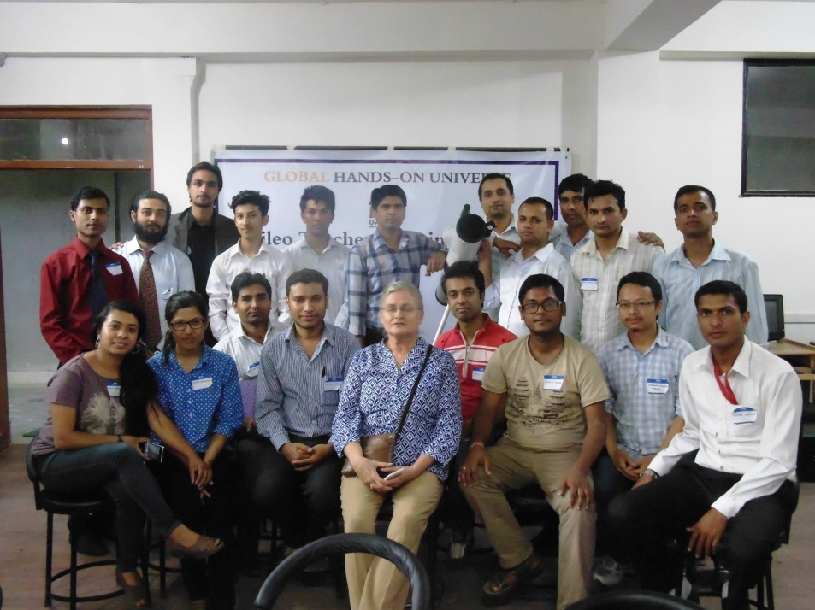
President of GHOU General Assembly, Ms. Bonnie Thurber with the participants and the trainers
Processing of Images Using Salsa J
Trainers taught in this session the use of image-processing software Salsa J. After a brief introduction to the software, the trainers provided the participants with a .fts image of quarter moon. The participants then learnt to adjust brightness and contrast for the given image. Then they processed these images selecting different color palettes like magenta, spectrum et cetera using LUT option. Likewise, they also learnt about the difference between the .fts and .jpeg image formats and how to import them. Afterwards, the participant teachers were trained to measure the approximate sizes of the craters of Moon. For that the diameter of moon was calculated in pixels using the tools in Salsa J. Comparing the known value of lunar diameter in kilometres, the value of 1 pixel in terms of kilometres was determined. The teachers measured the sizes of a few craters and compared them to the area of Nepal.

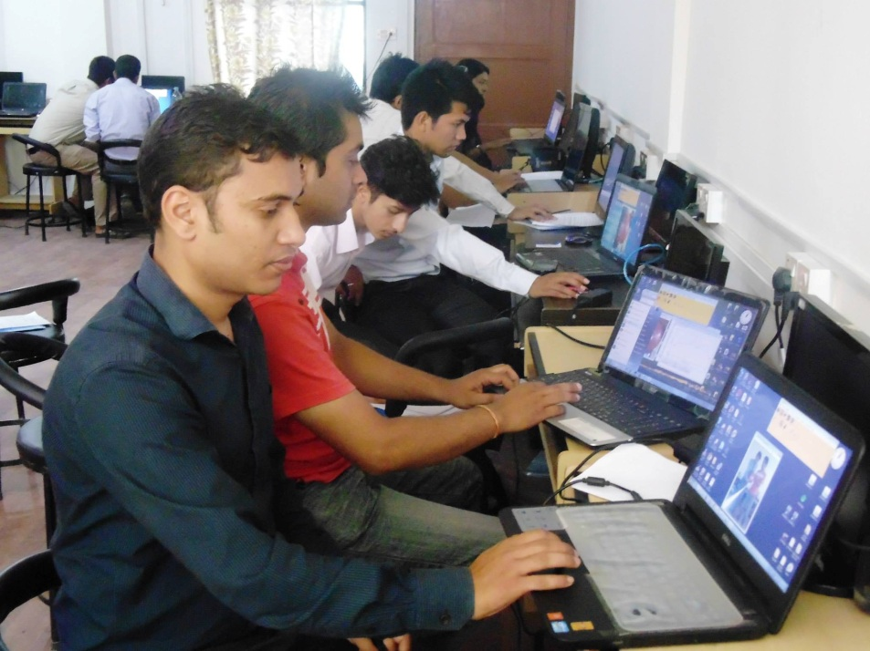
Participant teachers using Salsa J for image-processing

Observing Celestial Bodies Using Stellarium
After the introduction of the virtual planetarium software Stellarium, the participant teachers were trained to track any desired celestial body from a particular place on Earth or any other planet. They also learnt about the Azimuth & Altitude angles. The possible uses of this software in the classroom were also discussed.

Planning Night-time Observing Sessions
Observing and tracking a particular celestial body in the space using a telescope is always tricky. The participant teachers learnt on this session about when and where to look at the celestial bodies from. The participant teachers were trained to plan for observing some stars and the Moon for the details of its craters.

Day 2

Learning the Position of the Sun in a Particular Time and Season
The position and of the Sun isn’t the same all around the year. The times of sunrise and sunset also aren’t the same. The positions of the Sun in different seasons were found out using Stellarium. The data for summer and winter solstices was collected using the software Stellarium. The data was then entered in the software Origin. When the result was obtained, the participant teachers were able to know how the position of the Sun varies and how the sunset and sunrise are later in the winter season as compared to summer.

Viewing the Night Sky during the Daytime through Telescopes around the World
Micro Observatory Robotic Telescope Network of the Harvard-Smithsonian Centre for Astrophysics allows people all around the globe to control their telescopes online and obtain desired images from the universe. The participant teachers learnt to use the website and the procedure to obtain the images. They learnt how to select a particular celestial object and set up the exposure time to obtain its image. They were amazed to learn that they could now obtain an image of any desired celestial object anytime, without any hassle, into their own emails.

Measuring Distance Using Parallax
In order to determine the distance to an object using parallax we need to, the object needs to be viewed from two different points of view. In this activity, the software Stellarium was used to view the moon from two different locations on the Earth which were very close to the equator. The two locations were Quito in Ecuador and Nairobi in Kenya. Then the participant teachers were directed to determine the length of the baseline and to measure the parallax angle using Stellarium. The participant teachers then calculated the distance from the baseline to the moon. There was not a big difference and the calculated distance was around 3400 kilometres.

Learning How to Use GTTP Nepal Website
The GTTP Nepal website (http://www.gttp-nepal.org) was developed to record the progresses made by the GTTP Teachers in their classes or during the after-school activities they conduct with the participation of their students. The website also helps connect and share their ideas with other registered GTTP Teachers. President of GHOU General Assembly, Ms. Bonnie Thurber provided each participant teacher with a unique username and password so as they could upload their activities in the classrooms in the GTTP Nepal website. Ms. Thurber also showed the participant teachers to login to the website and to upload contents into it.

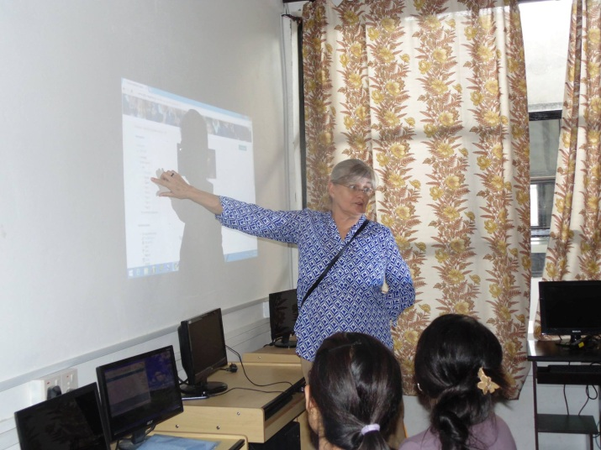
Ms. Thurber training the participants to use the official GTTP Nepal website
Making Telescope Using PVC Tubes and Lenses
In those schools where resources are scarce, locally available materials can make a difference. One of the examples is the PVC Tube Telescope. PVC Tube Telescope, as the name suggests, is a simple refractive telescope made from PVC tubes and lenses. The participant teachers were divided into two groups and each group was trained to make a PVC Tube telescope of its own. Later, they attached their self-made telescopes on tripods for the stability during their use. Most of the teachers were looking forward to make this kind of telescope in the classrooms so as children could possess telescopes of their own.

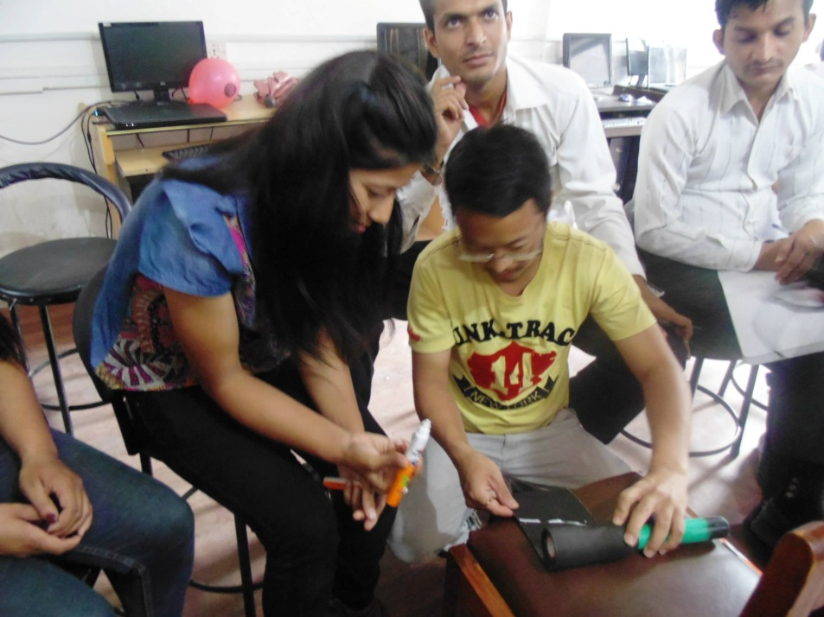
Participant teachers making a telescope from PVC tubes and lenses
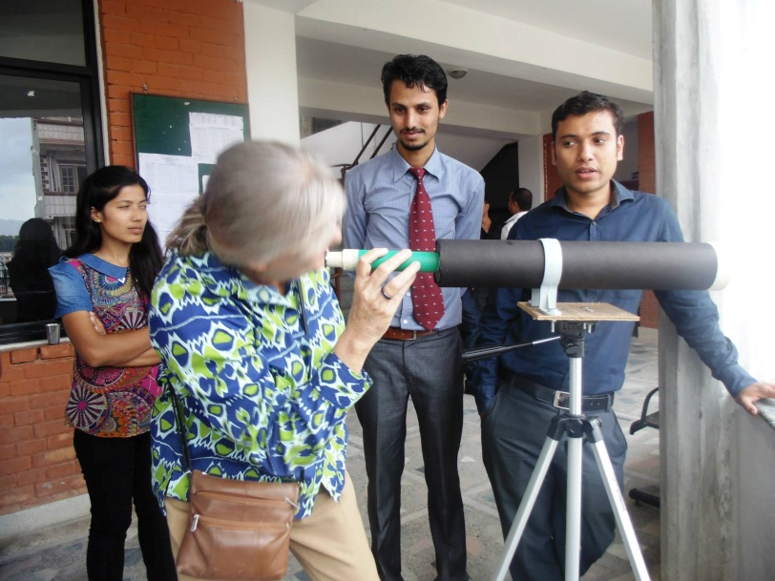
Ms. Thurber looking through a PVC tube telescope made by the participant teachers
Taking Images Using a Smartphone and Calibration of the Plate Scale
In this session, the trainers got a balloon for each group of participant teachers and each group was directed to inflate the balloon to an approximate diameter of 15 centimetres. The participant teachers then took a picture of balloon using a smartphone from a point having the distance of 2 metres and another picture from about twice the distance of the first point. Using the tools in Salsa J, the approximate diameter of the balloon was measured in pixels and the angular size of balloon from the first point was calculated. Now that they had the angular size and the pixels of balloon, they calculated the plate scale. This scale could be used for any picture using this camera. Then they had a conversation about application of this process to the field of astronomy.
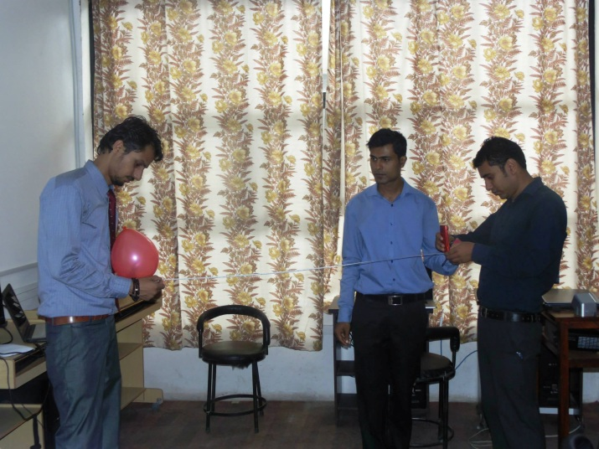
A participant teacher taking pictures of an inflated balloon from his smartphone

Speech from Dr. Rishi Shah
Dr. Rishi Shah, an academician from National Academy of Science & Technology (NAST) visited the workshop and delivered a speech on conveying practical science education to the students through organizing science workshops for the teachers. He also quoted the importance and necessity of practical science education and how it can be used in the classrooms. It was indeed an inspiring speech to the teachers by Dr. Shah.

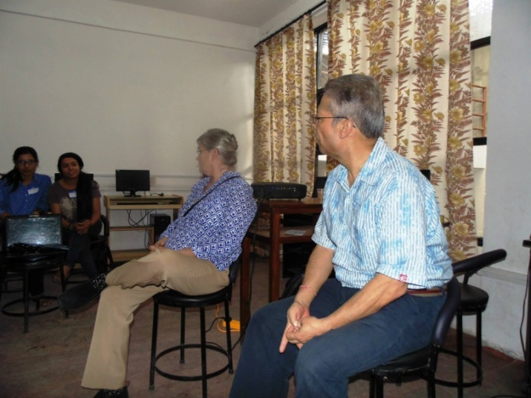
Dr. Shah and Ms. Thurber interacting with the participant teachers

Observing the Sky through a Sophisticated Telescope
At the end of Day 2, NAGSS used its reflective telescope of an aperture of 114 milimetres and a focal length of 900 milimetres to train the participant teachers on how to track and view celestial bodies at night from a sophisticated telescope as such. The participant teachers viewed the Moon from the telescope and were amazed to view the details of the craters on it. This indeed was a good experience for them.

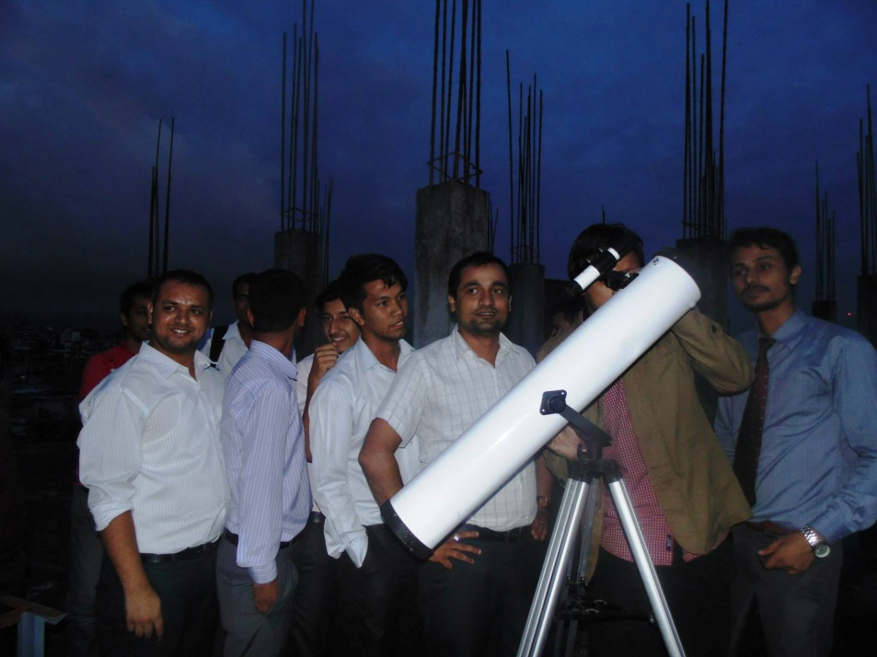
Participant teachers queuing up to watch the moon

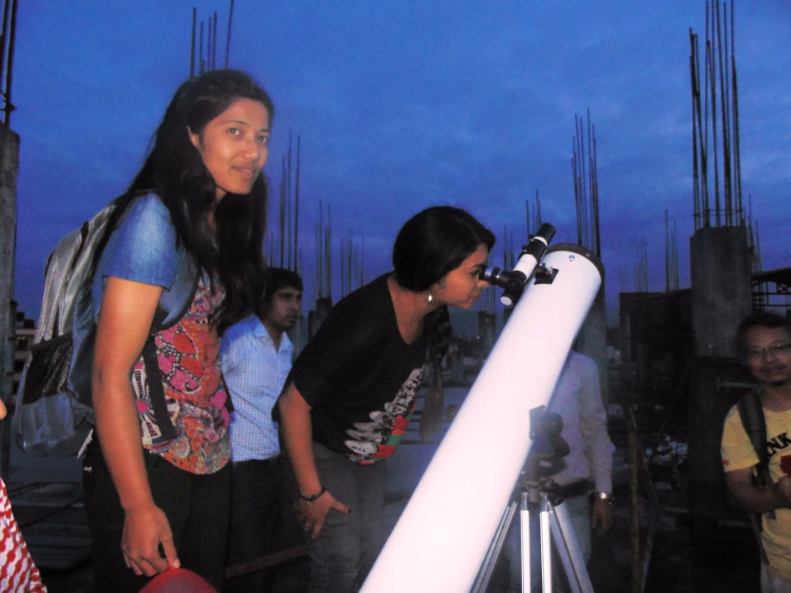
A participant teacher observing the moon

Day 3

Learning about Jupiter, its Moons & its Mass
In this session, the participant teachers were directed to stack the .fts images of the moons of Jupiter using Salsa J. After stacking the images, they created an animation using the same software.

Making Working Models of the Major Constellations
In this session, the participant teachers were trained to make working models of some of the major constellations seen from the Northern Hemisphere. They used LED bulbs, chart papers, crayons, pieces of wire, pieces of plywood and battery cells to make a working model of constellations Ursa Major and Ursa Minor on their own. They were excited to teach this to their students after the workshop.

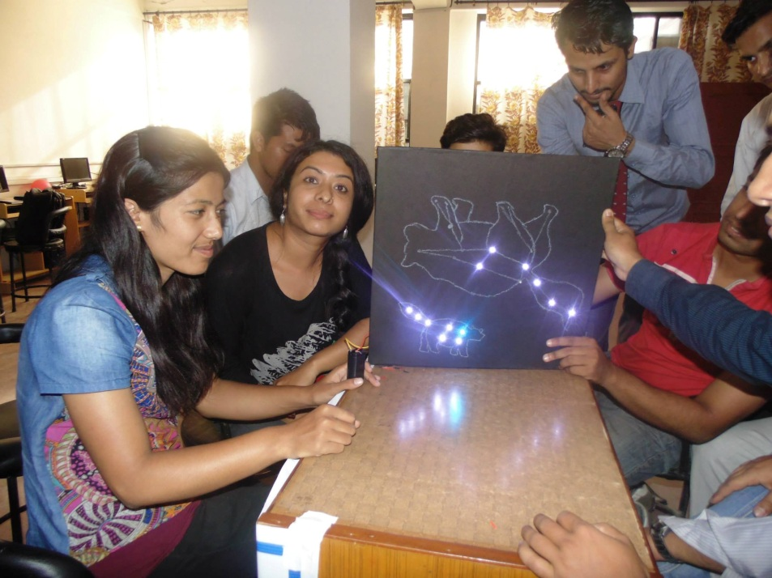
Participants with a constellation model made by themselves

Learning about the Practical Application in the Classroom and/or after School
The participant teachers were trained to apply the things they learnt in the classrooms during or after school. They were trained on how to make the students enthusiastic and curious over the subjects of astronomy and space science and how to use the application of practical science education to serve this purpose. Trainers gave the participant teachers some teaching tips that would make the lecture-based classes more interesting to the students through the practical education and the use of modern tools and technologies.

Interpretations of the Participant Teachers about the GTTP 2015 Kathmandu
The participant teachers discussed about their personal experiences of the GTTP 2015 Kathmandu and how it would be beneficial to themselves and their students. They all stated that it was a great privilege for them to have joint with GTTP and to learn practical science through it. They were certain that it would directly improve the learning capabilities of the students and would broaden their young minds.

Presentation of Certificates and the Closing Ceremony
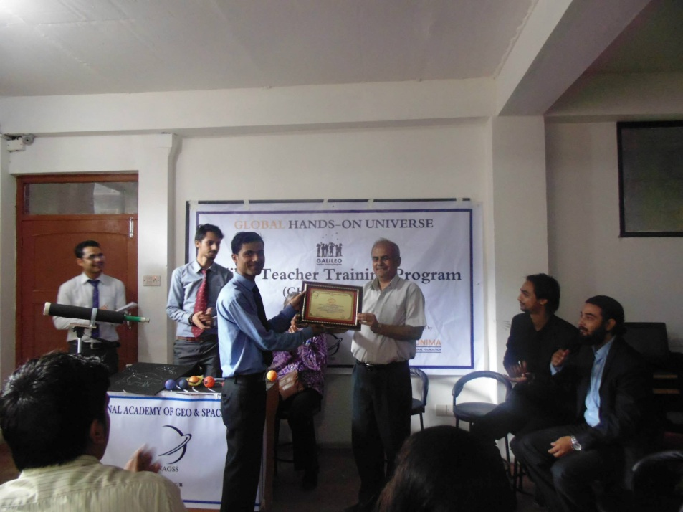
At the completion of the workshop, all the participant teachers were presented with GTTP Teacher Certificates by Ms. Bonnie Thurber, the President of GHOU General Assembly. After that, Ms. Thurber presented the workshop trainers with GTTP Ambassador Certificates. Following that, the principal of AEF, Mr. Ishwori Prasad Lamichhane was presented with the honorary membership of NAGSS by Mr. Niraj Raj Karna, the President of NAGSS. Ms. Bonnie Thurber was presented with the NAGSS ‘Token of Love’ by Mr. Ayush Parajuli, the Vice President of NAGSS.
NAGSS President with the Principal of AEF

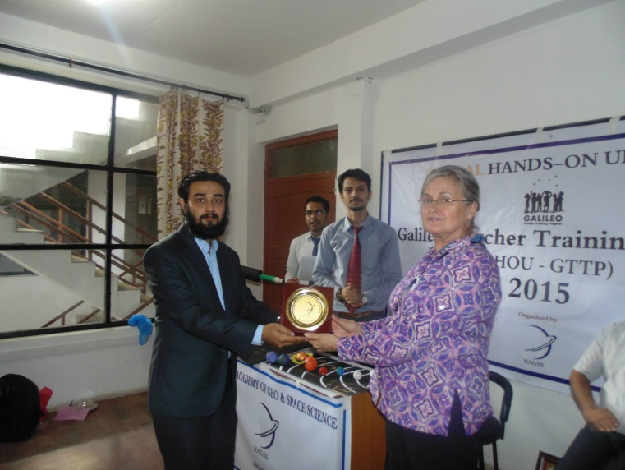
Mr. Lamichhane delivered a speech on how workshops like these help the academic sector of the nation and why they should be organized time and again. Mr. Sumit Jha, NAGSS Spokesperson explained the future plans of NAGSS on organizing more workshops like these for teachers and students alike.

NAGSS Vice President with Ms. Bonnie Thurber
4

Conclusion

The GHOU-GTTP 2015 Kathmandu was a productive event where all the participant teachers got to learn about delivering practical science education to their students using advanced tools and resources. It was attended by teachers from distinguished schools inside and outside of Kathmandu valley, thus NAGSS expects that a decent number of students are going to be profited from it. NAGSS tried its label best to provide the teachers with all the best of the resources it could for the workshop. NAGSS feels privileged to have organized the workshop and would be glad to organize more of these in the forthcoming days.

NAGSS believes that this workshop certainly allowed the participant teachers to stay current on the latest progress in science education. This workshop was a forum where the participant teachers learnt about new ideas from the specialists and shared their best teaching ideas with the co-participants. It helped the participant teachers to gain knowledge, learn about quality resources and opportunities and to see the latest technology and materials. It has provided the participant teachers the opportunity to maintain and continue to collaborate with programs and participants from across and beyond the nation. It has provided the ideas that can be used right away to improve the student experience in the classrooms all over the nation which has made this workshop so meaningful.

Since there is so much to learn and so much to gain from a workshop as this, the GHOU-GTTP 2015 Kathmandu will be followed by several students-focused follow-up workshops at various regions of the nation under the supervision of NAGSS. NAGSS assures that it would by all means help the participant teachers willing to organize this kind of workshops at local level. With its network all over the nation, NAGSS intends to do the best it can to promote the GHOU-GTTP in both national and local levels and wishes to benefit as more schools as possible. As NAGSS has always been emphasizing on practical education, it is always affirmative to provide its guidance and support for workshops as this.

The participant teachers were glad to have attended the workshop and to have learnt so much from it. They appreciated the platform of GTTP as it makes the teachers able to apply practical science education in the classroom and makes them and ultimately their students familiar with the latest tools, technologies, inventions and discoveries in the field of astronomy and space science. They agreed that this workshop would indeed improvise their teaching approach in the classroom and that it would be a far lot better than how it would be prior to the workshop. NAGSS would like to thank all the participant teachers for sparing their valuable time to attend the workshop.
5

Appendices

APPENDIX 1
List of Participants, Trainers & Representatives

Participants
- Mr. Amar Budhathoki - Teacher
Orion Secondary School
Lalitpur

- Mr. Ankit Poudel - Tutor
Nava Kshitiz Institute
Kathmandu

- Mr. Ashok Pokhrel - Teacher
Everest College of Multiple Studies
Kathmandu

- Mr. Ayush Parajuli - Vice President
National Academy of Geo & Space Science
Lalitpur

- Mr. Chandan Kumar Chaudhary - Teacher
Brighter Academy
Bara

- Mr. Deepak Basaula - Principal
Global United Secondary Boarding School
Dhading

- Mr. Ganesh Subedi - Teacher
Charles Darwin School
Kathmandu

- Mr. Gopi Krishna Bhujel - Teacher
Peace Nepal Academy
Kathmandu
- Mr. Guneshwar Pandit - Teacher
Columbus International School
Kathmandu

- Mr. Kiran Sitaula - Teacher
Laligurans Educational Institute
Lalitpur

- Ms. Meena Shrestha - Teacher
Jan Kalyan Secondary School
Kathmandu

- Mr. Nava Raj Poudyal - Teacher
Arunima Educational Foundation
Kathmandu

- Mr. Prakash Thapa Magar - Teacher
Creative Model Academy High School
Kathmandu

- Mr. Prayash Rimal - Trust Officer
National Academy of Geo & Space Science
Lalitpur

- Mr. Ram Kumar Basnyat - Teacher
Gaurishanker English Secondary School
Bhaktapur

- Ms. Rashmi Dahal - Teacher
United School
Lalitpur

- Mr. Sudan Dahal - Teacher
Peace Nepal Academy
Kathmandu

- Mr. Sumit Jha - Spokesperson
National Academy of Geo & Space Science
Lalitpur

- Mr. Ujjwal Poudel - Teacher
Arunima Educational Foundation
Kathmandu

- Mr. Yubaraj Acharya - Teacher
Arunima Educational Foundation
Kathmandu

Trainers
- Mr. Niraj Raj Karna - President
National Academy of Geo & Space Science
Lalitpur

- Mr. Sushil Bhattarai - GTTP Certified Teacher/Trainer
Kathmandu

Representatives – GHOU
- Ms. Bonnie Thurber - President of General Assembly
Global Hands-On Universe

Representatives – AEF
- Mr. Ishwori Prasad Lamichhane - Founder Principal
Arunima Educational Foundation
Kathmandu

- Mr. Buddhi Prasad Regmi - Vice Principal
Arunima Educational Foundation
Kathmandu

- Mr. ………….. Shrestha - Teacher
Arunima Educational Foundation
Kathmandu

APPENDIX 2
Acknowledgements

National Academy of Geo & Space Science would like to thank the following people for making the GHOU – GTTP 2015, Kathmandu a fruitful and a memorable event.

Dr. Carl Pennypacker - President, Global Hands-On Universe
Ms. Rosa Doran - Chairperson, Galileo Teacher Training Program
Ms. Bonnie Thurber - President of General Assembly, Global Hands-On Universe
Mr. Ishwori P. Lamichhane - Founder Principal, Arunima Educational Foundation
Mr. Buddhi P. Regmi - Vice Principal, Arunima Educational Foundation
Dr. Rishi Shah - Academician, National Academy of Science & Technology
Mr. Niraj Raj Karna - President, National Academy of Geo & Space Science
Mr. Ayush Parajuli - Vice President, National Academy of Geo & Space Science
Mr. Prayash Rimal - Trust Officer, National Academy of Geo & Space Science
Mr. Sushil Bhattarai - Member, Organizing Committee - GTTP Kathmandu 2015
Mr. Sumit Jha - Spokesperson, National Academy of Geo & Space Science
Mr. ……………. Shrestha - Teacher, Arunima Educational Foundation

