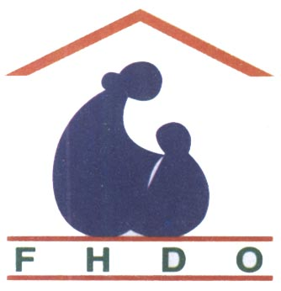
``Healthy Mother, Healthy Child. Happy Family, Prosperous Country ’’
Family Health Development Organization (FHDO)
B. A. College Road. Sirajgonj
Bangladesh

About FHDO
With head quarter at Sirajganj, a district level town in Bangladesh, we are an integrated Family Health Care and Development system built in 2001, a long standing organization. To-day we are one of the largest rural, non-for-profit health care and development system in Bangladesh.

Our Mission
We are committed to improving the human condition. We are dedicated to work for the health of mother, new born and child. With Health development interventions. FHDO strives to bring about a positive change in the quality of life of the poor people of the country. FHDO is committed to make its programs Maternal, newborn & child Health Care using innovative methods and appropriate technologies. FHDO believes and is actively involved in promoting women rights, gender equity. Working manpower and volunteers are sufficient and self-sustained to run the program.

Our vision
We are committed to work for improving human condition through exceptional care, innovation and discovery. FHDO is a secular NGO with a participatory bottom-up and non-directive approach. FHDO want that all types of maternal, newborn & child mortality are reduced form the society. FHDO wishes that everybody irrespective of their cast and creed reduce maternal, newborn & child and live in peace and harmony.

Our Values
- Courage :
The strength to preserve, use our voices and take action.

(b) Passion :
The enthusiasm for mother, newborn and child. We work with commitment to organization

(c) Resolve:
The adherence to the systems that align actions to excellence, efficiency and purpose.

- Advancement:
The pursuit of individual and organizational growth and development.

A Non-Profit Organization to make a dream come true:
Every minute of every day, woman & newborn baby dies needlessly from complications of pregnancy or childbirth. Some experienced medical professionals and eminent social workers were united and formed Family Health Development Organization (FHDO) in 2001. FHDO has been working in the field of reproductive health of pregnant mothers & their newborn baby health care in Bangladesh. In the halls of power, FHDO fights for save women's lives, reducing mother, newborn, and child mortality. FHDO works with local communities to raise awareness, create innovative solutions, and implement effective programs. FHDO dedicated to maternal health, founded out of a determination to remedy this neglect. FHDO has been working ever since — collaboratively, innovatively, and effectively — to make pregnancy and childbirth safer in Bangladesh. Maternal, newborn & child mortality are among the most common problems worldwide. In rich countries these mortality do not exist anymore. In poor countries, instead, often there is a lack of competences and resources to maternal, newborn & child health cure, which in fact frequently adequately treated.

Phone: +88075162638 E-mail: fhdo_2bd@yahoo.com Web: www.fhdo.webs.com

``Healthy Mother, Healthy Child. Happy Family, Prosperous Country ’’
Family Health Development Organization (FHDO)
B. A. College Road. Sirajgonj
Bangladesh
BACKGROUND
Great progress has been made in maternal and neonatal health in Bangladesh since the 2001. Maternal death rates were reduced to a twentieth of their former level while prenatal mortality rates also decreased correspondingly. However, such dramatic improvements were not seen in countries. Since the objectives of the Safe Motherhood Initiative are included in those of FHDO can be regarded as the non-government organization dedicated to the goals of the Safe Motherhood Initiative. The Family Health Development Organization (FHDO) was founded in 2001in Bangladesh. It has registration bearing no 640/ 2001. dated 14-05-2001 under the Directorate Of Social Welfare, Government Of The People’s Republic Of Bangladesh. The program goals of this non Govt. Voluntary Organization is to work towards the reduction of maternal and infant mortality as well as the improvement of reproductive and child health status in Bangladesh.

AIMS
With the ever-widening disparity in maternal and prenatal mortality in poor people. FHDO help with professional training, appropriate technology, and suitable management protocols and operational research is urgently required. With the use of the Internet and other lines of communication, many of these needs can now be easily met, given the will and commitment of individuals. This is where the great potential benefit of FHDO lies; networking between groups and individuals to share ideas and experience. It is widely recognized that most causes of maternal and prenatal mortality can be prevented with cheap, good, basic care. A clear understanding of common problems, the prevention and correct management of important complications, the provision of practical management protocols, a short list of essential drugs, and robust, simple equipment are both available and affordable. FHDO is ideally places to provide a bridge between groups of health care workers in many poor communities. Self-help training packages and distance learning courses in practical and appropriate maternal and prenatal care could be shared at minimal cost. Specific problems can be resolved by Internet communication while unsolved technical and protocol difficulties. FHDO has the committed members and good will to make a difference and improve the care of pregnant women and infants in Bangladesh. The aims of FHDO are to promote the health and welfare of mothers and children, particularly in Bangladesh, as part of the overall goal to improve the health of all people. The health of mothers, newborns and children does not only depend on the gynecologists - obstetricians, but also the deontologists, midwives and nurses. FHDO should therefore aim for a closer working relationship between these categories. At regular meetings like general assembly and executive board meetings these persons should have a possibility for mutual exchange of experiences. The projects elaborated and financed by FHDO are especially destined for the basic care of the pregnant mothers and their newborns. Therefore these projects should be destined for Bangladesh. Thanks to the use of complicated, technical methods in the field of gynecology and neonatology during the last decades, extraordinary results were.

Phone: +88075162638 E-mail: fhdo_2bd@yahoo.com Web: www.fhdo.webs.com

``Healthy Mother, Healthy Child. Happy Family, Prosperous Country ’’
Family Health Development Organization (FHDO)
B. A. College Road. Sirajgonj
Bangladesh

STRATEGY
The vision of FHDO is to improve maternal and prenatal care in Bangladesh by facilitating and support health care.

MDGs 4 and 5
Improving the health of mothers and their newborns.
Reduction in deaths among children under age 5 by two-thirds (MDG 4) and among pregnant.
Women by three-quarters (MDG 5) from 1990 levels by 2015.
Supporting programs to promote safe pregnancy and childbirth, family planning, and the sexual. and reproductive empowerment of women (MNCH).

Our Organization:
A non-profit organization, FHDO has active programs in countries in Bangladesh. Family Health Development Organization (FHDO) in 2001 with it’s headquartering at Sirajgonj a district level town having liaison office at Uttara in capital city Dhaka. FHDO was established to investigate the broad aspects of human development as a means of understanding developmental disabilities, including intellectual and development al disabilities and the events that occur during pregnancy Today, FHDO conducts and supports research on all stages of human development from pre-conception to adulthood, to better understand the health of communities, families, mothers, newborns and children. The organization is a non-government organization (NGO), non-profit and religiously neutral organization. The language used by the organization is English. The organization stresses building organizational capacity to solve the development problems .The organization builds up strategic leadership which is associated with risk, vision and ideas. The leadership procures essential resources inspiring members and stakeholders to perform in ways that attain the mission .The organization have an ideal structure with General Secretary as Executive Director as head of the organization the role of each member within the organization is well defined with flexible to adapt changing. Some highly trained individuals do the core works of the organization the organization has a very efficient staffs that are reasonably comfortable with working conditions and stimulated by the environment .Assessing staffing needs some of the specific takes involved in management include recruitment and hiring the best people. The organization keeps personal records of the staffs. The organization works in good environmental conditions like reasonable space in a hired building with adequate light, clean water, dependable supply of electricity and transportation to and from the working place. The organization has a library, Information System, Hard ware and Soft ware .The organization has good program Management System .The cash and assets are being audited regularly. The organization monitors and evaluates technical, administrative and logistic support to the projects. The process management takes place at every level of the organization the executive body takes prompt decision to solve any problem arose Plan, policies and procedures set in course for organization members. The organization creates mechanism that help its members gain both formal and informal information and achievement .The program objectives of projects are being monitored .The organization generally uses its staffs as evaluators and in some special circumstances evaluators from outside.

Phone: +88075162638 E-mail: fhdo_2bd@yahoo.com Web: www.fhdo.webs.com

``Healthy Mother, Healthy Child. Happy Family, Prosperous Country ’’
Family Health Development Organization (FHDO)
B. A. College Road. Sirajgonj
Bangladesh

General Body
Executive Committee
Research Consultant

Secretary cum Executive Director
Director
Finance
Director
Admin
Director
Planning
Deputy
Director

Director Recruitment
Director
H R
FHDO – Director Body
ORGANOGRAM

Phone: +88075162638 E-mail: fhdo_2bd@yahoo.com Web: www.fhdo.webs.com

``Healthy Mother, Healthy Child. Happy Family, Prosperous Country ’’
Family Health Development Organization (FHDO)
B. A. College Road. Sirajgonj
Bangladesh

Board of Directors:

Kohinoor Begum
Founder of FHDO, Chair of the Board, Secretary cum Executive Director of FHDO. Previously served the Saving Newborn Lives initiative to reduce newborn and maternal mortality in Bangladesh; has over 30 years of experience in reproductive, maternal and child health in Bangladesh. She obtained diploma in Gyne & Obs in Dhaka Medical College. She gathered much experiences working with ICDDR-B and LAMP Hospital, Dinajpur, Bangladesh. She rendered medical support to the injured Freedom Fighters at the time of war of liberation of Bangladesh in 1971.

Mirza Morium Mukta
Founder member of FHDO. Received degree from Sirajganj Mohela College; also holds board positions with Field Foundation. Presently She Carrying Finance Director.

Nassiruddin Badol
Founder member of FHDO. Received Bachelor’s degree from Sirajganj government College; also holds board positions with Field Foundation. Lawyer specializing in not-for-profit with many years of field experience in health issues. Previously held key management positions in multinational organization. Presently She Carrying Planning Director.

Mrs. Selina Begum
Founder and Executive member of FHDO. Received Bachelor’s degree from Sirajganj Government College; she also holds board positions with sincerely. Previously held key nonprofit management, social and charity work. Presently she carries Director Admin of FHDO.

Md. Nazrul Islam
Executive Member of FHDO. Received degree from Sirajganj government College; he gathered many years of experience social since in department of Sociology, Rajshahi University. previously held key nonprofit management, charity work in maternal, newborn & child health care and clinical management & trial. Presently he Carrying Deputy Director of FHDO.

Mrs Kohinur Begom (Teacher)
Founder and Executive member of FHDO. Received Bachelor’s degree from Sirajganj Government College; he gathered many years of experience child education and management. Presently she carries Director Recruitment of FHDO.

Mrs. Jolyna yasmin
Founder and Executive member of FHDO. Received Bachelor’s degree from Sirajganj Government College; he gathered many years of experience pothokoly child education and management. Presently she carries Board member of FHDO. Previously held key nonprofit management, charity work in women’s rights. Presently she carries Director Human Resource of FHDO.

Phone: +88075162638 E-mail: fhdo_2bd@yahoo.com Web: www.fhdo.webs.com

``Healthy Mother, Healthy Child. Happy Family, Prosperous Country ’’
Family Health Development Organization (FHDO)
B. A. College Road. Sirajgonj
Bangladesh

Founder at FHDO

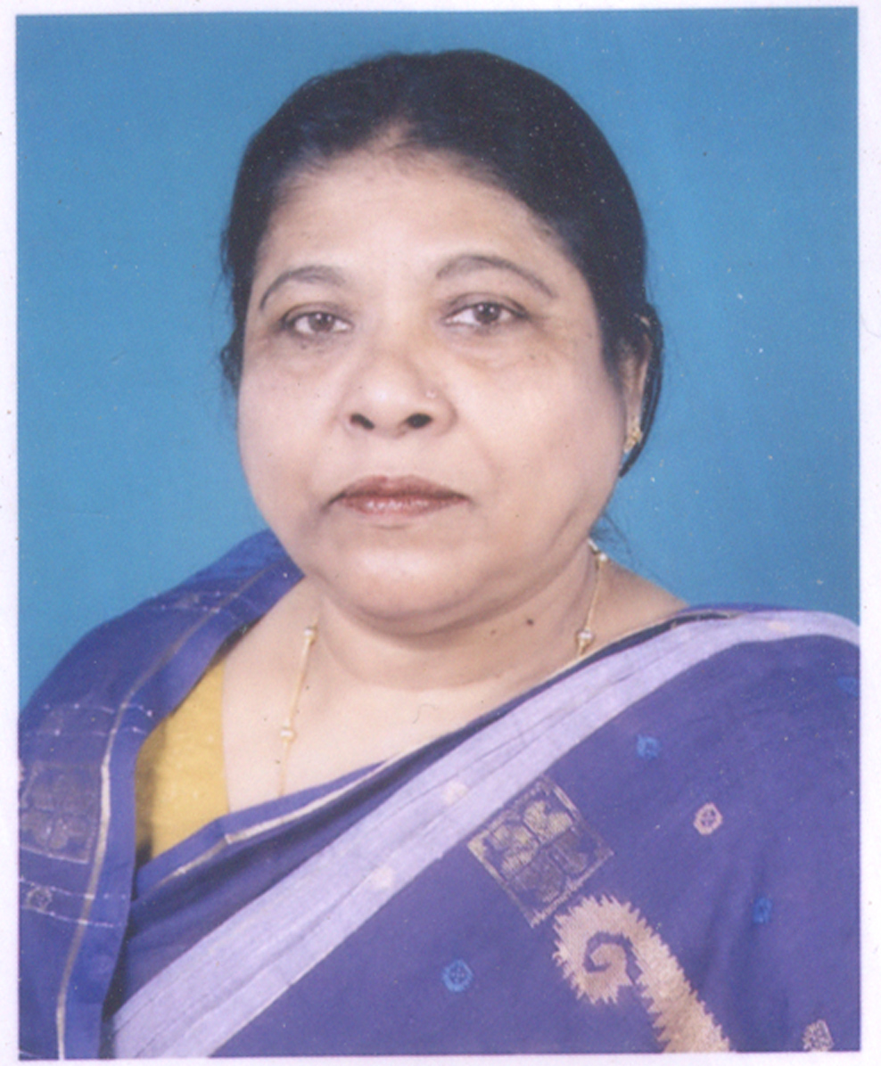
Kohinoor Begum
Secretary cum Executive Director

Mrs. Kohinoor Begum was born in Bangladesh in1950.She was graduated under Rajshahi University. She obtained diploma in Gyne & Obs in1968. She joined in Family Planning Department and worked as Family Welfare Visitor at (MCWC). She was trained in Septic Abortion in 1984.She was trained in management technology under ICDDR-B, Dhaka in 1985. She was trained in EOC under Department of Gynecology and Obstetric, Dhaka Medical College, Bangladesh in 1994. She was trained on Nursing Care and O.T Management by MCHTI-Dhaka. She was awarded TOT by the Maternal and Child health Training Institute. She obtained farther EOC training at World Mission Prayer League, Inc. LAMP Hospital, Dinajpur. She obtained Contraceptive Technology training under Family Planning Clinical Supervision Team. She was awarded certificate in Maternal and Neonatal health care by Director of health services Bangladesh.
She started Non-government civil society (NGO) organization Family Health Development Organization (FHDO) in 1996 and has been rendering health services to the mother and children in the area. Presently she has been elected Director of the Organization. She earned reputation in the field by organizing Free Satellite Clinics at the time of post flood periods. Mrs. Kohinoor Begum is widely known as technical expert on maternal and reproductive health care. She gathered much experiences working with ICDDR-B. Free Medical Services to the Mother, Child and Adolescents is organized at office premises on every Monday. She works in neo-natal pneumonia, dysentery, dehydration of new born baby. She also works in nutrition, health education, HIV/AIDS and safe water, sanitation, among the poor people. She rendered medical support to the injured Freedom Fighters at the time of war of liberation of Bangladesh in 1971.

The Staff, the soul of our undertaking
The true strength of FHDO stems from the diversity of its members. Surgeons, nurses, anesthetist, instrument nurses and other professional figures are organized in well coordinated teams. Thus they render the activity totally autonomous in any situation. Besides, the organization of a Logistics Office, of a Communication Office, and of activities supported by entrepreneurs, lawyers, notaries, secretaries, typographers and journalists allows us to coordinate the service without ever improvising and without depending on external structures.
All the services and activities are realized on a voluntary basis. This permits the Association to conduct surgical procedures at very low costs: 150 euros per procedure.

Phone: +88075162638 E-mail: fhdo_2bd@yahoo.com Web: www.fhdo.webs.com

``Healthy Mother, Healthy Child. Happy Family, Prosperous Country ’’
Family Health Development Organization (FHDO)
B. A. College Road. Sirajgonj
Bangladesh

PLANNED ACTIVITIES:
1. Maternal child health surveys repeated, recorded, analyzed, and disseminated in the country.

2. Increased, expanded, and enhanced direct MCH health care services for women and children in the clinics, coupled with comparable levels of MCH health promotion / community outreach activities.

3. Training in health promotion and education techniques in maternal child health issues and approaches for community peer educators.

4. Community based health promotion activities in mother and child health, integral infant-child development, family planning, sexual health issues and strategies, especially around sexually transmitted diseases (STDs).

5. Community animation, community organization, leadership development among community women to ensure empowerment of women around issues of reproductive, maternal and child health.

6. Information sharing and dissemination of information among MCH health workers in Bangladesh.

7. Holistic consideration of day to day health and hygiene practices, with health education by example through ICS, organic demonstration gardens, water point and latrine provision, in cooperation with the local communities.

8. Community-based Health Centers (HCs) are established to provide quality maternal and natal care. Health Outreach Services (HOS) are provided to make services further available. Appropriate vaccines for polio & measles administered through National Immunization Days in targeted areas.

9. Traditional Birth Attendants (TBAs) & Peer Educators are provided quality training on safe child-delivery. Health Centre & Health Outreach staff members are trained on gender-sensitive information dissemination on maternal health, family planning, STDs.

10. Mothers' Clubs, Youth Clubs and Girls' and Women Clubs, etc are set up to empower individuals from different demographics in making choices for healthy sexuality, family planning and helping them play their part in designing community resources in these areas, providing health education to all on key issues around prevention and control of high-burden, communicable diseases, STDs, malaria, respiratory infections, diarrhea diseases, malnourishment etc.

Phone: +88075162638 E-mail: fhdo_2bd@yahoo.com Web: www.fhdo.webs.com

``Healthy Mother, Healthy Child. Happy Family, Prosperous Country ’’
Family Health Development Organization (FHDO)
B. A. College Road. Sirajgonj
Bangladesh

What FHDO Is doing ?
Presently FHDO is working in the field of maternal ,newborn, and child health in the rural areas Sirajganj district The field workers make house to house visit and talk with pregnant mothers .They are advised to be careful of their health’s and their fetus .Their weight, blood pressure , blood sugar level are being recorded. They are advised to safe delivery homes public or private as they like. FHDO has a clinical trial facility namely Kohinoor Nursing Home at Sirajganj town. It is a 10 -bed nursing home where mother and child health care is being rendered. After delivery mothers are advised to breast feeding for 6 months. The newborns are being given Polio Vaccine Vitamin K-one, Vitamin A cap. NID and EPL programs are being held at FHDO premises. FHDO runs with institutional and private donations. Our organizational capacity entails six interrelated underlies an institutions performance and these are Strategic leadership, Human resource, Core resource, Program Management, Process Management, and Inter Institutional Linkage. Each of these areas contains various components which range in importance among institutions.FHDO takes every opportunity to provide this essential information to all women who attend antenatal care, deliver in a facility, are referred for emergency care services or receive postnatal services.

Postpartum care: Postpartum women need to know the advantages of timing and spacing their next pregnancy for their own and their baby’s health, and that it is possible to become pregnant before the return of menses. If they are not breastfeeding, their fertility may return by six weeks after childbirth.

Postabortion care: A woman’s fertility can return within two weeks after an abortion or miscarriage. So, it is essential that women who receive postabortion care leave clinics with modern contraceptive methods and FP information. By providing FP counseling and appropriate contraceptive methods at the time women receive postabortion care services, providers can help women avoid the dangerous cycle of unwanted pregnancy and abortion.

Cervical cancer screening: Of all cervical cancers, Integrating simple, single visit cervical visualization and treatment technologies with existing FP programs can have a major impact on women’s health in developing countries. And alternatively, integrating FP with existing cervical cancer screening programs can further expand women’s access to crucial services.

HIV counseling: Clients who seek HIV counseling and clients who seek FP services are often the same people, and they are often women. Clients, providers and programs can all benefit from the synergies of these two types of services. For example, by averting unintended and high-risk pregnancies among HIV-positive women, FP reduces mother-to-child transmission of HIV.We work with key stakeholders to develop FP counseling messages and job aids for HCT service providers. Using these tools, providers can tailor FP services to be sensitive to HIV clients’ specific needs.

Child health care: Women who do not seek postnatal care for themselves can be reached during well-child visits. By providing an integrated package of care during well-child visits—adding information about FP options and breastfeeding—we can reach women who might otherwise miss this opportunity to avoid unplanned pregnancies.

Essential Components for High-Quality FP/RH Service Delivery:
The quality and availability of FP/RH services depend upon up-to-date, evidence-based national policies, guidelines and standards. In addition, the delivery of high-quality FP/RH services requires a stable infrastructure that supports pre-service education and in-service training. These systems, in turn, produce and sustain a strong health workforce.

Phone: +88075162638 E-mail: fhdo_2bd@yahoo.com Web: www.fhdo.webs.com

``Healthy Mother, Healthy Child. Happy Family, Prosperous Country ’’
Family Health Development Organization (FHDO)
B. A. College Road. Sirajgonj
Bangladesh

Another RH Focus: Cervical Cancer Prevention (CECAP):
Each year about 493,000 new cases of cervical cancer occur and approximately 274,000 women die from this disease. However, unlike many cancers, cervical cancer can be prevented. In collaboration with stakeholders and partners, FHDO pioneered the single visit approach (SVA)—a unique, medically safe, acceptable and effective approach to cervical cancer prevention for low-resource settings. The SVA consists of visual inspection using dilute acetic acid (VIA) to detect precancerous lesions on the cervix, followed by the offer of treatment using a freezing technique (cryotherapy) during the same visit.

HIV/AIDS Prevention, Care and Treatment:
The United Nations sixth Millennium Development Goal (MDG) called for the halting and reversal of the spread of HIV by 2015, and the achievement of universal access to HIV/AIDS treatment by 2010. Although progress has been made, the epidemic continues to devastate countless lives. This is especially true in developing countries, where HIV/AIDS has placed enormous burden on already strained health care systems and a dwindling health workforce, and where more than 90% of the world’s HIV-infected population lives. Women and children are among the hardest hit, with women 15 years of age and older making up half of the world’s HIV-infected population, and an estimated 2.1 million children living with HIV/AIDS as of 2007. FHDO has brought evidence-based innovations to the prevention, care and treatment of HIV/AIDS and other infectious diseases. Our technical expertise in HIV/AIDS encompasses a broad range of technical areas, including:

Prevention of mother-to-child transmission of HIV(PMTCT), addressing the main mode of HIV infection in children

Counseling & treatment for HIV, considered the gateway to comprehensive HIV prevention, care and treatment for people who test positive, as well as reinforced prevention for those who test negative Male circumcision (MC), shown to reduce the risk of female-to-male HIV transmission by 60%

Prevention of medical transmission of HIV and other infectious diseases through simple infection prevention practices, as well as post-exposure prophylaxis for HIV Provision of adult and pediatric antiretroviral therapy (ART), treatment for opportunistic infections and palliative care, from the facility to the community level

Integration of HIV / AIDS services with tuberculosis ( TB ), cervical cancer, malaria in pregnancy, family planning and maternal and child health services, to address the problem of co-infection among HIV/AIDS patients and to reach as many people as possible.

Infection Prevention and Control :
For more than a decade, FHDO implementing evidence-based standards for infection prevention (IP) practices that protect both client and health care worker, developing and implementing efforts in Bangladesh. By systematically integrating IP into health care initiatives such as family planning, reproductive health, maternal and newborn health, and HIV/AIDS prevention programs, countries may reduce the spread of infectious diseases, promote the use of effective waste management, minimize environmental pollution and reduce the perceived risk of HIV infection for health care providers. Changing perceptions about this risk helps to reduce health care worker attrition and increases the likelihood that sufficient numbers of students will continue to complete basic education to become physicians, nurses, midwives and other types of health personnel.

Phone: +88075162638 E-mail: fhdo_2bd@yahoo.com Web: www.fhdo.webs.com

``Healthy Mother, Healthy Child. Happy Family, Prosperous Country ’’
Family Health Development Organization (FHDO)
B. A. College Road. Sirajgonj
Bangladesh

Innovations in Training Methods and Technologies:
In 2001, FHDO clinical training skills manual—the FHDO training approach. Using a systematic “training of trainers” approach, FHDO has created qualified physician, nurse and midwife, traditional birth attendants & skilled birth attendants training in Bangladesh.

Our research works:
1. Women Health:
(a) Pre natal Care:
Bring mom-to-be under regular check up, education and support through the pregnancy.
- Breast Cancer.
(c) Cervical Cancer.
- Gestational Diabetes
- Pregnancy support to mom- to- be.
- Pregnancy Tuberculosis.
- Fertility problems.
- Pregnancy, labor, delivery and post partum care.
- Menopause.
- Hormone Replacement Therapy(HRT)

2. Children’s Health Care:
- Children’s growth and development.
- Children’s diet and nutrition and breast feeding..
- Children’s behavior.
- Children’s school issue.
- Children’s immunization
Our Partners:
FHDO works with governments, non-governmental organizations, professional groups, and international agencies to make pregnancy, childbirth and Newborn safer around the world. We build partnerships at all levels to fight for stronger commitments to women's & Child health, share ideas and experiences, respond to local needs, maximize effective use of resources, minimize duplication, and encourage replication of successful models and approaches. FHDO welcomes partnership with organizations like hospitals, clinics, community health centers. These partnerships will lead to development of services designed to meet each community’s specific needs. FHDO partners with organizations that have an interest in advancing global health.
Working together to improve maternal, Newborn, Child and reproductive health
As a leader in the struggle to improve maternal, Newborn & Child health in the Country, FHDO works to build the political commitment and financial investment needed to prevent millions of women and babies from dying needlessly from causes that are routinely prevented or treated in wealthy. We actively participate in dialogues with governments of both developed and developing nations; speak out at the global summits; collaborate and strategize with advocates for HIV/AIDS, Maternal & child survival, and other important causes to demand working health systems and effective, accessible health care for all; develop publications and articles that stimulate awareness and action among policymakers, technical experts, and opinion leaders; and engage in a range of initiatives and partnerships. FHDO’s experience, ability, and agility in working in global health partnerships puts us in a unique position to ensure that Millennium Development Goal (MDG) 4, 5, 6— Improve maternal, newborn & child health — and its targets, including reproductive health, remain high on the developing agenda.

Phone: +88075162638 E-mail: fhdo_2bd@yahoo.com Web: www.fhdo.webs.com

``Healthy Mother, Healthy Child. Happy Family, Prosperous Country ’’
Family Health Development Organization (FHDO)
B. A. College Road. Sirajgonj
Bangladesh

‘A Monday Free Clinic’ for mother, newborn and child is being run by FHDO at its facility center Kohinoor Nursing Home on every Monday. A good number of patients attend the clinic .M/S AMBEE Pharmaceuticals Ltd of Bangladesh joined with us with their life saving drugs to make the mission a success. Thanks to them.
Presently FHDO has been implementing a project on mother and child health care and development name and style ‘Mayer Shukh’ (Mother’s Happiness) at 03 sub-districts in Sirajganj District. With its own fund.
Key initiatives include:
1. Partnership for Maternal, Newborn & Child Health (PMNCH).
2. The Global Alliance for Vaccination and Immunization (GAVI).

3. The White Ribbon Alliance (WRA).

4. Partnership member of The Word Health Organization (WHO).

FHDO cultivates contact with International Family Care (IFC), CARE, ICDDR-B and LAMB project and Hospital, Dinajpur, Bangladesh.

The simple equation and logo, of our organization:

FHDO: A simple equation:
F = Family, H = Health, D = Development, O = Organization.

Logo: A Child in Mother’s lap in a facility.

Phone: +88075162638 E-mail: fhdo_2bd@yahoo.com Web: www.fhdo.webs.com

Your information has been successfully submitted, thank you!

Thank you!
You will hear back from the UN within fourteen days.
Where will my information go?
Your information will be matched with the interests of different UN organisations and sent directly to the ones who are the most likely to be interested in partnership.
When will I hear back?
- Now - There will be a confirmation message from us, now, in the email account you have submitted.
- Within 14 days - There is a wide range of organisations within the UN System and your proposal will shortly be routed to those that appear to be the best match. UN personnel will review your proposal and you will receive a reply within the next 14 days
- After 14 days - If, regrettably, no UN organisation finds it possible to partner in this way, the website will let you know. At the same time the website will offer you the opportunity, should you so wish, to extend your offer to non-profit organisations around the world that may be able to enter your proposed partnership.
Back to Home Page
View the partnership proposal you submitted to the UN

