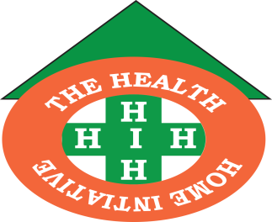

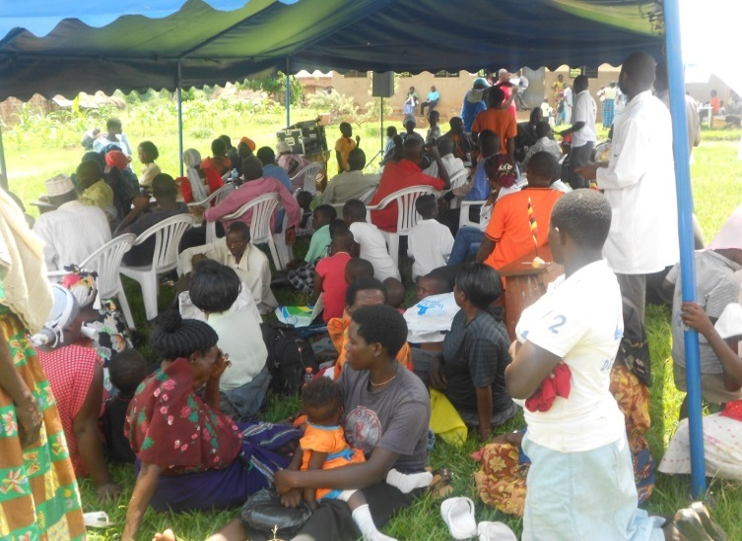The HEALTH HOME INITIATIVE (HHI)

PERFOMANCE APPRAISAL REPORT 2013-2015

**MESSAGE FROM THE CHAIRPERSON-HHI BOARD OF TRUSTEES**

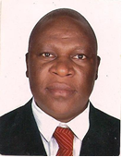

*We thank God who has enabled us to turn the mile stones in our vision into realities. We have worked with the Ministry of Health and othert stakeholders in communities all geared at promoting and improving health situations of the vulnerable elderly, women, youth and children.*

*N*

*Our ambition and desire as a team has always been to uplift the standards of living by addressing more pertinently health issues.*

*For the year 2012-2015, we have worked hand in hand with the government, and other development partners who supported HHI with financial resources and technical guidance. Through this period we have registered both successes and challenges and also forged the way forward for further improvement.*

*In a special way, I would like to take this opportunity to thank all our financiers including organizational members. Without their presence little would have been registered.*

*Finally, I would like to thank all those who participated in producing this report particularly members of staff. We are also grateful to all our partners and communities we have interacted with for the success of Health Home Initiative activities.*

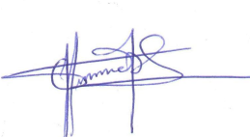

*Mr. Ngoobi Alex*

*Board of trustee member*

*Health Home Initiative*

**COUNTRY DIRECTOR’S MESSAGE**

*Dear members, partners and other stakeholders, it is my humble pleasure to communicate to you once again. Thank you very much for the time, financial resources and energy you have dedicated to Health Home Initiative. The year 2012-2015 has been a tough one but at the same time a learning experience and therefore we should aim higher not forgetting to remain focused to our goal, mission and objectives.*

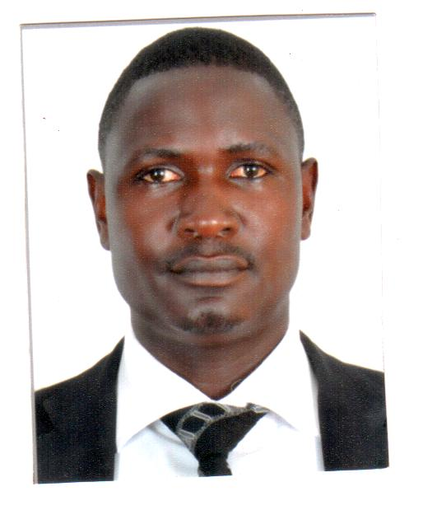

*We had and still challenged with limited financial resources but I am much aware that through your unreserved determination and dedication, this year God will continue to bless our works.*

*On behalf of the entire team, I would like to extend our appreciation to our partners notably;* ***FRIENDS IN UK,*** *for the financial contribution and capacity building support. I thank Board members more especially the Chairperson for the continuous encouragement and also for being with us in trying to mobilize resources for the Organization.*

*In the coming years let us maintain the good relationship we have with our partners as a strategy that will aid HHI in meeting its obligations of providing support services to the neediest and hard to reach elderly, women, children and youth, thus securing the greatest improvement in health and livelihoods of our communities.*

*Do not forget “****teamwork, concern for the poor, commitment, accountability and transparency are our strength****”*

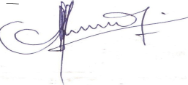

*Mr. Wagalala Simon*

*Country Director*

*The Health Home Initiative*

**Table of Contents**

List of Abbreviations/Acronyms--------------------------------------------------------------5

Executive Summary-----------------------------------------------------------------------------6

Organizational ------------------------------------------------------------------------------------7

Building of Networks and Partnerships-------------------------------------------------------8

Improved Health Service Delivery-------------------------------------------------------------9

Training and Capacity Building----------------------------------------------------------------17

Organizational Governance---------------------------------------------------------------------19

Organizational Capacitance----------------------------------------------------------------------21

Lessons Learnt-------------------------------------------------------------------------------------22

Challenges------------------------------------------------------------------------------------------23

Future Plans and Way forward-------------------------------------------------------------------23

**List of abbreviations/Acronyms**

AIDS-Acquired Immune Deficiency Syndrome

CHO- Community Hive Organization

DHO-District Health Officer

FGD-Focus Group Discussion

HCT-HIV Counseling and Testing

HHI-Home Health Initiative

HIV-Human Immune deficiency Virus

HMIS- Health Management Information System

ILTMN-Insecticide Long Lasting Treated Mosquito Nets.

MGLSD- Ministry of Gender Labor, and Social Development.

MHI- Mobile Hospital International

MOH- Ministry of Health

NGO-Non-Governmental Organization

NYV-National Youth Voice

OCAT-Organizational Capacity Assessment Team

OVC-Orphans and Vulnerable Children

RDT- Rapid Diagnostic Test

WACCA- Women against Cervical Cancer Association

**Executive Summary**

The Health Home Initiative (HHI) is fully registered Non-Governmental Organization under the NGO Board Registration Act with Registration No ***S.8771***.

The organization targets vulnerable elderly persons, Orphans and other Vulnerable Children (OVC), women and youths.

HHI was established to provide holistic family health care in relation to curative, preventive and nutritional care, and in addition maternal and reproductive health related rights including HIV/AIDS services

Detailed in the report is the organizational background and what HHI stands for including the specific objectives.

In a nutshell this report provides an account of key achievements, lessons learnt, strategic orientation, partnerships, challenges, and recommendations with a grand finale outlining the future plans. The report covers a two year period 2013-2014.

With technical and financial support from partners and commitment of staffs HHI has recorded tremendous achievements which contribute to the realization of the set goals and objectives of the organization as outlined in this report.

The report has been segmented to highlight achievements in the different programmatic and thematic areas with particular mention of partners in the implementation and symbiosis,

1. **ORGANIZATIONAL BRIEF**

The Health Home Initiative (HHI) is fully registered Non-Governmental Organization under the NGO Board Registration Act with Registration No ***S.8771***.

HHI was established to provide holistic family health care in relation to curative, preventive and nutritional care, and in addition maternal and reproductive health related rights including HIV/AIDS services. The organization targets vulnerable elderly persons, Orphans and other Vulnerable Children (OVC), women and youths.

HHI promotes community empowerment with the enhancement of community knowledge as a key pillar in the centre development process.

The strategic mode of service delivery constitutes partnership and networking, capacity building, community participation and involvement, engagement of community volunteers and working with local leaders.

**The Mission Statement of the Organization states thus; *To contribute to a healthy community by integrating preventive and curative care service delivery in order to complete the health management system for the elderly, vulnerable children ,women and youth.***

HHI has a fully fledged Board of Directors that has tested professionals in the fields of Health, , community development and social work and administration. The board is responsible for policy formulation and monitors all programs of the organization. With the strong board a lot has been achieved in the last two years.

At the programmatic level HHI implements a number of programs in key thematic areas under the stewardship of the Country Director. This team is responsible for the operational and tactical operations of the organization and develops programs and projects in line with the organizational goals and objectives. The team also engages community volunteers who support the community mobilization function of the organization with active involvement of the target groups.

* 1. **SPECIFIC OBJECTIVES**

The specific objectives of the organization inter alia include;

1. To promote the provision of primary health care service through contribution to strengthening of the health care system.

2. To promote access to safe water including standardized hygiene and environmental sanitation practices.

3. To support access to socio-economic opportunities for increased households incomes, quality education and nutrition targeting the vulnerable.

4. To increase access to quality palliative care and cancer services for women.

5. To lobby and advocate for rural for the promotion of women and children health rights.

While implementing the above set of organizational objectives, HHI is guided by the core values and principles of accountability and transparency which facilitate the implementation of programs in line with the mission, vision and objectives, respect for human dignity, involvement and participation of beneficiaries, equity and equality as summarized in her core values.

**2.1 ACTIVITIES CONDUCTED AND ACHIEVEMENTS.**

HHI during the reporting period implemented activities in line with set work plans and budgets. Elucidated here below are the key activities and achievements for 2013-2014.

**2.1.1 SUMMARY DELIVERABLES**

* Building of networks and partnerships in service delivery.
* Contribution to improved service delivery
* Training and capacity building
* Interning students from tertiary institutions
* Strategic Plan formulation and development.

**A**

**BUILDING OF PARTNERSHP AND NETWORKS IN HEALTH SERVICE DELIVERY**

**By and large through this component the organization as successfully created and strengthened partnership and networks.**

Partnerships were crafted and the existing ones strengthened with Ministry of Health (MoH), Mulago Mobile Hospital International, National Institute of Medical Records and information Management, stroke Rehabilitation Centre, St Joseph Clinic and Laboratory, Women against Cervical Cancer Association (WAACA)

The strategic partnerships created enabled HHI to effectively and efficiently implement the planned activities.

**B**

**CONTIBUTION TO IMPROVED HEALTH SERVICE DELIVERY**

Under this program component, HHI organized and implemented the following activities aimed at increasing easy access to and utilization of basic health care services among vulnerable groups.

1. **Trained community members in Malaria Prevention and injuries control strategies.**

During the period under review the organization organized 3 workshops and built the capacities of local communities and volunteers in Wakiso District on Malaria and injuries prevention and control. Key outputs included the training of 150(80F, 70M) community members specifically from Busukuma and Nangabo Sub counties. . One of the key observations is that this training strengthened community members’ response regarding health challenges through collective actions and responsibility.

**Table 1: Schematic Representation of community people trained in malaria prevention and injury control for 2012**

|  |  |  |  |
| --- | --- | --- | --- |
| **District: Wakiso** | **Age Bracket (18-59 years)** | |  |
| **Sub counties** | **Male** | **Female** | **Total** |
| **Busukuma** | 20 | 40 | 60 |
| **Nangabo** | 30 | 60 | 90 |
| **Grand total** | **50** | **100** | **150** |

Participants through Focus Group Discussions (FGD) raised the following important issues that required immediate attention:-

* Participants identified malaria as one of the major causes of death especially among Children fewer than 5 years and therefore called for HHI and government efforts to scale up the awareness campaigns in addition to providing free Insecticide Long Lasting Treated Mosquito Nets (ILTMN). HHI established that some people who were provided with mosquito nets were putting them to different usage like drying cassava and making cages for rearing chicks. The assumption was that most of those that received the nets did not get prior sensitization about the proper usage of mosquito nets.
* During the trainings participants also stressed the need for increasing access to HIV counseling and testing services given the recent HIV statistical report (2011) that indicated prevalence of 7.3%. ***‘’Many of us are not aware of our HIV Sero Status but no one is not abstaining’***’ Mr. James Mutyaba noted.

1. **Community sensitization outreaches on Malaria prevention and injuries control.**

As a strategy for disease prevention, the trained community people who acquired practical skills and knowledge in malaria prevention and injuries control applied the knowledge by organizing community sensitization outreaches. 3 outreaches were carried out and 150 (100 female and 50 male) members were sensitized about malaria prevention strategies.



An analytical look at the graph above shows active participation and involvement of women in the community outreaches than their male counterparts. This shows that there is need to come up with strategies that will increase male participation in promoting good health in their families.

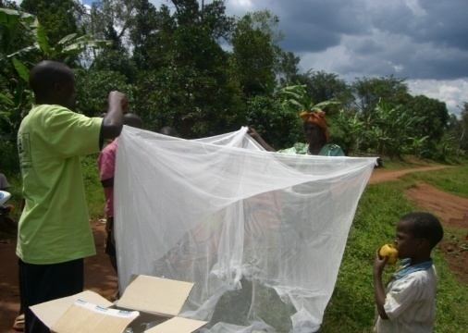In addition, 1000 Insecticide mosquito nets were also distributed to household members including children under the ages of five years. Out of the people benefited, 700 were children under five years, 100 pregnant mothers (25-35 years) and 200 elderly persons of 60 years and above. These nets were donated by friends of UK. Thirdly, 350 children were worm proofed for the prevention and treatment of allied infections.

1. **Mobile Clinic Day Outreaches.**

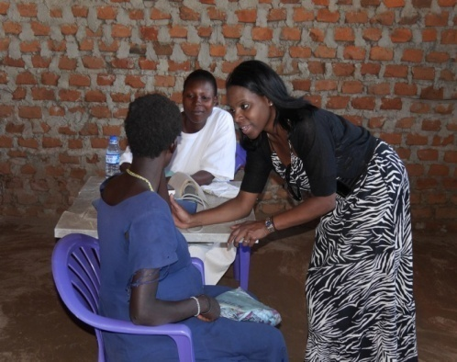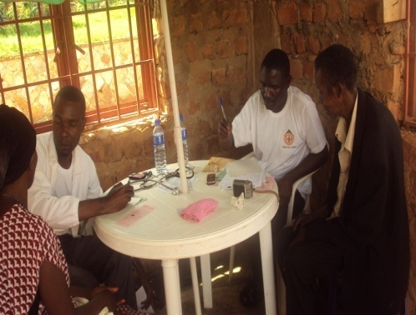Access to basic health care services remains a challenge among rural communities. Reports from Ministry of Health continue to indicate a health service gap and call for collective action from development partners to reverse the trend. HHI is supporting the bridging of the existing service gaps in the health sector through its mobile clinic day outreach service model. With support from Eagles Wings Charity UK, PEARL Humanitarian Relief, Mukono District Health Department, Kimenyedde Health Center II, MJAB, Mengo Medicare School of Dental and individual doctors, 4 major clinic day outreaches were conducted in Nebbi, Wakiso, Kampala and Mukono districts during the reporting period. In these outreaches, HHI provided free basic medical care which increased access to and utilization of services by the rural vulnerable communities. 2000 people benefited from the services provided out of which 600 (30%) were male, 900 (45%) female, 300 (15%) children and 200(10%) older persons.

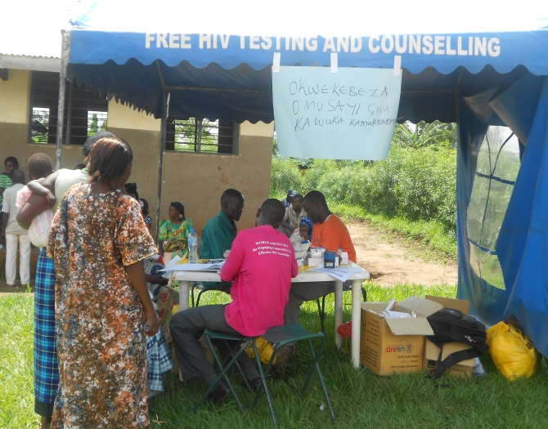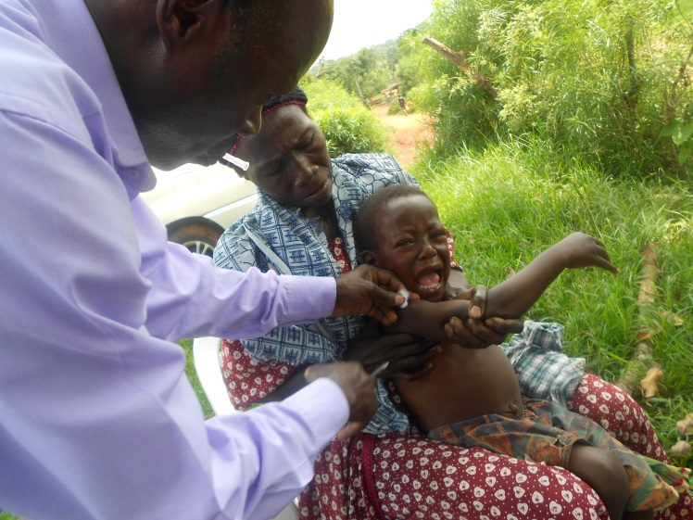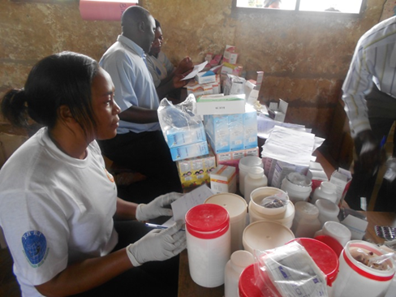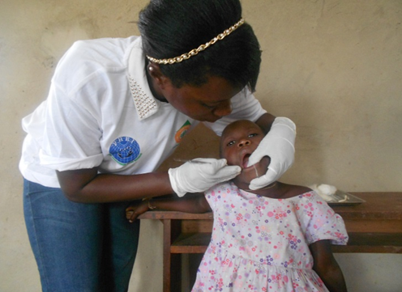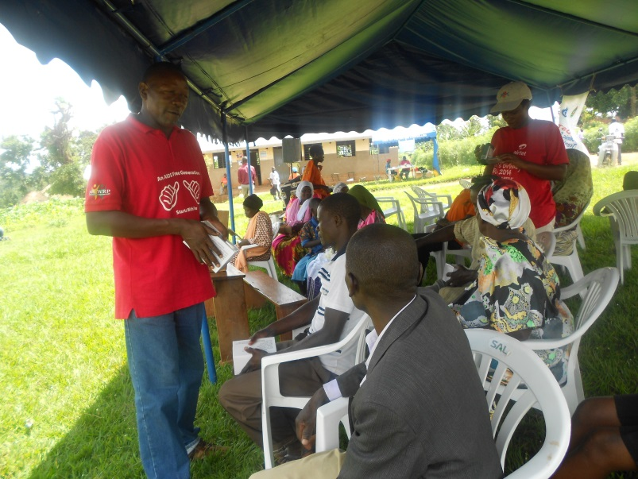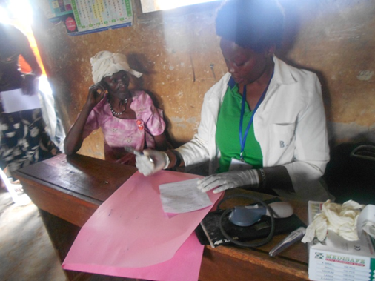

***Above: Community Members accessing different free basic medical care services during mobile clinic day outreaches in Mukono, Kampala,Wakiso and Nebbi Districts.***

**Table 2:** Beneficiary Location**.**

|  |  |  |
| --- | --- | --- |
| **District** | **Subcounty** | **Village** |
| Mukono | Kimenyedde | Kiwafu, Nakiguddo, Nteete |
| Nebbi | Several Sub Counties | Unjoku,Pangero,Akabaa,Paduk,Arumukeng,Namurwodho,Agwok,Onulu,Nyawachwaka,Pangidhu,Nyaravur,Erusi,Zombo,Paminya,Panyabong,Alengo,Godali,Jupanziri,Thata,Tingkori,Opedhere,Nyarakwaca,Amvor/Vur,Namiwondhu,Kochi and Kasuku. |
| Wakiso | Busukuma Sub-County | Kiwenda, Sitabaale |
| Kampala | Kawempe Municipality | Kalerwe and Mulago |

**Services provided included**

* HIV Counseling and Testing (HCT) services and RTD- malaria testing,
* Blood pressure and Neuropathy assessment, Malaria treatment, deworming, treatment of respiratory infections, cancer screening and immunization, dental and general assessment.
* Drugs dispensed were Anti-Malarial Drugs, De-worming tablets and syrups, Anti-hypertensive drugs, Anti-biotics (Tabs/Caps and Syrups) Analgesics’ Vitamins, Anti -acids/Anti- ulcers drugs. Others requested were Laboratory items, RDTs-Malaria, HIV kits, Ear and eye drops/ointments, HCG, Urine sticks, Disposable Gloves and Cotton wool 500g.

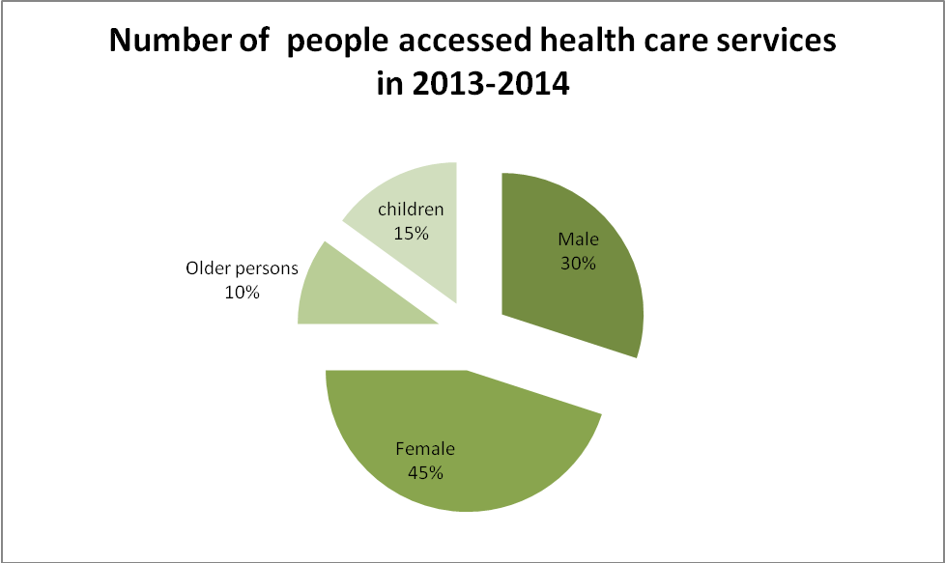**Pie Chart 1: Beneficiaries of medical care services.**

**Analysis and observations made concerning the services offered included the following**

* The majority of rural people still have limited factual information about HIV/AIDS especially its spread and prevention measures. One beneficiary was quoted as saying, ***“HIV is spread through handshake with an infected person”.***
* Access to basic health care services was recorded to still be a big challenge as many people came to access the free services.
* Results from the dental section indicated that majority of patients had a periodontal problem. Common cases were for extraction and bleeding gums. It was also recommended that dental services are still needed to be extended closer to rural communities because it ranked high among the health complications affecting children and adults.
* According to the tests undertaken, it was revealed that malaria complications scored high among children of age bracket 4-15 years old. A bigger number of children who came for the services were found with malaria symptoms and signs. More sensitization and mosquito nets are still needed to be given to children and pregnant mothers.
* Older persons too were identified as being at a disadvantaged position when it comes to access to health care services. Given their status, they hardly afford to reach out to the nearby government health facility which increases their vulnerability.

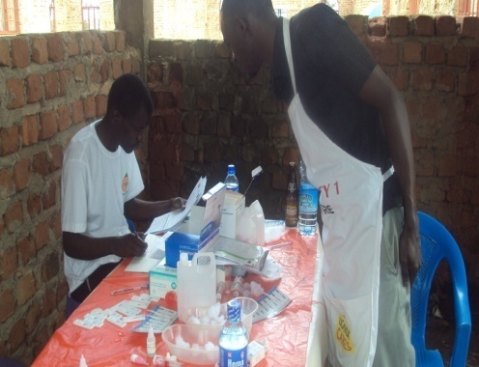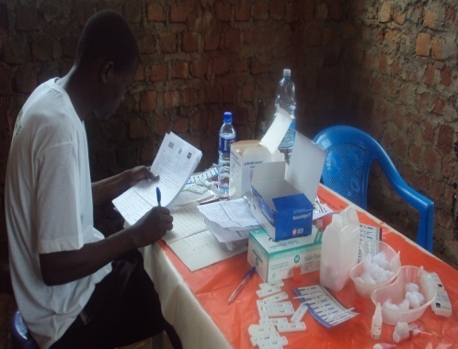

***Older persons in Busukuma Sub County receiving several free basic health services provided by HHI and partners in 2013***

* The health facilities recorded low staff capacity and this was among the key factors for poor health care service delivery. Community members also revealed constant drug stock outs has many failed to get drugs on visits to health facilities.HHI was requested to intensify the mobile clinic day outreaches to bridge the existing lacuna.

HHI worked in partnership with partners who provided support during clinic day outreaches. Among the support provided included;

* **ABACUS Pharmaceutical Company donated an assortment of drugs/** medicines which were dispensed during the clinic day outreaches. ; Without their support little success would have been recorded during such outreaches.

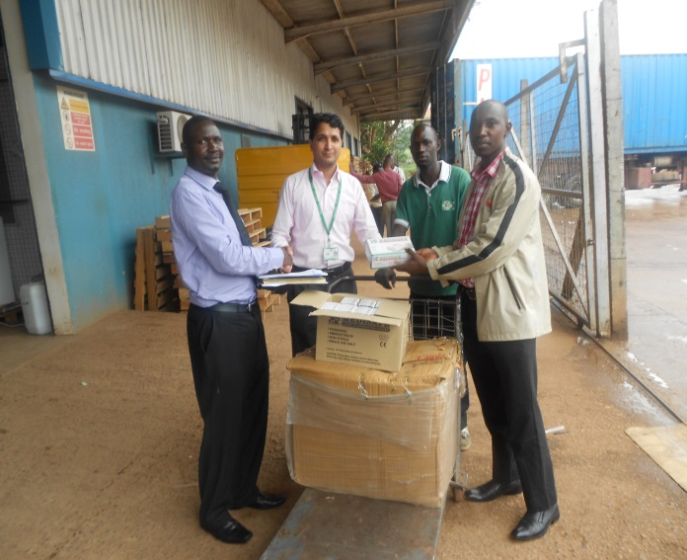

***HHI staffs receiving a donation of drugs from ABACUS Pharmaceutical company offices in Nakawa in 2014***

* 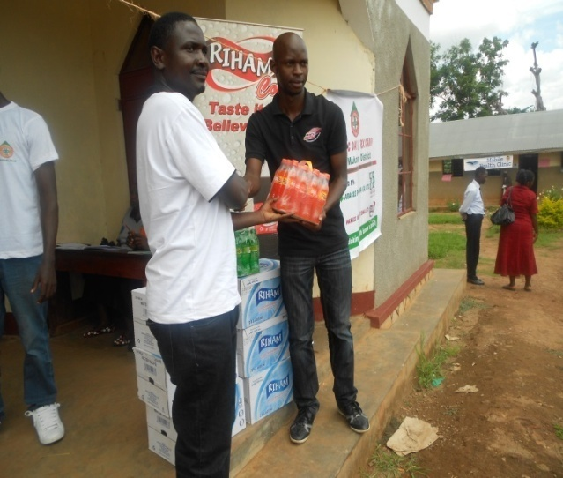**Haris International Limited** provided soft drinks during the clinic day which included water and soft drinks

***The Country Director of HHI receiving donation of refreshments from the Senior Marketing Officer from Hariss International Limited at the clinic day outreach in Kiwafu Primary school in Kimenyedde Sub-County***

* **Mukono District Health Department** supported in mobilizing communities and allocated a health team that supported HHI team during the clinic day. The team also provided health education through Focus Group Discussions.

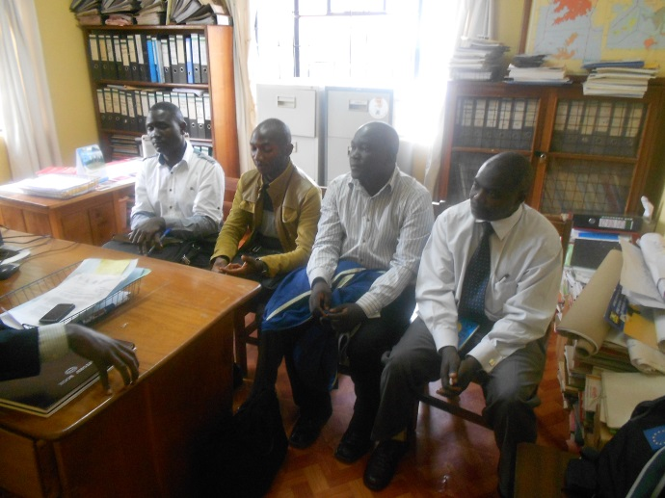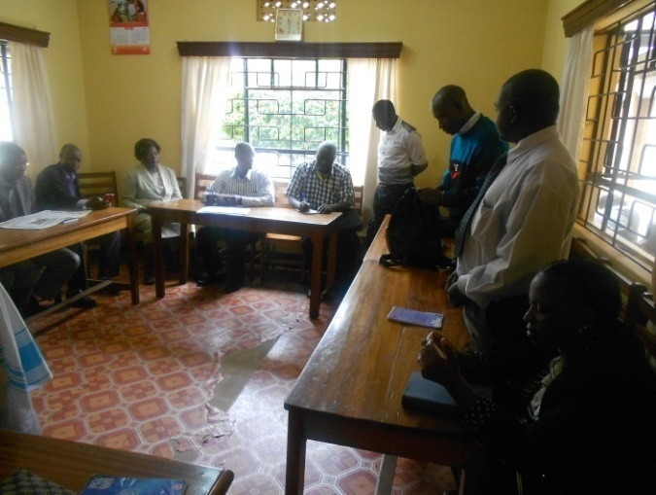

***HHI staff with Mukono district health team headed by the DHO during planning meeting for clinic day outreach.***

1. **Electric Surgery Operations.**

HHI in partnership with Mulago mobile hospital international conducts elective surgery operations on daily basis. For the year 2012, 300 elective surgery operations were managed both at the Centre and within the communities of Kiwonvu Zone, Kawempe, kazo in Wakiso District and Kiboga. In general, majority of the clients complained of lower abdominal pain with PV bleeding. Others had palpable abdominal masses suspicious of fibroids, uterine prolapsed and ovarian cysts as examined by a specialist gynecologist a situation that forced medical officers to refer them to 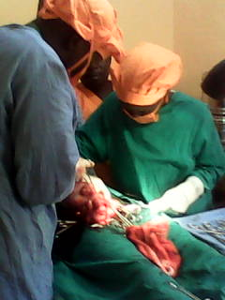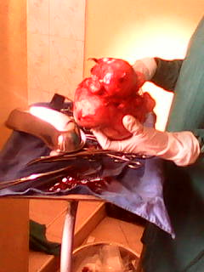Mulago Hospital for further medical interventions.

Elective operations taking place at the centre

It is important to note that there is great need to intensify the cancer screening campaign to for wider coverage to benefit the hard to reach communities. Cancer remains one of the silent diseases claiming women’s lives due to lack of awareness. Through this exercise, HHI found out that in rural settings, women still associate cancer to witchcraft and this increases their vulnerability.

HHI established that there is a need to intensify sensitization about all cancers to rural women and men such that were possible can access screening services earlier. Due to lack of service provision on cancer screening, HHI will continue to forge partnerships so that such services are rolled out in rural settings to save lives.

Ministry of Health, it is recommended should decentralize cancer screening services targeting hard to reach rural areas such that women of reproductive age are screened. In addition interventions that encourage men involvement in supporting women are exceptional.

**c**

TRAINING AND **CAPACITY BUILDING**

* 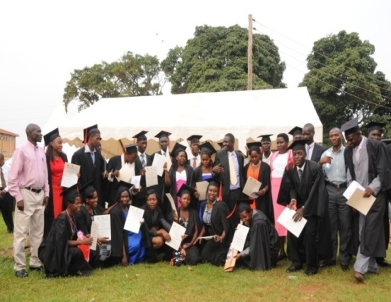 **Training in Records and Information Management**

One of HHI core program areas is building and strengthening health care systems in Uganda. In May 2013 HHI established the National Institute of Medical Records and Information Management to contribute to the reduction of the health systems data and information management challenges. Emphasis was placed on the existing records cadres from public and private health facilities.

In essence by equipping them with relevant skills and knowledge in medical records and information, HHI is contributing to the government’s efforts towards effective designing, planning and programming for quality health service delivery in the country. To date the institute has graduated 150 record cadres and some have been employed by government hospitals such as Nebbi , Arua , Iganga hospitals including Maracha , Kibuki health centers, Bedside Service Kampala, Baylor Uganda and Cancer Institute Mulago. It is anticipated that the human resource trained will support the ministry to bridge the existing gaps in 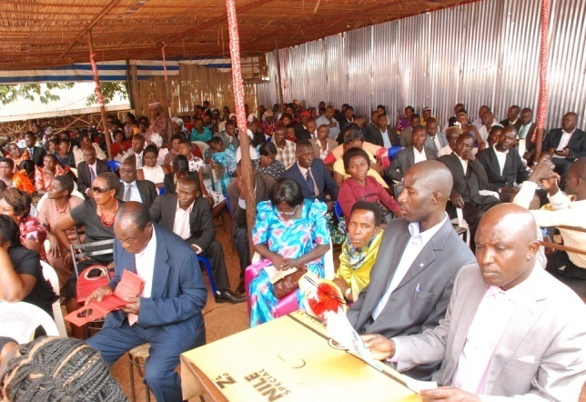collecting quality health information and timely reporting for planning purposes

***Photos above show the Graduation ceremony organized by NIMRIM. In the bottom left corner directors of the institute. In the right corner a representative from Ministry of Public Services unveiling the new log for the institute and launched it.***

**INTERNSHIP PROGRAM**

1. **Trained university students in relevant fields of professionalism.**

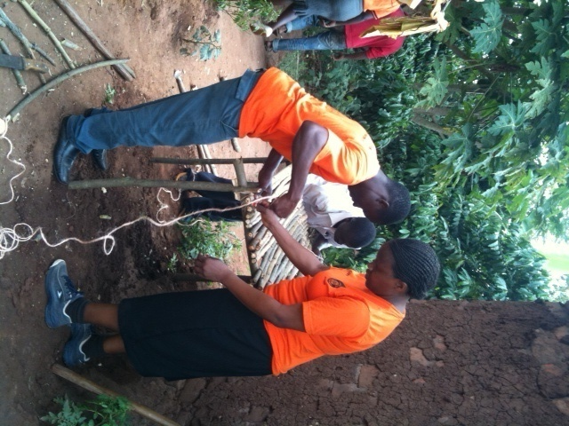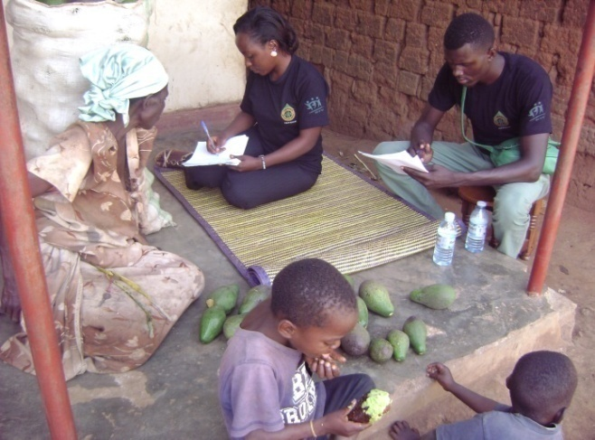 In addition to building the capacity of medical records cadres, HHI has in place an internship program that is aimed at equipping students from various institutions of learning with practical skills and knowledge for community transformation after school. Our major focus is put on social scientists, psychologists, Adult and community educators, development studies, project managers, M & E officers and teachers. In June 2013, HHI in collaboration with Community Hive Organization (CHO), National Youth Voice and Ministry of Gender Labour and social development (MGLSD) recruited and trained 40 students from Makerere, Kyambogo, Ndejje universities. Among the areas in which students acquired practical skills and knowledge included; Project identification and designing, developing work plans and budgets, participatory monitoring and evaluation, community mobilization, proposal and concept development, field visits, data collection and reporting.

1. **HHI Mini-indicator Survey on Health Management Information Systems (HMIS)**

As part of the internship program, in 2015, HHI recruited 20 university students who participated in the mini HMIS indicator survey. The survey aimed at assessing the existence and effectiveness of the Health Management Information Systems (HMIS) in Kampala and Wakiso Districts. Information was gathered from 380 health facilities. Results of the survey indicated that 80% of private clinics do not have and use Ministry of Health (MoH) HMIS tools. The few that had the HMIS tools had insufficient skills to correctly use them.

***Intern students during the mapping exercise for OVC, sanitation and hygiene cleanliness for older persons and mentorship at HHI offices in 2013.***

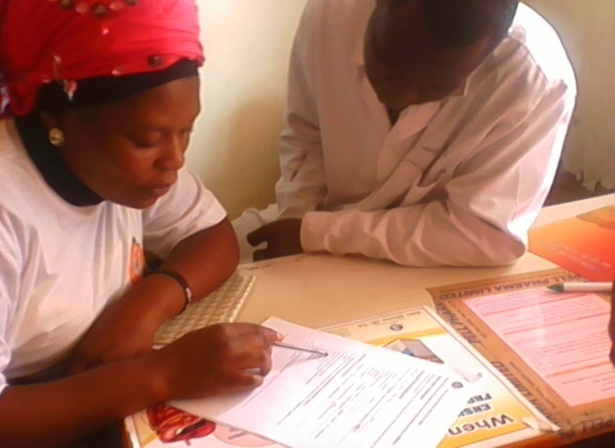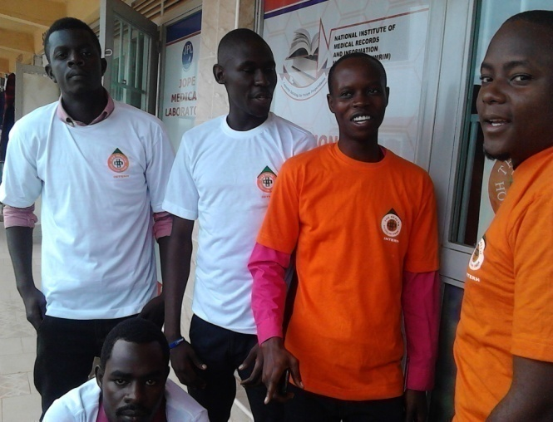

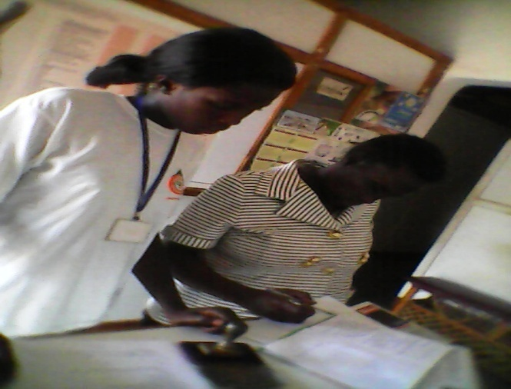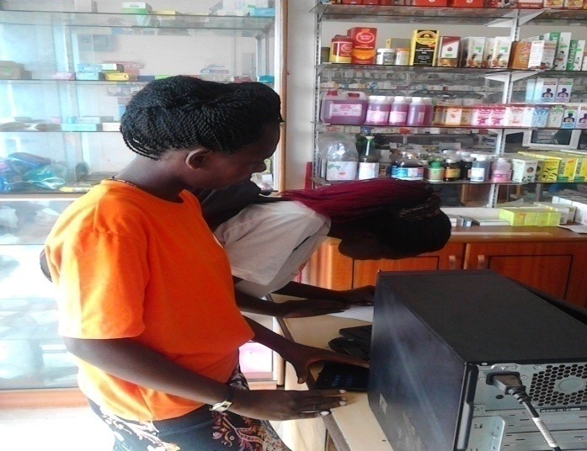

**ORGANIZATIONAL GOVERNANCE**

**Staff meetings:**

meetings are held purposely to internally review and share organization progress. During the meetings, quarterly work plans were revised, challenges were identified and strategies were laid down and put into practice to address the challenges. These meetings were crucial in that various experiences were shared and lessons learnt for better planning and improvement in service delivery.

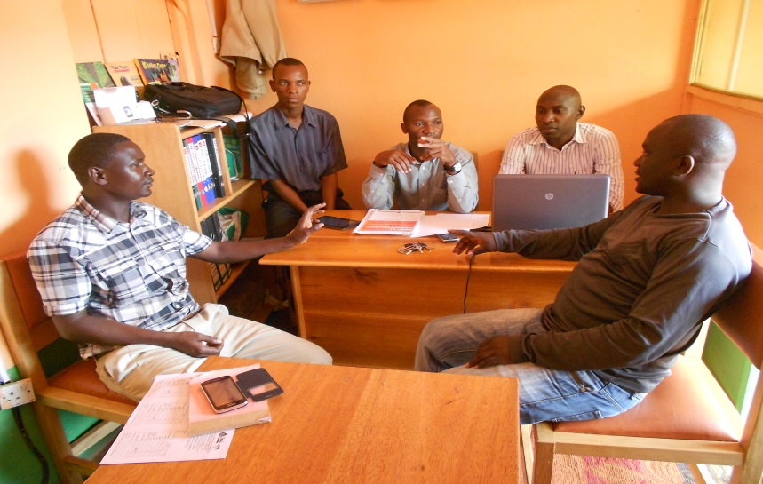

***Across section of university intern students during the Min HMIS indicator survey exercise that was carried out in Kampala and Wakiso districts.***

*Staff meeting in progress at HHI offices*

**Board Meetings**

During the reporting time as mandated by the constitution, board meetings were held purposely to share organization progress as well as reviewing the leadership positions of the board.6 board members attended and among the most important issues raised included;

* All members were appreciative of the capabilities of the implementing team that enabled the organization to move forward and seen in both electronic and print media. For example website development and hosting, print of IEC materials for publication.
* Members were informed that the organization had relocated to more spacious premises with new furniture acquired.
* Members highlighted the tactical and strategic direction of the organization and issues discussed included; meeting rental costs for office space, monthly remuneration for staff, and mobilization of resources with the need to up the IT requirements of the organization.

Based on the needs that were highlighted, members resolved to market the organization to potential development partners and also attract people to register for membership with HHI as strategies for mobilizing resources.

**Development of Strategic plan 2013-2018**

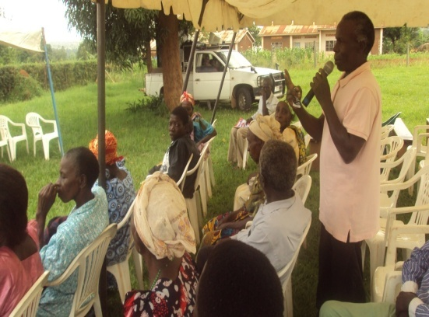HHI developed the 2013-2018 Strategic -Plan to provide a blue print for how it can realize its objectives over the coming five years. To ensure that the plan is relevant, reflects the interests of its members, and is realistic, HHI embarked on a number of processes to generate the plan.

First, HHI commissioned an Organizational Capacity Assessment Team (OCAT) that evaluated the niche. The OCAT provided valuable insights into HHI`s organizational development. Many of its key recommendations are incorporated in the Strategic Plant.

A myriad of stake holders were consulted during this process as detailed in the relevant documents. Desk reviews were undertaken and a number of national policies and guidelines were reviewed which included the Uganda Health policy, HIV and AIDS strategic plans and policies, the national Safe Motherhood Program document, Safe Male Circumcision (SMC) Strategy and HHI progress reports, National Malaria Control Strategy and annual reports from HHI.

New core and thematic areas were agreed upon which included; HIV prevention, Child mortality reduction, Injury control, Cancer prevention, screening and management, Institutional capacity building and strengthening

**Development and distribution of IEC materials**

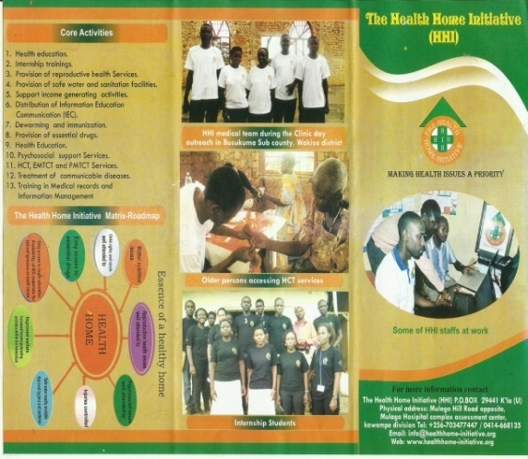HHI and its partnered with Community Hive Organization (CHO), National Youth Voice (NYV) and Mobile Hospital International (MHI) in the development of 4000 posters and brochures.

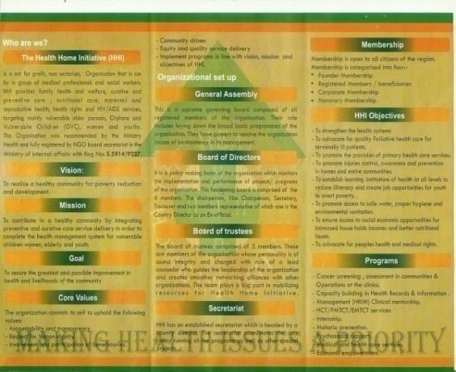The developed materials were distributed to various educational institutions including Makerere , Cavendish , Kyambogo , Kampala International Universities and Makerere Institute of social development among others. Other materials were distributed within communities in the catchments areas in Wakiso and Kampala districts including translate versions in the local languages.

During the reporting period 1000 posters and brochures were distributed. Subsequent evaluations highlighted the need for scaling up the intervention to cover wider areas.

**ORGANIZATIONAL CAPACITANCE**

Over time the financial and human resource capacity of HHI has been reviewed and developed with financial control systems instituted and in place..

HHI has in place a human resource manual and a volunteer policy. HHI has also instituted an experienced team with knowledge in project planning and design, implementation, monitoring and evaluation

HHI also boasts of experience in managing grants and projects from partners and benefactors like Civil Society Fund (CSSF), Independent Development Fund (IDF), Positive Action for Children Fund (PACF)-UK, Youth to Youth Fund (Y2Y Fund)-ILO, Action AID International Grants, Plan Uganda and Save the Children International (SCI). .

**LESSONS LEARNT**

* Despite selfless government interventions to fight HIV/AIDS in the district, the HIV prevalence rate is rather increasing and therefore, there is a great need to intensify the applicable and realistic prevention interventions.
* A large population in traditional communities still has limited access to affordable health care services due to long traveling distances, very few health centres coupled with limited staff.
* Community members especially community volunteers and community leaders have the willingness to identify and deal with their community concerns as members but still have limited capacity in areas of community mobilization, resource mobilisation , leadership, group formation and dynamics among others that are essential for communal development.
* Due to a host of needs in communities, HHI and its partners have a great role to play in mobilizing resources with active involvement of staff and the board of Directors of the Organization.
* Partnership is strength as exhibited by the number of partners and other stakeholders who were very instrumental during activities implementation.
* Through working with universities and students HHI gives an opportunity for students to acquire hands on skills which are relevant to the development communities.

**CHALLENGES**

* Despite the aforementioned achievements HHI registered during the reporting period, the organization faced challenges and other fetters compounded by the limited resource envelope that partly crippled the planned implementation plan. However, HHI managed to work within the budget and available financial and non financial resources for results orientation.
* It is common knowledge that identified beneficiaries have overwhelming expectations from implementing agencies including HHI. As a panacea during the activity implementation, community members were always sensitized about the dire need of the ownership of the programs.

**FUTURE PLANS AND WAY FORWARD**

For the year 2016-2018, HHI plans to scale up its activities to benefit more vulnerable communities in Uganda. In addition we plan to strengthen the internship program such that more university student’s benefit.HHI resource mobilization team plans to aggressively target resources using the developed strategic plan and through proposal and concept paper development.

HHI also plans to initiate the campaign of providing free medical care services to vulnerable communities of Mukono and Wakiso Districts.