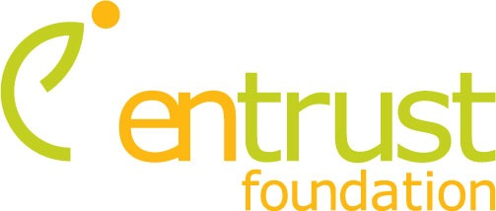


PO Box 553, Doncaster 3108
Tel 0404 458 810
www.entrust.org.au
Funding Criteria
- Entrust Foundation -

What We Do
The goal of Entrust is to be an effective foundation, leading by example - directing our giving where there is less waste and greater effectiveness. This means we support principles of results-driven giving, while striving to maximize our own grants through the promotion of approved projects, to current and potential donors.
Entrust seeks to promote and contribute to "grass roots" organisations that are already delivering a positive result and are not highly visible to donors in Australia. We wish to help the poorest of the poor, in difficult countries, develop leaders, give opportunities to children-at-risk, help provide primary health or education in a way that reflects our Christian values. We want to facilitate positive life change for communities and individuals.
Giving that Delivers
Every potential Project we investigate must pass through our Evaluation Filters, in order to determine its integrity and strategic impact.
These filters include the following elements:

1. Results Focused – (not Need Driven)
The most important test is whether money given ultimately benefits those who need it – will the donation changes lives?
Philanthropy represents an opportunity to mobilise financial and intellectual resources, to address issues of greatest need - in order to deliver extraordinary results in the lives of the needy.
2. Measurable Results
Measurable evidence of lives being changed only happens when the project partners are able to demonstrate clarity of purpose, sound planning, well-informed choices and measurable impact.
Our goal is to see more money and resources flowing to where it can do the greatest good. We want to see less waste & more life-changing impact. This, we believe, will enable donors to give with confidence.
3. Local Initiatives & Local Enterprise
Most of the projects we adopt have little or no exposure in Australia. Many donors give to worthy projects within Australia – only because they are not exposed to mammoth needs in other places. By directing funding towards local initiatives and local people to run these programs, the cost is low for the impressive results they deliver. The size of grants managed by Entrust is between $10,000 and $150,000 – with proven partners. This money is highly leveraged and efficiently used when placed wisely with local partners.
4. Wise Investment
We don’t want to simply give money away...we want to invest in life-changing initiatives. When astute people invest their money they spend considerable effort checking research, establishing objectives, creating a plan and consulting advisors. They forecast a return, assess the risk, measure results, and modify their investment strategies accordingly.
Entrust believes intelligent philanthropy should be wisely focused and produce great results; it changes lives and builds communities.

5. Sustainable & Accountable
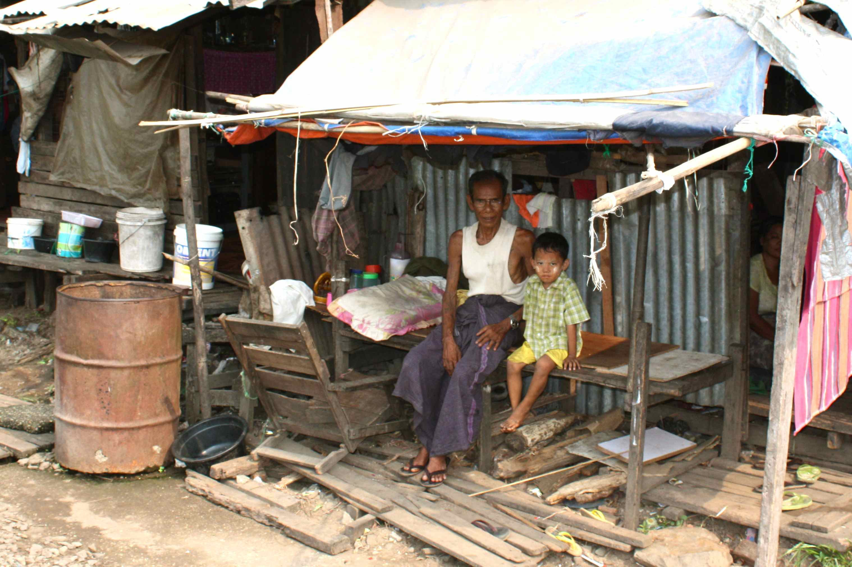
Entrust links with partners to invest in sustainable change. In order to deliver lasting results, long term change must be sustainable after the grant is used. We want the grant to bring about change, confident that longer term, on-going support will not be required.
We explicitly evaluate sustainability risk and will not recommend programs that will be reliant on outside help indefinitely. We highly prize open, transperant realtionships with our Project Partners. They agree to regulary report on progress and be transperant and accountable for the funds directed to them. If parameters change - they will tell us - and we inform Donors. Not everything always goes to plan. Timelines stretch, governemnts change, disasters occur; but the strength of our partnerships ensure that open, honest communication is not negotiable!
6. Greatest Value... in the Hardest Places
We understand that the most exceptional giving opportunities are in the world's hardest places.
Acute need abounds in the Developing World. Sadly, as foreign aid travels through government channels, INGO’s with local and inetbnational offices, resources dissipate.
For over 30 years, Entrust Foundation (an initiatiuve of Mission Enterprises ) has worked hard developing high quality, reliable local partnerships to find and qualify the most effective programs in the world's hardest places. We work with locals to leverage their knowledge so we can make a lasting impact in the lives of the poor and vulnerable.
7. Soft Heart... Hard Head
Generosity arises from our deeply-held passions and values. Our giving is motivated by compassion for others in need – “doing to others as you would have them do to you”. Our desire to help is cultivated in a soft heart. Our soft heart does not mean we have a soft head! We experience the most satisfaction in giving when we join heart and head; when we know that the money provided actually changes the lives of specific people and communities. Because of this we focus on initiatives that address the greatest human needs. For us, helping kids living in a slum is more compelling than saving an arts program.


Project Funding
Entrust regularly uncovers little-known yet highly effective projects in the world's hardest places. These grassroots projects are top performers though they may never be noticed outside their countries without Entrust’s global network and proactive search.
These are presented as ‘Current Projects’ on our web site (www.entrust.org.au). Our Donor Partners select those that match their giving interests and can fully or partly fund a varity of projects. Each one is backed up by a Project Application (available on request) which is our careful research, including analysis of expected outcomes and risks in the project. For each project funded, the donor receives a Project Report at the end of the grant period, evaluating results achieved.
Having a project accepted does not guarantee that the funding will automatically follow. Entrust's parent organisation - Mission Enterprises - will contribute to the project by providing guidance, admin, gift distribution, Govt compliance and oversight. We work with others to partner with us to fund the project. We guarantee that 100% of all donated funds will actually get to the project and that we will cover any overhead needed to make this a reality.

Our Donor Partners
Our Donor Partners are individuals, businesses, families & organisations who share some common traits:
- Passion for giving that makes a difference in the lives of people and communities in the hard places of the world
- Purpose in giving, expecting their grants to produce life-changing results that can be verified
- Desire to connect their resources with effective, local, social entrepreneurs
- Frustration at the lack of reliable, independent information on giving opportunities
- Concern that 100% of the money given will be used on the project
- Willingness to take risks as long as they are assessed and disclosed
- Desire for systematic feedback on the specific impact of grants made
- That people understand we do this in response to Jesus’ requirement that we “help the poor, feed the hungry and take care of the orphan and outcasts”.
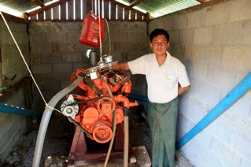
Administration Costs
Research shows that many international charities retain 15% to 60% of donations to cover fundraising and overhead costs. Entrust Donor Partners avoid all of these costs because we channel our donors support directly to local programs. We ensure that 100% of the grant gets to the actual program because we pay for the admin from our own funds.
Our project partners are taught how to use the money wisely and send regular information on progress reporting on results. This gives donors confidence and ensures a long term relationship that will continue to benefit all involved.

